Create build.sbt
build.sbt is the configuration file used by SBT (Scala Build Tool).
It specifies:
- Scala version
- Project dependencies
- Libraries required by the application
The Spark Core dependency provides the RDD API.
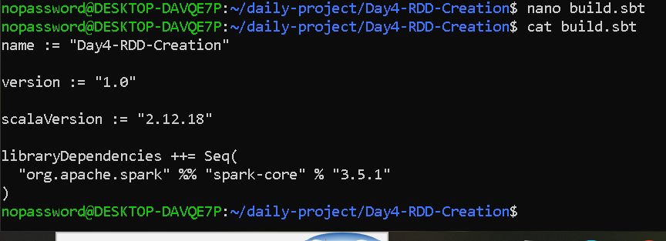

Create transaction data
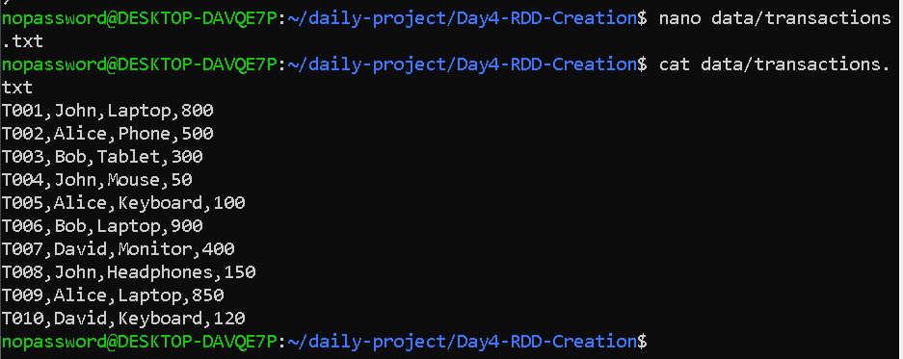
Each transaction contains:
Transaction ID, Customer, Product, Amount
Create customer data
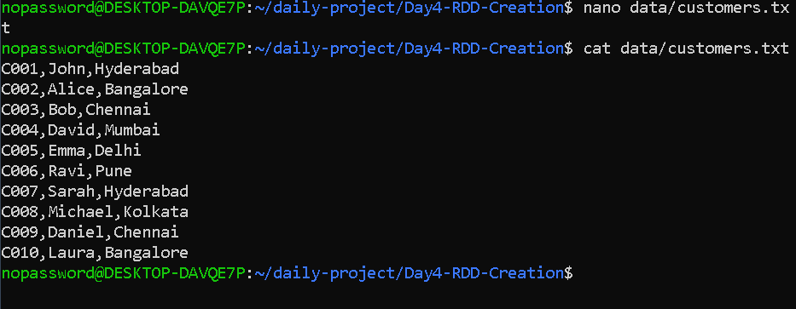

Create the Scala Spark program
import org.apache.spark.{SparkConf, SparkContext}

object Day4RDD {

def main(args: Array[String]): Unit = {

// --------------------------------------------------
// Spark configuration
// --------------------------------------------------

val conf = new SparkConf()
.setAppName("Day4 RDD Creation")
.setMaster("local[2]")

val sc = new SparkContext(conf)

println("========== DAY 4 RDD CREATION ==========")

// --------------------------------------------------
// 1. Create RDD from Scala collection
// --------------------------------------------------

val numbers = Seq(1, 2, 3, 4, 5, 6, 7, 8, 9, 10)

val numberRDD = sc.parallelize(numbers)

println("\n1. RDD CREATED FROM COLLECTION")
println("Original data: " + numberRDD.collect().mkString(", "))

// --------------------------------------------------
// 2. map operation
// --------------------------------------------------

val squaredRDD = numberRDD.map(x => x * x)

println("\n2. MAP OPERATION")
println("Squared values: " + squaredRDD.collect().mkString(", "))

// --------------------------------------------------
// 3. filter operation
// --------------------------------------------------

val evenRDD = numberRDD.filter(x => x % 2 == 0)

println("\n3. FILTER OPERATION")
println("Even numbers: " + evenRDD.collect().mkString(", "))

// --------------------------------------------------
// 4. flatMap operation
// --------------------------------------------------

val sentences = Seq(
"Spark is fast",
"RDD is distributed",
"Scala is powerful"
)

val sentenceRDD = sc.parallelize(sentences)

val wordsRDD = sentenceRDD.flatMap(line => line.split(" "))

println("\n4. FLATMAP OPERATION")
println("Words: " + wordsRDD.collect().mkString(", "))

// --------------------------------------------------
// 5. Read transactions from text file
// --------------------------------------------------

val transactionRDD =
sc.textFile("data/transactions.txt")

println("\n5. TRANSACTION RDD")
println("Number of transactions: " + transactionRDD.count())

transactionRDD.collect().foreach(println)

// --------------------------------------------------
// 6. Calculate total sales
// --------------------------------------------------

val totalSales = transactionRDD
.map(line => line.split(","))
.map(fields => fields(3).toDouble)
.sum()

println("\n6. TOTAL SALES")
println("Total sales: " + totalSales)

// --------------------------------------------------
// 7. Filter high-value transactions
// --------------------------------------------------

val highValueTransactions = transactionRDD
.filter(line => line.split(",")(3).toDouble >= 500)

println("\n7. HIGH VALUE TRANSACTIONS")
highValueTransactions.collect().foreach(println)

// --------------------------------------------------
// 8. Inspect partitions
// --------------------------------------------------

println("\n8. PARTITION INFORMATION")

println(
"Number of partitions in numberRDD: " +
numberRDD.getNumPartitions
)

println(
"Number of partitions in transactionRDD: " +
transactionRDD.getNumPartitions
)

println(
"Default parallelism: " +
sc.defaultParallelism
)

// --------------------------------------------------
// 9. Process customer file
// --------------------------------------------------

val customerRDD =
sc.textFile("data/customers.txt", 4)

println("\n9. CUSTOMER FILE")

println(
"Customer RDD partitions: " +
customerRDD.getNumPartitions
)

println("Customer records:")

customerRDD.collect().foreach(println)

// --------------------------------------------------
// Stop Spark
// --------------------------------------------------

sc.stop()

println("\n========== APPLICATION COMPLETED ==========")
}
}
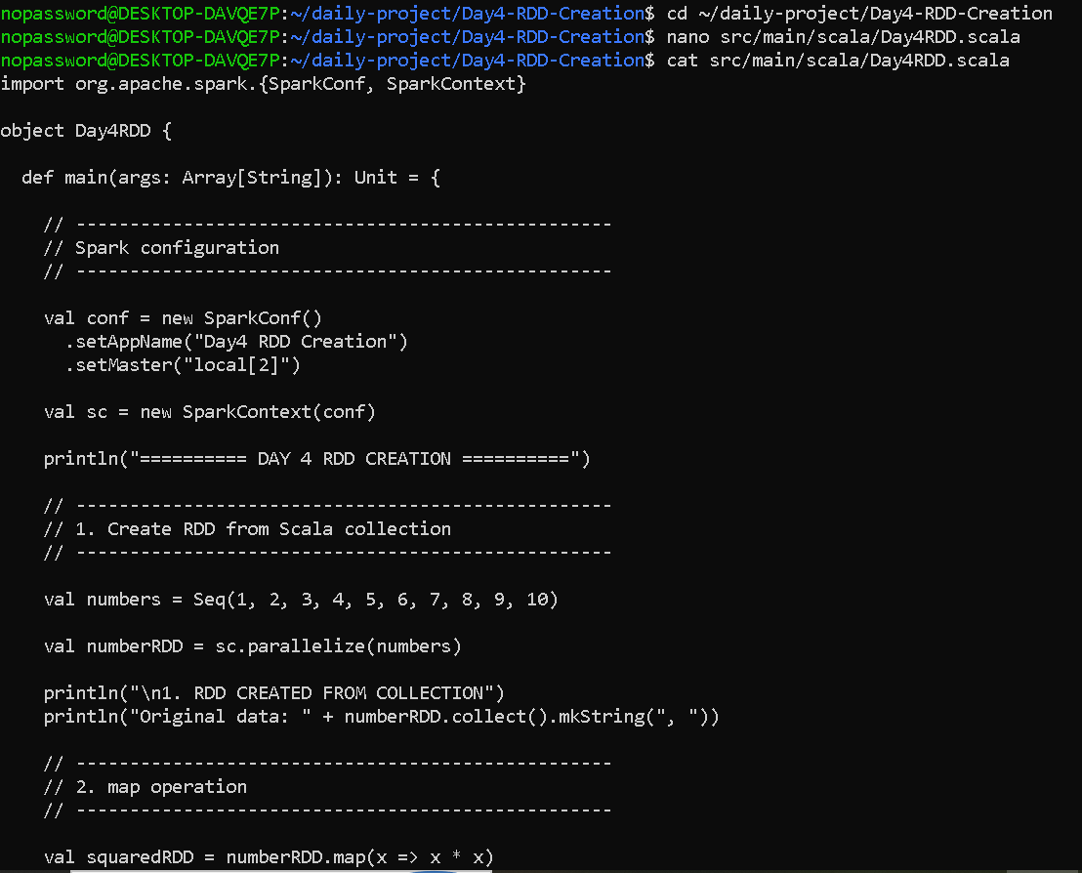

Process a large customer file split into multiple partitions.
- seq 1 10000 | awk '{print "C"$1",Customer"$1",Hyderabad"}' > data/large_customers.txt
This created a large customer file containing 10,000 records.
- wc -l data/large_customers.txt
That proves that 10,000 customer records are created.
- head data/large_customers.txt
shows the first 10 records.
- tail data/large_customers.txt
shows the last 10 records.

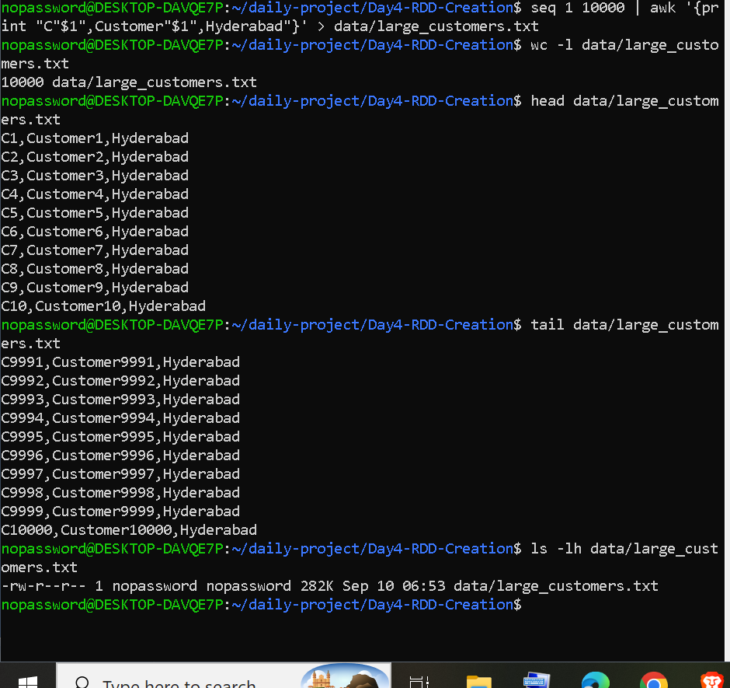

Processing a Large Customer File Using Multiple Partitions
The purpose of this code is not just to create a large file. It demonstrates how Spark takes a large dataset, converts it into an RDD, divides it into partitions, and processes those partitions.

In this step, a large customer dataset containing 10,000 records is loaded into an RDD using Spark's textFile() method. A minimum of four partitions is requested to demonstrate how Spark divides large datasets into smaller partitions for parallel processing. The number of records and partitions is then inspected. Finally, the filter() transformation is used to identify customers from Hyderabad, and count() is used to calculate the number of matching customers.
// --------------------------------------------------
// 10. Large customer file scenario
// --------------------------------------------------

val largeCustomerRDD =
sc.textFile("data/large_customers.txt", 4)

println("\n10. LARGE CUSTOMER FILE")

println(
"Number of customer records: " +
largeCustomerRDD.count()
)

println(
"Number of partitions: " +
largeCustomerRDD.getNumPartitions
)

val customersFromHyderabad =
largeCustomerRDD.filter(
line => line.endsWith("Hyderabad")
)

println(
"Hyderabad customers: " +
customersFromHyderabad.count()
)

Result--

- RDD transformations
I first created an RDD from a Scala collection. Then I used map to square every number, filter to select even numbers, and flatMap to split sentences into individual words."
These are your core RDD transformation results.
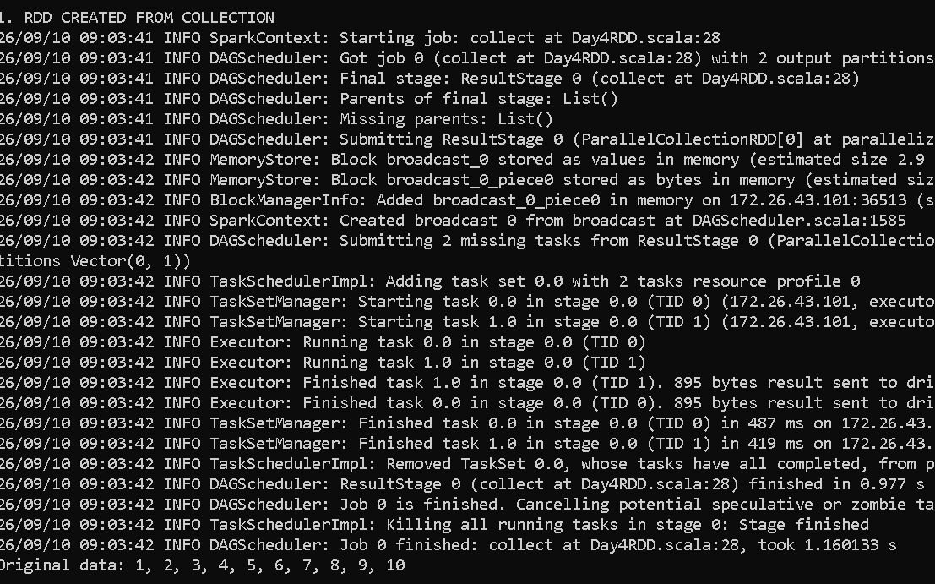

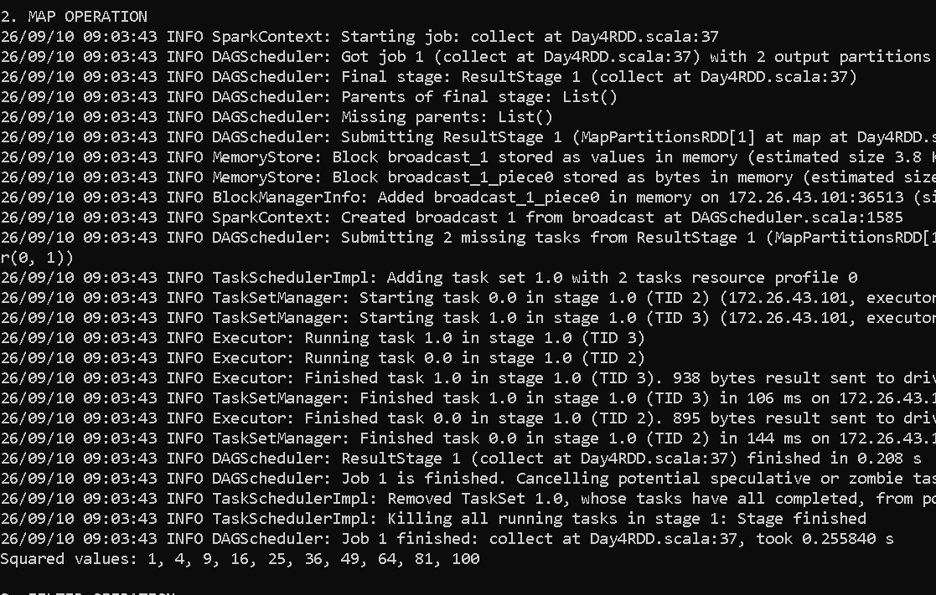
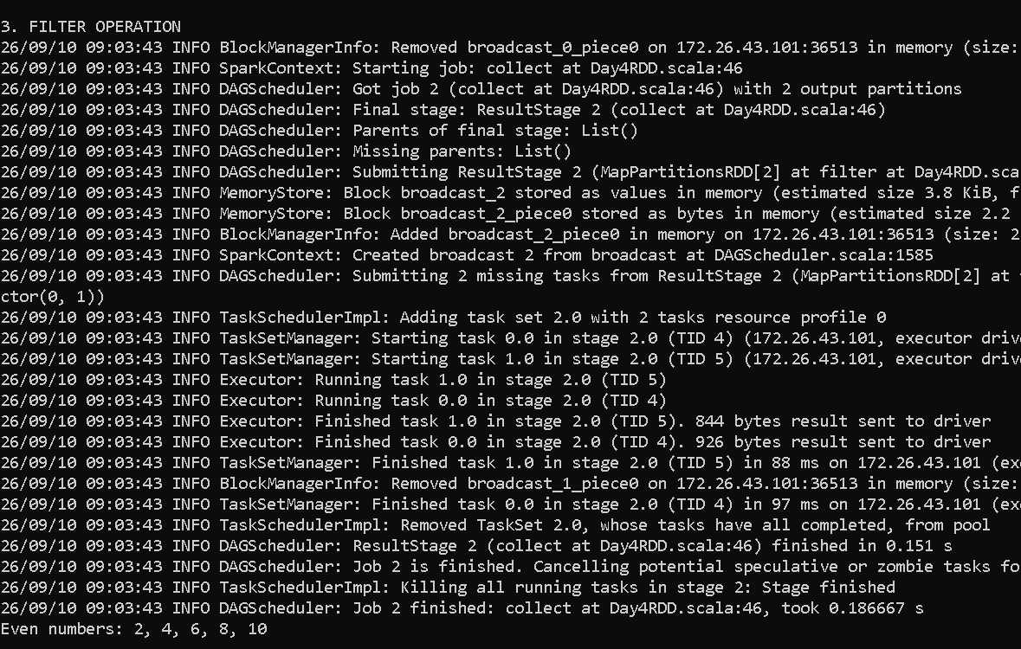

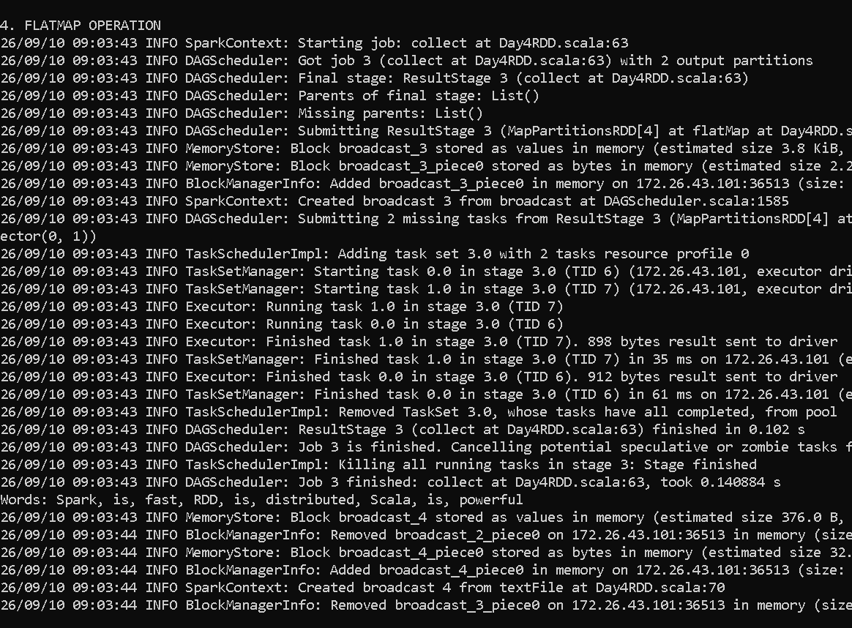
- Transaction and total sales
The transaction text file using sc.textFile(). Each line represents one transaction. I split each line by commas, extracted the fourth field containing the sales amount, converted it to Double, and used the sum() action. The total sales calculated was 4170.0."
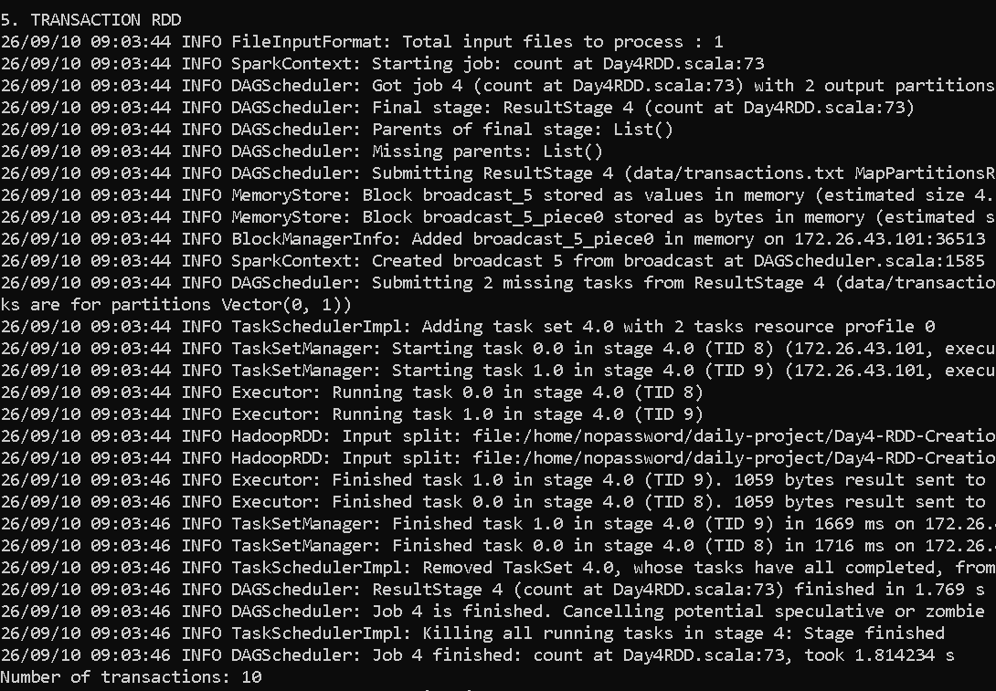

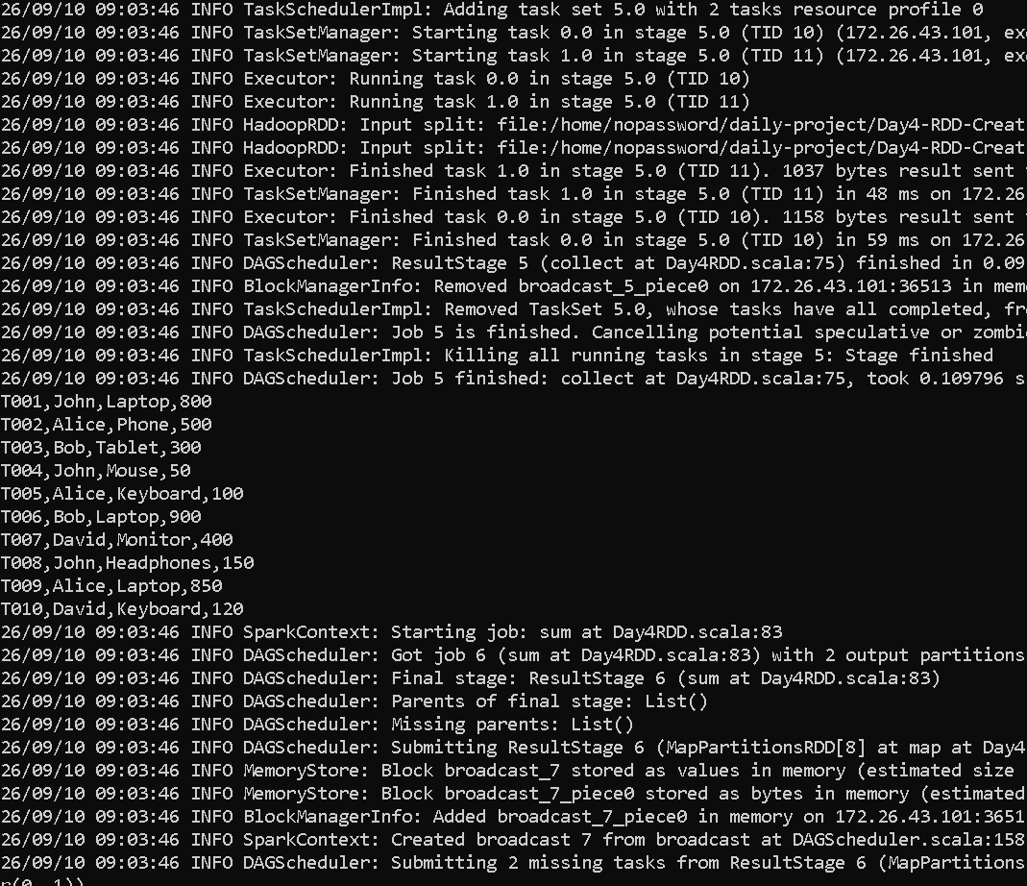

- Partitions and default parallelism
Spark configured to run in local mode using two execution threads with local[2]. Therefore, the default parallelism reported by Spark is 2. The RDDs created in this part also have two partitions.
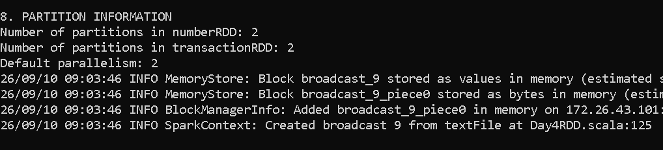

- Customer File – RDD Partitioning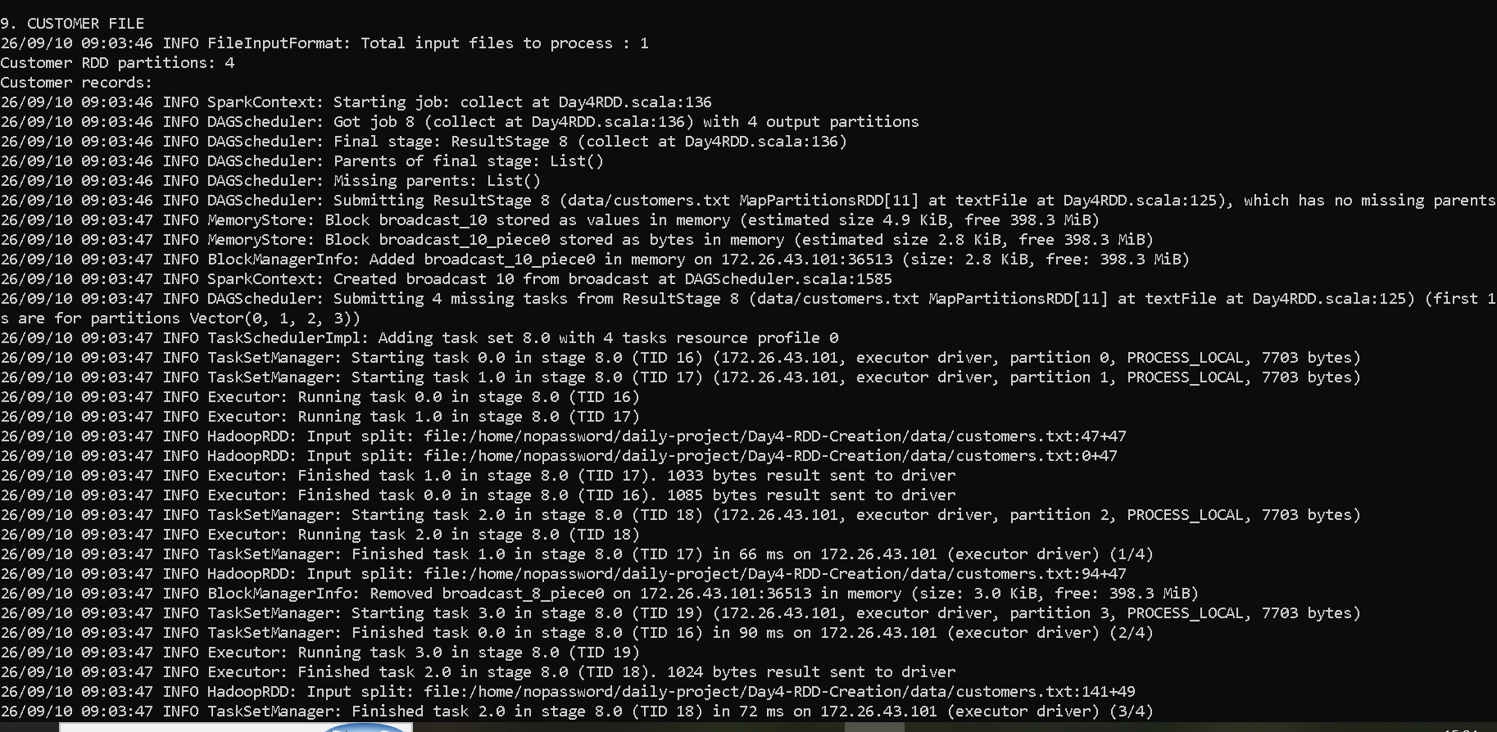

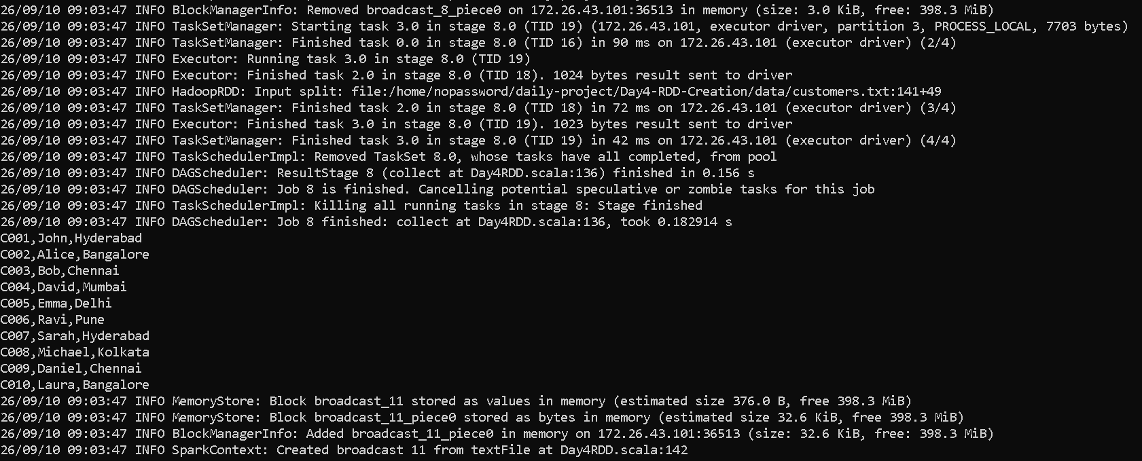
- Large customers FILE
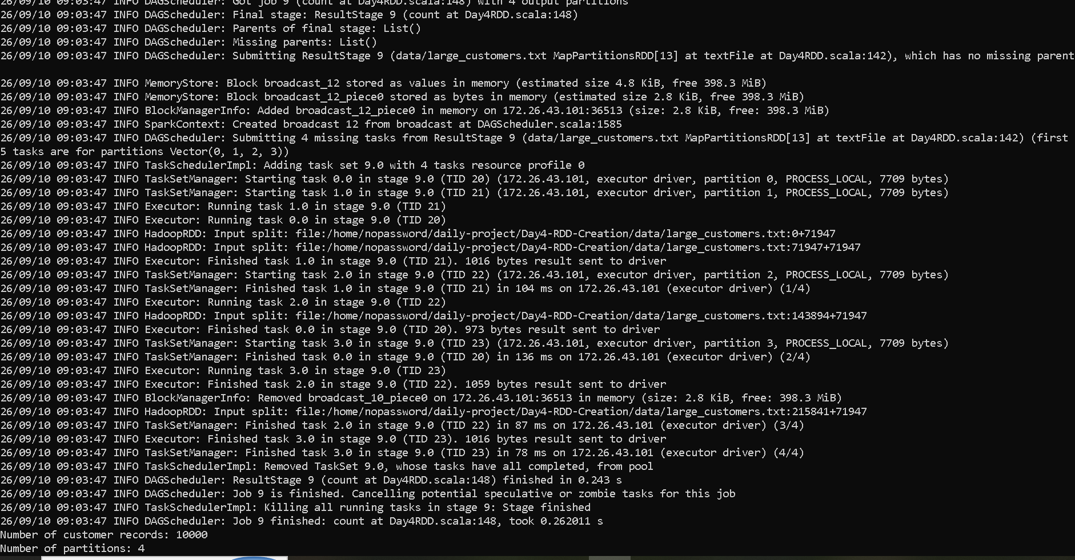

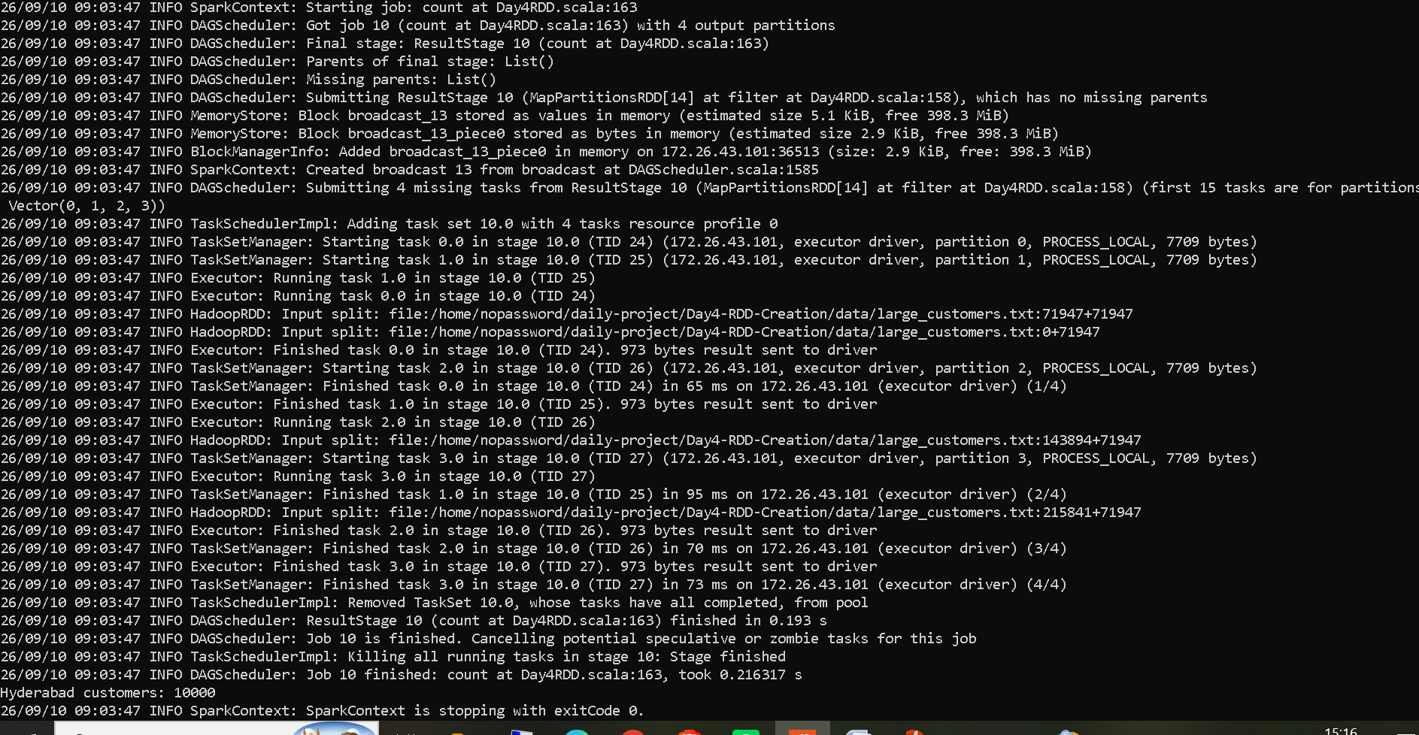

A large customer file containing 10,000 records was processed using Apache Spark RDDs. The file was divided into 4 partitions. Spark created four tasks corresponding to partitions 0, 1, 2, and 3 and successfully processed all four partitions. This demonstrates how Spark partitions large datasets so that the data can be processed in parallel. The RDD contained 10,000 customer records across 4 partition

Here I am demonstrating the large customer file scenario. My file contains 10,000 customer records. Spark divided the file into 4 partitions. We can see partitions 0, 1, 2 and 3 in the log, and Spark created four tasks to process them. After all four tasks completed, the output shows 10,000 customer records and 4 partitions. This demonstrates distributed partition-based processing of a large file."

