Day25-Window-Operations

Create the SBT configuration:
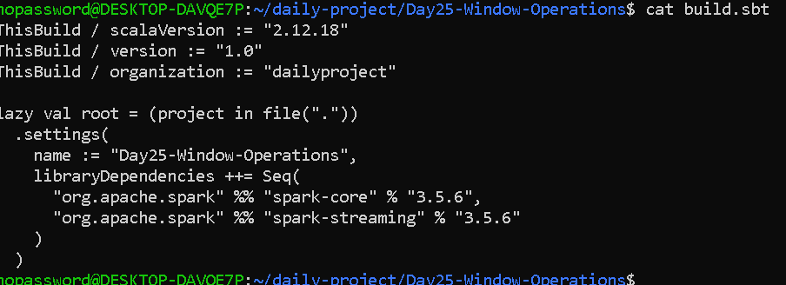

Create the logging configuration:
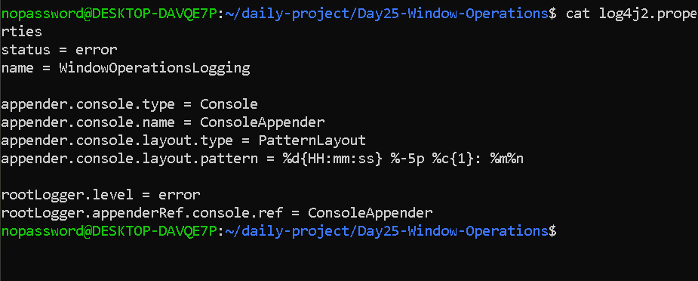

Create the Scala program
cat > WindowOperations.scala <<'EOF'
import org.apache.spark.SparkConf
import org.apache.spark.streaming._
import org.apache.spark.rdd.RDD

import scala.collection.mutable
import scala.concurrent.duration._

object WindowOperations {

def main(args: Array[String]): Unit = {

// true = quick demonstration; false = actual 10-minute window
val demoMode = true

val batchInterval =
if (demoMode) Seconds(2) else Seconds(2)

val windowSize =
if (demoMode) Seconds(10) else Minutes(10)

val slidingInterval =
if (demoMode) Seconds(4) else Minutes(2)

val conf = new SparkConf()
.setAppName("Day25-Window-Operations")
.setMaster("local[2]")

val ssc = new StreamingContext(conf, batchInterval)
ssc.sparkContext.setLogLevel("ERROR")

// Required for window operations and state recovery
ssc.checkpoint("./checkpoint")

// Sample transaction data
val transactionBatches = Seq(
Seq("T01", "T02"),
Seq("T03", "T04"),
Seq("T05", "T06"),
Seq("T07", "T08", "T09", "T10"),
Seq("T11", "T12", "T13", "T14"),
Seq("T15", "T16", "T17", "T18", "T19"),
Seq("T20", "T21"),
Seq("T22", "T23", "T24", "T25"),
Seq("T26", "T27"),
Seq("T28", "T29", "T30")
)

val transactionQueue =
mutable.Queue[RDD[String]]()

transactionBatches.foreach { batch =>
transactionQueue.enqueue(
ssc.sparkContext.parallelize(batch)
)
}

val transactions = ssc.queueStream(
transactionQueue,
oneAtATime = true
)

// Operation 1: Count transactions in the window
val transactionCount = transactions.countByWindow(
windowSize,
slidingInterval
)

transactionCount.foreachRDD { rdd =>
rdd.collect().foreach { count =>
println(s"[WINDOW COUNT] Transactions in window: $count")

// Demonstration threshold
if (count >= 6) {
println(
s"[ALERT] Sudden transaction increase detected: $count transactions"
)
}
}
}

// Sample sales data: product -> sales amount
val salesBatches = Seq(
Seq(("Laptop", 50000.0), ("Phone", 20000.0)),
Seq(("Laptop", 45000.0), ("Phone", 15000.0)),
Seq(("Laptop", 55000.0), ("Phone", 18000.0)),
Seq(("Laptop", 60000.0), ("Phone", 25000.0)),
Seq(("Laptop", 40000.0), ("Phone", 12000.0)),
Seq(("Laptop", 70000.0), ("Phone", 30000.0)),
Seq(("Laptop", 48000.0), ("Phone", 16000.0)),
Seq(("Laptop", 52000.0), ("Phone", 22000.0)),
Seq(("Laptop", 65000.0), ("Phone", 27000.0)),
Seq(("Laptop", 75000.0), ("Phone", 35000.0))
)

val salesQueue =
mutable.Queue[RDD[(String, Double)]]()

salesBatches.foreach { batch =>
salesQueue.enqueue(
ssc.sparkContext.parallelize(batch)
)
}

val sales = ssc.queueStream(
salesQueue,
oneAtATime = true
)

// Operation 2: Calculate rolling sales for each product
val rollingSales = sales.reduceByKeyAndWindow(
(a: Double, b: Double) => a + b,
windowSize,
slidingInterval
)

rollingSales.foreachRDD { rdd =>
val results = rdd.collect().sortBy(_._1)

if (results.nonEmpty) {
println("[ROLLING SALES] Total sales in current window:")

results.foreach { case (product, total) =>
println(f" $product%s -> Rs. $total%.2f")
}
}
}

println(s"Batch interval: $batchInterval")
println(s"Window size: $windowSize")
println(s"Sliding interval: $slidingInterval")
println("Starting Window Operations...")

ssc.start()
ssc.awaitTerminationOrTimeout(35000)
ssc.stop(stopSparkContext = true, stopGracefully = true)
}
}
EOF

OUTPUT—
