Day7-Immutability-Lineage-Fault-Tolerance

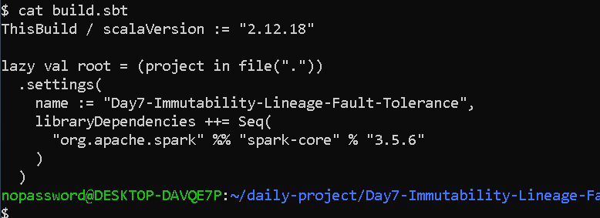

import org.apache.spark.{SparkConf, SparkContext}

object Day7LineageFaultTolerance {

def main(args: Array[String]): Unit = {

val conf = new SparkConf()
.setAppName("Day7-Immutability-Lineage-Fault-Tolerance")
.setMaster("local[2]")

val sc = new SparkContext(conf)

sc.setLogLevel("WARN")

println("======================================")
println("DAY 7 - RDD IMMUTABILITY, LINEAGE")
println("AND FAULT TOLERANCE")
println("======================================")

// --------------------------------------------------
// STEP 1: Create the original RDD
// --------------------------------------------------

val numbers = sc.parallelize(1 to 20, 4)

println("\nOriginal RDD:")
println(numbers.collect().mkString(", "))

// --------------------------------------------------
// STEP 2: Filter even numbers
// --------------------------------------------------

val evenNumbers = numbers.filter(_ % 2 == 0)

println("\nEven Numbers:")
println(evenNumbers.collect().mkString(", "))

// --------------------------------------------------
// STEP 3: Multiply each number by 10
// --------------------------------------------------

val multipliedNumbers = evenNumbers.map(_ * 10)

println("\nMultiplied Numbers:")
println(multipliedNumbers.collect().mkString(", "))

// --------------------------------------------------
// STEP 4: Keep numbers greater than 50
// --------------------------------------------------

val filteredNumbers = multipliedNumbers.filter(_ > 50)

println("\nNumbers greater than 50:")
println(filteredNumbers.collect().mkString(", "))

// --------------------------------------------------
// STEP 5: Create final transformation
// --------------------------------------------------

val finalResult = filteredNumbers.map(_ + 5)

println("\nFinal Result:")
println(finalResult.collect().mkString(", "))

// --------------------------------------------------
// STEP 6: Display RDD Lineage
// --------------------------------------------------

println("\n======================================")
println("RDD LINEAGE")
println("======================================")

println(finalResult.toDebugString)

// --------------------------------------------------
// STEP 7: Demonstrate Immutability
// --------------------------------------------------

println("\n======================================")
println("RDD IMMUTABILITY")
println("======================================")

val original = sc.parallelize(List(10, 20, 30, 40))

val transformed = original.map(_ * 2)

println("Original RDD:")
println(original.collect().mkString(", "))

println("Transformed RDD:")
println(transformed.collect().mkString(", "))

println("The original RDD remains unchanged.")

// --------------------------------------------------
// STEP 8: Simulate executor loss conceptually
// --------------------------------------------------

println("\n======================================")
println("FAULT TOLERANCE SIMULATION")
println("======================================")

println("Assume one executor loses a partition.")
println("Spark checks the RDD lineage.")
println("The lost partition is recomputed from the previous transformations.")
println("The complete RDD does not need to be recreated.")
println("This demonstrates Spark's fault-tolerance mechanism.")

// --------------------------------------------------
// STEP 9: Stop Spark
// --------------------------------------------------

sc.stop()
}
}

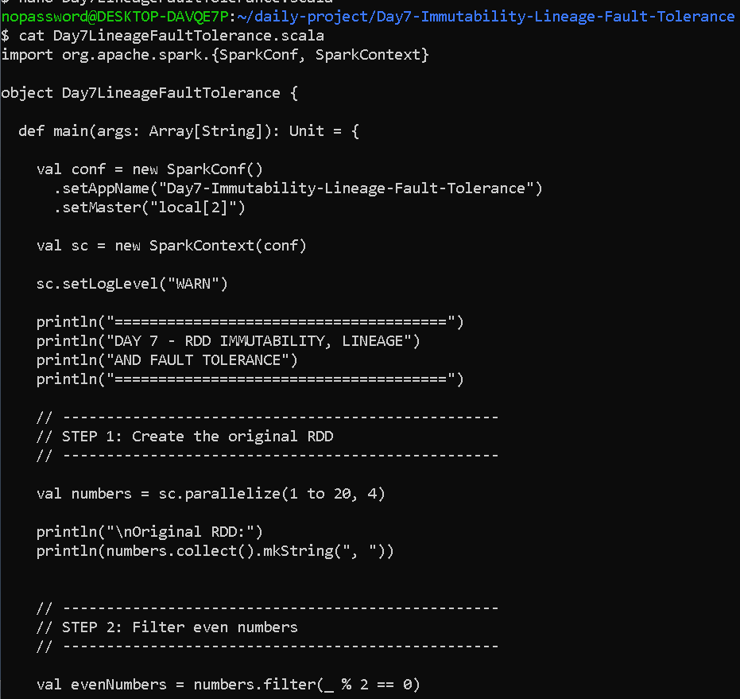

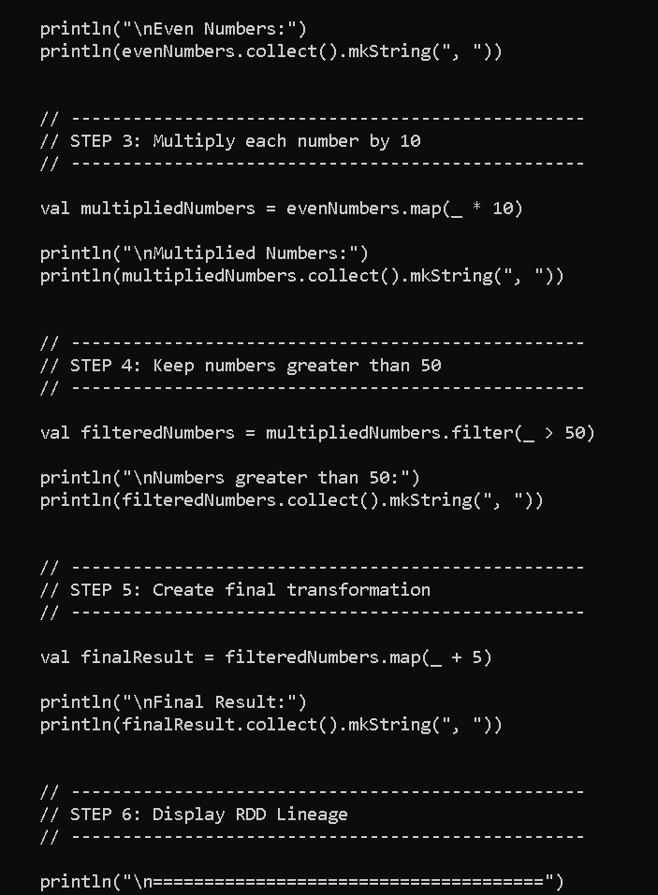

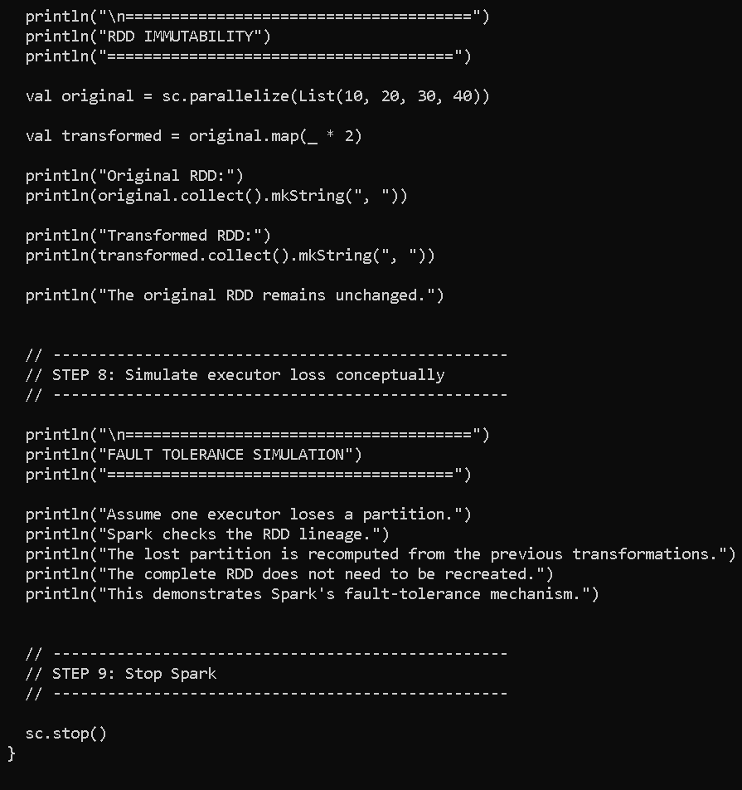

OUTPUT—
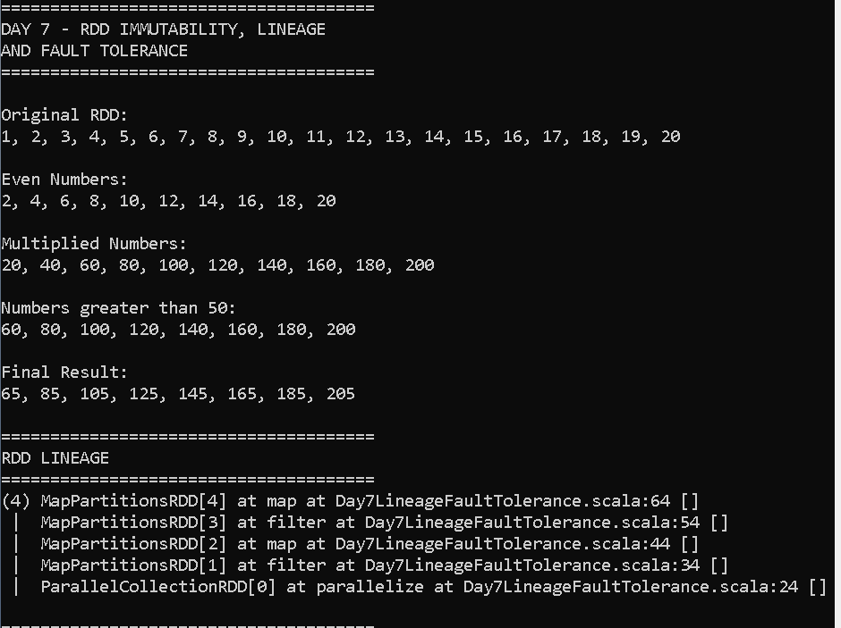

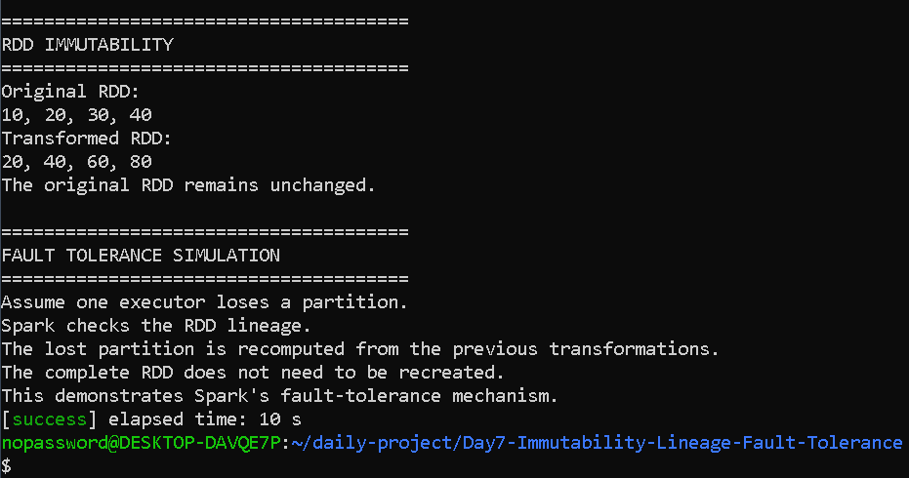

Day 7 — Immutability, Lineage and Fault Tolerance

1. Introduction
Apache Spark provides a distributed data processing framework that can process large datasets efficiently. One of Spark's fundamental abstractions is the Resilient Distributed Dataset (RDD).
An RDD is a distributed collection of data that is divided into partitions and processed across Spark executors. RDDs support transformations and actions and maintain information about how they were created.
This experiment focuses on three important properties of RDDs:
- Immutability
- Lineage
- Fault tolerance
The practical implementation uses Scala and Apache Spark.

2. Objectives
The objectives of this experiment are:
- To create a multi-step RDD transformation chain.
- To understand how Spark maintains RDD lineage.
- To demonstrate that RDDs are immutable.
- To understand how Spark recovers lost partitions.
- To conceptually simulate executor loss.
- To understand how lineage contributes to Spark's fault tolerance.

3. Technologies Used
- Ubuntu / WSL
- Scala 2.12.18
- Apache Spark
- SBT
- IntelliJ/VS Code or Nano
- Git and GitHub

4. RDD Immutability
RDDs in Apache Spark are immutable. This means that once an RDD is created, its contents cannot be directly modified.
When a transformation such as map() or filter() is applied to an RDD, Spark creates a new RDD instead of changing the original RDD.
For example:
numbers
|
| map(_ * 2)
↓
doubledNumbers
The original numbers RDD remains unchanged, while doubledNumbers contains the transformed data.
Immutability provides several advantages:
- It makes distributed processing easier to reason about.
- Multiple operations can safely use the same original RDD.
- Spark can track dependencies between RDDs.
- It supports reliable recovery through lineage.
- It avoids problems caused by modifying shared distributed data.

5. Multi-Step Transformation Chain
In this experiment, the following transformation chain was created:
numbers
|
| filter(_ % 2 == 0)
↓
evenNumbers
|
| map(_ * 10)
↓
multipliedNumbers
|
| filter(_ > 50)
↓
filteredNumbers
|
| map(_ + 5)
↓
finalResult
The first RDD contains numbers from 1 to 20.
The first transformation selects only even numbers.
The second transformation multiplies each selected number by 10.
The third transformation keeps only values greater than 50.
The final transformation adds 5 to each remaining value.
Therefore, each RDD is derived from the previous RDD without modifying the previous RDD.

6. RDD Transformations
Transformations are operations that create a new RDD from an existing RDD.
Examples include:
- map()
- filter()
- flatMap()
- union()
- reduceByKey()
Transformations are generally evaluated lazily. Spark records the transformation instead of immediately executing the complete computation.
In this experiment, the following transformations were used:

filter()
The filter operation selects elements that satisfy a condition.
Example:
numbers.filter(_ % 2 == 0)
This selects only even numbers.

map()
The map operation transforms every element of an RDD.
Example:
evenNumbers.map(_ * 10)
This multiplies every even number by 10.

7. RDD Lineage
RDD lineage is the record of the transformations used to create an RDD.
For this experiment, the lineage can be represented as:
ParallelCollectionRDD
|
| filter
↓
Even Numbers RDD
|
| map
↓
Multiplied RDD
|
| filter
↓
Filtered RDD
|
| map
↓
Final RDD
Spark maintains this dependency information so that it knows how an RDD was produced.
The lineage can be inspected using:
toDebugString
For example:
finalResult.toDebugString
This displays information about the RDD dependencies and partitions.

8. Why Lineage is Important
Lineage is important because Spark does not need to store every intermediate result permanently.
Instead, Spark remembers how the result was produced.
If an intermediate partition is lost, Spark can use the lineage information to determine which transformations need to be executed again.
This provides an important mechanism for fault tolerance.

9. Fault Tolerance
Fault tolerance means that a distributed system can continue processing even when some components fail.
In Spark, RDDs achieve fault tolerance using lineage.
Suppose the following RDD exists:
numbers
↓
filter
↓
map
↓
filter
↓
finalResult
Assume one partition of the intermediate RDD is lost because an executor fails.
Spark can identify the lost partition and recompute it using the original data and the required transformations.
Therefore, Spark does not necessarily need to recompute every partition of the complete dataset.

10. Executor Loss Simulation
For this assignment, executor loss is simulated conceptually rather than by physically killing a Spark executor.
Assume that the Spark application has multiple executors:
Executor 1 → Partition 1
Executor 2 → Partition 2
Executor 3 → Partition 3
Executor 4 → Partition 4
Suppose Executor 2 fails.
The partition stored or being processed by Executor 2 may become unavailable.
Spark detects the failure and uses the RDD lineage to determine how to recreate the lost partition.
Conceptually:
Lost Partition
↓
Check Lineage
↓
Find Parent RDD
↓
Reapply Required Transformations
↓
Recompute Lost Partition
↓
Continue Processing
This demonstrates why lineage is a key part of Spark's fault-tolerance mechanism.

11. Why RDDs Do Not Need Direct Modification
RDDs are immutable because directly modifying distributed data would make dependency tracking and failure recovery more difficult.
Instead of modifying an existing RDD, Spark creates a new RDD for every transformation.
For example:
rdd1 = original RDD
rdd2 = rdd1.map(...)
rdd3 = rdd2.filter(...)
The original RDD remains unchanged.
This creates a clear dependency graph:
rdd1 → rdd2 → rdd3
Spark can use this dependency graph when recovering lost data.

12. Result
The experiment successfully demonstrated:
- Creation of a multi-step RDD transformation chain.
- RDD immutability.
- RDD lineage.
- Use of toDebugString() to inspect lineage.
- Conceptual recovery of a lost partition.
- The role of lineage in Spark fault tolerance.

13. Conclusion
This experiment demonstrates three important characteristics of Spark RDDs: immutability, lineage, and fault tolerance.
RDDs are immutable because transformations create new RDDs instead of modifying existing data. Spark maintains lineage information that describes the dependencies between RDDs.
If an executor fails and a partition is lost, Spark can use this lineage information to recompute the lost partition from its parent RDDs. Therefore, lineage allows Spark to recover lost data without requiring the entire computation to be restarted.
The experiment provides a practical understanding of how Spark maintains reliable distributed processing even when failures occur.

QUESTIONS FOR STUDY..

"What happens if an executor fails?"
Say:
If an executor fails, the partitions being processed or stored by that executor may be lost. Spark uses the RDD lineage to determine how those lost partitions were generated. It recomputes only the required lost partitions from their parent RDDs and transformations rather than recomputing the entire dataset.

"Did you actually kill an executor?"
For this assignment, say:
No. I simulated executor loss conceptually because the assignment asks us to identify what Spark would recompute. The program demonstrates the lineage, and the fault-tolerance scenario explains how Spark would recover a lost partition.
That's completely reasonable for the stated scenario.

10. Important viva question: Why immutable?
If your mam asks:
"Why are RDDs immutable?"
Answer:
RDDs are immutable because Spark does not modify an existing distributed dataset. Instead, every transformation creates a new RDD. This makes the dependency graph predictable and allows Spark to maintain lineage. If data is lost, Spark can use the lineage to recompute it.

11. Important viva question: What is lineage?
Simple answer:
Lineage is the sequence of transformations used to create an RDD.
Example:
RDD1
↓ filter
RDD2
↓ map
RDD3
↓ filter
RDD4
This chain is the lineage of RDD4.

12. Important viva question: What is fault tolerance?
Say:
Fault tolerance is the ability of a system to continue working even when some components fail. Spark provides fault tolerance for RDDs by using lineage to recompute lost partitions.

13. Important viva question: Does Spark recompute the entire RDD?
Say:
Not necessarily. Spark identifies the lost partition and recomputes the required partition using its lineage and parent RDDs. Other partitions that are still available do not need to be recomputed.

