Day16-Aggregations

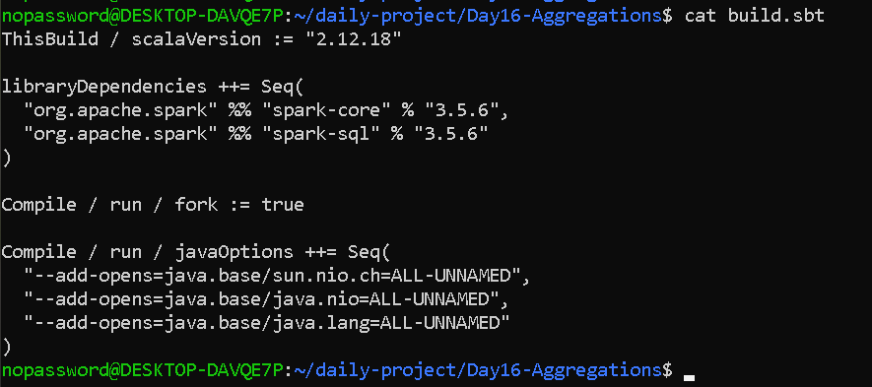

import org.apache.spark.sql.SparkSession
import org.apache.spark.sql.functions._

object AggregationsPractice {

def main(args: Array[String]): Unit = {

// Create SparkSession
val spark = SparkSession.builder()
.appName("Day16 Aggregations Practice")
.master("local[*]")
.getOrCreate()

import spark.implicits._

// --------------------------------------------------
// Employee Salary Data
// --------------------------------------------------

val employees = Seq(
("Lisha", "IT", "Developer", 60000),
("Anu", "IT", "Developer", 70000),
("Rahul", "IT", "Manager", 90000),
("Priya", "HR", "Recruiter", 50000),
("Kiran", "HR", "Manager", 65000),
("Arun", "Finance", "Analyst", 55000),
("Meena", "Finance", "Manager", 80000),
("Vijay", "Sales", "Executive", 45000),
("Divya", "Sales", "Manager", 75000),
("Ravi", "Sales", "Executive", 50000)
).toDF("name", "department", "job", "salary")

println("========== EMPLOYEE DATA ==========")
employees.show()

// --------------------------------------------------
// 1. Basic Aggregations
// --------------------------------------------------

println("========== BASIC AGGREGATIONS ==========")

employees.select(
count("*").alias("employee_count"),
sum("salary").alias("total_salary"),
avg("salary").alias("average_salary"),
min("salary").alias("minimum_salary"),
max("salary").alias("maximum_salary")
).show()

// --------------------------------------------------
// 2. Department-wise Salary Statistics
// --------------------------------------------------

println("========== DEPARTMENT-WISE SALARY STATISTICS ==========")

employees
.groupBy("department")
.agg(
count("*").alias("employee_count"),
sum("salary").alias("total_salary"),
avg("salary").alias("average_salary"),
min("salary").alias("minimum_salary"),
max("salary").alias("maximum_salary")
)
.show()

// --------------------------------------------------
// 3. GroupBy with Multiple Columns
// --------------------------------------------------

println("========== GROUP BY DEPARTMENT AND JOB ==========")

employees
.groupBy("department", "job")
.agg(
count("*").alias("employee_count"),
avg("salary").alias("average_salary"),
sum("salary").alias("total_salary")
)
.show()

// --------------------------------------------------
// 4. HAVING-like Filtering
// --------------------------------------------------

println("========== DEPARTMENTS WITH AVERAGE SALARY > 60000 ==========")

employees
.groupBy("department")
.agg(
count("*").alias("employee_count"),
avg("salary").alias("average_salary"),
sum("salary").alias("total_salary")
)
.filter($"average_salary" > 60000)
.show()

// --------------------------------------------------
// Hospital Department Revenue Data
// --------------------------------------------------

val hospital = Seq(
("Cardiology", "Chennai", 120, 250000),
("Cardiology", "Chennai", 100, 210000),
("Neurology", "Chennai", 80, 180000),
("Neurology", "Chennai", 90, 200000),
("Orthopedics", "Chennai", 110, 190000),
("Orthopedics", "Chennai", 95, 170000),
("Pediatrics", "Chennai", 130, 160000),
("Pediatrics", "Chennai", 125, 155000),
("Cardiology", "Pondicherry", 70, 140000),
("Neurology", "Pondicherry", 60, 125000)
).toDF(
"department",
"location",
"patients",
"revenue"
)

println("========== HOSPITAL DATA ==========")
hospital.show()

// --------------------------------------------------
// 5. Hospital Department Revenue Metrics
// --------------------------------------------------

println("========== HOSPITAL DEPARTMENT REVENUE ==========")

hospital
.groupBy("department")
.agg(
count("*").alias("records"),
sum("patients").alias("total_patients"),
sum("revenue").alias("total_revenue"),
avg("revenue").alias("average_revenue"),
min("revenue").alias("minimum_revenue"),
max("revenue").alias("maximum_revenue")
)
.show()

// --------------------------------------------------
// 6. Hospital Department + Location
// --------------------------------------------------

println("========== DEPARTMENT AND LOCATION REVENUE ==========")

hospital
.groupBy("department", "location")
.agg(
sum("patients").alias("total_patients"),
sum("revenue").alias("total_revenue"),
avg("revenue").alias("average_revenue")
)
.show()

// --------------------------------------------------
// 7. HAVING-like Hospital Filtering
// --------------------------------------------------

println("========== DEPARTMENTS WITH REVENUE > 350000 ==========")

hospital
.groupBy("department")
.agg(
sum("revenue").alias("total_revenue"),
sum("patients").alias("total_patients")
)
.filter($"total_revenue" > 350000)
.show()

spark.stop()
}
}

OUTPUT—

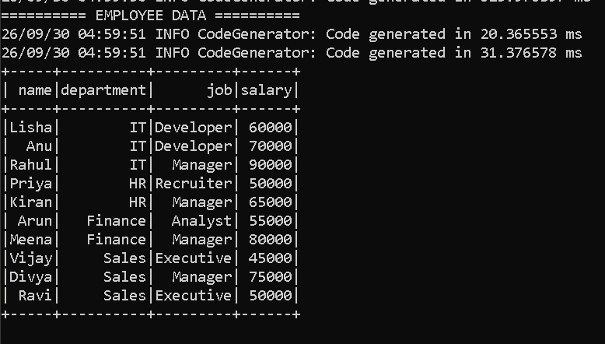

========== BASIC AGGREGATIONS ==========

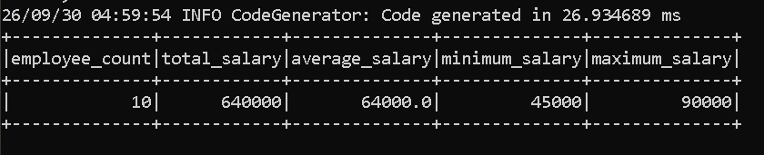

========== DEPARTMENT-WISE SALARY STATISTICS ==========

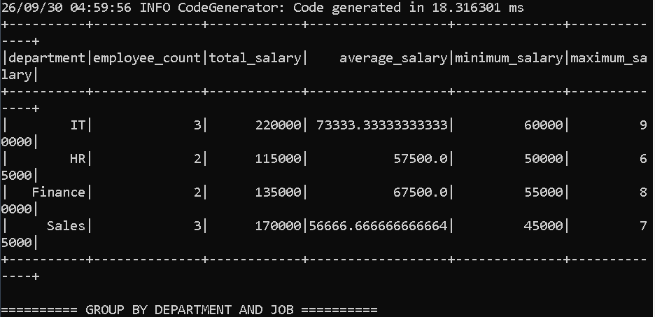

========== GROUP BY DEPARTMENT AND JOB ==========

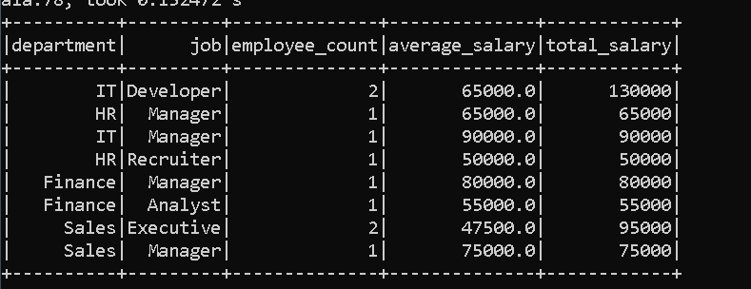

========== DEPARTMENTS WITH AVERAGE SALARY > 60000 ==========

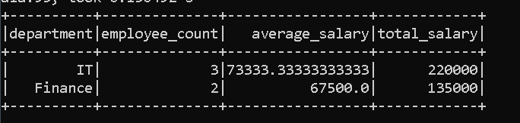

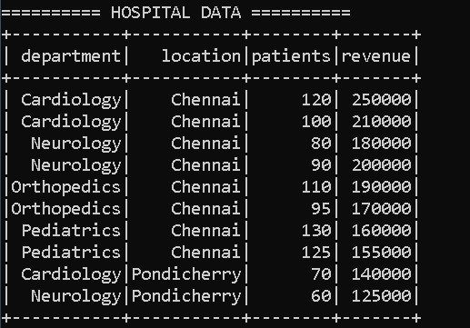

========== HOSPITAL DEPARTMENT REVENUE ==========

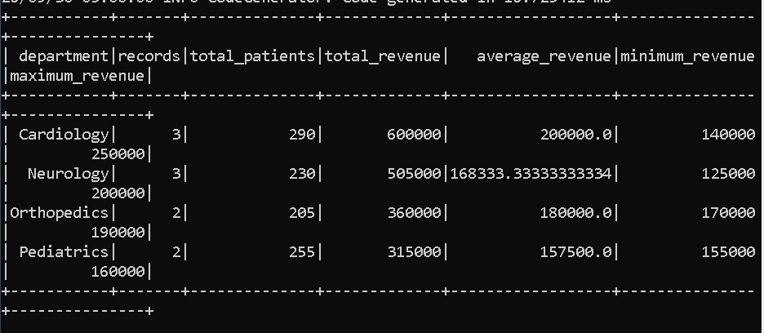

========== DEPARTMENT AND LOCATION REVENUE ==========

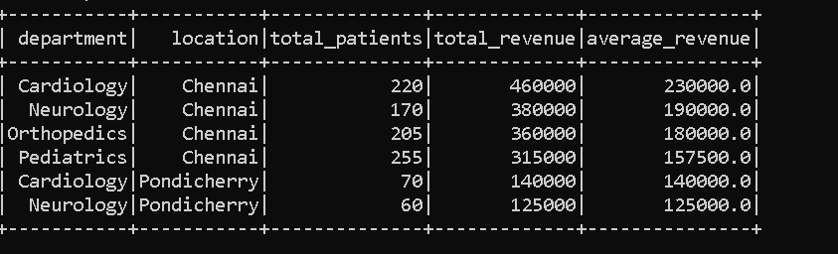

========== DEPARTMENTS WITH REVENUE > 350000 ==========

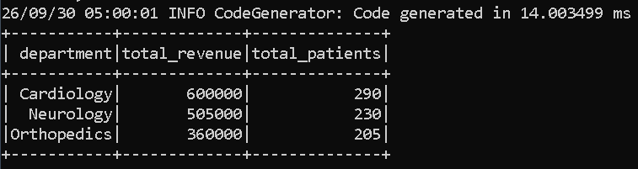

Q1. What is aggregation?
Answer:
Aggregation means combining multiple rows and calculating summary information such as count, sum, average, minimum or maximum.

Q2. What does groupBy() do?
groupBy() groups rows with the same values in one or more columns so that aggregation can be performed separately for each group.

Q3. What is agg()?
agg() is used to apply one or more aggregation functions such as count, sum, avg, min and max after grouping.

Q4. Can we group by multiple columns?
Yes. For example, groupBy("department", "job") groups records based on the combination of department and job.

Q5. What is the difference between WHERE and HAVING?
WHERE filters individual rows before aggregation, whereas HAVING filters groups after aggregation.

Q6. How do you implement HAVING in Spark DataFrame API?
We perform groupBy() and agg() first, and then use filter() on the aggregated column.
Example:
df.groupBy("department")
.agg(sum("revenue").alias("total_revenue"))
.filter($"total_revenue" > 350000)

Q7. Why do we use alias()?
alias() gives a meaningful name to the resulting column. For example, sum("salary").alias("total_salary") names the calculated column total_salary.

Q8. What is the difference between sum() and avg()?
sum() calculates the total of values, while avg() calculates their arithmetic mean.

Q9. What does count("*") mean?
It counts the number of rows in the DataFrame or group.

Q10. Explain your Day 16 project in 30 seconds.
"In Day 16, I practiced Spark DataFrame aggregations. First, I used count, sum, average, minimum and maximum on employee salary data. Then I grouped the data by department and also by multiple columns such as department and job. I implemented HAVING-like filtering by applying filter after aggregation. Finally, I created a hospital revenue scenario where I calculated department-wise patient count, total revenue, average revenue, minimum revenue and maximum revenue."

