scala-day1

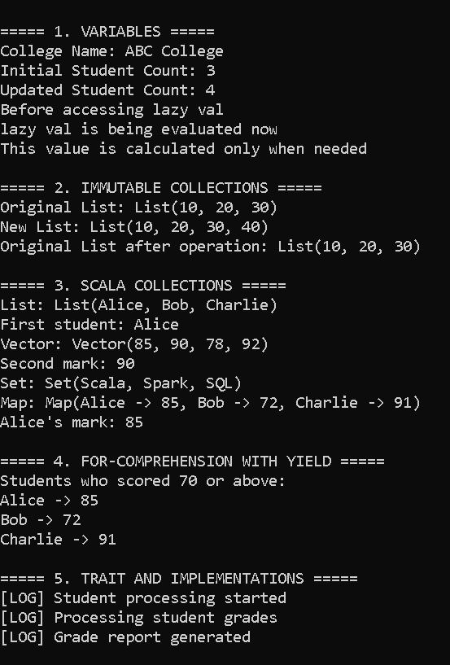
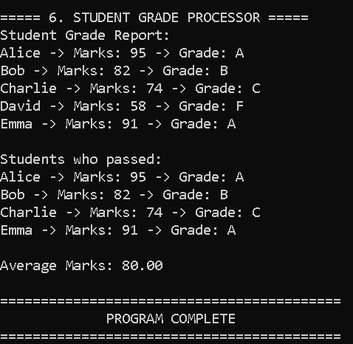

- val
val collegeName = "ABC College"
val is immutable. Once assigned, we cannot reassign it.
- var
var studentCount = 3
studentCount = 4
var is mutable, so its value can be changed.
- lazy val
lazy val message = {
println("lazy val is being evaluated now")
"This value is calculated only when needed"
}
A lazy val is evaluated only when we access it for the first time.
- Immutable List
val numbers = List(10, 20, 30)

val updatedNumbers = numbers :+ 40
The original list isn't changed.
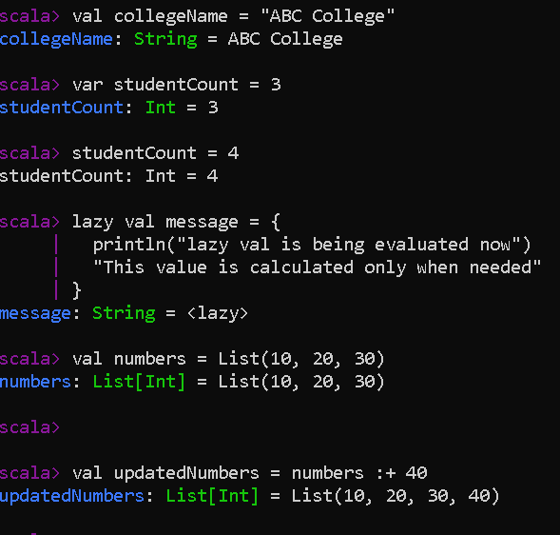

List vs Vector vs Set vs Map
You can explain it like this:
Collection | Purpose | Example
List | Ordered sequence | List("A","B","C")
Vector | Indexed sequence | Vector(10,20,30)
Set | Unique values | Set("Scala","Spark")
Map | Key-value pairs | Map("Alice" -> 85)

- List stores ordered elements.
val names = List("Alice", "Bob")
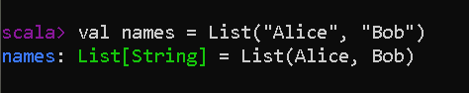

- Vector is useful when we need indexed access.
val marks = Vector(80, 90, 70)
- The duplicate "Scala" is removed.

val subjects = Set("Scala", "Spark", "Scala")
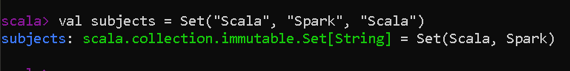

- Map stores data as key-value pairs.

val marks = Map(
"Alice" -> 85,
"Bob" -> 72
)
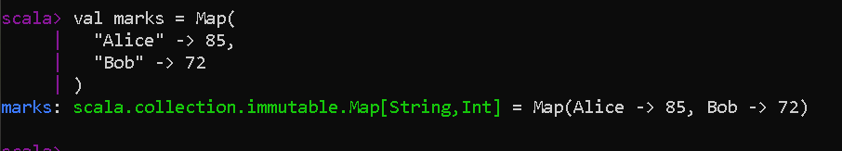

Then, I created a students list containing student names and marks.
Using a for-comprehension with yield, I filtered students who scored 70 or above and stored them in a new collection called passedStudents.
Finally, I used foreach to print the names and marks of the passed students.
val students = List(
| ("Alice", 85),
| ("Bob", 72),
| ("Charlie", 91),
| ("David", 65)
| )

val passedStudents = for {
| (name, marks) <- students
| if marks >= 70
| } yield (name, marks)

passedStudents.foreach {
| case (name, marks) =>
| println(s"$name -> $marks")
| }
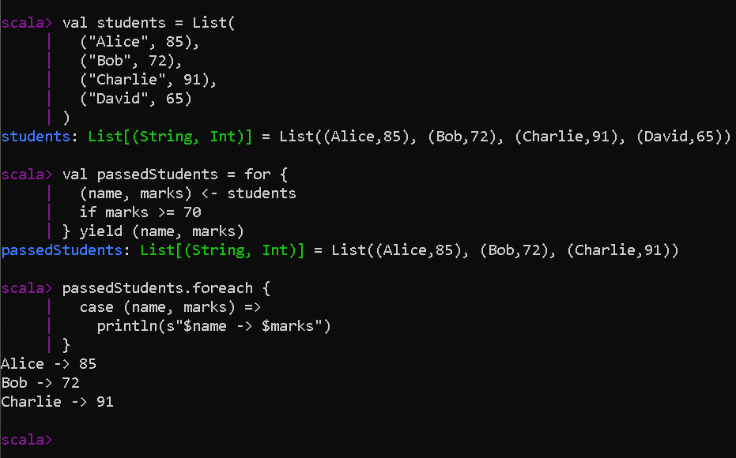

I created a Logger trait with a log() method and implemented it in the StudentProcessor and GradeReporter classes.
trait Logger {
|
| def log(message: String): Unit = {
| println(s"[LOG] $message")
| }
| }
class StudentProcessor extends Logger

class GradeReporter extends Logger
