**Matlab code**

Ridge

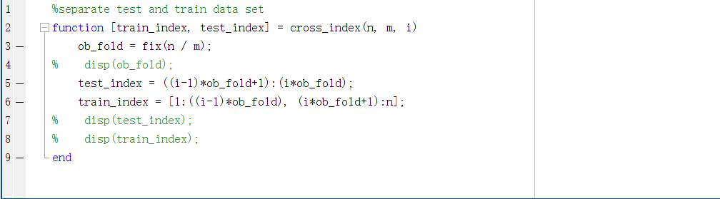

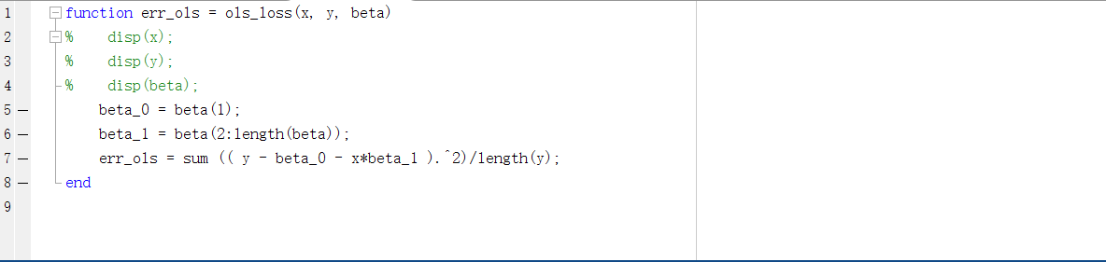

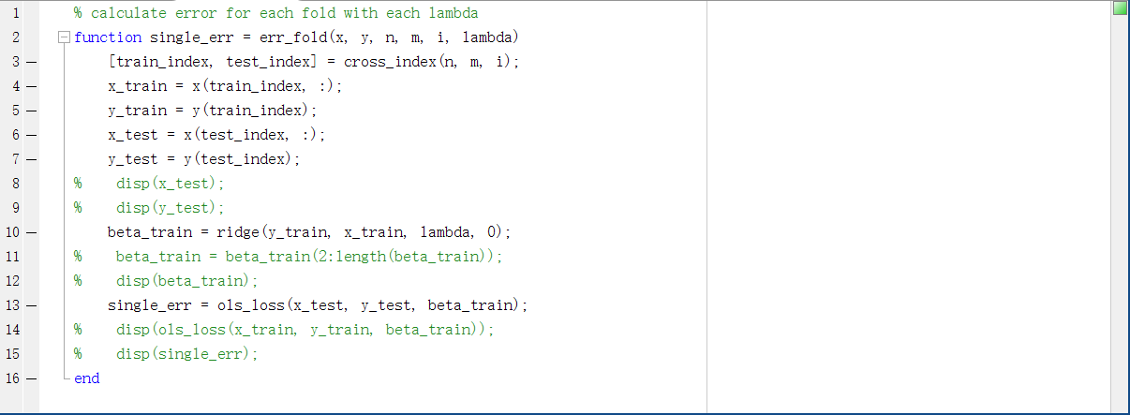

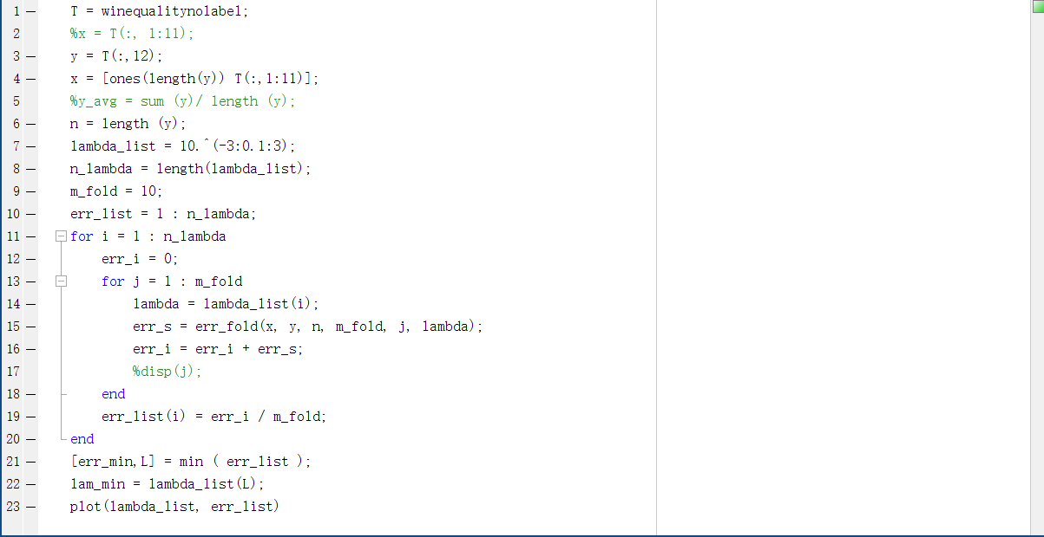

Lasso

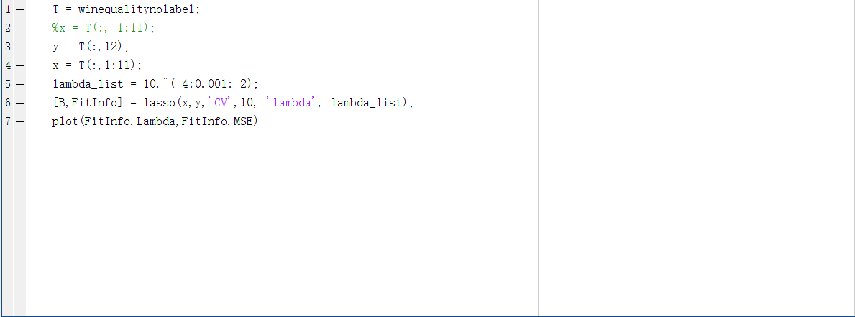

Elastic Net

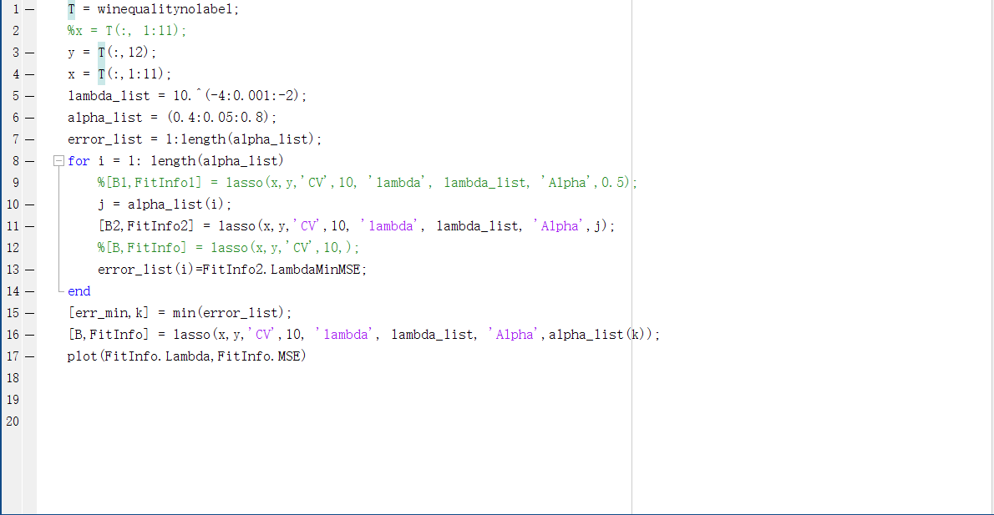

**Result and Plot**

Ridge

Error vs Lambda

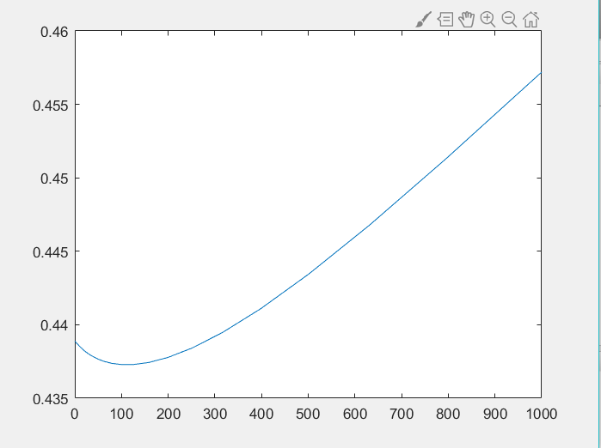

Error value

Lambda

The Minimum error is 0.4373, the Lambda is 100.

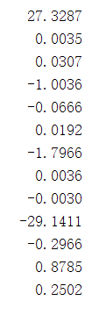

Lasso

Error vs Lambda

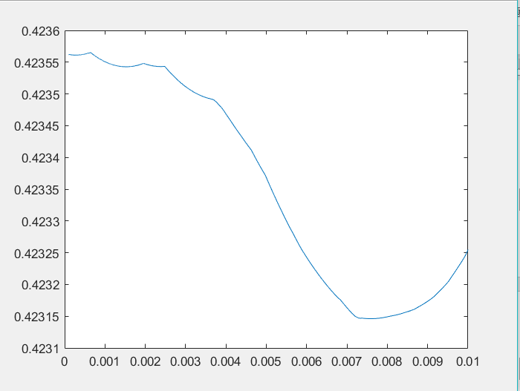

Error value

Lambda

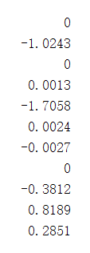 The Minimum error is 0.4231, the Lambda is 0.0076. The Beta is:

Elastic Net

Error vs Lambda

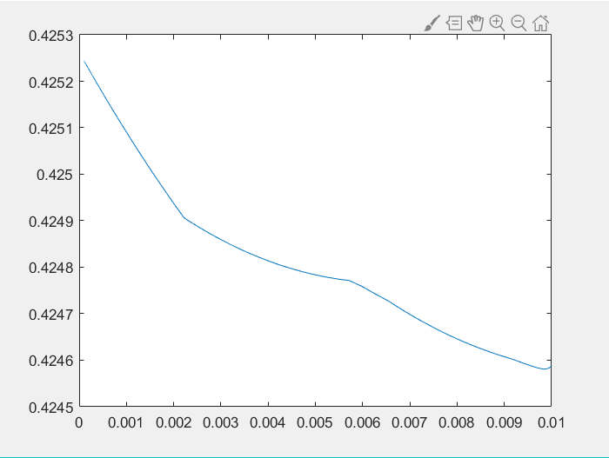

Error value

Lambda

The Minimum error is 0.4246, the Lambda is 0.0099, and Alpha is 0.5.

Beta is

