您必须连接到 Wi-Fi 或蜂窝数据网络才能把这个地理坐标转换成地址信息。
You must connect to a Wi-Fi or cellular data network to reverse the geographical coordinate to address information.

无法确定当前位置，但是您可以通过地图设置地址。
Cannot get current location, but you can set destination by Maps.

目的地
Destination

距离当前位置：XX公里
Distance to Current Location: XX km

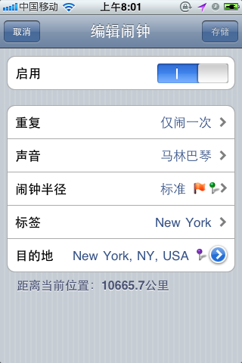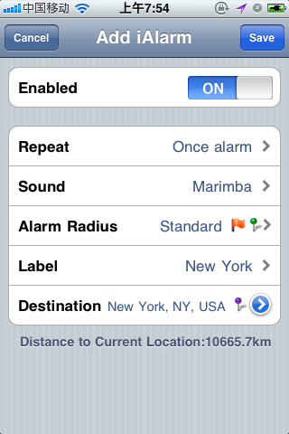

拖拽来改变目的地
Drag to Change Destination

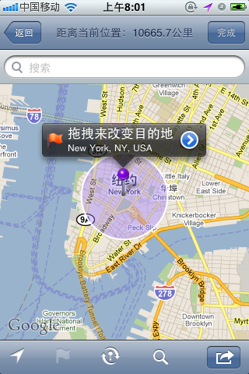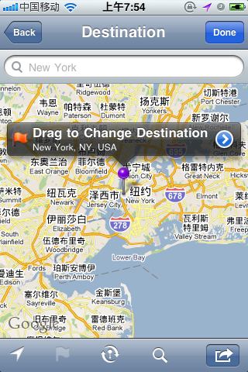

完全版升级包
Full Version Upgrade Package
Or
Full Version Upgrade Packages

升级到完全版，能够解除“位置闹钟”数量的限制。
Updated to Full Version, the number limit of the Location Alarm could be removed.

这是一个位置闹钟，当你到达设定区域时，它会提醒你。你会很快喜欢上它的，这是因为：

✭ 在后台运行，不会对你有任何影响。
✭ 采用最新技术，非常省电。
✭ 完成设定后，在其使用过程中无需网络连接。
✭ 美观易用，简洁流畅。

    它是出行的好伴侣。你可以专心的沉浸在音乐、视频、游戏中，或者安心的打个瞌睡，却不会错过你的目的地！

It is a Location Alarm when you arrive at certain region pre-set, you are alarmed. You will love it soon because of the following reasons:

✭ Back ground operation, no interruption at all;
✭ Latest technology for efficient power consuming;
✭ After setup, no network requirement during the travel;
✭ Simple and friendly design, and good looking.

It is the trustful partner for travellers. You will enjoy music, videos, games, or even catnaps, etc., and no chance to miss your stop!

