Solidity KYC project

Open a remix ide in browser(https://remix.ethereum.org/) and create a new file named KYC.sol, then copy the KYC.sol content into remix and save it.

Select the compiler version as 0.5.8 in the compiler tab and compile the code.

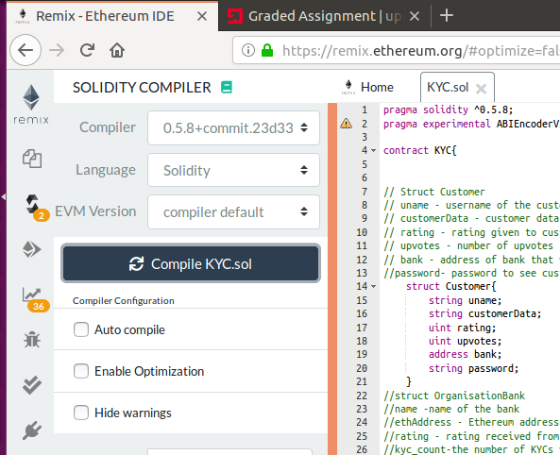

Go to deploy & run tab and deploy with a gas limit of 9000000.

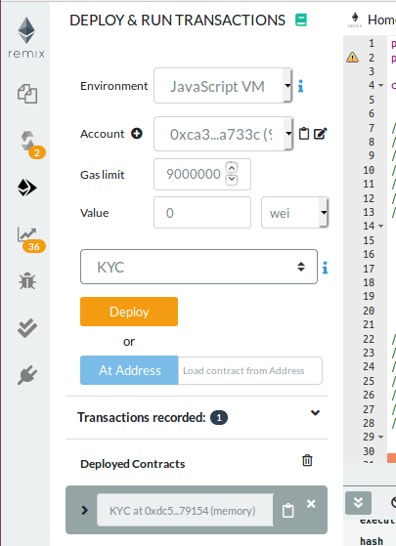

Expand the deployed contract this will list all the public and external functions available in the code.

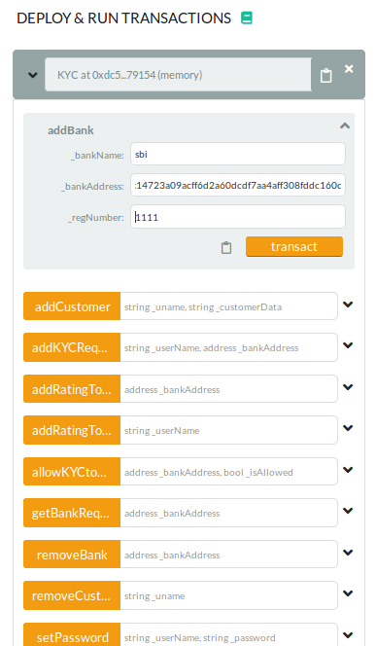

Test cases

1)Create a new bank, copy the deployed address(in my case 0xca35b7d915458ef540ade6068dfe2f44e8fa733c) and using this address(this will be the owner of the contract) create a new bank using below function

Function: addBank

params:
_bankName : sbi
_bankAddress,: 0xca35b7d915458ef540ade6068dfe2f44e8fa733c
_regNumber:1111

Return: 0 for success

2)Using viewCustomerData function bank can check hash of the customer

Function: viewCustomerData
Params:
_uname :lishoy
_password: // if password set for the customer then need to provide password else make it blank

Return :Customer does not exist //if no customer available else we will get the data hash

3)Create a new KYC request using the function addKYCRequest

Function: addKYCRequest

Params:
_userName : Lishoy
_bankAddress: 0xca35b7d915458ef540ade6068dfe2f44e8fa733c

4)Bank Creates Customer using the function addCustomer

Function : addCustomer
Params:
_uname: Lishoy
_customerData:111

Return: 0 if success else 1

5)Add another Bank using addBank function, provide another address available in the remix, also run with owner account address

Function: addBank
params:
_bankName : canara
_bankAddress,: 0x14723a09acff6d2a60dcdf7aa4aff308fddc160c
_regNumber:1112

Return: 0 for success

6) Using addRatingToBank we can give rating to canara bank

Function: addRatingToBank

Params:
_bankAddress: 0x14723a09acff6d2a60dcdf7aa4aff308fddc160c

Return: 0 if success else return 1

7) To view bank rating use the function getBankRating

Function: getBankRating
Params:
_bankAddress: : 0x14723a09acff6d2a60dcdf7aa4aff308fddc160c

Return: rating

8)using the function addRatingToCustomer Bank can rate the customer

Function: addRatingToCustomer
Params:
_userName: Lishoy

Return: 0 if success else return 1

9)To check Customer rating use the function getCustomerRating

Function : getCustomerRating
Params:
_userName:Lishoy
Return:1// customer rating

10)Admin Bank can allow other bank to do KYC using the function allowKYCtoBank

Function: allowKYCtoBank
Params:
_bankAddress,: 0x14723a09acff6d2a60dcdf7aa4aff308fddc160c
_isAllowed: true //default this is false, to allow KYC option make this true

11)To restrict other bank from accessing customer data they can set password

Function: setPassword
Params:
_userName: Lishoy
_password: password

12) To view customer details we can use the function viewCustomer

function : viewCustomer

Params:
_uname: Lishoy
_password: password //before setting password we can view customer without password

Return: customer details

13) We can update customer data using the function updateCustomer

Function: updateCustomer
Params:
_uname: Lishoy
_dataHash: 222

14)To get the last updated bank address of the customer we can use the function getCustomerAccessHistory

Function: getCustomerAccessHistory

Params
_userName: Lishoy

Return: address of the bank

15) To remove customer use removeCustomer

Function: removeCustomer
Params:
_uname: Lishoy

16) To get Bank name from address use function getBankName

Function: getBankName

Params:
_bankAddress: 0x14723a09acff6d2a60dcdf7aa4aff308fddc160c
Return: canara

17) To get Bank address from bank name use function getBankAddress
Function: getBankAddress
Params: canara

Return: 0x14723a09acff6d2a60dcdf7aa4aff308fddc160c

18)To remove Bank use the function removeBank

Function: removeBank

Params:
_bankAddress: 0x14723a09acff6d2a60dcdf7aa4aff308fddc160c

Return: return 0 if successfully removed the bank else returns 1 if bank not present

