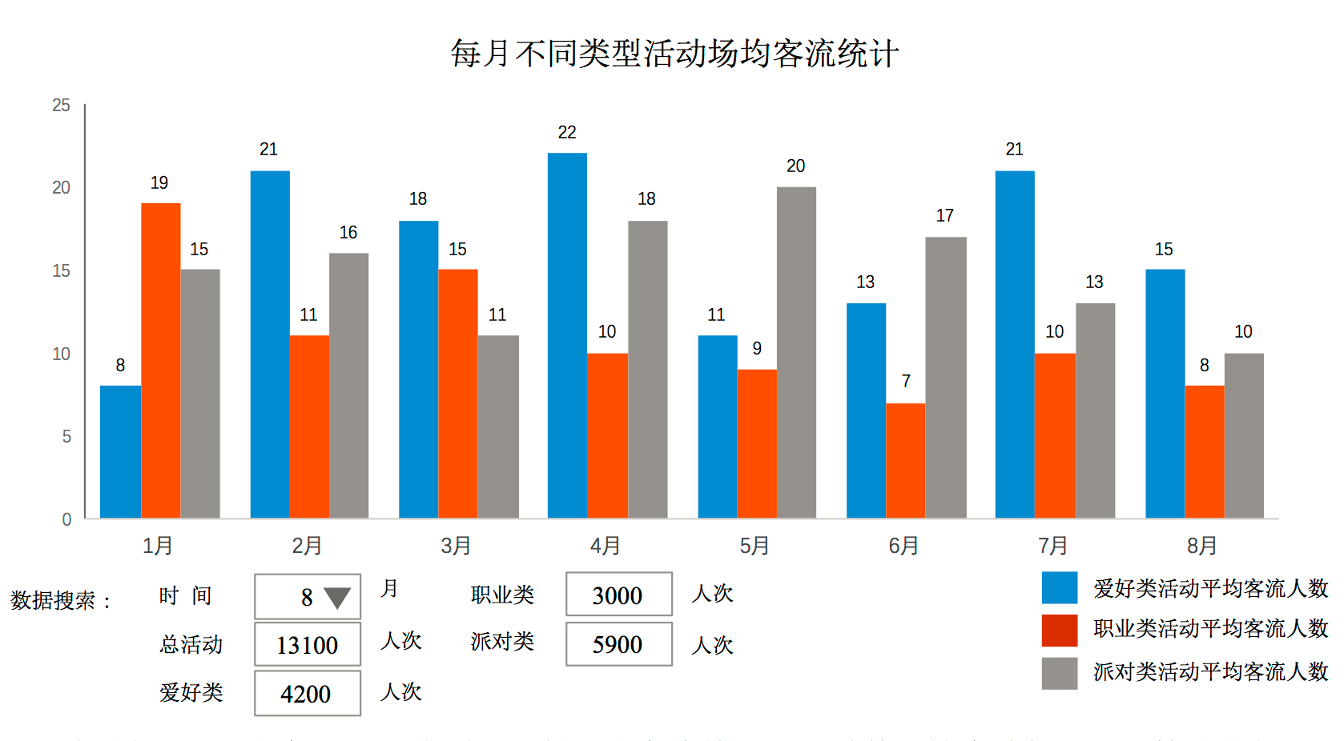
请求地址
api/apiactivitychart/geteverymonthaveragecost
返回结果
{"code":1,"typelist":[{"saleactivitytypeid":2,"saleactivitytypename":"爱好类"},{"saleactivitytypeid":1,"saleactivitytypename":"排队类"},{"saleactivitytypeid":3,"saleactivitytypename":"职业类"}],"allaveragelist":[{"nmonth":7,"average":651},{"nmonth":8,"average":333},{"nmonth":9,"average":651},{"nmonth":10,"average":333}],"averagebytypelist":[{"month":7,"average":877,"count":2,"saleactivitytypeid":2},{"month":7,"average":200,"count":1,"saleactivitytypeid":3},{"month":8,"average":350,"count":2,"saleactivitytypeid":2},{"month":8,"average":300,"count":1,"saleactivitytypeid":3},{"month":9,"average":877,"count":2,"saleactivitytypeid":2},{"month":9,"average":200,"count":1,"saleactivitytypeid":3},{"month":10,"average":350,"count":2,"saleactivitytypeid":2},{"month":10,"average":300,"count":1,"saleactivitytypeid":3}],monthlist":[1,2,3,4,5,6,7,8,9,10,11,12]}
说明
typelist 活动类型列表 saleactivitytypeid 类型Id 类型内容 saleactivitytypename
Allaveragelist 每月所有类型的平均成本 nmonth
月份 average 成本
Averagebytypelist 按照类型每种类型的平均成本
month 月份 average 平均成本 count 类型场次 saleactivitytypeid类型ID
monthlist 月份列表

请求路径
api/apiactivitychart/geteverymonthaveragepassengerflow
返回
{"code":1,"typelist":[{"saleactivitytypeid":2,"saleactivitytypename":"爱好类"},{"saleactivitytypeid":1,"saleactivitytypename":"派对类"},{"saleactivitytypeid":3,"saleactivitytypename":"职业类"}],"alltotallist":[{"nmonth":7,"totalpassengerflow":241},{"nmonth":8,"totalpassengerflow":351},{"nmonth":9,"totalpassengerflow":1254},{"nmonth":10,"totalpassengerflow":1240}],"averagebytypelist":[{"month":7,"average":53,"count":3,"saleactivitytypeid":2,"totalpassengerflow":161},{"month":7,"average":80,"count":1,"saleactivitytypeid":3,"totalpassengerflow":80},{"month":8,"average":131,"count":2,"saleactivitytypeid":2,"totalpassengerflow":263},{"month":8,"average":88,"count":1,"saleactivitytypeid":3,"totalpassengerflow":88},{"month":9,"average":399,"count":2,"saleactivitytypeid":2,"totalpassengerflow":799},{"month":9,"average":455,"count":1,"saleactivitytypeid":3,"totalpassengerflow":455},{"month":10,"average":360,"count":2,"saleactivitytypeid":2,"totalpassengerflow":720}],monthlist":[1,2,3,4,5,6,7,8,9,10,11,12]}
说明 typelist 分类列表 saleactivitytypeid 分类Id saleactivitytypename 分类名称
Alltotallist 每月所有客流总次数 nmonth 月份 totalpassengerflow
客流总次数
Averagebytypelist 每月每种类型的平均客流量和当月某类型总客流量
Month 月份 average 平均客流量 saleactivitytypeid 类型ID
Totalpassengerflow 总次数 monthlist 月份列表

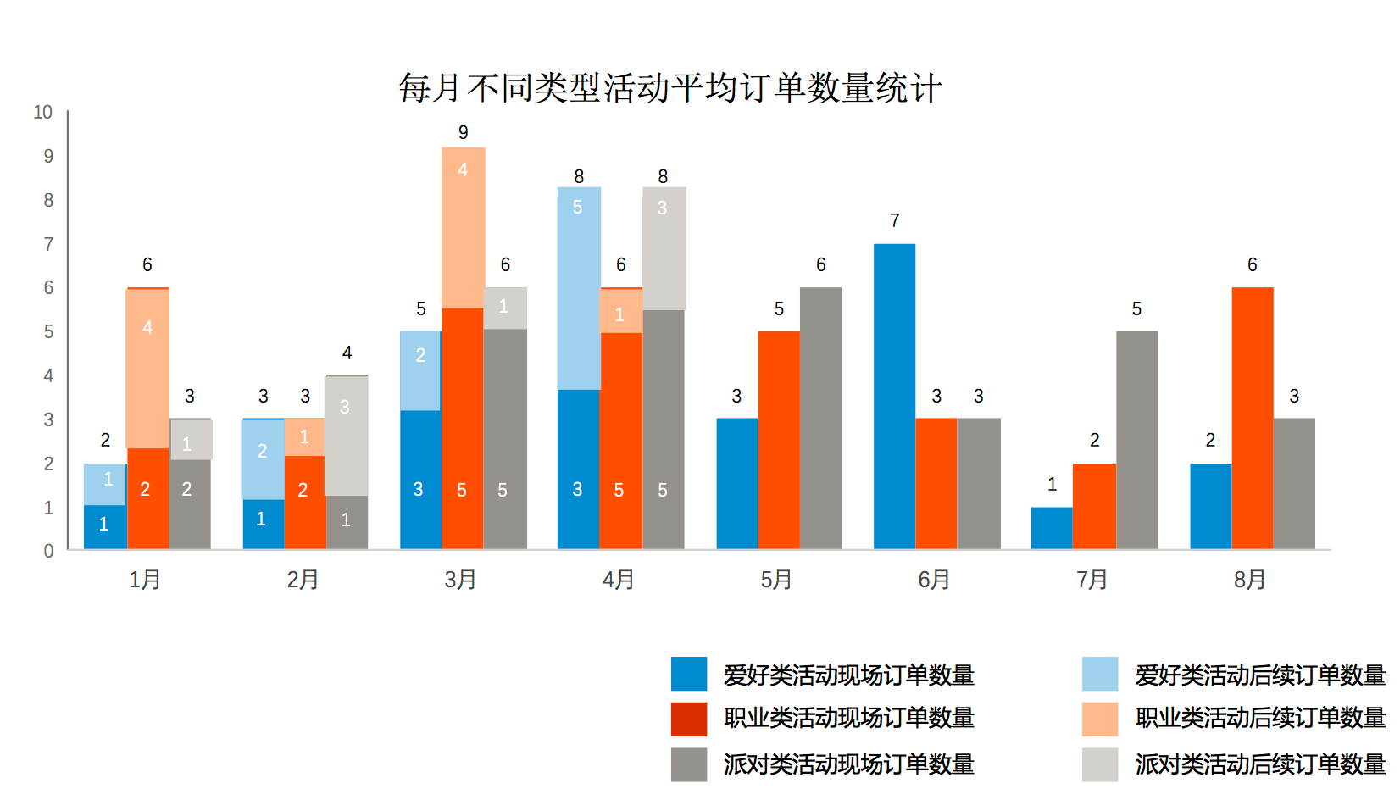

请求地址api/apiactivitychart/geteverymonthaverageorder
返回
{"code":1,"typelist":[{"saleactivitytypeid":2,"saleactivitytypename":"爱好类"},{"saleactivitytypeid":1,"saleactivitytypename":"派对类"},{"saleactivitytypeid":3,"saleactivitytypename":"职业类"}],"averagelist":[{"saleactivitytypeid":2,"nmonth":7,"orderquantityaverage":31,"orderquantityaverage1":5},{"saleactivitytypeid":3,"nmonth":7,"orderquantityaverage":8,"orderquantityaverage1":8},{"saleactivitytypeid":2,"nmonth":8,"orderquantityaverage":5,"orderquantityaverage1":4},{"saleactivitytypeid":3,"nmonth":8,"orderquantityaverage":25,"orderquantityaverage1":6},{"saleactivitytypeid":2,"nmonth":9,"orderquantityaverage":6,"orderquantityaverage1":3},{"saleactivitytypeid":3,"nmonth":9,"orderquantityaverage":5,"orderquantityaverage1":7},{"saleactivitytypeid":2,"nmonth":10,"orderquantityaverage":6,"orderquantityaverage1":7},{"saleactivitytypeid":3,"nmonth":10,"orderquantityaverage":9,"orderquantityaverage1":8}],monthlist":[1,2,3,4,5,6,7,8,9,10,11,12]}

说明 typelist 分类列表 saleactivitytypeid 分类Id saleactivitytypename 分类名称

averagelist 每月每种类型平均列表
saleactivitytypeid 类别Id nmonth 月份 orderquantityaverage 现场订单平均数 laterorderquantityaverage 后续订单平均数 monthlist 月份列表

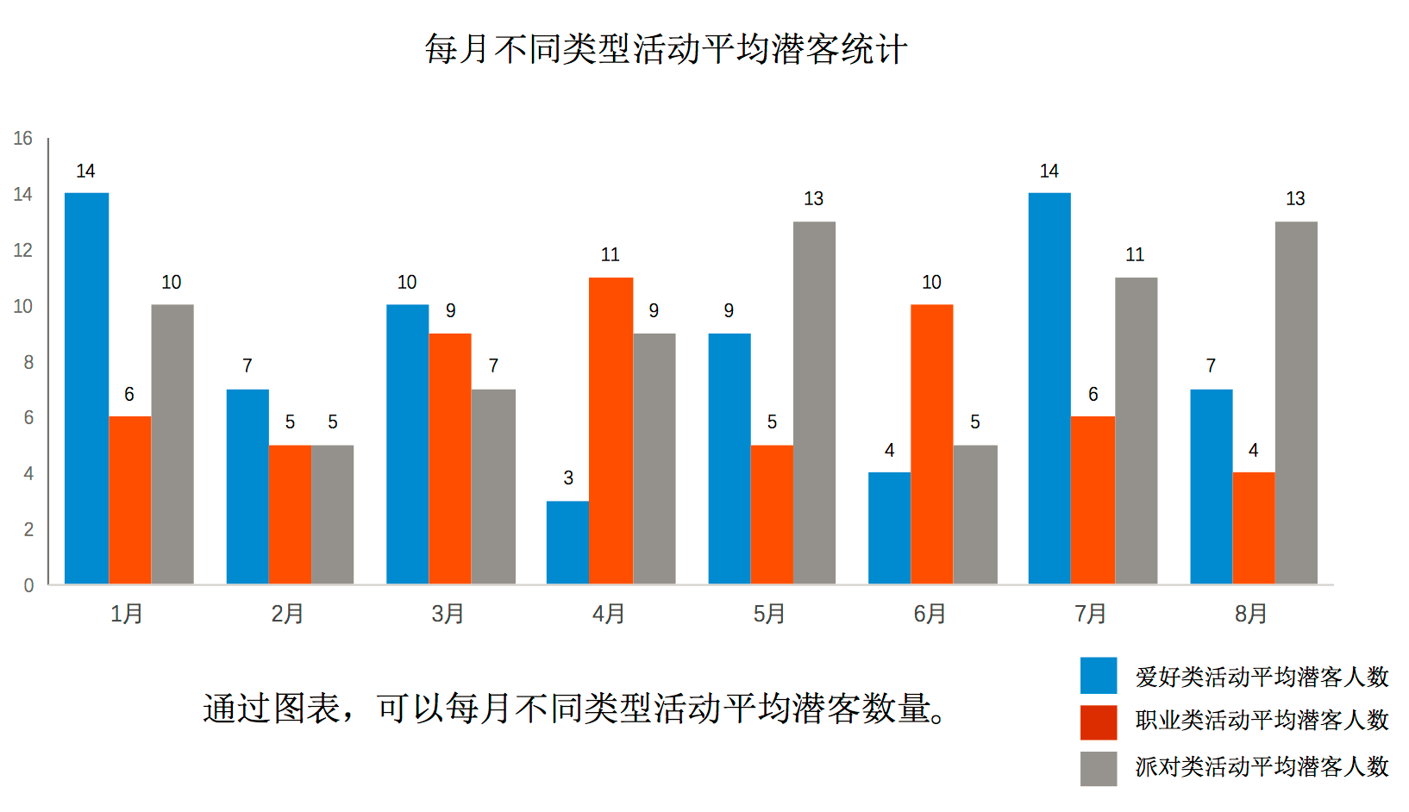

请求路径 api/apiactivitychart/geteverymonthaveragelatentpassengerflow
返回
{"code":1,"typelist":[{"saleactivitytypeid":2,"saleactivitytypename":"爱好类"},{"saleactivitytypeid":1,"saleactivitytypename":"派对类"},{"saleactivitytypeid":3,"saleactivitytypename":"职业类"}],"averagelist":[{"saleactivitytypeid":2,"nmonth":7,"latentpassengerflowaverage":4},{"saleactivitytypeid":3,"nmonth":7,"latentpassengerflowaverage":5},{"saleactivitytypeid":2,"nmonth":8,"latentpassengerflowaverage":7},{"saleactivitytypeid":3,"nmonth":8,"latentpassengerflowaverage":3},{"saleactivitytypeid":2,"nmonth":9,"latentpassengerflowaverage":7},{"saleactivitytypeid":3,"nmonth":9,"latentpassengerflowaverage":5},{"saleactivitytypeid":2,"nmonth":10,"latentpassengerflowaverage":6},{"saleactivitytypeid":3,"nmonth":10,"latentpassengerflowaverage":5}],"monthlist":[1,2,3,4,5,6,7,8,9,10,11,12]}

说明 typelist 分类列表 saleactivitytypeid 分类Id saleactivitytypename 分类名称
其他 同上 monthlist 月份列表

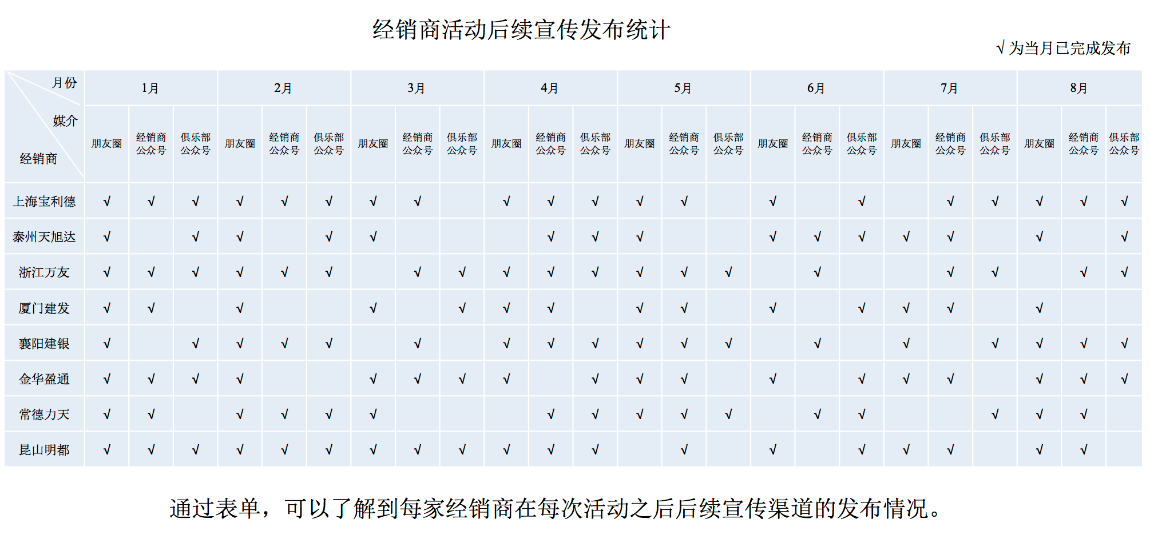
请求地址api/apiactivitychart/geteverymonthpublishwaystatistics
返回
{"code":1,"agencylist":[{"agencyid":1,"agencyname":"上海宝利德"},{"agencyid":14,"agencyname":"上海宝利德2"},{"agencyid":15,"agencyname":"上海宝利德3"},{"agencyid":16,"agencyname":"上海宝利德4"}],"averagelist":{"1":[{"month":1,"publishwaylist":[]},{"month":2,"publishwaylist":[]},{"month":3,"publishwaylist":[]},{"month":4,"publishwaylist":[]},{"month":5,"publishwaylist":[]},{"month":6,"publishwaylist":[]},{"month":7,"publishwaylist":[0,1,2]},{"month":8,"publishwaylist":[0]},{"month":9,"publishwaylist":[1]},{"month":10,"publishwaylist":[0,1,2]},{"month":11,"publishwaylist":[]},{"month":12,"publishwaylist":[]}],"14":[{"month":1,"publishwaylist":[]},{"month":2,"publishwaylist":[]},{"month":3,"publishwaylist":[]},{"month":4,"publishwaylist":[]},{"month":5,"publishwaylist":[]},{"month":6,"publishwaylist":[]},{"month":7,"publishwaylist":[1]},{"month":8,"publishwaylist":[1]},{"month":9,"publishwaylist":[]},{"month":10,"publishwaylist":[1]},{"month":11,"publishwaylist":[]},{"month":12,"publishwaylist":[]}],"15":[{"month":1,"publishwaylist":[]},{"month":2,"publishwaylist":[]},{"month":3,"publishwaylist":[]},{"month":4,"publishwaylist":[]},{"month":5,"publishwaylist":[]},{"month":6,"publishwaylist":[]},{"month":7,"publishwaylist":[0]},{"month":8,"publishwaylist":[0]},{"month":9,"publishwaylist":[0]},{"month":10,"publishwaylist":[]},{"month":11,"publishwaylist":[]},{"month":12,"publishwaylist":[]}],"16":[{"month":1,"publishwaylist":[]},{"month":2,"publishwaylist":[]},{"month":3,"publishwaylist":[]},{"month":4,"publishwaylist":[]},{"month":5,"publishwaylist":[]},{"month":6,"publishwaylist":[]},{"month":7,"publishwaylist":[]},{"month":8,"publishwaylist":[]},{"month":9,"publishwaylist":[0,1,2]},{"month":10,"publishwaylist":[]},{"month":11,"publishwaylist":[]},{"month":12,"publishwaylist":[]}]},"monthlist":[1,2,3,4,5,6,7,8,9,10,11,12],"pubishwaylist":[{"pubishwayid":"0","pubishwayname":"朋友圈"},{"pubishwayid":"1","pubishwayname":"经销商公众号"},{"pubishwayid":"2","pubishwayname":"俱乐部公众号"}]}

说明 agencylist 经销商列表 agencyid 经销商编号 agencyname
经销商名称
Pubishwaylist 推广的列表 pubishwayid 推广方式ID pubishwayname
推广方式名称

Monthlist 月份列表
Averagelist 要显示的数据集合
{"1":[{"month":1,"publishwaylist":[]},{"month":2,"publishwaylist":[]},{"month":3,"publishwaylist":[]},{"month":4,"publishwaylist":[]},{"month":5,"publishwaylist":[]},{"month":6,"publishwaylist":[]},{"month":7,"publishwaylist":[0,1,2]},{"month":8,"publishwaylist":[0]},{"month":9,"publishwaylist":[1]},{"month":10,"publishwaylist":[0,1,2]},{"month":11,"publishwaylist":[]},{"month":12,"publishwaylist":[]}

标红数字1 代表经销商编号 与上面经销商列表id对应 publishwaylist 里面是 推广方式id的集合 为空就是一个都没有

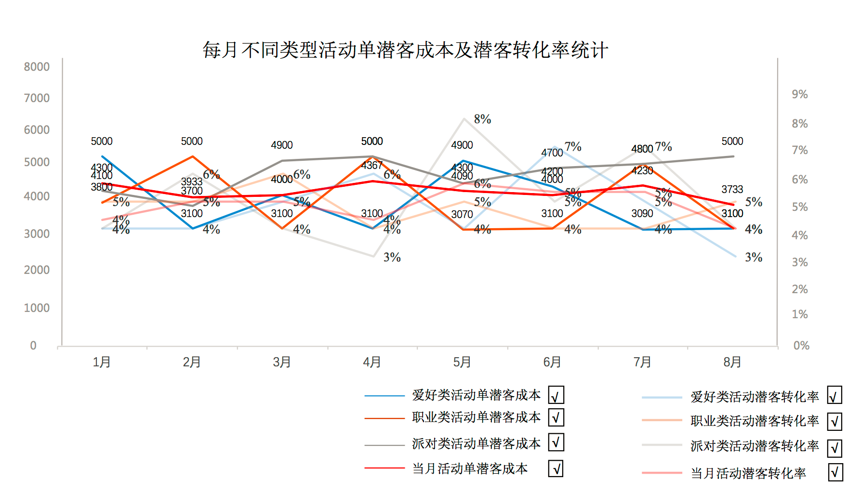
请求地址
api/apiactivitychart/geteverymonthpassengerflowchange

{"code":1,"typelist":[{"saleactivitytypeid":2,"saleactivitytypename":"爱好类"},{"saleactivitytypeid":1,"saleactivitytypename":"派对类"},{"saleactivitytypeid":3,"saleactivitytypename":"职业类"},{"saleactivitytypeid":4,"saleactivitytypename":"车主"}],"averagelist":[{"saleactivitytypeid":2,"nmonth":7,"LatentPassengerFlowcost":212,"rate":"7%"},{"saleactivitytypeid":3,"nmonth":7,"LatentPassengerFlowcost":40,"rate":"6%"},{"saleactivitytypeid":2,"nmonth":8,"LatentPassengerFlowcost":50,"rate":"5%"},{"saleactivitytypeid":3,"nmonth":8,"LatentPassengerFlowcost":100,"rate":"3%"},{"saleactivitytypeid":2,"nmonth":9,"LatentPassengerFlowcost":2,"rate":"91%"},{"saleactivitytypeid":3,"nmonth":9,"LatentPassengerFlowcost":40,"rate":"1%"},{"saleactivitytypeid":2,"nmonth":10,"LatentPassengerFlowcost":5,"rate":"18%"},{"saleactivitytypeid":3,"nmonth":10,"LatentPassengerFlowcost":60,"rate":"1%"}],"allaveragelist":[{"nmonth":7,"LatentPassengerFlowcost":162,"rate":"7%"},{"nmonth":8,"LatentPassengerFlowcost":58,"rate":"5%"},{"nmonth":9,"LatentPassengerFlowcost":2,"rate":"58%"},{"nmonth":10,"LatentPassengerFlowcost":7,"rate":"11%"}],"monthlist":[1]}
说明
typelist 类型列表 saleactivitytypeid 类型ID
saleactivitytypename 类型名称
averagelist 按照类型和月份统计的列表
saleactivitytypeid 类别ID nmonth 月份
latentPassengerFlowcost 潜客成本 rate 潜客转化率
allaveragelist 按照月份统计列表 同上 monthlist 月份列表

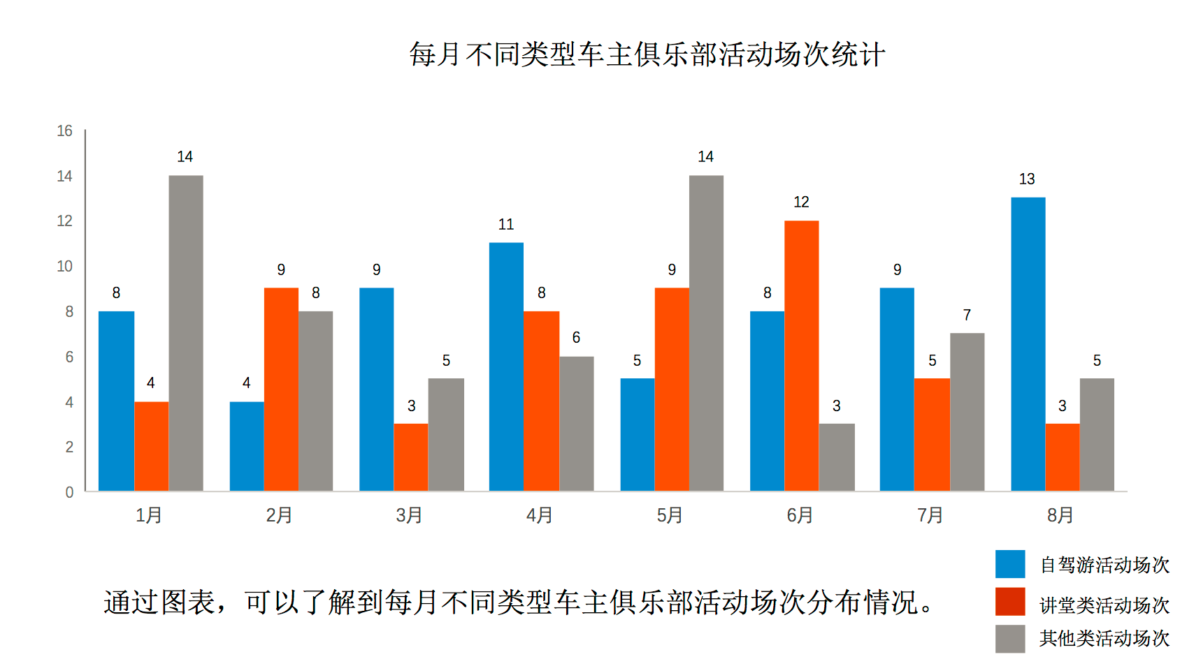
请求地址
api/apiactivitychart/geteverymonthclubactivitybuildecount

返回
{"code":1,"typelist":[{"saleactivitytypeid":3,"saleactivitytypename":"自驾游"},{"saleactivitytypeid":4,"saleactivitytypename":"讲堂"},{"saleactivitytypeid":5,"saleactivitytypename":"其他类"}],"averagelist":[{"nmonth":1,"count":2},{"nmonth":2,"count":2},{"nmonth":3,"count":1},{"nmonth":4,"count":1},{"nmonth":5,"count":1}],"monthlist":[1]}

typelist类型列表 saleactivitytypeid 类型ID saleactivitytypename 类型名称
Averagelist 详细列表 nmonth 月份 count 月的数量

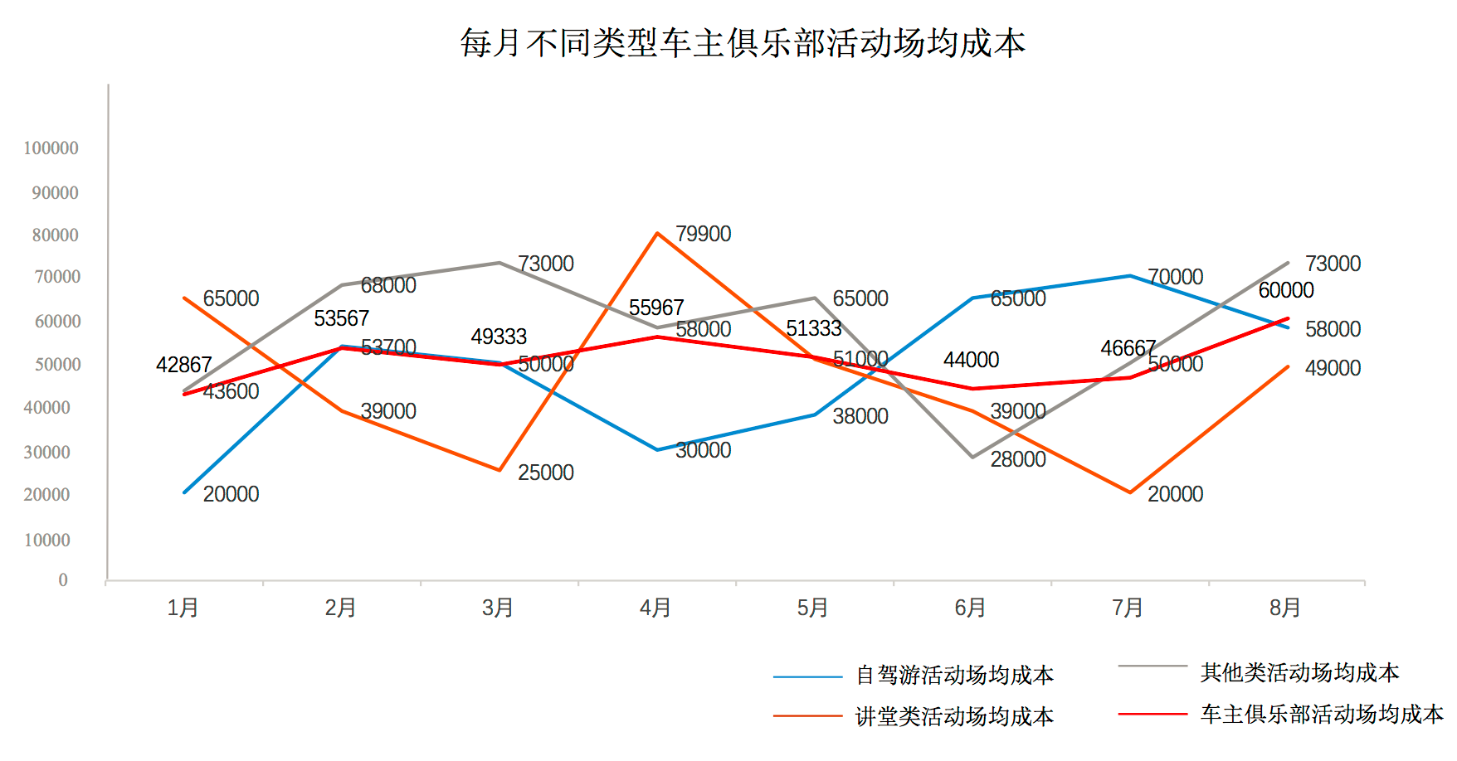
请求地址：api/apiactivitychart/geteverymonthclubaveragecost

返回 {"code":1,"typelist":[{"saleactivitytypeid":3,"saleactivitytypename":"自驾游"},{"saleactivitytypeid":4,"saleactivitytypename":"讲堂"},{"saleactivitytypeid":5,"saleactivitytypename":"其他类"}],"averagelist":[{"clubactivityinfoid":1,"nmonth":1,"costaverage":522},{"clubactivityinfoid":2,"nmonth":1,"costaverage":944},{"clubactivityinfoid":3,"nmonth":2,"costaverage":300},{"clubactivityinfoid":4,"nmonth":2,"costaverage":200},{"clubactivityinfoid":5,"nmonth":3,"costaverage":877},{"clubactivityinfoid":6,"nmonth":4,"costaverage":99},{"clubactivityinfoid":7,"nmonth":5,"costaverage":113}],"allaveragelist":{"Table":[{"nmonth":1,"costaverage":733},{"nmonth":2,"costaverage":250},{"nmonth":3,"costaverage":877},{"nmonth":4,"costaverage":99},{"nmonth":5,"costaverage":113}]},"monthlist":[1]}
说明
typelist类型列表 saleactivitytypeid 类型ID saleactivitytypename 类型名称
averagelist 按照类型的列表 clubactivityinfoid 类型ID nmonth 月份 costaverage 成本平均值

allaveragelist 月份平均成本列表 nmonth 月份 costaverage 平均成本金额

