Usage Guide for Conformance-Software

Nomor Research GmbH

Munich, Germany

[info@nomor.de](mailto:info@nomor.de)

13 July 2018

Table of Contents

1 Introduction 3

2 Usage Guide on DASH Conformance 3

2.1 Steps to run conformance test 4

3 Usage Guide on Extension to HbbTV-DVB Conformance 17

3.1 Additions and steps for HbbTV-DVB conformance testing 17

4 Usage Guide on Live Conformance Tool 20

Table of Figures

Figure 1 User-Interface of Conformance-Software 3

Figure 2 MPD URL input method 4

Figure 3 MPD input using File Upload option 5

Figure 4 Submission of the MPD 6

Figure 5 Display of progress information 7

Figure 6 MPD Feature list option 8

Figure 7 A look of Feature list 9

Figure 8 Results getting continuously updated 10

Figure 9 Completion of Conformance test 11

Figure 10 Highlighting all the sections of results 12

Figure 11 MPD error results 12

Figure 12 MPD error report 13

Figure 13 Showing conformance error in Segment Validation 14

Figure 14 Sample error report of Representation/Segment Validation 15

Figure 15 MPD-only conformance option selection 15

Figure 16 Results of MPD-only conformance 16

Figure 17 Additions to UI for HbbTV-DVB validation 17

Figure 18 MPD validation results for HbbTV-DVB 18

Figure 19 MPD error report of HbbTV-DVB validation 18

Figure 20 Additional cross-representation results 19

Figure 21 Invoking Dynamic service validation tool 20

Figure 22 Inputs for the live conformance 21

Figure 23 Results of the live conformance 22

# Introduction

This document presents the usage guide for the Conformance Software tool. The screenshots of the User Interface (UI) are added to explain how the testing of the DASH content and visualization of the results can be done.

In Section 2, usage guide for the DASH conformance software is presented. Subsequently, in Section 3, HbbTV-DVB additional usage is presented. Finally, in Section 4, the live conformance tool usage guide is provided.

# Usage Guide on DASH Conformance

The web-based UI of the Conformance Software tool is shown in Figure 1.

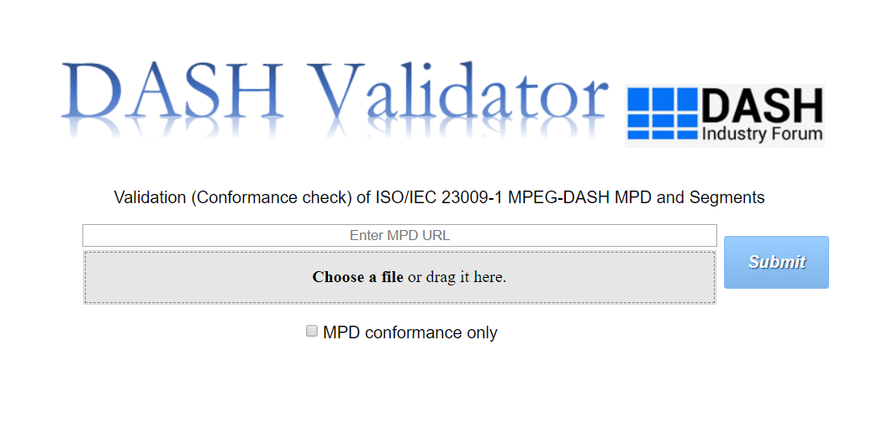

Figure 1 User Interface of the Conformance Software

## Steps to run conformance test

1. Provide an MPD URL in the MPD input bar as in Figure 2. Alternatively, a local MPD file can be provided by either clicking on ‘Choose a file’ option or directly dragging the file and dropping it on the highlighted area shown in Figure 3.

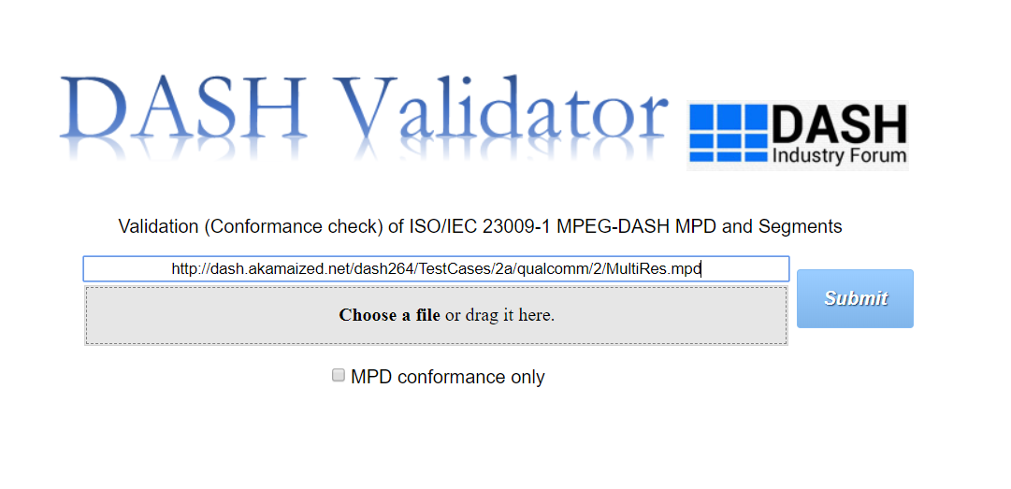

Figure 2 MPD URL input method

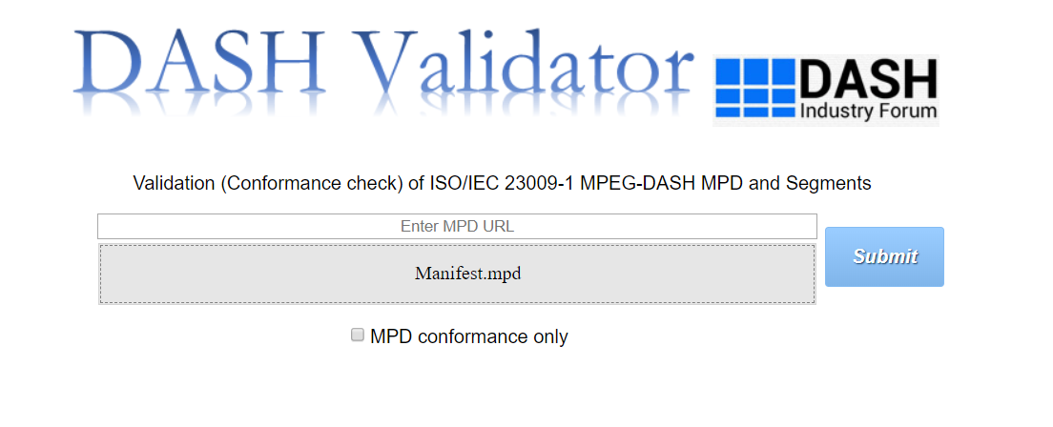

Figure 3 MPD input using File Upload option

1. Once the MPD has been provided, click on the ‘Submit’ button and the UI looks as in Figure 4. The user has an additional option to run only MPD conformance which is shown later in this guide.

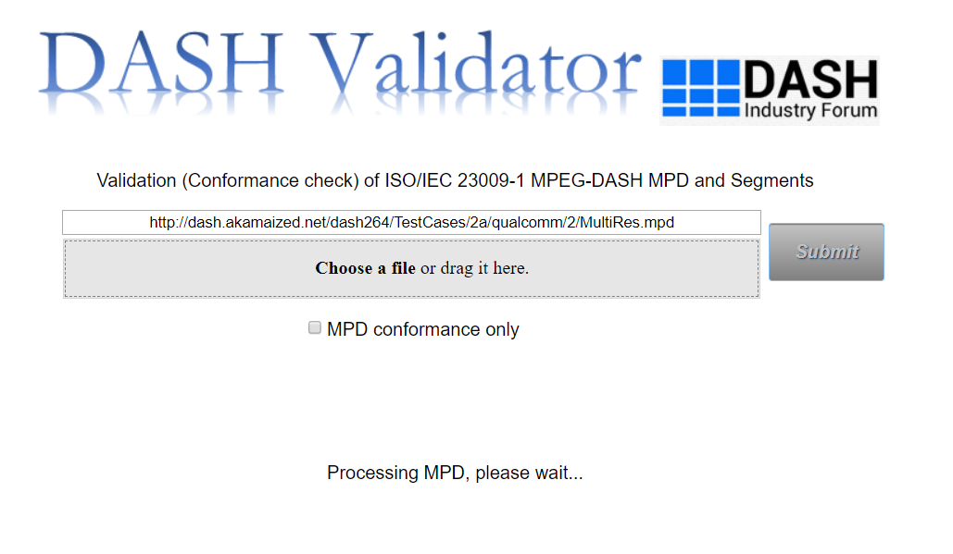

Figure 4 Submission of the MPD

1. The progress information is printed once the MPD processing starts. Profiles of MPD are also displayed on the UI as shown in Figure 5.

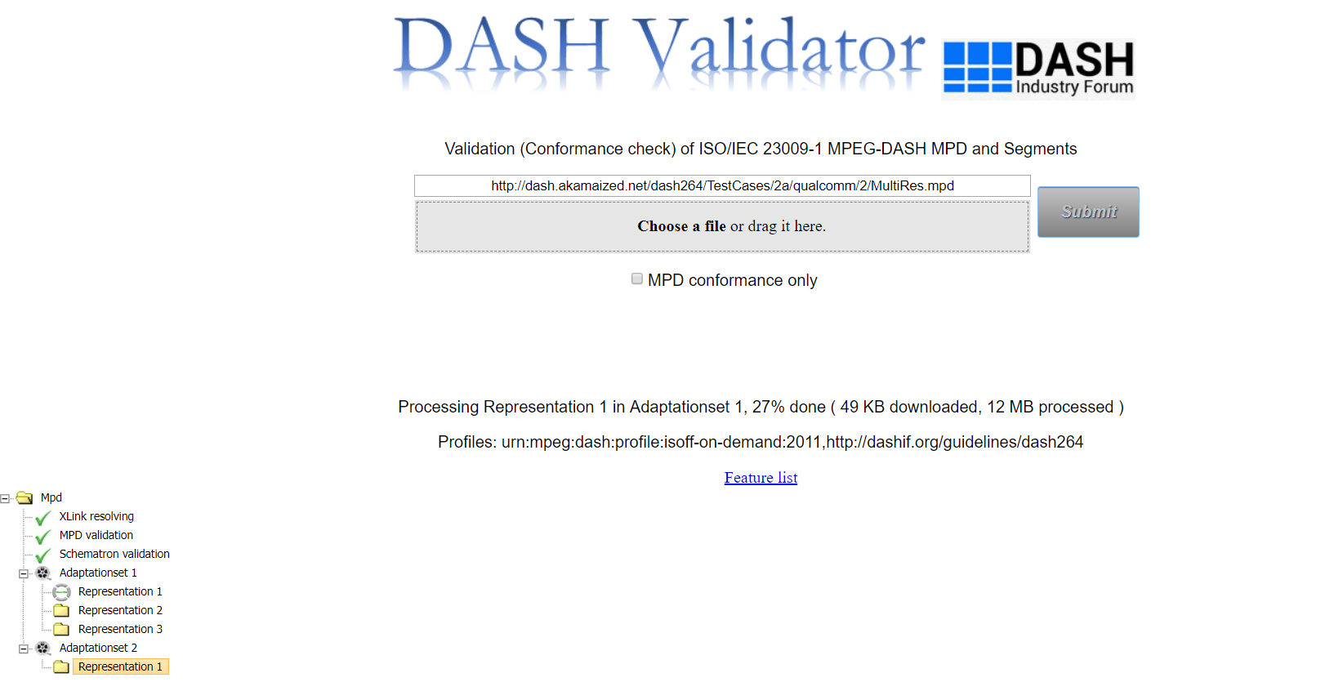

Figure 5 Display of progress information

1. To view the list of features, i.e., all the elements and attributes present in the given MPD, click on the link ‘Feature list’ shown in Figure 6. When clicked on, a new tab opens with the feature list, depicted in Figure 7.



Figure 6 MPD Feature list option

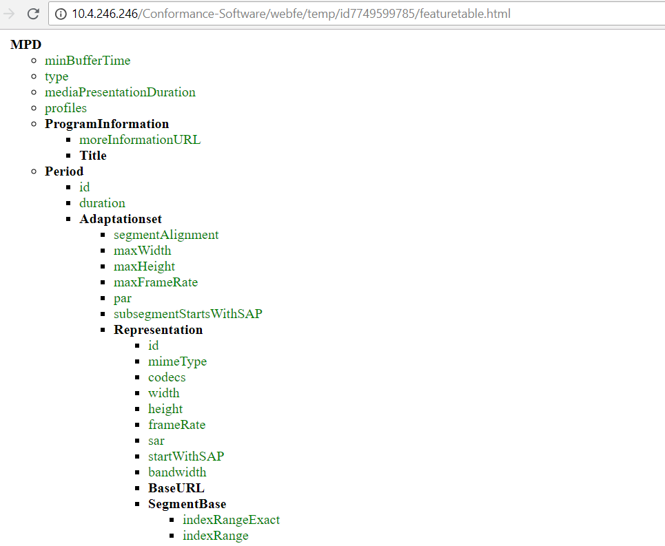

Figure 7 A look of Feature list

1. The results of the conformance testing get updated continuously after the ‘Submit’ button is pressed. Intermediate results are shown as in screenshot in Figure 8.



Figure 8 Results getting continuously updated

1. Once the conformance testing is completed, it is indicated on the webpage as highlighted in Figure 9. Hence all the results are available for the user.

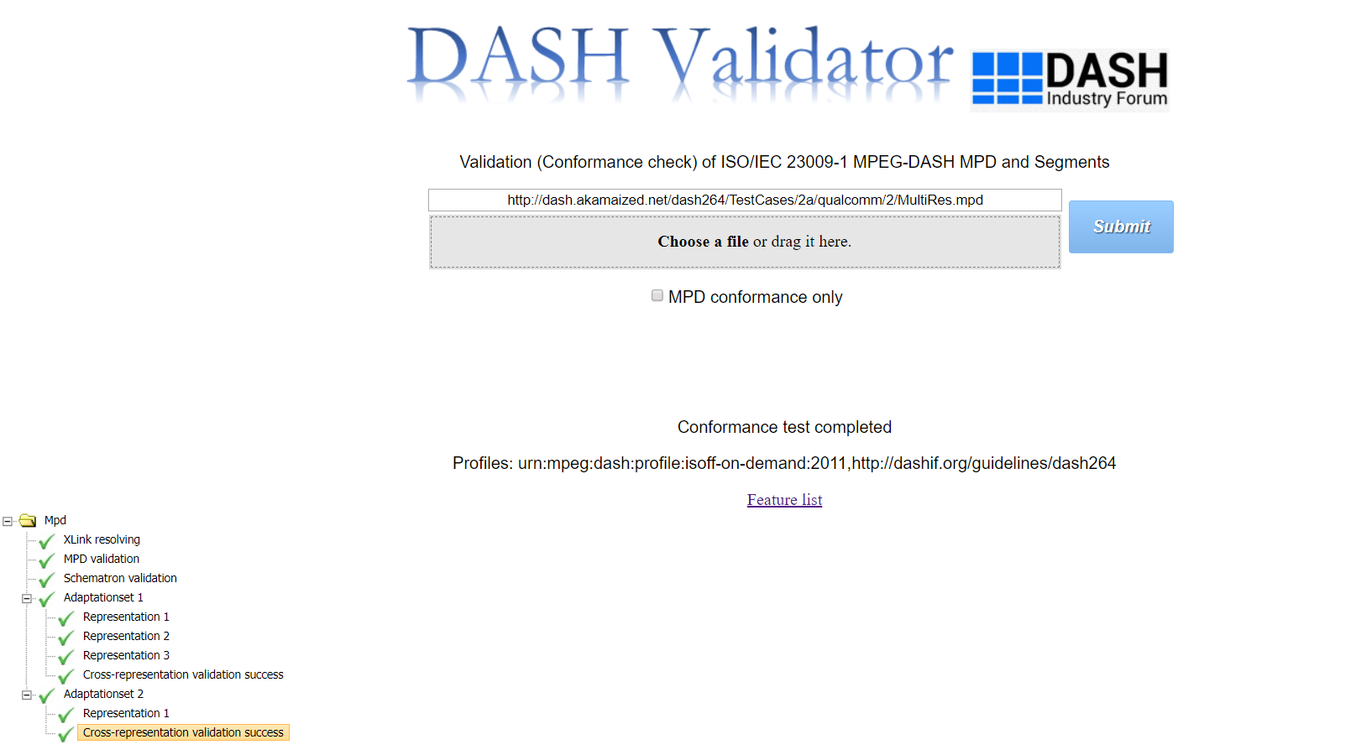

Figure 9 Completion of Conformance test

1. In this step, let us review only the results section of the webpage in detail. The results are formatted in a tree structure. Results can be categorized in three sections as follows:
2. MPD results

This section consists of Xlink Validation, MPD Validation and Schematron Validation results.

1. Representation/Segments validation results

This section consists of representation validation results performed for each individual Representation

1. Cross-representation validation results

This section consists of cross-representation validation results performed for the Representations within the same Adaptation Set

Figure 10 highlights the abovementioned sections (a,b,c) of results. When a result section passes the related conformity checks, that section is ticked off with green. Figure 10 shows an example where all result sections passed all the checks related to them.

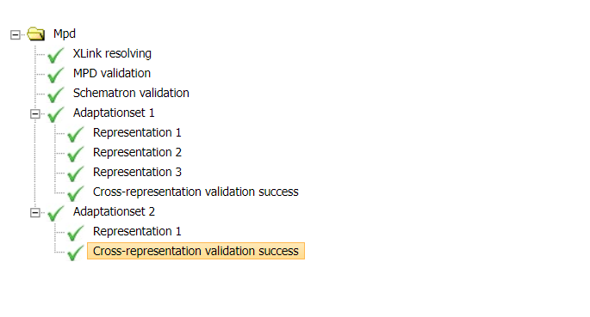

c.

b.

a.

Figure 10 Highlighting all the sections of results

1. When the MPD validation is not successful, it is indicated with a ‘wrong’ sign in front of the respective result section. A sample result is shown in Figure 11. Here, a conformance error has occurred in the Schematron section. In addition, when error occurs in any section, a link to the corresponding error report is provided.

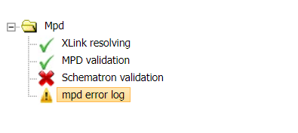

Figure 11 MPD error results

1. When error occurs in any section of MPD testing, a link to the MPD error log report is provided as in Figure 11. The ‘mpd error log’ can be opened by double-clicking the provided link. The report opens in a new tab. As shown in Figure 12, the abovementioned error from Schematron section is highlighted.

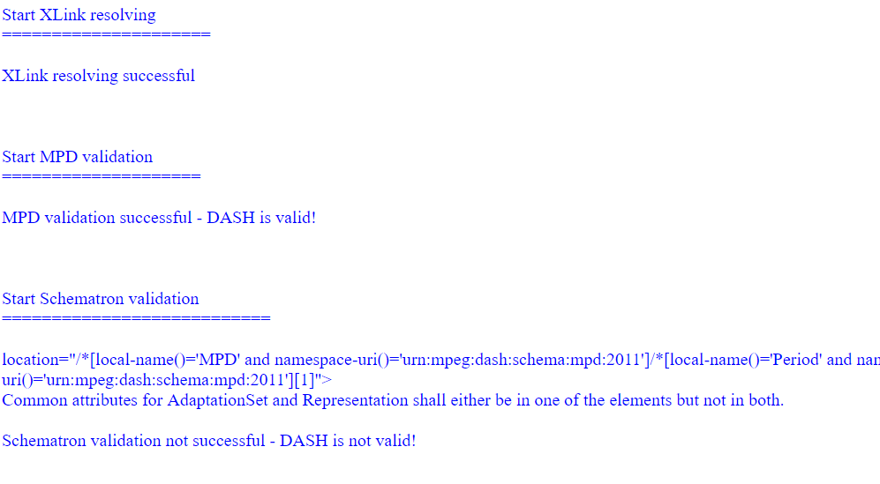

Figure 12 MPD error report

1. When there is no conformance issue with the MPD validation, the software conducts the Segment Validation and rest of the results are produced, namely representation results and cross-representation results. Similar to MPD results display, when there is any conformance error in any of the representation validation sections, a ‘wrong’ icon is displayed with the link to its error log report (For an example, please refer to Figure 13).

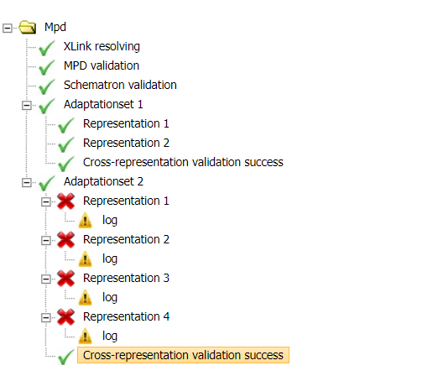

Figure 13 Showing conformance error in Segment Validation

1. The link for the error log of each Representation result also opens in a new tab and consists of detailed error report, showing the locations of error (which box/atom in mp4 file) and the error statements (For an example, please refer to Figure 14). Similar to how MPD validation and Segment/Representation validation results are presented, Cross-representation validation results also contain log report in case of non-conformity.

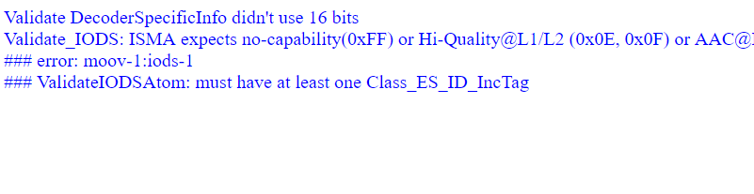

Figure 14 Sample error report of Representation/Segment Validation

1. User also has the option to just test MPD conformance using the checkbox on the UI as shown in Figure 15. Hence conformance software stops after MPD validation part. Corresponding exemplar results are provided in Figure 16.

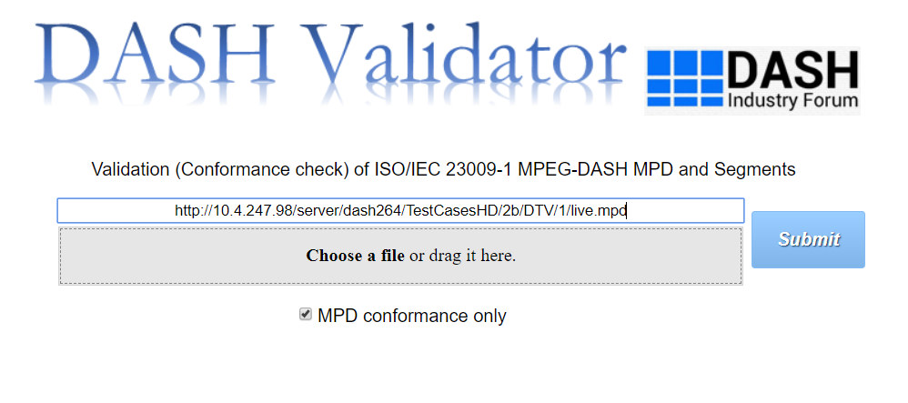

Figure 15 MPD-only conformance option selection

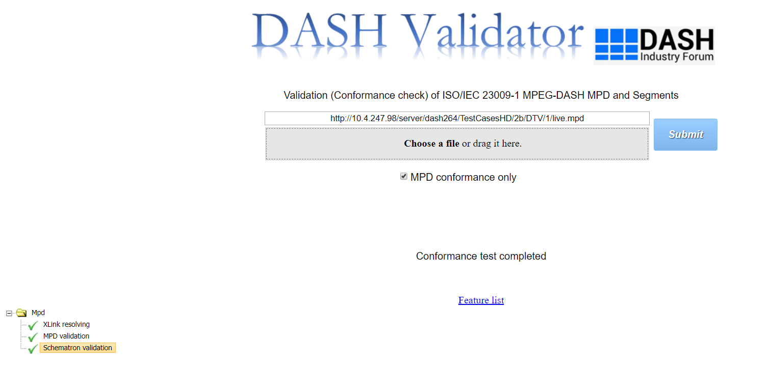

Figure 16 Results of MPD-only conformance

# Usage Guide on Extension to HbbTV-DVB Conformance

This section explains the usage of the Conformance Software tool after the tool is extended to provide support for HbbTV and DVB specifications.

## Additions and steps for HbbTV-DVB conformance testing

1. A new checkbox option is provided for user to select additional profiles to be enforced on the provided MPD for validation. Selection options are “HbbTV” and “DVB” as shown in Figure 17.

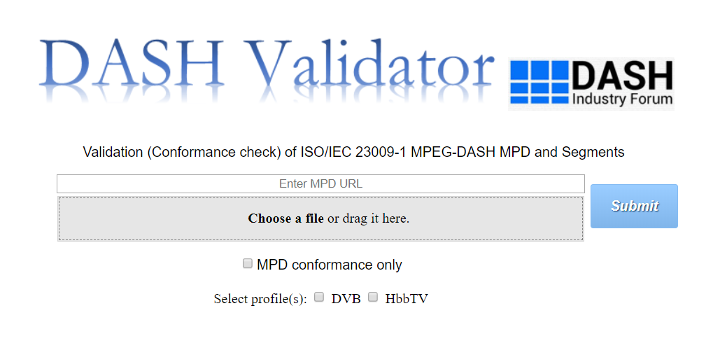

Figure 17 Additions to UI for HbbTV-DVB validation

1. Conformance testing procedure is the same as in Section 2.1. There are two additional sections in the result display tree as follows:
   1. MPD validation results specific to HbbTV-DVB (See 3)
   2. Cross-representation results specific to HbbTV-DVB (See 4)

Another addition to the UI is that the links to the log report are always provided, even in the case of no errors. Hence the user can access the log report of all result sections and view information and warning messages apart from regular error messages.

1. MPD validation results specific to HbbTV-DVB are shown in Figure 18. The MPD log report is shown in Figure 19 which now contains additional section for HbbTV-DVB MPD rules validation.

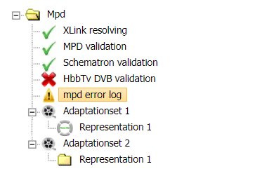

Figure 18 MPD validation results for HbbTV-DVB

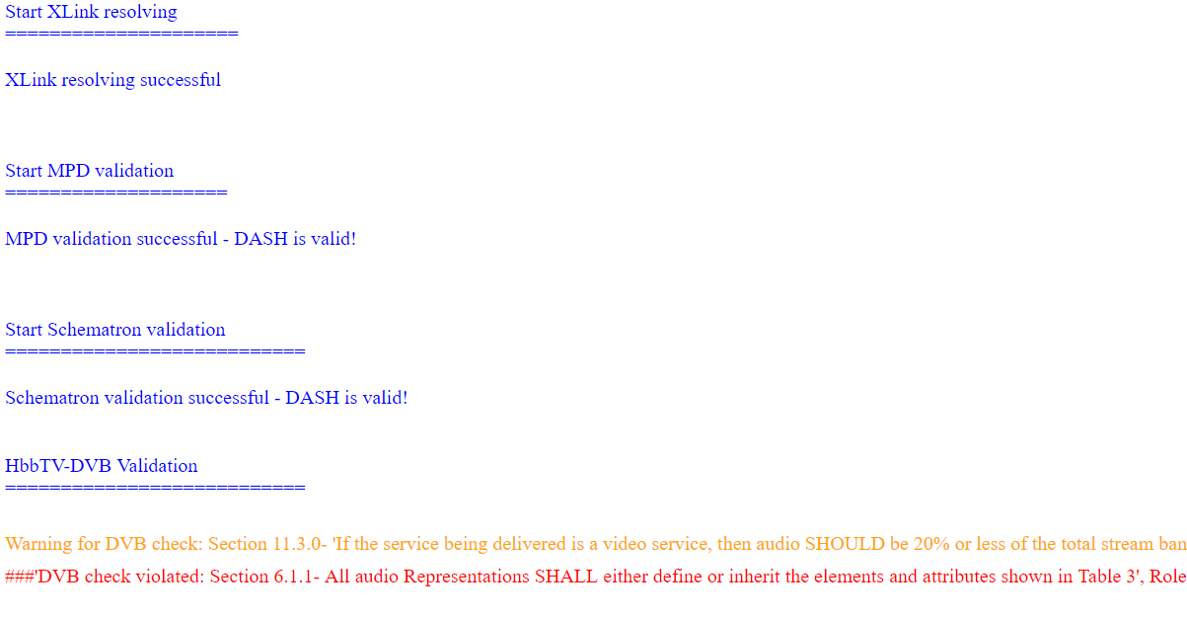

Figure 19 MPD error report of HbbTV-DVB validation

1. After conformance test is completed, the results tree is as shown in Figure 20. Similar to MPD validation log report, the log file of each Segment/Representation now contains the additional error/warning/information messages related to HbbTV/DVB checks. On the other hand, Cross-Representation validation results specific to HbbTV-DVB has a new section in tree as highlighted in Figure 20.

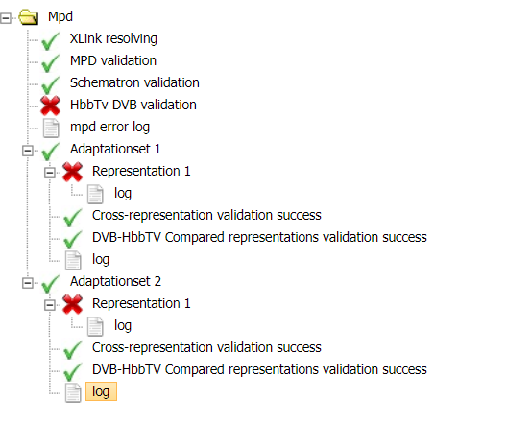

Figure 20 Additional cross-representation results

# Usage Guide on Live Conformance Tool

In this section, the usage guide for Live Conformance tool or Dynamic Service Validator is presented. As there are no additional features required to perform live conformance checks for HbbTV-DVB, this section is common for DASH and HbbTV-DVB.

1. Live conformance tool is invoked when the provided MPD for conformance testing is of type ‘dynamic’. The live conformance tool is opened in a new tab by clicking on ‘Dynamic_timing_validation’ button (Refer to Figure 21).

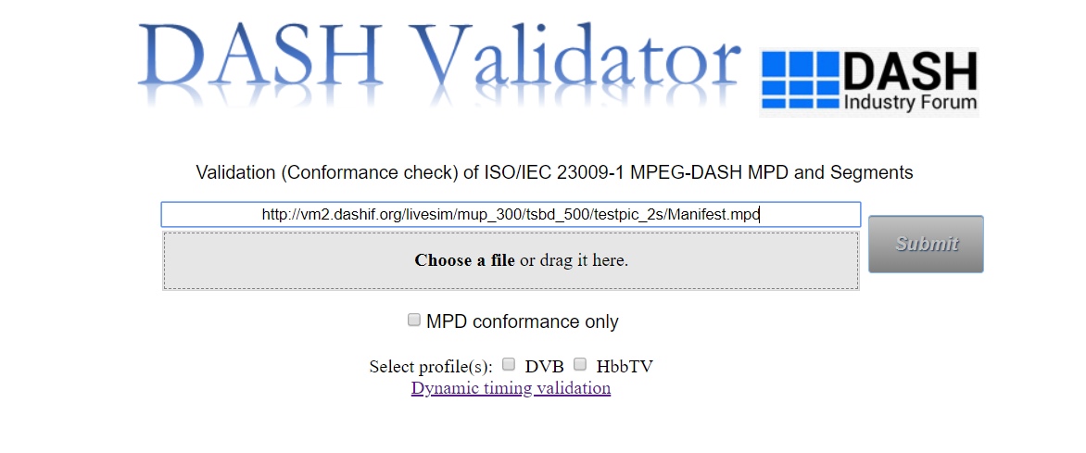

Figure 21 Invoking Dynamic service validation tool

1. Figure 22 shows the Live Conformance tool UI. MPD is directly loaded from the Conformance Software UI. Pressing ‘Start’ button starts the live conformance testing. If desired, RTT corrections in msec and Dynamic clock skew can be provided in the UI.

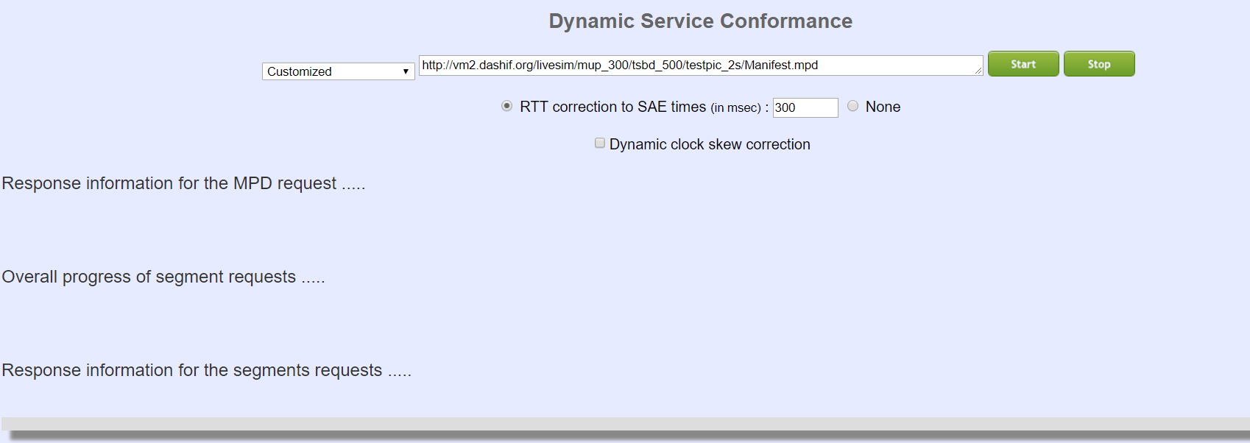

Figure 22 Inputs for the live conformance

1. Results are presented in different sections on the webpage as shown in Figure 23. They are titled as:
   1. ‘Response information for the MPD request’ (displaying MPD fetch and publish times, number of available segments),
   2. ‘Overall progress of segment requests’ (displaying number of successful checks, mean RTT and clock skew),
   3. ‘Response information for segment requests’ (displaying the status of availability start time and end time checks - Status: OK or Not Found).

“Status: OK” indicates the conformity for the availability start time checks as the segment was available at the availability start time signaled by the MPD. “Status: Not Found” indicates the conformity for the availability end time checks as the segment was not available at the availability end time signaled by the MPD.

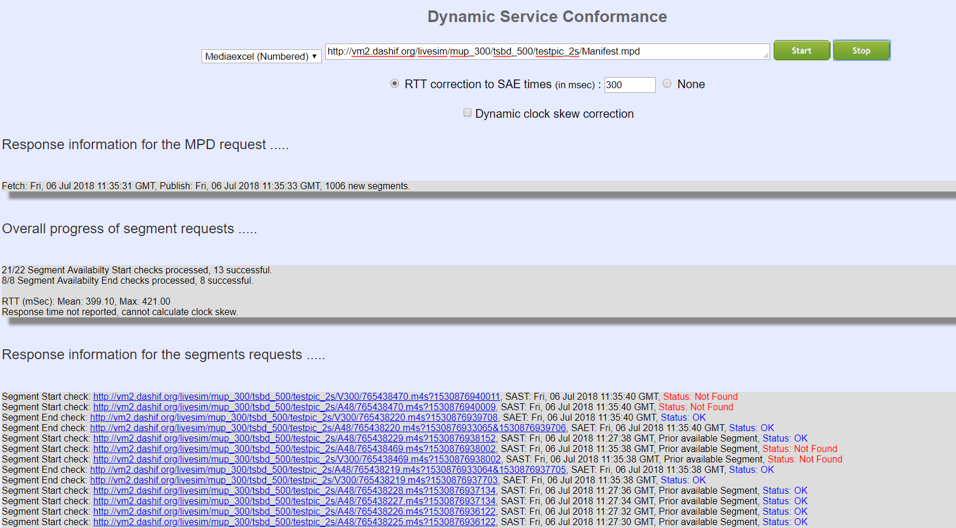

Figure 23 Results of the live conformance