December 3, 2007

Michael E. Hom
c/o Lenstech
3258(A) 17th Street
San Francisco, CA. 94110
Dear Michael,

This letter will confirm your agreement to speak at the Lake Merritt Breakfast Club on Thursday, December 6, 2007.

We ask that you arrive at the Martha Corprew Garden Center (see enclosed map) prior to 7:00 a.m., so that you can join us in breakfast. Our meeting begins at 7:30 a.m.; you will be introduced at 8:00 a.m.; the meeting will end at 8:30 a.m.. I suggest 20 minutes of presentation time, followed by 10 minutes of question time. We can accommodate slides, DVDs, etc. Let me know what visual aids you will require. You can expect between 50 and 80 persons in the audience. Your Chair of the Day (introduction) is the Honorable John Sutter and he will introduce you to the club.

Lake Merritt Breakfast Club (LMBC), sponsors of Children’s Fairyland and the Necklace of Lights, was organized in 1933 to promote the benefits of fellowship and friendship. LMBC is now a social/service organization whose purpose is to promote and preserve Lake Merritt and the surrounding lakeside park.

We gather every Thursday from 7:00-8:30 a.m. to exchange greetings, network, and hear local, national or international speakers discuss topics of significance-today’s economy, environment, culture, Oakland, and the world. LMBC is one of Oakland’s ultimate boosters with members from Alameda and Contra Costa counties-from Mayors, City Council representatives to movers and shakers in the legal, business and arts communities who have played an energetic part in Oakland activities and its continuing growth.

Please confirm you acceptance to speak on the above listed date by signing the enclosed copy of this letter and returning to me.

Very truly yours

Robert K. Stewart
Vice President / Program Chair, LMBC
(925) 552 0535
Email: rksdiablo@aol.com

Enclosures

ACCEPTED BY: _________________________________ Date: _______________________________

Location: Martha Corprew Garden Center also known as ‘Lake Merritt Garden Center’
Lakeside Park Garden Center
Inside Lakeside Park (Lake Merritt)
666 Bellevue Avenue, Oakland, California 94610
Bellevue Ave., Children’s Fairyland Entrance off of Grand Ave Oakland, CA

Garden Center Building
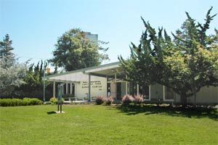

Parking: Guest Speaker Parking (one parking spot) is provided directly in front of the Garden Center and is mark by a colorful Duck sign ‘Guest Speaker’ for your convenience.
Map:
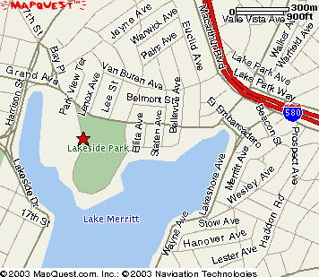

For additional information you may reach me on my home phone: 925.552.0535

Your Scheduled Speaking Date is: 6 December 2007 THANK YOU !!

