Exploratory Data Analysis
Shopping Behavior Dataset

3,900 customer transactions across 16 variables

February 2026

1. Executive Summary
This report presents an exploratory data analysis of a shopping behavior dataset containing 3,900 customer transaction records. The dataset captures 16 variables spanning customer demographics, purchase details, product attributes, and behavioral indicators. The analysis examines distributions, relationships, and patterns across these dimensions to characterize the customer base and identify notable trends.
Key findings include a customer base skewing male (68%) with a broad age range (18–70), relatively uniform spending patterns across product categories and demographic segments, near-universal adoption of discounts among subscribers, and minimal correlation among the numeric variables. The dataset contains no missing values across all 16 fields.

2. Dataset Overview

2.1 Structure and Scope
The dataset comprises 3,900 unique customer records (one per Customer ID) with 16 variables. Four variables are numeric (Age, Purchase Amount, Review Rating, Previous Purchases) and twelve are categorical (Gender, Item Purchased, Category, Location, Size, Color, Season, Subscription Status, Discount Applied, Payment Method, Frequency of Purchases). There are no missing values in any field.

2.2 Variable Summary
Variable | Type | Description
Customer ID | Integer | Unique identifier (1–3,900)
Age | Integer | Range 18–70, mean 44.1, SD 15.2
Gender | Categorical | Male (68.0%) / Female (32.0%)
Item Purchased | Categorical | 25 distinct items (Blouse, Pants, Jewelry most frequent)
Category | Categorical | Clothing (44.5%), Accessories (31.8%), Footwear (15.4%), Outerwear (8.3%)
Purchase Amount | Integer | Range $20–$100, mean $59.76, SD $23.69
Location | Categorical | All 50 US states represented (75–96 per state)
Size | Categorical | M (45.0%), L (27.0%), S (17.0%), XL (11.0%)
Color | Categorical | 25 distinct colors
Season | Categorical | Roughly equal distribution across 4 seasons
Review Rating | Float | Range 2.5–5.0, mean 3.75, SD 0.72
Subscription | Binary | No (73.0%) / Yes (27.0%)
Discount Applied | Binary | No (57.0%) / Yes (43.0%)
Previous Purchases | Integer | Range 1–50, mean 25.4, SD 14.4
Payment Method | Categorical | 6 methods, nearly equal distribution (612–677 each)
Frequency | Categorical | 7 levels from Weekly to Annually, roughly equal

3. Demographic Analysis

3.1 Age Distribution
Customer ages are approximately uniformly distributed between 18 and 70 years old, with a mean of 44.1 and a standard deviation of 15.2. This uniform spread suggests the retailer attracts customers across the full adult age spectrum without strong skew toward any particular age cohort. When grouped into decade-wide bins, the 26–35, 36–45, 46–55, and 56–65 bands each contain approximately 730–750 customers, while the 18–25 group has 571 and the 66–70 group has 355 (reflecting its narrower 5-year range).
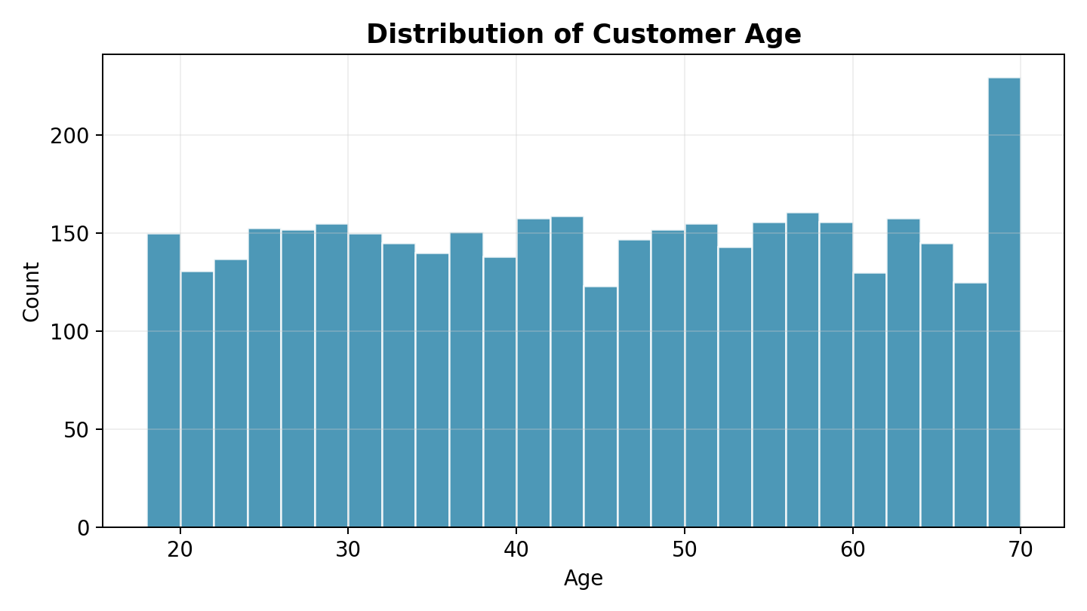

3.2 Gender Distribution
The dataset contains substantially more male customers (2,652, or 68.0%) than female customers (1,248, or 32.0%). This 2:1 ratio is notable and may reflect the characteristics of the customer base, the product mix, or data collection methodology. Despite this imbalance, the two groups show virtually identical purchasing behavior: mean purchase amounts of $59.54 (male) versus $60.25 (female) and comparable review ratings.
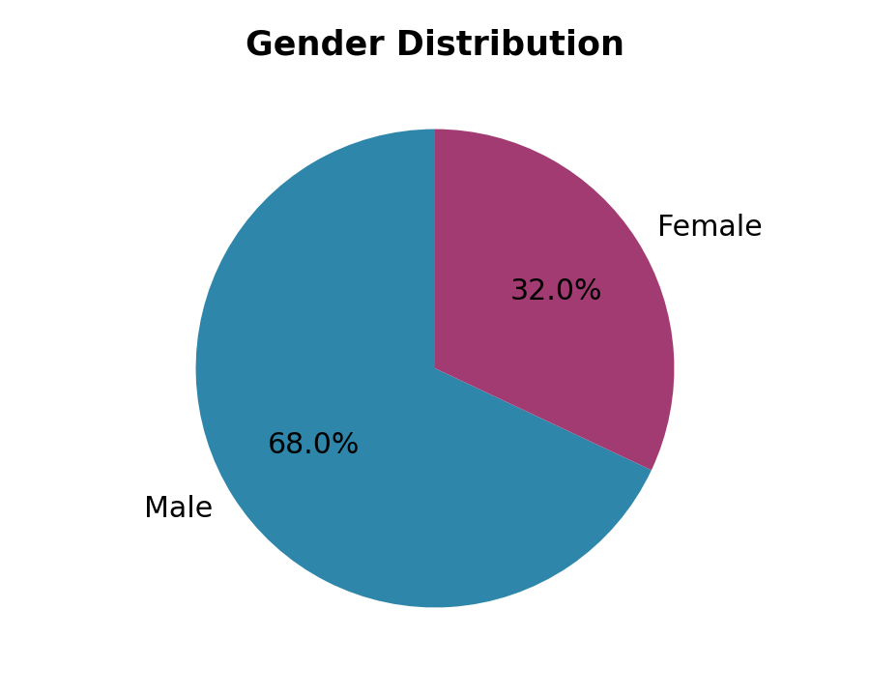

4. Purchase Analysis

4.1 Purchase Amount Distribution
Purchase amounts range from $20 to $100 with a mean of $59.76 and a median of $60. The distribution is approximately uniform across this range, with no strong concentration at any particular price point. The standard deviation of $23.69 reflects this wide, even spread rather than clustering around the mean.
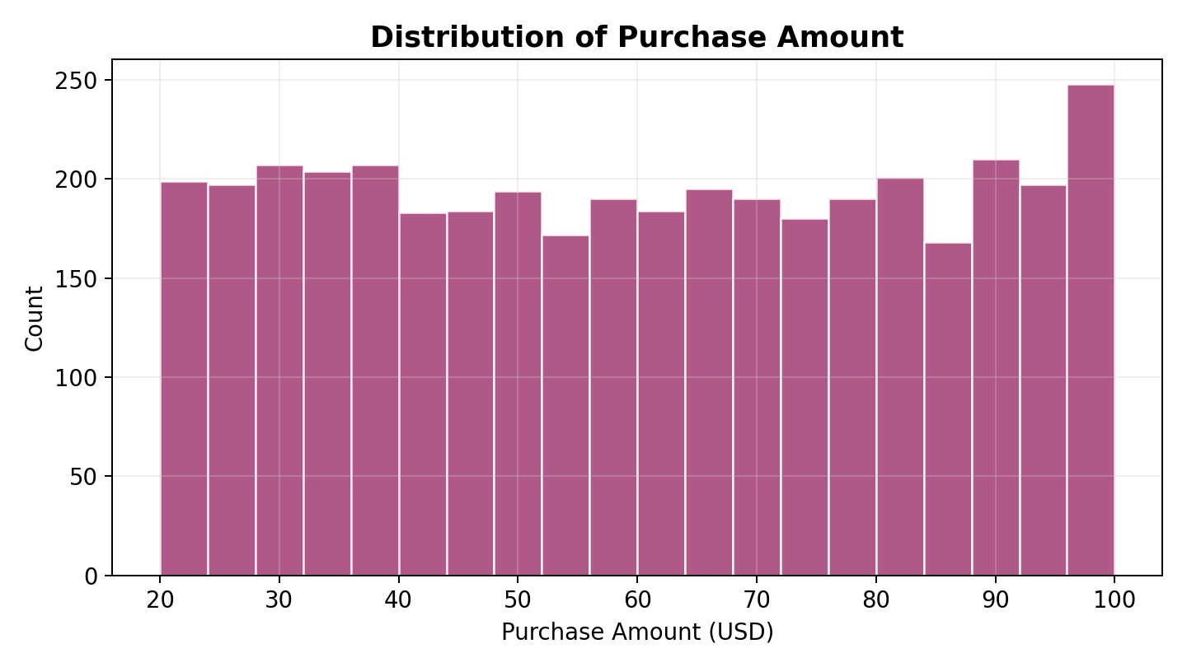

4.2 Purchase Amount by Category
Mean purchase amounts are remarkably consistent across the four product categories, with Clothing ($60.03), Accessories ($59.84), and Footwear ($60.26) all within $0.50 of each other. Outerwear shows a slightly lower mean at $57.17, though the medians and spreads are comparable. The box plots below illustrate the similar distributions across categories.
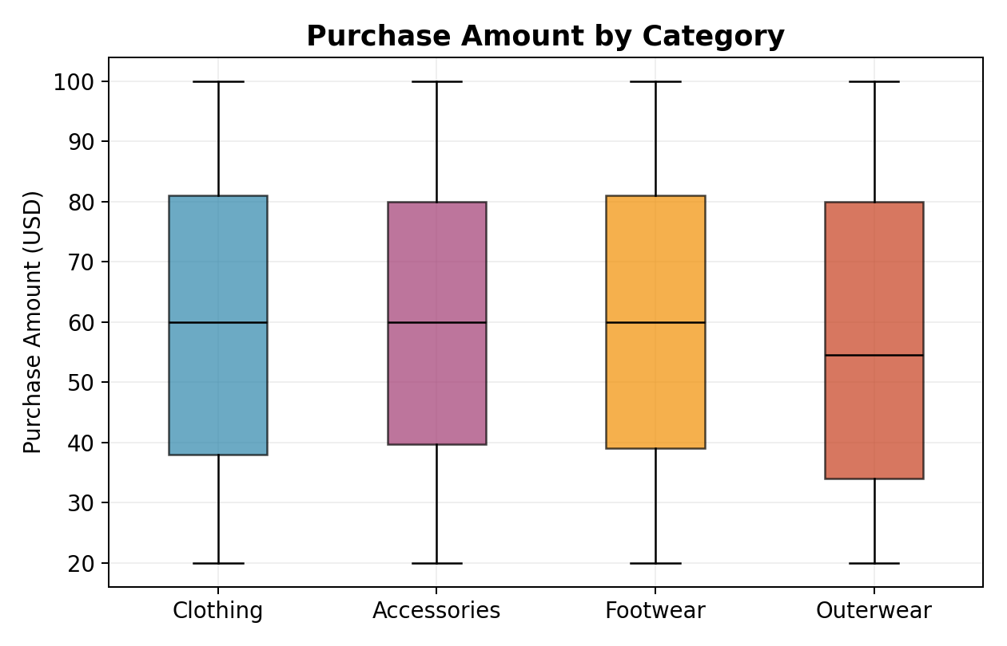

4.3 Seasonal Patterns
Transaction volumes are nearly equal across seasons (955–999 per season). Fall ($61.56) and Winter ($60.36) show modestly higher mean purchase amounts than Spring ($58.74) and Summer ($58.41), though the differences are small (approximately $3 between the highest and lowest). This pattern aligns with expectations around colder-weather purchases being slightly higher-value.
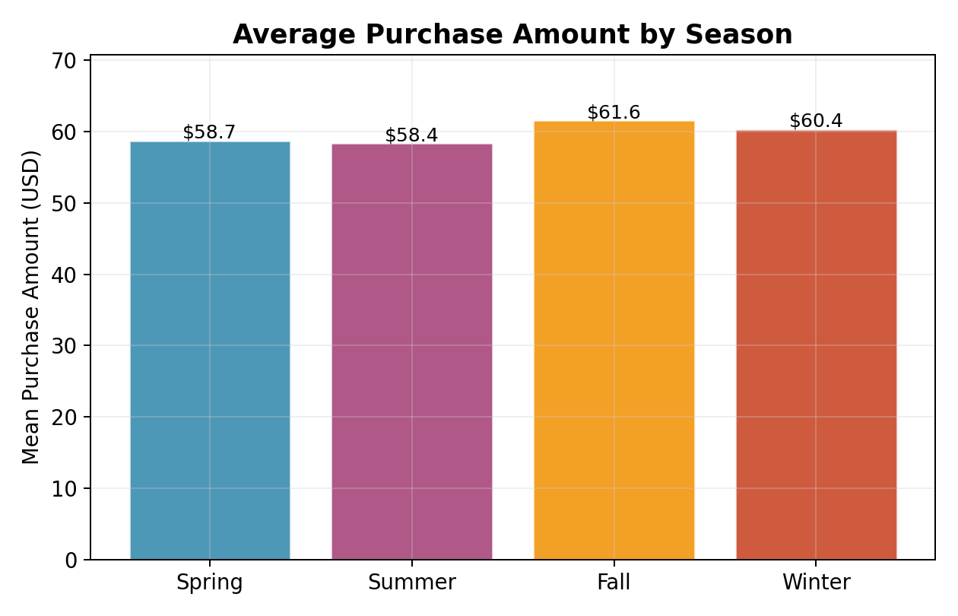

5. Product and Payment Analysis

5.1 Product Categories
Clothing dominates the product mix at 44.5% of all purchases (1,737 transactions), followed by Accessories at 31.8% (1,240), Footwear at 15.4% (599), and Outerwear at 8.3% (324). The 25 individual items are distributed fairly evenly within their categories, with the most popular items (Blouse, Pants, Jewelry) each accounting for about 4.4% of total transactions.
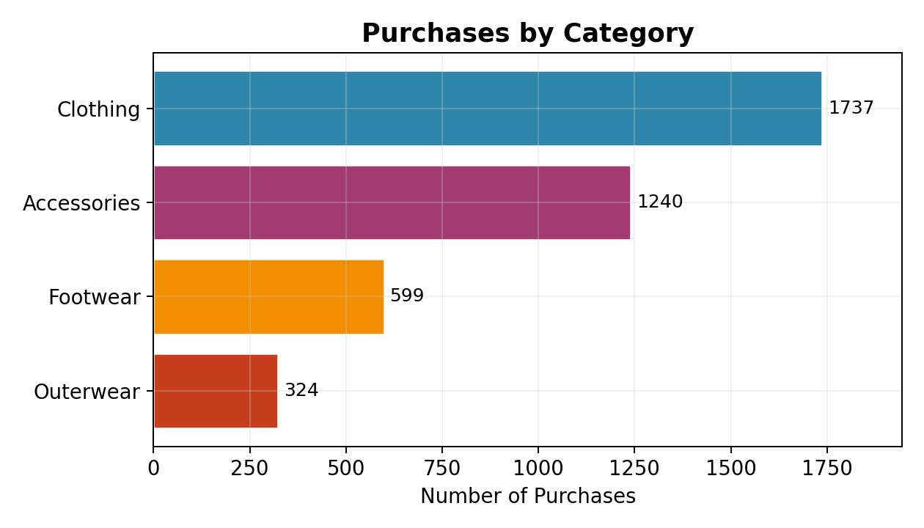

5.2 Payment Methods
Six payment methods are used with strikingly similar frequency: PayPal (677), Credit Card (671), Cash (670), Debit Card (636), Venmo (634), and Bank Transfer (612). This near-uniform distribution suggests no strong customer preference for any single payment channel, and indicates the retailer has successfully enabled a balanced set of payment options.
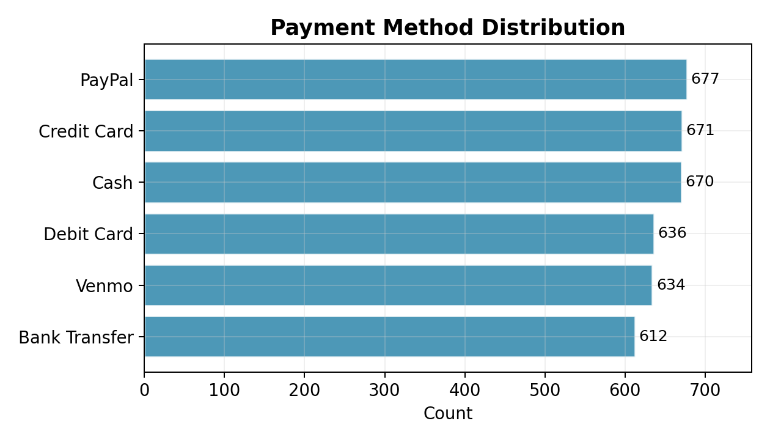

5.3 Purchase Frequency
Purchase frequency spans seven categories from Weekly (539) to Annually (572), with all categories in the narrow range of 539–584 customers. This uniformity across frequency bands is unusual and suggests the data may have been balanced or sampled to produce even representation. Note that Fortnightly and Bi-Weekly appear as separate categories despite being equivalent in practice.
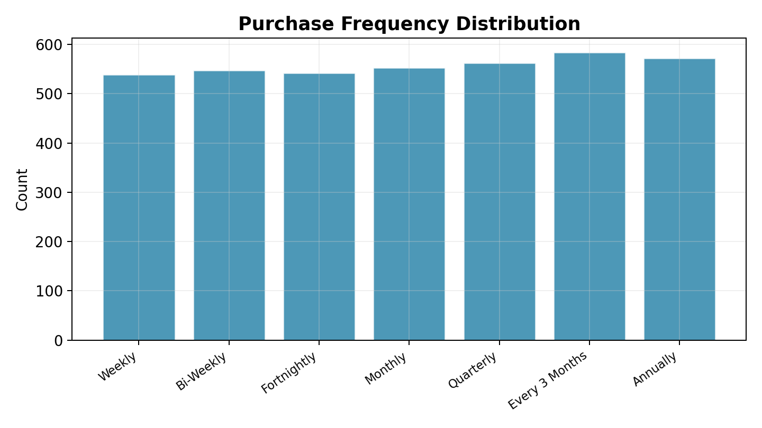

6. Customer Behavior Analysis

6.1 Review Ratings
Review ratings range from 2.5 to 5.0 with a mean of 3.75 and a standard deviation of 0.72. The distribution is approximately uniform within this range. No ratings below 2.5 appear in the data, suggesting either a floor effect or data filtering. Ratings are consistent across categories (means of 3.72–3.79) and across subscription groups.
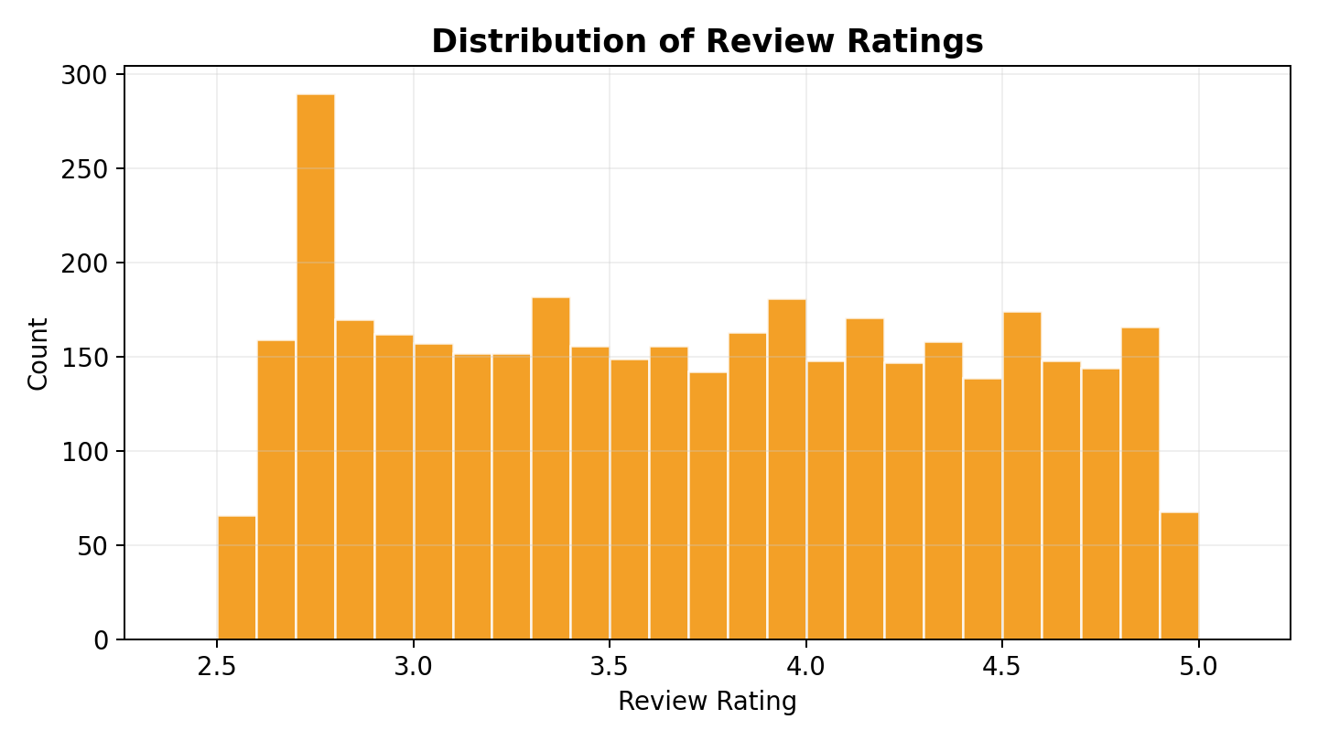

6.2 Subscription and Discounts
Only 27% of customers hold subscriptions (1,053 out of 3,900). The most striking finding in the dataset is the relationship between subscription status and discount usage: 100% of subscribers received discounts, while only 22% of non-subscribers did. This deterministic pattern suggests discounts are a direct benefit of the subscription program rather than independently applied promotions. Despite this structural difference in discount access, subscribers and non-subscribers show nearly identical mean purchase amounts ($59.49 vs. $59.87).
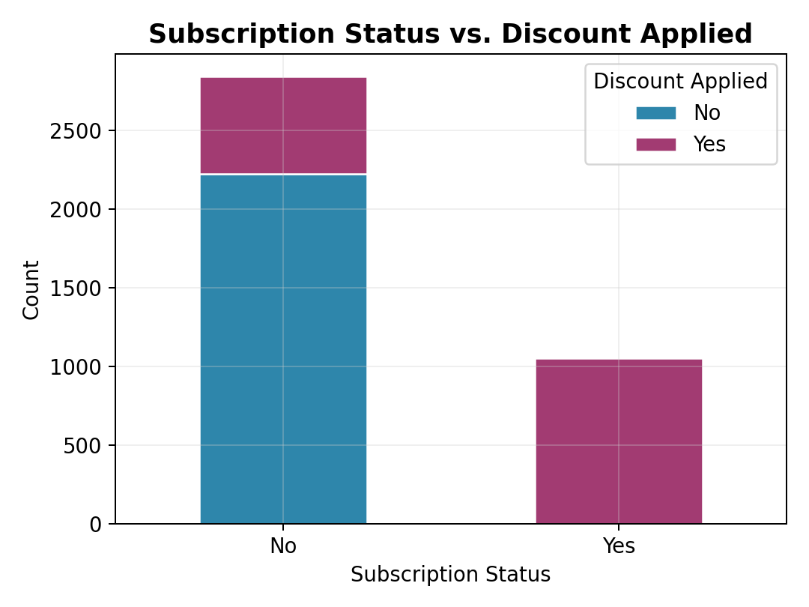

6.3 Previous Purchase History
The Previous Purchases variable ranges from 1 to 50 with a mean of 25.4 and a median of 25, indicating a fairly experienced customer base on average. The distribution is approximately uniform across this range. Subscribers show marginally higher previous purchase counts (mean 26.1) compared to non-subscribers (25.1), though this difference is modest.

7. Correlation Analysis
The correlation matrix reveals effectively no linear relationships among the four numeric variables. The strongest correlation is between Age and Previous Purchases at r = 0.04, which is negligible. Purchase Amount shows near-zero correlation with Age (r = −0.01), Review Rating (r = −0.002), and Previous Purchases (r = 0.008). This absence of meaningful correlations suggests that spending behavior is independent of customer age, satisfaction ratings, and purchase history within this dataset.
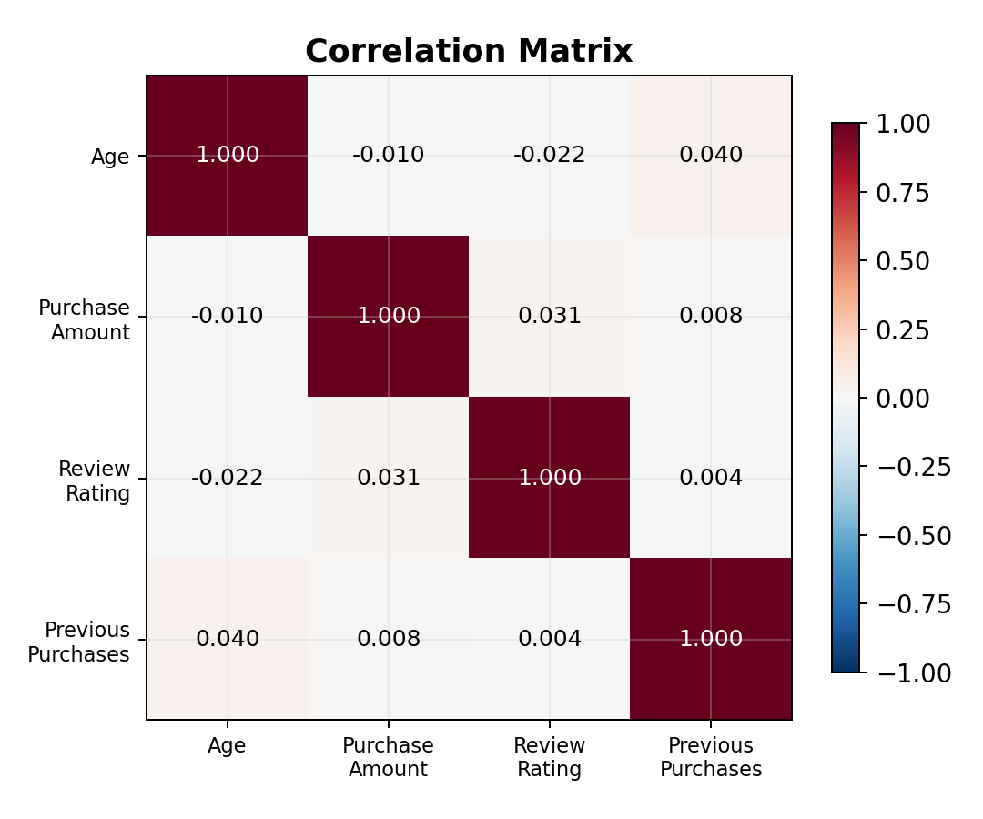

8. Key Findings and Observations

8.1 Notable Patterns
- Deterministic subscription-discount link: All 1,053 subscribers received discounts, while only 624 of 2,847 non-subscribers did. This is the single strongest structural pattern in the data.
- Uniform distributions: Age, Purchase Amount, Review Rating, Previous Purchases, Payment Method, and Purchase Frequency all exhibit approximately uniform distributions, which is atypical of organic behavioral data.
- Gender imbalance: The 68/32 male-to-female ratio is the most prominent demographic skew, though it does not correlate with differences in spending or satisfaction.
- Minimal inter-variable relationships: Near-zero correlations among all numeric variables indicate that the measured attributes are largely independent of one another.
- Seasonal modesty: Fall and Winter purchases average only $2–3 more than Spring and Summer, a statistically minor difference.

8.2 Data Quality Notes
- The uniformity of many distributions (age, purchase amount, payment method, frequency) is unusual for real-world behavioral data and may indicate synthetic data generation or deliberate balancing.
- "Fortnightly" and "Bi-Weekly" appear as separate purchase frequency categories despite denoting the same interval.
- "Quarterly" and "Every 3 Months" similarly represent the same frequency and could be consolidated.
- Review ratings have a minimum of 2.5, which may indicate truncation or a constrained rating scale.
- Zero missing values across all 3,900 records and 16 fields is atypical for transactional data and supports the possibility of a curated or synthetic dataset.

