Temporal Validation of Low Birth Weight Classification in a National Peruvian Birth Registry (2015–2025)
Moisés Evangelista Gamarra¹; Jerremi Aron Chancan Labajos¹; Arnold Albert Huaman Zamora^{1;}
¹Servicio Nacional de Adiestramiento en Trabajo Industrial, Lima, Perú, mevangelistag@senati.pe, 1520481@senati.pe, 1634031@senati.pe

Abstract—Low birth weight (LBW) remains an important marker of maternal and newborn health. We compared eight machine-learning algorithms using 4,853,689 records from the Peruvian Live Birth Certificate registry (2015–2025) and a temporal split between development data (2015–2024) and a 2025 holdout (n = 345,020). The pipeline entered 24 predictor columns, including newborn sex, place of birth, birth attendant, and delivery funding source. Because these four variables are recorded during the delivery episode and may not be available for antenatal decision-making, the analysis is interpreted as retrospective registry-based classification rather than early clinical prediction. CatBoost had the highest mean nested cross-validation ROC-AUC (0.6705), whereas HistGradientBoosting had the highest descriptive ROC-AUC on the 2025 holdout (0.6924; 95% CI, 0.6886–0.6959; PR-AUC, 0.1630). Model comparison, selection of the F1-optimal threshold, and recalibration were all examined using the 2025 data; consequently, threshold-dependent and post-recalibration estimates are exploratory rather than confirmatory. HistGradientBoosting substantially overestimated absolute risk before recalibration (mean predicted probability, 46.31%; observed prevalence, 6.43%; ECE, 0.3988), and the decision curves did not demonstrate positive net benefit over the treat-none strategy across the displayed threshold range. Performance also fell to chance levels among mothers aged 14 years or younger (ROC-AUC, 0.4971; n = 851). These findings characterize the limits of the current registry model but do not support early clinical deployment. A locked development-calibration-threshold-test design, removal of delivery-time variables, and independent validation are required before clinical use.
Keywords—low birth weight; registry-based classification; temporal validation; calibration; fairness; machine learning.

I. INTRODUCTION
Low birth weight (LBW), defined by the World Health Organization as a birth weight below 2,500 grams, is one of the most widely used sentinel indicators of maternal and child health. Joint estimates from UNICEF and the World Health Organization indicate that the global prevalence of LBW was approximately 14.7% of live births in 2020, with an international target of reducing this burden by 30% between 2012 and 2025 [1], [2]. Its clinical significance extends beyond the neonatal period. Longitudinal evidence has documented associations between LBW and poorer cognitive performance during childhood [3], as well as an increased risk of obesity and metabolic disorders in adulthood [4].
The use of machine learning for LBW prediction has increased substantially, with reported ROC-AUC values ranging from 0.79 to 0.96 [5]–[8]. However, a recent systematic review identified several recurring methodological shortcomings in this literature [9], including validation based on random data splits rather than temporal or external validation, the use of synthetic oversampling on already limited datasets, and the absence of an explicit distinction between variables available before delivery and outcome-related variables generated during the obstetric event itself.
The present study addresses a narrower question: how well can machine-learning algorithms classify LBW from a national administrative birth record under temporal validation? The intended analysis time point is completion of the delivery record. It is not an antenatal prediction tool, because part of the predictor set is generated during the delivery episode. Stating this time point explicitly prevents retrospective data availability from being mistaken for prospective clinical availability.
The study contributes a nationwide temporal benchmark, compares internal nested cross-validation with a later calendar-year holdout, and audits calibration, decision-curve behavior, interpretability, fairness, drift, and robustness. These analyses are used to identify limitations rather than to claim clinical readiness.

II. RELATED WORK

A. Low Birth Weight as a Public Health Problem
LBW is also one of the principal indicators of maternal and child health worldwide and is strongly associated with an increased risk of neonatal mortality, complications during the perinatal period, and adverse effects on growth, neurodevelopment, and health later in life [2], [3].
Despite advances in prenatal and perinatal care, LBW continues to impose a substantial burden on healthcare systems, particularly in low- and middle-income countries, where multiple biological, obstetric, and socioeconomic determinants converge [1], [2]. Owing to its multifactorial nature, the early identification of pregnancies at risk of LBW remains a clinical and epidemiological challenge, motivating the development of strategies aimed at improving its prediction and prevention [1], [4].

B. Low Birth Weight Prediction Using Machine Learning
In recent years, machine learning has become a widely adopted approach for predicting low birth weight owing to its ability to model complex relationships among multiple maternal, obstetric, and sociodemographic factors [9], [10]. Unlike traditional statistical approaches, these models can capture nonlinear interactions and patterns that are difficult to represent using conventional techniques, which has led to a growing body of research aimed at improving the early identification of pregnancies at risk of LBW [8].
The literature reports a wide variety of algorithms applied to this task, including logistic regression, Random Forest, Support Vector Machine, neural networks, XGBoost, LightGBM, and CatBoost, among others [9]–[11]. Consequently, the available evidence does not identify a single algorithm as consistently superior across all LBW prediction scenarios, suggesting that predictive performance depends largely on the characteristics of the study population and the information available in each dataset [9], [10].

C. Evolution of Predictive Model Evaluation
The evaluation of predictive models for low birth weight has progressively evolved from approaches focused exclusively on discrimination performance toward more comprehensive assessments that consider multiple dimensions of model performance [9], [10]. Traditionally, model comparisons have been based primarily on metrics such as the receiver operating characteristic area under the curve (ROC-AUC), accuracy, sensitivity, and specificity, which quantify classification performance but provide limited information regarding other aspects relevant to clinical application [9].
More recent studies have expanded model evaluation to incorporate analyses of calibration, interpretability, temporal stability, robustness, and statistical comparisons between predictive models [10], [12]–[14]. Calibration assesses the agreement between predicted probabilities and observed outcomes, whereas interpretability methods such as SHAP facilitate the identification of the factors contributing most to both individual and global predictions [12], [13]. Likewise, several studies have begun to incorporate external or temporal validation procedures, as well as statistical tests to compare model performance and assess the reliability of the reported results [10], [15].
This evolution reflects a growing emphasis on more rigorous and comprehensive evaluations of predictive models, in which performance is no longer interpreted solely on the basis of a single discrimination metric but rather through a set of complementary criteria that enable the assessment of their clinical utility, stability, and interpretability across different application settings.

D. Current State of Research
The reviewed literature demonstrates substantial progress in the application of machine learning to low birth weight prediction, driven by both the development of more advanced algorithms and the gradual incorporation of more comprehensive evaluation strategies [9], [10]. However, published studies exhibit considerable heterogeneity with respect to the populations analyzed, data sources, variables considered, and validation protocols employed, making direct comparison of the reported results and the generalization of their conclusions difficult [9], [10].
Furthermore, although most studies focus on improving predictive performance through algorithm comparison, there is a growing trend toward evaluations that integrate aspects such as calibration, interpretability, and temporal validation to provide a more comprehensive characterization of predictive model performance [10], [12], [15]. This evolution reflects a shift in research focus from identifying the best-performing algorithm toward achieving a more comprehensive understanding of the capabilities and limitations of predictive models across different clinical and population settings [10], [15].

III. MATERIALS AND METHODS

A. Study Design
The overall study methodology and the multi-level validation strategy are summarized in Fig. 1, which illustrates the complete methodological workflow, and Fig. 2, which presents the validation framework employed.

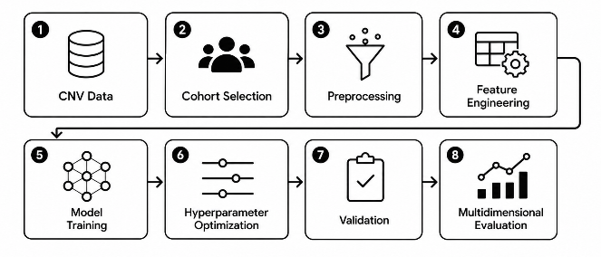
Figure 1. Methodological workflow of the study.
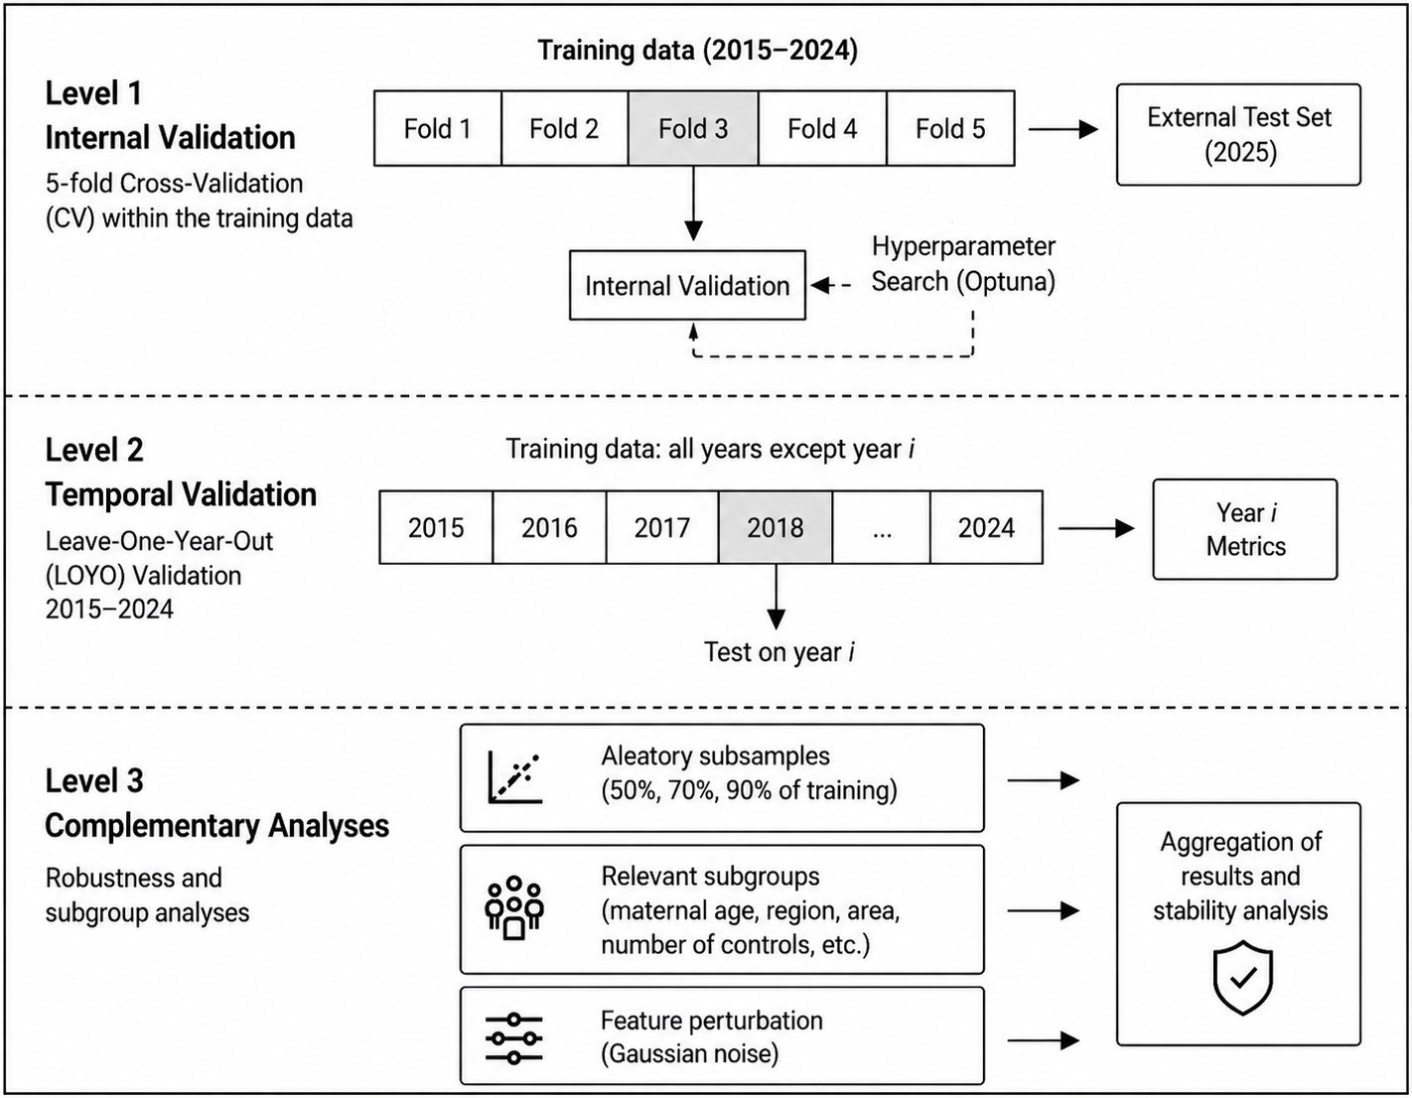
Figure 2. Validation framework employed.
This retrospective observational study compared and temporally evaluated machine-learning classifiers for LBW using a nationwide administrative registry. The analysis was reported with reference to TRIPOD+AI and STROBE, and risk-of-bias domains were considered using PROBAST+AI. Because several predictors were recorded during the delivery episode, the study is framed as registry-based classification at record completion, not early antenatal prediction.

B. Data Source and Study Cohort
The data used in this study were obtained from the Live Birth Certificate database of the Peruvian Ministry of Health (CNV–MINSA) [16], a nationwide administrative database that routinely records maternal, obstetric, and neonatal information collected during delivery care. The consolidated version available as of November 30, 2025, was used, comprising 4,874,510 records corresponding to births that occurred between 2015 and 2025.
The data were used exclusively for research purposes as anonymized administrative records, with no possibility of identifying the individuals included in the database [16].
The complete cohort selection process is summarized in Fig. 3, presented as a STROBE-style flow diagram detailing the inclusion and exclusion stages of the study records.

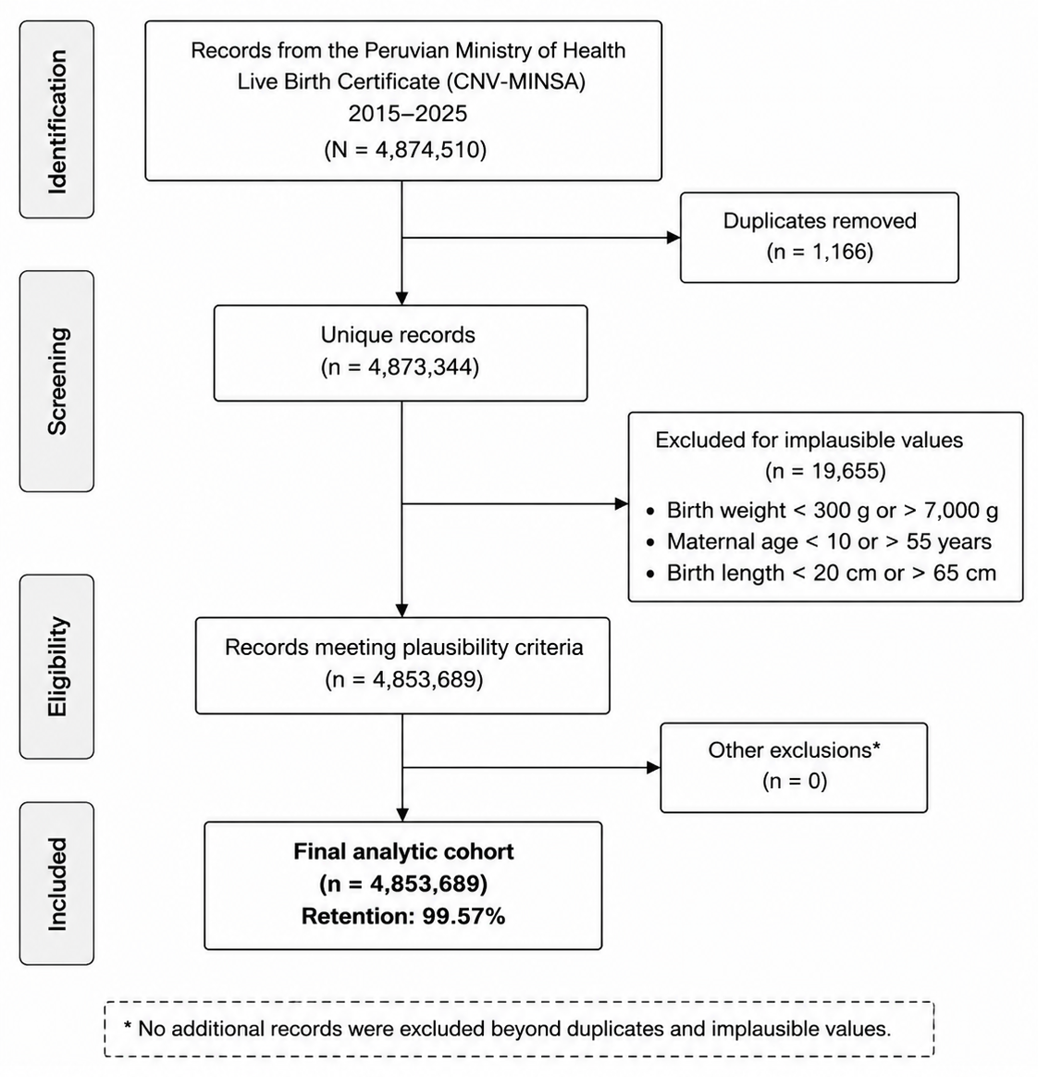
Figure 3. STROBE-style cohort flow diagram.
To ensure the quality and consistency of the analyzed cohort, a data quality control process based on clinical plausibility criteria was applied. This approach was supported by international recommendations for cleaning vital registration data [17] and by previous perinatal studies conducted in Peru [18], [19]. Consistent with these studies, records with birth weight outside the range of 300–7,000 g, maternal age below 10 or above 55 years, and birth length outside the range of 20–65 cm were excluded, thereby ensuring the epidemiological validity and clinical consistency of the study cohort.
Additionally, 1,166 duplicate records were excluded. In the absence of a more detailed breakdown of the auditing process, the remaining excluded records (19,655) corresponded to observations that failed to meet at least one of the clinical plausibility criteria. As a result, the final cohort consisted of 4,853,689 births, corresponding to a retention rate of 99.57% of the initial study population.

C. Outcome, Predictor Availability, and Leakage Assessment
LBW (BAJO_PESO) was defined as birth weight below 2,500 g. The prediction time point for the reported analysis was completion of the birth record. Twenty-four columns entered the modeling pipeline: maternal and obstetric history variables, engineered terms, and four delivery/newborn-context variables. Table I lists the exact inputs and makes their timing explicit.
Table I. Predictor Columns Entered in the Modeling Pipeline
Feature group | Predictors entered in the pipeline
Maternal/demographic | Maternal age; educational level; marital status
Obstetric history | Previous pregnancies; living children; deceased children; abortions/fetal deaths
Derived indicators | ROA; TPF; EM; primigravida; grand multiparity*; extreme maternal age; prior reproductive loss
Interactions/nonlinear terms | Age×ROA; age×pregnancies; ROA×primigravida; TPF×extreme-risk; age²; ROA²
Delivery/newborn context | Newborn sex; delivery funding source; place of birth; birth attendant
Note: Twenty-four columns entered the pipeline. Newborn sex, place of birth, birth attendant, and delivery funding source are delivery-context variables and prevent interpretation as early antenatal predictors. The grand-multiparity indicator was constant after cleaning and therefore carried no predictive information.
Variables directly derived from the outcome, including birth weight, birth length, and gestational age at birth, were excluded, as were the high-cardinality facility code and geographic region (the latter was retained only for fairness analyses). Nevertheless, exclusion of direct outcome variables does not remove temporal leakage relative to an early-prediction scenario when delivery-context variables remain in the model.
A statistical leakage screen was performed on 300,000 records using Pearson and Spearman correlations, univariate ROC-AUC, mutual information, and a composite score. No predictor showed near-deterministic association with LBW; the highest univariate ROC-AUC was 0.606 for birth attendant. This screen assesses statistical association only and cannot establish whether a variable is available at the intended clinical time point. Predictor timing was therefore evaluated separately.
Missingness was highest for recorded abortions or fetal deaths (74.02%), followed by previous pregnancies (9.61%), living children (5.40%), and deceased children (0.03%). The registry also used sentinel values such as -1, so the reported null percentages do not capture all unavailable information. The missing-data mechanism could not be identified from the observed data alone.

D. Feature Engineering and Preprocessing
Based on the original variables, seven derived features were constructed to represent obstetric history and maternal risk factors. These included the sum of reproductive losses (ROA), the fetal loss rate (TPF), the successful pregnancy index (EM), as well as binary indicators for primigravida, grand multiparity, extreme maternal risk, and history of reproductive loss.
The construction of these variables follows recommended practices in epidemiological and maternal–neonatal health research, where composite indicators are derived to capture cumulative risk and improve analytical validity [22]–[24]. Their formal definitions are presented in Equations (1)–(7).

$$\begin{aligned}ROA=H_{f}+A_{m}\end{aligned}$$ | (1)
where:
- $H_{f}$: number of deceased children.
- $A_{m}$: number of stillbirths or maternal abortions.

$$\begin{aligned}TPF={\left[\frac{ROA}{N_{e}}\right]}_{\left[0,1\right]}\end{aligned}$$ | (2)
where $N_{e}$ represents the total number of pregnancies.

$$\begin{aligned}EM={\left[\frac{H_{v}}{N_{e}}\right]}_{\left[0,1\right]}\end{aligned}$$ | (3)
where $H_{v}$ denotes the number of living children.

$$\begin{aligned}PRIMIGESTA=\left\{\begin{matrix}1, & N_{e}=1 \\ 0, & otherwise\end{matrix}\right.\end{aligned}$$ | (4)

$$\begin{aligned}{GRAN}_{MULTIPARA}=\left\{\begin{matrix}1, & N_{e}≥5 \\ 0, & otherwise\end{matrix}\right.\end{aligned}$$ | (5)

$$\begin{aligned}{RIESGO}_{EXTREMO}=\left\{\begin{matrix}1, & E<15∨E>40 \\ 0, & otherwise\end{matrix}\right.\end{aligned}$$ | (6)
where $E$ denotes maternal age.

$$\begin{aligned}{ANTECEDENTE}_{PERDIDA}=\left\{\begin{matrix}1, & H_{f}>0∨A_{m}>0 \\ 0, & otherwise\end{matrix}\right.\end{aligned}$$ | (7)

Additionally, four interaction terms were incorporated: maternal age × sum of reproductive losses, maternal age × previous pregnancies, sum of reproductive losses × primigravida status, and fetal loss rate × extreme maternal risk indicator. Two quadratic terms, corresponding to maternal age and the sum of reproductive losses, were also included to capture nonlinear relationships without relying exclusively on the inductive capacity of tree-based models.
The inclusion of these terms follows methodological recommendations from applied regression [25], polynomial modeling approaches [26], and epidemiological evidence on factor interactions [27].
Before encoding, categories with a relative frequency below 1% in the training period were grouped as OTRO_RARO for maternal education, delivery funding source, and place of birth. The latter two variables are retained here only as delivery-context registry features, not as antenatal predictors.
Subsequently, categorical variables were imputed using the most frequent category and encoded using one-hot encoding, with categories representing less than 0.1% of the training set (approximately 4,500 observations) removed. Numerical variables were imputed using the median and subsequently standardized.
All preprocessing operations were fitted on records from 2015–2024. Exploratory analysis was used for descriptive quality checks. Statistical preprocessing isolation does not resolve the separate issue of whether a predictor would be known before delivery.

E. Predictive Models
Eight machine learning algorithms representing different families of classifiers were evaluated, including linear models, decision tree-based methods, ensemble methods, and boosting techniques. This set combines an interpretable linear model as a baseline with tree-based ensemble methods selected for their consistently strong performance on tabular classification tasks.
Consistent with recent evidence, deep neural networks were not included because, for this type of data, tree-based models generally achieve comparable or superior performance while requiring lower training complexity.
Table II. Predictive Models Evaluated
Model | Abbreviation | Family | Main Characteristics
Logistic Regression | LR | Linear model | Common baseline for binary classification
Extra Trees | ET | Ensemble (Bagging) | Highly randomized trees to reduce variance
Random Forest | RF | Ensemble (Bagging) | Averages multiple trees using bagging
Balanced Random Forest | BRF | Balanced ensemble (Bagging) | Balances classes through undersampling within each tree
XGBoost | XGB | Gradient Boosting | Sequential optimization using regularized gradient boosting
LightGBM | LGBM | Gradient Boosting | Leaf-wise tree growth for efficient training
CatBoost | CAT | Gradient Boosting | Native handling of categorical variables
HistGradient Boosting | HGB | Gradient Boosting | Histogram-based algorithm to accelerate training on large datasets

The pipeline search space also included AdaBoost; however, this algorithm was not retained in the final set of evaluated models, and its analysis is left for future work. Accordingly, the comparison presented in this study is restricted to the eight models described above.
Given the prevalence of low birth weight (6.11%; approximately 1:15), class imbalance was addressed using the native weighting or resampling strategies implemented within each algorithm, without resorting to synthetic oversampling techniques, owing to the large absolute number of positive cases (>296,000).

F. Hyperparameter Optimization
Hyperparameter optimization was performed using Optuna, employing the Tree-structured Parzen Estimator (TPE) sampler and the Median Pruner to terminate unpromising configurations early. The search budget was adjusted according to the computational cost of each algorithm: 30 trials for XGBoost, LightGBM, and CatBoost, and 20 trials for Random Forest, Extra Trees, Balanced Random Forest, and HistGradientBoosting, whereas Logistic Regression was trained using a fixed configuration. Each optimization study was limited to a maximum runtime of 1,800 s. XGBoost, LightGBM, and CatBoost additionally employed early stopping.
The hyperparameter search spaces defined for each algorithm are summarized in Table III.
Table III. Hyperparameter Search Space Used in Optuna
Model | Optimized Hyperparameters | Search Space
Random Forest (RF) | n_estimators | 50–150
 | max_depth | 4–14
 | min_samples_leaf | 10–80
 | max_features | Sqrt
Balanced Random Forest (BRF) | n_estimators | 55–148
 | max_depth | 4–12
 | min_samples_leaf | 10–59
Extra Trees (ET) | n_estimators | 50–150
 | max_depth | 4–14
 | min_samples_leaf | 10–80
CatBoost (CAT) | iterations | 100–250
 | depth | 3–7
 | learning_rate | 0.01–0.20
 | l2_leaf_reg | 0.1–15
 | bagging_temperature | 0.0–1.5
LightGBM (LGBM) | n_estimators | 50–200
 | max_depth | 3–7
 | learning_rate | 0.01–0.18
 | subsample | 0.70–1.00
 | colsample_bytree | 0.60–1.00
 | reg_alpha, reg_lambda | 0.001–8
XGBoost (XGB) | n_estimators | 50–200
 | max_depth | 3–7
 | learning_rate | 0.01–0.18
 | subsample | 0.70–1.00
 | colsample_bytree | 0.60–1.00
 | reg_alpha, reg_lambda | 0.001–10
HistGradient Boosting (HGB) | max_iter | 50–150
 | max_depth | 3–7
 | learning_rate | 0.01–0.20
 | min_samples_leaf | 10–80
 | l2_regularization | 0.001–10

G. Validation Strategy
Model evaluation used three related procedures. Hyperparameters were explored with 3 × 3 nested cross-validation on a reproducible 50,000-record subsample from 2015–2024. Leave-one-year-out analyses on the same sampling scale described temporal variability within 2015–2024. Each final algorithm was then fitted on all 2015–2024 records (n = 4,508,669), and predictions were generated for the 2025 holdout (n = 345,020).
The 2025 records were isolated from parameter fitting, but they were subsequently used for several decisions: comparison of the eight algorithms, designation of HistGradientBoosting as the index model, selection of the F1-optimal threshold, comparison of recalibration methods, decision-curve analysis, and subgroup assessment. Thus, 2025 is a temporal holdout for model fitting but not a fully locked confirmatory test for all reported post hoc choices. Bootstrap confidence intervals used 1,000 resamples of the same holdout.

H. Model Evaluation
Model evaluation was structured into three components:
1) Discrimination: recall, specificity, precision, F1-score, ROC-AUC, PR-AUC, Matthews correlation coefficient (MCC), balanced accuracy, and negative predictive value (NPV), with PR-AUC considered the primary complementary metric because of the class imbalance.
2) Calibration: Brier score, expected calibration error (ECE), maximum calibration error, and the Hosmer–Lemeshow test were computed on the 2025 predictions. Temperature scaling, isotonic regression, and Platt scaling were fitted and assessed on those same predictions to quantify apparent recalibration only; no separate calibration cohort was available.
3) Threshold selection: six strategies were examined on the 2025 predictions. The threshold maximizing F1 was reported descriptively. Because the threshold and its performance were estimated on the same observations, threshold-dependent metrics were not treated as independent validation results.

I. Complementary Analyses
The complementary analyses were diagnostic and were not used to establish clinical usefulness. They characterized interpretability, fairness, temporal stability, robustness, calibration limitations, and decision-curve behavior.
Decision Curve Analysis (DCA) compared each model with treat-all and treat-none strategies over threshold probabilities from 0.01 to 0.50. Because the input probabilities were uncalibrated and no independent calibration-validation sequence was available, fixed probability bands were not retained as validated clinical risk categories.
Model interpretability was assessed using SHAP values computed with PermutationExplainer, complemented by permutation feature importance and partial dependence plots (PDPs) and individual conditional expectation (ICE) plots [13], [29].
Fairness was evaluated across newborn sex, natural region, and maternal age group (≥200 observations per subgroup) using ROC-AUC, recall, false positive rate, positive predictive value, demographic parity, and calibration gap [30].
Finally, temporal stability was quantified using the Population Stability Index (PSI), Wasserstein distance, the Kolmogorov–Smirnov statistic, and the Jensen–Shannon divergence to detect distributional changes in the data across time periods [31]. Robustness was evaluated by introducing random perturbations, completely random missing data, and noise into numerical variables at intensities of 0.05, 0.15, and 0.30.

IV. RESULTS

A. Model Comparison
The ranking differed by evaluation stage. CatBoost had the highest mean nested cross-validation ROC-AUC (0.6705), followed by XGBoost (0.6672) and LightGBM (0.6665); HistGradientBoosting ranked lower in nested cross-validation (0.6621). On the 2025 holdout, HistGradientBoosting had the highest descriptive ROC-AUC (0.6924) and PR-AUC (0.1630), closely followed by CatBoost (ROC-AUC, 0.6903; PR-AUC, 0.1603). HistGradientBoosting is therefore described as the best-performing algorithm on the 2025 holdout, not as a model independently selected before that holdout was inspected.
Table IV. Descriptive Performance on the 2025 Temporal Holdout
Model | AUROC (95% CI) | PR-AUC | Recall
Logistic Regression | 0.668 (0.665–0.672) | 0.114 | 0.473
Random Forest | 0.679 (0.675–0.682) | 0.132 | 0.331
XGBoost | 0.680 (0.676–0.683) | 0.131 | 0.401
LightGBM | 0.647 (0.643–0.651) | 0.099 | 0.594
CatBoost | 0.690 (0.687–0.694) | 0.160 | 0.303
HistGradient Boosting | 0.692 (0.689–0.696) | 0.163 | 0.325
Extra Trees | 0.660 (0.656–0.663) | 0.109 | 0.477
Balanced Random Forest | 0.686 (0.683–0.690) | 0.144 | 0.318

The ROC curves overlapped substantially. HistGradientBoosting and CatBoost showed a small descriptive advantage on the 2025 records, but the absolute ROC-AUC difference between them was 0.0021. With this sample size, statistical significance should not be confused with a clinically meaningful improvement.

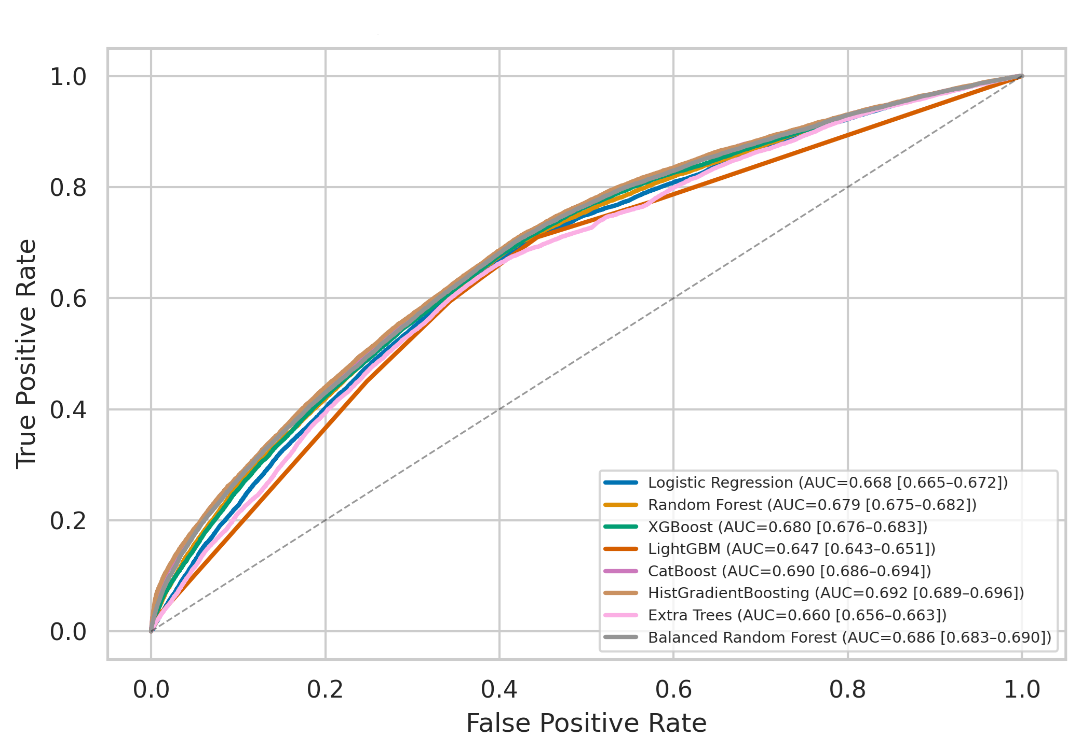
Figure 4. ROC curves of the evaluated classifiers.
Fig. 5 presents the precision–recall curves, providing a more specific assessment of performance on the minority class corresponding to low birth weight cases. Unlike the ROC curves, the differences among models are more evident at lower recall levels, where HistGradientBoosting and CatBoost maintain higher precision. However, as recall increases, all curves progressively converge toward the baseline, reflecting the decline in precision inherent to a class-imbalanced problem and highlighting the usefulness of PR-AUC as a complementary metric for comparing classifier performance in this setting.

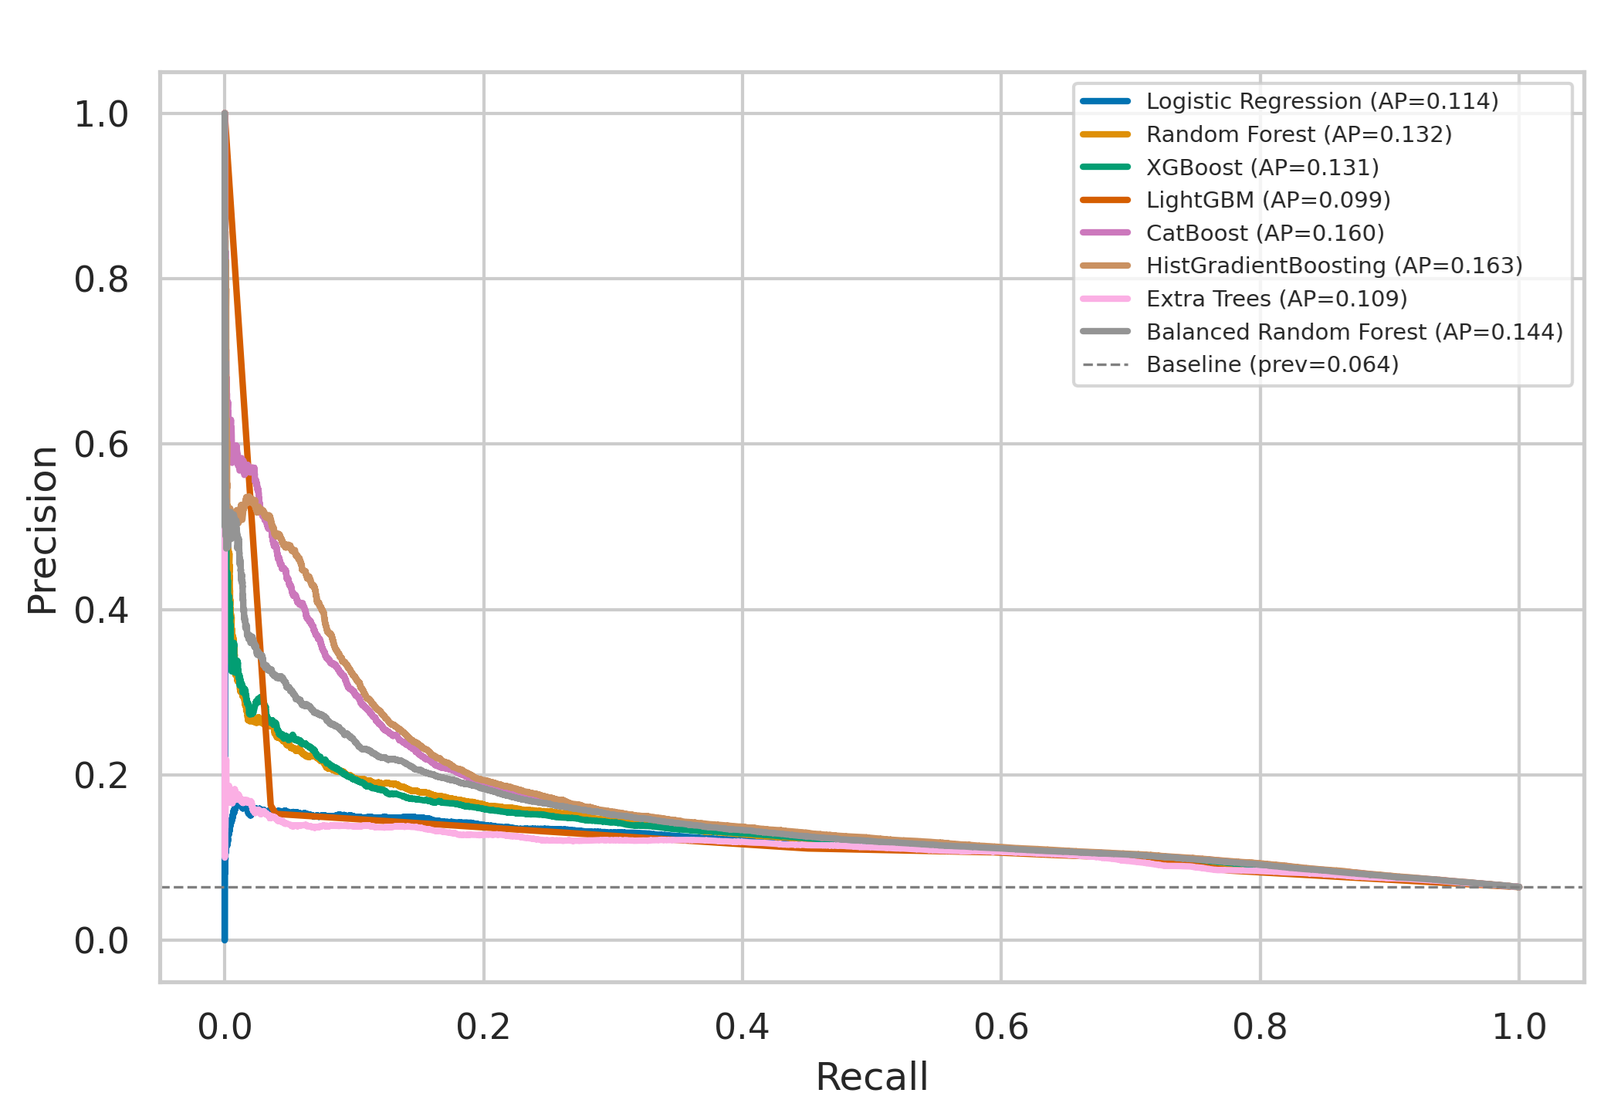
Figure 5. Precision–recall curves of the evaluated classifiers.

B. Performance on the 2025 Temporal Holdout
The 2025 temporal holdout contained 345,020 records, including 22,182 LBW cases (6.43%). Table V reports the HistGradientBoosting confusion matrix at the threshold selected on these same records.
Table V. HistGradientBoosting Confusion Matrix at the Post Hoc F1 Threshold
Prediction | LBW | Non-LBW | Total
Positive | 7,197 | 40,746 | 47,943
Negative | 14,985 | 282,092 | 297,077
Total | 22,182 | 322,838 | 345,020
Note: LBW = low birth weight. The threshold of 0.626 maximized F1 on the same 2025 observations used to construct this confusion matrix; the estimates are therefore apparent, not independently validated operating characteristics.
At a threshold of 0.626, recall was 32.45%, specificity 87.38%, and precision 15.01%. The model identified 7,197 of 22,182 LBW cases and missed 14,985 (67.56%). Of 47,943 positive classifications, 40,746 were false positives (84.99%). This operating point does not support individual clinical decision-making.
The 2025 results demonstrate temporal transport of discrimination within the same national registry. They do not constitute external validation, and reuse of the holdout for model comparison and threshold selection prevents a confirmatory interpretation of threshold-dependent performance.

C. Sample-Size Sensitivity
Using the same 2025 holdout, ROC-AUC changed from 0.6915 to 0.6924 as the training fraction increased from 20% to 100%, while the training ROC-AUC changed from 0.6902 to 0.6893. This descriptive curve suggests little incremental gain from additional records under the current feature set.

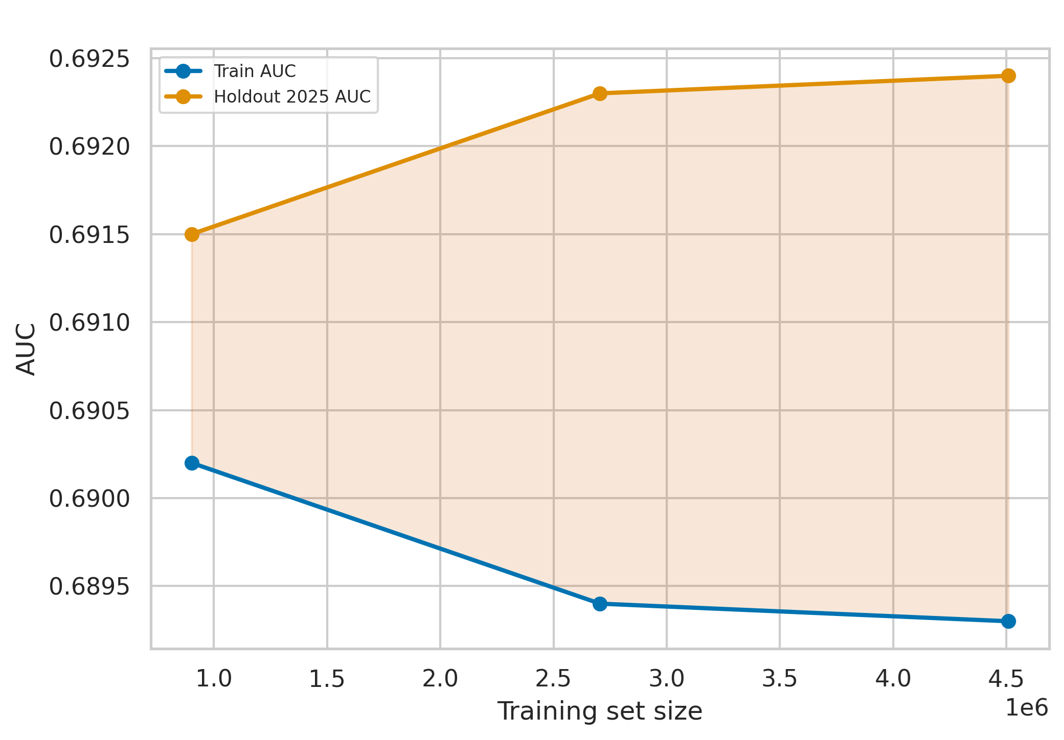
Figure 6. Sample-size sensitivity of HistGradientBoosting on the 2025 holdout.
The close curves show no evident overfitting in this experiment, but they do not prove an immutable predictive ceiling: the same holdout was repeatedly evaluated, and performance could change with a clinically timed predictor set, improved data quality, or external populations.
Across the 50,000-record nested analyses, mean ROC-AUC ranged from 0.6564 to 0.6705. Leave-one-year-out ROC-AUC ranged from 0.6599 in 2015 to 0.6825 in 2024. These results indicate moderate temporal stability within the registry but should not be used to infer that more informative predictors would fail to improve performance.

D. Decision Curve Analysis and Clinical Utility
The decision curves in Fig. 7 remain below the treat-none reference (net benefit = 0) across the displayed clinically relevant threshold range. Negative net benefit indicates that using these model outputs would produce more harm-weighted false positives than benefit from true positives under the assumptions of the analysis.
Accordingly, the DCA does not support clinical utility for HistGradientBoosting, CatBoost, or the other evaluated classifiers in their current uncalibrated form. No favorable threshold range is claimed.

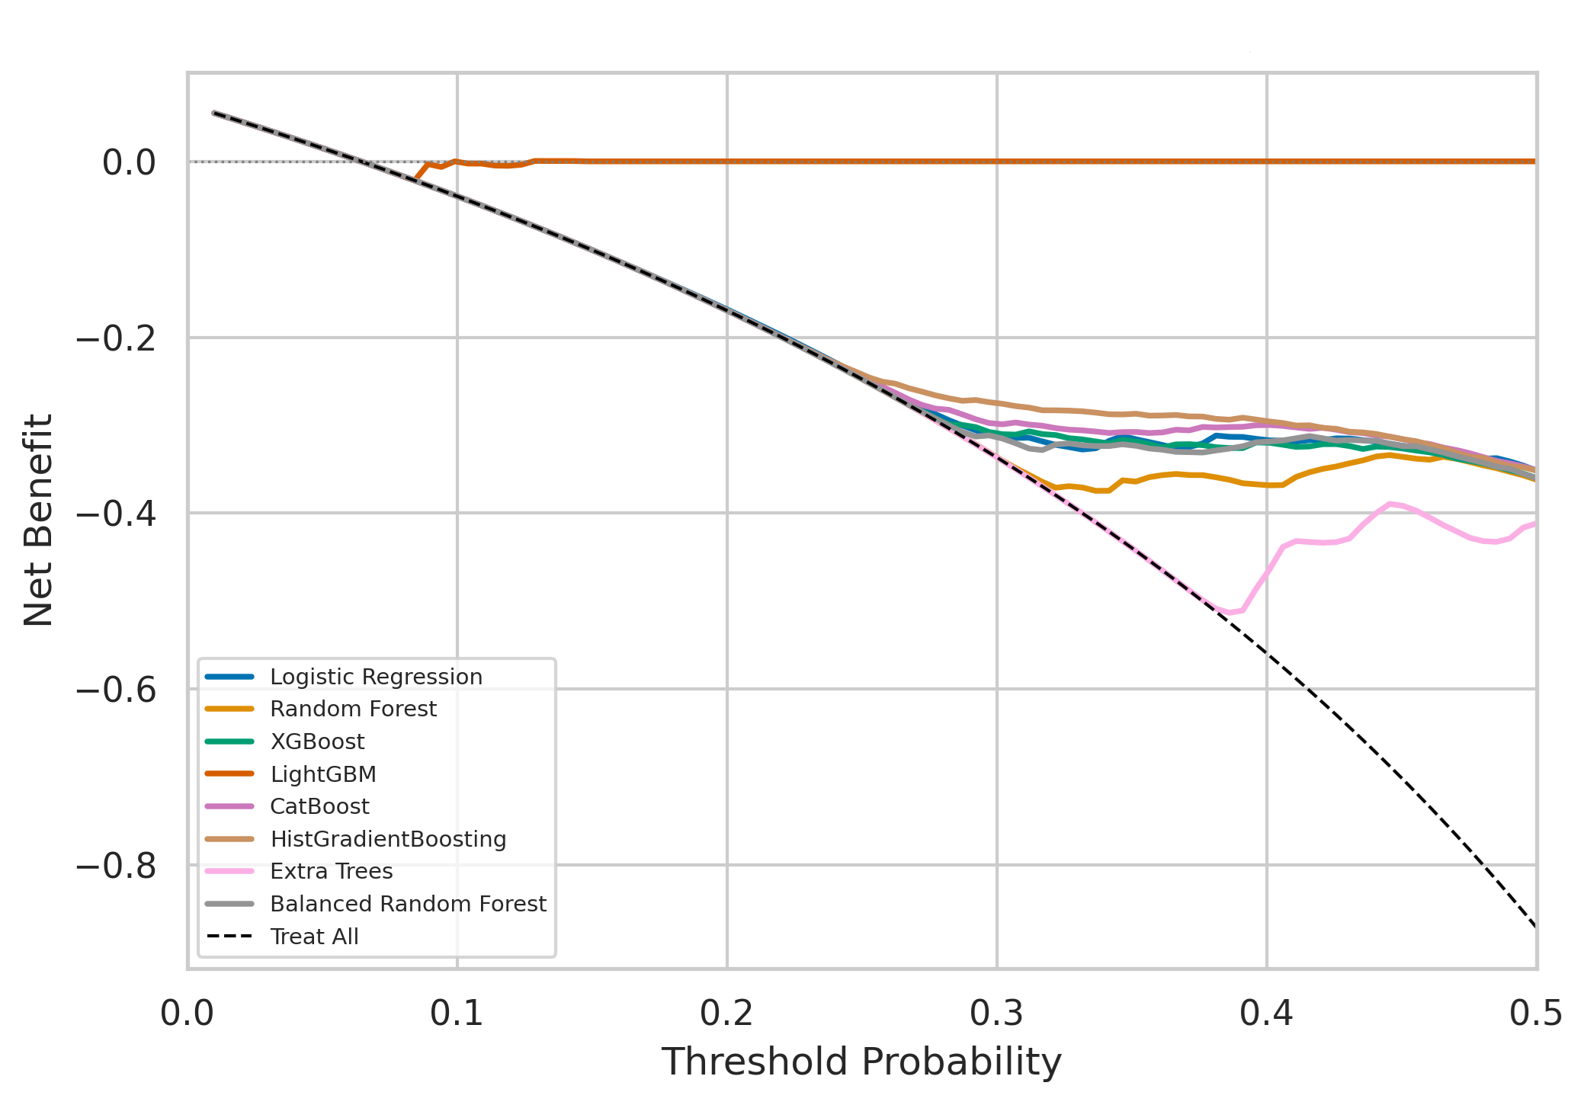
Figure 7. Decision curves of the evaluated classifiers using uncalibrated probabilities.
The previously explored cut points of 0.20, 0.40, and 0.60 were applied to markedly uncalibrated probabilities and evaluated on the same holdout used for model comparison. Those bands are therefore not reported as clinical risk strata. Risk categories must be derived from calibrated probabilities and validated in a separate external or prospective cohort.

E. Interpretability
Birth attendant was the leading feature in both SHAP and permutation analyses, followed by maternal pregnancy history; delivery funding source was also influential. Because birth attendant and funding source arise from the delivery context, their importance reinforces that the current model is a retrospective registry classifier and cannot be interpreted as an early antenatal model.
SHAP values were calculated for one-hot encoded categories, whereas permutation importance was calculated for aggregated variables. The values are not directly comparable; only the broad ranking is discussed.
Table VI. Feature Importance According to SHAP and Permutation Analyses
Rank | SHAP (Mean |SHAP|) | Permutation Feature Importance (ΔROC-AUC)
1 | Birth attendant (Obstetrician): 0.0974 | Birth attendant (Obstetrician): 0.0974
2 | Number of maternal pregnancies: 0.0780 | Number of maternal pregnancies: 0.0780
3 | Number of living children: 0.0723 | Number of living children: 0.0723
4 | — | Delivery funding source: 0.0432
Note: SHAP magnitudes refer to encoded categories and permutation importance to original variables. Delivery-context features are shown to document the fitted model, not to endorse their use in early prediction.
Fig. 8 shows that the most influential variables exhibit nonlinear relationships with the predicted probability of low birth weight.

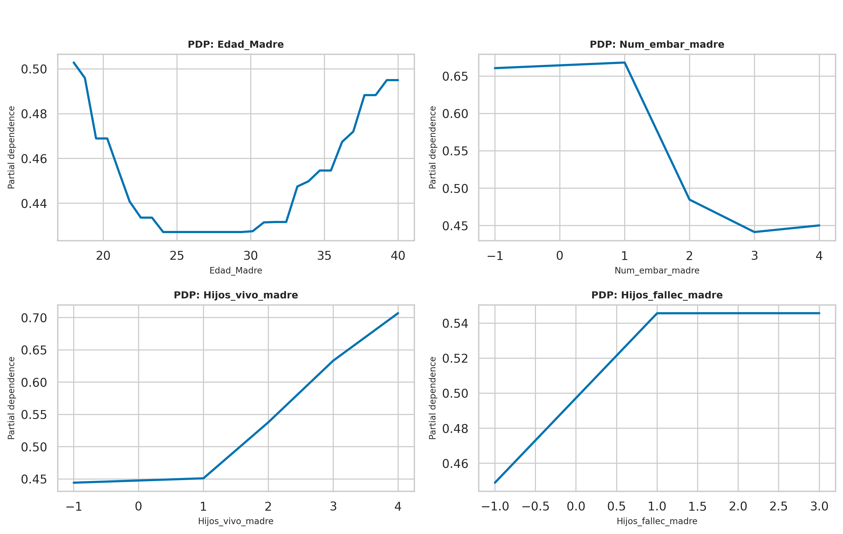
Figure 8. Partial dependence plots for selected variables.
Maternal age exhibited a U-shaped pattern, with the lowest predicted probabilities observed approximately between 23 and 30 years of age and higher probabilities at both younger and older ages. In contrast, the number of living children showed a positive relationship with the predicted risk, whereas the number of deceased children increased the predicted probability up to approximately one event, after which the effect stabilized. The number of pregnancies displayed a non-monotonic relationship, with the predicted probability decreasing after the second pregnancy. These findings indicate that the effects of the most influential variables cannot be adequately described by simple linear relationships and demonstrate the model's ability to capture complex patterns present in the data.

F. Calibration
Raw probabilities were poorly calibrated for all models except LightGBM. HistGradientBoosting had an ECE of 0.3988, and its mean predicted probability was 46.31% compared with an observed LBW prevalence of 6.43%. Platt or isotonic recalibration produced low apparent ECE values when fitted and assessed on the same 2025 data, but these values require validation in a separate cohort.
Table VII. Apparent Calibration Before and After Recalibration
Model | Raw ECE | Apparent ECE after recalibration*
Logistic Regression | 0.4114 | 0.0010
Random Forest | 0.4154 | 0.0029
XGBoost | 0.4095 | 0.0030
LightGBM | 0.0416 | 0.0006
CatBoost | 0.4035 | 0.0026
HistGradientBoosting | 0.3988 | 0.0037
Extra Trees | 0.4274 | 0.0015
Balanced Random Forest | 0.4089 | 0.0033
Note: ECE = expected calibration error. Post-recalibration ECE is an apparent estimate because each method was fitted and evaluated on the same 2025 predictions; it is not an independently validated calibration result. Platt scaling was examined for LightGBM and HistGradientBoosting; isotonic regression was examined for the remaining models.
Figure 9 shows most calibration curves below the 45-degree line: observed event rates were lower than the corresponding predicted probabilities. This pattern represents systematic overestimation of absolute LBW risk, not underestimation.

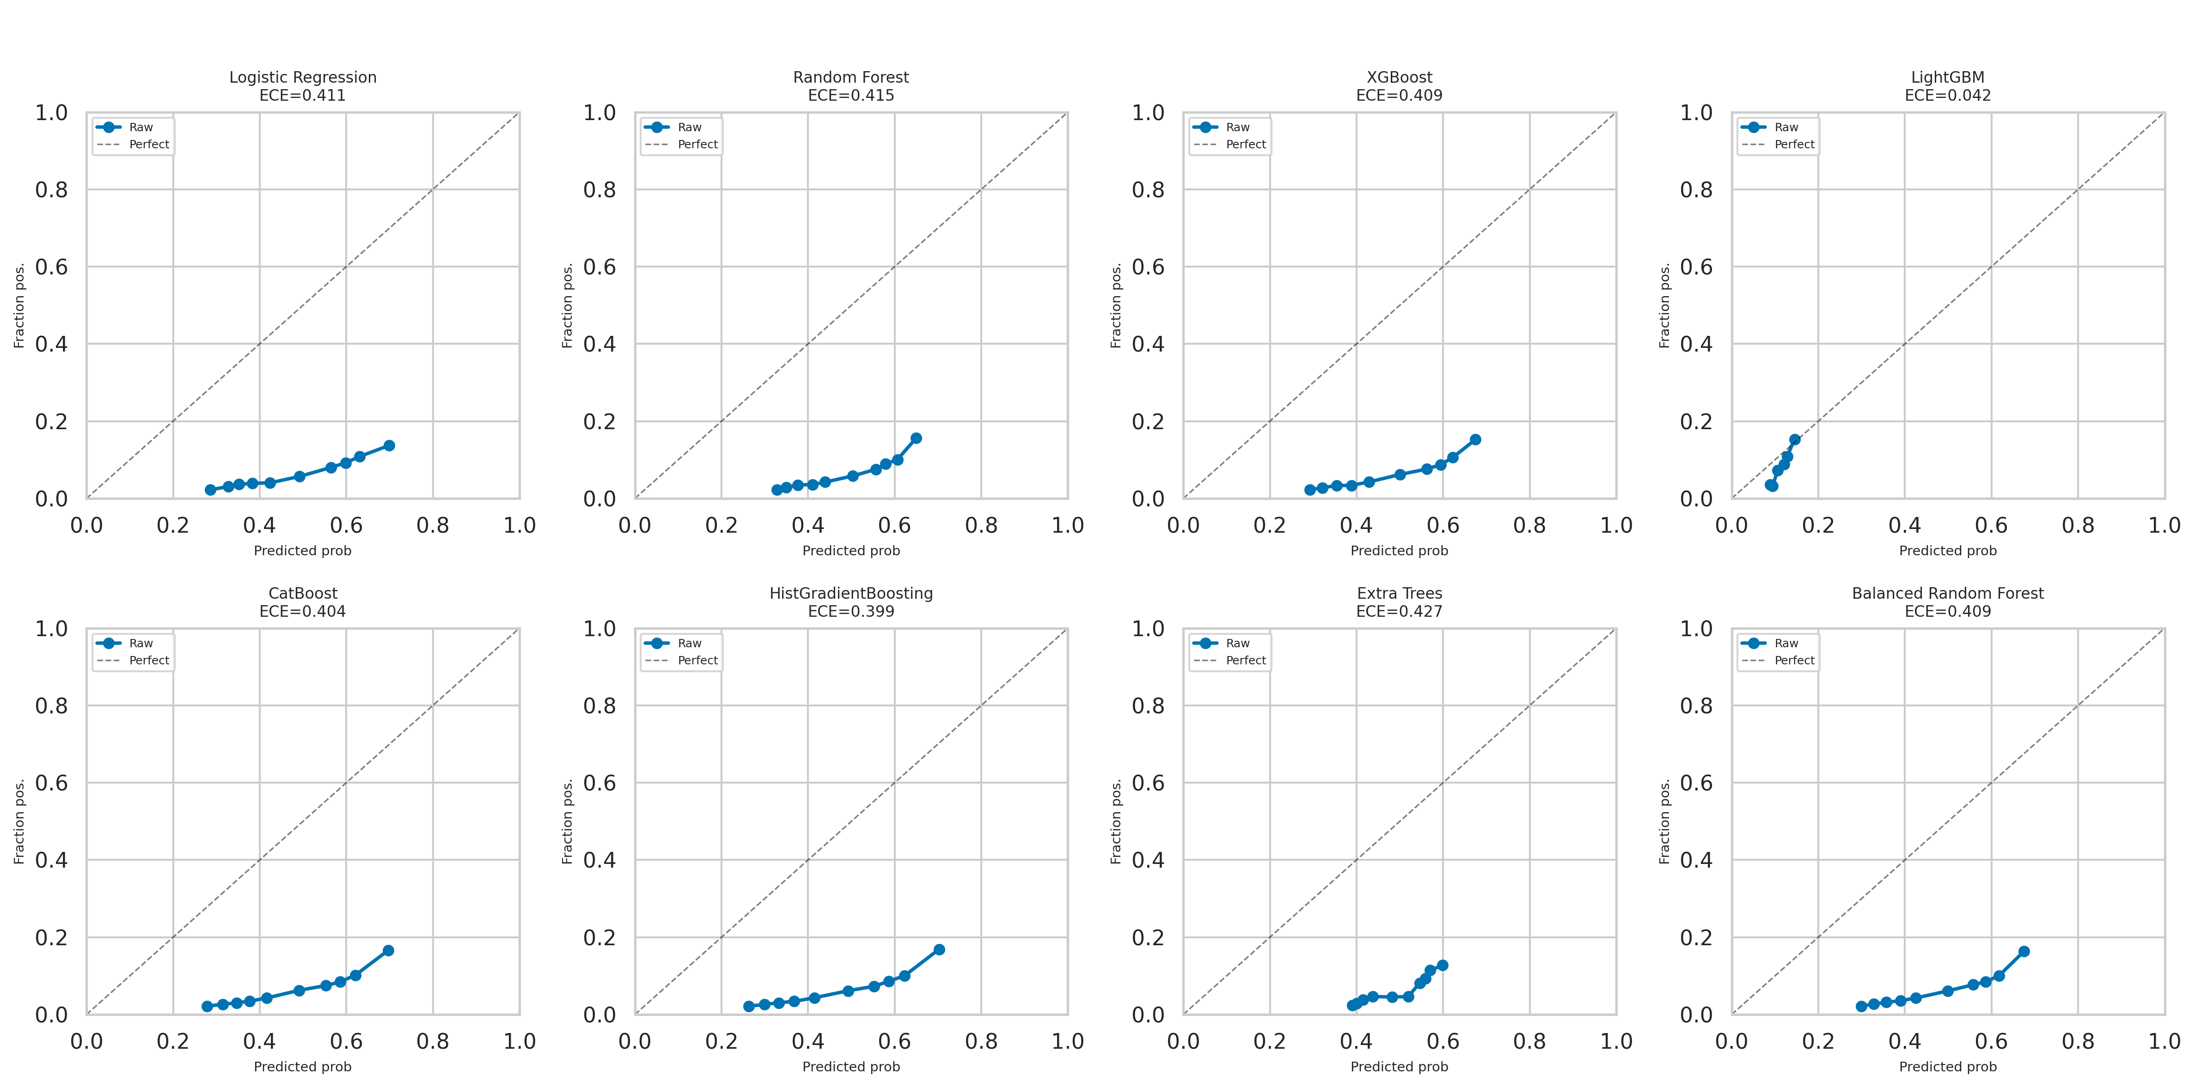
Figure 9. Calibration curves before recalibration.
The raw outputs cannot be interpreted as absolute risk. The apparent recalibration analysis demonstrates that correction is possible, but calibrated probabilities were not independently validated and were not used to support risk categories or clinical decisions in this revision.

G. Fairness Audit
Table VIII summarizes discrimination and threshold-dependent performance across sex, natural region, and maternal age groups. Sex differences were small, regional differences were moderate, and the largest heterogeneity occurred across maternal age groups.
The weakest discrimination occurred among mothers aged 14 years or younger (n = 851; ROC-AUC, 0.4971), although the small subgroup makes the estimate imprecise. Calibration gaps based on raw probabilities were 0.5051 (≤14 years), 0.4520 (15–19 years), 0.3786 (20–34 years), and 0.4312 (≥35 years); these large positive gaps are consistent with risk overestimation and should not be interpreted as validated subgroup risk estimates.
Table VIII. HistGradientBoosting Performance Across Population Subgroups
Subgroup | N | ROC-AUC | Recall
Sex
Female | 168,537 | 0.6898 | 0.3626
Male | 176,447 | 0.6930 | 0.2831
Natural region
Coast | 192,778 | 0.7008 | 0.3209
Highlands | 88,943 | 0.6964 | 0.3257
Jungle | 43,490 | 0.6696 | 0.3352
Highlands–Jungle | 18,970 | 0.6787 | 0.3170
Missing | 839 | 0.6910 | 0.4038
Maternal age
≤14 years | 851 | 0.4971 | 0.6769
15–19 years | 33,291 | 0.6335 | 0.4731
20–34 years | 227,206 | 0.6902 | 0.2155
≥35 years | 83,672 | 0.6951 | 0.4765
Note: FPR = False Positive Rate. The sum of the Sex subgroup categories (n = 344,984) differs from the total number of observations in the test set (n = 345,020) by 36 records, corresponding to a category with fewer than 200 observations that was excluded according to the minimum sample size threshold established for the fairness analysis.

H. Temporal Stability and Data Drift
The prevalence of low birth weight remained stable throughout the study period, while most obstetric variables exhibited minimal drift across years. Maternal age showed the greatest temporal variation (maximum PSI = 0.061); however, this value remained below the threshold commonly associated with meaningful changes in data distribution. Overall, these findings support the temporal stability of the cohort and suggest that data drift had a limited impact on model performance.

I. Robustness
Table IX shows that missingness caused the largest decline in ROC-AUC (−0.0318 at the 0.30 level), followed by Gaussian noise (−0.0152) and the reported low-magnitude perturbation (−0.0015). These are descriptive stress tests on the same 2025 holdout.
Table IX. HistGradientBoosting Robustness Under Perturbation
Perturbation Type | Level 0.05 | Level 0.15 | Level 0.30
Gaussian noise | 0.6924 | 0.6911 | 0.6772
Missing data (MCAR) | 0.6854 | 0.6733 | 0.6606
Low-magnitude random perturbation | 0.6924 | 0.6919 | 0.6909
Note: Values are ROC-AUC estimates after perturbing the 2025 temporal holdout. Because the same holdout supported multiple post hoc analyses, these stress tests are descriptive rather than independent validation results.

V. DISCUSSION

A. Why Is the ROC-AUC Approximately 0.69?
The 2025 ROC-AUC values are lower than many estimates reported in the LBW machine-learning literature [5]–[10]. The current study supports the value of temporal evaluation but does not establish a purely antenatal benchmark, because four retained inputs belong to the delivery context. Comparisons with studies using different prediction times, variables, and validation designs should therefore remain descriptive.

B. What Does the Model Actually Learn?
The strongest signals came from birth attendant, obstetric history, and delivery funding source. These variables may encode care pathways, access, referral, and institutional practice rather than maternal biological risk [33], [34]. Their influence also creates a temporal-availability problem for any early-prediction claim and may transport poorly to other health systems.

C. Fairness in Early Adolescent Mothers
The most relevant fairness finding was the decline in ROC-AUC to 0.4971 among mothers aged 14 years or younger (n = 851), a performance indistinguishable from random chance and accompanied by a false positive rate (FPR) of 66.85%. Compared with the minimal ROC-AUC difference observed between sexes (0.0032) and the moderate difference across natural regions (0.0312), the disparity by maternal age reached 0.1980, while the adverse impact ratio between maternal age groups was 0.11—well below the conventional threshold of 0.80—confirming that the disparity extends beyond discrimination performance to the positive classification rate itself. Although the small subgroup size implies wide confidence intervals, the finding is supported by the clinical evidence: much of the risk attributed to early maternal age is mediated by socioeconomic disadvantage and reduced access to prenatal care rather than by biological immaturity [35], [36], and in Peru, poverty has been identified as the strongest determinant in this population according to the 2022 ENDES survey [37]. It is therefore plausible that the registry does not capture these underlying mechanisms and that a dedicated model may be required, providing a clear example of how acceptable aggregate performance can conceal severe failures in minority subgroups [30], [38]–[40].

D. Methodological Implications
Temporal splitting reduces one important source of optimism, but it does not by itself prevent leakage from predictors recorded after the intended prediction time. In addition, the 2025 holdout was reused for algorithm comparison, threshold selection, recalibration assessment, and clinical-utility analyses. With 345,020 observations, very small differences can yield small p-values; effect size, prespecified selection rules, and locked evaluation data are more informative than significance alone [41].

E. Clinical and Research Implications
The present model should not be used for population triage or individual decisions. The DCA did not demonstrate positive net benefit, raw probabilities substantially overestimated risk, threshold-dependent metrics were optimized on the evaluation cohort, and performance was inadequate in the youngest maternal-age group. A future clinical model should first define an antenatal time point, exclude delivery and neonatal variables, reserve distinct data for model selection, calibration, threshold selection, and final testing, and then undergo external and prospective impact evaluation [15], [28], [42]–[44].

F. Limitations
Several limitations materially constrain interpretation. First, the pipeline included newborn sex, place of birth, birth attendant, and delivery funding source; the study is therefore not an early antenatal prediction model. Second, CatBoost ranked first in nested cross-validation whereas HistGradientBoosting ranked first on the 2025 holdout, and the latter was designated only after the holdout was inspected. Third, the same 2025 cohort was used for model comparison, threshold optimization, recalibration assessment, DCA, and subgroup analyses. Fourth, calibration methods were not validated on separate data, and no independent risk strata were available. Fifth, validation came from a later year of the same registry rather than an external health system. Additional limitations include the 50,000-record subsamples used for nested and leave-one-year-out analyses, 74.02% recorded missingness for abortions/fetal deaths, sentinel values not counted as nulls, a constant grand-multiparity feature, and absence of fetal biometry, blood pressure, hemoglobin, and body-mass index. The subgroup aged 14 years or younger was small, and its estimate requires uncertainty intervals and dedicated validation.

VI. CONCLUSIONS
This nationwide registry analysis provides a temporal benchmark for LBW classification, not an early clinical prediction model. The strongest 2025 discrimination was observed for HistGradientBoosting (ROC-AUC, 0.6924), whereas CatBoost ranked first in the nested development analysis.
Raw probabilities markedly overestimated LBW risk, the selected threshold was optimized on the evaluation cohort, and decision-curve analysis did not demonstrate positive net benefit. The reported risk bands were therefore withdrawn as clinical categories.
The model also showed substantial heterogeneity by maternal age and relied strongly on delivery-context features. These findings define important methodological constraints but do not establish clinical usefulness.
A clinically oriented next study should specify an antenatal prediction time, remove all variables unavailable at that time, prespecify model selection, use separate development, calibration, threshold-selection, and final-test partitions, and validate calibrated risk categories in an external prospective cohort before any deployment claim.

REFERENCES
[1] J. Krasevec et al., “Study protocol for UNICEF and WHO estimates of global, regional, and national low birthweight prevalence for 2000 to 2020,” Gates Open Res., vol. 6, p. 80, Jul. 2022, doi: 10.12688/gatesopenres.13666.1.
[2] World Health Organization, “Global Nutrition Targets 2025: Low Birth Weight Policy Brief,” World Health Organization, Geneva, Switzerland, WHO/NMH/NHD/14.5, 2014. [Online]. Available: https://www.who.int/publications/i/item/WHO-NMH-NHD-14.5
[3] H. Gu et al., “A gradient relationship between low birth weight and IQ: A meta-analysis,” Sci. Rep., vol. 7, no. 1, p. 18035, Dec. 2017, doi: 10.1038/s41598-017-18234-9.
[4] F. R. Jornayvaz, P. Vollenweider, M. Bochud, V. Mooser, G. Waeber, and P. Marques-Vidal, “Low birth weight leads to obesity, diabetes and increased leptin levels in adults: the CoLaus study,” Cardiovasc. Diabetol., vol. 15, no. 1, p. 73, Dec. 2016, doi: 10.1186/s12933-016-0389-2.
[5] D. A. Alabbad et al., “Birthweight Range Prediction and Classification: A Machine Learning-Based Sustainable Approach,” Mach. Learn. Knowl. Extr., vol. 6, no. 2, pp. 770–788, Apr. 2024, doi: 10.3390/make6020036.
[6] X. Wu et al., “Interpretable machine learning model for predicting low birth weight in singleton pregnancies: a retrospective cohort study,” BMC Pregnancy Childbirth, vol. 25, no. 1, p. 1159, Nov. 2025, doi: 10.1186/s12884-025-08318-0.
[7] “Utilization of tree-based machine learning models for predicting low birth weight cases,” BMC Med. Inform. Decis. Mak., 2024, doi: 10.21203/rs.3.rs-4572430/v1.
[8] T. B. Reza and N. Salma, “Prediction and feature selection of low birth weight using machine learning algorithms,” J. Health Popul. Nutr., vol. 43, no. 1, p. 157, Oct. 2024, doi: 10.1186/s41043-024-00647-8.
[9] J. Gao et al., “Methodological conduct and risk of bias in studies on prenatal birthweight prediction models using machine learning techniques: a systematic review,” BMC Pregnancy Childbirth, vol. 25, no. 1, p. 696, Jul. 2025, doi: 10.1186/s12884-025-07727-5.
[10] A. Victor, F. Almeida, S. P. Xavier, and P. H. C. Rondó, “Predicting low birth weight risks in pregnant women in Brazil using machine learning algorithms: data from the Araraquara cohort study,” BMC Pregnancy Childbirth, vol. 25, no. 1, p. 320, Mar. 2025, doi: 10.1186/s12884-025-07351-3.
[11] A. Ranjbar, F. Montazeri, M. V. Farashah, V. Mehrnoush, F. Darsareh, and N. Roozbeh, “Machine learning-based approach for predicting low birth weight,” BMC Pregnancy Childbirth, vol. 23, no. 1, p. 803, Nov. 2023, doi: 10.1186/s12884-023-06128-w.
[12] M. Cui et al., “Predicting macrosomia and low birth weight with interpretable machine learning,” BMC Pregnancy Childbirth, vol. 26, no. 1, p. 217, Feb. 2026, doi: 10.1186/s12884-026-08667-4.
[13] S. Lundberg and S.-I. Lee, “A Unified Approach to Interpreting Model Predictions,” Nov. 25, 2017, arXiv: arXiv:1705.07874. doi: 10.48550/arXiv.1705.07874.
[14] G. S. Collins, J. B. Reitsma, D. G. Altman, and K. G. M. Moons, “Transparent Reporting of a multivariable prediction model for Individual Prognosis Or Diagnosis (TRIPOD): The TRIPOD Statement,” Ann. Intern. Med., vol. 162, no. 1, pp. 55–63, Jan. 2015, doi: 10.7326/M14-0697.
[15] E. W. Steyerberg, Clinical Prediction Models: A Practical Approach to Development, Validation, and Updating. in Statistics for Biology and Health. Cham: Springer International Publishing, 2019. doi: 10.1007/978-3-030-16399-0.
[16] Ministerio de Salud - MINSA, “Registros de Nacidos Vivos en el Perú (2015–2025).” [Online]. Available: https://n9.cl/cnv-minsa
[17] UNFPA América Latina y el Caribe, Guía para la evaluación de la calidad de registros de nacimientos y defunciones en América Latina y el Caribe. UNFPA, 2025. [Online]. Available: https://n9.cl/unfpa-guia
[18] O. Tipiani-Rodríguez, Y. L. Bocanegra-Becerra, C. Huarag-Chavarry, K. Figueroa-Morales, and M. Á. PoncianoBiaggi, “Restricción de crecimiento intrauterino según curvas personalizadas peruanas: estudio de validación y precisión diagnóstica,” Rev. Peru. Ginecol. Obstet., vol. 70, no. 1, Mar. 2024, doi: 10.31403/rpgo.v70i2593.
[19] Ministerio de Economía y Finanzas del Perú, “Programa Salud Materno Neonatal.” [Online]. Available: https://n9.cl/salud-materno-neonatal
[20] Ministerio de Salud - MINSA, “Diccionario de Datos de los Registros de Nacidos Vivos en el Perú (2015–2025).” [Online]. Available: https://n9.cl/diccionarioCNV
[21] M. Jin, “Handling missing data in longitudinal randomized clinical trials within the framework of targeted learning under MAR and MNAR,” Contemp. Clin. Trials, vol. 162, p. 108245, Mar. 2026, doi: 10.1016/j.cct.2026.108245.
[22] World Health Organization, Strategies toward ending preventable maternal mortality (EPMM). World Health Organization, 2015. [Online]. Available: https://www.who.int/docs/default-source/mca-documents/qoc/quality-of-care/strategies-toward-ending-preventable-maternal-mortality-(epmm).pdf
[23] J. Villar et al., “Caesarean delivery rates and pregnancy outcomes: the 2005 WHO global survey on maternal and perinatal health in Latin America,” The Lancet, vol. 367, no. 9525, pp. 1819–1829, 2006, doi: 10.1016/S0140-6736(06)68704-7.
[24] J. Villar et al., “Maternal and neonatal individual risks and benefits associated with caesarean delivery: multicentre prospective study,” BMJ, vol. 335, no. 7628, p. 1025, Nov. 2007, doi: 10.1136/bmj.39363.706956.55.
[25] D. W. Hosmer, S. Lemeshow, and R. X. Sturdivant, Applied Logistic Regression, 3rd ed. Wiley, 2013.
[26] P. Royston, Multivariable model-building: a pragmatic approach to regression analysis based on fractional polynomials for modelling continuous variables. in Wiley series in probability and statistics. Chichester, England: John Wiley, 2008.
[27] S. Greenland, “Interactions in Epidemiology: Relevance, Identification, and Estimation,” Epidemiology, vol. 20, no. 1, pp. 14–17, Jan. 2009, doi: 10.1097/EDE.0b013e318193e7b5.
[28] A. J. Vickers and E. B. Elkin, “Decision Curve Analysis: A Novel Method for Evaluating Prediction Models,” Med. Decis. Making, vol. 26, no. 6, pp. 565–574, 2006, doi: 10.1177/0272989X06295361.
[29] C. Molnar, Interpretable Machine Learning: A Guide for Making Black Box Models Explainable, 3rd ed. Christoph Molnar, 2022. [Online]. Available: https://christophm.github.io/interpretable-ml-book/
[30] A. Rajkomar, M. Hardt, M. D. Howell, G. S. Corrado, and M. H. Chin, “Ensuring Fairness in Machine Learning to Advance Health Equity,” Ann. Intern. Med., vol. 169, no. 12, pp. 866–872, 2018, doi: 10.7326/M18-1990.
[31] J. G. Moreno-Torres, T. Raeder, R. Alaiz-Rodríguez, N. V. Chawla, and F. Herrera, “A unifying view on dataset shift in classification,” Pattern Recognit., vol. 45, no. 1, pp. 521–530, Jan. 2012, doi: 10.1016/j.patcog.2011.06.019.
[32] A. Koivu and M. Sairanen, “Predicting Risk of Stillbirth and Preterm Pregnancies with Machine Learning,” Health Inf. Sci. Syst., vol. 8, no. 1, p. 14, 2020, doi: 10.1007/s13755-020-00105-9.
[33] R. P. Cárdenas-Urrelo, “Modelo de intervención para mejorar los indicadores sanitarios maternos del seguro integral de salud peruano,” Rev. Salud Amaz. Bienestar, vol. 1, no. 1, p. e229, Jan. 2022, doi: 10.51252/rsayb.v1i1.229.
[34] S. Parodi, “Evaluando los efectos del Seguro Integral de Salud (SIS) sobre la equidad en la salud materna en el contexto de barreras no económicas al acceso a los servicios,” GRADE Manuscripte-Version Available Httpcies Org Pefilesactive0parodi Pdf, 2005, [Online]. Available: https://cies.org.pe/wp-content/uploads/2022/08/28451480-evaluando-los-efectos-del-seguro-integral-de-salud-sis.pdf
[35] W. F. D. Azevedo, M. B. Diniz, E. S. V. B. D. Fonseca, L. M. R. D. Azevedo, and C. B. Evangelista, “Complications in adolescent pregnancy: systematic review of the literature,” Einstein São Paulo, vol. 13, no. 4, pp. 618–626, Jun. 2015, doi: 10.1590/S1679-45082015RW3127.
[36] E. B. Gama Filho and others, “Is Adolescent Pregnancy a Risk Factor for Low Birth Weight?,” Rev. Assoc. Médica Bras., 2013, doi: 10.1590/S0034-89102013000100003.
[37] J. Montalván-Santillán and D. Flores-Cortez, “Determinantes del Embarazo Adolescente en el Perú: Un Análisis Secundario de la Encuesta Demográfica y de Salud Familiar (ENDES) 2022,” Rev. Int. Salud Materno Fetal, 2024.
[38] Z. Obermeyer, B. Powers, C. Vogeli, and S. Mullainathan, “Dissecting Racial Bias in an Algorithm Used to Manage the Health of Populations,” Science, vol. 366, no. 6464, pp. 447–453, 2019, doi: 10.1126/science.aax2342.
[39] M. Hardt, E. Price, and N. Srebro, “Equality of Opportunity in Supervised Learning,” 2016, arXiv. doi: 10.48550/ARXIV.1610.02413.
[40] I. Y. Chen, E. Pierson, S. Rose, S. Joshi, K. Ferryman, and M. Ghassemi, “Ethical Machine Learning in Healthcare,” Annu. Rev. Biomed. Data Sci., vol. 4, no. 1, pp. 123–144, Jul. 2021, doi: 10.1146/annurev-biodatasci-092820-114757.
[41] D. R. Roberts et al., “Cross‐validation strategies for data with temporal, spatial, hierarchical, or phylogenetic structure,” Ecography, vol. 40, no. 8, pp. 913–929, Aug. 2017, doi: 10.1111/ecog.02881.
[42] B. Van Calster, D. Nieboer, Y. Vergouwe, B. De Cock, M. J. Pencina, and E. W. Steyerberg, “A Calibration Hierarchy for Risk Models Was Defined: From Utopia to Empirical Data,” J. Clin. Epidemiol., vol. 74, pp. 167–176, 2016, doi: 10.1016/j.jclinepi.2015.12.005.
[43] B. Van Calster, D. J. McLernon, M. van Smeden, L. Wynants, and E. W. Steyerberg, “Calibration: The Achilles Heel of Predictive Analytics,” BMC Med., vol. 17, p. 230, 2019, doi: 10.1186/s12916-019-1466-7.
[44] C. J. Kelly, A. Karthikesalingam, M. Suleyman, G. Corrado, and D. King, “Key challenges for delivering clinical impact with artificial intelligence,” BMC Med., vol. 17, no. 1, p. 195, Dec. 2019, doi: 10.1186/s12916-019-1426-2.

