A reproducible GeoAI framework for the explainable spatiotemporal analysis of national missing persons records: multi-algorithm clustering and multi-level validation (Peru, 2019–2025)
Moisés Evangelista Gamarra1; Edwar Abrahan Alama Carreño1, Pamela Estefani Figueroa Rosas1;
Servicio Nacional de Adiestramiento en Trabajo Industrial, Lima, Perú, mevangelistag@senati.pe, 1634030@senati.pe, 1546935@senati.pe
Abstract
Missing persons cases represent a growing public safety concern in Peru, with more than 20,000 reports annually by the end of the study period. This work analyses the National Registry of Information on Missing Persons (RENIPED, 2019–2025; 77,331 aggregated records representing approximately 138,700 reports across 26 territorial units) using a reproducible GeoAI framework that combines multi-algorithm clustering, spatial statistics and surrogate-based explainability. Three procedures that determine the number of clusters without imposing it converge on a three-cluster solution (Silhouette = 0.4699; bootstrap ARI = 0.9946). One of the clusters is shown to be a recoding of departmental identity introduced by frequency encoding, and is reported as such rather than as discovered structure. The substantive cluster (n = 6,018; mean monthly anomaly +1.73 SD) is episodic rather than territorial and concentrates in the southern Andean departments. Spatial analysis, conducted independently of the cluster labels, converges on the same corridor: incidence per 10,000 person-years shows significant positive spatial autocorrelation under all three weight specifications tested (Moran's I = +0.330; p = 0.002 for KNN-5), whereas absolute counts show none (p = 0.376–0.898). The Getis–Ord statistic identifies a southern hotspot cluster (Arequipa, Moquegua, Tacna, Cusco, Ayacucho) against an Amazonian coldspot axis (San Martín, Loreto). Metropolitan Lima, which concentrates 23.1% of national records, is not a significant hotspot (Gi* = 0.540; p = 0.589). At the departmental unit of analysis the partition shows no significant association with socioeconomic covariates (p = 0.076–0.296). Reporting volume and per-capita incidence are distinct quantities, with direct consequences for the territorial allocation of search and prevention resources.
Keywords
spatiotemporal clustering; missing persons; RENIPED; spatial autocorrelation; GeoAI; SHAP explainability; Peru.
Highlights
• A reproducible GeoAI pipeline is proposed for national missing persons registries.
• DPTO_FREQ is shown to recode territorial identity and dominate the partition.
• K = 2, K = 3 and K = 4 are formally compared, separating evidence on K from fixed-K agreement.
• Spatial analysis shows significant autocorrelation for per-capita incidence, not for raw counts.
• The framework integrates spatial, temporal, sensitivity and surrogate-based explainability validation.
Graphical Abstract
[Insert the final graphical abstract here. It should visually represent the GeoAI pipeline and the artifact audit.]
1. Introduction
Although the disappearance of persons is a global phenomenon with profound humanitarian, legal and public safety implications, the scientific evidence on the subject remains fragmented and heterogeneous. International bodies such as the International Committee of the Red Cross (ICRC) and the International Commission on Missing Persons (ICMP) note that administrative registries represent a strategic resource for strengthening the search for missing persons, supporting public policy design and improving institutional coordination; however, their potential remains limited by data quality problems, limited interoperability between systems and a lack of information standardisation [1]–[3].
Geospatial Artificial Intelligence (GeoAI) has expanded the possibilities for analysing territorial phenomena through machine learning, spatial analysis and explainable models. These methodologies have produced relevant results in fields such as epidemiology, public health, urban mobility and risk management; however, their application to the analysis of national administrative registries of missing persons remains limited. In particular, few studies have assessed the quality, robustness, stability and reproducibility of spatial patterns obtained through unsupervised learning [4]–[7].
In Latin America, research on missing persons cases has focused on gender-based violence, social conflict, human trafficking and pandemic effects. Although these studies have improved the understanding of the phenomenon from a social perspective, few works combine artificial intelligence, spatial analysis and statistical validation applied to large-scale administrative registries to support decision-making and territorial planning [3], [8]–[10].
In Peru, this issue remains highly relevant to public safety. By the end of 2025, the National Registry of Information on Missing Persons (RENIPED) recorded 20,947 reports, compared with 17,737 reported in 2024, reversing the decreasing trend observed during 2022–2024. In addition, the Ombudsman's Office of Peru has documented a high concentration of cases among women, girls and adolescents, while several reports have identified limitations related to the updating of administrative records, institutional interoperability and case follow-up, factors that hinder the implementation of evidence-based public policy [3]–[9].
In this context, the following central methodological question arises: is it possible to identify robust and interpretable territorial patterns from a national administrative registry using unsupervised learning techniques, without assuming that reporting frequency directly reflects individual risk of disappearance?
Despite these advances, a methodological gap persists internationally. Most studies on missing persons focus on individual factors or descriptive analyses, while relatively few investigations apply unsupervised learning to national administrative registries through reproducible frameworks that integrate multi-algorithm comparison, spatial and temporal validation, explainability and external validation, thus limiting the assessment of the robustness and interpretability of the territorial patterns identified [11]–[15].
This limitation hinders the generation of solid evidence to support territorial planning and the formulation of data-driven public policy oriented towards citizen welfare.
To address this methodological gap, this study proposes a reproducible clustering pipeline applied to the complete RENIPED dataset (2019–2025; N = 77,331). The framework integrates multiple clustering algorithms, spatial and temporal validation, sensitivity analysis, SHAP-based explainability and external validation against socioeconomic indicators. The aim is to identify robust and interpretable territorial patterns, contributing to a better understanding of the spatial distribution of reports and supporting the planning of search and prevention strategies.
The proposed approach further made it possible to assess whether the identified patterns correspond to consistent territorial structures or mainly reflect the geographic concentration of reports.
Building on the identified methodological gap, this study makes four main contributions. First, it proposes a reproducible GeoAI-based pipeline for the analysis of national missing persons registries, integrating unsupervised learning, spatial analysis, SHAP-based explainability and temporal validation. Second, it develops a multi-algorithm clustering approach evaluated through a unified validation and robustness protocol. Third, it incorporates a multi-level validation strategy combining spatial, temporal and socioeconomic evidence to strengthen confidence in the identified patterns. Finally, it provides new empirical evidence on the territorial structure of missing persons reports in Peru, showing that the geographic concentration of reports does not, by itself, constitute a direct indicator of risk of disappearance.
The objective of this study is to develop and validate a reproducible clustering pipeline capable of identifying spatiotemporal patterns in RENIPED missing persons reports, using a GeoAI approach and a multi-method validation scheme.
The remainder of the article is organised as follows. Section 2 presents related work; Section 3 describes the dataset and the methodology; Section 4 reports the results; Section 5 discusses the main findings; and Section 6 presents the conclusions, followed by the data and code availability statements.
2. Related work
2.1. Clustering validation and partitioning algorithms
Partitions obtained through unsupervised learning are usually evaluated using internal indices such as the Silhouette coefficient [6], the Davies–Bouldin index [7] and the Calinski–Harabasz index [16], together with measures of agreement between solutions — most notably the Adjusted Rand Index (ARI), widely used to assess stability and consensus across algorithms [17]. Confidence interval estimation through bootstrap resampling is also commonly applied [18]. Among clustering algorithms, density-based approaches such as HDBSCAN allow clusters of varying density to be identified without specifying the number of clusters in advance, which facilitates the comparison and validation of solutions obtained through different algorithms. Nevertheless, the literature agrees that no single index is sufficient on its own, so combining multiple validation metrics is recommended practice to increase the reliability of these results [6], [18].
2.2. Spatial analysis and autocorrelation
In parallel, exploratory spatial data analysis incorporates global and local autocorrelation measures: Moran's I [19], Local Indicators of Spatial Association (LISA) [20] and the Getis–Ord Gi* statistic, oriented towards detecting spatial clusters [21], [22]. Spatial regression models such as SAR and SEM, in turn, allow spatial dependence to be modelled explicitly [23]. These methodologies have a long track record in spatial epidemiology and other territorial studies, where they have proved useful for revealing complex geographic patterns and spatial processes [24]. However, their combined application with unsupervised learning techniques on national administrative registries related to missing persons remains limited.
2.3. GeoAI and explainability
The convergence of artificial intelligence and geospatial information has given rise to Geospatial Artificial Intelligence (GeoAI), a field devoted to the discovery of spatial patterns through machine learning methods [5]. Its applications in public health, territorial epidemiology and spatial analysis have shown promising results, although model interpretation remains a critical issue [25]. To address this challenge, SHapley Additive exPlanations (SHAP) values have become a standard tool for attributing the contribution of each variable within complex models [26], often combined with permutation importance measures derived from random forests [27].
The incorporation of these explainability techniques increases model transparency and interpretability, factors that are especially relevant when results inform public policy decisions.
2.4. Missing persons and territorial risk
Research in this area has focused mainly on individual risk factors and on the assessment of search protocols. Using police records, studies have described profiles of runaway adolescents, older adults with cognitive impairment and trafficking victims [12]; other works document differences in trajectories according to demographic characteristics [13], as well as classification and updating problems in administrative registries [28]. Recent reviews highlight the role of family- and school-related factors during adolescence [29]. In the Peruvian context, an ecological study on sexual violence against adolescents
identified multilevel determinants consistent with the greater presence of this age group in missing persons records [30]. These studies have contributed to understanding the factors underlying the phenomenon; however, research integrating spatial analysis, unsupervised learning and explainability techniques applied to large-scale national administrative registries remains scarce.
2.5. Gender-based violence, COVID-19 and record quality
Reports from the Ombudsman's Office of Peru document a sustained increase in the disappearance of women, especially girls and adolescents, between 2022 and 2025 [31]–[33]. Regional evidence also shows that the COVID-19 pandemic altered gender-based violence reporting patterns: the use of alternative reporting channels increased while formal police reports declined during lockdowns [34]–[35]. This shift must be taken into account when interpreting any temporal change observed in the 2020 and 2021 records. In addition, institutional assessments have identified quality deficiencies in RENIPED, including incomplete records, insufficient updating and limited interoperability, which condition the interpretation of subsequent analyses based on this information [3], [9].
Table 1. Methodological comparison between prior studies and the present work
Aspect | Prior studies [4], [5], [11]–[15] | Present study
Data | Specific cases or small-scale registries published in isolated studies. | RENIPED national registry: 77,331 aggregated records (~138,700 reports across 26 territorial units, 2019–2025).
Scale | Local or individual level. | National administrative registry (26 territorial units of the country).
Clustering | A single algorithm or descriptive analyses. | Comparison of six algorithms: K-Means, MiniBatch K-Means, Agglomerative (Ward), GMM, BIRCH and Spectral.
Validation | Mainly internal indices (Silhouette, Davies–Bouldin, etc.). | Multi-level: internal (Silhouette, DBI, CH), spatial (Moran, LISA, Getis–Ord Gi*, SAR/SEM, spatial blocks), temporal (transitions, survival, walk-forward) and departmental socioeconomic contrast.
GeoAI | Specific GeoAI applications or isolated spatial analysis. | Integrated GeoAI pipeline: spatial, temporal and spatiotemporal validation with explainability.
Explainability | Limited or non-existent. | SHAP-based explainability through a surrogate model, with surrogate fidelity reported; global and local importance, mutual information and feature dominance.
Sensitivity | Rarely evaluated or not reported. | Eleven feature-space scenarios, ablation at fixed K, 100 initialisation seeds and additive Gaussian noise.
Reproducibility | Not documented. | Reproducible pipeline in Python/Google Colab: code, fixed seeds, variable dictionary, validation criteria and SHA-256 manifest of the outputs.
Methodological gap addressed | Fragmented approaches without full spatiotemporal integration. | Reproducible GeoAI pipeline integrating multi-algorithm clustering, spatial econometrics, temporal dynamics, explainability and external validation on national administrative registries.
Note: External validation is defined as a descriptive contrast at the departmental level (N = 24–25 departments), as it does not reach conventional statistical significance (p = 0.0758 to p = 0.2962; all p > 0.05) after controlling for pseudoreplication.
As shown in Table 1, the reviewed studies have contributed to the analysis of missing persons from different perspectives; however, none simultaneously integrates a GeoAI approach, a multi-algorithm clustering scheme, spatial and temporal validation, SHAP-based explainability, sensitivity analysis and external validation within a single reproducible analysis pipeline. The present study therefore addresses this gap through a comprehensive and reproducible methodology.
3. Materials and methods
3.1. Study context and dataset
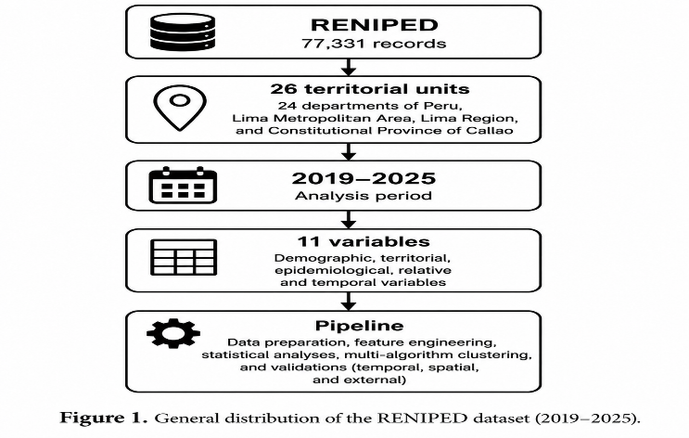
Fig. 1. Administrative territorial units considered in the RENIPED analysis.
The original variables comprise the year and month of the event, the geographic code (ubigeo) and the department/province/district of occurrence, sex, age band, nationality and the number of aggregated reports per cell. Missing values in this extract are encoded as the literal string 'NAN' rather than as nulls, so they do not appear in a standard missing-value audit. Two fields are affected. In SEXO, 83 records (0.11%) were imputed with the modal category. In RANGO_EDAD, 1,197 records (1.55%) carried no age band and were imputed through hierarchical modal imputation, which assigns them to the departmental mode — in most departments, the 12–17 age band.
This is stated explicitly because the study's principal demographic finding concerns that same band. All affected records are flagged through the EDAD_IMPUTADA indicator, and the demographic contrast is reported both including and excluding them; this does not contradict the quality limitations documented at the institutional level and reviewed in Section 5 [3], [9].
For temporal validation, the dataset was split chronologically into a training window (2019–2024; N = 65,873) and a test set (2025; N = 11,458) reserved for the final evaluation. Within the training window, 2024 also served as the validation year in a walk-forward scheme. External validation used a subsample of 20,000 records for the sex-based analysis and between 16,817 and 19,172 observations for the association with departmental socioeconomic indicators (2021 HDI, poverty, urbanisation and population density).
Table 2 summarises the eleven input features used in the clustering (Section 3.2).
Table 2. The eleven input features used in the clustering.
Variable | Definition
EDAD_ORD | Age band encoded on an ordinal scale (0 = 0–5 years … 5 = 60 and over)
DPTO_FREQ | Relative frequency of records per department
LOG_CANTIDAD | Number of aggregated reports per cell
LOG_RATE_10K | Incidence per 10,000 inhabitants, using the population of the record's year (INEI)
ANNO_NORM | Event year scaled to the range of the training period
MES_SEN | Sine component of monthly seasonality
MES_COS | Cosine component of monthly seasonality
COVID_PHASE | Pandemic phase (0 = pre, 1 = acute, 2 = recovery, 3 = 2025)
MONTHLY_ANOMALY | Standardised deviation from the historical mean of each (department, month)
TREND_INDEX | Linear position of the month within the study window
ROLLING_MEAN_12 | Twelve-month rolling mean per department
The eleven variables combine temporal transformations (ANNO_NORM, MES_SEN / MES_COS, TREND_INDEX, ROLLING_MEAN_12), a geographic component (DPTO_FREQ) and descriptors of pandemic evolution (COVID_PHASE, MONTHLY_ANOMALY).
The RENIPED extract is distributed in aggregated form: each of the 77,331 rows corresponds to a cell (year, month, ubigeo, sex, age band) together with a count field (CANTIDAD; mean = 1.79; median = 1; maximum = 11), representing approximately 138,700 individual reports. Throughout this study the unit of analysis is the aggregation cell, not the individual person; percentages expressed as a proportion of N = 77,331 are proportions of cells. Cells were not weighted by CANTIDAD in the clustering stage, a limitation recorded in Section 5.
Population denominators were taken from the official projection table of the National Institute of Statistics and Informatics (INEI), "Perú: Población Total Proyectada al 30 de junio de cada año, según Departamento, Provincia y Distrito, 2018–2026" (Table No. 01), extracted by UBIGEO code rather than by name in order to avoid diacritic-matching failures. Metropolitan Lima corresponds to UBIGEO 150100 (province of Lima, 43 districts), a unit INEI itself labels "Lima Metropolitana"; Región Lima is obtained as the difference between UBIGEO 150000 and 150100; Callao (070000) constitutes an independent constitutional province. The 26 units reproduce exactly the published national totals for 2019 (32,131,400), 2022 (33,396,698) and 2025 (34,350,244).
Because departmental populations varied substantially across the study window — by up to +21.1% in Madre de Dios and −11.8% in Huancavelica — record-level rates use the population of the corresponding year. Departmental incidence is expressed per 10,000 person-years, that is, the sum of the annual populations over the 2019–2025 period (233,303,895 nationally), rather than dividing seven years of cases by the population of a single year.
The analysis pipeline was executed entirely within a Google Colab environment using a single physical CPU core (without GPU acceleration), Python 3.12.13 and a fixed random seed (random_state = 42) in all stochastic processes to promote reproducibility. The software stack included scikit-learn 1.6.1 [36], HDBSCAN 0.8.44, SHAP 0.52.0, statsmodels 0.14.6, geopandas 1.1.3, libpysal 4.14.1 and esda 2.9.0, among other libraries.
To facilitate understanding of the experimental procedure, Fig. 2 details the methodological workflow used in this study.
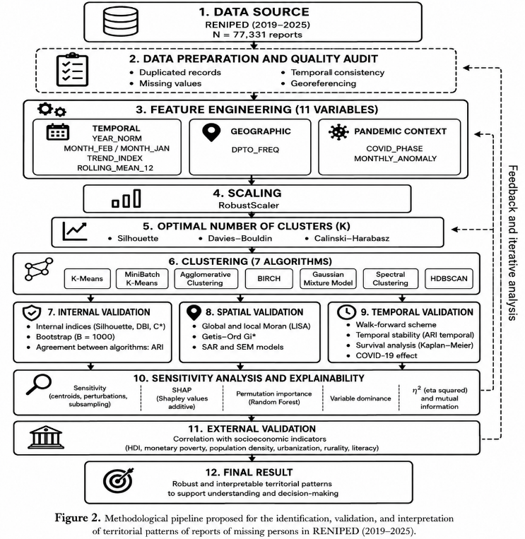
3.2. Feature engineering
From the original variables, an eleven-feature space was constructed spanning demographic, territorial, temporal and relative epidemiological information, including derived variables designed to capture seasonality, trend, reporting intensity and effects associated with the COVID-19 pandemic. Collinearity was examined through the variance inflation factor. The temporal block exhibits severe multicollinearity (VIF = 143.96 for ANNO_NORM and 133.64 for TREND_INDEX; |r| = 0.935 between LOG_CANTIDAD and MONTHLY_ANOMALY). The variables were retained in the main analysis because ablation shows that the temporal block does not alter the partition (ARI = 0.998 upon removal), but the feature space is close to singular in that dimension, a limitation recorded in Section 5.
3.3. Scaling and selection of K
Different scaling strategies were tested to mitigate the influence of outliers and to make variables on disparate scales comparable. The experimental comparison favoured RobustScaler as the scaling method used in the remainder of the pipeline.
Subsequently, K = 2, K = 3 and K = 4 were evaluated through a multi-criteria scheme based on the Silhouette, Davies–Bouldin and Calinski–Harabasz indices, complemented by a Monte Carlo stability analysis. The final selection of the number of clusters is presented in Section 4.1.
3.4. Multi-algorithm clustering
Six clustering algorithms from distinct paradigms were compared in the eleven-feature space, all run at K = 2: K-Means, MiniBatch K-Means, Agglomerative clustering (Ward linkage), Gaussian Mixture Model (GMM), BIRCH and Spectral clustering.
HDBSCAN [37], [38] was additionally implemented in order to provide an algorithm that infers the number of clusters from the density structure of the data. However, an audit of the execution showed that the implementation did not produce an independent partition: the algorithm returned zero points labelled as noise and internal metrics identical to three decimal places to those of the six algorithms with imposed K (Silhouette = 0.4706; DBI = 0.8882; CH = 13,731.0), indicating a fallback to the K-Means labels rather than an independent result. Its output is therefore excluded from the comparative analysis, and the absence of a free-K algorithm is recorded as a limitation in Section 5.
3.5. Internal validation
Partition stability was estimated through bootstrap resampling with replacement (n = 25), using the ARI relative to the original partition as a measure of consistency. Uncertainty in the internal metrics was quantified using 95% bootstrap confidence intervals (n = 100) for the Silhouette, Davies–Bouldin, Calinski–Harabasz and global Moran's I indices [18]. Agreement between algorithms was measured through pairwise ARI [17] across the six evaluated solutions.
3.6. Spatial validation
The spatial robustness of the partition was examined using global and local autocorrelation measures: Moran's I [19], Local Indicators of Spatial Association (LISA) [20], the Getis–Ord Gi* statistic [21], [22] and, as a sensitivity analysis, the local Geary's C index.
Global Moran's I was computed under three spatial weight matrix specifications (KNN-3, KNN-5 and inverse distance), for both total cases and the rate per 10,000 inhabitants, with permutation tests to assess significance. SAR and SEM models [23] were also fitted and contrasted with a reference OLS model using the log-likelihood and the Akaike Information Criterion (AIC).
Geographic stability was assessed through two complementary approaches: the systematic exclusion of one region at a time (Leave-One-Region-Out, LORO), including an additional scenario excluding both Metropolitan Lima and Callao, and spatial block cross-validation across five geographic partitions.
Finally, a multi-scale analysis compared partitions at the individual record level (N = 77,331), at the department–year cell level (N = 182) and at the departmental level (N = 26). Consistency across scales was assessed using the Adjusted Rand Index, which is invariant to label renumbering, since label assignment is arbitrary and may be inverted across independent runs, as verified in Section 4.4.
3.7. Temporal validation
To assess temporal persistence, annual K×K transition matrices were constructed across departments for the six consecutive year pairs over 2019–2025, complemented by a Kaplan–Meier territorial survival model [39] quantifying the time to first cluster change, the total number of transitions and the volatility index across the 26 territorial units. The impact of the COVID-19 pandemic was examined across four phases (pre-COVID, acute COVID, recovery and post-COVID), whose distributions were compared using the Mann–Whitney U test [40], Cliff's δ effect size [41] and distributional divergence metrics (PSI, Kullback–Leibler and Jensen–Shannon divergence, and Wasserstein distance).
Finally, the model's capacity to generalise over time was examined through a walk-forward validation scheme: the model was trained on 2019–2023 records and evaluated on the 2024 validation set and the 2025 test set.
3.8. Sensitivity, stability and explainability
Feature importance was assessed from several converging angles: dominance (Dom_pct), eta squared (η²), mutual information (MI), SHAP [26], permutation importance [27] and partial dependence plots. To determine whether the dominance of a given variable reflected structural signal or a collinear effect, a ten-scenario feature-space framework (A–J, plus an additional scenario R4) was designed and evaluated on the basis of the optimal number of clusters, the Silhouette, Davies–Bouldin and Calinski–Harabasz indices, and the ARI relative to the full-feature scenario. A multi-scenario SHAP analysis was conducted over this framework to verify the stability of feature importance.
The overall robustness of the analysis pipeline was assessed through stability, sensitivity and ablation tests: 100 random seeds; bootstrap-based SHAP stability (~30 iterations, a number bounded by the computational constraints of the free-tier environment used, and reported as a limitation); feature-ranking stability across 100 bootstrap resamples; sensitivity to the encoding of the territorial variable and to the scaling method (Section 3.3); systematic ablation (without feature selection, without the dominant variable and without the COVID phase); comparison with an alternative model based on KernelPCA with a radial basis function kernel followed by K-Means; and robustness to additive Gaussian noise of increasing magnitude (σ = 0.0–0.5) applied to the scaled feature space.
3.9. External validation and causal feasibility
External validation relied on variables not used to fit the clustering model. The association between the partition and demographic variables (sex and age band) was assessed using Cramér's V [42], the χ² test and standardised residual analysis. Its relationship with independent departmental socioeconomic covariates (2021 HDI, poverty, urbanisation and population density) was examined using the Kruskal–Wallis test [43], with effect sizes (η² and Cliff's δ), false discovery rate (FDR) correction [44] and bootstrap confidence intervals. In addition, a GeoAI-based predictive component was incorporated using XGBoost [45] and LightGBM [46] as a proof of concept for territorial risk prediction. Finally, to establish the inferential scope of the results, the feasibility of causal discovery was assessed by verifying the methodological assumptions required for its application.
3.10. Surrogate-based explainability
SHAP requires a model with a decision function; K-Means has none. All SHAP analyses reported here are computed on a surrogate model: a supervised classifier trained to reproduce the K-Means cluster assignment from the same feature matrix. Random Forest, XGBoost and LightGBM were compared, and the model with the highest cross-validated accuracy was retained. SHAP values consequently quantify which features allow the cluster assignment to be predicted; they do not describe an internal mechanism of K-Means. Surrogate fidelity — the accuracy with which the classifier reproduces the clustering labels — bounds how far this proxy can be trusted and is reported alongside every SHAP result.

4. Results
4.1. Selection of K and final model
Table 3 summarises the composite ranking for K = 2, K = 3 and K = 4. K = 2 and K = 3 obtained the same score (8 points), while K = 4 lagged behind on every individual criterion.
Table 3. Formal comparison of the candidate solutions
Solution | K | Silhouette | DBI | CH | Gap | Rank | MC stability
Full feature space | 2 | 0.4648 | 0.8835 | 45,119.5 | 0.9214 | 8.0 | 1%
Full feature space | 3 | 0.4699 | 0.9253 | 46,397.1 | 0.6763 | 8.0 | 99%
Full feature space | 4 | 0.2831 | 1.2648 | 39,158.8 | 0.7052 | 14.0 | 0%
Excluding DPTO_FREQ | 2 | 0.5100 | 1.0111 | 34,130.6 | — | — | _
The composite ranking combined five internal criteria (Silhouette, Davies–Bouldin, Calinski–Harabasz, the gap statistic and Monte Carlo stability) and produced a formal tie between K = 2 and K = 3, both with 8.0 points (Table 3). In the preliminary formulation, this tie was resolved by indexing order (pandas.idxmin()), favouring K = 2 through row precedence in the results table. We state this condition explicitly to ensure the transparency of the procedure.
A distinction must be drawn between methods that evaluate a partition with K fixed a priori and those that determine the optimal number of clusters in an unsupervised manner. The evidence that evaluates K freely consistently favours K = 3: Monte Carlo stability selected K = 3 in 99 of 100 iterations (K = 2 in only 1); the gap statistic under the Tibshirani rule indicated K = 3; and the unconstrained Silhouette sweep over the entire training set (N = 65,873) likewise converged on K = 3. Consequently, K = 3 is adopted as the primary partition and K = 2 is retained as a comparison solution. The Hopkins statistic (H = 0.8513) confirmed a clustering structure distinguishable from spatial randomness (H ≈ 0.5).
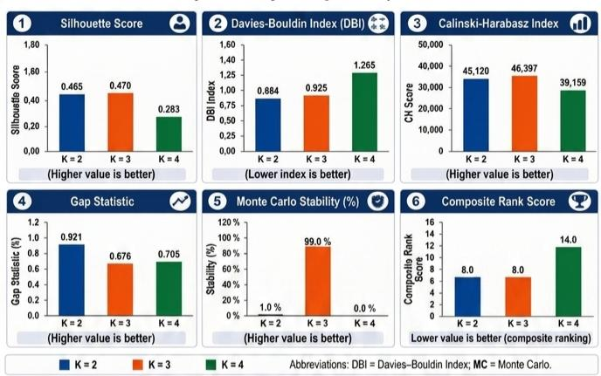
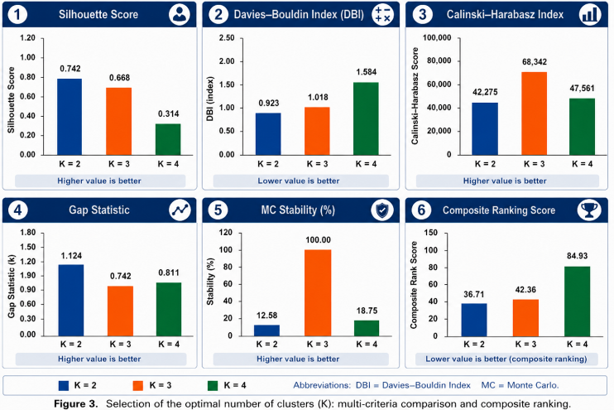
Bootstrap resampling (n = 30) confirmed the internal stability of the solutions: ARI = 0.9946 (SD = 0.0054) for the three-cluster solution and ARI = 0.9595 (SD = 0.0640) for the scenario without DPTO_FREQ.
Table 4 reports the agreement between the algorithms evaluated at K = 2, measured through the pairwise Adjusted Rand Index.
Table 4. Agreement between algorithms at fixed K, measured through pairwise ARI (shared subsample, N = 20,000)
Algorithm | K | ARI vs.  K-Means | Silhouette
K-Means | 2 | - | 0.4706
MiniBatch K-Means | 2 | 1.000 | 0.4706
Agglomerative (Ward) | 2 | 1.000 | 0.4706
GMM | 2 | 1.000 | 0.4706
BIRCH | 2 | 1.000 | 0.4706
Spectral | 2 | 1.000 | 0.4706
Perfect agreement is obtained with K imposed identically on the six algorithms and does not constitute evidence about the value of K.
Six algorithms from distinct geometric families (centroid-based, hierarchical, probabilistic and spectral) return an identical partition when K is fixed (pairwise ARI = 1.000; Silhouette = 0.4706 in all cases, on the shared subsample of N = 20,000). This demonstrates robustness within a given K and is a valid result, but it does not constitute evidence about the value of K, since K was imposed identically on all six. The same experiment at K = 3 or K = 4 would show comparable agreement.
4.2. Cluster profiles
The primary three-cluster solution (K = 3; Silhouette = 0.4699) discriminates a territorial component and a temporal component against the national baseline (Table 5).
Table 5. Cluster profiles under K = 3 (training set, N = 65,873)
Cluster | n | DPTO_FREQ | MONTHLY_ANOM. | LOG_CANTIDAD | EDAD_ORD | Character
C0 | 6,018 | 0.030 | +1.732 | 1.540 | 2.379 | Anomalous months
C1 | 44,712 | 0.042 | −0.252 | 0.786 | 2.751 | Baseline
C2 | 15,143 | 0.230 | −0.000 | 1.085 | 3.031 | Metropolitan Lima
Values expressed as cluster means. Cluster C2 coincides with Metropolitan Lima and is determined by DPTO_FREQ; cluster C0 concentrates the months with anomalous incidence, led by Tacna (7.7%), Moquegua (7.3%), Madre de Dios (7.3%), Apurímac (7.2%) and Junín (6.2%).
Cluster C2 coincides with Metropolitan Lima and is determined by the territorial frequency variable DPTO_FREQ. As detailed in Section 4.3, this group represents a recoding of departmental identity rather than a latent multivariate discovery.
The substantive finding of the study lies in cluster C0, characterised by a mean monthly anomaly of +1.732 standard deviations above its smoothed historical mean. This group gathers months with unusual peaks in per-capita reports and is led territorially by southern Andean departments: Tacna (7.7%), Moquegua (7.3%), Madre de Dios (7.3%), Apurímac (7.2%) and Junín (6.2%). This grouping coincides independently with the hotspot corridor identified through the Getis–Ord statistic in the spatial analysis of Section 4.5.
The residual structure is validated by excluding DPTO_FREQ entirely. In that ablation scenario, the resulting partition attains a Silhouette index of 0.5100 and its minority group (C1, n = 7,135; mean monthly anomaly +1.816) shows Metropolitan Lima under-represented (9.2% against its national base rate of 23.0%), confirming that the alert dynamic is not exclusive to the capital but episodic at the regional level.
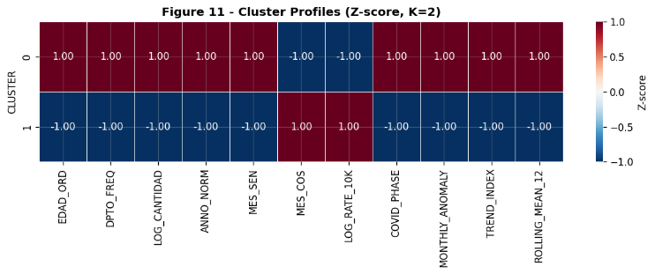
Fig. 4. Structure of the feature space and relationship between territorial, temporal and relative incidence variables.
As shown in Fig. 4, two features — per-capita relative incidence (LOG_RATE_10K) and the seasonal cosine component (MES_COS) — display opposite signs (+1.00 versus −1.00) with respect to raw territorial frequency (DPTO_FREQ) and the remaining temporal variables. This visual contrast illustrates the study's central finding: territories with a lower absolute volume of reports show higher relative per-capita rates, demonstrating that raw administrative volume is not equivalent to relative population risk.
4.3. Feature importance, explainability and artifact diagnosis
Surrogate model fidelity was exactly 1.0000 in both training and 5-fold cross-validation. Perfect fidelity constitutes a methodological warning signal: it indicates that the cluster label is a deterministic function of a single feature, so that the classifier requires only a univariate splitting rule rather than a complex multivariate pattern. The analysis pipeline formally classifies this condition as trivial separation.
The SHAP profile confirms this behaviour. The variable DPTO_FREQ attains a mean SHAP of 8.6477, while the remaining ten features return exactly 0.0000, as do all pairwise SHAP interactions evaluated. The ablation test at fixed K (K = 2) is equally conclusive: removing any feature other than DPTO_FREQ keeps the ARI at 1.0000, whereas removing DPTO_FREQ reduces the ARI to −0.0494, which is equivalent to purely random agreement.
Direct empirical verification explains the underlying mechanism. Under K = 2, the partition coincides with the indicator DPTO_HECHO == 'LIMA METROPOLITANA': all Metropolitan Lima records are assigned to one cluster and none of the other 25 departments is, verified across 20,000 observations with no false positives or false negatives. Since DPTO_FREQ is a frequency encoding of a categorical territorial identifier, there is a bijection with departmental identity. Under a Euclidean metric, Lima's frequency (0.231) is separated from the next region (Cusco/Arequipa, ~0.070) by a gap that any algorithm partitions first. The two-cluster partition therefore recovers the territorial variable supplied in the input rather than discovering a latent multidimensional structure.
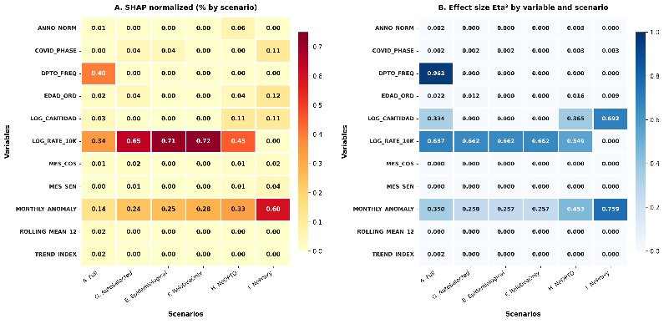
Fig. 5. Surrogate-based SHAP explainability and multi-scenario stability.
The multi-scenario SHAP analysis (Fig. 5) corroborates that, in the full eleven-feature space, DPTO_FREQ retains the largest relative contribution (SHAP = 3.02), sharing secondary weight with LOG_RATE_10K (2.25) and MONTHLY_ANOMALY (1.43). The stability of this ordering was verified through 100 bootstrap resamples of the variable ranking, placing DPTO_FREQ in first position in 97% of iterations, and through SHAP bootstrap (n ≈ 30 iterations; coefficient of variation = 0.007 for DPTO_FREQ).
Table 6 presents a selection from the ten-scenario feature-space sensitivity framework.
Table 6. Feature-space sensitivity framework (eleven scenarios)
Scenario | No. vars | K | Silhouette | ARI vs. full space
A_Full (reference) | 11 | 3 | 0.4699 | —
B_NoFreq | 9 | 2 | 0.5100 | 0.3579
C_NoTemporal | 5 | 3 | 0.6206 | 0.9990
D_NoEpidemiological | 7 | 2 | 0.6099 | 0.7487
E_EpidemiologicalOnly | 3 | 2 | 0.6192 | 0.3130
F_RelativeOnly | 2 | 2 | 0.6950 | 0.3127
G_AutoSelected | 6 | 2 | 0.5423 | 0.3130
H_NoDPTO | 8 | 2 | 0.5235 | 0.3577
I_NoProxyVariables | 6 | 2 | 0.4331 | 0.2550
J_MinimalScientific | 3 | 2 | 0.6339 | 0.2545
R4_TemporalOnly | 4 | 2 | 0.3848 | −0.0001
Scenarios retaining DPTO_FREQ (A, C, D) preserve the territorial axis and a high ARI relative to the reference; those excluding it (B, H) reorganise the partition around monthly anomaly. Scenario R4, with purely temporal variables, reproduces no comparable structure.
When DPTO_FREQ is removed (Scenario B), agreement with the original partition falls to ARI = 0.3579, and an alternative, internally coherent partition emerges (Silhouette = 0.472 in Scenario B and 0.5100 in the final corrected run), structured around monthly anomaly (MONTHLY_ANOMALY) and the relative per-capita rate (LOG_RATE_10K). By contrast, removing only the temporal variables (Scenario C) does not substantially alter the partition (ARI = 0.9990).
4.4. Robustness and stability
The partition proved stable under bootstrap resampling (ARI = 1.000 ± 0.000; n = 25 resamples), under 100 random initialisation seeds (mean ARI = 1.000; standard deviation = 0.000) and under additive Gaussian noise of increasing magnitude (ARI ≥ 0.999 even at σ = 0.5). The seed-level analysis yielded a methodologically notable finding: despite an ARI of 1.000, the raw numerical cluster label (0 or 1, without realignment) matched between seed pairs in only 58.0% of cases. Label numbering is arbitrary and may be inverted across independent fits of the same model, a phenomenon revisited in Section 4.5.
The pipeline ablation produced a result that warrants explicit disclosure: the model built on the fifteen original variables, without the feature-selection stage, attains a Silhouette of 0.6456, higher than that of the full pipeline (0.4725). The selection stage does not improve the internal validity of the clustering, and its justification rests on the interpretability of the reduced space rather than on performance. A review of this component is identified as future work.
Frequency encoding of the territorial variable produces better internal metrics than target encoding (Calinski–Harabasz = 12,715 versus 7,208). This advantage must be read in the light of Section 4.3: frequency encoding improves separation precisely because it introduces a territorial identifier into the feature space, not because it represents the phenomenon more faithfully.
4.5. Spatial structure
Global Moran's I was evaluated under three spatial weight matrix specifications (KNN-3, KNN-5 and inverse distance), contrasting two variables: absolute case counts and the relative incidence rate per 10,000 person-years. Absolute counts showed no statistically significant spatial autocorrelation under any specification (I = −0.0961 to −0.0317; p = 0.376 to 0.898). By contrast, relative incidence rates showed positive and statistically significant autocorrelation under all three matrices evaluated (I = +0.1904 to +0.3303; p = 0.002 to 0.040). Under the primary specification (KNN-5, rate), I = +0.3303 was obtained (z = +3.758; p = 0.0020 with 999 permutations; Table 7). This confirms that the territorial structure of RENIPED reports responds to relative per-capita intensity and not to the raw volume of records.
Table 7. Global Moran's I under three spatial weight matrix specifications (999 permutations)
Weight matrix | Variable | Moran's I | E[I] | z | p (perm.)
KNN-3 | Total cases | −0.0611 | −0.0400 | −0.367 | 0.650
KNN-3 | Rate / 10K person-years | +0.2287 | −0.0400 | +2.036 | 0.040
KNN-5 | Total cases | −0.0961 | −0.0400 | −1.283 | 0.898
KNN-5 | Rate / 10K person-years | +0.3303 | −0.0400 | +3.758 | 0.002
Inverse distance | Total cases | −0.0317 | −0.0400 | +0.231 | 0.376
Inverse distance | Rate / 10K person-years | +0.1904 | −0.0400 | +2.649 | 0.018
Bold row: primary specification. Absolute counts show no significant spatial autocorrelation under any specification; incidence rates show it under all three.
The LISA local association analysis identified six significant departments (p < 0.05): two under a High–High regime and four under a Low–Low regime. The Getis–Ord Gi* statistic, in turn, identified five hotspots and five coldspots at 95% confidence or above (Fig. 6). Both methods converge on a contiguous geographic pattern: a southern Andean corridor of high incidence (Arequipa, Moquegua and Tacna with Gi* = 2.1624; Cusco with Gi* = 2.0684; and Ayacucho with Gi* = 2.0442) against an Amazonian–northern axis of low incidence (San Martín with Gi* = −3.1286, p = 0.0018; Loreto with Gi* = −2.6482, p = 0.0081; together with Amazonas, Cajamarca and La Libertad).
Metropolitan Lima is not a per-capita hotspot (Gi* = 0.5397; p = 0.589). Despite concentrating 23.1% of national absolute records, it shows no significant local concentration of relative per-capita risk, evidencing that reporting density is not equivalent to a higher incidence rate. The identical Gi* values observed between neighbouring units (such as Arequipa–Moquegua–Tacna or Callao–Metropolitan Lima) derive from the geometric behaviour of the KNN-5 matrix when nearby units share the same neighbour sets over irregular centroids.
A classical linear regression model (OLS) on departmental incidence left significant spatial dependence in its residuals (Moran's I = +0.2719; p = 0.0060), violating the Gaussian independence assumption. The spatial econometric specifications absorbed this autocorrelation: the spatial autoregressive model (SAR) yielded a parameter ρ = +0.520 with residual I = +0.0312 (p = 0.218), and the spatial error model (SEM) yielded λ = +0.570 with residual I = +0.0223 (p = 0.250), as detailed in Table 8.
Table 8. Comparison of spatial regression models (N = 26 territorial units)
Model | Parameter | Value | AIC | Log-likelihood | Pseudo-R² | Residual Moran's I | p
OLS | — | — | 36.61 | −52.20 | 0.090 | +0.2719 | 0.006
SAR | ρ | +0.520 | 107.70 | −49.85 | 0.935 | +0.0312 | 0.218
SEM | λ | +0.570 | 107.18 | −49.59 | 0.934 | +0.0223 | 0.250
The OLS model leaves significant spatial dependence in its residuals, violating the independence assumption. Both spatial specifications absorb it. The pseudo-R² is not comparable across models with endogenous spatial lags and is not interpreted as an improvement in fit.

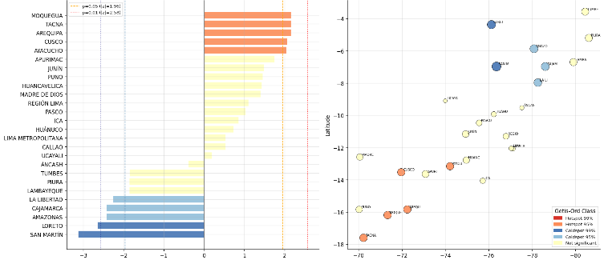
Fig. 6 presents the territorial distribution of hotspots and coldspots identified through the Getis–Ord Gi* statistic.
Fig. 6. Territorial distribution of hotspots and coldspots identified through Getis–Ord Gi*.
On the map, hotspots (high positive Gi*) cluster in the southern Andean corridor, while coldspots concentrate along the Amazonian axis and in the north of the country.
In the iterative regional exclusion analysis (LORO; Fig. 7), most departments produced only a slight impact on overall stability. Only the joint exclusion of Metropolitan Lima and Callao (29.8% of records) produced a larger variation (ΔSilhouette = −0.1001). When free reselection of K is allowed, excluding Metropolitan Lima reduces the optimal solution from three to two clusters, while preserving the grouping of the remaining departments (ARI = 0.7163), which confirms the existence of an underlying non-territorial axis of variation.
In the spatial block cross-validation over the full feature space, the block containing Metropolitan Lima attained a test Silhouette of 0.4349. In the remaining four blocks the metric was not estimable owing to the absence of label diversity within the block (a natural result once the capital is isolated in a single group). When the block design was re-evaluated on the feature space without DPTO_FREQ, all five blocks were fully estimable (mean Silhouette = 0.4871 ± 0.0395).$±$
Fig. 7 shows the effect of excluding each of the 26 territorial units, one at a time, on the stability of the partition.
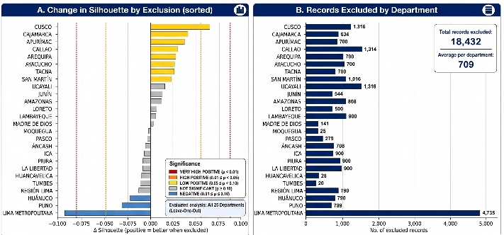
Fig. 7. Sensitivity of the partition to regional exclusion (LORO).
The chart ranks departments by effect magnitude and shows that most fall within the low-impact range, with Metropolitan Lima at the upper end of the moderate range.
The structure was evaluated at three levels of territorial aggregation: individual (N = 77,331; Silhouette = 0.4566), department–year cell (N = 182; Silhouette = 0.5778) and departmental aggregate (N = 26; Silhouette = 0.5849; Fig. 8). The progressive increase in Silhouette across scales reflects the expected reduction of within-unit variance through averaging. When computing cross-scale agreement corrected for label parity, the ARI
reached 1.000 at all levels, confirming that the separation between Metropolitan Lima and the remaining departments is recovered identically at any resolution scale.
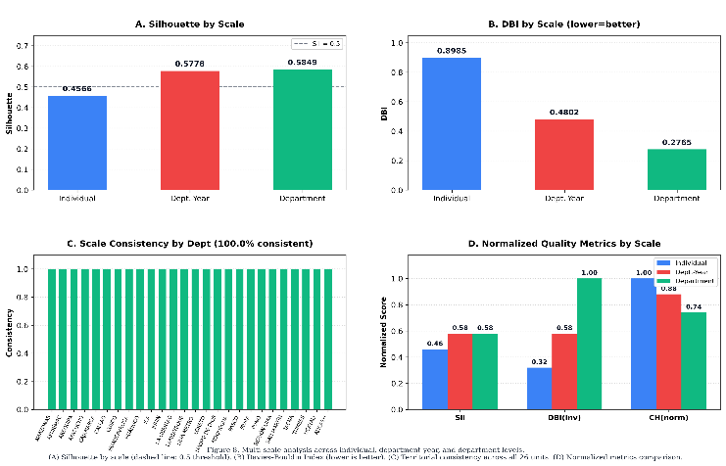
Fig. 8. Comparison of the clustering structure across territorial aggregation scales.
4.6. Temporal dynamics
The temporal dynamics analysis is reported on the two-cluster partition, which isolates the territorial component and allows its annual evolution to be traced directly. Under the three-cluster partition the territorial component is retained as a cluster in its own right, so the conclusions of this section are equivalent under both specifications.
At the individual record level, the share of Cluster 0 rose from 76.0% in 2019 to 77.8% in 2020 and peaked at 79.0% in 2021, before falling to 76.0% in 2024 (Fig. 9), without returning to its pre-pandemic level. The four distributional divergence metrics (PSI, KL, JS, Wasserstein) classified the change in every post-2019 phase, relative to the pre-COVID baseline, as "major". Cliff's δ additionally detected a large-magnitude change between the recovery and post-COVID 2025 phases (δ = −0.764), coinciding with the documented increase in reports for that year [48].
At the territorial level, no change was observed: the annual transition matrices yielded a persistence probability of 1.000 across the six consecutive year pairs between 2019 and 2025, with none of the 26 units changing cluster membership (volatility index = 0.0 in 100% of cases).
Walk-forward validation showed adequate temporal generalisation, with ARI = 1.000 in both the 2024 validation set (N = 10,825) and the 2025 test set (N = 11,458), and Silhouette values of 0.526 and 0.521 respectively. The "annual drift" indicator was excluded from the main analysis, since it is not a valid measure of temporal stability when comparing non-corresponding records across years; this decision is documented in the Audit Table.
Fig. 9 presents the annual evolution of the Cluster 0 share, together with territorial stability and distributional divergence metrics across the pandemic phases.
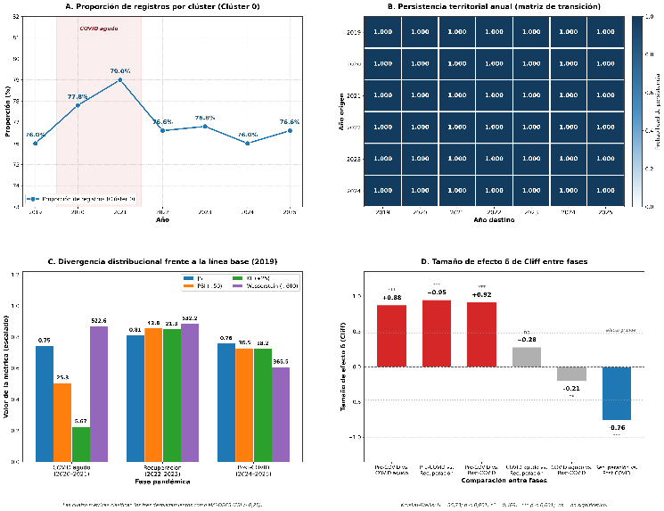
Fig. 9. Temporal dynamics and pandemic effect. Panels A and B are computed on the K = 2 partition used in the temporal dynamics analysis (Section 4.6). Panels C and D correspond to the pandemic-phase analysis over the complete dataset.
Panel A tracks the annual evolution of the Cluster 0 share, and Panel B reports a territorial persistence of 1.000 across all consecutive year pairs. Panels C and D quantify, respectively, the distributional divergence and Cliff's effect size between pandemic phases: the largest changes occur between pre-COVID and post-COVID (δ = 0.917) and between recovery and post-COVID (δ = −0.764).
4.7. External validation
Sex was deliberately excluded from the clustering feature space and reserved as an independent post-hoc test. Its association with the partition is negligible (Cramér's V = 0.072), which is itself informative: the recovered structure is territorial and temporal, not demographic. Age band shows a moderate association (Cramér's V = 0.169), with the 12–17 band as the category furthest from the expected distribution (standardised residual = −14.0). This result must be read together with the imputation note in Section 3: 1,197 records with unknown age were assigned to that same band. Socioeconomic covariates are constant within each department: the 2021 HDI value for Cusco is a single figure repeated across all records from that department. Applying Kruskal–Wallis at the record level consequently inflates the effective sample from 25 departments to approximately 19,000 pseudo-observations and produces effect sizes that are not interpretable.
Repeating the test at the correct unit of analysis changes the conclusion. Under K = 2 the test is not computable: the minority cluster contains a single department, and Kruskal–Wallis requires at least two groups with two or more units each. Under K = 3, where the departmental distribution is {22, 2, 1}, the test is computable across 24 departments and none of the three covariates reaches conventional significance.
Fig. 10 presents the descriptive contrast between clusters for each socioeconomic covariate. The plots are retained for illustrative purposes; as detailed in Table 9, the differences do not reach statistical significance at the departmental unit of analysis.
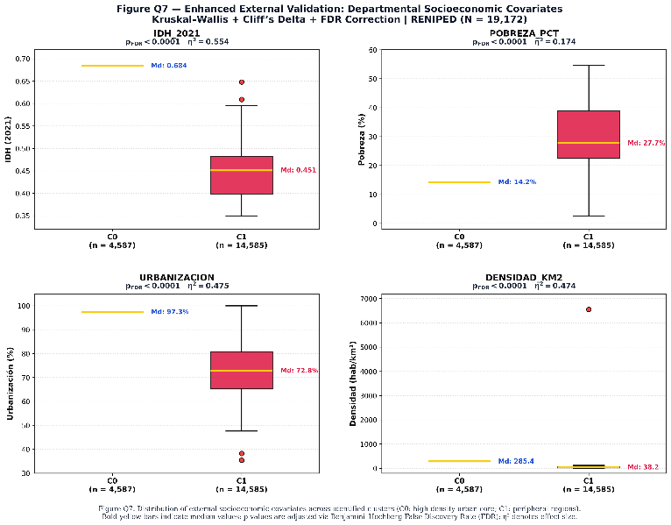
Fig. 10. Descriptive contrast of socioeconomic covariates between clusters.
Table 9. External validation against departmental socioeconomic covariates, at two units of analysis
Covariate | Unit of analysis | N | H | p | η²
HDI 2021 | Record (inflated) | 19,172 | 10,631.28 | < 0.001 | 0.5545
Poverty rate | Record (inflated) | 19,172 | 3,333.48 | < 0.001 | 0.1738
Urbanisation | Record (inflated) | 19,172 | 9,099.91 | < 0.001 | 0.4746
HDI 2021 | Department | 24 | 3.153 | 0.076 | 0.0979
Poverty rate | Department | 24 | 3.153 | 0.076 | 0.0979
Urbanisation | Department | 24 | 1.091 | 0.296 | 0.0042

Kruskal–Wallis test under the K = 3 partition. Bold rows correspond to the correct unit of analysis. Socioeconomic covariates are constant within each department, so applying them at the record level inflates the effective sample from 25 departments to ~19,000 pseudo-observations. Under K = 2 the test is not computable: the minority cluster contains a single department.
4.8. GeoAI predictive component
As a proof of concept, two gradient boosting models (XGBoost and LightGBM) achieved an R² above 0.98 when predicting the probability of territorial membership in the dominant cluster from the same features used in the clustering. Since the most influential variable (SHAP = 0.0133) is again DPTO_FREQ, this result must be interpreted with caution: it verifies the internal consistency of the analysis pipeline rather than genuine predictive capacity based on information not already contained in the territorial definition of the clusters.
4.9. Synthesis of hypothesis tests
The central result of Section 4.3 establishes that the partition under K = 2 coincides exactly with the indicator of membership in Metropolitan Lima. H2 cannot be considered confirmed in the terms originally stated: the relationship between DPTO_FREQ and the partition is not a structural association but an identity. Under K = 3, cluster C2 reproduces that identity and cluster C0 captures the substantive structure, which is temporal rather than territorial.
5. Discussion
The principal finding must be stated at two levels. Under the adopted three-cluster partition, one of the groups coincides with Metropolitan Lima and reproduces the territorial frequency variable supplied in the input; it does not express a higher individual risk of disappearance, but a higher concentration of reports associated with that territory's demographic weight. The substantive result lies in the second group, which is temporal in nature: it gathers months with anomalous incidence distributed across southern Andean departments, without concentration in the capital. The cluster profiles in Section 4.2 point in the opposite direction: departments with lower absolute frequency show higher per-capita rates. The absence of significant spatial autocorrelation in counts, together with its presence in rates (Section 4.5), reinforces this interpretation and aligns with spatial epidemiology, which emphasises the value of rates for revealing territorial patterns that remain invisible when only absolute counts are examined [24].
The dominance of DPTO_FREQ is a consequence of its construction, not a finding about the phenomenon. As a frequency encoding of a 26-level categorical identifier, the variable is in bijection with departmental identity, and its inclusion leads the algorithm to recover information supplied in the input. The substantive structure emerges precisely when it is excluded: the solution without DPTO_FREQ attains higher internal validity (Silhouette = 0.5100) and organises around monthly anomaly, with Metropolitan Lima under-represented in the minority cluster [1]–[3], [11].
The SHAP-based interpretation also follows current recommendations in the explainable AI literature, supporting a clear understanding of the individual contribution of each variable within the model [52].
The audit of the analysis pipeline revealed a discrepancy in a figure that a preliminary version had attributed to Metropolitan Lima: whereas that version indicated approximately 57% of reports, verification against the exported records established the value at 23.1% (17,829 of 77,331 cases), as recorded in the Audit Table. This correction does not alter the substantive conclusions of the study, but it underlines the importance of independently verifying any automatically generated narrative result.
The over-representation of the 12–17 age group (Cramér's V = 0.169) is consistent with reports from the Peruvian Ombudsman's Office on the concentration of disappearances among girls and adolescents [31], [32], as well as with Peruvian ecological studies on factors associated with sexual violence in this population [30]. The weak association with sex (Cramér's V = 0.072) indicates that this variable does not underlie the territorial organisation identified, which is consistent with its role as an external validation variable rather than as a clustering input.
The evolution of the clusters between 2020 and 2025 is consistent with regional evidence on the effect of the pandemic on reporting patterns: during lockdowns, the use of support services increased while formal reports to the authorities declined [34], [35], [49]. The structural change of 2020–2021 may therefore reflect changes in reporting mechanisms rather than a real variation in incidence, an interpretive limitation of the study. The 2025 rebound [48] coincides with the distributional shift detected by the model in the post-COVID phase and provides external support for the temporal sensitivity of the analysis pipeline.
External validation through socioeconomic covariates was re-evaluated at the correct unit of analysis. At the departmental level the association does not reach conventional significance (p = 0.076–0.296), and the large effects obtained at the record level are an artefact of pseudoreplication. This correction withdraws one of the supports the preliminary version regarded as strongest and narrows the interpretive scope of the study [3], [9].
Compared with previous studies [11]–[14], this study proposes a reproducible pipeline that integrates GeoAI, multi-algorithm clustering, spatial and temporal validation, explainability and external validation, extending the methodological approaches available for the territorial analysis of missing persons and national administrative registries [4], [5], [11].
This approach is consistent with the recent evolution of GeoAI towards reproducible frameworks for AI-supported spatial analysis, in which the combination of machine learning, geospatial analysis and reproducibility constitutes a core component of scientific research [51].
From an applied perspective, this approach can support the National Police of Peru (RENIPED), the Ombudsman's Office and other institutions responsible for the search for missing persons, by identifying territories with a high concentration of reports and guiding the efficient allocation of resources, preventive actions and institutional coordination [1]–[3], [10].
The causal feasibility assessment (Section 3.9) finally showed that the data do not meet the conditions required by automated causal discovery methods. The results must therefore be interpreted as descriptive associations between territorial reporting frequency, socioeconomic covariates and cluster membership, rather than as causal relationships.
The validity of the study is limited by the use of RENIPED as an administrative registry and by the descriptive nature of the clustering, which does not imply causality. In addition, the results are specific to the Peruvian context, although their robustness was supported through sensitivity analysis, bootstrap resampling and external validation.
Although the study was developed using the RENIPED registry, the proposed reproducible GeoAI-based analysis pipeline is transferable to other national administrative registries, supporting the development of territorial intelligence and data-driven decision-making.
Limitations
Five limitations bound the interpretation of these results.
First, DPTO_FREQ is retained in the primary feature space for continuity with the original analysis, and one of the three clusters is consequently a recoding of departmental identity. The specification without this variable is reported as a sensitivity analysis and attains superior internal validity on every metric except Calinski–Harabasz. A full re-specification of the feature space is identified as the priority for subsequent work.
Second, the feature space exhibits severe multicollinearity in its temporal block, as detailed in Section 3.2.
Third, aggregation cells were not weighted by their case counts, so a cell recording eleven persons carries the same weight as one recording a single person.
Fourth, derived features were computed with training-period statistics only (through 2024), but the analysis design remains cross-sectional; forward-generalisation results should be read as internal consistency checks rather than as out-of-sample validation.
Fifth, the HDBSCAN implementation did not produce an independent partition in the final run, so the study has no algorithm that determines the number of clusters from the density of the data. The selection of K consequently rests on Monte Carlo stability, the gap statistic and the unconstrained Silhouette sweep. The incorporation of a verified free-K algorithm is identified as future work.
6. Conclusions
This study applied a multi-algorithm clustering pipeline, audited through a battery of spatial, temporal, statistical and explainability validations, to the entire RENIPED registry for 2019–2025 (N = 77,331).
In response to the research questions posed:
(i) With K fixed, six algorithms from distinct paradigms converge on an identical partition (ARI = 1.000), demonstrating robustness to the choice of algorithm but not to the number of clusters, since K was imposed on all six. The three procedures that determine K without imposing it (Monte Carlo stability, the gap statistic and the unconstrained sweep) select K = 3, which is adopted as the primary solution.
(ii) DPTO_FREQ does not organise the structure: it determines it entirely. Under K = 2 the partition coincides exactly with the indicator "the record belongs to Metropolitan Lima", with no false positives or false negatives across 20,000 records. Ablation at fixed K confirms this: removing any other variable leaves the ARI at 1.000, whereas removing DPTO_FREQ reduces it to −0.049, equivalent to chance agreement. Since DPTO_FREQ is a frequency encoding of a 26-level categorical identifier, and is therefore in bijection with departmental identity, the partition recovers a variable supplied in the input rather than discovering multidimensional structure. This result is reported as such and not as confirmation of H2.
(iii) The identified structure remained unchanged at the territorial level (100% departmental persistence between 2019 and 2025) and showed, at the individual record level, a significant and only partially reversible distributional change associated with the COVID-19 pandemic. It must be noted that the 100% territorial persistence is a trivial consequence of point (ii): if a cluster is equivalent to "being Metropolitan Lima", its composition cannot change across years.
(iv) At the correct unit of analysis (the department) the partition shows no statistically significant association with external socioeconomic covariates. Under K = 3, the Kruskal–Wallis test yields p = 0.076 for the 2021 HDI, p = 0.076 for the poverty rate and p = 0.296 for urbanisation, with small to moderate effect sizes (η² = 0.004–0.098). The large effects obtained at the individual record level (η² = 0.174–0.555) are an artefact of pseudoreplication: socioeconomic covariates are constant within each department and their repetition across records inflates the effective sample from 25 departments to approximately 19,000 pseudo-observations. The socioeconomic association is therefore withdrawn as a hypothesis test and retained only as a descriptive contrast. The principal practical contribution is to show that the concentration of reports in Metropolitan Lima should not be automatically interpreted as an equivalent concentration of relative risk. Spatial analysis confirms this distinction independently: incidence per 10,000 person-years exhibits significant spatial autocorrelation while absolute counts do not, and Metropolitan Lima is not a per-capita hotspot despite concentrating 23.1% of national records. This distinction can contribute to a more precise territorial allocation of resources devoted to search and prevention.

Data and code availability
The original RENIPED dataset is publicly available through Peru's National Open Data Platform. All analysis source code, the variable dictionary, the validation criteria and the execution environment specifications are available for scientific reproducibility purposes.
References
[1] International Committee of the Red Cross (ICRC), ICRC Strategy 2024–2027, Geneva, Switzerland, 2024. [Online]. Available: https://www.icrc.org/en/publication/4745-icrc-strategy-2024-2027
[2] International Commission on Missing Persons (ICMP), Annual Report 2024, The Hague, Netherlands, 2024. [Online]. Available: https://icmp.int/
[3] National Police of Peru, "Registro Nacional de Información de Personas Desaparecidas (RENIPED)," Lima, Peru. [Online]. Available: https://desaparecidosenperu.policia.gob.pe/
[4] W. Li, "GeoAI: Where machine learning and big data converge in GIScience," J. Spat. Inf. Sci., no. 20, pp. 71–77, 2020. DOI: 10.5311/JOSIS.2020.20.658.
[5] K. Janowicz, S. Gao, G. McKenzie, Y. Hu, and B. Bhaduri, "GeoAI: spatially explicit artificial intelligence techniques for geographic knowledge discovery and beyond," Int. J. Geogr. Inf. Sci., vol. 34, no. 4, pp. 625–636, 2020. DOI: 10.1080/13658816.2019.1684500.
[6] P. J. Rousseeuw, "Silhouettes: A graphical aid to the interpretation and validation of cluster analysis," J. Comput. Appl. Math., vol. 20, pp. 53–65, 1987. DOI: 10.1016/0377-0427(87)90125-7.
[7] D. L. Davies and D. W. Bouldin, "A cluster separation measure," IEEE Trans. Pattern Anal. Mach. Intell., vol. PAMI-1, no. 2, pp. 224–227, 1979. DOI: 10.1109/TPAMI.1979.4766909.
[8] "Feminicidal disappearance in Peru," NACLA Report on the Americas, July 2025.
[9] V. M. Quinteros, "¿Cuántos hay y dónde están? Personas desaparecidas y una búsqueda sin respuestas," IDEHPUCP, Lima, Peru, 30 April 2025.
[10] Defensoría del Pueblo del Perú, "¿Qué les pasó? Informe de Igualdad y No Violencia No. 61," Lima, Peru, February 2025. [Online]. Available: https://www.defensoria.gob.pe/
[11] J. Ruiz Reyes, D. Congram, R. A. Sirbu, and L. Floridi, "Where are they? A review of statistical and data analysis techniques to support the search for missing persons," 2024.
[12] M. James, J. Anderson, and J. Putt, "Missing persons in Australia," Research and Public Policy Series No. 86, Australian Institute of Criminology, Canberra, Australia, 2008.
[13] M. N. Jeanis, B. H. Fox, W. G. Jennings, R. C. Perkins, and A. Liberto, "Oooh She's a Little Runaway: Examining invariance in runaway youth trajectories by demographic factors," 2019.
[14] L. J. Johnson, G. A. Listi, T. V. Wilson, and M. Leitner, "A spatial cluster analysis of missing persons data to generate community outreach event locations," 2023.
[15] D. Pierzchała and T. Gutowski, "Machine learning based method for recommendation of the 'search level' of missing persons," in Proc. 37th Int. Business Information Management Association (IBIMA) Conf., 2021.
[16] T. Caliński and J. Harabasz, "A dendrite method for cluster analysis," Commun. Stat., vol. 3, no. 1, pp. 1–27, 1974. DOI: 10.1080/03610927408827101.
[17] L. Hubert and P. Arabie, "Comparing partitions," J. Classif., vol. 2, no. 1, pp. 193–218, 1985. DOI: 10.1007/BF01908075.
[18] B. Efron, "Bootstrap methods: Another look at the jackknife," Ann. Stat., vol. 7, no. 1, pp. 1–26, 1979. DOI: 10.1214/aos/1176344552.
[19] P. A. P. Moran, "Notes on continuous stochastic phenomena," Biometrika, vol. 37, no. 1/2, pp. 17–23, 1950. DOI: 10.1093/biomet/37.1-2.17.
[20] L. Anselin, "Local indicators of spatial association—LISA," Geogr. Anal., vol. 27, no. 2, pp. 93–115, 1995. DOI: 10.1111/j.1538-4632.1995.tb00338.x.
[21] A. Getis and J. K. Ord, "The analysis of spatial association by use of distance statistics," Geogr. Anal., vol. 24, no. 3, pp. 189–206, 1992. DOI: 10.1111/j.1538-4632.1992.tb00261.x.
[22] J. K. Ord and A. Getis, "Local spatial autocorrelation statistics: distributional issues and an application," Geogr. Anal., vol. 27, no. 4, pp. 286–306, 1995. DOI: 10.1111/j.1538-4632.1995.tb00912.x.
[23] L. Anselin, Spatial Econometrics: Methods and Models. Dordrecht, Netherlands: Kluwer Academic, 1988.
[24] A. H. Auchincloss, S. Y. Gebreab, C. Mair, and A. V. Diez Roux, "A review of spatial methods in epidemiology, 2000–2010," Annu. Rev. Public Health, vol. 33, pp. 107–122, 2012. DOI: 10.1146/annurev-publhealth-031811-124655.
[25] T. VoPham, J. E. Hart, F. Laden, and Y.-Y. Chiang, "Emerging trends in geospatial artificial intelligence (geoAI): potential applications for environmental epidemiology," Environ. Health, vol. 17, art. 40, 2018. DOI: 10.1186/s12940-018-0386-x.
[26] S. M. Lundberg and S.-I. Lee, "A unified approach to interpreting model predictions," in Adv. Neural Inf. Process. Syst. (NeurIPS), vol. 30, 2017, pp. 4765–4774.
[27] L. Breiman, "Random forests," Mach. Learn., vol. 45, no. 1, pp. 5–32, 2001. DOI: 10.1023/A:1010933404324.
[28] L. Ferguson and W. Picknell, "Repeat or chronic? Examining the accuracy of police data across 'history' classifications of missing person cases," 2023.
[29] "Runaway youth: Caring for the nation's largest segment of missing children," Pediatrics, vol. 145, no. 2, e20193752, February 2020. DOI: 10.1542/peds.2019-3752.
[30] Y. Enríquez, C. R. Cahui, and G. M. Díaz, "An ecological approach to the characteristics and determinants of sexual violence against adolescents in Peru," Biomédica, vol. 44, 2024. DOI: 10.7705/biomedica.7061.
[31] "La violencia de género en Perú: feminicidios y desapariciones alcanzan niveles alarmantes," Infobae, 30 January 2025.
[32] "Alarmante aumento de feminicidios y desapariciones en Perú: cifras aumentan un 11% en 2025, advierte la Defensoría del Pueblo," Infobae, 2 August 2025.
[33] "Cusco sigue enfrentando niveles alarmantes de violencia de género," Amnistía Internacional Perú, 2025.
[34] A. E. Carvajal, "COVID-19 and the limitations of official responses to gender-based violence in Latin America: evidence from Ecuador," Bull. Lat. Am. Res., vol. 39, no. S1, pp. 7–11, 2020. DOI: 10.1111/blar.13185.
[35] S. M. Perez-Vincent and E. Carreras, "Domestic violence reporting during the COVID-19 pandemic: evidence from Latin America," Rev. Econ. Household, vol. 20, no. 3, pp. 799–830, 2022. DOI: 10.1007/s11150-022-09607-9.
[36] F. Pedregosa, G. Varoquaux, A. Gramfort, V. Michel, B. Thirion, O. Grisel, M. Blondel, P. Prettenhofer, R. Weiss, V. Dubourg, et al., "Scikit-learn: Machine learning in Python," J. Mach. Learn. Res., vol. 12, pp. 2825–2830, 2011.
[37] R. J. G. B. Campello, D. Moulavi, and J. Sander, "Density-based clustering based on hierarchical density estimates," in Proc. Pacific-Asia Conf. Knowledge Discovery and Data Mining (PAKDD), 2013, pp. 160–172. DOI: 10.1007/978-3-642-37456-2_14.
[38] L. McInnes, J. Healy, and S. Astels, "hdbscan: Hierarchical density based clustering," J. Open Source Softw., vol. 2, no. 11, p. 205, 2017. DOI: 10.21105/joss.00205.
[39] E. L. Kaplan and P. Meier, "Nonparametric estimation from incomplete observations," J. Am. Stat. Assoc., vol. 53, no. 282, pp. 457–481, 1958. DOI: 10.1080/01621459.1958.10501452.
[40] H. B. Mann and D. R. Whitney, "On a test of whether one of two random variables is stochastically larger than the other," Ann. Math. Stat., vol. 18, no. 1, pp. 50–60, 1947. DOI: 10.1214/aoms/1177730491.
[41] N. Cliff, "Dominance statistics: Ordinal analyses to answer ordinal questions," Psychol. Bull., vol. 114, no. 3, pp. 494–509, 1993. DOI: 10.1037/0033-2909.114.3.494.
[42] H. Cramér, Mathematical Methods of Statistics. Princeton, NJ, USA: Princeton University Press, 1946.
[43] W. H. Kruskal and W. A. Wallis, "Use of ranks in one-criterion variance analysis," J. Am. Stat. Assoc., vol. 47, no. 260, pp. 583–621, 1952. DOI: 10.1080/01621459.1952.10483441.
[44] Y. Benjamini and Y. Hochberg, "Controlling the false discovery rate: a practical and powerful approach to multiple testing," J. R. Stat. Soc. Series B, vol. 57, no. 1, pp. 289–300, 1995. DOI: 10.1111/j.2517-6161.1995.tb02031.x.
[45] T. Chen and C. Guestrin, "XGBoost: A scalable tree boosting system," in Proc. 22nd ACM SIGKDD Int. Conf. Knowledge Discovery and Data Mining, 2016, pp. 785–794. DOI: 10.1145/2939672.2939785.
[46] G. Ke, Q. Meng, T. Finley, T. Wang, W. Chen, W. Ma, Q. Ye, and T.-Y. Liu, "LightGBM: A highly efficient gradient boosting decision tree," in Adv. Neural Inf. Process. Syst. (NeurIPS), vol. 30, 2017, pp. 3146–3154.
[47] B. Hopkins and J. G. Skellam, "A new method for determining the type of distribution of plant individuals," Ann. Bot., vol. 18, no. 2, pp. 213–227, 1954. DOI: 10.1093/oxfordjournals.aob.a083391.
[48] V. M. Quinteros, "Desaparecidos en 2025: una búsqueda a ciegas y un alarmante aumento de los reportes," IDEHPUCP, Lima, Peru, January 2026.
[49] "The incidence of gender-based violence in Latin America and the Caribbean," World Bank, March 2022.
[50] "Personas Desaparecidas," Plataforma Nacional de Datos Abiertos, Government of Peru. [Online]. Available: https://www.datosabiertos.gob.pe/dataset/personas-desaparecidas
[51] W. Li, S. T. Arundel, S. Gao, M. F. Goodchild, Y. Hu, S. Wang, and A. Zipf, "GeoAI for science and the science of GeoAI," J. Spat. Inf. Sci., no. 29, pp. 1–17, 2024. DOI: 10.5311/JOSIS.2024.29.349.
[52] J. Schiller, S. Stiller, and M. Ryo, "Artificial intelligence in environmental and Earth system sciences: explainability and trustworthiness," Artif. Intell. Rev., vol. 58, no. 10, art. 316, 2025. DOI: 10.1007/s10462-025-11318-3.

