**Phase 2 Report**

**CMSC 495 6381 Current Trends and Projects in Computer Science (2208)**

**Group Charlie**

James Lisle

Aniebiet Jacob

Mark Tasker

Catherine Wingfield

Sam Shanzhong Yuan

***University of Maryland University College***

**Loan Amortization Calculator**

Revision: 1.1

Date: 09/28/2020

**Revision History**

|  |  |  |  |
| --- | --- | --- | --- |
| **Revision** | **Date** | **Name(s) of Editor** | **Description** |
| 1.0 | 09/28/2020 | Wingfield | Original Document |
| 1.1 | 09/29/2020 | Lisle | Assorted updates |
|  |  |  |  |
|  |  |  |  |
|  |  |  |  |
|  |  |  |  |
|  |  |  |  |
|  |  |  |  |
|  |  |  |  |
|  |  |  |  |
|  |  |  |  |
|  |  |  |  |
|  |  |  |  |
|  |  |  |  |

**Phase 2 Report**

# Project Status

The development effort for the Loan Amortization Calculator for Group Charlie continues, see table 1. The project remains on track with no major issues to report.

|  |  |  |
| --- | --- | --- |
| **Phase 2** | | |
| Connect Client to Service | 9/23-9/29 | Document Updates   1. Build Environment 2. User Guide 3. Technical Design 4. Test Plan 5. Project Plan |
| Review and enhance validation. | 9/23-9/29 |
| Enhance JUnit tests for unit tests | 9/23-9/29 |
| Test ping Timer class over a long duration (4 hours) | 9/23-9/29 |
| Add field for email address & verification code to GUI if amortization table is selected. Include validation that sends email account a verification code to prove user controls account | 9/23-9/29  **Deferred until Phase 3** |
| Review Service Calculation class | 9/23-9/29 |
| Review and Enhance JUnit tests for unit tests | 9/23-9/29 |
| Update WSDL with email address. | 9/23-9/29  **Deferred until Phase 3** |
| Service Testing using SoapUI | 9/23-9/29 |
| Create Itext PDF helper class for creating pdf documents | 9/23-9/29  **Revisting in Phase 3** |
| Add SendGrid Email App to Heroku Environment | 9/23-9/29 |
| Addhoc online training session to review the steps for creating a SOAP client and SOAP service using Apache Axis2, Eclipses, and Tomcat. | 9/24 |

**Table 1 – Task Detail Group Charlie in Phase 2**

**Primary Activities**

The issue of service availability for the Loan Amortization Calculator service from last week has been resolved based on the introduction of a background ping operation from the client. The service availability is periodically checked and the <Calculate> button is enabled/disabled accordingly.

Tasks performed this week included the wiring of the SOAP call from the client to the service, refactoring of JUnit tests in client and service, basic loan scenarios submitted to the service using the client (figure 1), scenario testing the service from SopaUI (figure 2), load testing the service from SoapUI (figure 3), and the creation of a basic amortization schedule in the form of a PDF file.

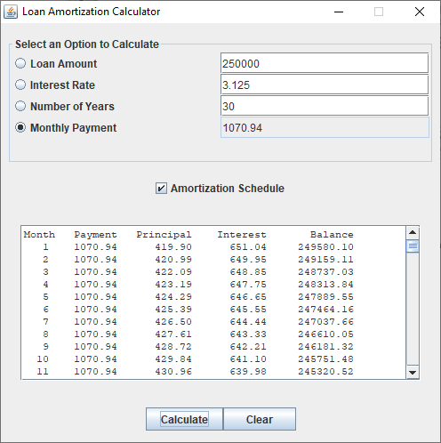

**Figure 1 – Loan Amortization Calculator Testing Scenario**

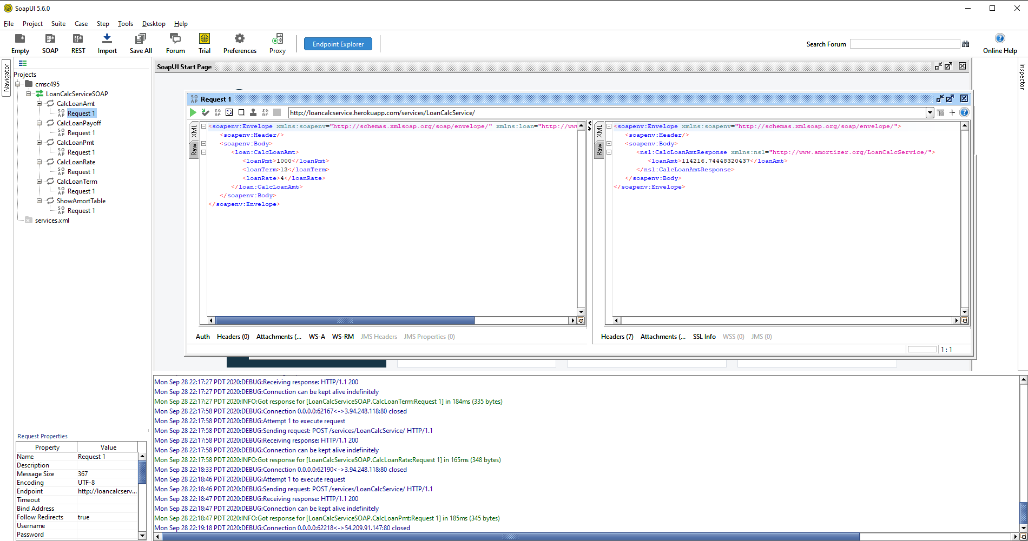

**Figure 2 – SoapUI Unit Testing Scenarios**

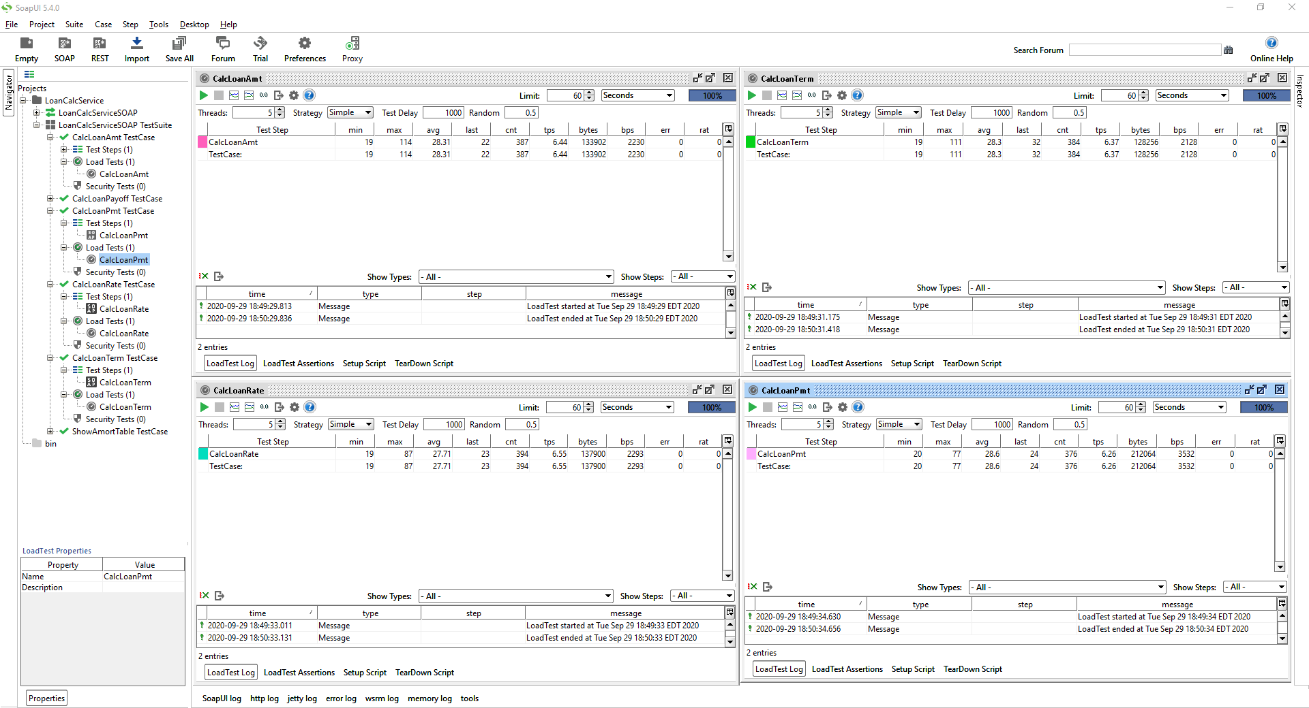

**Figure 3 – SoapUI Load Testing Scenarios**