**Phase 3 Report**

**CMSC 495 6381 Current Trends and Projects in Computer Science (2208)**

**Group Charlie**

James Lisle

Aniebiet Jacob

Mark Tasker

Catherine Wingfield

Sam Shanzhong Yuan

***University of Maryland University College***

**Loan Amortization Calculator**

Revision: 1.0

Date: 10/6/2020

**Revision History**

|  |  |  |  |
| --- | --- | --- | --- |
| **Revision** | **Date** | **Name(s) of Editor** | **Description** |
| 1.0 | 10/06/2020 | Lisle | Original Document |
|  |  |  |  |
|  |  |  |  |
|  |  |  |  |
|  |  |  |  |
|  |  |  |  |
|  |  |  |  |
|  |  |  |  |
|  |  |  |  |
|  |  |  |  |
|  |  |  |  |
|  |  |  |  |
|  |  |  |  |

**Phase 3 Report**

# Project Status

Overall this project is on track. There has been slight difficulty with generating a well formatted PDF so again that has been deferred until Phase 4 and may not occur. A simple HTML formatted email has taken it’s place for the moment and been noted. For Phase 3, the emphasis has been on adding email capability of an amortization schedule which required a new dialog for the client to enforce 2-step email verification, generating new service artifacts based on an updated WSDL, code modifications to the service to provide 2-step email verification, email interfacing with the SendGrid service, creation of a server side class for sending emails with and without attachments using the SendGrid service, access of a service properties file for third party service access credentials, and generation of a service based amortization schedule. At this point all features are present except for generating an amortization schedule in a PDF format. This may or may not occur in Phase 4 based on time constraints.

|  |  |  |
| --- | --- | --- |
| **Phase 3** | | |
| Add 2-step email verification dialog to client | 9/30-10/06 | Document Updates   1. User Guide 2. Technical Design 3. Test Plan 4. Project Plan |
| Update amortization schedule displayed to include loan info with interest paid | 9/30-10/06 |
| Client Security Review | 9/30-10/06 |
| Defer final PDF generation modifications until Phase 4 | 9/30-10/06 |
| Update WSDL with email address and pin verification. | 9/30-10/06 |
| Generate Web Service artifacts for client and service for 2-step verification for email address. | 9/30-10/6 |
| Create email class for SendGrid – EmailManager – that allows emails with and without attachements. | 9/30-10/6 |
| Service Testing of Email Functionality | 9/30-10/6 |
| Add property file for SendGrid API access | 9/30-10/6 |
| Add amortization schedule generation to service. | 9/30-10/6 |
| Service Security Review | 9/30-10/6 |
| End to End testing | 9/30-10/6 |  |
| Assorted bug fixes | 9/30-10/6 |  |

**Primary Activities**

* The creation of a 2-Step Email Verification dialog was created in the client to allow the user to enter an email and submit it to the service as the first step of verification. The service generates an 8-digit randomized pin and sends it to the user’s email. Assuming the user has access to the email account the pin is retrieved, entered in the dialog, and submitted to the service for the second step of verification. If the pin submitted matches the pin generated and sent to the user’s email the email is accepted for use and displayed on the main form.
* A header was added to the quick display on the main form showing the loan characteristics including total amount of interest paid over the life of the loan.
* The WSDL was modified to include additional operations for 2-step email verification.
* Additional methods were added to the service to provide the code for 2-step verification.
* A property file was added to the service for email API authentication.
* End to end testing has continued.

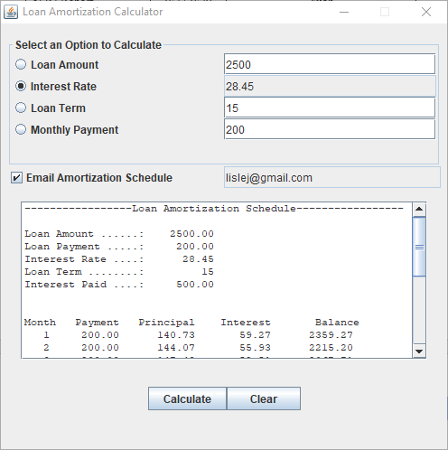

**Figure 1 – Loan Amortization Calculator with Email Verification**

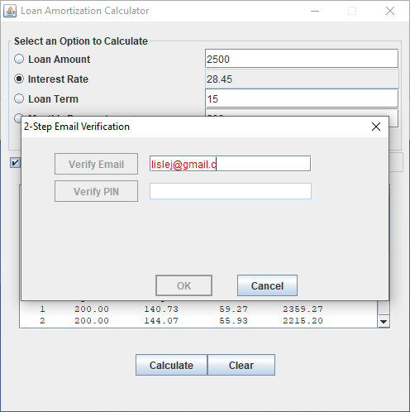

**Figure 2 – Email Verification Dialog**

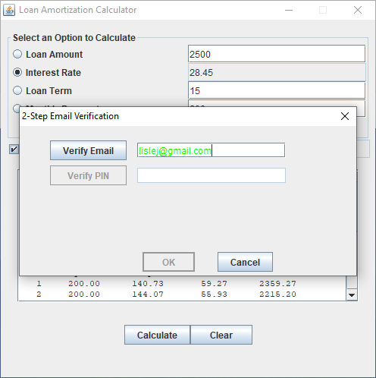

**Figure 3 – Email Verification Dialog**

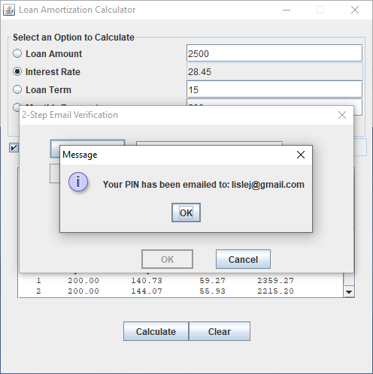

**Figure 4 – Email Verification Dialog**

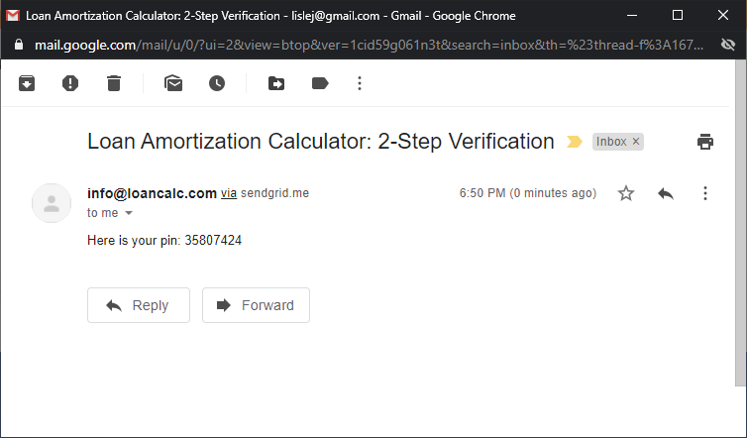

**Figure 5 – Email with PIN**

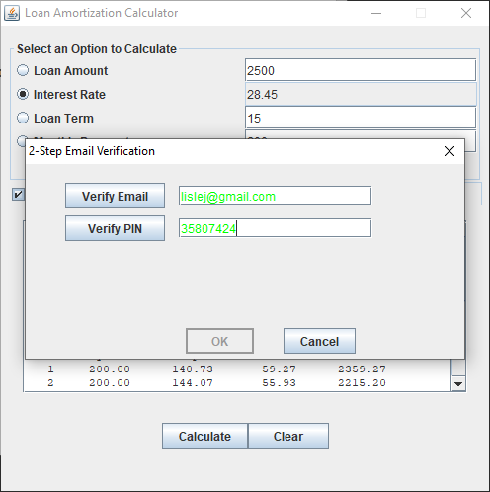

**Figure 6 – Email verification PIN entry**

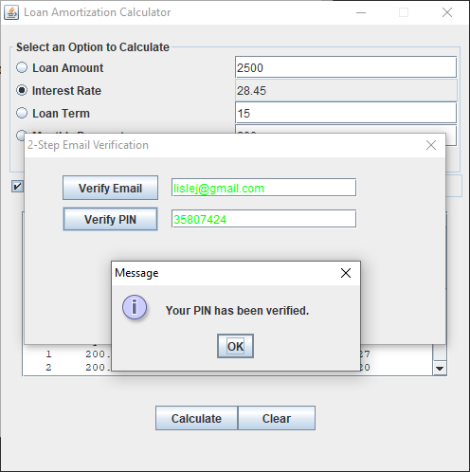

**Figure 7 – Email verification complete**

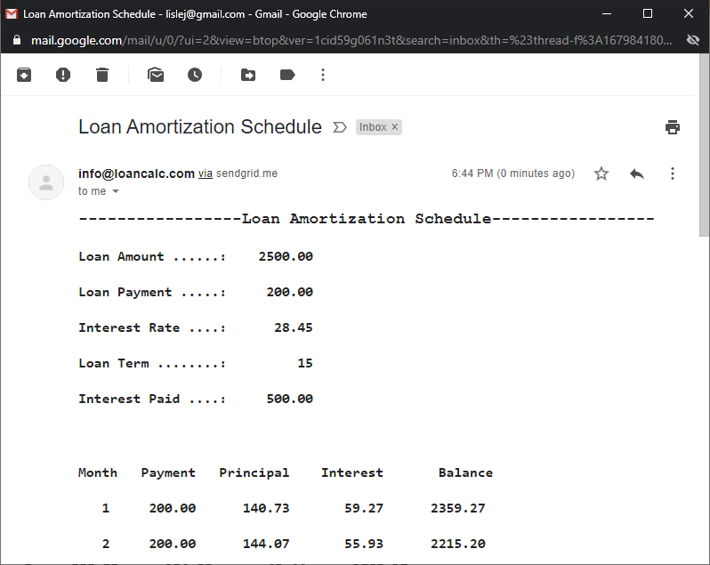

**Figure 8 – Loan Amortization Schedule Email**

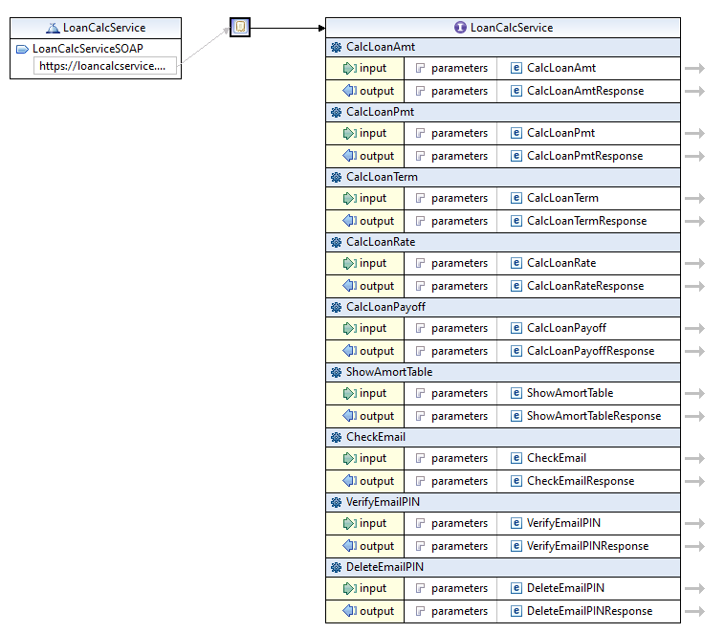

**Figure 9 – Updated LoanCalcService WSDL**