**Loan Amortization Calculator**

**User Guide**

**CMSC 495 6381 Current Trends and Projects in Computer Science (2208)**

**Group Charlie**

James Lisle

Aniebiet Jacob

Mark Tasker

Catherine Wingfield

Sam Shanzhong Yuan

***University of Maryland University College***

Revision: 1.0

Date: 09/07/2020

**Revision History**

|  |  |  |  |
| --- | --- | --- | --- |
| **Revision** | **Date** | **Name(s) of Editor** | **Description** |
| 1.0 | 09/07/2020 | James Lisle | Original Document |
|  |  |  |  |
|  |  |  |  |
|  |  |  |  |
|  |  |  |  |
|  |  |  |  |
|  |  |  |  |
|  |  |  |  |
|  |  |  |  |
|  |  |  |  |
|  |  |  |  |
|  |  |  |  |
|  |  |  |  |

**Objectives**

This User Guide provides a basic illustration of the proposed Loan Amortization Calculator GUI, details for calculating any 1 of 4 variables, defines the installation setup, and states the minimum system requirements to run the application.

**Loan Amortization Calculator Usage**

The Loan Amortization Calculator shown in figure 1 provides the end user with the ability to calculate 1 of the 4 variables defined in the amortization equation shown in figure 2.

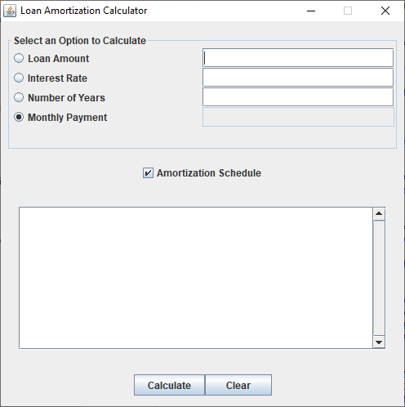

**Figure 1 – Loan Amortization Calculator**

$$A=P \frac{{r(1+r)}^{n}}{{(1+r)}^{n}-1}$$

where

* A = loan payment per term
* P = loan principal
* r = interest rate per term
* n = total number of payments

**Figure 2 – Amortization Equation**

**Calculation Setup**

As shown in figure 1, there are four possible variables that can be calculated. Select the option that is desired by clicking on the radio button that represents the target variable. Upon selection the corresponding data entry field will be disabled leaving the other three to be filled with the loan characteristics of interest. In the case shown in figure 1 the Monthly Payment is the variable to be calculated as indicated by the targeted radio button and the associated field that is disabled. Enter values for Loan Amount, Interest Rate, and Number of Years. If an Amortization Schedule is desired select the associated Check Box.

**Calculation Submission**

Once the values for the desired calculation have been entered select the Calculate button to submit the loan characteristics to the Loan Calculation Service for computation. Depending on connection speed and current service utilization the result will take anywhere from ~200ms to several seconds to completed. The target field calculated will be populated with the result once the response is received from the service or if an error occurred a dialog box will result describing the error condition and possible remedies.

**Clearing Calculator**

To reset the current state of the Amortization Loan Calculator to the default settings, select the Clear button.

Note: Additional snapshots and scenarios to be added as the application development proceeds.

A label that indicates the availability of the service will also be added.

**Loan Amortization Calculator Application Setup**

Step 1. Create a directory for the Loan Amortization Calculator.

Step 2. Copy the LoanCalcClient.jar into the directory created in Step 1.

Step 3. Confirm that a Java Runtime Environment is installed on your system and the version.

* Open a command window
* Type java –version at the prompt and press the Enter key
* Compare your result with Figure 3 - Java Not Found and Figure 4 - Java Found.
* If Java is missing install version 8 or greater on your system.

Step 4. Confirm that the Loan Amortization Calculator runs on your system by executing the

LoanCalcClient.jar file by double clicking on it or run it from the command line by typing

java LoanCalcClient.jar.

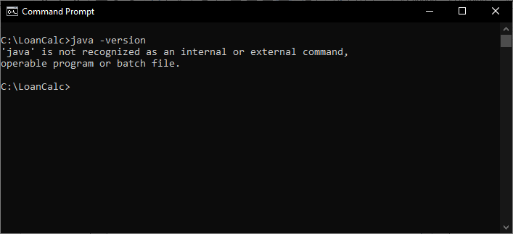

Figure 3 – Java not found message

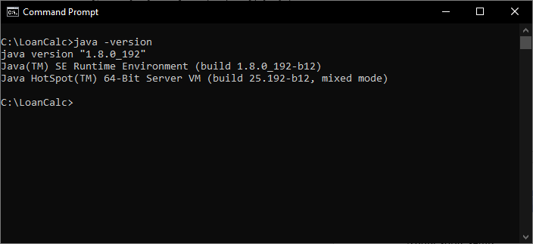

Figure 4 – Java found message

Note: Add corresponding messages for Macintosh and Linux

**Minimum System Requirements**

The Loan Amortization Calculator is a Java application that communicates with a Loan Calculation Service running in the Cloud. To use this application you need a computer that has at least 4GB of memory, 1 GB of free disk drive space, a Java Runtime Environment version 8 or greater, internet connectivity, and Windows 7 or greater, Mac OS X 10.6 or greater, or Linux with kernel version of 2.26 or greater as the operating system.

To Do

Trouble Shooting Section

* Calculations
* Connectivity
* Java Runtime Environment Setup

All Calculation Scenarios

* Loan amount
* Loan payment
* Loan interest
* Loan term

Amortization Schedule Details