

Example Test Plan

 | Start Date | End Date
Network Build (Setup)
Testing Date

Table of Contents
Attendees 3
Introduction 5
Equipment 6
Design and Topology Diagram 7
Test 1. Description: Baseline Connectivity Test 8
Test 1. Procedures: 8
Test 1. Expected Results and Success Criteria: 9
Test 1. Conclusions 10
Appendix 11

Attendees

Name | Company | Position

Introduction

An introduction to the testing explaining briefly what the purpose of the test is, and what should be observed. Include a brief description of testing goals. List all tests you intend to run.

For example:

The purpose of this prototype is to demonstrate how the individual access layer VLANs can be configured to separate traffic from the end-devices, IP telephones, and video cameras. The intent is to demonstrate that computers on VLAN 2 cannot access devices on the voice or video VLANs unless expressly granted permission.

- Test 1: Baseline Connectivity Test
- Verify physical and IP connectivity between devices on the prototype network.
- Collect operational baselines.
- Demonstrate IP connectivity between devices on the same VLANs.
- Demonstrate lack of IP connectivity between devices on different VLANs.
- Test 2: VLAN Routing Test
- Demonstrate routing of traffic between separate VLANs, unrestricted.
- Demonstrate routing of traffic between separate VLANs with restrictions.
- Simulate traffic and compare to baselines.

Equipment
List all of the equipment needed to perform the tests. Be sure to include cables, optional connectors or components, and software.

Qty. Req | Model | Any additional options or software required | Substitute | IOS Software Rev.
2 | 2960 Layer 2 switch | none | Any 2950 or 2960 model switch | 12.2 or above
2 | 37xx multilayer switch | none | Any multilayer switch or router with minimum 2 FastEthernet ports. | 12.2 or above
2 | Personal Computer end-devices | FastEthernet NIC | At least one PC and any other IP end-device (camera, printer, etc.) | Windows, MAC or Linux operating system.
6 | Cat 5 or above straight-through patch cables. | none | none | n/a
4 | Cat 5 or above cross-over patch cables | none | none | n/a

Design and Topology Diagram
Place a copy of the prototype network topology in this section. This is the network as it should be built to be able to perform the required tests. If this topology duplicates a section of the actual network, include a reference topology showing the location within the existing or planned network. Initial configurations for each device must be included in the Appendix.

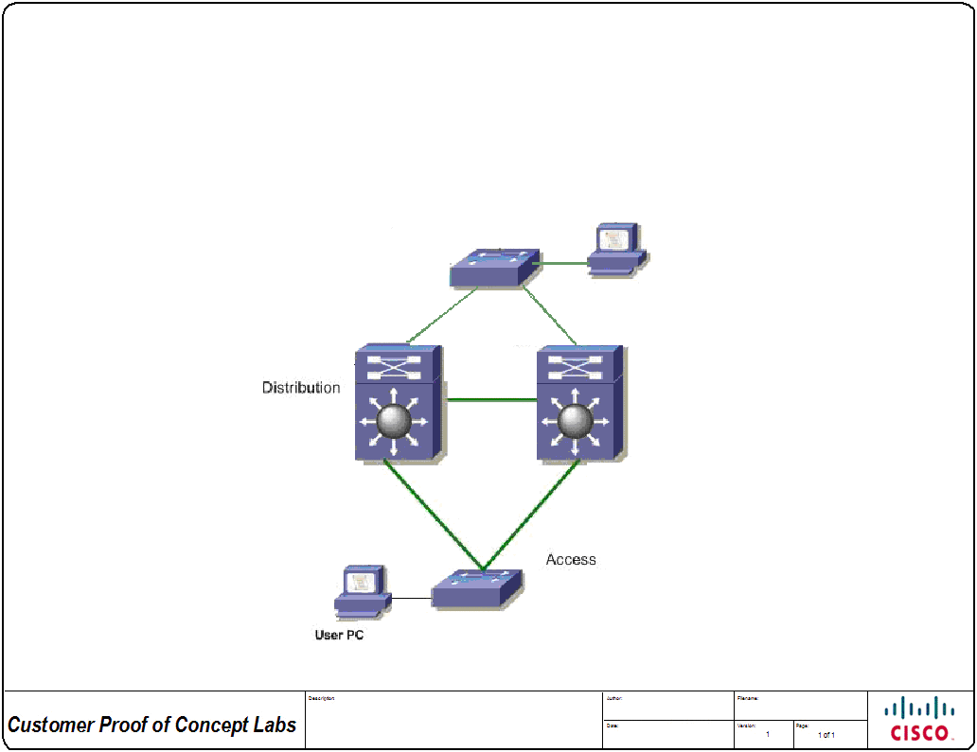
Figure 1: Topology - Prototype test topology.
Add a description about this design here that is essential to provide a better understanding of the testing or to emphasize any aspect of the test network to the reader.

For each test to be performed state the goals of the test, the data to record during the test, and the estimated time to perform the test.

Test 1. Description: Baseline Connectivity Test

Goals of Test:
The goal of the baseline is to verify that the topology is up and running with the proper protocols and features.

Data to Record:
Configurations
Routing Tables
CPU & Memory
Ping Test Output

Estimated Time:
120 minutes

Test 1. Procedures:
Itemize the procedures to follow to perform the test.
- Console into one of the devices in the topology and ping all of the other devices in the topology. Record any anomalies.
- Start a log file and get the “show running-config”, “show ip route”, “show processes cpu sorted”, “show processes cpu history” and the first few lines of “show memory” (should we be using short cuts here or the full syntax?)
- Telnet to all of the other devices and get the same information.
- Start baseline traffic and use the “show interface” and “traceroute” commands to verify that the traffic is taking the correct routes through the network.
- Test IP connectivity between host devices on the same VLAN.
- Test IP connectivity between host devices on different VLANs.

Test 1. Expected Results and Success Criteria:

List all of the expected results. Specific criteria that must be met for the test to be considered a success should be listed. An example of specific criteria is: “A requirement that ping response times cannot exceed 100 ms.”
- All networking devices are connected and accessible through Telnet.
- Hosts on a VLAN can ping successfully to other hosts on the same VLAN.
- Hosts on different VLANs are unable to ping successfully.

Test 1. Results and Conclusions

Record the results of the tests and the conclusions that can be drawn from the results.

Appendix

Record the starting configurations, any modifications, log file or command output, and any other relevant documentation.

