Call for papers

“Information Technologies and Learning Tools”
ISSN Online: 2076-8184

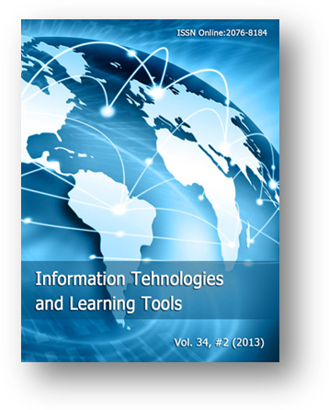
“Information Technologies and Learning Tools” is a bimonthly scientific peer-reviewed free of charge e-journal, published full-text article online with immediate open-access.
Branch of science: education
Journal contains researches in ICT in education, actual problems of information technologies and learning tools, distance education methodology, theory and history of informatization in education area.

Available manuscript languages: Ukrainian, Russian, English
Publication frequency: 6 issues per year

The journal is included to the "List of academic professional editions of Pedagogical Sciences", approved by Resolution of the Presidium of Higher Attestation Commission of Ukraine from April 12, 2007 № 1-05/4 (Bulletin HAC of Ukraine № 7 in 2007).

Ratings: The journal holds the 13th place in Top100 most cited in the "The rating of the scientific journals of Ukraine", compiled by Vernadsky National Library.

Indexing: The journal is indexed in the following databases (see more on the web-cite):

- WorldCat, USA
- ULRICHSWEB™ Global Serials Directory, USA
- Electronic Journals Index, USA
- NewJour, USA
- Journal finder, USA
- getCITED, Canada
- IndexCopernicus, Poland
- Journals for Free, Portugal
- OneSearch, Great Britain
- Petra Christian University Journal Directory, Indonesia
- Scirus, Elsevier B.V., the Netherland
- The search in public archives of Ukraine
- Directory of Research Journal Indexing, India
- Research Bible, Japan
- Directory of Open Access Journals, Sweden
- CCG-IBT BIBLIOTECA, Mexica

Web-site: http://journal.iitta.gov.ua
Contact E-mail: journal@iitta.gov.ua

Editor-in-chief:
Dr. Valeriy Yu. Bykov –
Dr. of Engineering Sciences, Professor,
Academician of NAPS of Ukraine, Kyiv

