Manuscript requirements

- GENERAL REQUIREMENTS:

- Manuscript Language: Ukrainian, Russian and English.
- The Manuscript - from 16000 to 40 000 characters with spaces. The optimal amount – 20 000 characters with spaces.
- The text should be typed in text editor MS Word.
- Page: A4, all margins - 2.5 cm, without headers and footers and page numbering.
- Main text - font Times New Roman, regular, strings without hyphens.
- Paragraph Settings:
    - alignment - the width;
    - spaced - 1;
    - first line indent - 1 cm;
    - paragraph spacing - 0 mm.

- PUBLISHING DESIGN OF ARTICLE STRUCTURAL ELEMENTS:
- Author’s Name (gross left-aligned, bold, 10 pt);
- Academic title, Academic degree, Position (left-aligned, 10 pt);
- Place of work: name, locality (left aligned, 10pt);
- e-mail (left aligned, italic, 10 pt);

- Title (12 pt, bold, capital letters, paragraph without indenting the first line, centered);
- the word "Abstract." (bold, 10 pt). Later in the same line - abstract length from 600 to 800 characters (regular, width, 10 pt);
- phrase "Keywords" (10 pt, bold). Later in the same line - keywords - 3 to 8 terms separated by ";" (10 pt, regular, width, indentation left and right - 1 cm);
- Basic text (font Times New Roman, 12 pt) should be consisted of the following:

1. INTRODUCTION (a separate paragraph indentation: before 24, after - 12, bold, 12 pt,
bold, left aligned);
Statement of the problem.
Analysis of recent research and publications.
- A reference given in square brackets, for example [10];
- Comma separated pages [3, 35] - 3-d source of 35th page;
- Multiple sources are separated by semicolons [3, 35; 5; 7,2-45].
The purpose of the article.
2. METHODS
3. FINDINGS
4. Conclusions and prospects for further research

- References (TRANSLATED AND TRANSLITERATED)
All in-text citations should be listed in the reference list in Roman script:
- subheading "REFERENCES (TRANSLATED AND TRANSLITERATED)" (a separate paragraph indentation: before 24, after - 12, bold, 12 pt, bold, left aligned);
- list of translated and transliterated references (type - 10pt);

- Line "Text of the article was accepted by Editorial Team __.201_ " (right alignment);

- III. FORMATting of individual objects:
1.1. Subtitle of the first level (single line, bold, left alignment, spacing 1 cm)
1.1.1. Subtitle of the second level (single line, bold, italic, left indent 1.5 cm)

All illustrations, diagrams, software code and tables should be located as far as they are mentioned in the text (not at the end of the article).
3.1.1. Formulas
Equations and mathematical symbols and letters which denote the variables in the text should be typed in MS Equation, without frame and fill. Font-Times New Roman 12pt, centered, numbered - in parentheses to the right.

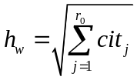 (1)

where 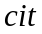- the number of citations, - the largest index number of the series , such that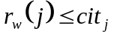
3.1.2. Lists
Lists are issued as follows:
- Numbered - "1." "1)», «a»;
- Labeled - «-», «•».
3.1.3. The software code
Samples of the software code should be typed by font Courier New, 9 pt. Before and after the code it is necessary to leave a blank line.

def nicedet(M):
s="$\\left|\\begin{array}{ccc} "
for i in range(M.nrows()):
for j in range(M.ncols()):
s=s+" "+latex(M[i,j])
if j!=M.ncols()-1:
s=s+"&"
s=s+"\\\\"
3.1.4. Tables
Tables are numbered, centered, without spaces. The word "Table 1.", italic, right. Format of table name: centered, bold, position - above the table. After the table it is necessary to leave a blank line.

Table 1
Didactics possibilities of webinar-oriented platforms
Didactics tasks | Means of webinar-oriented platform
Presentation of initial information, illustration of teacher’s explanation | - audio and video conferencing;  - whiteboard  - electronic bulletin;  - joint visit Web sites;  - demonstration of the software;  - demo presentations and files of various formats.
Providing of team interaction | - text chat, audio and video conferencing;  - collaboration with the white and documents;  - additional virtual rooms for group learning.
Evaluation of learning achievements | - tests, interviews with immediate visualization of the results.

3.1.5. Figures
Figures should be clear, centered, numbered and have a caption. Format of Figure caption: centered, italic, position – under the Figure. Before and after Figure’s caption it should be left one blank line.

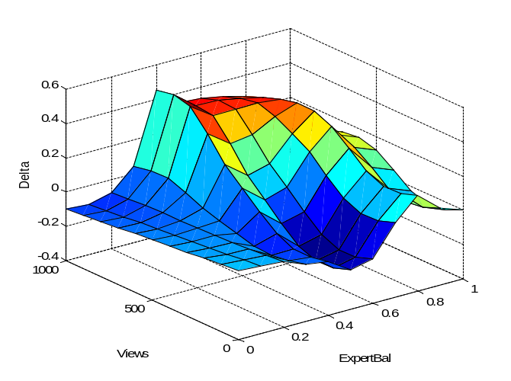

Figure1. Surface of errors of Sugeno type fuzzy systems

