Free-view Video Communication Using Multiple Color-depth Cameras

(An Ongoing Project…)

1. System illustration



2. Technical components

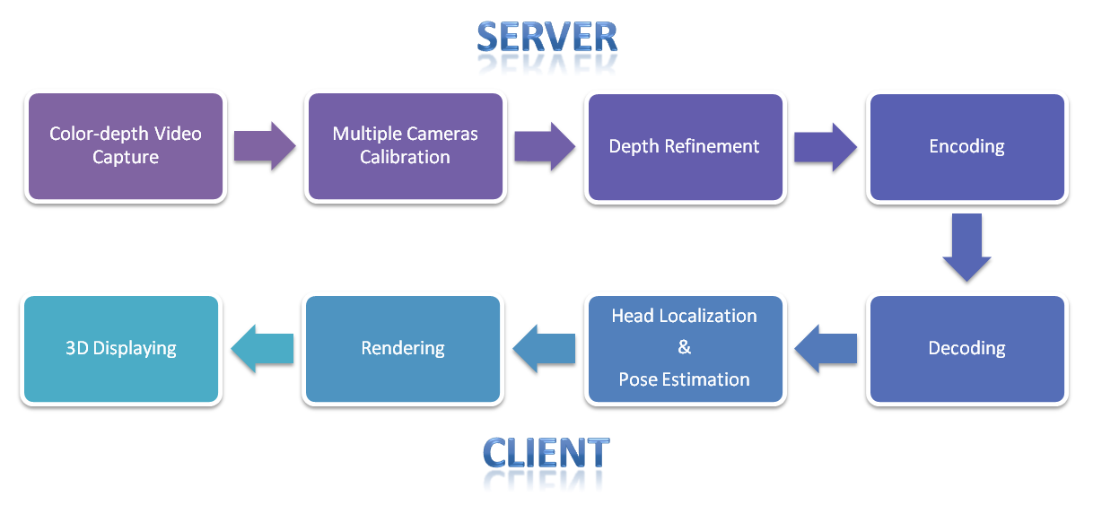

3. Current status

Table 1. A prototype system has been developed with the following processing components

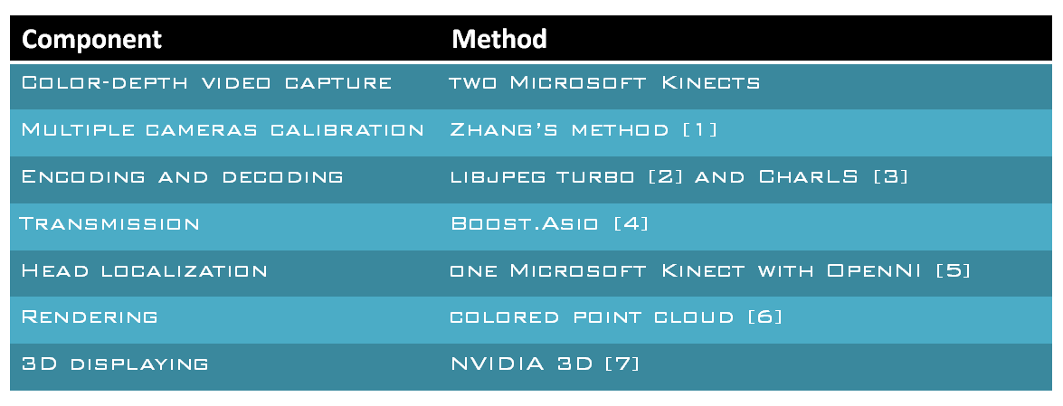

4. Future works

Research works are being carried out focusing on several technical topics: multiple cameras calibration, depth enhancement, and head pose estimation.

5. Group members

* PostDoc: Songnan Li ([snli@ee.cuhk.edu.hk](mailto:snli@ee.cuhk.edu.hk))
* PhD student: Lu Sheng ([lsheng@ee.cuhk.edu.hk](mailto:lsheng@ee.cuhk.edu.hk))
* Supervisor: King Ngi Ngan ([knngan@ee.cuhk.edu.hk](mailto:knngan@ee.cuhk.edu.hk))

6. References

[1] Z. Zhang, “A flexible new technique for camera calibration,” TPAMI, 22(11), pp. 1330-1334, 2000.

[2] A fast JPEG coding library – libjpeg turbo, available at: <http://libjpeg-turbo.virtualgl.org>

[3] A fast JPEG-LS coding library – CharLS, available at: <http://charls.codeplex.com>

[4] Boost.Asio library for network transmission, available at: [http://www.boost.org](http://www.boost.org/)

[5] OpenNI, available at: <http://openni.org>

[6] N. Fukushima’s code, available at: <http://nma.web.nitech.ac.jp/fukushima/openni/NICVSample4.cpp>

[7] NVIDIA 3D vision, <http://www.nvidia.com/object/3d-vision-main.html>