

Common Data Model for Nonprofits & Dynamics 365 Nonprofit Accelerator:

Frontline Humanitarian Logistics Mapping Guide

**Published**: December 2020

**Accelerator Release Version**: 3.0

Table of Contents

Background & Key References 3

Solution Overview 4

Dynamics 365 Nonprofit Accelerator Frontline Humanitarian Logistics Solution 5

Solution requirements 6

FHL Data Standard Technical Overview 6

FHL Data Standard Master Records 8

FHL Data Standard And Common Data Model for Nonprofits Mapping 10

Next Steps 11

# **Background & Key References**

*(Note: quoted content below is from the following* [*NetHope*](https://nethope.org/) *reference:* [*FRONTLINE HUMANITARIAN LOGISTICS: WORKING TOGETHER FOR A MORE EFFICIENT AND EFFECTIVE RESPONSE*](https://nethope.org/2020/10/06/frontline-humanitarian-logistics-working-together-for-a-more-efficient-and-effective-response/)*”*

“Many of the world’s 71 million forcibly displaced people depend on humanitarian response for life-saving support. In post-disaster and conflict environments, getting the right aid to the right people is complex, because many of the more traditional systems and processes that work in other situations do not work in this ‘last mile’ at the frontline of aid delivery.

With many nonprofit organizations moving to deploy or replace their core Enterprise Resource Planning (ERP) capability in 2019/20, there was a systemic opportunity to deliver a sustainable technology capability for the humanitarian community. This would enable interoperability across the sector and provide a large efficiency gain to all.”

To save time and costs and enable interoperability of information systems within and between organizations, NetHope and 24 of its nonprofit membership organisations began the FHL Data Standard project.

This FHL Data Standard project, led by Oxfam, GOAL, and NetHope, brought together experiences from nonprofits, some of the world’s biggest technology companies with expertise in supply chain management, technology consultants and academics with a focus on humanitarian logistics,” and resulted in the publishing of the inaugural version (v1.0.2 - September 2020) of the Frontline Humanitarian Logistics Data Standard.

“The inaugural version of the FHL Data Standard includes the common processes across frontline humanitarian logistics and the common data entities agreed against each process” by the Frontline Humanitarian Logistics Project Team.

The following NetHope Solution Center links are key references for this Guide:

* [Frontline Humanitarian Logistics Data Standard Overview](https://solutionscenter.nethope.org/resources/initiatives/frontline-humanitarian-logistics)
* [Frontline Humanitarian Logistics Data Standard and Guide for Use (Version 1.0.2)](https://solutionscenter.nethope.org/assets/collaterals/Frontline_Humanitarian_Logistics_Data_Standard_and_Guide_v1_0_2.docx)

Common terms used in this document and their abbreviations include:

* Common Data Model for Nonprofits: CDM
* Dynamics 365 Nonprofit Accelerator: Accelerator
* Frontline Humanitarian Logistics: FHL
* Frontline Humanitarian Logistics Data Standard: FHL Data Standard
* Microsoft Tech for Social Impact: TSI or Microsoft TSI

# **Solution Overview**

Microsoft was a key supporter of and technical partner in the FHL Data Standard project. In conjunction with key partners, Microsoft has mapped the FHL Data Standard to the CDM for Nonprofits and the Accelerator. This document is an overview of this mapping and related Microsoft solutions, including:

1. **Dynamics 365 Nonprofit Accelerator Frontline Humanitarian Logistics Data Schema**

This solution includes the Frontline Humanitarian Logistics extensions to the Common Data Model for Nonprofits implemented in the Dynamics 365 Nonprofit Accelerator. You can access this data schema via the Dynamics 365 Nonprofit Accelerator on [AppSource](https://appsource.microsoft.com/en-US/product/dynamics-365/msnfp.msftnonprofitcommondatamodel?src=office&tab=overview).

1. **Common Data Model for Nonprofits & Dynamics 365 Nonprofit Accelerator Mapping Guide** which includes this document and the accompanying NFP.Accelerator.3.0.-.FHL.Data.Standard.Mapping.xlsm mapping document.

Note: v3.0 of the CDM and Accelerator represent the first mapping to the inaugural FHL Data Standard. As the CDM, Accelerator, partner solutions and the FHL Data Standard evolve, and as customers and partners implement solutions, this content and associated solution components will be updated.

# **Dynamics 365 Nonprofit Accelerator Frontline Humanitarian Logistics Solution**

The Common Data Model for Nonprofits has been extended with entities, attributes and relationships to support select FHL Data Standard components. The following CDM and Accelerator extensions have been added with the v3.0 Release:

1. Extensions to the following existing (pre v3.0) entities:
   1. Address
   2. Designation Plan
   3. Award
   4. Payment Asset
2. New Entities, Attributes and Relationships (v3.0):
   1. Item Request
   2. Item Request Line
   3. Item Type
   4. Item Group
   5. Item

The following diagram describes the extensions included in the CDM and Accelerator v3.0 Release:

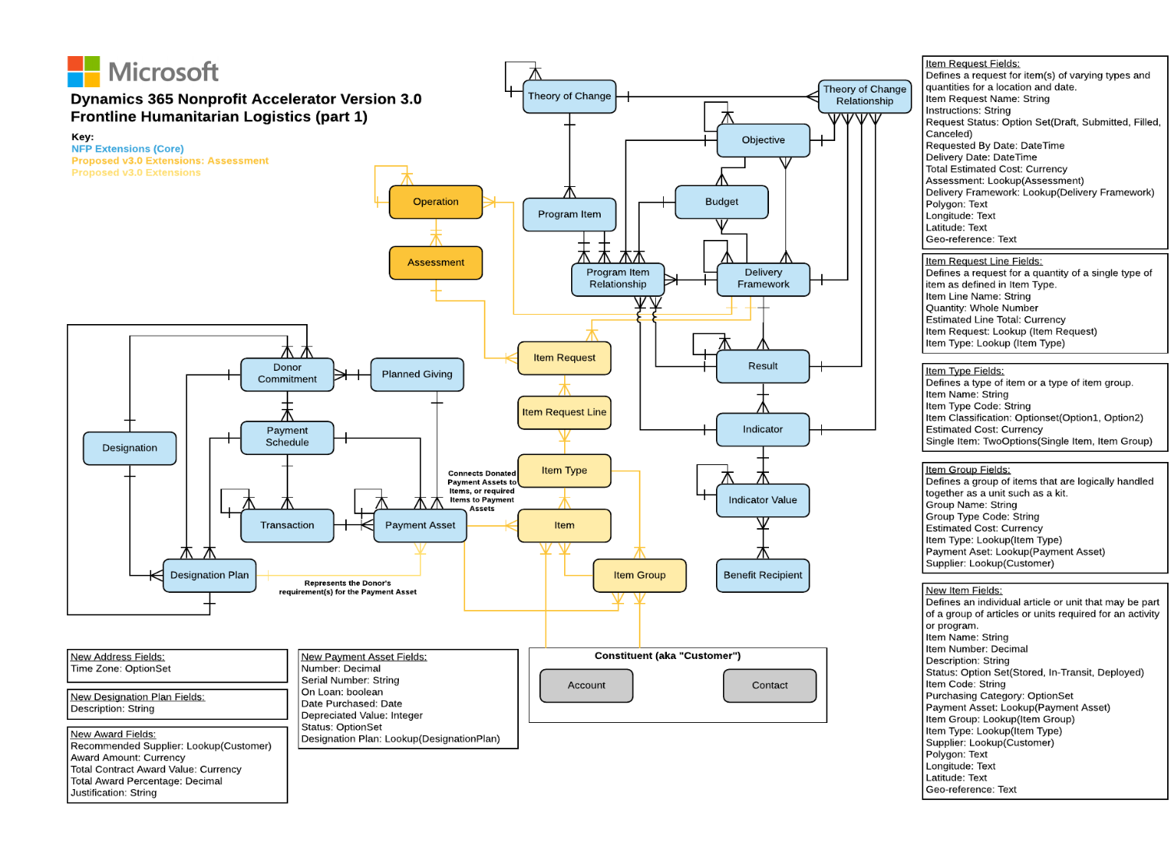

# **Solution requirements**

This solution requires the Nonprofit Accelerator version 3.0 and a Power Platform license.

# **FHL Data Standard Technical Overview**

Refer to the Frontline Humanitarian Logistics Data Standard and Guide referenced above for complete details and/or updated versions of the FHL Data Standard. Some content from this document has been included below for reference, given it’s relevance to mapping the FHL Data Standard to the CDM for Nonprofits and Accelerator.

The two relevant components of the FHL Data Standard are:

1. **Process Framework, including 10 Process Groups and 89 Process Categories/Variants**

The process framework includes 10 Level 1 Process Groups (see diagram).

* 4 Process Groups (shaded in blue) are mainly generic to any sector/ industry (Procurement is represented by two variants 2a and 2b as similar but distinct set of processes under one Procurement Process Group)
* 3 Process Groups are specific to the Humanitarian sector (shaded in orange)
* 3 Process Groups (shaded in gray) are enablers or support processes.

Each Process Group is divided into Level 2 Process Categories or Process Variants. Processes are listed in the order following the commonly accepted flow of goods, as seen in the diagram below:

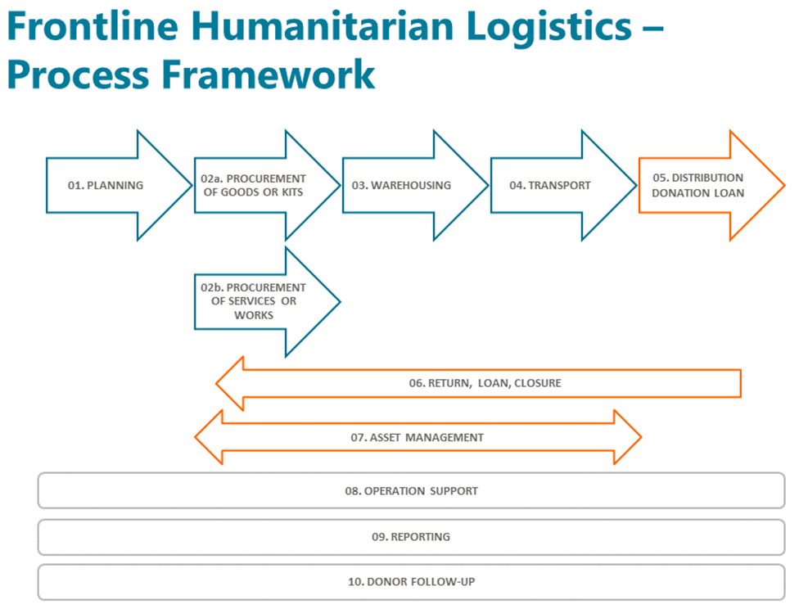

(Source: FHL Data Standard Guide v1.0.2)

Processes are described in the FHL Data Standard workbook, including the following columns:



Note: the following PL1 Process Group definitions are from the FHL Data Standard source workbook. They utilize a more detailed naming convention compared to the diagram above, however the numbers for the process groups in the diagram above refer to the appropriate PL1 Process Groups in the FHL Data Standard.

| **PL1 Process Group** | **Comment/ Description** |
| --- | --- |
| 01 Supply and Logistics Planning | The processes associated with determining needs and actions to achieve supply chain objectives. |
| 02 Procurement | The processes associated with ordering, delivery, receipt and transfer of: a. goods or kits, b. services or work. |
| 03 Warehousing | The processes associated with storing and managing the inventory of goods or kits. |
| 04 Transport | The processes associated with managing fleet, carriers and LSPs, selecting modes of transportation and routes, as well as placing/loading goods. |
| 05 Distribution Donation Loan | The processes associated with performing order management and order fulfillment activities, donations and loans. |
| 06 Return Loan Closure | The processes associated with moving goods back from a customer through the supply chain to address defects in product, ordering, or to perform upkeep activities. |
| 07 Assets | The processes associated with procuring, allocating, maintaining and monitoring assets required to operate the supply chain (assets include cars and fleet). |
| 08 Support | The processes associated with establishing, maintaining and monitoring support resources. |
| 09 Reporting | The processes associated with querying sources to capture data needed to inform internal and external stakeholders and support decision making. |
| 10 Donor follow-up | The processes associated with the management of donors funding: associating each good or service with a specific source of funding through the entire supply chain. |

1. **Data Items which are structured into three data levels**

The Data Items by intention, represent functional sector requirements rather than a technical data structure. The Data Standard will be enabled in technical partner technologies as appropriate for their respective data structures (refer to the FHL Data Standard Thesaurus for alternate naming conventions).

* + Level 1: Data Entity Groups: 77
    - Level 1 Data Entity Groups are designed to be the inputs and outputs of the Level 2 processes and are typically Master Data Records, Transaction Data Sets, Reports and Systems Transaction Forms
  + Level 2: Data Entities: 162
    - Level 2 Data Entities are sub-groups of data within each Data Entity Group. There are 162 unique Data Entities across the Standard.
  + Level 3: Data Elements: 353
    - Level 3 Data Elements are the lowest level of data in the Standard. They represent the individual data fields or components that must be present in the business system in order to execute or report on the processes supported by each Level 1 Data Entity Group. There are 353 unique Data Elements in the Standard used a total of 855 times across all Data Entity Groups.

Data items are described in the FHL Data Standard workbook, including the following columns:

# **FHL Data Standard Master Records**

A key FHL Data Standard Level 1 Data Entity Group characteristic is “Master Data Records.” Ensuring common understanding and use of Master Data Records is the best method to achieve interoperability and reduce effort and cost for customers and partners.

* FHL Master Data Records include consistent sets of identifiers used across the organization
* They define key entities used to execute the organization’s transactions
* They represent key anchor points to the CDM and other Microsoft Services (i.e. Microsoft Dynamics 365 Finance, Supply Chain, etc.)
* Products and solutions built upon or mapped to the FHL Master Records will enable interoperability by honoring a common definition of the key entities used to execute transactions

The following table provides high level mappings between the FHL Master Data Records and Microsoft Services (Note: additional partner mappings are also available outside from partners).

| **#** | **FHL Master: DL1 Data Entity Group Name** | **DL2 Data Entity Name** | **Microsoft Service** | **Microsoft Service Detail** |
| --- | --- | --- | --- | --- |
| 1 | Location Master | Supplier Warehouse | Dynamics 356: Supply Chain | Functional Locations |
| 2 | Location Master | Warehouse | Dynamics 356: Supply Chain | Warehouse Management |
| 3 | Location Master | Field Location | Dynamics 356: Supply Chain | Functional Locations |
| 4 | Location Master | Address | Dynamics 356: Supply Chain | Address |
| 5 | Supplier Master | Supplier General | Dynamics 356: Supply Chain | Asset Management |
| 6 | Supplier Master | Ship From Address | Dynamics 356: Supply Chain | Asset Management |
| 7 | Supplier Master | Remit to Address | Dynamics 356: Supply Chain | Asset Management |
| 8 | Supplier Master | Contact | Nonprofit Common Data Model | Constituent |
| 9 | Supplier Master | Payment | Dynamics 356: Supply Chain | Asset Management |
| 10 | Supplier Master | Delivery | Dynamics 356: Supply Chain | Asset Management |
| 11 | Supplier Master | Tax | Dynamics 356: Finance | Tax |
| 12 | Item Master | Item General | Dynamics 356: Supply Chain | Asset Management |
| 13 | Item Master | Item Purchase | Dynamics 356: Supply Chain | Asset Management |
| 14 | Item Master | Item Order | Dynamics 356: Supply Chain | Asset Management |
| 15 | Item Master | Item Inventory | Dynamics 356: Supply Chain | Asset Management |
| 16 | Item Master | Item Warehouse | Dynamics 356: Supply Chain | Asset Management |
| 17 | Item Master | Buffer Stock | Dynamics 356: Supply Chain | Asset Management |
| 18 | Currency Exchange Rate Master | Exchange Rates | Dynamics 365 | Currency |
| 19 | Warehouse Master | Warehouse General | Dynamics 356: Supply Chain | Asset Management |
| 20 | Warehouse Master | Address | Dynamics 356: Supply Chain | Address |
| 21 | Warehouse Master | Warehouse Location | Dynamics 356: Supply Chain | Warehouse Management |
| 22 | Asset Master | Asset General | Nonprofit Common Data Model | Item/Item Group |
| 23 | Asset Master | Asset Location | Dynamics 356: Supply Chain | Functional Locations |
| 24 | Asset Master | Asset Insurance | Dynamics 356: Supply Chain | Asset Management |
| 25 | Asset Master | Asset Valuation | Dynamics 356: Supply Chain | Asset Management |
| 26 | Asset Master | Donor | Nonprofit Common Data Model | Constituent |

Dynamics 365 Supply Chain Management Asset Management is an advanced module for managing assets and maintenance jobs in Dynamics 365 Supply Chain Management. Asset Management integrates seamlessly with several modules in Finance and Operations apps.

Due to the recommended mapping of FHL Data Standard to Dynamics 365 Supply Chain Management with a focus on Asset Management, this diagram has been included from Microsoft Documents for reference:

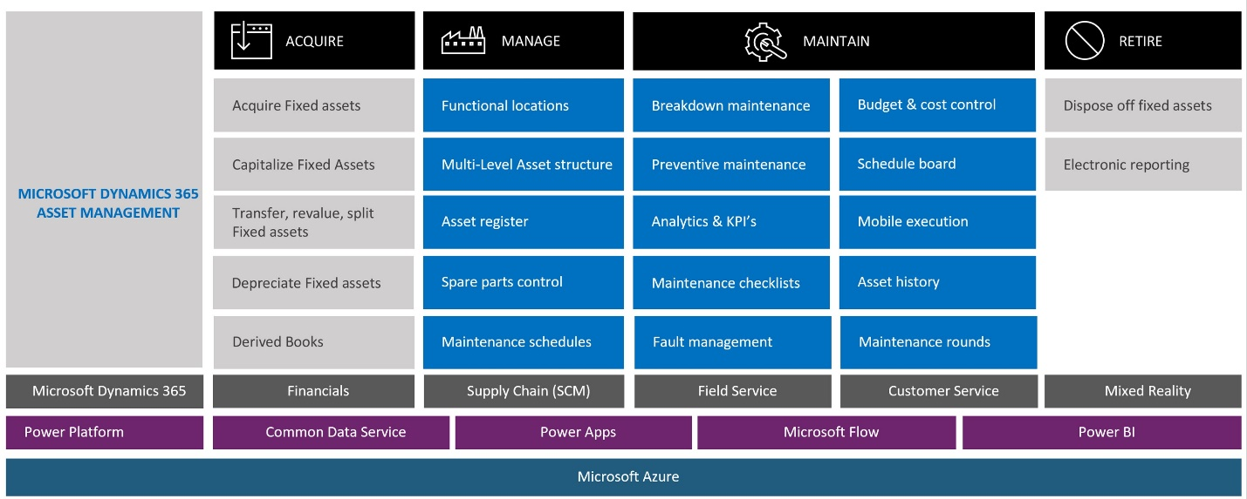

Source: [Dynamics 365 Asset Management Overview on Microsoft Docs](https://docs.microsoft.com/en-us/dynamics365/supply-chain/asset-management/)

# **FHL Data Standard And Common Data Model for Nonprofits Mapping**

The second component of this solution is a mapping between the FHL Data Standard and the CDM for Nonprofits v3.0. This is an initial mapping, as all DL1, DL2 and DL3 FHL Data Standard items are not mapped to CDM for Nonprofits entities/attributes in this version (per the content above re Supply Chain and/or partner solutions). Instead, the focus for this version of the mapping is:

1. Mapping of CDM for Nonprofits entities and attributes to the FHL Data standard where mapping confidence is 100%.
2. Mapping Dynamics 365 Services and partner solutions to the FHL Data Standard for DL1, DL2 and DL3 FHL Data Standard items not included in 1.

The mapping can be found in the following document: NFP.Accelerator.3.0.-.FHL.Data.Standard.Mapping.xlsm, in the “Data” tab. See the following columns (I to N) for the mapping details:



The following are the definitions of the Mapping Columns:

| Column | Label | Definition | Sample Value |
| --- | --- | --- | --- |
| I | Target(s) | Defines the solution mapped to the FHL DL3 item | CDM, Dynamics 365, Partner Solution Name |
| J | Entity | The entity defined in the Target(s) | Item |
| K | Attribute Label | The attribute in the entity defined in the Target(s) | Item Name |
| L | API Name | The API name of the attribute defined in K. | Item Name |
| M | Comments | Any notes, guidance, logic, etc. related to the mapping | “Program is a unit of work…” |
| N | Confidence | The confidence of the mapping between the Target/Entity/Attribute and the FHL DL3 Item | 100% |

# **Next Steps**

This guide has been created based on the inaugural version of the Frontline Humanitarian Logistics Data Standard (v1.0.2), the current (as of November 2020) version of the Common Data Model for Nonprofits and Dynamics 365 Nonprofit Accelerator (v3.0) and Microsoft and partner solutions.

As each of these standards, models, services and solutions evolves, this guide will be maintained. In addition, as customers and partners create and/or implement FHL Data Standard aligned solutions, this guide will be updated with guidance that contributes to the FHL Data Standard goals of increased interoperability and reduced cost and effort to implement FHL Data Standard aligned solutions.