

Nonprofit Accelerator ERD and How-to Guide

**Published**: September 2020

**Accelerator Release Version**: v3.0

Table of Contents

Overview 3

Entities and Attributes 3

Entity Relationship Diagrams 4

How to Model Constituent to Finance integration process 4

How to Model Program Delivery to Finance integration process 5

How to Model Donations to Finance integration process 6

How to Model Grants and Awards to Finance integration process 7

How to Model a Constituent 8

How to Model Awards 9

How to Model a Benefit Recipient 10

How to Model a Household 11

How to Model an Organization 12

How to Model Membership 13

How to Model Fundraising 14

How to Model Fundraising to Program Delivery 15

How to Model Program Delivery & Results 16

How to Model Program Delivery to Constituent 17

How to Model IATI Codelist Sync Process 18

How to Model IATI Organization & Activity Standards 19

How to Model Case Management 20

How to Model Project Management and Program Design 21

How to Model Assessment 22

How to Model Volunteer Management 23

How to Model Frontline Humanitarian Logistics 24

# Overview

Applies To: Dynamics 365 (online)

The Microsoft Dynamics 365 Nonprofit Accelerator (“Accelerator”) is a solution released by Microsoft to help drive adoption of the Business Application Power Platform by nonprofit partners and providers, including the Common Data Model, The Common Data Services, Dynamics and Power BI. The Accelerator contains installable solutions that include standard entity attribute extensions, new nonprofit entities, pre-built dashboards, workflows, sample data as well as other tools to help customers and partners build and deploy new nonprofit solutions.

This documentation provides an overview of the key entities, attributes, relationships and metadata included in the Accelerator.

## Entities and Attributes

The Accelerator model contains a number of attribute extensions to existing Common Data Model entities as well as new entities. The prefix “msnfp” is consistent throughout all these extensions.

In this document, concepts that are mapped to existing entities, such as Account or Addresses, have the name of the existing entity in the title as well.

Additional metadata on the entities and the attributes can be found by installing the Accelerator and using the Dynamics metadata browser.

Additional Resources:

1. Learn more about the [Common Data Model](https://github.com/Microsoft/CDM)
2. Download the Dynamics 365 Nonprofit Accelerator from [AppSource](https://appsource.microsoft.com/en-us/product/dynamics-365/msnfp.msftnonprofitcommondatamodel?src=office&tab=Overview)
3. The nonprofit common data model, solutions, data samples, Power BI Examples, SDK extensions and more are provided as part of the open-source creative license available on [GitHub](https://github.com/Microsoft/Dynamics-365-Industry-Accelerators/tree/master/nfp)
4. Information about Microsoft’s [Nonprofit Offerings](https://www.microsoft.com/en-us/nonprofits)
5. First Look at the [Nonprofit Accelerator](https://community.dynamics.com/365/b/dynamics365isvsuccess/archive/2018/11/08/a-first-look-at-the-dynamics-365-nonprofit-accelerator)
6. [Additional Topics](https://community.dynamics.com/365/b/dynamics365isvsuccess/archive/2018/08/01/dynamics-365-brings-industry-focus-through-the-microsoft-power-platform-and-solution-accelerators) about the accelerators

# Entity Relationship Diagrams

The following conceptual entity relationship diagrams provide overviews of key entity relationships and examples in the Common Data Model.

## How to Model Constituent to Finance integration process

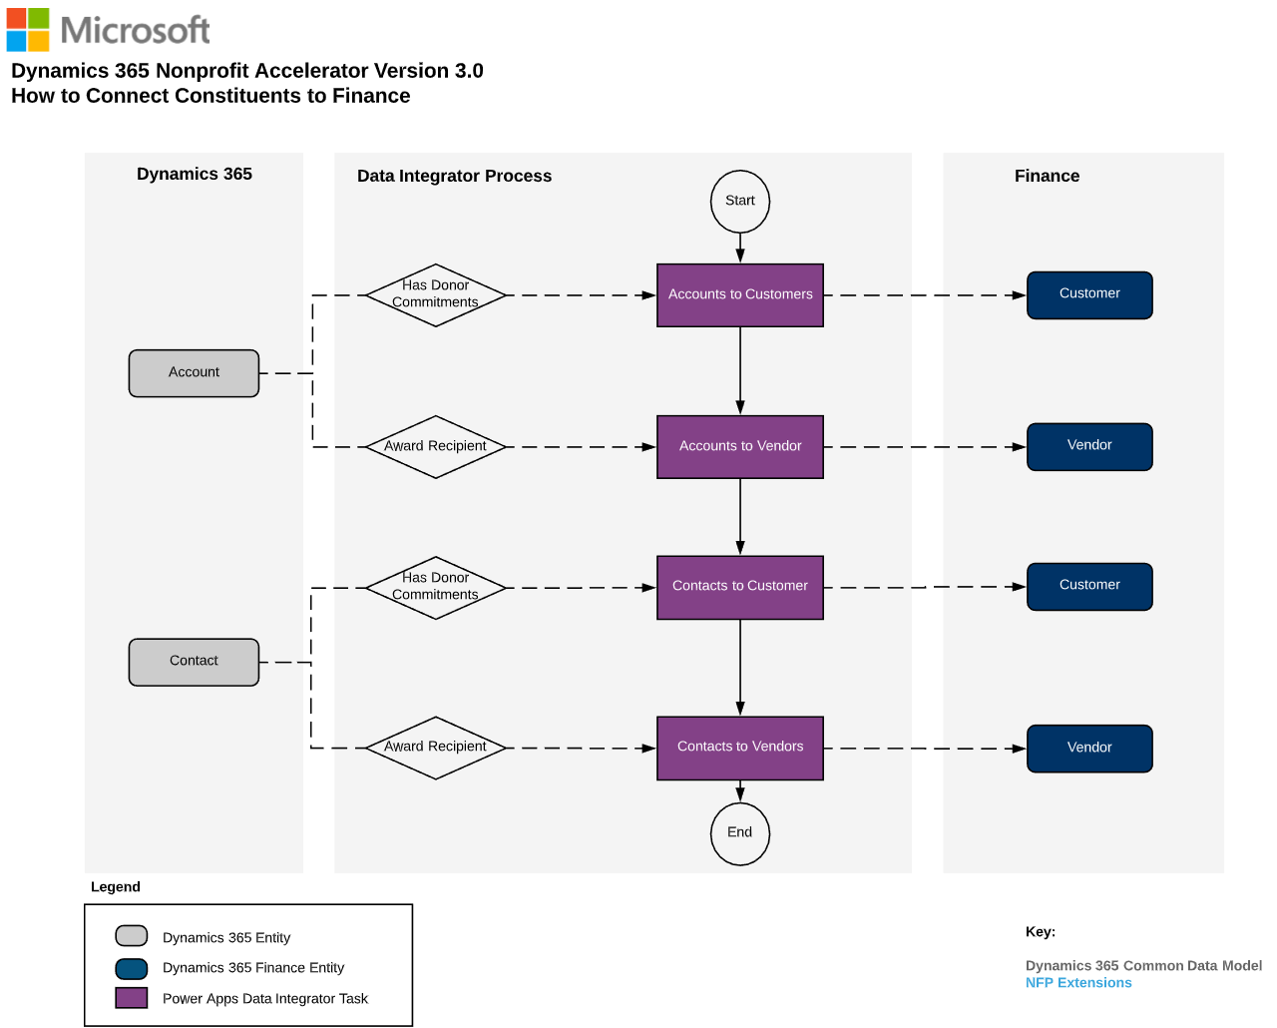

Figure 1: Diagram for Connecting Constituent to F&O

## How to Model Program Delivery to Finance integration process

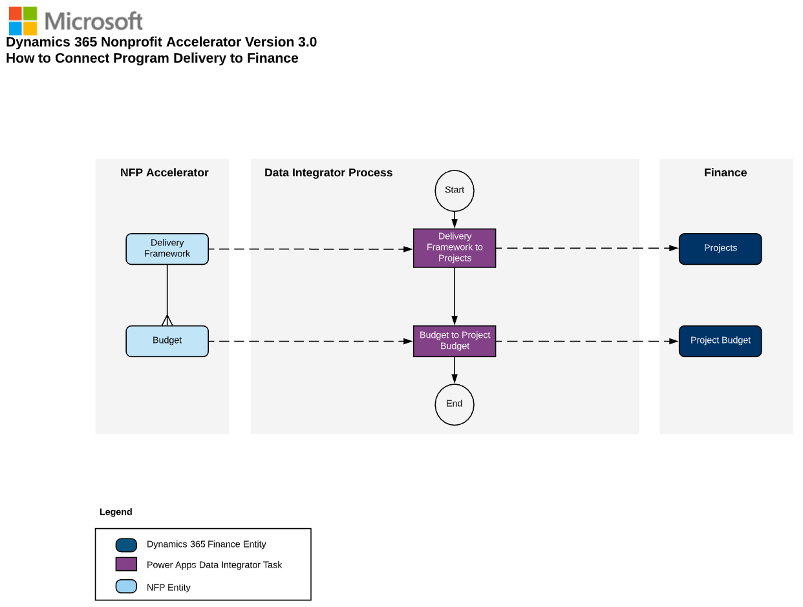

Figure 2: Diagram for Connecting Program Delivery to F&O

## How to Model Donations to Finance integration process

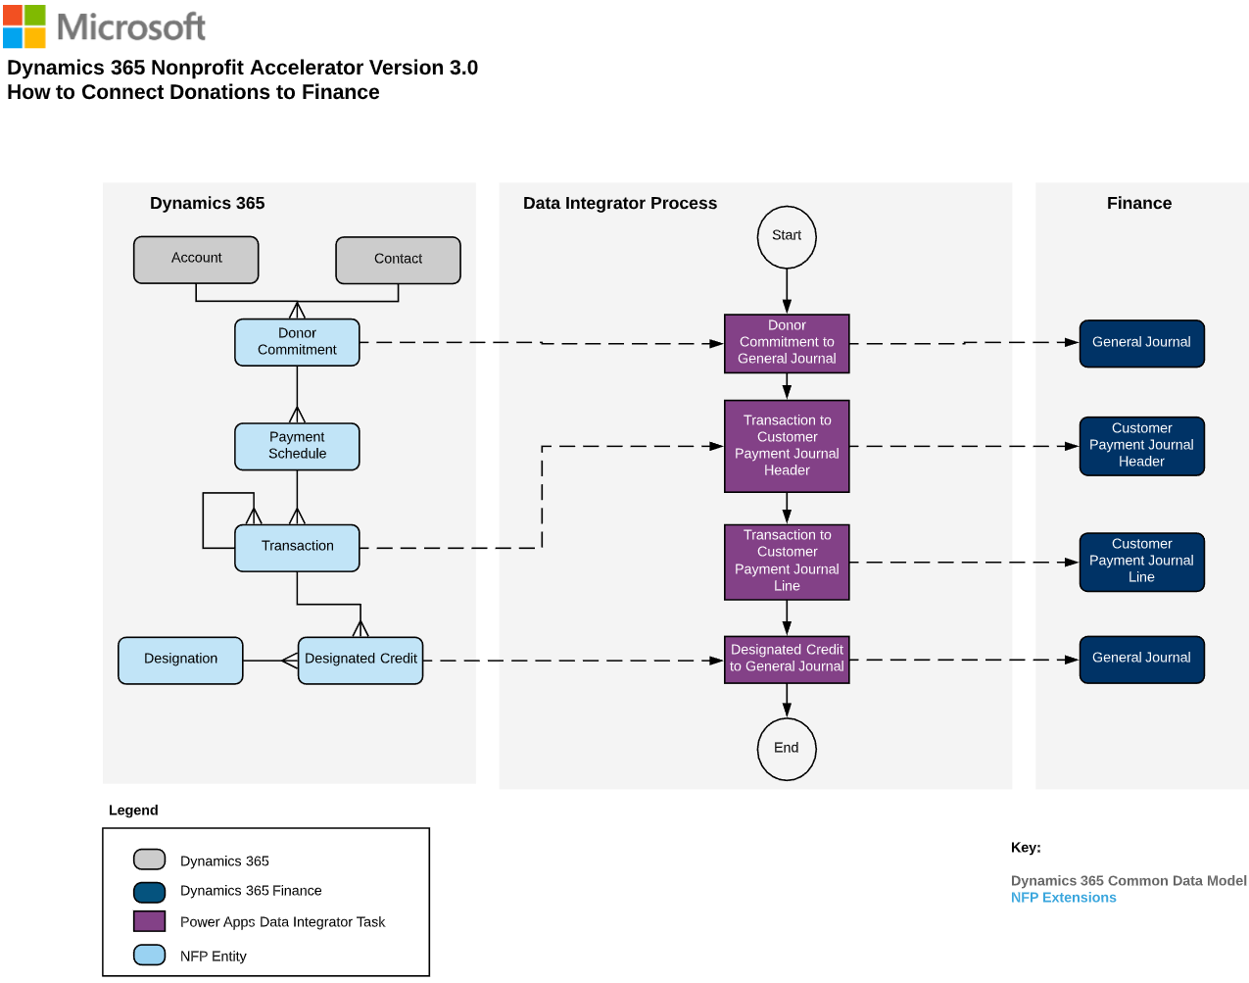

Figure 3: Diagram for Connecting Donations to F&O

## How to Model Grants and Awards to Finance integration process

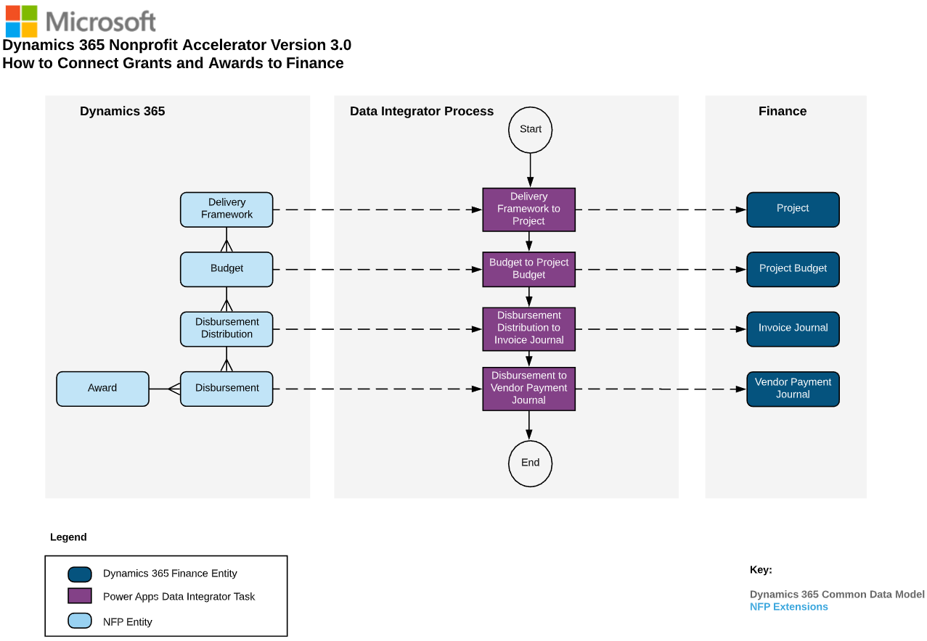

Figure 4: Diagram for Connecting Grants and Awards to F&O

## How to Model a Constituent

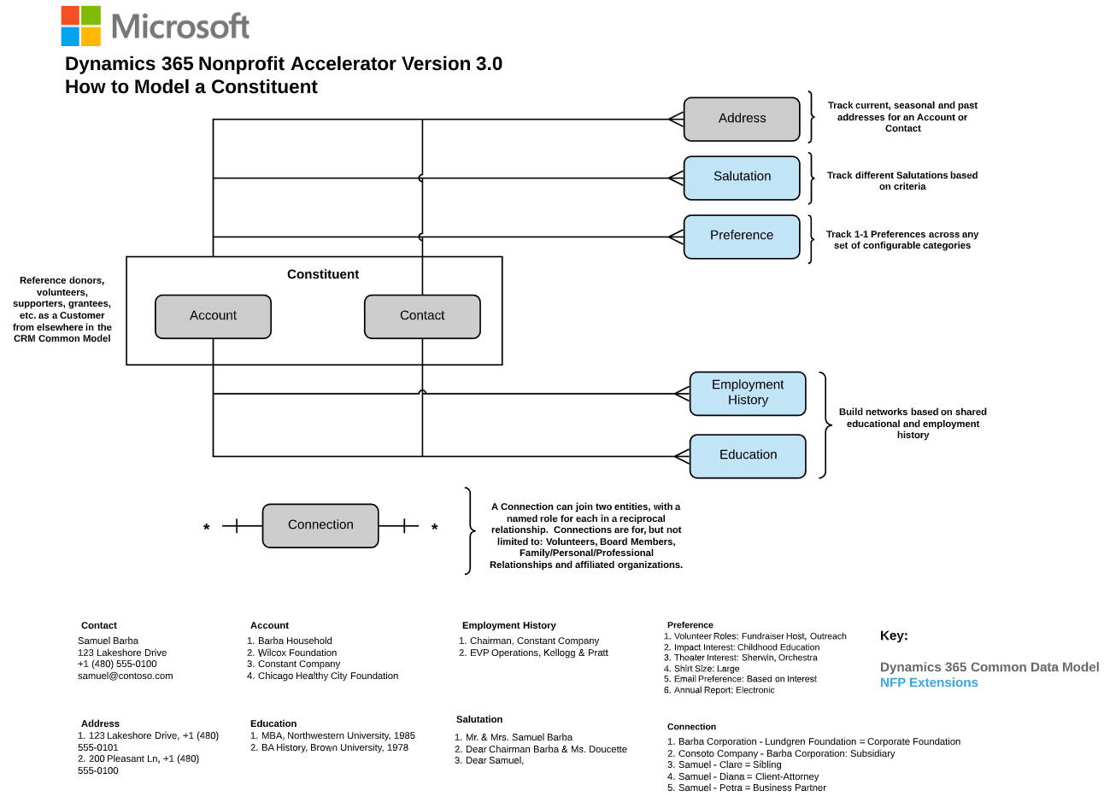

Figure 5: Diagram of How to model a Constituent

## How to Model Awards

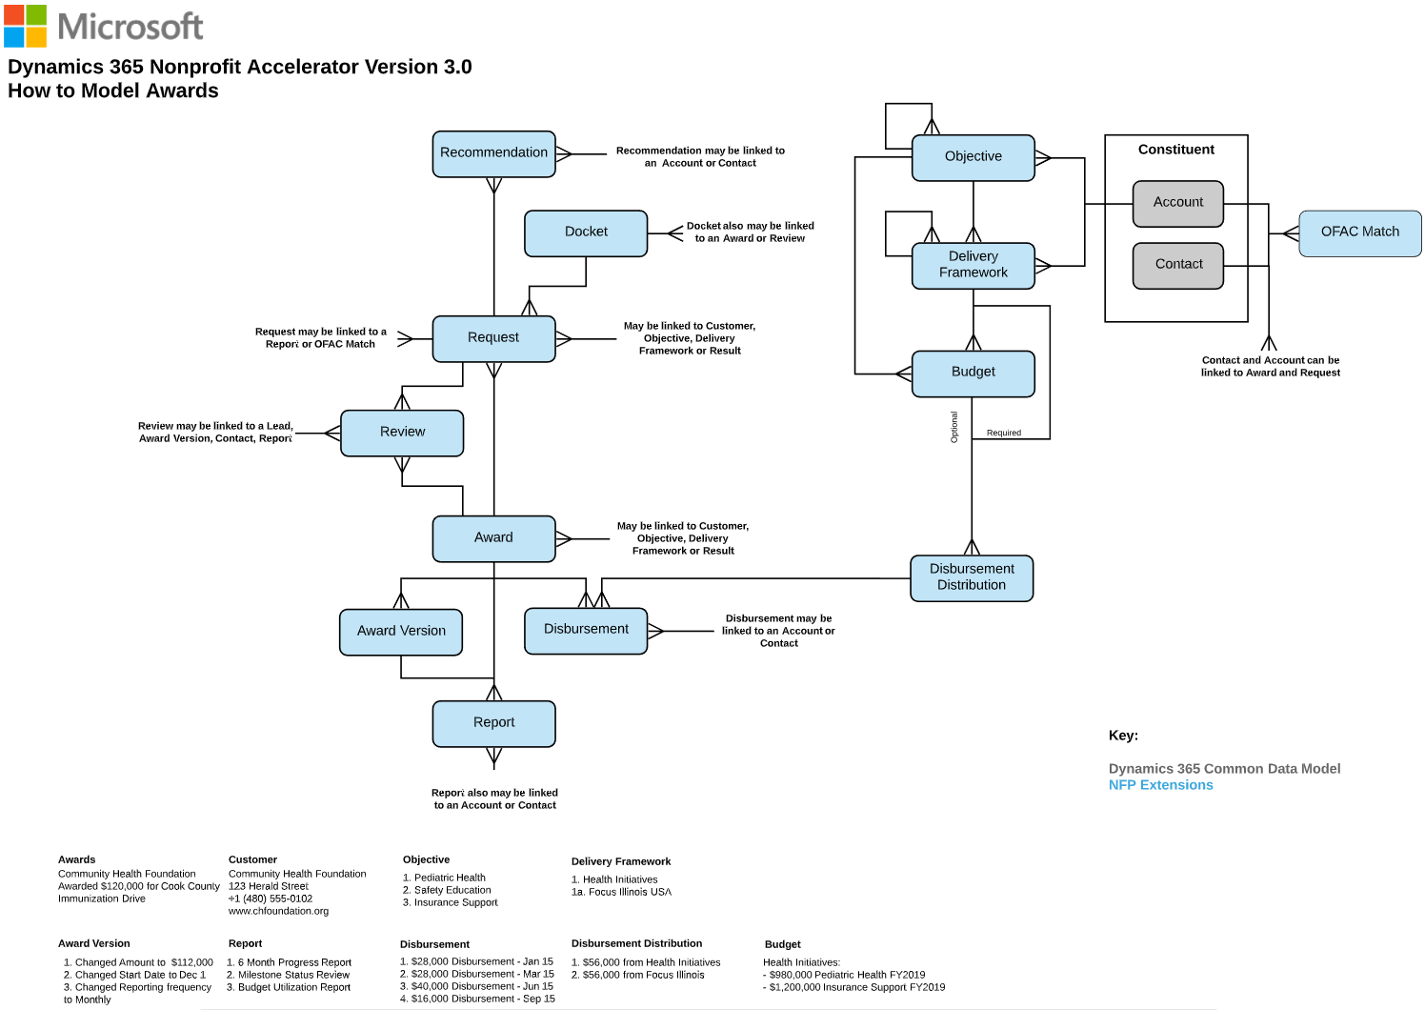

Figure 6: Diagram of How to Model Awards

## How to Model a Benefit Recipient

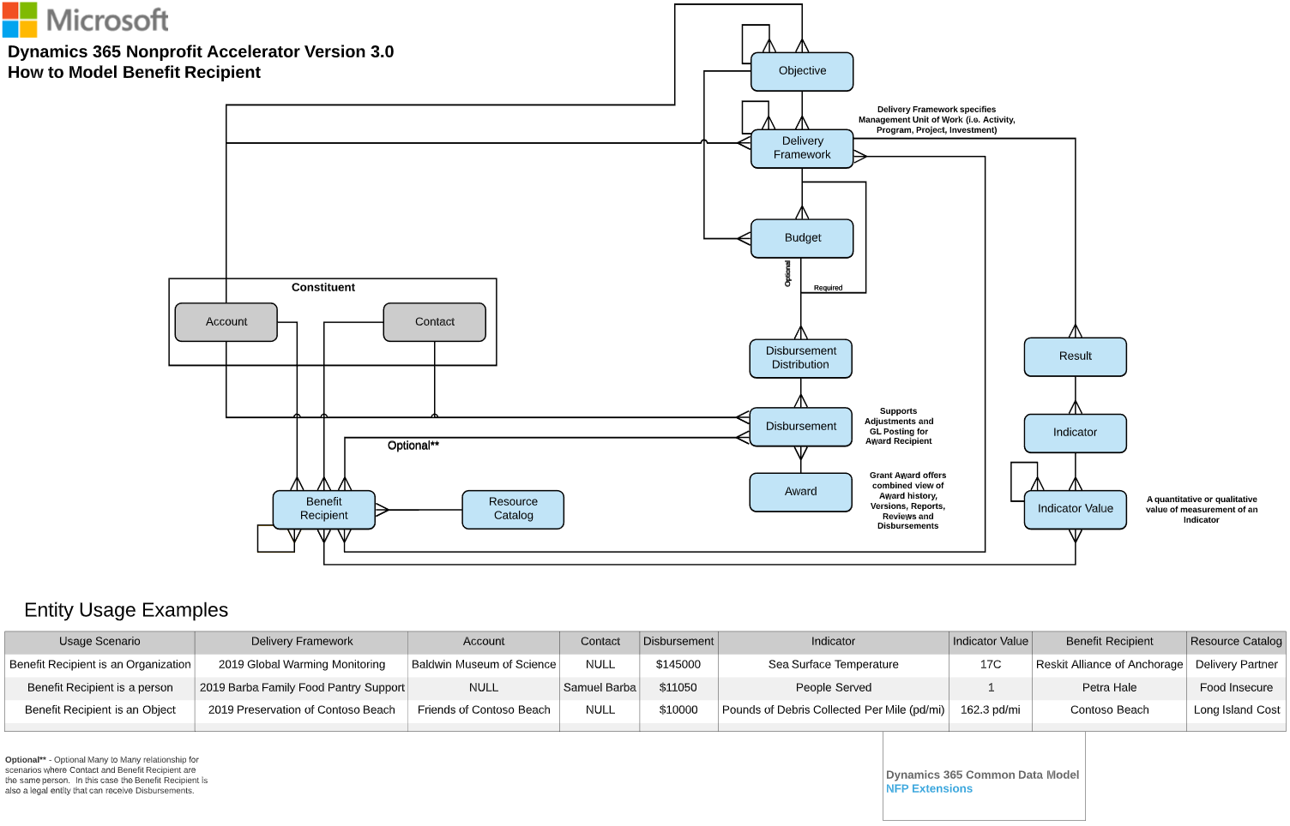

Figure 7: Diagram of How to Model a Benefit Recipient

## How to Model a Household

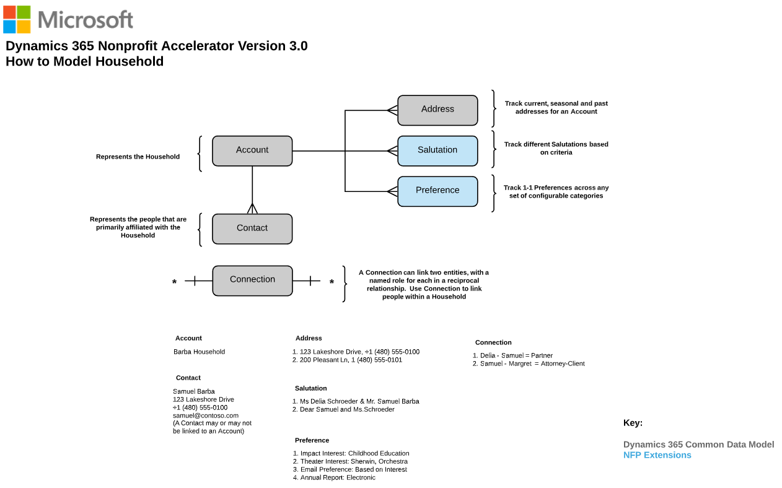

Figure 8: Diagram of How to Model a Household

## How to Model an Organization

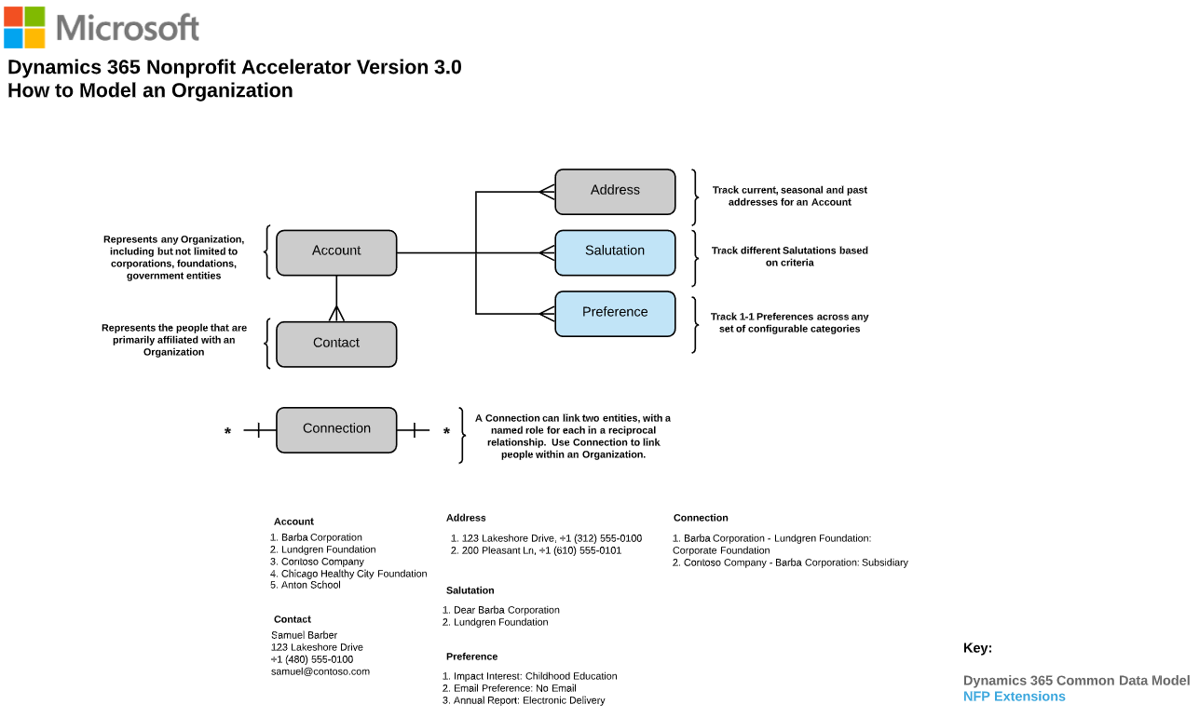

Figure 9: Diagram of How to Model an Organization

## How to Model Membership

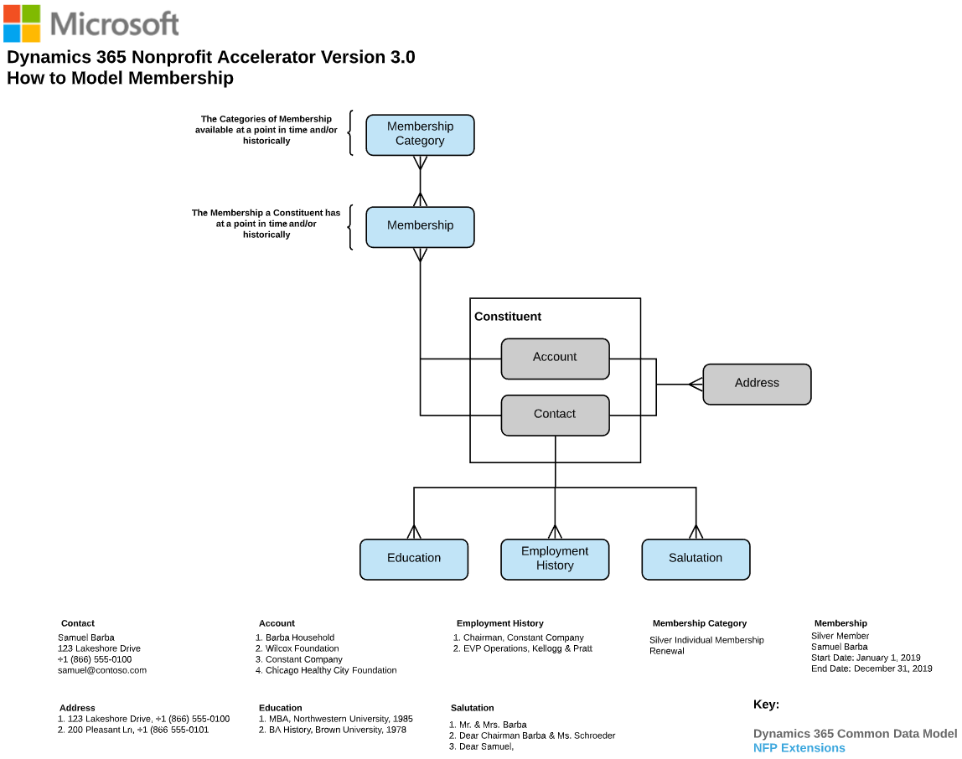

Figure 11: Diagram of How to Model Membership

## How to Model Fundraising

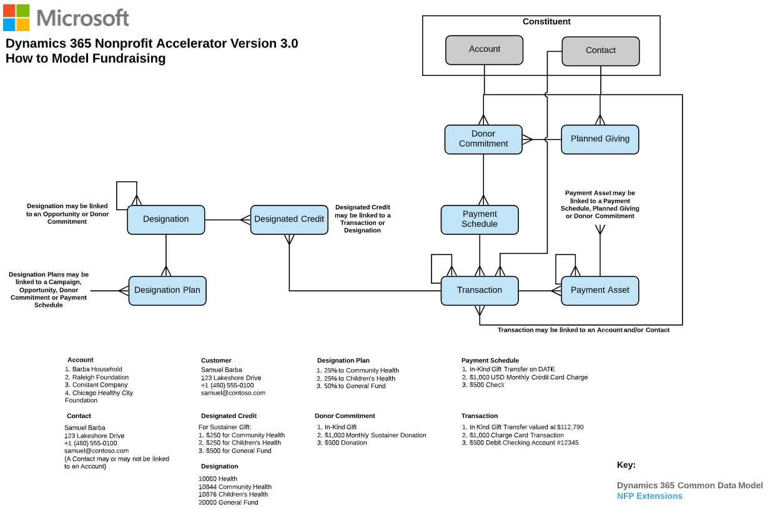

Figure 12: Diagram of How to Model Fundraising

## How to Model Fundraising to Program Delivery

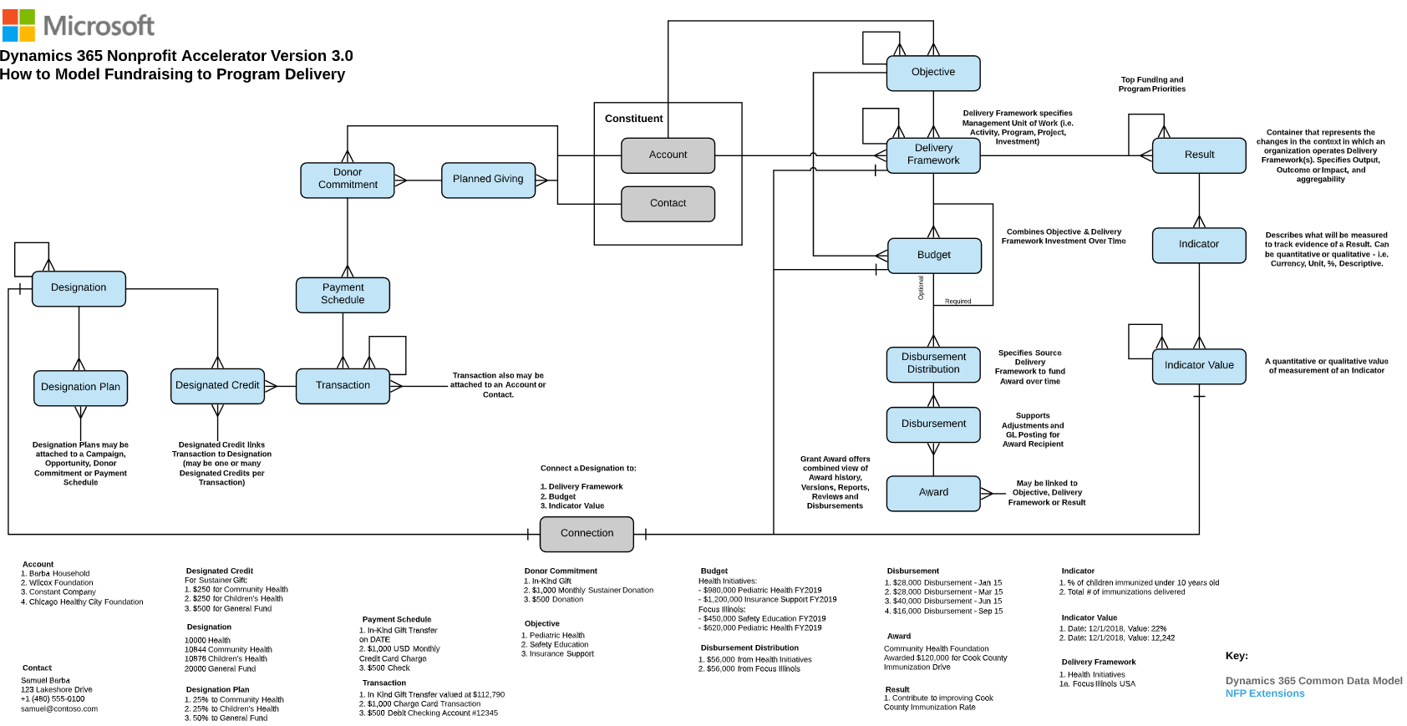

Figure 13: Diagram of How to Model Fundraising to Program Delivery

## How to Model Program Delivery & Results

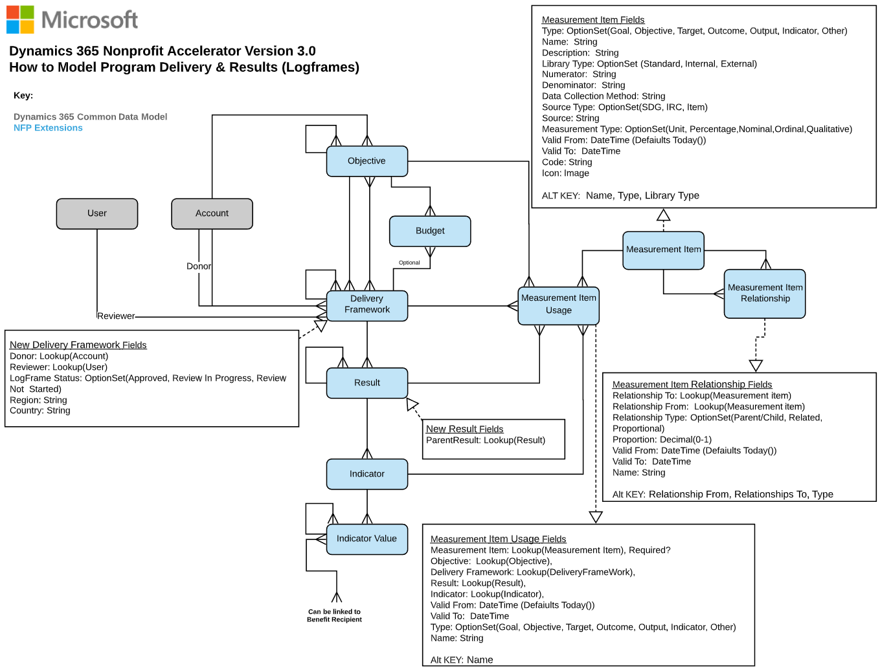

Figure 14: Diagram of How to Model Program Delivery and Results

## How to Model Program Delivery to Constituent

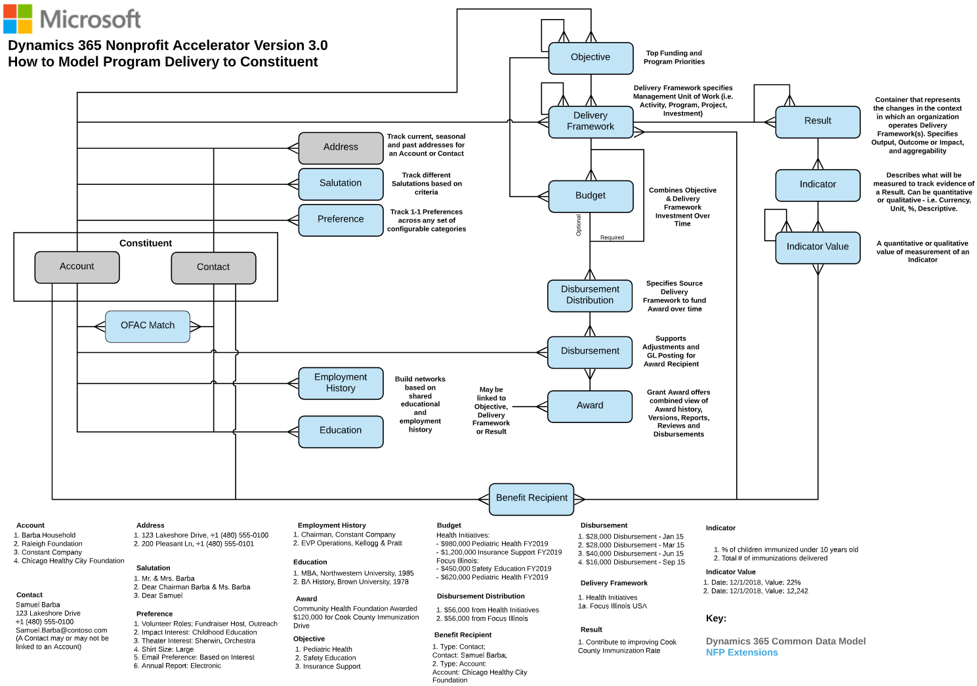

Figure 15: Diagram of How to Model Program Delivery to Constituent

## How to Model IATI Codelist Sync Process

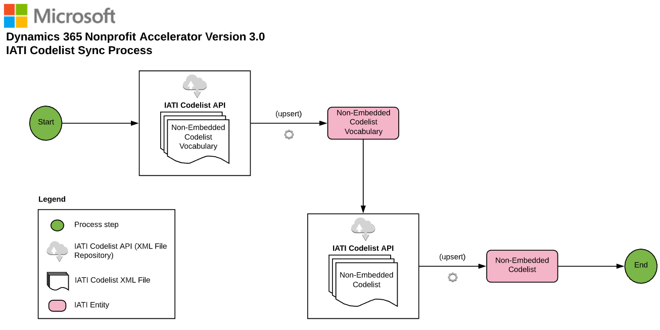

Figure 16: Diagram of Modeling IATI Codelist Sync Process

## How to Model IATI Organization & Activity Standards

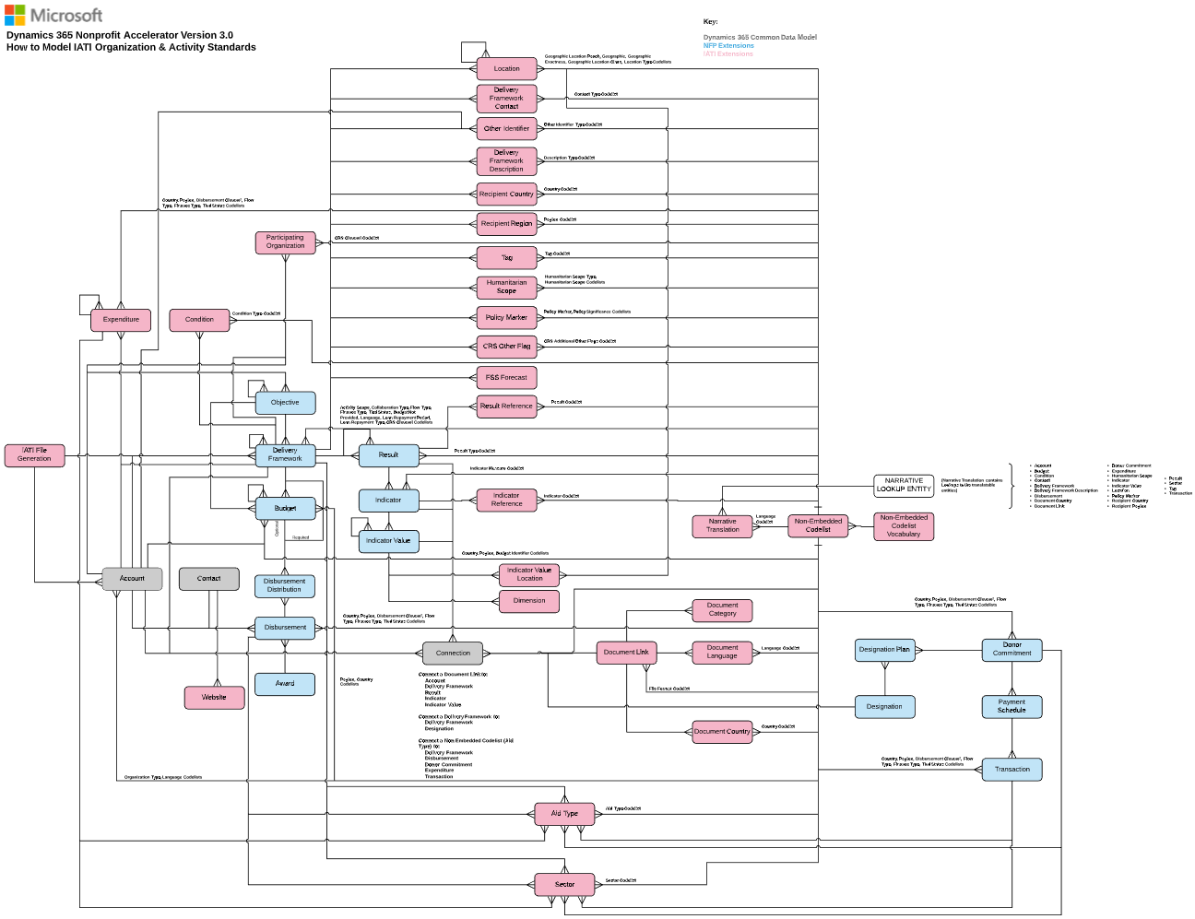

Figure 17: Diagram of Model IATI Organization & Activity Standards

## How to Model Case Management

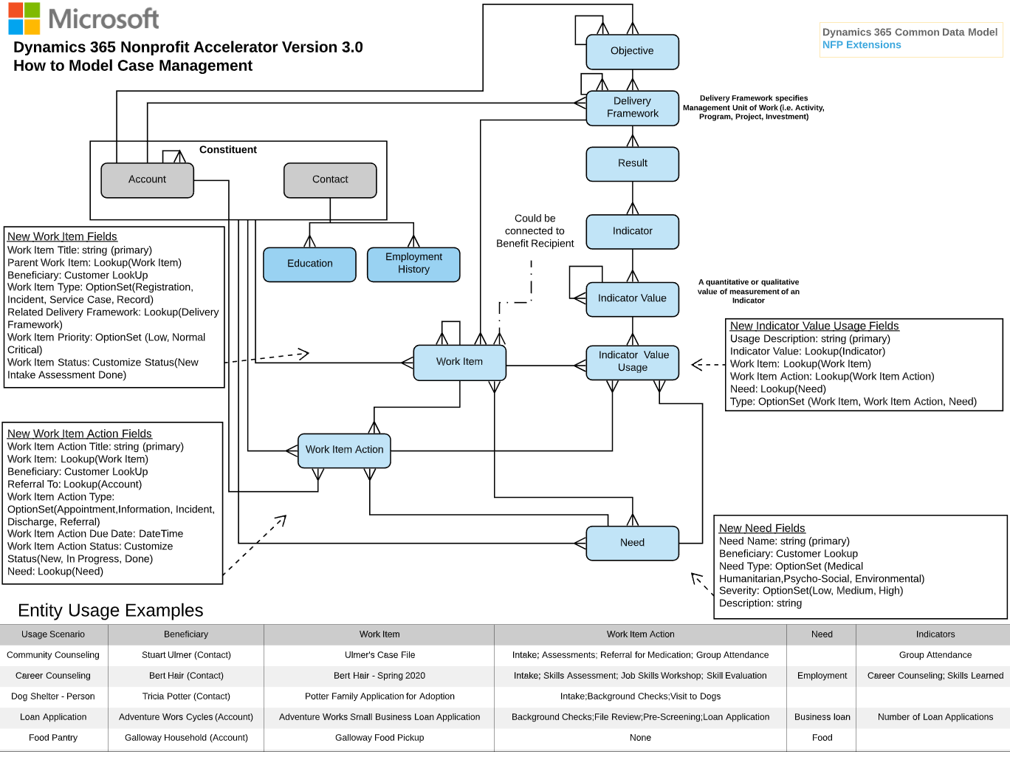

Figure 18: Diagram of Model of Case Management

## How to Model Project Management and Program Design

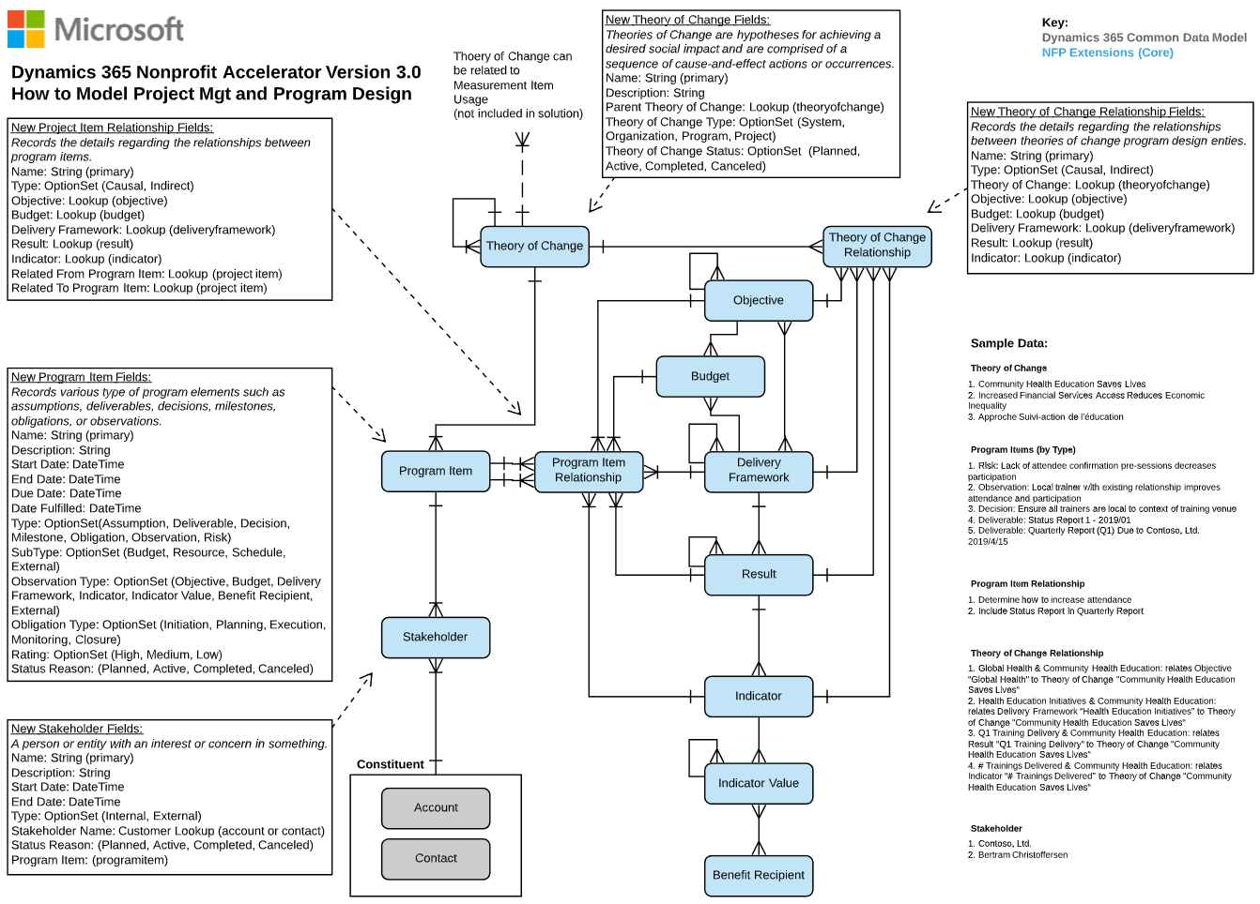

Figure 19: Diagram of Model Project Management and Program Design

## How to Model Assessment

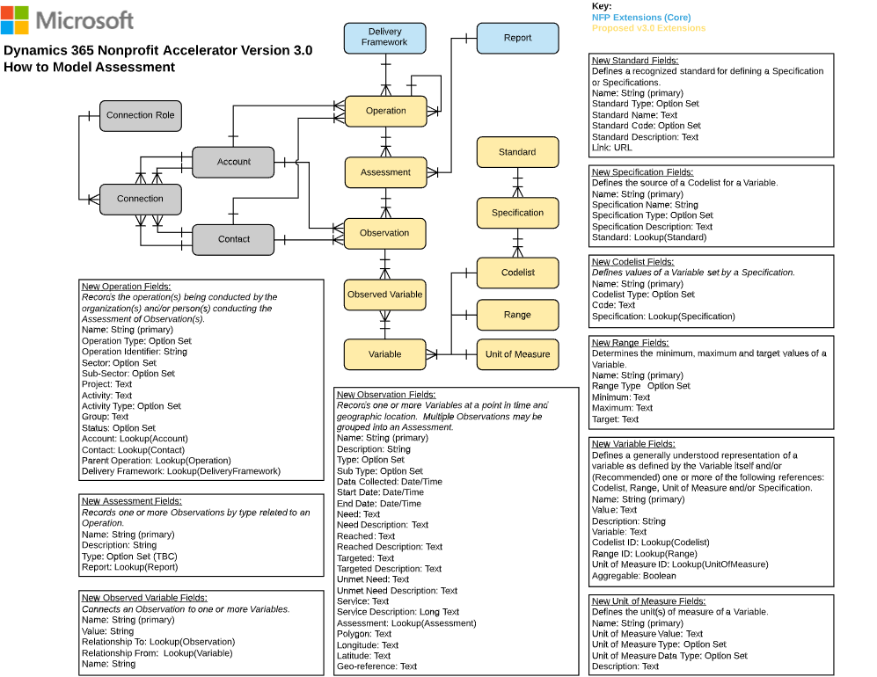

Figure 20: Diagram of Model Assessment

## How to Model Volunteer Management

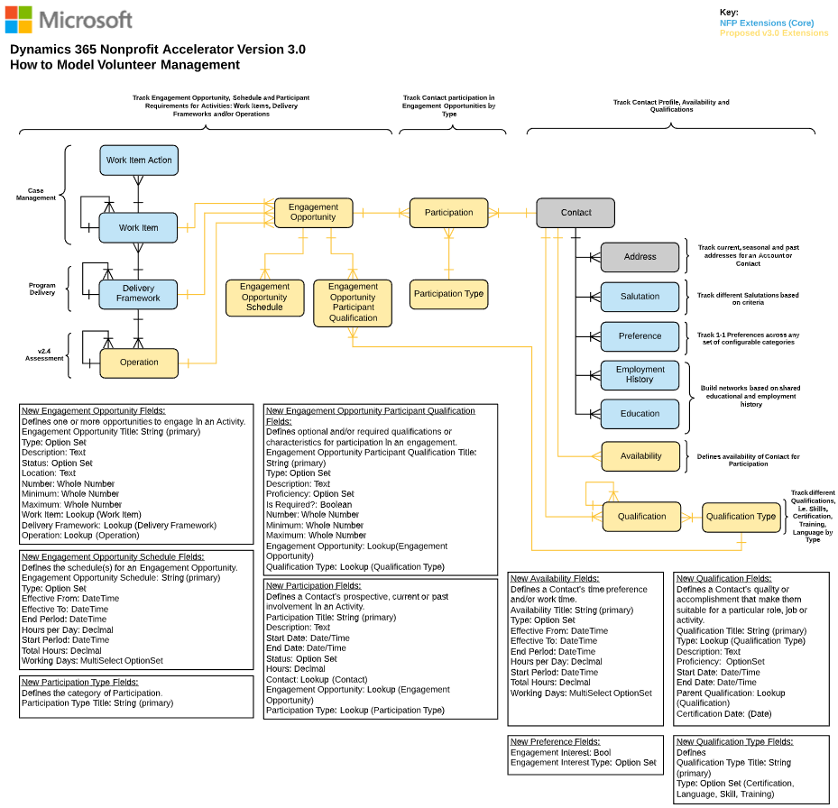

Figure 21: Diagram of Model Volunteer Management

## How to Model Frontline Humanitarian Logistics

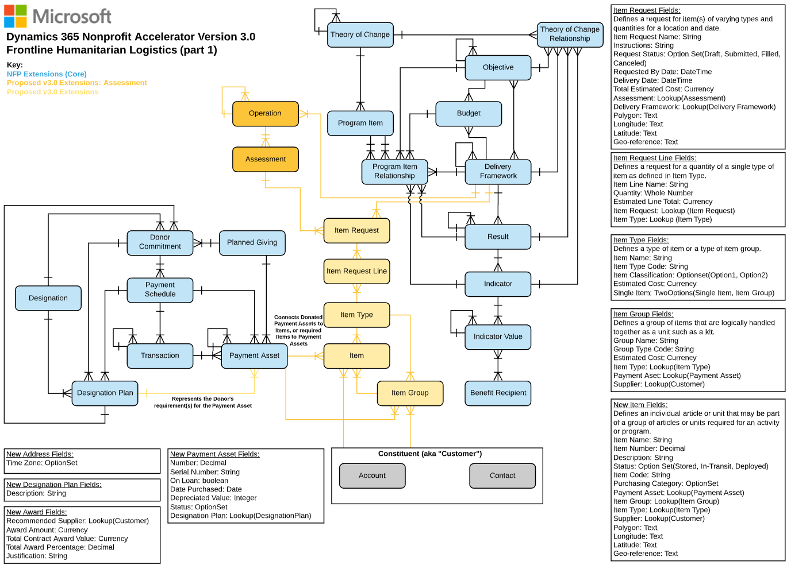

Figure 21: Diagram of Model Frontline Humanitarian Logistics