

Nonprofit Operations Toolkit

Admin Guide

**Published**: December 2020

**Release Version**: v1.1.3.5

Contents

Overview 3

Nomenclature Update 3

Getting Started 3

Minimum Requirements 3

Installing Nonprofit Operations Toolkit 5

Overview of Functionality 8

Setting up Nonprofit Operations Toolkit 8

Understanding Users & Security Roles 8

Company Information 10

Master Records 20

Worker Management 20

Vendor Management 23

Funder Management 24

Agreement Management 25

Award Management 27

Project Management 29

Budgets & Effort Plans 32

Project Budgeting 32

Cost Center Budgeting 36

Effort Planning 39

Worker Cost Schedules 41

Time & Expenses 42

Time Tracking 42

Expense Management 50

Setup Additional Capabilities 59

Add Document Storage using SharePoint 59

Get Microsoft Power Apps Office Add-in 59

Get the Power Apps Mobile app 59

Enable Data Auditing 59

Learn more about the Power Platform 59

# Overview

The Nonprofit Operations Toolkit helps small nonprofits implement effective project and awards management processes that reduce costs and build trust with funders. The toolkit consists of Power Apps that use familiar tools such as Excel and SharePoint to keep critical information accurate and accessible.

This toolkit is built on Microsoft’s Power Platform and integrates seamlessly with Office 365 capabilities. Though the solution does not depend directly on Microsoft Dynamics and does not require a Dynamics license, certain Power Apps functionality is made possible by the underlying technology of Dynamics 365 Customer Engagement and therefore shares documentation referenced throughout this material.

The toolkit makes use of key tables included in the [Dynamics 365 Nonprofit Accelerator](https://docs.microsoft.com/en-us/common-data-model/nfp-accelerator) including: Award, Budget, Designation and Delivery Framework.

# Nomenclature Update

Please note that the follow names have been updated and changed ([More Information](https://docs.microsoft.com/en-us/powerapps/maker/common-data-service/data-platform-intro#terminology-updates)):

|  |  |
| --- | --- |
| **Legacy term** | **Current term** |
| Entity, entities | Table, tables |
| Field, fields, Attribute, attributes | Column, columns |
| Record, records | Row, rows |
| Option set, multi select option sets  Picklist, picklists | Choice, choices |
| Two Options | Yes/No |

# Getting Started

The purpose of this material is to provide guidance for initial setup of the solution and creation of core records. Take a moment to review each section carefully prior to moving ahead.

## Minimum Requirements

Before using Nonprofit Operations Toolkit, we recommend that you verify that your computer or mobile device meets or exceeds the minimum system requirements for the solution.

### Browsers

|  |  |
| --- | --- |
| **Browser** | **Operating System** |
| Chrome (latest version) | Windows 8.1 and 10  Android 5 or later  iOS 8 or later  macOS 10.8 or later |
| Microsoft Edge (latest version) | Windows 10 |
| Microsoft Internet Explorer 11 (compatibility off) | Windows 8.1 and 10 |
| Mozilla Firefox | Windows 8.1 and 10 |
| Apple Safari (latest version) | iOS 8 or later  macOS 10.8 or later |

### Mobile Devices

|  |  |
| --- | --- |
| **Minimum required** | **Recommended** |
| iOS 9.3 or later | iOS 10 or later with at least 2GB of RAM |
| Android 5 or later | Android 7 or later with at least 4GB of RAM |

### Office

To use either the Nonprofit Operations Toolkit app or the Time & Expense mobile app, users must have a valid Office 365 account.

To get the most out of the web app with Microsoft Office integration features, such as Export to Excel, you must have one of the following Microsoft Office versions on the computer that is running the Nonprofit Operations Toolkit app:

* Office 365
* Office 2016

For more advanced reporting and analysis scenarios, you can connect directly to the Common Data Service using Excel and Power Query. For this capability you must have one of the following Microsoft Office versions on the computer that is running Excel:

* Office 365 ProPlus

### Power Apps

Many Office 365 licenses include a Power Apps for Office 365 license that allows users to run certain kinds of apps that access Office 365 data, however, this does not include the ability to run apps that store data in the Common Data Service.

For organizations that do not have Dynamics 365, Nonprofit Operations Toolkit requires users to have a standalone Power Apps license.

|  |  |
| --- | --- |
| **With this plan** | **A user can** |
| Power Apps Per App Plan  Power Apps Per User Plan Power Apps Plan 2 | Create and manage Power Apps environments (with permissions)  Work with the Nonprofit Operations Toolkit app  Work with the Time & Expense mobile app |
| Power Apps Plan 1 | Work with the Time & Expense mobile app |

To learn more about Power Apps licensing, see [Power Apps Licensing Overview](https://docs.microsoft.com/en-us/power-platform/admin/pricing-billing-skus).

|  |
| --- |
| **Note** |
| Licensing changes to Power Apps and Power Automate are coming in October 2019. To learn more, see [Power Apps and Power Automate licensing FAQs for October 2019](https://docs.microsoft.com/en-us/power-platform/admin/powerapps-flow-licensing-faq). |

## Installing Nonprofit Operations Toolkit

Nonprofit Operations Toolkit is distributed and deployed as one or more solution files. Solution files consist of a ZIP file that can contain pre-configured components including: apps, flows, tables, business rules and more.

To learn more about Power Apps solutions, see [Working with Solutions](https://docs.microsoft.com/en-us/powerapps/maker/common-data-service/solutions-overview).

### Getting the latest solution files

Nonprofit Operations Toolkit is distributed through an [open source repository on GitHub](https://github.com/microsoft/Industry-Accelerator-Nonprofit-Operations) for independent software vendors, system integrators and other partners to develop purpose-built solutions for nonprofit scenarios.

Visit the [Releases](https://github.com/microsoft/Industry-Accelerator-Nonprofit-Operations/releases) area of the repository for the latest solution files necessary for a complete installation include the following:

1. NonprofitCore
2. NonprofitOperationsToolkit
3. NonprofitOperationsToolkitFlows

Each file will have a suffix indicating the version of the file resulting in a file name such as: *NonprofitOperationsToolkit_1_1_3_4_managed.zip*.

### Create an environment and database

An environment is a space to store, manage, and share your organization’s data, apps, and flows. They also serve as containers to separate apps that may have different roles, security requirements, or target audiences. How you choose to use environments depends on your organization and the apps you are working with or trying to build. For example:

* You might choose to deploy your apps to a single environment.
* You might create separate environments that correspond to specific teams or departments in your organization, each containing the relevant data and apps for each audience.
* You might also create separate environments for different global branches of your organization.
* You might create separate environments that group the Test and Production versions of your apps.

To learn more about Power Apps environments, see [Manage Power Apps Environments](https://docs.microsoft.com/en-us/power-platform/admin/environments-overview). To learn more about plan planning for and administering Power Apps, see [Administering a Power Apps deployment](https://aka.ms/powerappsadminwhitepaper).

The database created within an environment uses the Common Data Service and is required by Nonprofit Operations Toolkit.

|  |
| --- |
| **Important** |
| When creating the database, you will be asked to select a currency. Choose the currency your organization uses as its base currency in your accounting system. The currency you choose will be setup as the base currency in the solution. |

|  |
| --- |
| **Tip** |
| If you are previewing or evaluating this solution, it is recommended that you create a new **Trial** environment to work in. |

To create a new environment and database for this solution, see [Create an environment in Power Apps](https://docs.microsoft.com/en-us/power-platform/admin/create-environment-powerapps).

### Import the solution

In a new environment, the solution (ZIP) files need to be imported in the following sequence:

1. NonprofitCore_x_x_x_x_managed.zip
2. NonprofitOperationsToolkit_x_x_x_x_managed.zip
3. NonprofitOperationsToolkitFlows_x_x_x_x_managed.zip

To import the solution files, navigate to your desired Power Apps environment and follow the steps outlined in [Import a Power Apps solution](https://docs.microsoft.com/en-us/powerapps/maker/common-data-service/import-update-export-solutions).

#### To validate app accessibility

Upon completion of the import process, validate that the solution is accessible:

1. Select **Apps** from the left navigation.
2. Note that the apps listed include:
   1. Nonprofit Operations Toolkit
   2. Nonprofit Operations Toolkit - Time & Expense
3. Select **Nonprofit Operations Toolkit**.
4. The web application will open in a new browser window.

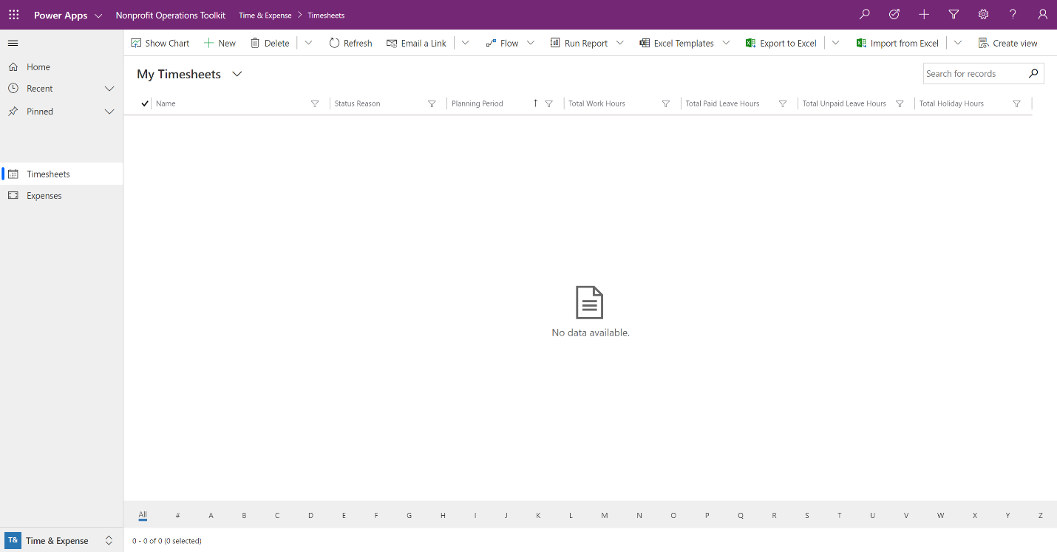

You are now ready to begin entering your organizations information, adding users and configuring additional Office 365 integration features.

## Overview of Functionality

Nonprofit Operations Toolkit includes a basic and functional configuration in several areas.

|  |  |
| --- | --- |
| **To** | **See** |
| Manage the core records that describe your organization such as business units, currencies, offices and planning periods. | Company Information |
| Create and manage detailed information about your workers, vendors, funders, awards and projects. | Master Records |
| Create and manage financial plans for projects and indirect costs or plan how your workers’ time will be allocated across efforts. | Budgets & Effort Plans |
| Collect, track and compile time and reimbursable expenses associated with projects or indirect costs. | Time & Expense |
| Setup integrated document storage with SharePoint, use the Excel add-in to interact directly with your data or enable data auditing. | Additional Capabilities |

# Setting up Nonprofit Operations Toolkit

Information in Nonprofit Operations Toolkit is structured using basic records and creating relationships among them. This model promotes data quality and reliable reporting while offering information managers a degree of control over what records are available for use.

Many records refer to foundational pieces of information such as Planning Periods or Currencies. For that reason, setting up the solution starts by entering this foundational information.

## Understanding Users & Security Roles

Users can be managed at an environment level and are based on the user accounts associated with your Office 365 tenant. For more information see, [Configure Environment Security](https://docs.microsoft.com/en-us/power-platform/admin/database-security).

Security roles are used to limit access to data. To learn more about how security roles are used by Power Apps see, [Security Roles and Privileges](https://docs.microsoft.com/en-us/dynamics365/customer-engagement/admin/security-roles-privileges).

In addition to the security roles provided by the platform, there are a series of preconfigured security roles that come with Nonprofit Operations Toolkit. An individual user can have any combination of roles assigned; however, they should have the Nonprofit Team Member role assigned as a minimum.

|  |
| --- |
| **Important** |
| The System Administrator role has sweeping permissions to modify the system. To avoid unintended changes during normal operation, it is good practice to only assign this role to a user account created specifically for the purposes of making platform changes. |

|  |  |
| --- | --- |
| **Security Role** | **Description** |
| Nonprofit Team Member | All users expected to access the toolkit should have this role assigned. With this role, users are able to track Time and Expenses. |
| Nonprofit Team Manager | Responsible for approval of time of assigned Workers. |
| Nonprofit Global Cost Center Manager | Responsible for planning, executing administrative work and approving cost center expenses. |
| Nonprofit Global Project Manager | Responsible for budgeting, executing projects, approving project expenses, as well as effort planning. |
| Nonprofit Global HR Administrator | Responsible for managing all Worker record information. |
| Nonprofit Global Finance Administrator | Responsible for core accounting functions and records. |

Each role has specifically configured access to information throughout the system. Based on a user’s assigned role(s) they may be able to see a certain type of record or may only be able view the record and not modify it.

### To delete records

Once a record is created, other records may refer to it to build a more complete picture of your organization. For this reason, the ability to Delete records is restricted to specific security roles.

|  |
| --- |
| **Tip** |
| In many cases, it is better practice to deactivate a record rather than delete it. For more information, see [Deactivate accounts or contacts](https://docs.microsoft.com/en-us/powerapps/user/deactivate-activate-account-contact) for an example on working with active or inactive records. |

### To assign security roles

To see a list of the enabled users in your environment, use the following steps:

1. Open the web application and click the settings icon () in the topmost menu bar then choose **Advanced Settings**.
2. Click the dropdown arrow next to **Settings** in the topmost menu bar then choose **Security**.
3. Click **Users**.
4. Select a user in the list by ticking the checkbox to the left of the users name.
5. Click **MANAGE ROLES** in the menu bar above the list.
6. Tick the checkbox the left of one or more role names and click **OK**.

### To associate a worker to a user

Associating a worker with a user record allows the system to show relevant information to that user under certain circumstances. Each user should have an associated worker record.

Associate a worker to a user using these steps:

1. Open the web application and go to **Administration**.
2. Select **Users** from the left navigation.
3. Select a user from the list.
4. In the **Worker** field, choose the worker associated with this user.
5. Click **Save** in the lower-right corner of the window.

|  |
| --- |
| **Important** |
| To ensure the solution behaves as expected, start by entering relevant **Company Information**. |

## Company Information

The most capabilities of the toolkit build upon the records outlined in this section. It is common for these records to be tightly controlled and managed by individuals responsible for managing financial information.

### Add an Administrative Worker

Throughout the initial setup, records will require a reference to a worker. Creating the first worker at this point simplifies setup activities that follow.

|  |
| --- |
| **Tip** |
| Consider adding a worker in your organization that is typically responsible for managing financial information. |

#### To create the initial worker record

1. Open the web application and go to **Master Records**.
2. Select **Workers** in the left navigation.
3. Click **New** in the menu bar above the list.
4. Enter minimum required fields for your new worker.
5. Click **Save & Close** in the menu bar above the record.

To start entering your initial company information, open the web application and select **Administration** from the area selector in the lower-left corner of the screen. You will notice the left-navigation is divided into three groups: Finance, Company and System. Follow the steps in the sections below to enter baseline company information.

### Business Units

Business units are logical groupings of related business activities. They are often described as departments or divisions and have a parent/child relationship to support reporting. Your organization has a default business unit created for you that is the root business unit and is unable to by modified. All other business units roll-up to that organization.

|  |
| --- |
| **Example** |
| Consider the following organization that has two divisions each with two departments:   * Organization   + Public Health Initiatives     - Zambia Country Program     - Tropical Diseases   + Administrative Services     - Finance & Technology     - Human Resources |

Each business unit can have just one parent business unit. Each business unit can have multiple child business units.

|  |
| --- |
| **Note** |
| Business Units are a concept inherited from Power Apps’ use of the Dynamics 365 Customer Engagement platform. To learn more, see [Create or Edit Business Units](https://docs.microsoft.com/en-us/dynamics365/customer-engagement/admin/create-edit-business-units). |

#### Operational details

##### Relevant security roles

To create a new business unit, a user needs the following Security Role:

* Nonprofit Global Finance Administrator

#### To add a business unit

1. Open the web application and go to **Administration**.
2. Select **Business Units** from the left navigation.
3. Click **New** in the menu bar above the list.
4. Enter details for your new business unit.
5. Click **Save & Close** in the menu bar above the record.

### Currencies

When a database is created in a Power Apps environment, a currency is selected. This is your organization’s base currency and will appear as the default currency in the system. Nonprofit Operations Toolkit is multicurrency and currencies are referenced by several records throughout the system.

#### Operational details

##### Relevant security roles

To add a new currency, a user needs the following Security Role:

* Nonprofit Global Finance Administrator

#### To add a currency

If you receive an award or need to create a budget in a different currency, you can add a new currency and its exchange rate using these steps:

1. Open the web application and go to **Administration**.
2. Select **Currencies** in the left navigation.
3. Click **New** in the menu bar above the list.
4. Enter details for your new currency.
5. Click **Save & Close** in the menu bar above the record.

The following table shows sample values for an organization whose base currency is USD and needs to add the Euro as a currency.

|  |  |  |
| --- | --- | --- |
| **Property** | **Value** | **Description** |
| Currency Name | Euro | Name of the currency |
| Currency Code | EUR | ISO Code of the currency |
| Currency Symbol | € | Symbol used when currency is displayed |
| Exchange Rate | 0.89 | Value of new currency relative to one unit your base currency (e.g. 1 USD equals 0.89 EUR) |
| Currency Precision | 2 | Number of values to show after the decimal |

|  |
| --- |
| **Note** |
| Exchange rates do not update automatically and will need to be manually updated whenever the use of a new rate is desired.  The updated exchange rate does not immediately apply to amounts of the existing records. When any amount field gets updated on an existing record, the updated exchange rates are used to calculate new base values on that record. |

### Offices

Offices represent physical locations that your organization works from. This can be useful for internal cost analysis, understanding geographic aspects of workers, agreements, vendors or when creating financial reports for international scenarios.

#### Operational details

##### Relevant security roles

To add a new office, a user needs the following Security Role:

* Nonprofit Global Finance Administrator

#### To add an office

1. Open the web application and go to **Administration**.
2. Select **Offices** from the left navigation.
3. Click **New** in the menu bar above the list.
4. Enter details for your new office.
5. Click **Save & Close** in the menu bar above the record.

### Cost Centers

Cost centers represent a specific collection of costs associated with an organizational unit that may be tracked for accounting purposes. Cost centers are useful for tracking operating or indirect costs and they are associated with a single Business Unit.

Nonprofit Operations Toolkit allows organizations to create budgets for cost centers, as well as associate time and expenses.

|  |
| --- |
| **Example** |
| We will use the example from the Business Units section earlier in this document to illustrate how the organization could add cost centers to plan or track operating costs associated with each department and division:   * Organization   + Public Health Initiatives   ***Public Health Initiatives Management Costs***   * + - Zambia Country Program   ***Zambia Country Program Management Costs***  ***Zambia Country Program Facilities Costs***   * + - Tropical Diseases   ***Tropical Diseases Management Costs***   * + Administrative Services   ***Administrative Services Management Costs***   * + - Finance & Technology   ***Global Accounting Costs***  ***Global Technology Costs***   * + - Human Resources   ***Global Human Resources Costs*** |

#### Operational details

##### Relevant security roles

To add a new cost center, a user needs the following Security Role:

* Nonprofit Global Finance Administrator

##### Dependent functionality

Noteworthy workflows, rules or functions that rely on accurate cost center information include:

|  |  |
| --- | --- |
| **Topic** | **Description** |
| Budgeting, effort planning, time and expense management functionality | Often expects a cost center if a project and activity are not supplied by a user. |
| Expense submission | Expects a cost center to have a manager. |

#### To add a cost center

1. Open the web application and go to **Administration**.
2. Select **Cost Centers** from the left navigation.
3. Click **New** in the menu bar above the list.
4. Enter details for your new cost center.
5. Click **Save & Close** in the menu bar above the record.

|  |
| --- |
| **Note** |
| Cost centers require a worker record be identified as the cost center manager. If you are setting up your first cost center and did not setup an initial worker, see Add an Administrative Worker. |

### Funds

Funds are used to plan and track the use of financial resources provided to your organization in addition to awards. A fund may have specific restrictions associated with use of the resources or it may be unrestricted.

To facilitate reporting, funds can roll-up to a parent.

|  |
| --- |
| **Example** |
| In this example, the organization has a top-level fund with restrictions that dictate how resources must be used. Child funds have been added that share those restrictions, as well as carry restrictions that are specific to each fund.   * Water Treatment Fund   + Water for Maternal Health   + Clean Water for Schools |

#### Operational details

##### Relevant security roles

To add a new fund, a user needs the following Security Role:

* Nonprofit Global Finance Administrator

##### Dependent functionality

Noteworthy workflows, rules or functions that rely on accurate fund information include:

|  |  |
| --- | --- |
| **Topic** | **Description** |
| Project budgeting | A specific fund can be associated with a project budget line to indicate planned use of those resources. |

#### To add a fund

1. Open the web application and go to **Administration**.
2. Select **Funds** from the left navigation.
3. Click **New** in the menu bar above the list.
4. Enter details for your new fund.
5. Click **Save & Close** in the menu bar above the record.

### GL Accounts

General ledger accounts are created and maintained in your accounting system. Not all the GL accounts in your accounting system need to be added. Only expense-type GL accounts are referenced in the toolkit and you may only need to enter accounts that you intend to use during budgeting.

#### Operational details

##### Relevant security roles

To add a new GL account, a user needs the following Security Role:

* Nonprofit Global Finance Administrator

##### Dependent functionality

Noteworthy workflows, rules or functions that rely on accurate GL account information include:

|  |  |
| --- | --- |
| **Topic** | **Description** |
| Budgeting | Project and cost center budgets lines map to specific GL accounts to enable reporting when compared with posted transactions from your financial system. |
| GL Transactions | Posted GL transactions from your financial system can be mapped to records and stored in the toolkit database to facilitate reporting. |

|  |
| --- |
| **Tip** |
| Using a name that includes the name of the account and the number makes their use in the system more convenient (e.g. TRAVEL – 6200). |

#### To add a GL account

1. Open the web application and go to **Administration**.
2. Select **GL Accounts** from the left navigation.
3. Click **New** in the menu bar above the list.
4. Enter details for your new GL account.
5. Click **Save & Close** in the menu bar above the record.

### Pay Frequencies

Pay frequencies are used to define the timing for compensation (e.g. Annual, Hourly) and provide conversion factors to be used when converting a compensation amount from one frequency to another.

#### Operational details

##### Relevant security roles

To add a new pay frequency, a user needs the following Security Role:

* Nonprofit Global Finance Administrator

##### Dependent functionality

Noteworthy workflows, rules or functions that rely on accurate pay frequency information include:

|  |  |
| --- | --- |
| **Topic** | **Description** |
| Worker Cost Schedules | This process relies on converted values of compensation and benefits. |

#### Standard pay frequencies

A standard set of pay frequency values should be entered as follows:

|  |  |  |  |  |  |
| --- | --- | --- | --- | --- | --- |
| **Name** | **Type** | **Annual** | **Monthly (12)** | **Weekly** | **Hourly** |
| Annual | Annual | 1 | 0.083333333 | 0.019230769 | 0.000480769 |
| Monthly | Monthly (12) | 12 | 1 | 0.230769 | 0.005769 |
| Monthly 13 | Monthly (13) | 13 | 1.083333 | 0.25 | 0.00625 |
| Weekly | Weekly | 52 | 4.333333 | 1 | 0.025 |
| Hourly | Hourly | 2080 | 173.333333 | 40 | 1 |

#### To add standard pay frequencies

1. Open the web application and go to **Administration**.
2. Select **Pay Frequencies** from the left navigation.
3. Click **New** in the menu bar above the list.
4. Enter details for your new pay frequency.
5. Click **Save & Close** in the menu bar above the record.
6. Repeat until the full set is entered.

### Benefit Rates

Benefit rates are used to calculate a worker’s anticipated total cost (compensation and benefits). For example, if a worker’s total cost with financial compensation and benefits is $36 per hour with $25 per hour (71.4%) going to financial compensation and $11 per hour going toward benefits, you have an effective benefit rate of 30.5%.

Benefit rates are entered as a decimal so a benefit rate of 30.5% would be 0.305.

#### Operational details

##### Relevant security roles

To add a new benefit rate, a user needs the following Security Role:

* Nonprofit Global Finance Administrator

#### To add a benefit rate

1. Open the web application and go to **Administration**.
2. Select **Benefit Rates** from the left navigation.
3. Click **New** in the menu bar above the list.
4. Enter details for your new benefit rate.
5. Click **Save & Close** in the menu bar above the record.

### Planning Periods

Planning periods are used to plan and track cost and effort. These are most often simply calendar months of the year. It is important that these be controlled and setup accurately taking care to enter the month, year, start and end dates.

|  |
| --- |
| **Tip** |
| Budgets rely heavily planning periods and can span multiple years. If you operate financially on monthly basis, it is recommended to add planning periods for several years in the future and control use of specific periods through activation or deactivation. |

#### Operational details

##### Relevant security roles

To add a new planning period, a user needs the following Security Role:

* Nonprofit Global Finance Administrator

##### Dependent functionality

Noteworthy workflows, rules or functions that rely on accurate planning period information include:

|  |  |
| --- | --- |
| **Topic** | **Description** |
| Budgeting | A process that generates period-specific amounts for budget lines relies on active planning periods. |
| Effort planning | Effort plans are specific to individual planning periods. |
| Time tracking | An active planning period is required to create a timesheet. |
| Worker Cost Schedules | This process relies on active planning periods. |

|  |
| --- |
| **Important** |
| To ensure budget processes run as expected, after creating a series of planning periods revisit each new record to set the Next Period value to period that immediately follows. |

#### To add a planning period

1. Open the web application and go to **Administration**.
2. Select **Planning Periods** from the left navigation.
3. Click **New** in the menu bar above the list.
4. Enter details for your new planning period.
5. Click **Save & Close** in the menu bar above the record.
6. Review all planning periods to ensure a Next Period value is set where possible.

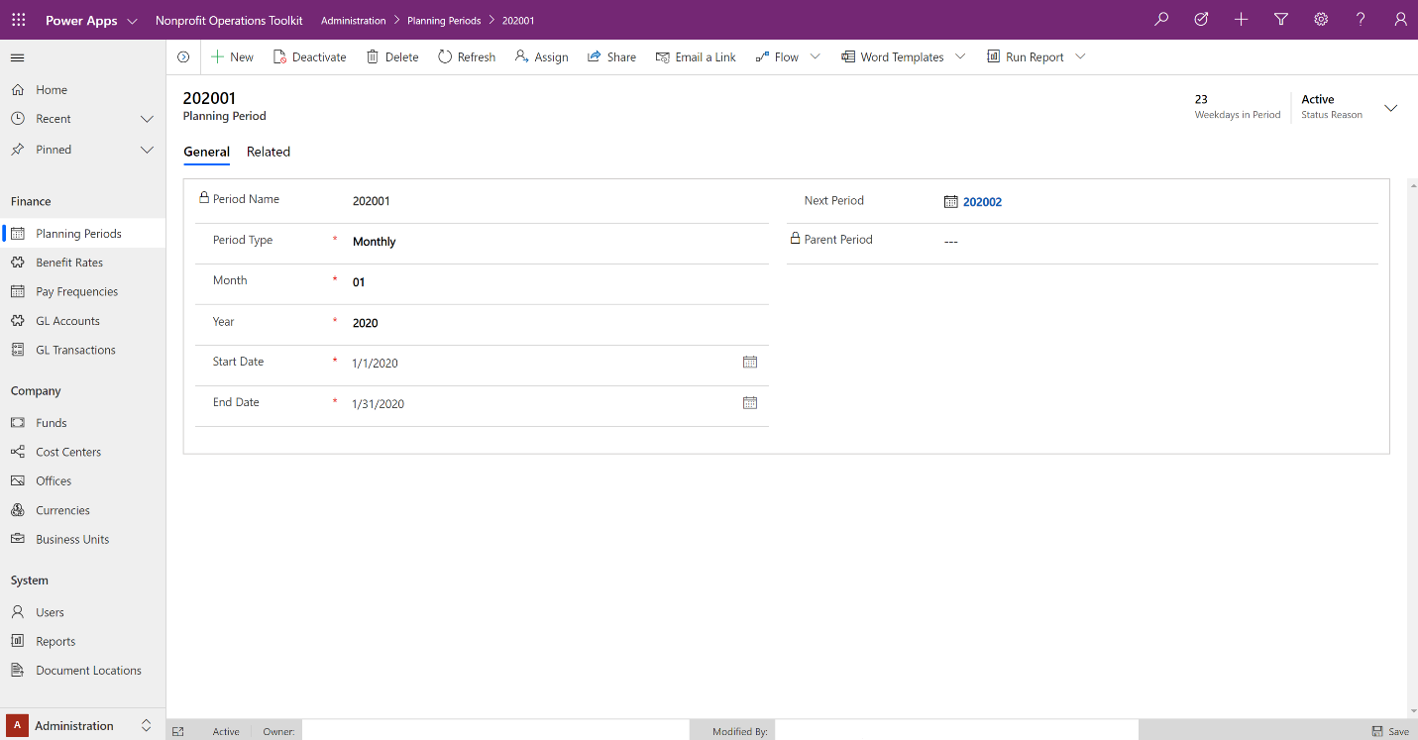

# Master Records

Master records are pieces of information that your organization relies on to conduct operations. This information warrants centralized management and control to ensure accuracy and reliability.

To start, open the web application and select **Master Records** from the area selector in the lower-left corner of the screen. Follow the steps in the sections below to enter your initial master records.

## Worker Management

Workers represent the people that contribute toward operational or project delivery efforts. While Nonprofit Operations Toolkit does not have full Human Capital Management capabilities, it is useful to maintain basic personnel information in the system for use in budgeting and planning.

### Operational Details

#### Relevant security roles

To add a new worker, identification number or compensation plan, a user needs the following Security Role:

* Nonprofit Global HR Administrator

#### Dependent functionality

Noteworthy workflows, rules or functions that rely on accurate worker information include:

|  |  |
| --- | --- |
| **Topic** | **Description** |
| Time & Expense app | Requires a worker to be associated with a user. |
| Time submission | Expects a worker to have a manager. |
| Worker Cost Schedule | Uses compensation information to generate records. |

### Adding Workers

Maintaining accurate worker information supports additional processes including budgeting, effort planning and time management.

#### To add a worker

1. Open the web application and go to **Master Records**.
2. Select **Workers** in the left navigation.
3. Click **New** in the menu bar above the list.
4. Enter minimum required fields for your new worker.
5. Click **Save & Close** in the menu bar above the record.

Worker information is categorized into three areas: Profile, Personal and Compensation. Follow the steps below to create a worker with information in all three areas.

#### To add worker profile information

1. Open the web application and go to **Master Records**.
2. Select **Workers** from the left navigation.
3. Click **New** in the menu bar above the list.
4. Enter profile details for your new worker.
5. Click **Save** in the menu bar above the record.

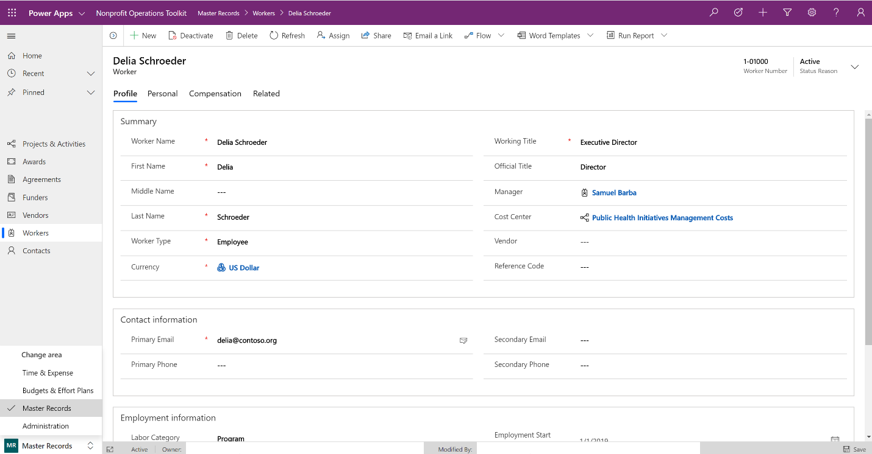

#### To add personal information

1. After saving a worker record, click the **Personal** tab above the form.
2. Enter personal details for your new worker.
3. If you choose to add an identification number, you can use your browser’s back button to return to the record.
4. Click **Save** in the lower-right corner of the window.

#### To add compensation information

To maintain an accurate history of compensation factors for a given worker, the toolkit supports effective dating and can have multiple compensation plans active at the same time.

|  |
| --- |
| **Tip** |
| In scenarios where a component of a worker’s compensation is changing (e.g. new pay or benefit rate), consider setting the expiration date on the affected plan and creating a new plan with the effective date of the change. |

1. After saving a worker record, click the **Compensation** tab above the form.
2. Click **Add New Compensation Plan** on the right side of the menu above the compensation plans list.
3. Enter compensation plan details for your worker.
4. Click **Save** in the lower-right corner of the window.
5. Use your browser’s back button to return to the worker record or use the breadcrumb links in the topmost menu bar.

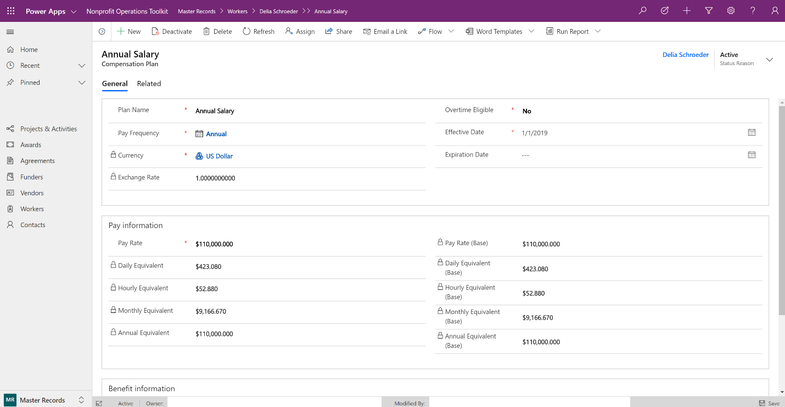

## Vendor Management

Vendors records track information about the organizations you make payments to while conducting operations. In addition to general information, agreements and other documents can be associated directly with vendors.

### Operational Details

#### Relevant security roles

To add a new vendor, a user needs the following Security Role:

* Nonprofit Global Finance Administrator

### Adding Vendors

Managing centralized vendor information ensures agreements, payments and documents are accessible and accurate. The toolkit supports a parent/child relationship among vendors in cases where it is necessary to track a distinct record for a vendor that may roll-up to a larger organization.

#### To add a vendor

1. Open the web application and go to **Master Records**.
2. Select **Vendors** from the left navigation.
3. Click **New** in the menu bar above the list.
4. Enter details for your new vendor.
5. Click **Save & Close** in the menu bar above the record.

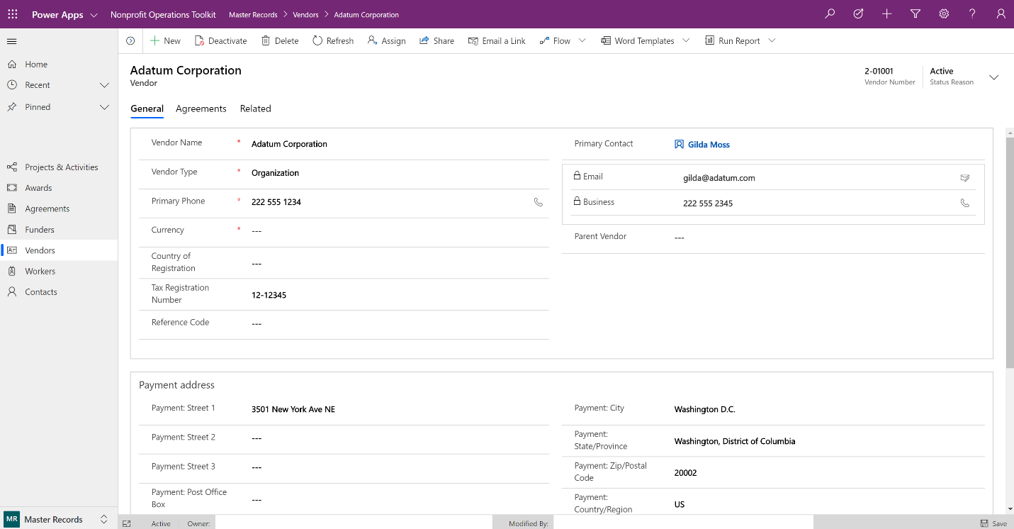

## Funder Management

Funders are those organizations or individuals that provide resources for use by your organization.

### Operational Details

#### Relevant security roles

To add a new funder, a user needs the following Security Role:

* Nonprofit Global Finance Administrator

### Adding a Funder

#### To add a funder

1. Open the web application and go to **Master Records**.
2. Select **Funders** from the left navigation.
3. Click **New** in the menu bar above the list.
4. Enter details for your new funder.
5. Click **Save & Close** in the menu bar above the record.

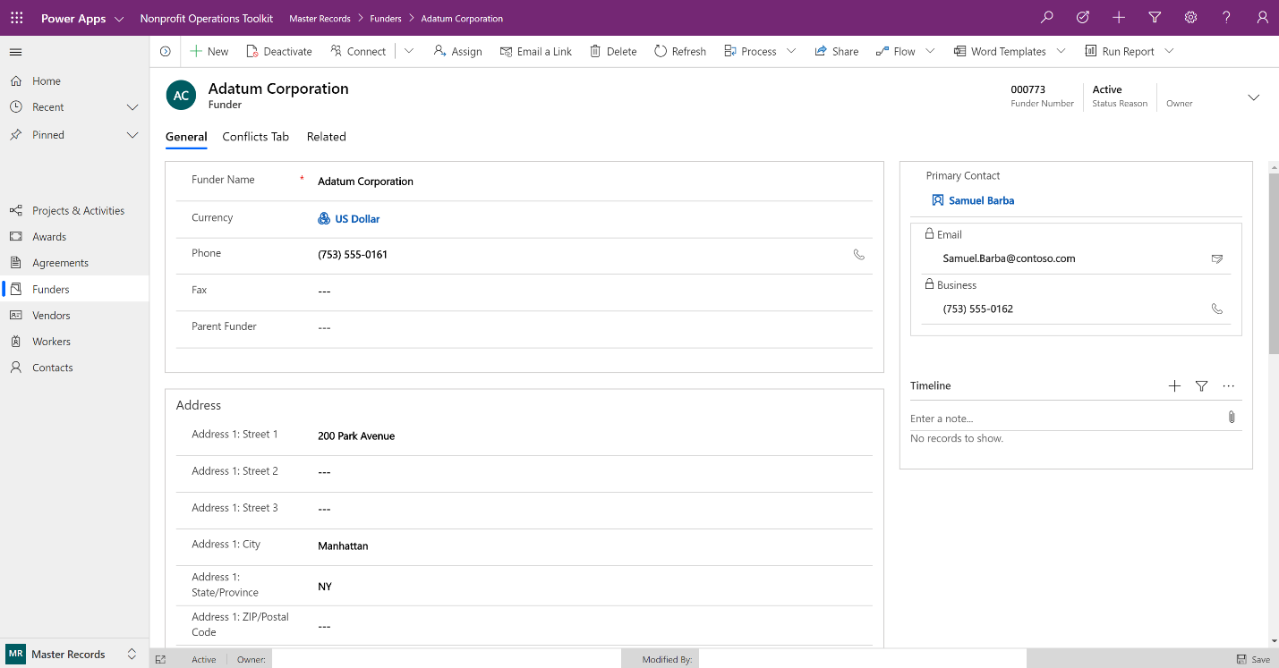

## Agreement Management

Agreements represents a documented and potentially binding arrangement between an external party and your organization.

### Operational Details

#### Relevant security roles

To add a new agreement, a user needs one the following Security Roles:

* Nonprofit Global Finance Administrator
* Nonprofit Global Project Manager

#### Configured status reasons

The following values have been created to represent a standard lifecycle:

|  |  |  |
| --- | --- | --- |
| **Status** | **Status Reason** | **Description** |
| Active | Draft | Actively being created or planned. |
| Active | Pending | Awaiting signatures. |
| Active | Executed | Signed and actively being exercised. |
| Inactive | Draft | Abandoned prior to execution. |
| Inactive | Completed | Commitments fulfilled and no longer active. |
| Inactive | Terminated | Formerly executed and ended prior to completion. |

### Adding an Agreement

Agreements can be added to many records in the toolkit including awards, cost centers, funders, vendors, and project activities. Not all agreements have a financial component.

#### To add an agreement

1. Open the web application and go to **Master Records**.
2. Select **Agreements** from the left navigation.
3. Click **New** in the menu bar above the list.
4. Enter details for your new agreement.
5. Click **Save & Close** in the menu bar above the record.

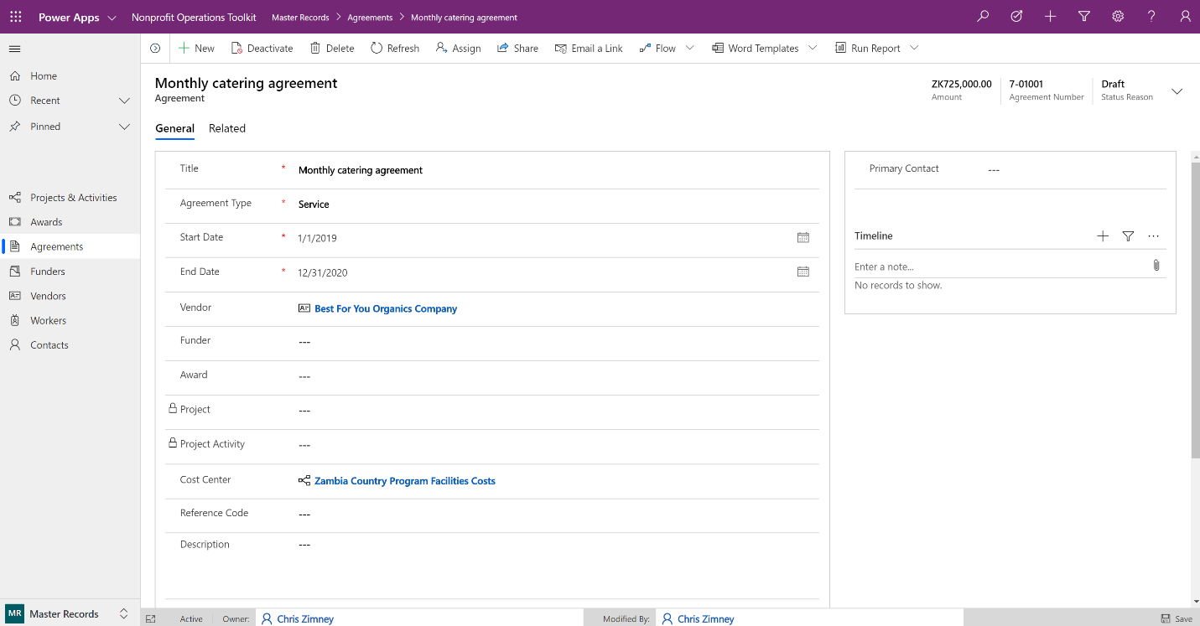

|  |
| --- |
| **Note** |
| Files associated with an agreement can be uploaded and accessible from within the agreement record by setting up integration with SharePoint. For more information, see Add Document Storage using SharePoint. |

## Award Management

Award records hold details of financial support to be provided by the associated funder.

### Operational Details

#### Relevant security roles

To add a new award, a user needs one the following Security Roles:

* Nonprofit Global Finance Administrator
* Nonprofit Global Project Manager

#### Dependent functionality

Noteworthy workflows, rules or functions that rely on accurate award information include:

|  |  |
| --- | --- |
| **Topic** | **Description** |
| Project budgeting | A specific award and cost category can be associated with a project budget line to indicate planned use of those resources. |

#### Configured status reasons

The following values have been created to represent a standard lifecycle:

|  |  |  |
| --- | --- | --- |
| **Status** | **Status Reason** | **Description** |
| Active | Preliminary | Actively being created or planned. |
| Active | Pending | Awaiting signatures. |
| Active | Awarded | Signed and actively being exercised. |
| Inactive | Not Awarded | Abandoned prior to being awarded. |
| Inactive | Closed | Commitments fulfilled and no longer active. |

### Adding an Award

#### To add an award

1. Open the web application and go to **Master Records**.
2. Select **Awards** from the left navigation.
3. Click **New** in the menu bar above the list.
4. Enter details for your new award.
5. Click **Save & Close** in the menu bar above the record.

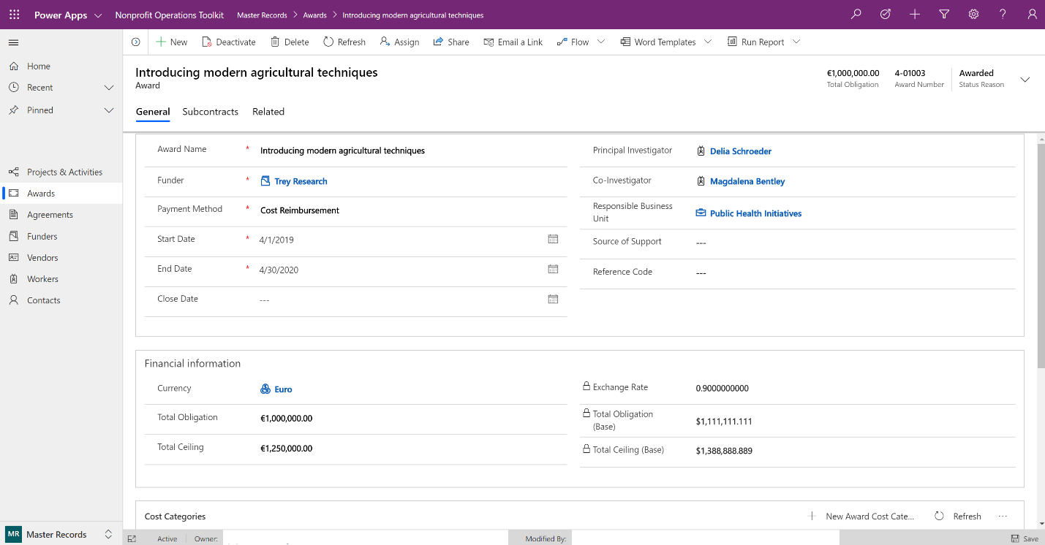

#### To add an award cost category

Funders that issue grants through awards often expect to see budgets and actual expenses grouped by categories that they define. Each award record can have specific cost categories for use in preparing budgets or funder reports.

After saving an award record, enter cost categories using these steps:

1. When viewing an award record, click **Add New Award Cost Category** on the right side of the menu above the cost categories list.
2. Enter cost category details for your award.
3. Click **Save** in the lower-right corner of the window.
4. Use your browser’s back button to return to the award record or use the breadcrumb links in the topmost menu bar.

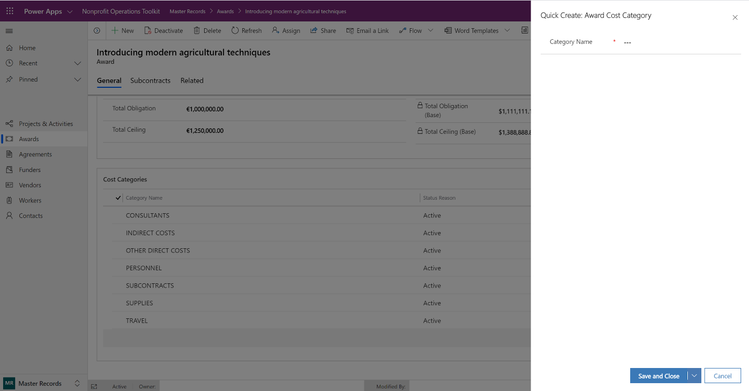

## Project Management

Project records capture the duration, work and costs associated with an effort. The system supports projects funded by a single award or no award necessary for internal or bid & proposal work. Projects require at least one project activity since all planning, time and expenses are tracked at the project activity level. For this reason, a project activity is generated automatically when a new project is created. A project can have as many project activities as are needed.

|  |
| --- |
| **Example** |
| Consider the following project that has three activities:   * Implement study of mp1H treatment effects   + Project Management   + Preliminary analysis and data collection design   + Implementation of data collection and site visits |

Each activity could have a unique timeframe, set of costs or personnel that are associated with that aspect of the work.

### Operational Details

#### Relevant security roles

To add a new project, a user needs the following Security Role:

* Nonprofit Global Project Manager

#### Dependent functionality

Noteworthy workflows, rules or functions that rely on accurate project information include:

|  |  |
| --- | --- |
| **Topic** | **Description** |
| Cascading status values | A flow runs in the background that updates the statuses of associated project activities to valid values when a user changes the status reason of a project. |

#### Configured status reasons

The following values have been created to represent a standard lifecycle for both project and project activity records.

|  |  |  |
| --- | --- | --- |
| **Status** | **Status Reason** | **Description** |
| Active | Draft | Early stage of project setup and definition. Not intended to be transacted against. |
| Active | In-Progress | Work is in flight and related transactions/costs are expected to be associated. |
| Inactive | Paused | Set aside for an indefinite amount of time. New connections, plans or transactions should not be associated. |
| Inactive | Completed | Completed as planned or was cancelled and has transactions associated with it. Records are read-only. |
| Inactive | Disregarded | Cancelled or abandoned and not expected to be pursued in the future. No transactions have been associated. |

### Adding a Project

#### To add a project

1. Open the web application and go to **Master Records**.
2. Select **Projects** from the left navigation.
3. Click **New** in the menu bar above the list.
4. Enter details for your new project.
5. Click **Save & Close** in the menu bar above the record.

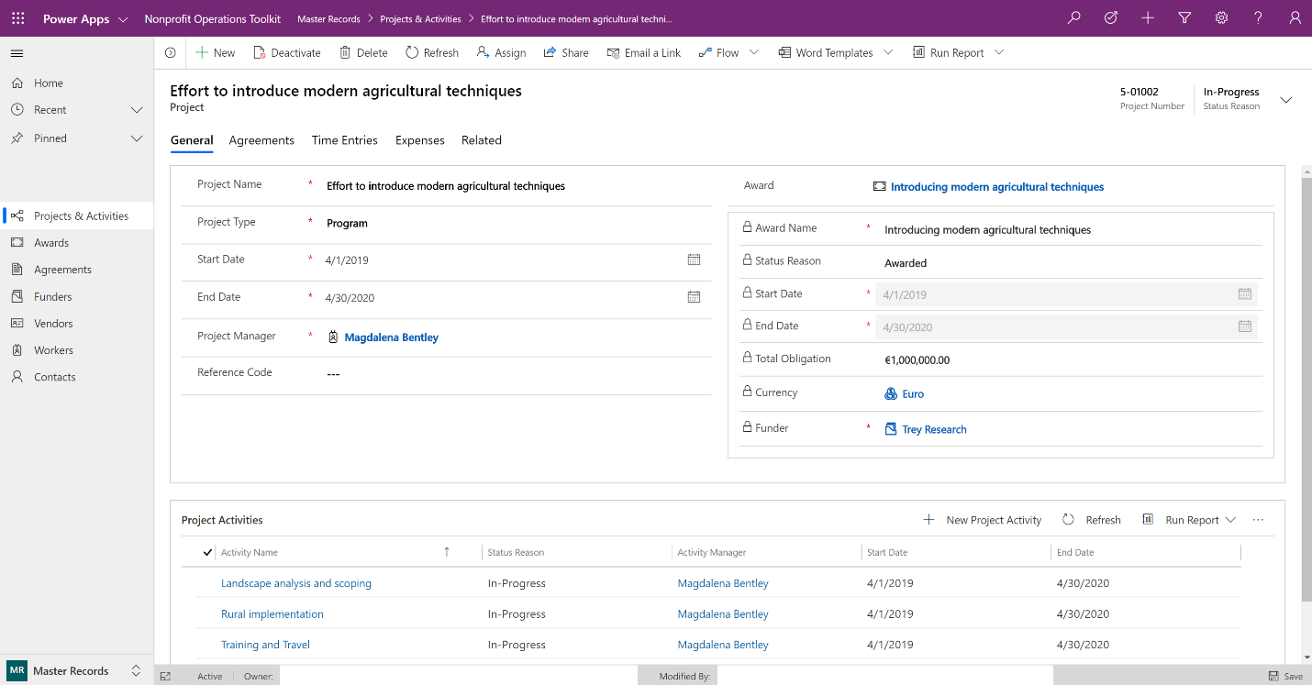

#### To add a project activity

1. When viewing a project record, click **Add New Project Activity** on the right side of the menu above the project activity list.
2. Enter the details of your new project activity.
3. Click **Save** in the lower-right corner of the window.
4. Use your browser’s back button to return to the project record or use the breadcrumb links in the topmost menu bar.

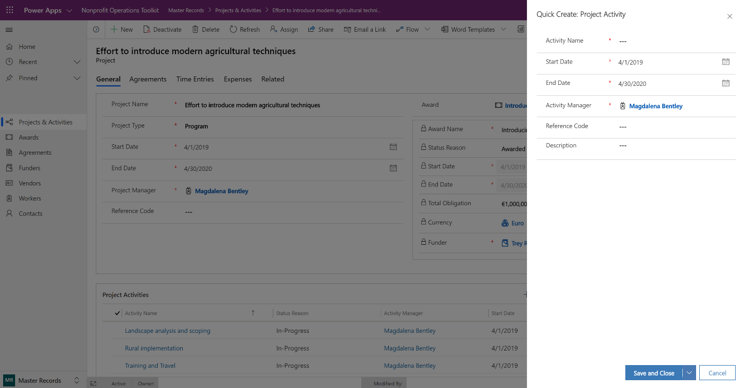

# Budgets & Effort Plans

Budgets represent financial plans associated with projects or cost centers. Effort plans are used to show what projects and/or cost centers a worker is expected to be working on over a series of planning periods.

To start, open the web application and select **Budgets & Effort Plans** from the area selector in the lower-left corner of the screen. Follow the steps in the sections below to enter your initial master records.

## Project Budgeting

Project budgets are comprised of budget lines that describe the nature of costs associated with the budget and when combined with period-specific planning can give a complete picture of how and when costs are expected to be incurred.

### Operational Details

#### Relevant security roles

To add a new project budget or budget lines, a user needs one the following Security Roles:

* Nonprofit Global Finance Administrator
* Nonprofit Global Project Manager

#### Dependent functionality

Noteworthy workflows, rules or functions that rely on accurate project budget information include:

|  |  |
| --- | --- |
| **Topic** | **Description** |
| Cascading status values | A flow runs in the background that updates budget line statuses to valid values when a user changes the status reason of a budget. |
| Generating budget line periods | When a budget line is added, a flow runs in the background that generates budget line periods and distributes the line amount across the periods. |

#### Configured status reasons

The following values have been created to represent a standard lifecycle of a project budget.

|  |  |  |
| --- | --- | --- |
| **Status** | **Status Reason** | **Description** |
| Active | Draft | Budget is being authored prior to internal review. Not intended to be transacted against. Can be deleted. |
| Active | Submitted | Budget has been submitted for approval by Funder. Not intended to be modified or transacted against. |
| Active | Live | Following approval, this budget is created and actively managed to during project execution. Certain aspects can be modified. |
| Inactive | Disregarded | Cancelled or abandoned and not expected to be pursued in the future. |
| Inactive | Superseded | A formerly Live budget that was replaced and deactivated when an updated Draft was Approved and made Live (e.g. Amendment scenario). |

### Adding a Project Budget

|  |
| --- |
| **Note** |
| Project budgets can only be created from within an existing project record. |

#### To add a project budget

After saving a project record, create an associated budget using these steps:

1. When viewing a project record, click the **Related** tab above the form then click **Project Budgets**.
2. Click **Add New Project Budget** on the left side of the menu above the budget list.
3. Enter the details of your new project budget.
4. Click **Save** in the menu bar above the record.

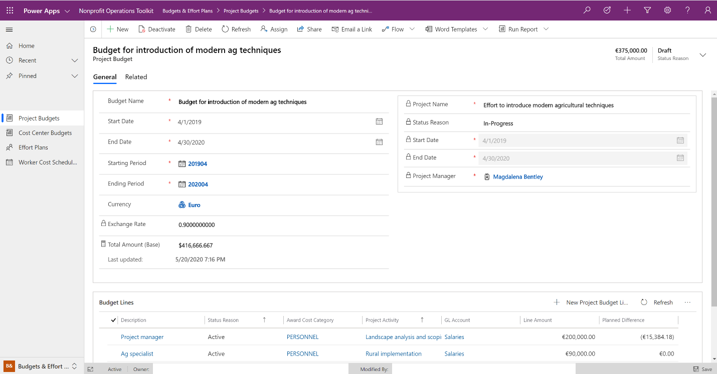

#### To add a project budget line

After saving a project budget, create an associated budget line using these steps:

1. When viewing a project budget record, click **Add New Project Budget Line** on the right side of the menu above the budget lines list.
2. Enter the details of your new budget line.
3. Click **Save** in the menu bar above the record.

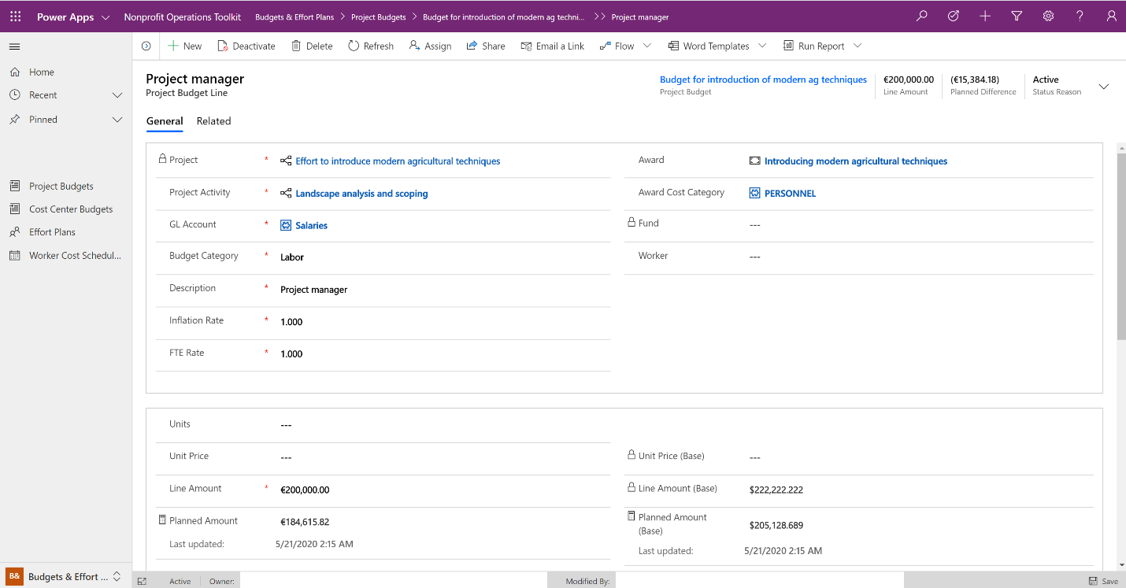

### Review Budget Line Periods

Upon saving a new budget line, the system will use the start and end periods specified on the budget to generate a series of budget line periods and distribute the total amount of the budget line across them. Because this happens in the background it can take a minute complete.

Review the budget line periods using these steps:

1. When viewing a project budget line record, scroll to the bottom of the page to find the budget line periods list.
2. Click the ellipsis (**…**) on the right side of the menu above the budget line periods list then click **Refresh** to see the generated periods.

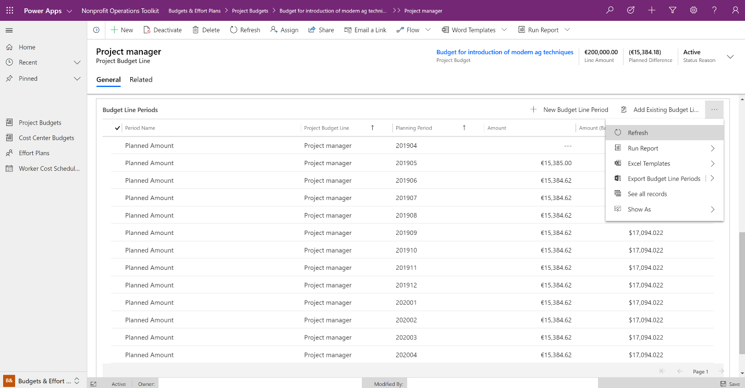

## Cost Center Budgeting

Cost Center budgets are comprised of budget lines that describe the nature of costs associated with the budget in the same way as project budgeting. These budgets are simpler than project budgets when it comes to the amount of information captured on a budget and budget line.

### Operational Details

#### Relevant security roles

To add a new cost center budget or budget lines, a user needs one the following Security Roles:

* Nonprofit Global Finance Administrator
* Nonprofit Global Cost Center Manager

#### Dependent functionality

Noteworthy workflows, rules or functions that rely on accurate cost center budget information include:

|  |  |
| --- | --- |
| **Topic** | **Description** |
| Cascading status values | A flow runs in the background that updates budget line statuses to valid values when a user changes the status reason of a budget. |
| Generating budget line periods | When a budget line is added, a flow runs in the background that generates budget line periods and distributes the line amount across the periods. |

#### Configured status reasons

The following values have been created to represent a standard lifecycle of a cost center budget.

|  |  |  |
| --- | --- | --- |
| **Status** | **Status Reason** | **Description** |
| Active | Draft | Budget is being authored prior to internal review. Not intended to be transacted against. Can be deleted. |
| Active | Live | Following approval, this budget is created and actively managed to during project execution. Certain aspects can be modified. |
| Inactive | Disregarded | Cancelled or abandoned and not expected to be pursued in the future. |
| Inactive | Superseded | A formerly Live budget that was replaced and deactivated when an updated Draft was Approved and made Live (e.g. Amendment scenario). |

### Adding a Cost Center Budget

#### To add a cost center budget

Cost center budgets behave in the same way as project budgets. However, you can create one directly from the side navigation using the following steps:

1. Open the web application and go to **Budgets & Effort Plans**.
2. Select **Cost Center Budgets** from the left navigation.
3. Click **New** in the menu bar above the list.
4. Enter details of your cost center budget.
5. Click **Save** in the menu bar above the record.

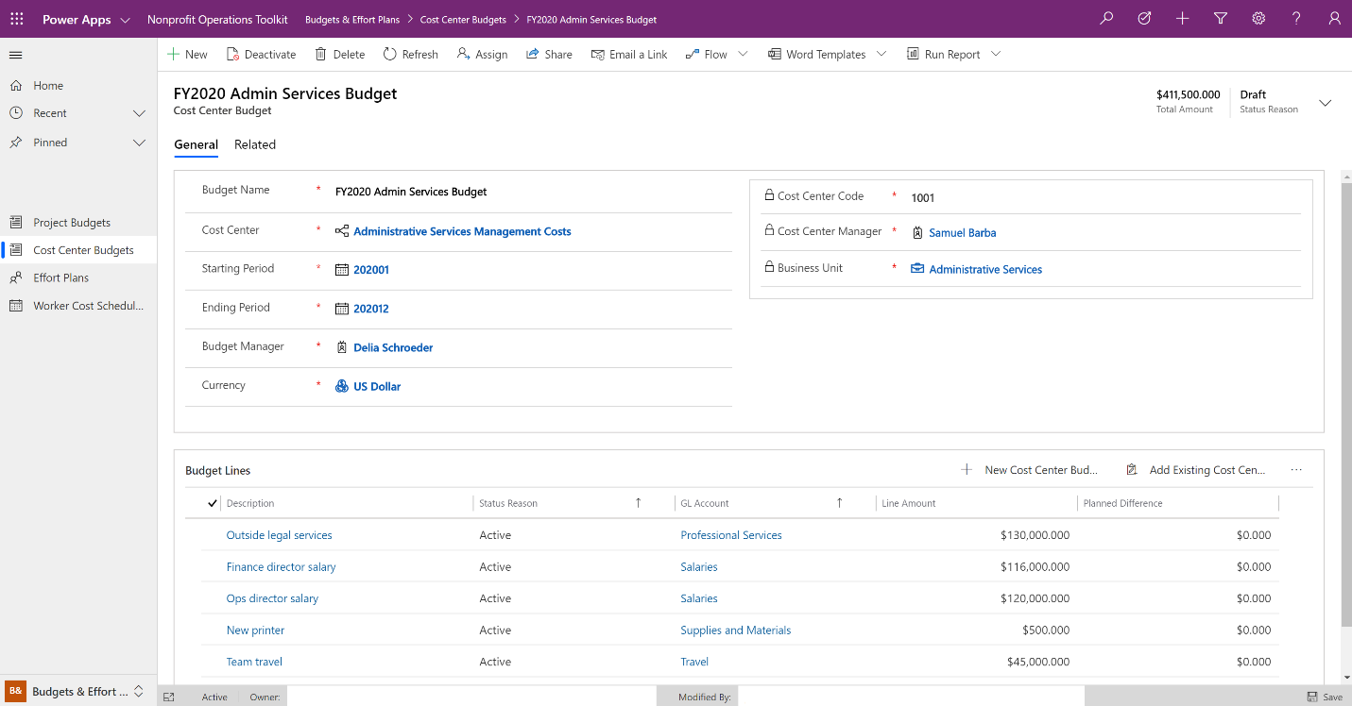

#### To add a cost center budget line

After saving a cost center budget, create an associated budget line using these steps:

1. When viewing a cost center budget record, click **Add New Cost Center Budget Line** on the right side of the menu above the budget lines list.
2. Enter the details of your new budget line.
3. Click **Save** in the menu bar above the record.

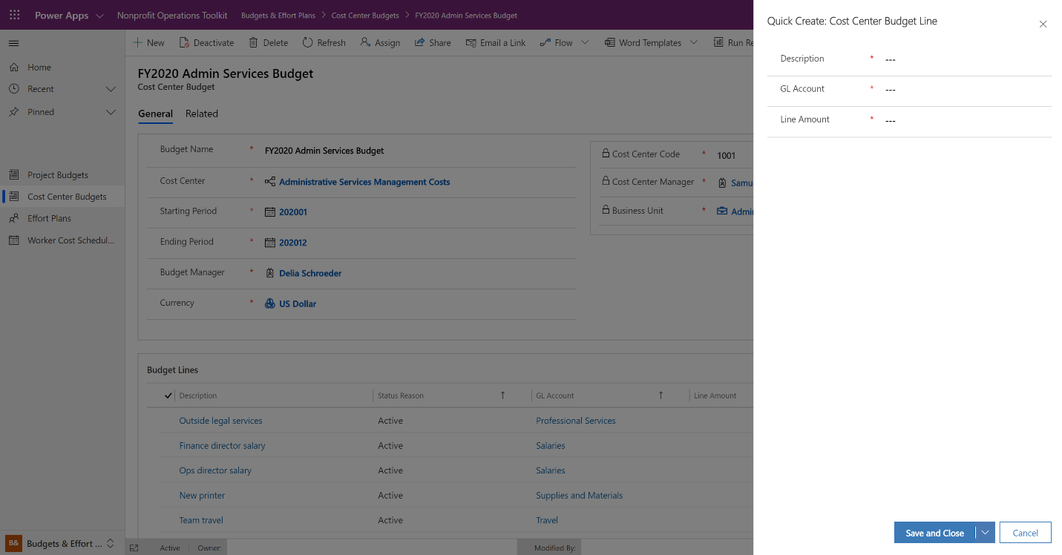

### Review Budget Line Periods

Review the budget line periods using these steps:

1. When viewing a cost center budget line record, scroll to the bottom of the page to find the budget line periods list.
2. Click the ellipsis (**…**) on the right side of the menu above the budget line periods list then click **Refresh** to see the generated periods.

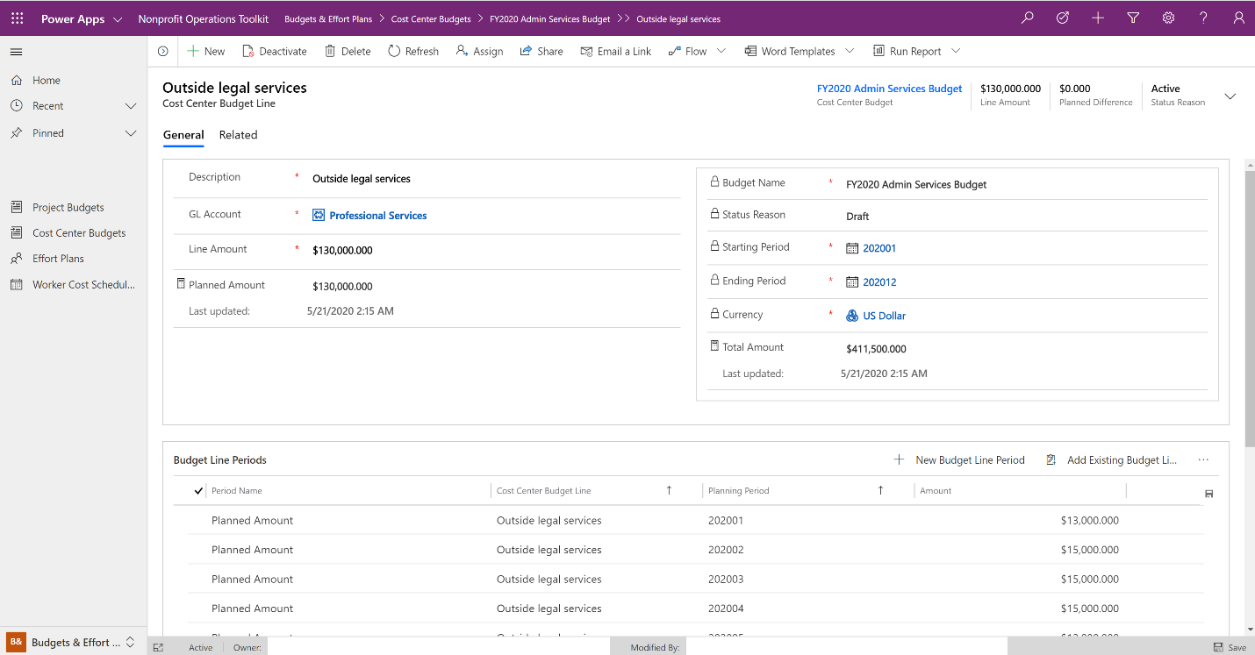

## Effort Planning

Use effort plans to get a complete view of the projects or cost centers your workers should associate their time with and ensure that no one worker is over-allocated during a specific planning period.

### Operational Details

#### Relevant security roles

To add a new effort plan, a user needs the following Security Role:

* Nonprofit Global Project Manager

### Add an Effort Plan

#### To add an effort plan

1. Open the web application and go to **Budgets & Effort Plans**.
2. Select **Effort Plans** from the left navigation.
3. Click **New** in the menu bar above the list.
4. Enter details for your new effort plan.
5. Click **Save & Close** in the menu bar above the record.

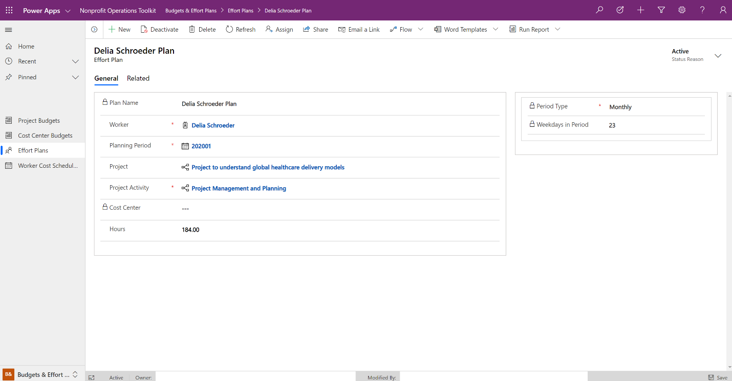

### Review Effort Plans

#### To review effort plans

1. Open the web application and go to **Budgets & Effort Plans**.
2. Select **Effort Plans** from the left navigation.
3. Click the filter icon () in the Plan Name, Worker or Planning Period column to narrow the values.
4. Alternatively, click **Export to Excel** in the menu bar above the list to download a file to your desktop for further analysis.

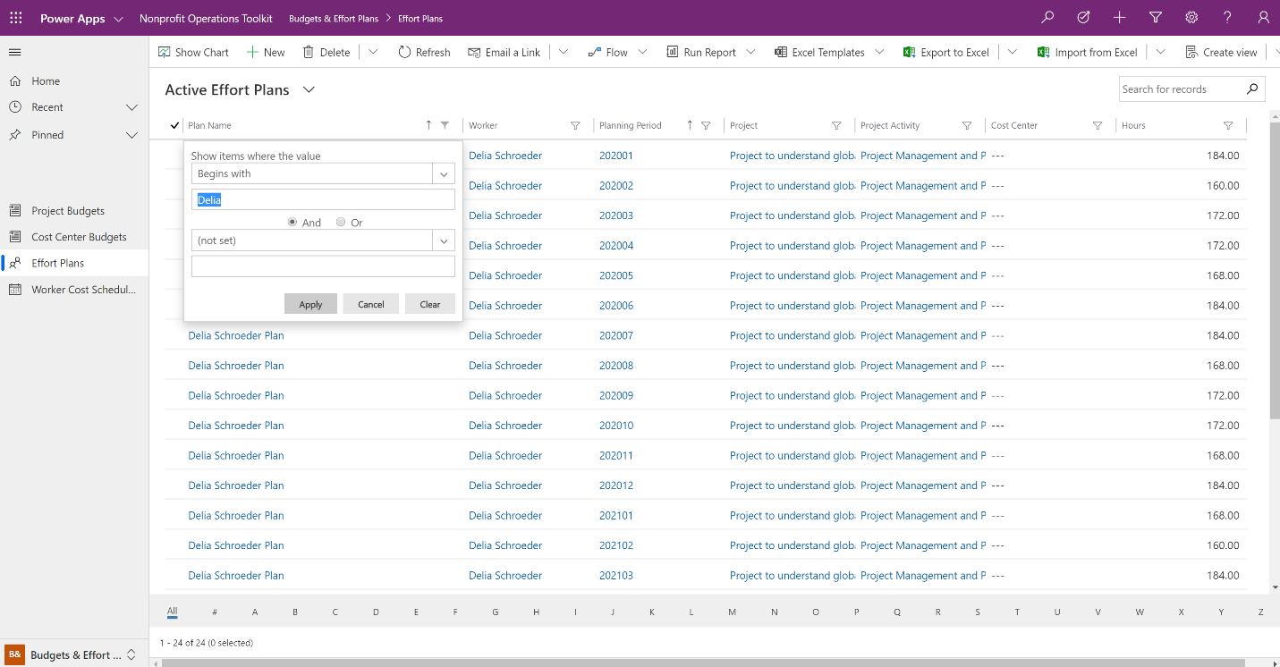

## Worker Cost Schedules

To support accurate budgeting and planning, the toolkit generates and maintains a table of compensation cost information for all active workers broken down by active planning period. The flow runs periodically in the background and aggregates effective compensation plans in base currency values.

### Operational Details

#### Relevant security roles

To view worker cost schedules, a user needs one the following Security Roles:

* Nonprofit Global Finance Administrator
* Nonprofit Global Project Manager

### Review Worker Cost Schedules

A flow is responsible for creating and updating worker cost schedule records.

#### To review worker cost schedules

1. Open the web application and go to **Budgets & Effort Plans**.
2. Select **Worker Cost Schedules** from the left navigation.
3. Click the filter icon () in the worker column to narrow the values to a specific worker.
4. Alternatively, click **Export to Excel** in the menu bar above the list to download a file to your desktop for further analysis.

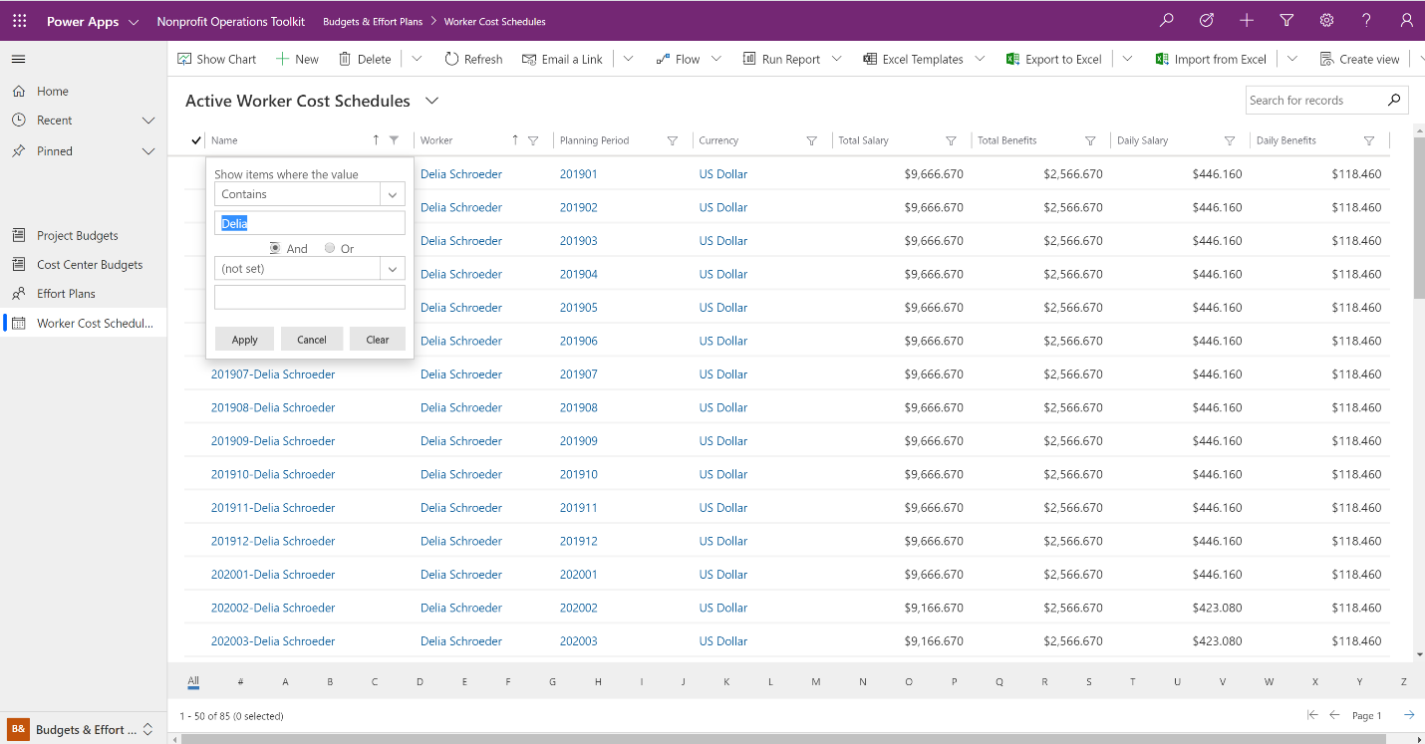

# Time & Expenses

Labor and reimbursable expenses are significant contributors to overall costs of a project or cost center. The system includes the ability for a worker to track time spent or expenses incurred toward projects or cost centers.

## Time Tracking

Upon saving a new timesheet, the system will generate a blank time entry for every weekday within the specified planning period. Because this happens in the background it can take thirty to sixty seconds to complete.

### Operational Details

#### Relevant security roles

To add a new timesheet or time entry, a user needs the following Security Role:

* Nonprofit Team Member

#### Dependent functionality

Noteworthy workflows, rules or functions that rely on accurate time information include:

|  |  |
| --- | --- |
| **Topic** | **Description** |
| Generating blank time entries | When a timesheet is added, a flow runs in the background that generates an empty time entry for each weekday in the planning period. |

#### Configured status reasons

##### Status reasons for timesheets

The following values have been created to represent a standard lifecycle of a timesheet.

|  |  |  |
| --- | --- | --- |
| **Status** | **Status Reason** | **Description** |
| Active | Draft | Timesheet has been created for a period that is not the current open time period. Not intended to be transacted against. |
| Active | Incomplete | Timesheet has time entries that have been submitted or approved. Timesheet can no longer be deleted. |
| Inactive | Completed | Timesheet is completed as planned and likely has transactions associated with it. Records are read-only. |

##### Status reasons for time entries

The following values have been created to represent a standard lifecycle of a time entry.

|  |  |  |
| --- | --- | --- |
| **Status** | **Status Reason** | **Description** |
| Active | Draft | Entry is being authored by a user prior to submission. Not intended to be transacted against. |
| Active | Submitted | Time entry has been submitted for approval and is awaiting action by the approver. Not intended to be transacted against. |
| Active | Approved | Time entry has been submitted for approval and was approved. Approved time entries are available for transactions/costs be associated. |
| Active | Rejected | Time entry has been submitted for approval and was rejected by the approver. Not intended to be transacted against. |
| Inactive | Completed | Time Entry is completed as planned and likely has transactions associated with it. Records are read-only. |

### Manage Time in the Web App

#### To add a timesheet and time entry in the web app

1. Open the web application and go to **Time & Expense**.
2. Select **Timesheets** from the left navigation.
3. Click **New** in the menu bar above the list.
4. Enter details for your new timesheet.
5. Click **Save & Close** in the menu bar above the record.

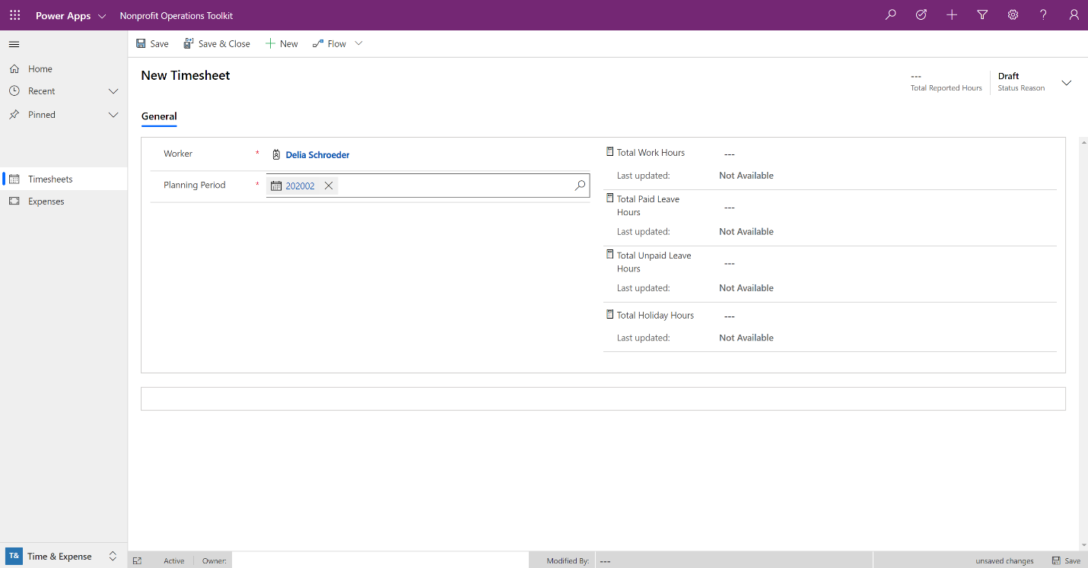

After creating a timesheet, add time to a time entry using these steps:

1. When viewing a specific timesheet record, select a time entry from the time entries list.
2. Enter the details of your time entry.
3. Click **Save** in the lower-right corner of the window.
4. Use your browser’s back button to return to the timesheet record or use the breadcrumb links in the topmost menu bar.

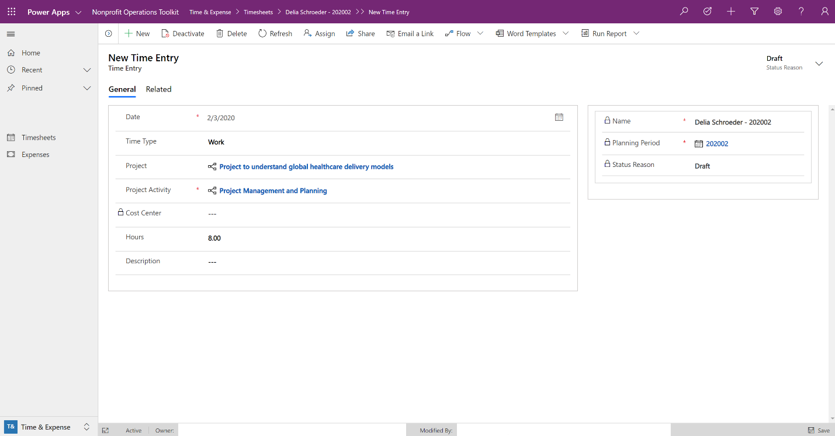

#### To submit time in the web app

Time submission is based on a user setting the status reason of a time entry to Submitted. Multiple time entries can be submitted at once.

1. Open the web application and go to **Time & Expense**.
2. Select **Timesheets** from the left navigation.
3. Select an individual timesheet from the list.
4. Select all or specific records from the **Time Entries** list.
5. Click **Edit** from the menu bar above the list.
6. In the **Change Multiple Records** window, expand the **Header** area and choose Submitted from the **Status Reason** dropdown.
7. Click **Change**.

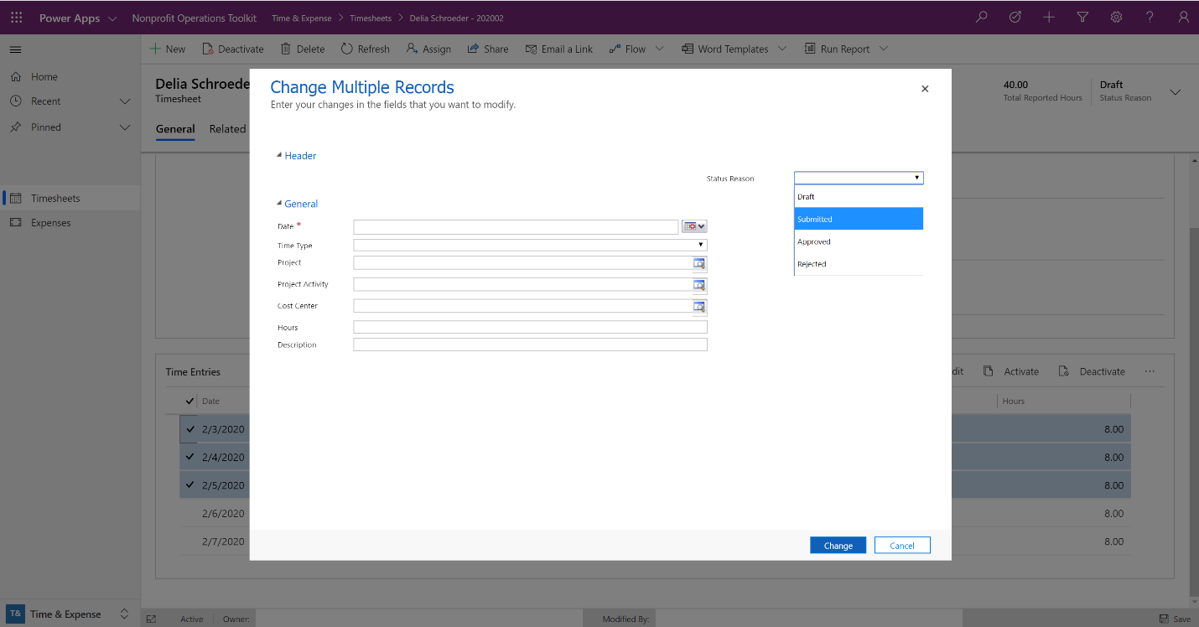

#### To approve or reject time in the web app

Time approval is based on a user setting the status reason of a time entry to Approved or Rejected. Multiple time entries can be approved or rejected at once. By default, the toolkit is designed to make it simple for a worker’s manager to be the time approver.

1. Open the web application and go to **Time & Expense**.
2. Select **Timesheets** from the left navigation.
3. Change the view from My Timesheets to **All Submitted Time** using the view dropdown menu.
4. Select an individual timesheet from the list.
5. Identify and select all or specific records from the **Time Entries** with a Status Reason of Submitted.
6. Click Edit from the menu bar above the list.
7. In the **Change Multiple Records** window, expand the **Header** area and choose Approved or Rejected from the **Status Reason** dropdown.
8. Click **Change**.

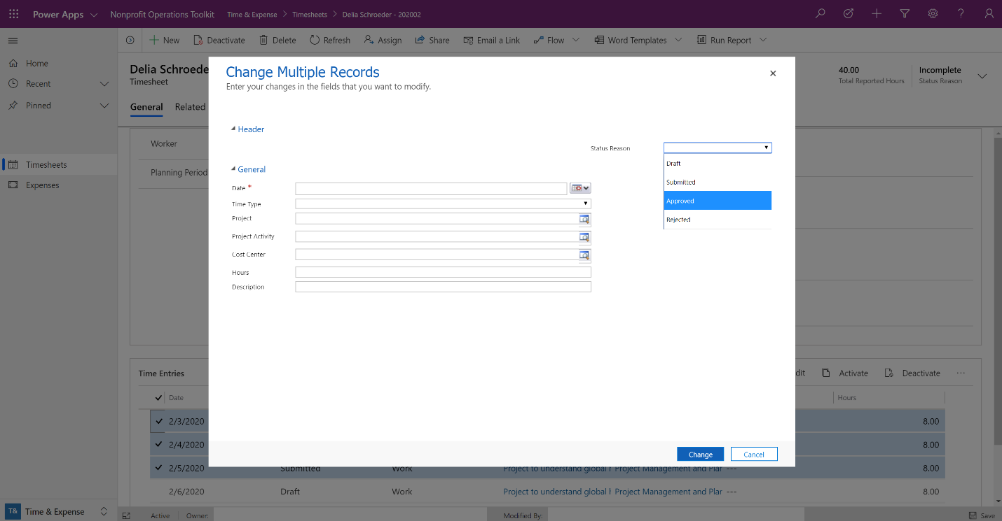

### Manage Time in the Mobile App

The mobile app is designed to work with timesheets in an active state. Completed timesheets will no longer appear in the mobile app.

#### To add a timesheet and time entry in the mobile app

1. Open the mobile application.
2. Tap the menu icon in the upper-left corner and tap **Timesheets**.
3. Tap the plus sign (**+**) in the top menu bar.
4. Enter details for your new timesheet.

|  |  |  |
| --- | --- | --- |
| A screenshot of a mobile open items | A screenshot of mobile navigation to timesheets | A screenshot of a mobile new timesheet |

After creating a timesheet, add time to a time entry using these steps:

1. When viewing an individual timesheet, tap the plus sign (**+**) or select a time entry from the time entries list.
2. Enter the details of your time entry.
3. Tap the check mark () in top menu bar.

|  |  |  |
| --- | --- | --- |
| A screenshot of mobile timesheets | A screenshot of a mobile timesheet | A screenshot of mobile new time entry |

#### To submit time in the mobile app

Only time entries that are in Draft or Rejected status will be submitted.

1. Open the mobile application.
2. Tap the menu icon in the upper-left corner and tap **Timesheets**.
3. Select an individual timesheet from the list.
4. Tap the submit icon (An image of an icon depicting a checkmark inside a document.) in the top menu bar.
5. Alternatively, select an individual time entry from the list and tap the submit icon.

|  |  |
| --- | --- |
| A screenshot of a mobile timesheet | A screenshot of a time entry to submit |

## Expense Management

Reimbursable expenses and advances can be created, submitted, reviewed and approved in the toolkit. Once payment is issued, a financial information manager should return to the toolkit to mark relevant expenses as Processed.

### Operational Details

#### Relevant security roles

To add a new expense, a user needs the following Security Role:

* Nonprofit Team Member

#### Configured status reasons

The following values have been created to represent a standard lifecycle of an expense.

|  |  |  |
| --- | --- | --- |
| **Status** | **Status Reason** | **Description** |
| Active | Draft | Expense is being authored prior to submission. Not intended to be transacted against. |
| Active | Submitted | Expense has been submitted for approval and is awaiting action by the approver. Not intended to be transacted against. |
| Active | Approved | Expense has been submitted for approval and was approved. Approved expenses are eligible for payment processing. |
| Active | Rejected | Expense has been submitted for approval and was rejected by the approver. Not intended to be transacted against. |
| Inactive | Processed | Expense is completed as planned and marked as processed by accounting after payment issued. Records are read-only. |
| Inactive | Disregarded | Expense is cancelled or abandoned and not expected to be pursued in the future. No transactions have been associated with the Expense. |

### Manage Expenses in the Web App

#### To add an expense in the web app

1. Open the web application and go to **Time & Expense**.
2. Select **Expenses** from the left navigation.
3. Click **New** in the menu bar above the list.
4. Enter details for your new expense.
5. Click **Save & Close** in the menu bar above the record.

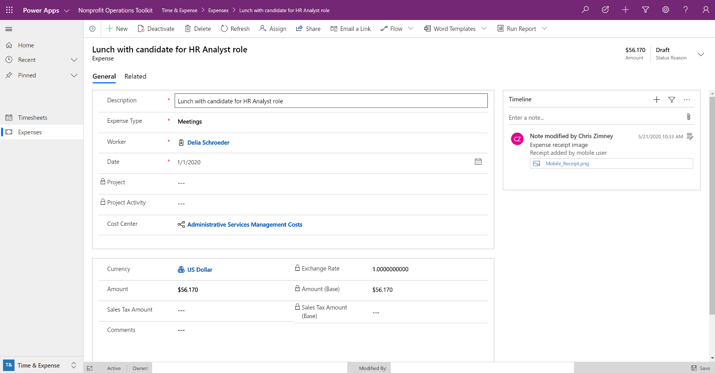

#### To submit an expense in the web app

Expense submission is based on a user setting the status reason of an expense to Submitted. Multiple expenses can be submitted at once.

1. Open the web application and go to **Time & Expense**.
2. Select **Expenses** from the left navigation.
3. Select all or specific expense records from the list.
4. Click **Edit** from the menu bar above the list.
5. If submitting multiple, in the **Change Multiple Records** window, expand the **Header** area and choose Submitted from the **Status Reason** dropdown then click **Change**.
6. If submitting an individual expense, expand the Status Reason dropdown menu in the upper-right corner of the record, choose Submitted and click **Save** in the lower-right corner of the browser window.

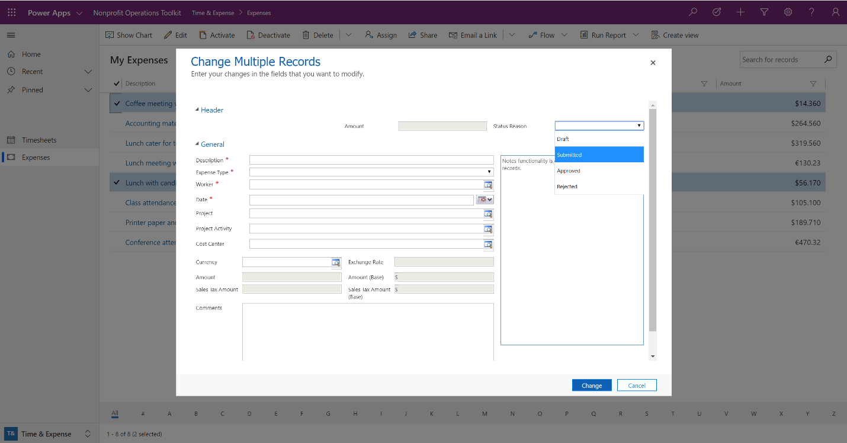

#### To approve or reject an expense in the web app

Expense approval is based on a user setting the status reason of an expense to Approved or Rejected. Multiple expenses can be approved or rejected at once. By default, the toolkit is designed to make it simple for a project activity manager or a cost center manager to approve expenses relevant to them.

1. Open the web application and go to **Time & Expense**.
2. Select **Expenses** from the left navigation.
3. Change the view from My Expenses to **All Submitted Project Expenses** or **All Submitted Cost Center Expenses** using the view dropdown menu.
4. Filter the list as needed and select all or individual expenses from the list.
5. If approving or rejecting multiple expenses, in the **Change Multiple Records** window, expand the **Header** area and choose Approved or Rejected from the **Status Reason** dropdown then click **Change**.
6. If approving or rejecting an individual expense, expand the Status Reason dropdown menu in the upper-right corner of the record, choose Submitted and click **Save** in the lower-right corner of the browser window.

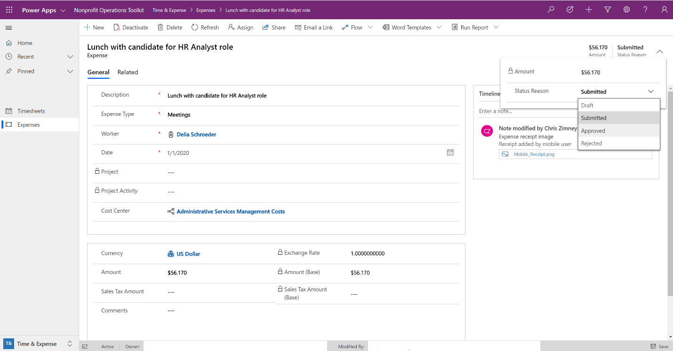

#### To process an expense in the web app

After issuing a payment for an approved expense from your accounting system, mark the expense as processed in the toolkit to let users know it has been completed.

1. Open the web application and go to **Time & Expense**.
2. Select **Expenses** from the left navigation.
3. Change the view from My Expenses to **All Approved Expenses to Process** using the view dropdown menu.
4. Filter the list as needed and select all or individual expenses from the list.
5. Click **Deactivate** in the menu above the list.
6. In the **Confirm Deactivation** window, choose **Processed** from the Status dropdown menu.
7. Click **Deactivate**.

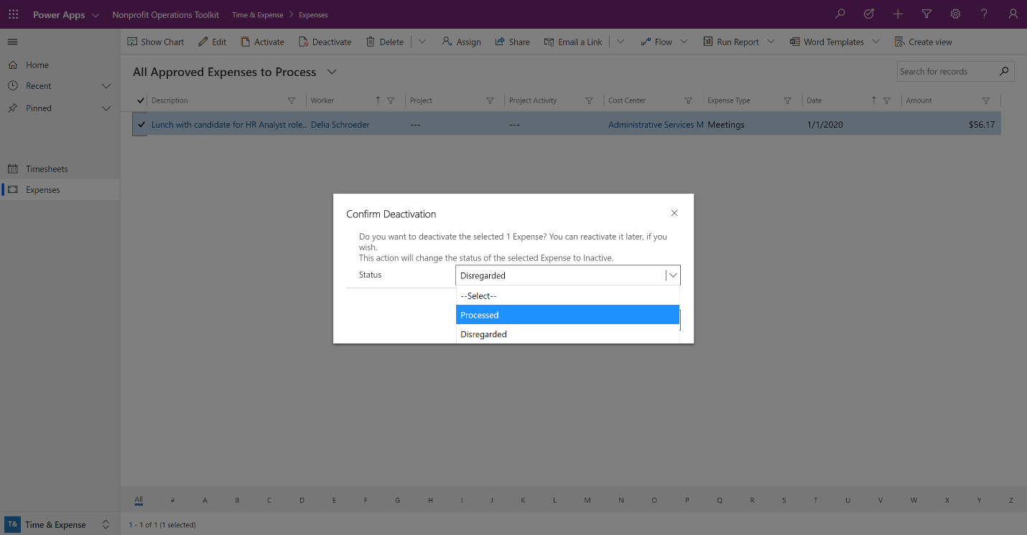

### Manage Expenses in the Mobile App

The mobile app is designed to work with expenses in an Active state. Processed or Disregarded expenses will no longer show in the mobile app.

#### To add an expense in the mobile app

1. Open the mobile application
2. Tap the menu icon in the upper-left corner and tap **Expenses**.
3. Tap the plus sign (**+**) in the top menu bar.
4. Enter details for your new expense.
5. Tap the check mark () in top menu bar.

|  |  |  |
| --- | --- | --- |
| A screenshot of mobile navigation to expenses | A screenshot of mobile expenses | A screenshot of a new mobile expense |

#### To add an expense receipt in the mobile app

1. Open the mobile application
2. Select an expense from the Open Items screen or create a new Expense.
3. Tap the plus sign (**+**) in the lower-right corner of the image area.
4. Use your mobile device or computer camera to focus on the receipt and tap the screen.
5. Tap the check mark () in top menu bar.

|  |  |  |
| --- | --- | --- |
| A screenshot of a mobile expense | A screenshot of mobile receipt capture | A screenshot of a mobile receipt added to expense |

|  |
| --- |
| **Important** |
| As of this writing, the mobile app supports the addition of a single receipt image that can only be removed from the web application. The image captured is stored with a specific name: “mobile_receipt” so the mobile app can identify it for display later. |

#### To submit an expense in the mobile app

Only expenses in Draft or Rejected status can be submitted.

1. Open the mobile application.
2. Tap the menu icon in the upper-left corner and tap **Expenses**.
3. Select an individual expense from the list.
4. Tap the submit icon (An image of an icon depicting a checkmark inside a document.) in the top menu bar.

|  |  |
| --- | --- |
| A screenshot of mobile expenses | A screenshot of a mobile expense to submit |

# Setup Additional Capabilities

## Add Document Storage using SharePoint

Several tables are preconfigured to use table-based document storage when SharePoint integration is enabled in your environment including: Agreements, Awards, Cost Center Budgets, Expenses, Funders, Project Budgets, Vendors and Workers.

For more information, see [Set up SharePoint Integration](https://docs.microsoft.com/en-us/dynamics365/customer-engagement/admin/set-up-sharepoint-integration).

## Get Microsoft Power Apps Office Add-in

In Excel, this add-in allows users to read, analyze, and edit data from Microsoft Power Apps and publish data changes back. Any errors encountered on publish are indicated to the user via row-by-row highlighting and a message containing number of rows created, updated, and deleted.

For more information, see [Microsoft Power Apps Office Add-in](https://appsource.microsoft.com/en-us/product/office/WA104380330?tab=Overview).

## Get the Power Apps Mobile app

The Power Apps Mobile app allows users to interact with all the apps that have been provisioned to them across their organization.

* iOS users should visit the App store to download the latest version.
* Android users should visit Google Play to download the latest version.

## Enable Data Auditing

The auditing feature logs changes that are made to records and user access so you can review the activity later.

For more information, see [Audit Data and User Activity for Security and Compliance](https://docs.microsoft.com/en-us/dynamics365/customer-engagement/admin/audit-data-user-activity#start-or-stop-auditing-for-an-organization).

# Learn more about the Power Platform

The Power Platform plays a significant role among Microsoft’s cloud offerings focused on creating apps, analyzing information and automating processes. Below are some additional references to help you learn more about what is possible with these tools.

|  |  |  |  |
| --- | --- | --- | --- |
|  | **Documentation** | **Recent News** | **Discussion** |
| Power Apps | [Getting Started](https://docs.microsoft.com/en-us/powerapps) | [Blog](https://powerapps.microsoft.com/en-us/blog/) | [Community](https://powerusers.microsoft.com/t5/PowerApps-Community/ct-p/PowerApps1) |
| Power Automate | [Getting Started](https://docs.microsoft.com/en-us/flow/) | [Blog](https://flow.microsoft.com/en-us/blog/) | [Community](https://powerusers.microsoft.com/t5/Microsoft-Flow-Community/ct-p/FlowCommunity) |
| Power BI | [Getting Started](https://docs.microsoft.com/en-us/power-bi/) | [Blog](https://powerbi.microsoft.com/en-us/blog/) | [Community](https://community.powerbi.com/) |