**Program to display Adjacency Matrix using Graph**

**Code :**

**#include <iostream>**

**#include <stdlib.h>**

**using namespace std;**

**class AdjacencyMatrix**

**{**

**private :**

**int adjarr[10][10];**

**int vertex,edge,choice,edge1,edge2;**

**public :**

**AdjacencyMatrix()**

**{**

**for(int j=0;j<vertex;j++)**

**{**

**for(int z=0;z<vertex;z++)**

**{**

**adjarr[j][z]=0;**

**}**

**}**

**}**

**void get()**

**{**

**do**

**{**

**cout<<"0.Exit\n01.Enter Data \n02.Display Adjacency Array \n";**

**cout<<"Enter Your Choice : "<<" ";**

**cin>>choice;**

**switch(choice)**

**{**

**case 0:**

**break;**

**case 1:**

**EnterData();**

**break;**

**case 2:**

**display();**

**break;**

**default:**

**cout<<"invalid input"<<endl<<endl;**

**}**

**}while(choice!=0);**

**}**

**void EnterData()**

**{**

**cout<<endl<<endl;**

**cout<<"Enter Number of Vertex : ";**

**cin>>vertex;**

**cout<<"Enter Number of Edge : ";**

**cin>>edge;**

**for(int i=0;i<edge;i++)**

**{**

**cout<<"Enter vertex that has an edge : ";**

**cin>>edge1;**

**cin>>edge2;**

**adjarr[edge1][edge2]=1;**

**adjarr[edge2][edge1]=1;**

**}**

**cout<<endl<<endl;**

**}**

**void display()**

**{**

**cout<<endl<<endl;**

**cout<<"Adjacency Matrix : ";**

**cout<<endl<<endl;**

**for(int j=0;j<vertex;j++)**

**{**

**for(int z=0;z<vertex;z++)**

**{**

**cout<<" "<<adjarr[j][z]<<" ";**

**}**

**cout<<endl<<endl;**

**}**

**cout<<endl<<endl;**

**}**

**};**

**int main()**

**{**

**AdjacencyMatrix d;**

**d.get();**

**return 0;**

**}**

**Output :**

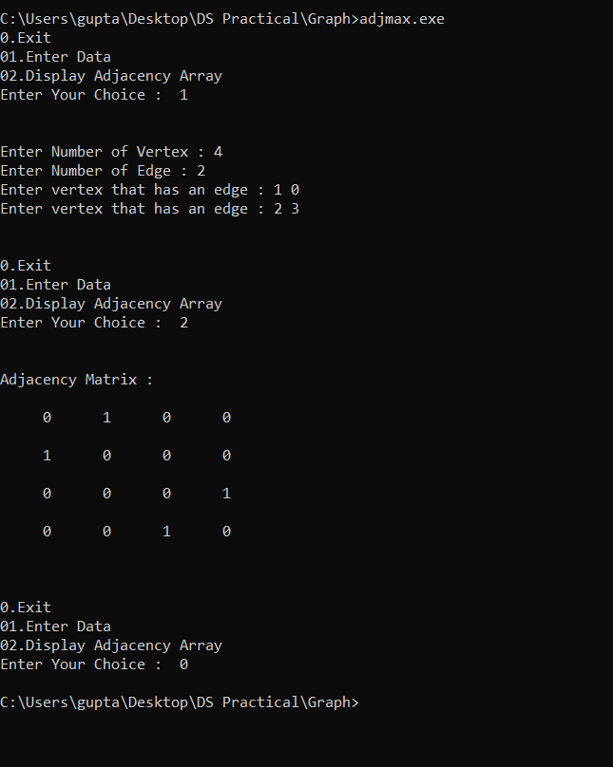

**Program to display DFS using Graph**

**Code :**

**#include <iostream>**

**#include <stdlib.h>**

**using namespace std;**

**class DFS**

**{**

**public :**

**int cost[10][10],stk[10],visit[10],visited[10];**

**int i,j,k,x,m,n,top,v,choice;**

**void get()**

**{**

**do**

**{**

**cout<<endl;**

**cout<<"0.Exit\n01.Enter Data \n02.Display DFS \n03.Display Adjacency Array \n";**

**cout<<"Enter Your Choice : "<<" ";**

**cin>>choice;**

**switch(choice)**

**{**

**case 0:**

**break;**

**case 1:**

**EnterData();**

**break;**

**case 2:**

**ShowDfs();**

**break;**

**case 3:**

**display();**

**break;**

**default:**

**cout<<"invalid input"<<endl<<endl;**

**}**

**}while(choice!=0);**

**}**

**void EnterData()**

**{**

**cout<<endl<<endl;**

**cout <<"Enter no of vertices:";**

**cin >> n;**

**cout <<"Enter no of edges:";**

**cin >> m;**

**cout <<"\nEDGES \n";**

**for(k=1; k<=m; k++)**

**{**

**cin >>i>>j;**

**cost[i][j]=1;**

**cost[j][i]=1;**

**}**

**cout <<"Enter initial vertex to traverse from:";**

**cin >>v;**

**cout<<endl<<endl;**

**}**

**void ShowDfs()**

**{**

**cout <<"DFS ORDER OF VISITED VERTICES:";**

**cout << v <<" ";**

**visited[v]=1;**

**k=1;**

**while(k<n)**

**{**

**for(j=n; j>=1; j--)**

**if(cost[v][j]!=0 && visited[j]!=1 && visit[j]!=1)**

**{**

**visit[j]=1;**

**stk[top]=j;**

**top++;**

**}**

**v=stk[--top];**

**cout<<v << " ";**

**k++;**

**visit[v]=0;**

**visited[v]=1;**

**}**

**}**

**void display()**

**{**

**cout<<endl<<endl;**

**cout<<"Adjacency Matrix : ";**

**cout<<endl<<endl;**

**for(int j=0;j<n;j++)**

**{**

**for(int z=0;z<n;z++)**

**{**

**cout<<" "<<cost[j][z]<<" ";**

**}**

**cout<<endl<<endl;**

**}**

**cout<<endl<<endl;**

**}**

**};**

**int main()**

**{**

**DFS d;**

**d.get();**

**return 0;**

**}**

**Output :**

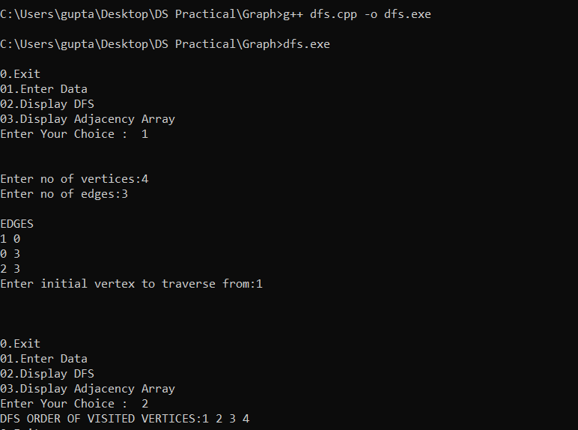

**Program to display BFS using Graph**

**Code :**

**#include <iostream>**

**#include <stdlib.h>**

**using namespace std;**

**class BFS**

**{**

**public :**

**int cost[10][10],qu[10],visit[10],visited[10];**

**int i,j,k,n,front,rare,v,choice,m;**

**void get()**

**{**

**do**

**{**

**cout<<endl;**

**cout<<"0.Exit\n01.Enter Data \n02.Display BFS \n03.Display Adjacency Array \n";**

**cout<<"Enter Your Choice : "<<" ";**

**cin>>choice;**

**switch(choice)**

**{**

**case 0:**

**break;**

**case 1:**

**EnterData();**

**break;**

**case 2:**

**ShowDfs();**

**break;**

**case 3:**

**display();**

**break;**

**default:**

**cout<<"invalid input"<<endl<<endl;**

**}**

**}while(choice!=0);**

**}**

**void EnterData()**

**{**

**cout<<endl<<endl;**

**cout <<"Enter no of vertices:";**

**cin >> n;**

**cout <<"Enter no of edges:";**

**cin >> m;**

**cout <<"\nEDGES \n";**

**for(k=1; k<=m; k++)**

**{**

**cin >>i>>j;**

**cost[i][j]=1;**

**cost[j][i]=1;**

**}**

**cout <<"Enter initial vertex to traverse from:";**

**cin >>v;**

**cout<<endl<<endl;**

**}**

**void ShowDfs()**

**{**

**cout <<"Visitied vertices:";**

**cout <<v<<" ";**

**visited[v]=1;**

**k=1;**

**while(k<n)**

**{**

**for(j=1; j<=n; j++)**

**if(cost[v][j]!=0 && visited[j]!=1 && visit[j]!=1)**

**{**

**visit[j]=1;**

**qu[rare++]=j;**

**}**

**v=qu[front++];**

**cout<<v <<" ";**

**k++;**

**visit[v]=0;**

**visited[v]=1;**

**}**

**}**

**void display()**

**{**

**cout<<endl<<endl;**

**cout<<"Adjacency Matrix : ";**

**cout<<endl<<endl;**

**for(int j=0;j<n;j++)**

**{**

**for(int z=0;z<n;z++)**

**{**

**cout<<" "<<cost[j][z]<<" ";**

**}**

**cout<<endl<<endl;**

**}**

**cout<<endl<<endl;**

**}**

**};**

**int main()**

**{**

**BFS b;**

**b.get();**

**return 0;**

**}**

**Output :**

