**1) Write a menu driven program to demonstrate Stack using array.**

**Code :**

**#include<iostream>**

**using namespace std;**

**class InfixToPostfix**

**{**

**public:**

**string stack[100],expression[100];**

**string equation;**

**int size,len,x,top;**

**InfixToPostfix()**

**{**

**top=-1;**

**}**

**void get()**

**{**

**cout <<"Enter the Equation : "<<" ";**

**getline(cin,equation);**

**x=equation.length();**

**equation.append(")",x);**

**top++;**

**stack[top]="(";**

**}**

**void operation()**

**{**

**for(int i=0;i<x;i++)**

**{**

**}**

**}**

**void display()**

**{**

**cout<<"The Given Equation is : ";**

**cout<<equation<<endl;**

**cout<<"The Stack Array : ";**

**for(int i=0;i<x+1;i++)**

**{**

**cout<<stack[i]<<" ";**

**}**

**cout<<endl;**

**cout<<"The Expression Array : ";**

**for(int i=0;i<x+1;i++)**

**{**

**cout<<expression[i]<<" ";**

**}**

**cout<<endl;**

**}**

**};**

**int main()**

**{**

**InfixToPostfix i;**

**i.get();**

**i.display();**

**return 0;**

**}**

**Output :**

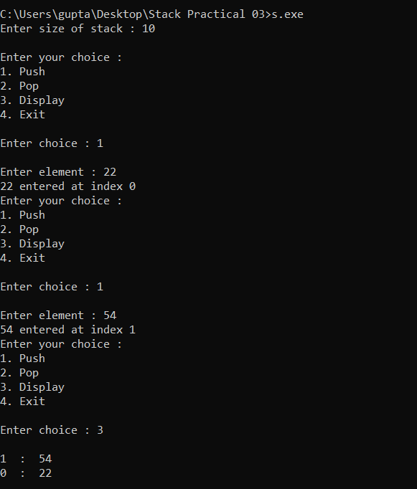

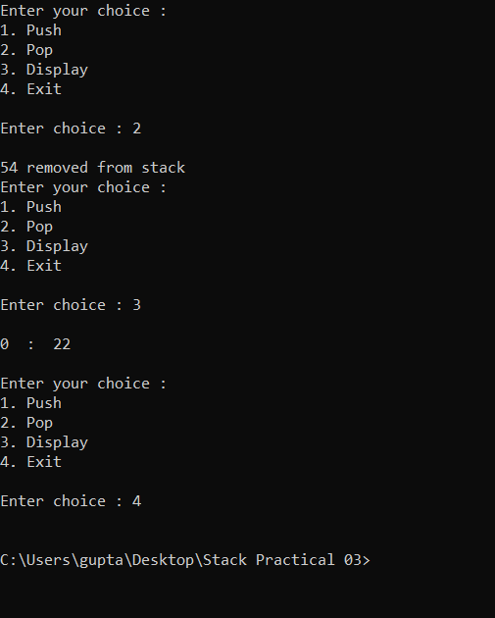

**2) Write a program to evaluate Postfix expression using Stack.**

**Code :**

#include<iostream>

#include<string.h>

#include<math.h>

using namespace std;

class PostFixEval

{

private:

int stack[100];

string eq;

int top,len,value,a,b,ans;

public:

PostFixEval()

{

top=-1;

}

void get()

{

cout<<"Enter String (Equation) : "<<" ";

getline(cin,eq);

len=eq.length();

for(int i=0;i<len;i++)

{

if(eq[i] == '+')

{

a=pop();

b=pop();

ans=b+a;

cout<<"Addition is : "<<ans<<endl;

push(ans);

}

else if(eq[i] == '-')

{

a=pop();

b=pop();

ans=b-a;

cout<<"Subraction is : "<<ans<<endl;

push(ans);

}

else if(eq[i] == '/')

{

a=pop();

b=pop();

ans=b/a;

cout<<"Division is : "<<ans<<endl;

push(ans);

}

else if(eq[i] == '*')

{

a=pop();

b=pop();

ans=b*a;

cout<<"Multiplication is : "<<ans<<endl;

push(ans);

}

else

{

value=eq[i]-48;

push(value);

}

}

}

void push(int value)

{

top++;

stack[top]=value;

cout<<value<<" Pushed ";

}

int pop()

{

int val=stack[top];

top--;

return val;

}

void display()

{

cout<<endl;

cout<<"The Answer of given Equation is : "<<stack[top];

}

};

int main()

{

PostFixEval p;

p.get();

p.display();

return 0;

}

**Output :**

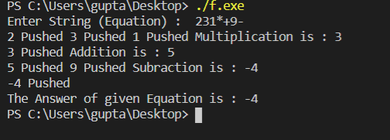

**3) Write a program to demonstrate Stack application (Infix to postfix expression conversion using Stack).**

**Code :**

**#include <iostream>**

**#include <string>**

**using namespace std;**

**class stack {**

**int top1, top2, size;**

**char s1[100], s2[100], var;**

**string s;**

**public:**

**stack()**

**{**

**top1 = top2 = -1;**

**}**

**void geteq()**

**{**

**cout << "\nEnter equation:- ";**

**getline(cin, s);**

**}**

**void push(char p)**

**{**

**top1++;**

**s1[top1] = p;**

**}**

**void push2(char p)**

**{**

**top2++;**

**s2[top2] = p;**

**}**

**char pop()**

**{**

**var = s1[top1];**

**top1--;**

**return var;**

**}**

**int prec(char p)**

**{**

**if (p == '+')**

**return 0;**

**if (p == '-')**

**return 0;**

**if (p == '*')**

**return 1;**

**if (p == '/')**

**return 1;**

**if (p == '^')**

**return 2;**

**}**

**void optr(char p)**

**{**

**char var1, var2;**

**var1 = pop();**

**if (var1 == '+' || var1 == '-' || var1 == '*' || var1 == '/' || var1 == '^') {**

**if (prec(p) > prec(var1)) {**

**push(var1);**

**push(p);**

**}**

**else {**

**push2(var1);**

**push(p);**

**}**

**}**

**else {**

**push(var1);**

**push(p);**

**}**

**}**

**void close()**

**{**

**char var;**

**var = pop();**

**while (var != '(') {**

**push2(var);**

**var = pop();**

**}**

**}**

**void comp()**

**{**

**int i = 0;**

**push('(');**

**while (s[i] != '\0') {**

**if (s[i] == '(')**

**push(s[i]);**

**else if (s[i] >= 'A' && s[i] <= 'Z')**

**push2(s[i]);**

**else if (s[i] >= 'a' && s[i] <= 'z')**

**push2(s[i]);**

**else if (s[i] == '+' || s[i] == '*' || s[i] == '-' || s[i] == '/' || s[i] == '^')**

**optr(s[i]);**

**else if (s[i] == ')')**

**close();**

**i++;**

**}**

**cout << "\nExpression:-";**

**i = 0;**

**while (i <= top2) {**

**cout << s2[i];**

**i++;**

**}**

**}**

**};**

**int main()**

**{**

**stack s;**

**s.geteq();**

**s.comp();**

**}**

**Output :**

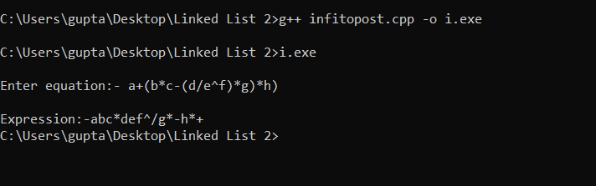

**4) Write a program to demonstrate Stack application (Balancing parenthesis using Stack).**

**Code :**

**#include <iostream>**

**#include <string>**

**using namespace std;**

**class StackOperations**

**{**

**char stack_arr[25];**

**string equation;**

**int top, x;**

**public:**

**StackOperations()**

**{**

**top = -1;**

**}**

**void operation()**

**{**

**cout << "Enter the Equation : "**

**<< " ";**

**getline(cin, equation);**

**x = equation.length();**

**cout << "The Given Equation is :" << endl;**

**for (int i = 0; i < x; i++)**

**{**

**cout << equation[i] << " ";**

**}**

**for (int i = 0; i < x; i++)**

**{**

**if (equation[i] == '(')**

**{**

**push(equation[i]);**

**}**

**if (equation[i] == ')')**

**{**

**if (top == -1)**

**{**

**cout << "Equation is not Balanced";**

**goto xyz;**

**}**

**else**

**{**

**pop();**

**}**

**}**

**}**

**compare();**

**xyz:**

**cout << endl;**

**}**

**void push(char c)**

**{**

**top = top + 1;**

**stack_arr[top] = c;**

**}**

**void pop()**

**{**

**if (top > -1)**

**{**

**stack_arr[top];**

**top = top - 1;**

**}**

**}**

**void compare()**

**{**

**if (top == -1)**

**{**

**cout << "Equation is balanced";**

**}**

**else**

**{**

**cout << "Equation is not balanced";**

**}**

**}**

**};**

**int main()**

**{**

**StackOperations s;**

**s.operation();**

**return 0;**

**}**

**Output :**

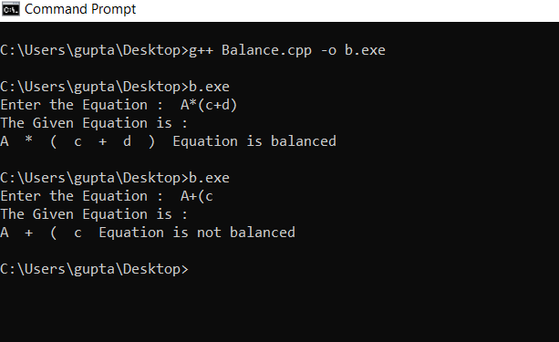

**5) Write a menu driven program to demonstrate Stack using linked list**

**Code :**

**#include<iostream>**

**#include<stdlib.h>**

**using namespace std;**

**struct node**

**{**

**int data;**

**struct node *next;**

**}**

**\*list=NULL,*p,*s,*q,*r,*top=NULL;**

**class StackUsingLinkedList**

**{**

**public:**

**int choice,value;**

**void get()**

**{**

**do**

**{**

**cout<<"0.Exit\n1.Push Operation\n2.Pop Operation\n3.Display\n";**

**cout<<"Enter Your Choice : "<<" ";**

**cin>>choice;**

**switch(choice)**

**{**

**case 0:**

**break;**

**case 1:**

**push_op();**

**break;**

**case 2:**

**pop_op();**

**break;**

**case 3:**

**display();**

**break;**

**default:**

**cout<<"invalid input"<<endl<<endl;**

**}**

**}while(choice!=0);**

**}**

**void push_op()**

**{**

**cout<<"Enter the value : ";**

**cin>>value;**

**p=(struct node*)malloc(sizeof(node));**

**p->data=value;**

**if(list == NULL)**

**{**

**list=p;**

**p->next=top;**

**top=p;**

**display();**

**}**

**else if (!p)**

**{**

**cout<<"Overflow (Memory Full) ";**

**}**

**else**

**{**

**top->next=p;**

**p->next=NULL;**

**top=p;**

**display();**

**}**

**}**

**void pop_op()**

**{**

**if(list == NULL)**

**{**

**cout<<"Under Flow (No Elements) ";**

**}**

**else**

**{**

**q=list;**

**while(q->next != NULL)**

**{**

**r=q;**

**q=q->next;**

**}**

**top=r;**

**top->next=NULL;**

**delete q;**

**display();**

**}**

**}**

**void display()**

**{**

**if(list==NULL)**

**{**

**cout<<endl<<"List is Empty "<<endl<<endl;**

**}**

**else**

**{**

**cout<<"The List is : ";**

**q=list;**

**while(q !=NULL)**

**{**

**cout<<q->data<<"|----->";**

**q=q->next;**

**}**

**cout<<endl<<endl;**

**}**

**}**

**};**

**int main()**

**{**

**StackUsingLinkedList s;**

**s.get();**

**return 0;**

**}**

**Output :**

**//Push**

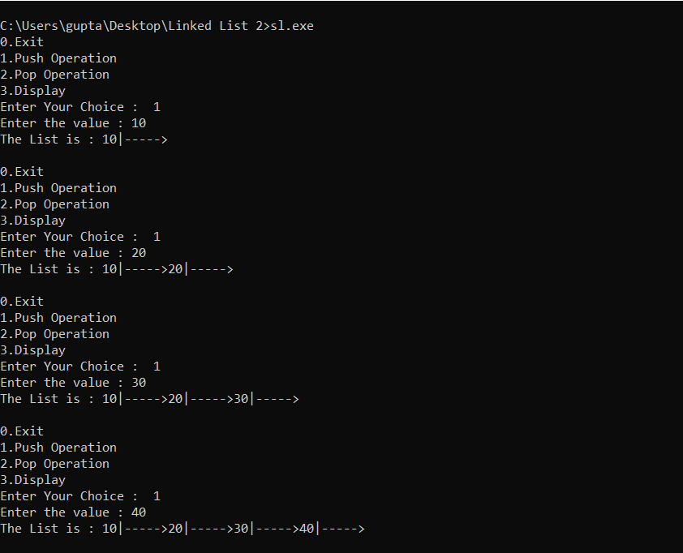

**//Pop**

