Homework Collecting System for Teachers Teaching in Different Universities

Brief Introduction
This system is aimed at building a system for teachers teaching in different universities to collect students homework easily with its features of cross-college and portability.

There are two kind of users, one is the professor and the other is the student.
For the professors, there are three main operations in this system. One is to set up classes, including adding classes and set the requirements of the homework. One is to collect homework. The third is to check whether a student has uploaded his/her homework with the certification code.
For the students, the main operation in this system is to upload his/her homework, after that, he/she can get a unique certification code to prove that the homework has been uploaded.

Programming Languages
HTML, CSS, JAVASCRIPT, PHP

Design of The Database
There are four tables in this system: “class”, “prof”, “student” and “certification”.
For the table “class”:
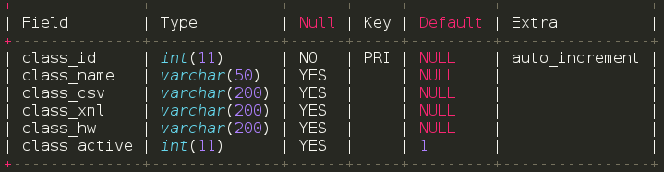
(“class_csv” stores the path of a csv file. For each class, there would be a csv file used to store the information about the students who are in this class. The information includes students’ email addresses and real name.)
(Each homework’s requirement would be stored in one XML file. The homework of one class would be in a certain folder and the “class_xml” records the path of this folder. Each class has a certain folder to store the homework XML files.)
(Each class has a folder to store the uploaded homework. The address of this folder is recorded in the “class_hw”.)
(Once a class has been created, its state would be “1” by default. If the class is over or need to be deleted, its information would not be deleted from this table, but its state would be set as “0”. “class_active” records the state of the class.)

For the table “prof”:
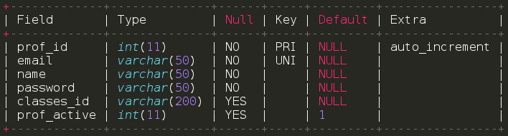
(“classes_id” recorded the classes that the prof is taught in. Different classes’ id would be splited by “,”.)
(“prof_active” records the state of the professor. “1” means the state is active, “0” means the state is inactive. )

For the table “student”:
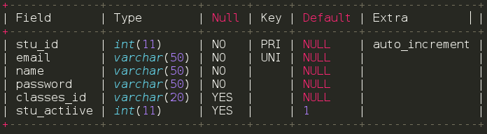
(“classses_id” records the classes that the student is in. Different classes’ id would be splited by “,”.)

For the table “certification”:
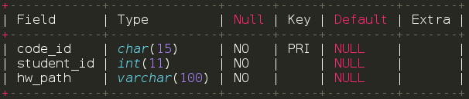
(“code_id” would be generated when a homework be uploaded. This id is unique. The first 13 characters is generated by the micro second of the current time and the 14th and 15th characters are both generated by a random number ranged from 0 to 9.)
(“student_id” records the id of the student who has uploaded the current homework.)
(“hw_path” records the path of the current homework that has been uploaded.)

Pages Display
1. index.html

2. For user who has already signed up, click button “Log In”.
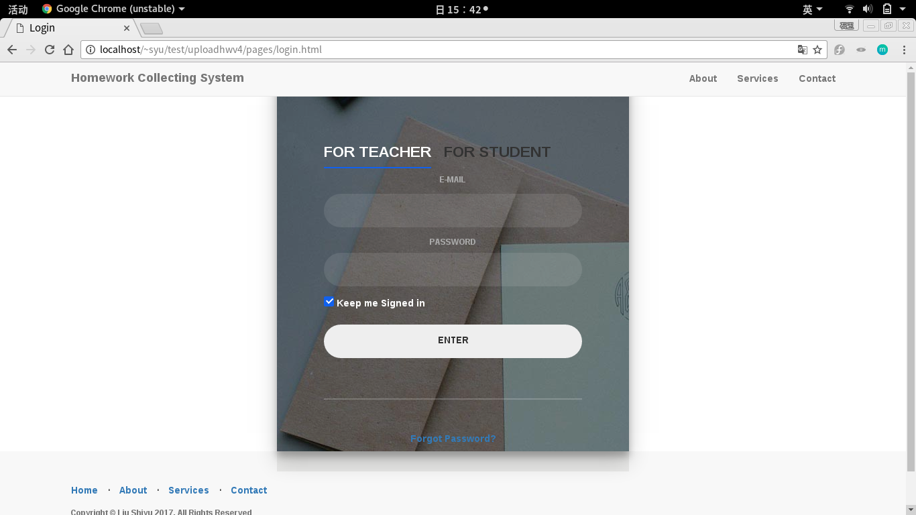
There are two options. One is for teacher and the other is for student. User need to choose his/her identity and then enter his/her e-mail and password. If the e-mail is not validate as the certain format of e-mail, there would be a warning.
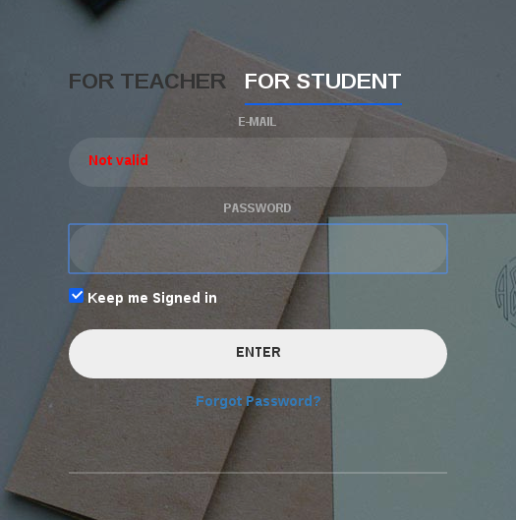

3. Log in as a professor. (e-mail is 1479536064@qq.com)
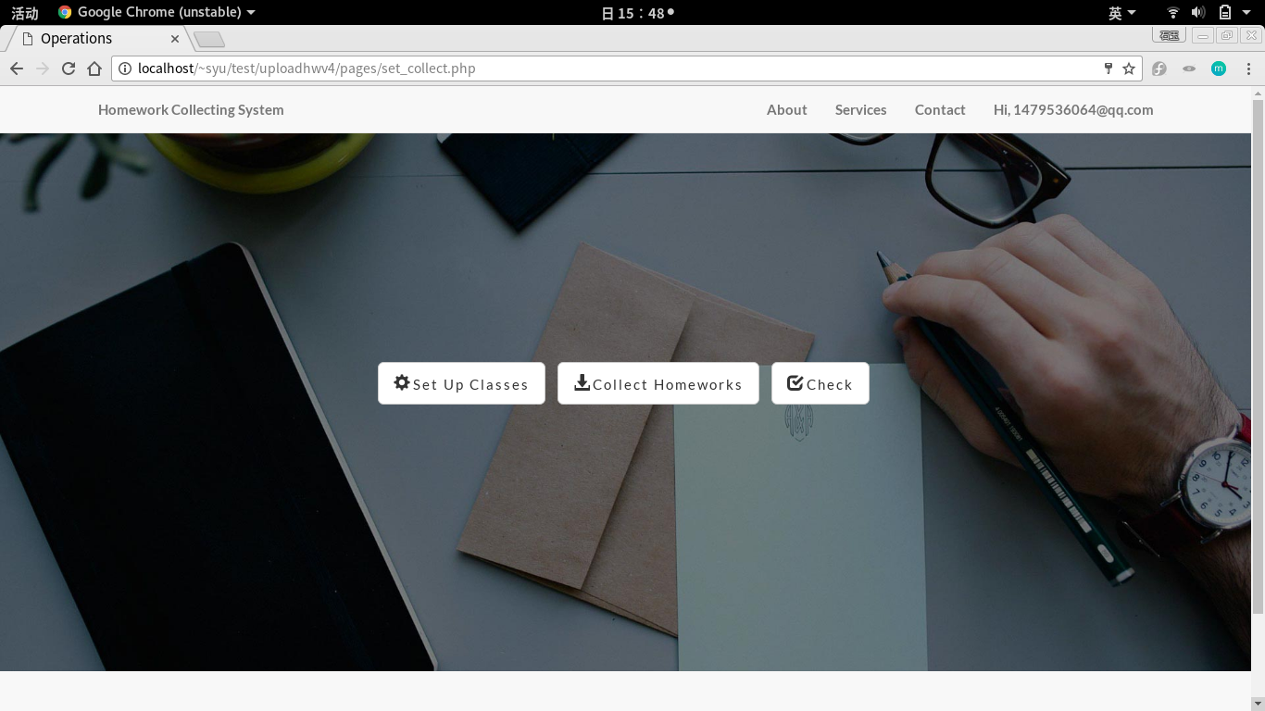

3.1 Click button “Set Up Classes”:
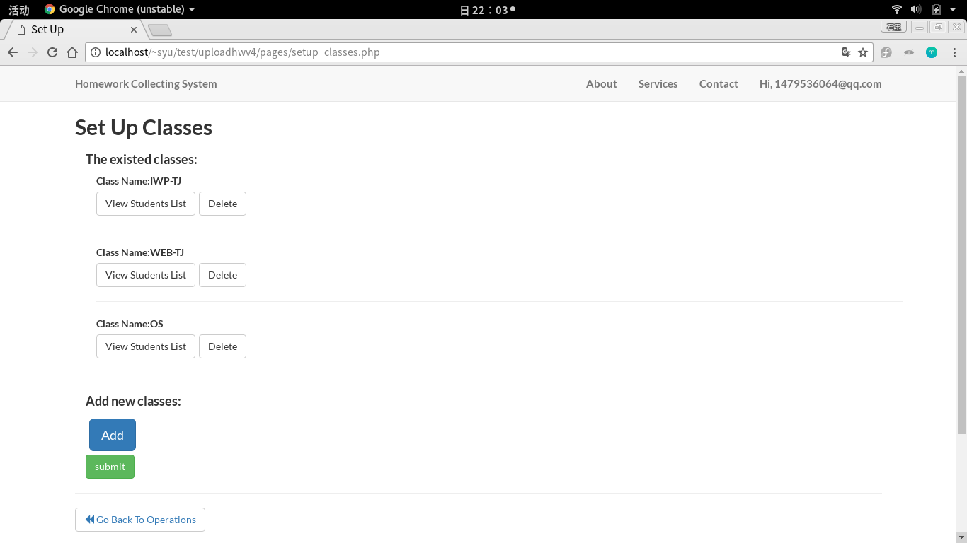
3.2 Then click “delete” to delete the existed class or click “Add” to add new classes.

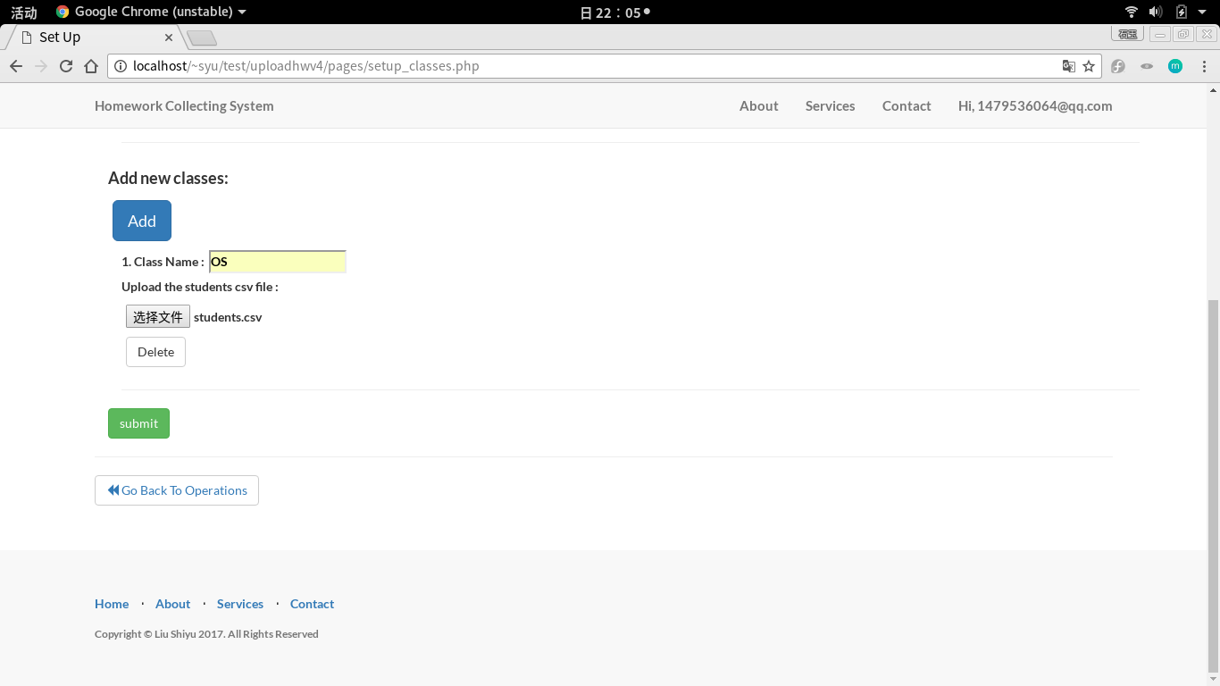
3.3 The csv file which contains this class’s students information is needed to be upload. And this system will set database according to this csv file automatically. Press “submit” to continue.

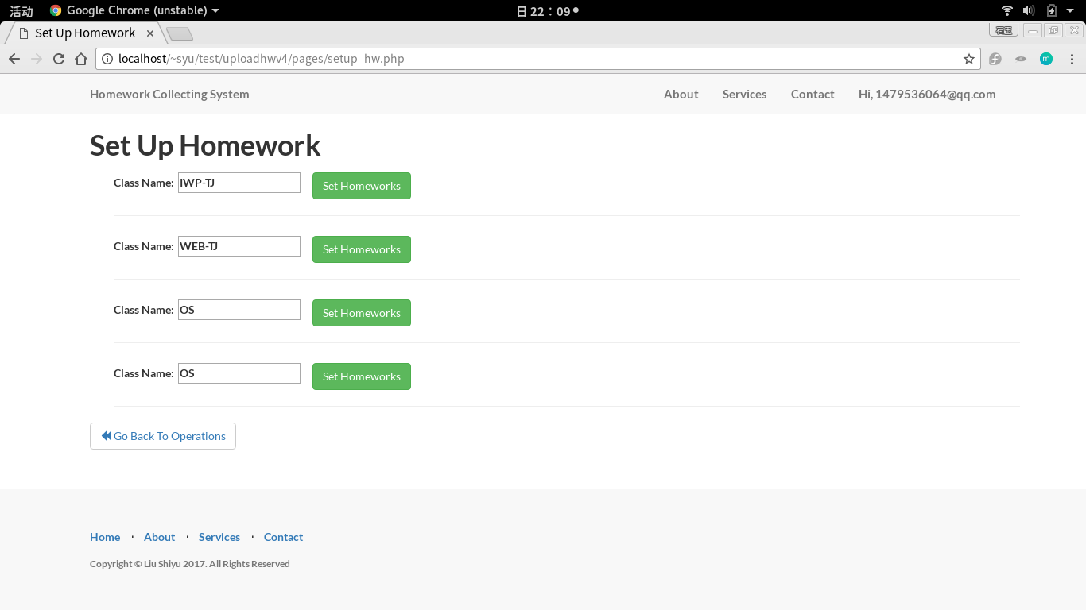
3.4 Click “Set Homework” to continue. Click “Add Homework” to set the requirements of the homework.
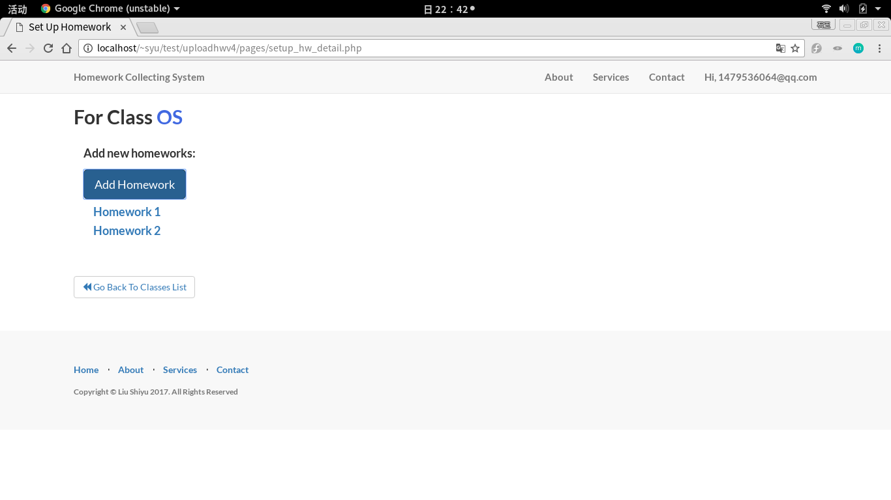
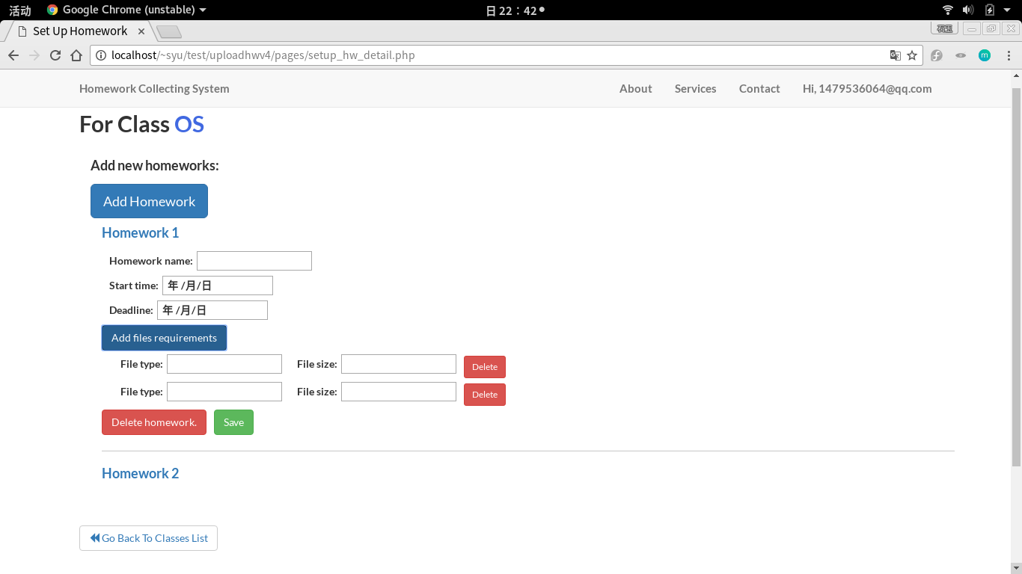

4.1 Click button “Collect Homework”:

