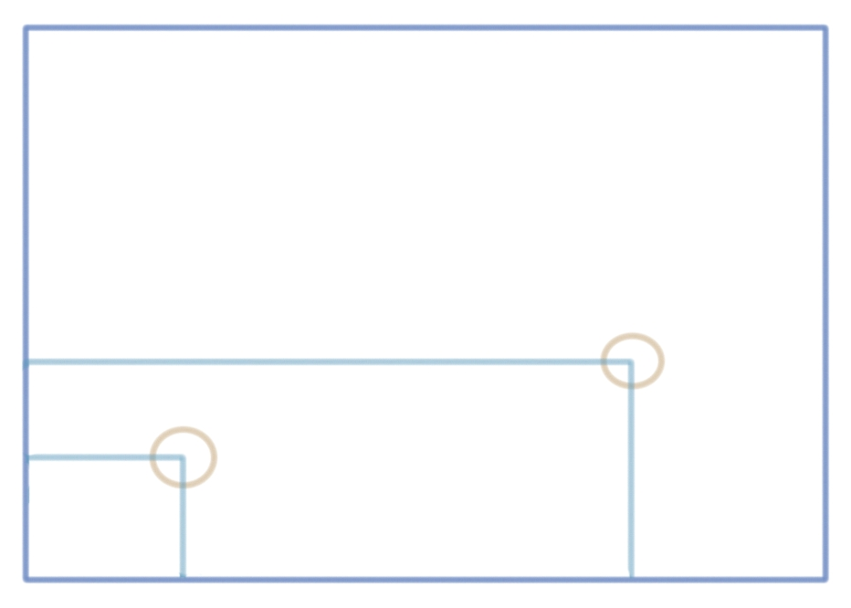
y_{board} = 28.4cm
x_{board} = 23.4cm

m_{total} = 113.75g

m₂ = 20.00g
x_{m2} = 18.6cm

y_{m2} = 9.3cm
m₁ = 50.00g
x_{m1} = 3.6cm
y_{m1} = 5.6cm

origin (0,0) cm

Using two strings, the center of mass was found to be at 9.4 cm horizontally and 9.4 cm vertically from the origin.
CM using string method: (9.4, 9.4) cm from origin

Balancing the board on a pencil, the center of mass was found to be at 9.5 cm horizontally and 9.2 cm vertically from the origin.
CM using balance method: (9.5, 9.2) cm from origin

Calculating the CM:
m_{board} = m_{total} - m₁ - m₂ = 113.75g - 50.00g - 20.00g = 43.75g
CM of board itself: x_{CMboard}= x_{board} / 2 = 23.4 / 2 = 11.7cm
y_{CMboard}= y_{board} / 2 = 28.4 / 2 = 14.2cm
CM:
x = Σx₁m₁ / Σm₁ = (x_{m1}* m₁+ x_{m2}* m₂+ x_{CMboard}* m_{board)} / (m₁₊ m₂₊ m_{board})
y = Σy₁m₁ / Σm₁ = (y_{m1}* m₁+ y_{m2}* m₂+ y_{CMboard}* m_{board)} / (m₁₊ m₂₊ m_{board})

x = (3.6*50+18.6*20+11.7*43.75) / (50+20+43.75) = 9.35cm
y = (5.6*50+9.3*20+14.2*43.75) / (50+20+43.75) = 9.56cm

Calculating the center of mass using the masses of the different components and their location gave a center of mass that was 9.35cm horizontally and 9.56cm vertically from the origin.
Calculated CM: (9.4, 9.6) cm from origin

