Curriculum Vitae - Chris Dorward, Front End Developer
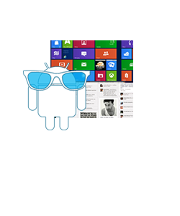

- HTML5 / CSS3 / XML to W3C standards
- Responsive Design
- Taxonomy
- Application Development
- GUI/UI Design, User Interface
- Browser compatibility
- Web Interface
- PHP MySQL & LAMP
- Mobile Apps, Apps Design
- E-commerce
- Web Graphics Design

Designing for tablets and smartphones
We started designing user interfaces when the web looked very different. We've seen and been a part of every iteration and every new technology. We never designed for print, only for screens. These days that means tablets and smartphones.

What is User Interface Design ?

What is Front End Development ?

