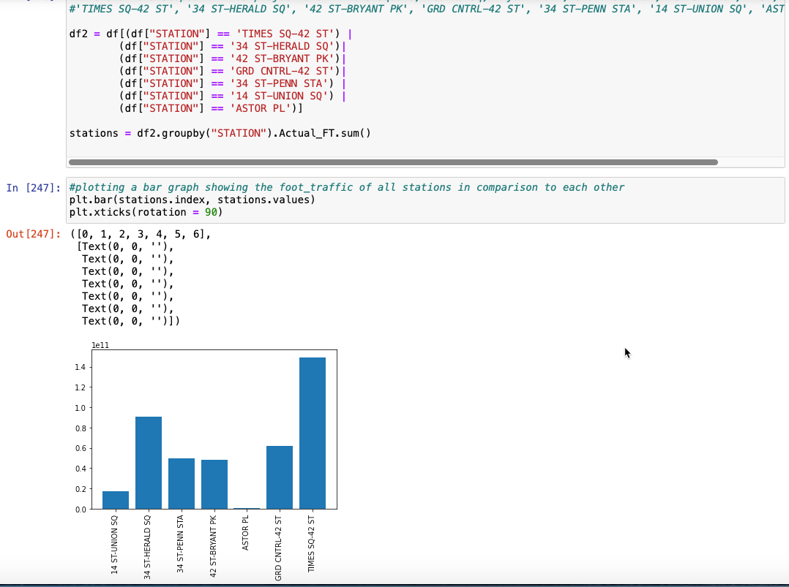

After selecting 7 main stations to analyze foot traffic, I created a bar chart using MatPlot to figure out how each station stack up against each in total foot traffic volume throughout the 3 months. I have yet to filter out the times between 10pm-4am.

I've pulled and cleaned the data as much as I could do. The process of pulling, concatenating, cleaning, filtering is described using pseudocode in the first attachment (previous file). In the 2nd attachment (this file), I attached the visuals by itself in a word doc.