安装软件的问题：
- 如果安装某个包时出现
sudo apt-get update 时会出现
ubuntu@ubuntu-ThinkPad-T460p:~$ sudo apt install libopencv-dev python3-opencv
Reading package lists... Done
Building dependency tree
Reading state information... Done
E: Unable to locate package python3-opencv
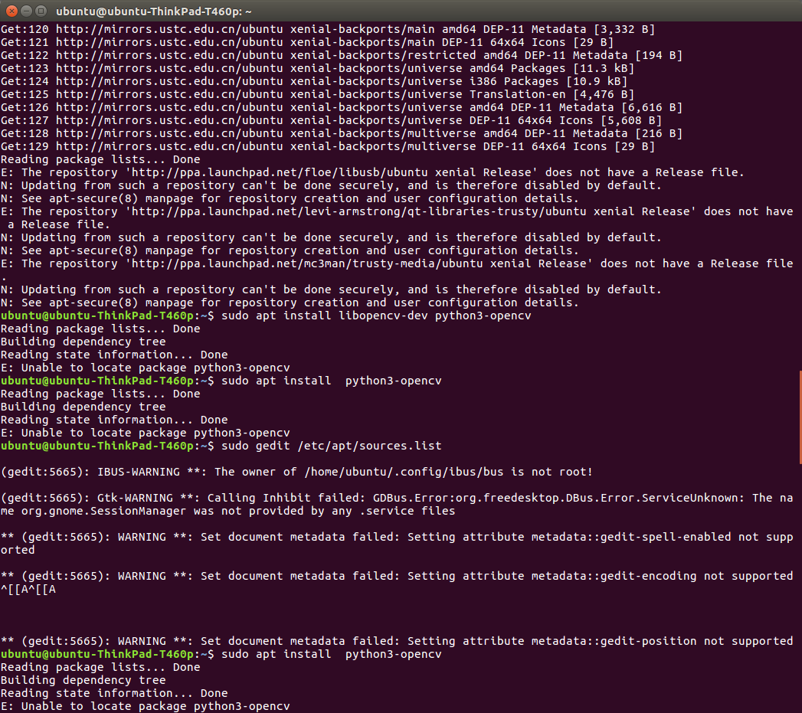

无法定位包的问题，这时因为没有执行sudo apt update 这个命令，如果执行这个命令出现问题，看下下一条解决办法。

- ubuntu@ubuntu-ThinkPad-T460p:~$ sudo apt update
Get:1 http://mirrors.sohu.com/ubuntu xenial InRelease [8 B]
Err:1 http://mirrors.sohu.com/ubuntu xenial InRelease
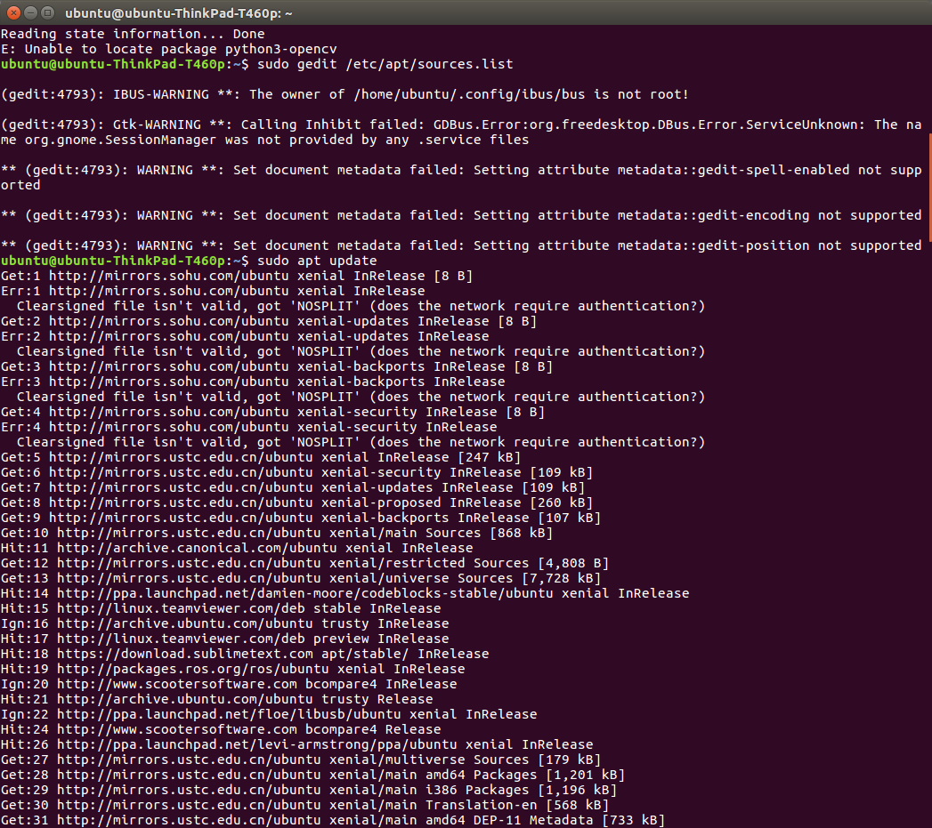
这类型的错误，是因为软件源的问题，解决办法是
ubuntu@ubuntu-ThinkPad-T460p:~$ sudo gedit /etc/apt/sources.list
编辑list文件，把里面的所有内容替换为
deb http://cn.archive.ubuntu.com/ubuntu/ xenial main restricted universe multiverse
deb http://cn.archive.ubuntu.com/ubuntu/ xenial-security main restricted universe multiverse
deb http://cn.archive.ubuntu.com/ubuntu/ xenial-updates main restricted universe multiverse
deb http://cn.archive.ubuntu.com/ubuntu/ xenial-backports main restricted universe multiverse ##测试版源
deb http://cn.archive.ubuntu.com/ubuntu/ xenial-proposed main restricted universe multiverse # 源码
deb-src http://cn.archive.ubuntu.com/ubuntu/ xenial main restricted universe multiverse
deb-src http://cn.archive.ubuntu.com/ubuntu/ xenial-security main restricted universe multiverse
deb-src http://cn.archive.ubuntu.com/ubuntu/ xenial-updates main restricted universe multiverse
deb-src http://cn.archive.ubuntu.com/ubuntu/ xenial-backports main restricted universe multiverse ##测试版源
deb-src http://cn.archive.ubuntu.com/ubuntu/ xenial-proposed main restricted universe multiverse

- ubuntu 16.04+QT 中配置opencv3.4.0
具体方法https://blog.csdn.net/wanzhen4330/article/details/82622664

