Four in one all cutting lamp
Use to tell the book
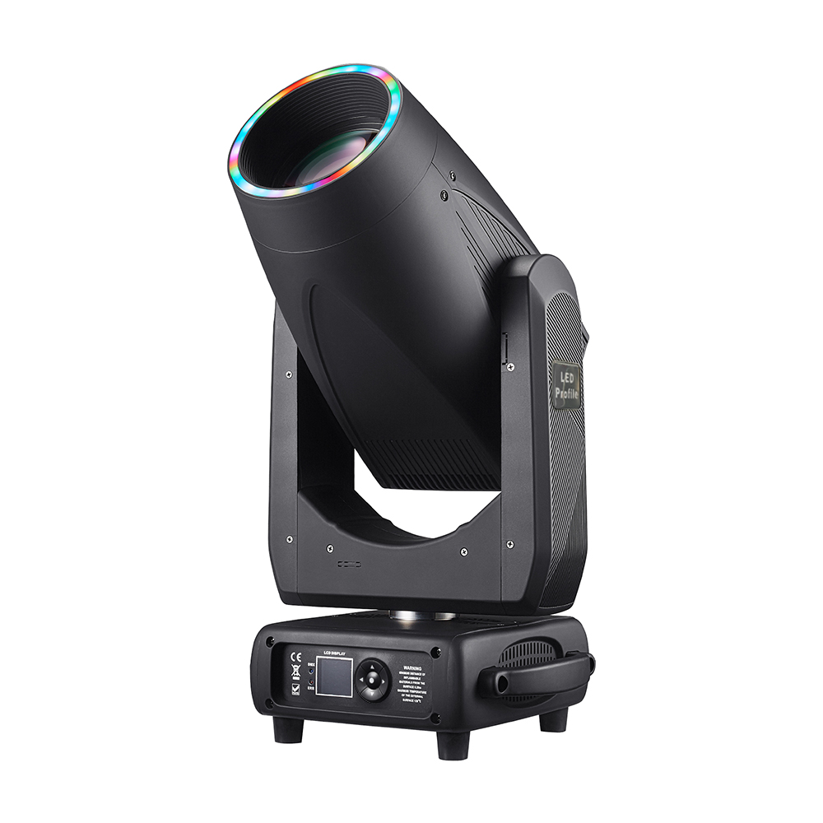

Read the instructions carefully before use

Catalogue
1. Precautions and installation 1
1.1 Statement 1
1.2 Maintenance 1
1.3 Product Precautions 1
1.4 Product Introduction 1
1.5 Signal Cable connection 2
1.6 Lamp Installation 3
2 Control Panel 4
2.1 Keystroke Instructions 4
2.2 Main Menu 5
2.2.1 Settings 6
3 Channel functions 7
3.1 Channel table 7
4 Common faults 11

Precautions and installation Precautions and installation
  - Statement
Thank you for choosing our products!734 This product is in good condition and the package is complete when it leaves the factory.For your safe and effective use of this product, please read this instruction carefully and completely before you use this product.This instruction manual contains important information for installation and use. Please install and operate in accordance with the instructions. At the same time, please keep this instruction manual properly for use at any time.Our company does not assume all responsibility for damage to luminaires or other performance due to individuals not following the instructions during installation, use or maintenance.
This manual is subject to technical changes without prior notice.

  - Maintenance
- Disconnect the power supply before performing maintenance.
- The lamp should be kept dry and avoid working in wet environment.
- Intermittent use will effectively extend the life of the luminaire.
- For good ventilation and lighting, take care to clean the fan and fan net as well as the lens frequently.
- Do not rub the light fixture housing with organic solvents such as alcohol to avoid damage.

  - Product Precautions
- This light fixture is for professional use only.
- Ensure that the power supply voltage is consistent with the equipment requirements before running.
- Do not place this product in a place that is easy to loosen or shake.
- In the process of use, if the lamp appears abnormal, it should stop using the lamp in time.
- In order to ensure the service life of the product, the product should not be placed in damp or leaking places, but also should not work in the environment where the temperature exceeds 60 degrees.
- After power failure, it takes 20 minutes to use the lamp to cool down fully before power use again.
- The rotating parts of the lamps and pasting accessories must be checked regularly. If they are loose and shake, they should be reinforced in time to prevent accidents.
- In order to ensure the normal use of this product, please read the instructions carefully.

  - Product Introduction
- Power of light source: 600W ;
- Voltage: AC 200V~240V/50~60Hz;
- Color disk1: Each disc consists of 9 disc white light;
- Color disk2: Includes CMY function;
- Color disk3: Includes CTO function;
- Pattern plate: 9 patterns are made up of white circles;
- Glass pattern: 5 patterns are made up of white circles;
- 540° translation, 270° tilt.
- Overheat protection;
- Control mode: DMX512/ master-slave/Automatic;
- IP20 protection level

  - Signal cable connection
Light fixtures feature standard DMX input and output 3-core or 5-core XLR sockets.Use a shielded twisted-pair signal cable designed for DMX 512;The signal line is generally connected at 150 meters, and the DMX512 signal amplifier must be added for long distance signal transmission.
Connect a shielded twisted-pair signal line from the DMX outlet of the controller to the DMX input of the first device, and from the DMX outlet of the first device to the DMX input of the second device, and so on, until all lights have been connected. Then install a terminal plug on the last connected light outlet 3-core jack on each circuit.(Weld a 4/1W, 120Ω resistor between the 2 and 3 pins of the 3-core pin cannon plug).

Important: The wires should not touch each other or the metal housing.

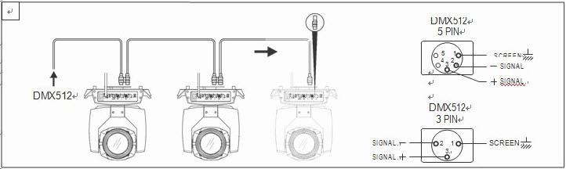
Figure 1 Schematic diagram of DMX signal cable connection
- Calculation method of starting address code of luminaire:
The initial address code of the current luminaire is equal to (the initial address code of the previous luminaire)+(the number of channels of the luminaire)
1: Start address code value A001 of the first luminaire.
2: The basic channel number of the controller, should be greater than or equal to the total number of channels used by the lamp.
3: Note: when using any controller, each lamp should have its own initial address code, if the initial address code of the first lamp is set A001, the number of lamp channel pass is 16CH;Then the start of the second lamp address code is set to A017;The initial address code of the third lamp is set to A033;And so on,(this setting also needs to be determined according to different control platforms)

  - Luminaire installation
Light fixtures can be placed horizontally, slanted, and hung upside down.Be sure to pay attention to the installation method when hanging diagonally and upside down.
As shown in Figure 2, before positioning the lamp, it is necessary to ensure the stability of the installation site. When installing the reverse hanging, it is necessary to ensure that the lamp does not fall down on the support frame. It is necessary to use the safety rope through the support frame and the lamp handle for auxiliary hanging to ensure safety. Prevent the luminaire from falling and sliding.
When installing and debugging the lamps, it is forbidden for pedestrians to pass under them. Regularly check whether the safety rope is worn and whether the hook screws are loose.
Our company does not assume any responsibility for all consequences caused by the fall of the lamp due to the unstable installation of the hanging.

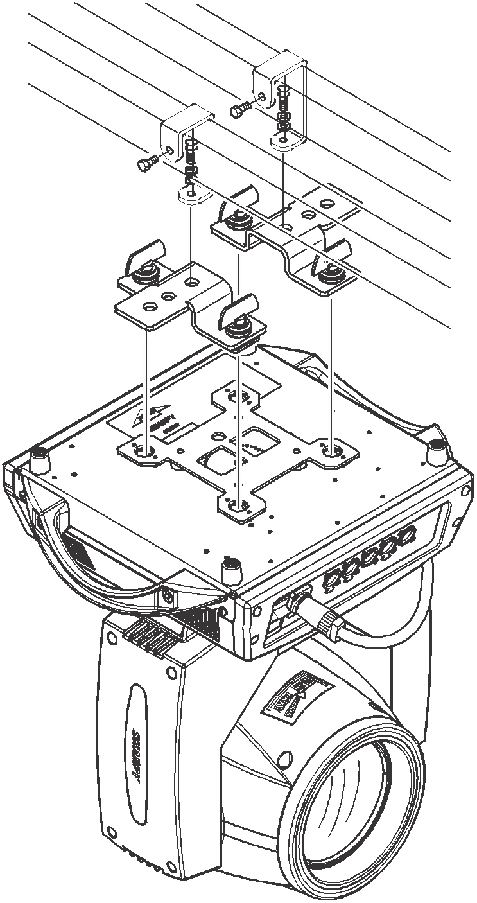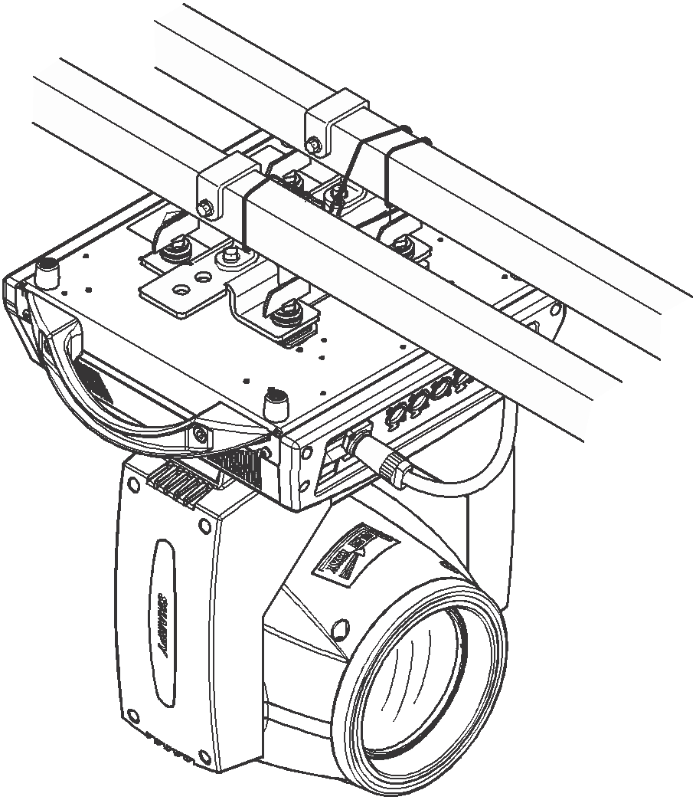
Figure 2. Schematic diagram of the lamp hanging upside down

Control panel

2.1 Key Instructions
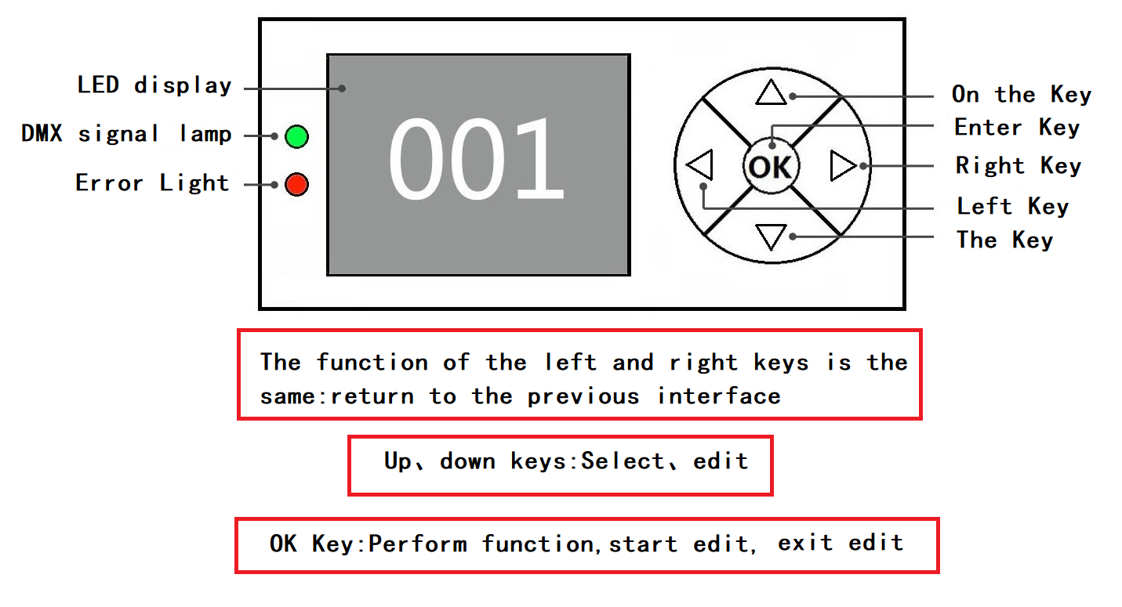
Figure 3 Schematic diagram of key description on the panel
The following takes "Modify DMX address code" as an example to describe the use of keys:
1, if the current is not the main interface, press the "left" key (one or more times) to return to the main interface
2, in the main interface, press the "up" key or "down" key to select the "DMX Settings" button
3. Press the "OK" key to enter the "DMX Settings" interface
4, press the "up" key or "down" key to modify the DMX address code
5, press the "OK" key to exit the editing state
6. Press the right button on the main interface to enter the calibration interface shortcut key.
7. Note: The shortcut keys at the bottom of the main interface, Chinese/English, screen rollover and reset, can only be manually touched, not pressed.
Figure the main menu diagram

2.2.1 DMX Settings
Key description: Press up or down is +1 or -1 mode;Press the right button is the next one;Press the left and confirm button to save and exit.
Manual instructions: Enter the hundreds place first, then the tens place, then the last place.(For example, to enter the 286 address code, click 2, then 8, and finally 6)
2.2.2 Menu
Main menu | Secondary menu | Three-level menu | Four-level menu | Five-level menu
DMX Setup | Dmx Address | 1 - 512
 | Channel Mode | 24CH
 | Run Mode | DMX
 |  | Auto
 |  | Sound
Personality | Pan Inverse | No
 |  | Yes
 | Tilt Inverse | No
 |  | Yes
 | Tilt Feedback | Off
 |  | On
 | Dimmer Curve | Linear
 |  | Square Law
 |  | Inv SQ Law
 |  | S-Curve
 | LED Frequency | 600Hz
 |  | 1200Hz
 |  | 2400Hz
 |  | 4800Hz
 |  | 9600Hz
 |  | 12000Hz
 |  | 24000Hz
 | No Data Mode | Blackout
 |  | Hold
 | M/S Mode | Slave
 |  | Master
 | Sensitivity | 10 - 100
Display | Display Rotate | Normal
 |  | Rotate 180
 | Display Intensity | 1-100
 | Temperature Unit | °C
 |  | °F
 | Language | English
 |  | 中文
Motor Reset | All | No
 |  | Yes
 | Tilt | No
 |  | Yes
 | Effect | No
 |  | Yes
Manual Control | Pan | 0 - 255
 | 。。。 | 0 - 255
 | Function | 0 - 255
DMX Live | Pan | 0 - 255
 | 。。。 | 0 - 255
 | Function | 0 - 255
Service | Password | Calibration | Motor | Pan | -128 -> 127
 |  |  |  | 。。。 | -128 -> 127
 |  | Factory Default | No

Channel parameter values (full version) :

CHANNEL | NAME | VALUE | DERIF
1 | Pan | 000-255 | 0-100%
2 | PanFine | 000-255 | 0-100%
3 | Tilt | 000-255 | 0-100%
4 | TiltFine | 000-255 | 0-100%
5 | PanTiltSpeed | 000-255 | Horizontal and vertical speed, fast to slow
6 | Frost | 000-127 | NO Frost
 |  | 128-255 | Frost cut in
7 | Dimmer | 000-255 | 0-100%
8 | DimmerFine | 000-255 | 0-100%
9 | Strobe | 000-009 | Open
 |  | 010-199 | Sync strobe slow to fast
 |  | 200-249 | Asynchronous strobe is slow to fast
 |  | 250-255 | Open
10 | CTO | 000-255 | From shallow to deep
11 | Cyan | 000-255 | From shallow to deep
12 | Magenta | 000-255 | From shallow to deep
13 | Yellow | 000-255 | From shallow to deep
14 | Colour1 | 000-009 | white
 |  | 010-024 | Color 1
 |  | 025-039 | Color 2
 |  | 040-054 | Color 3
 |  | 055-069 | Color 4
 |  | 070-084 | Color 5
 |  | 085-095 | Color 6
 |  | 096-109 | white +Color 1
 |  | 110-123 | Color 1+Color 2
 |  | 124-137 | Color 2+Color 3
 |  | 138-151 | Color 3+Color 4
 |  | 152-165 | Color 4+Color 5
 |  | 166-179 | Color 5+Color 6
 |  | 180-215 | Forward turn fast to slow
 |  | 216-220 | Stop
 |  | 221-255 | The reversal is slow to fast
15 | Colour2 | 000-009 | white
 |  | 010-036 | Color 1
 |  | 037-063 | Color 2
 |  | 064-089 | Color 3
 |  | 090-119 | white +Color1
 |  | 120-149 | Color 1+Color 2
 |  | 150-179 | Color 2+Color 3
 |  | 180-215 | Forward turn fast to slow
 |  | 216-220 | Stop
 |  | 221-255 | The reversal is slow to fast
16 | FixGobo | 000-010 | White
 |  | 011-020 | GOBO 1
 |  | 021-030 | GOBO 2
 |  | 031-040 | GOBO 3
 |  | 041-050 | GOBO 4
 |  | 051-060 | GOBO 5
 |  | 061-070 | GOBO 6
 |  | 071-080 | GOBO 7
 |  | 081-090 | GOBO 8
 |  | 091-101 | GOBO 9
 |  | 102-111 | GOBO 1: Jitter from slow to fast
 |  | 112-121 | GOBO 2: Jitter from slow to fast
 |  | 122-131 | GOBO 3: Jitter from slow to fast
 |  | 132-141 | GOBO 4: Jitter from slow to fast
 |  | 142-151 | GOBO 5: Jitter from slow to fast
 |  | 152-161 | GOBO 6: Jitter from slow to fast
 |  | 162-171 | GOBO 7: Jitter from slow to fast
 |  | 172-181 | GOBO 8: Jitter from slow to fast
 |  | 182-191 | GOBO 9: Jitter from slow to fast
 |  | 192-221 | Forward turn fast to slow
 |  | 222-225 | Stop
 |  | 226-255 | The reversal is slow to fast
17 | RotGobo | 000-009 | White
 |  | 010-025 | GOBO 1
 |  | 026-041 | GOBO 2
 |  | 042-057 | GOBO 3
 |  | 058-073 | GOBO 4
 |  | 074-089 | GOBO 5
 |  | 090-109 | GOBO 1: Jitter from slow to fast
 |  | 110-129 | GOBO 2: Jitter from slow to fast
 |  | 130-149 | GOBO 3: Jitter from slow to fast
 |  | 150-169 | GOBO 4: Jitter from slow to fast
 |  | 170-189 | GOBO 5: Jitter from slow to fast
 |  | 190-221 | Forward turn fast to slow
 |  | 222-223 | Stop
 |  | 224-255 | The reversal is slow to fast
18 | GoboRot | 000-127 | Pattern angle adjustment
 |  | 128-190 | Forward turn fast to slow
 |  | 191-192 | Stop
 |  | 193-255 | The reversal is slow to fast
19 | Focus | 000-255 | Focus, far to near
20 | Zoom | 000-255 | Zoom，far to near
21 | Prism1 | 000-127 | NULL
 |  | 128-255 | Prism1 cut in
22 | Prism1Rot | 000-063 | Prism angle adjustment
 |  | 064-126 | The prism is turning slower to faster
 |  | 127-128 | The prism rotation stops
 |  | 129-191 | Prism reversal is slow to fast
 |  | 192-255 | Prism jitter
23 | Framing Macro | 000-009 | NULL
 |  | 010-247 | Graphics switching
 |  | 248-255 | Automatic graphics switching
24 | Framing Up1 | 000-255 | 0-100%
25 | Framing Up2 | 000-255 | 0-100%
26 | Framing Down1 | 000-255 | 0-100%
27 | Framing Down2 | 000-255 | 0-100%
28 | Framing Left1 | 000-255 | 0-100%
29 | Framing Left2 | 000-255 | 0-100%
30 | Framing Right1 | 000-255 | 0-100%
31 | Framing Right2 | 000-255 | 0-100%
32 | Function | 210-210 | XY reset, hold 3S
 |  | 220-235 | The head motor is reset and held for 3S
 |  | 240-255 | All motors are reset and held for 3S
33 | Led Effect | 000-001 | NULL
 |  | 002-008 | SHOW 1
 |  | 009-015 | SHOW 2
 |  | 016-022 | SHOW 3
 |  | 023-029 | SHOW 4
 |  | 030-036 | SHOW 5
 |  | 037-043 | SHOW 6
 |  | 044-050 | SHOW 7
 |  | 051-057 | SHOW 8
 |  | 058-064 | SHOW 9
 |  | 065-071 | SHOW 10
 |  | 072-078 | SHOW 11
 |  | 079-085 | SHOW 12
 |  | 086-092 | SHOW 13
 |  | 093-099 | SHOW 14
 |  | 100-106 | SHOW 15
 |  | 107-113 | SHOW 16
 |  | 114-120 | SHOW 17
 |  | 121-127 | SHOW 18
 |  | 128-134 | SHOW 19
 |  | 135-141 | SHOW 20
 |  | 142-148 | SHOW 21
 |  | 149-155 | SHOW 22
 |  | 156-162 | SHOW 23
 |  | 163-169 | SHOW 24
 |  | 170-176 | SHOW 25
 |  | 177-183 | SHOW 26
 |  | 184-190 | SHOW 27
 |  | 191-197 | SHOW 28
 |  | 198-204 | SHOW 29
 |  | 205-211 | SHOW 30
 |  | 212-218 | SHOW 31
 |  | 219-225 | SHOW 32
 |  | 226-232 | SHOW 33
 |  | 233-239 | SHOW 34
 |  | 240-246 | SHOW 35
 |  | 247-253 | SHOW 36
 |  | 254-255 | SHOW 37
34 | Led Effect Speed | 000-255 | The speed goes from slow to fast

Common faults
According to some common faults, the corresponding solutions are put forward.Any unsolvable problems should be dealt with by professionals.Disconnect the light fixture before maintaining it.

The lamp will not accept control from the console after normal reset
- Check luminaire digital start address value and function options are correct;
- Check whether the connection of communication control line is correct, the communication line is too long or has been interrupted;
- Check whether the control equipment is invalid, check whether the serial access signal amplifier is invalid;
- Check whether the communication line is too long or other equipment interferes with each other;
- Optimize wiring, shorten the length of control signal lines, high voltage and low voltage lines separate wiring;
- Add signal amplifiers;
- Signal line using high-quality shielded twisted pair wire;
- Connect the signal terminal resistor (120 ohm) at the end of the lamp.

Luminaire does not start
- Check that the power supply parameters are consistent with the lamp;
- Check the poor contact caused by extrusion deformation, vibration and moisture of internal parts in the long distance transportation process
Or fall off.
- Please check whether the internal wire integration connector of the lamp has fallen off or loosened.
- Check whether the electronic components of the lamp (such as electronic transformer, PCB board, motor control board, etc.) are loose, short circuit and burned out.

When working, the action of the X or Y axis of the lamp is not normal
- Follow the previous step to check them one by one;
- Check whether the transmission belt corresponding to the X and Y axis directions in the lamp falls off and breaks;
- Check whether the data feedback receiver (optocoupler) corresponding to the X and Y directions in the lamp is damaged;
- Restart the machine and reset it once.

