**Market Basket Analysis**

by

Litan Li

Electronidex

The purpose of this effort was to gain actionable insights into Blackwell Electronics’ customer buying patterns by using one month’s worth of their transaction data. This will aid our decision makers, who must decide whether to acquire Blackwell or not. The Apriori algorithm was used to find association rules from the transaction data and actionable insights were extracted. Several items from their lineup would be attractive additions to our own, with potential for cross selling. Based on the insights gained, I recommend acquisition. In addition, I recommend promoting the HP Black & Tri-color ink and the Dell 2 Desktop to generate sales of their correlated items. We might also consider placing the ViewSonic monitor physically closer to our desktops and laptops in our stores, and display it as a recommendation on our website when customers add laptops and/or desktops to their shopping cart.

**Are there any interesting patterns or item relationships within Blackwell's transactions?**

The figure below shows the items purchased in transactions as shaded-in squares. Only 150 transactions are shown due to space limitations, and these are randomly sampled. A figure using the first 150 transactions, the second 150 transactions, and so forth look very much like the figure below. The figure shows that customer purchasing patterns did not vary across the month that this transaction data was taken. As a caveat, this assumes that the transaction data given by Blackwell were in chronological order.



The plot below shows the top 10 most frequently purchased items. Five desktops and three laptops made it to the list, along with the Apple Earpods and ViewSonic monitor.

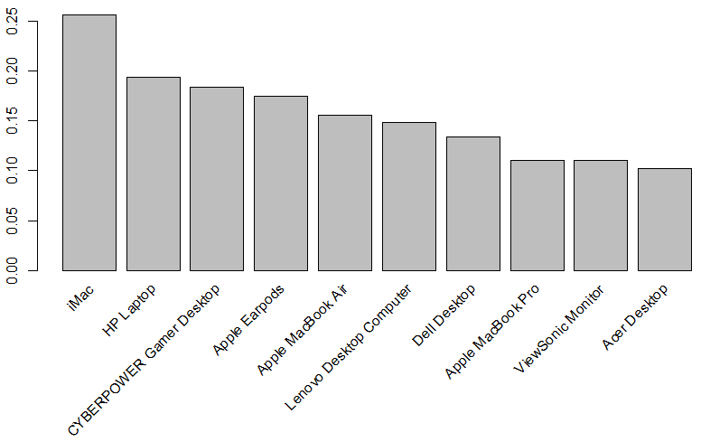

In addition to the insights above, the following were also found:

* Customers who purchased laptops, desktops, or both were more likely to choose the ViewSonic brand monitor to go with their systems than any other brand of monitors that appeared in transactions (LG, Samsung, HP, and Asus).
* Customers who purchased HP Black & Tri-color ink were almost four times more likely to purchase a ViewSonic brand monitor compared to the monitor’s typical rate of purchase. An explanation for this relationship is difficult to give, but the increase in purchase rate was quite substantial to ignore. In addition, customers who purchased this ink were almost 2.5 and 2 times more likely to purchase an HP laptop and an iMac respectively.

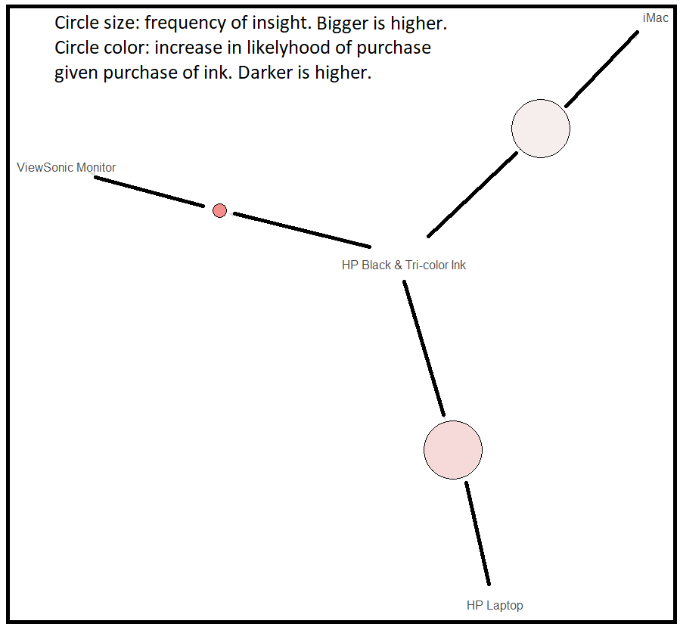

* Customers who purchased Dell 2 Desktops were almost four times more likely to purchase an Apple Magic Keyboard compared to the keyboard’s typical rate of purchase. In addition, they were more than 2 times more likely to purchase a Lenovo Desktop computer.

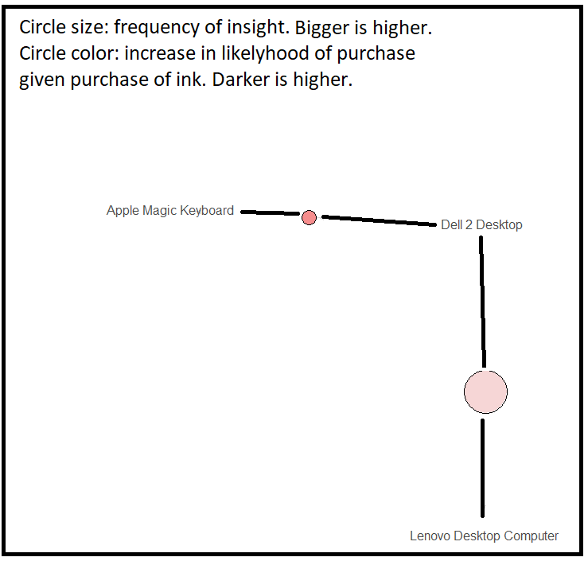

* We expect customers to buy only one computer system at a time, and perhaps include pieces of software or peripherals for their purchase. Perhaps they need a new laptop, or they are purchasing a desktop or laptop for the first time. However, many transactions show that customers were buying multiple computer systems from Blackwell in single transactions.

**Would Electronidex benefit from selling any of Blackwell's items?**

HP Black & Tri-color ink and Dell 2 Desktops both correlate with a purchase of another product, with a roughly 2-fold increase. Although the ViewSonic monitor appears in the top ten most frequently sold items in Blackwell’s transactions and seem to be a popular choice amongst customers buying laptops and desktops, it is already in our list of existing products. However, the ink and Dell desktop could become new and beneficial products in our existing product lineup.

**In your opinion, should Electronidex acquire Blackwell?**

Based on the alone transaction data, my recommendation is to acquire. Several items correlate with increased chances of sales of other products, and customers seem willing to purchase several computer systems at once from Blackwell in single transactions, which suggests some degree of loyalty to the store. These transactions also are likely to be high in total dollar amount.

**If Electronidex does acquire Blackwell, do you have any recommendations? (Ex: cross-selling items, sale promotions, should they remove items, etc.)**

I recommend promoting the HP Black & Tri-color ink and the Dell 2 Desktop to generate sales of their correlated items. We might also consider placing the ViewSonic monitor physically closer to our desktops and laptops in our stores, and display it as a recommendation on our website when customers add laptops and/or desktops to their shopping cart.