192.168.60.100

Sites + Apache

1. Install mysql connector

2. Install visual c++ redistributable

3. ODBC configuration

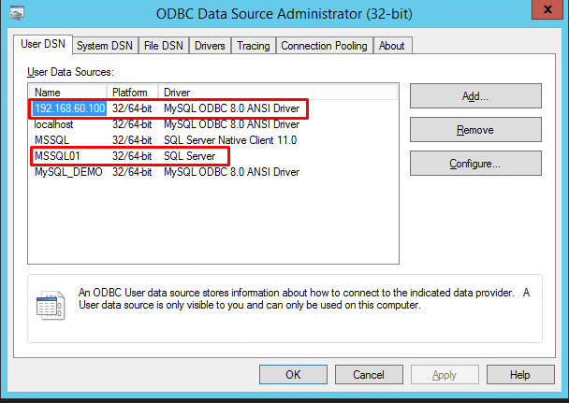

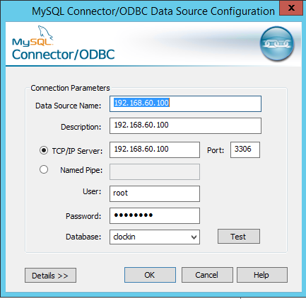

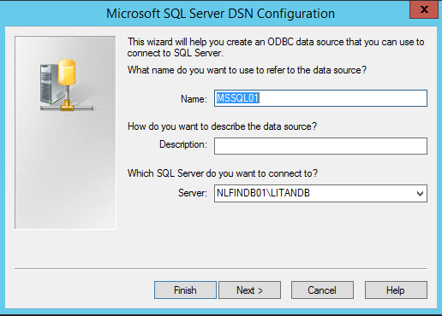

4. Create demo_attend database in MSSQL

USE [micro_data]

GO

SET ANSI_NULLS ON

GO

SET QUOTED_IDENTIFIER ON

GO

SET ANSI_PADDING ON

GO

CREATE TABLE [dbo].[demo_attend](

[id] [int] IDENTITY(7,1) NOT NULL,

[DateRecord] [varchar](50) NOT NULL,

[TimeRecord] [varchar](50) NOT NULL,

[TypeInOut] [varchar](250) NOT NULL,

[IdEmp] [varchar](250) NOT NULL,

[BadgeNum] [varchar](50) NOT NULL,

[ClockNum] [varchar](50) NOT NULL,

[ManualRec] [varchar](50) NOT NULL,

[EventId] [varchar](250) NOT NULL,

[Event_Time] [varchar](250) NOT NULL,

[Note] [varchar](50) NOT NULL,

[ProjectId] [varchar](250) NOT NULL,

[Meal] [varchar](50) NOT NULL,

CONSTRAINT [PK_attend_id] PRIMARY KEY CLUSTERED

(

[id] ASC

)WITH (PAD_INDEX = OFF, STATISTICS_NORECOMPUTE = OFF, IGNORE_DUP_KEY = OFF, ALLOW_ROW_LOCKS = ON, ALLOW_PAGE_LOCKS = ON) ON [PRIMARY]

) ON [PRIMARY]

GO

SET ANSI_PADDING OFF

GO

EXEC sys.sp_addextendedproperty @name=N'MS_SSMA_SOURCE', @value=N'clockin.attend' , @level0type=N'SCHEMA',@level0name=N'dbo', @level1type=N'TABLE',@level1name=N'demo_attend'

GO

5. Run .exe.

6. Check if added.

7. move to dbo.ReadRecords.

INSERT INTO micro_data.dbo.ReadRecords(Terminal_ID, Badge_ID, Rec_Date, Rec_Time, Type_InOut)

 SELECT Terminal_ID, Badge_ID, Rec_Date, Rec_Time, Type_InOut FROM micro_data.dbo.demo_attend

 UNION

 SELECT Terminal_ID, Badge_ID, Rec_Date, Rec_Time, Type_InOut FROM micro_data.dbo.ReadRecords;

GO

8. Rec_Time am\pm.