B
Bay Lawn
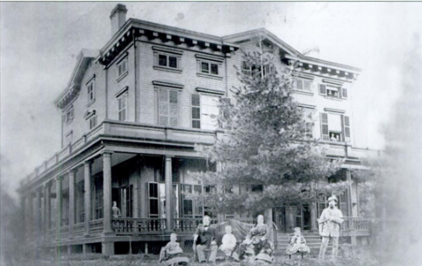
Location: between present-day 218th and 219th Streets and 36th and 38th Avenues. Flushing, Queens, New York.
Built:1849

Architectural Description
Bay Lawn was a large mid-nineteenth-century country estate overlooking Little Neck Bay in what is now the Bayside section of Queens. The mansion was a substantial, three-story residence of formal, classically influenced design, surrounded by landscaped grounds suitable for large social gatherings. Contemporary photographs show a broad, symmetrical structure with a columned veranda wrapping the principal façade, deep eaves with decorative brackets, and tall sash windows, giving the house both grandeur and openness to its waterfront setting.
The estate commanded expansive views of Little Neck Bay and the surrounding countryside. Its lawns, trees, and outbuildings formed one of the most prominent private properties in the Bayside–Flushing area during the mid- and late nineteenth century. The setting made Bay Lawn a favored venue for outdoor entertainments and evening receptions.
History
After serving a single term as mayor of New York City (1845–1847), Andrew Hutchens Mickle purchased land in Bayside in 1849 from Abraham Bell, a major landholder in the area. Mickle retired from active political life and established Bay Lawn as his country residence.
Mickle was a prominent New York tobacconist and Democratic politician associated with Tammany Hall. His second wife was Mary Nicoll Lawrence, daughter of Judge Effingham Lawrence (1779–1850), builder of the Stone House in 1822. Through this marriage, Bay Lawn became closely connected to the Lawrence family, long established in northern Queens.
During the Mickles’ residence, Bay Lawn was known for its social life. Newspaper accounts describe “elegant hops” and evening entertainments attended by members of prominent New York and Long Island families. One such event was reported in the New York Herald on August 25, 1870, noting the extensive illumination of the grounds with lanterns and the tasteful decoration of the house with flowers and vines.
Andrew H. Mickle died at Bay Lawn on January 25, 1863. The estate remained associated with the family for several decades afterward. His daughter, Janet Campbell Mickle (1857–1939), married Effingham Lawrence III (1856–1899), further reinforcing the property’s place within the Lawrence kinship network.
Later, the Mickle family moved to the Lawrence Homestead on 221st Street and 41st Avenue. Bay Lawn itself was destroyed by fire in October 1890. No original structures survived the blaze.
In 1902, the former Mickle tract was sold for development for $50,000. Developers reused the name “Bay Lawn” for the subdivision, though the original mansion and estate had already vanished.

Beauregard
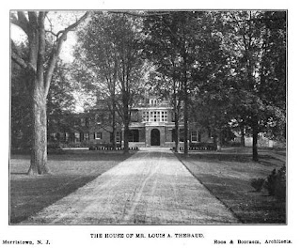

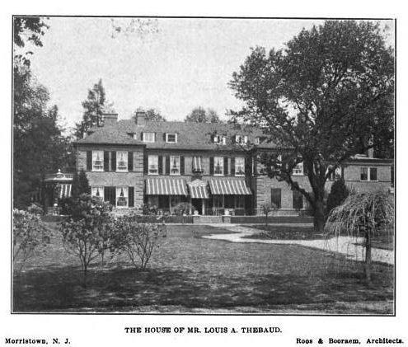

Location: Morristown, New Jersey
Built: c. 1905–1907
Architects: Roos & Booraem

Architect
Roos & Booraem was a New York City-based architecture firm active in the late 19th and early 20th centuries. The partnership formed in 1899 when Philip W. Roos (a German-born architect who immigrated to the U.S. around the early 1880s, became a citizen in 1883, and started his own practice in 1893) joined forces with Hugh Toler Booraem (sometimes referred to as H. Toler Booraem). The firm operated out of New York, with offices including at 32 Nassau Street and connections to addresses like the Trust Company Building in Morristown. They notably served as the in-house architects for the Mutual Life Insurance Company of New York (MONY) until around 1905, when that relationship ended.

Architectural Description
Beauregard was conceived as a large, symmetrical country house in a restrained classical idiom. The long, brick main façade is articulated by evenly spaced windows and capped by a hipped roof with dormers, lending the house a low, horizontal emphasis appropriate to its expansive grounds. A broad central entrance, approached by a long drive, establishes axial formality, while secondary elevations are softened by porches and terraces that connect the house to its landscaped setting. The overall effect is one of controlled grandeur—imposing in scale but conservative in ornament.

Interior
______________
Hall
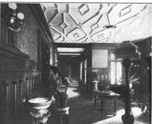
The entrance hall is a long, axial space designed to impress through proportion rather than excess. Paneled walls and a coffered ceiling establish a formal tone, while the hall functions as the organizing spine of the house, connecting principal reception rooms and framing views through to the garden.
______________
Living Room

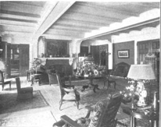

The living room is expansive and horizontally oriented, with a beamed ceiling and large fireplace anchoring the space. Generous windows and French doors admit light and open the room toward the grounds, emphasizing comfort and sociability over ceremonial formality.
______________
Dining Room
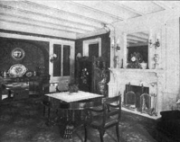

The dining room continues the classical vocabulary with heavy beams, paneled walls, and a prominent mantel. Its scale suggests large formal dinners, while the restrained decorative program reflects the early twentieth-century preference for solidity and permanence rather than ornamented display.
Billiard Room
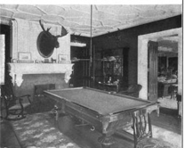

The billiard room is more masculine in character, organized around a central table and fireplace. Darker finishes and a lower ceiling create a sense of enclosure and leisure, marking it as a retreat within the larger house.
_______________
Morning Room
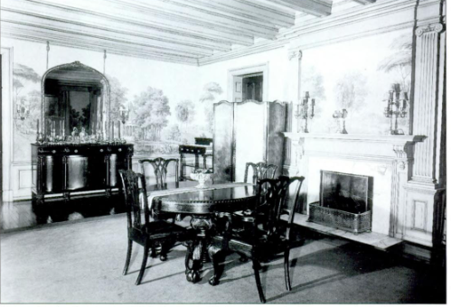

The morning room at Beauregard is an intimate, light-oriented space designed for informal meals and daytime use. Its low beamed ceiling and refined classical fireplace create a sense of enclosure, while painted wall panels with landscape scenes soften the room’s formality and introduce a pastoral note appropriate to a country house. Furnished with a modest dining table and sideboard, the room balances elegance and ease, reflecting its role as a transitional space between the house’s formal reception rooms and the rhythms of daily family life.

History
Beauregard was built for Louis Andrew Thébaud, a member of a socially prominent Franco-American family whose fortunes were transformed by his 1886 marriage to Gertrude Lee McCurdy, daughter of Richard Aldrich McCurdy, longtime president of the Mutual Life Insurance Company of New York. Prior to this marriage, Thébaud’s means were respectable but limited; the McCurdy fortune—derived from vast insurance interests—made possible a level of architectural ambition previously beyond his reach.

After residing at Idlewild in Morris Plains, Thébaud turned to Morristown, where in 1905 McCurdy acquired a 300-acre estate formerly belonging to B. O. Canfield. The existing house was demolished, and Beauregard was erected as a new family seat, designed by Roos & Booraem, architects favored by wealthy New York clients for their assured handling of large Georgian-inspired houses. After Thébaud’s death, the house remained associated with the family; his much younger second wife, Andrée des Étangs, lived at Beauregard until her death in 1983. The estate has since been adapted for institutional use and now forms part of a Care One facility

Bedford
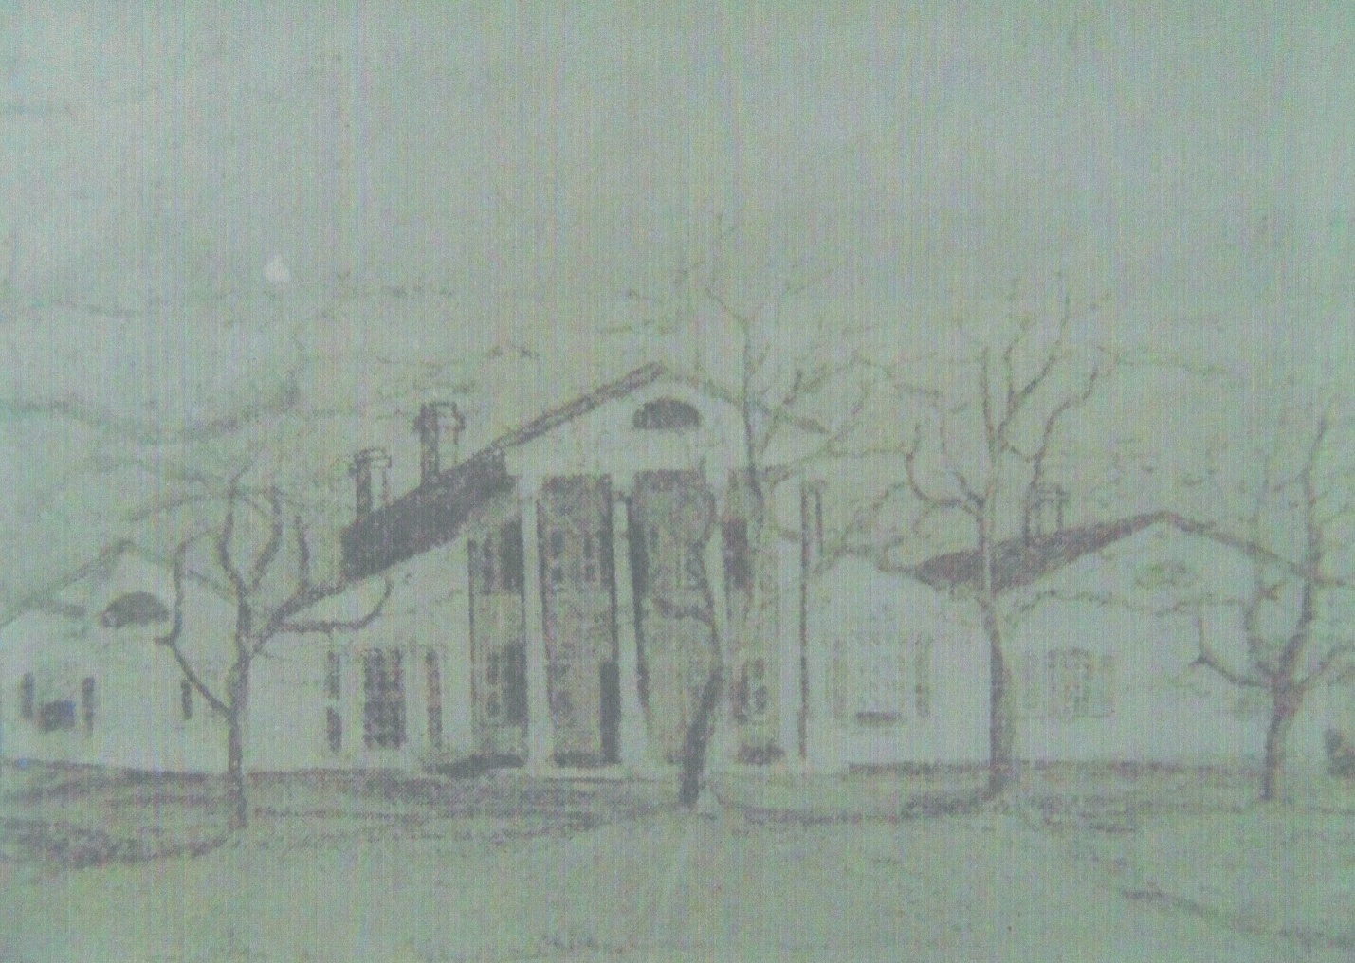

Location: near Shepherdstown in Jefferson County, Virginia (now West Virginia). The estate sat in the Shenandoah Valley region, close to the Potomac River
Built: 1799-1801.

Architectural Description
It was described as “a large and handsome old colonial mansion, built of brick, with stuccoed walls.” It featured “a splendid portico, supported by four large wooden pillars which were said to have been made from the masts of the famous revolutionary ship, the ‘Constition”.
History
The house known as Bedford was built around 1799–1801 by Daniel Bedinger (c. 1761–1818) and his wife, Sarah (Sally) Rutherford Bedinger. It was constructed on or near the site of an earlier family home/property. Daniel Bedinger was a Revolutionary War veteran (served as a young prisoner of war, later rose in rank) who settled in the area after the war. He died at Bedford in 1818, and it was described as a place of hospitality.
The Burning of Bedford
The burning of Bedford, the historic Bedinger/Lee family estate near Shepherdstown, West Virginia (then Virginia), on July 19, 1864, stands as one of the most poignant episodes of Union General David Hunter's scorched-earth campaign in the Shenandoah Valley. Hunter, commanding Federal forces under instructions from Lieutenant General Ulysses S. Grant to devastate the region's agricultural resources—"eat out Virginia clear and clean" so thoroughly that even crows would need to carry their own provisions—interpreted his orders aggressively. While Grant specified that houses should not be burned but provisions and livestock removed, Hunter exceeded these bounds, targeting civilian homes of prominent Confederate sympathizers as retaliatory measures against a population he viewed as hostile. This approach followed earlier acts like the destruction of the Virginia Military Institute and Governor John Letcher's home in Lexington, and came amid Confederate reprisals, such as Jubal Early's forces burning Postmaster General Montgomery Blair's Maryland residence.

Hunter's orders escalated in mid-July from his Harpers Ferry headquarters. On July 17, via Special Orders No. 128, he dispatched Captain Franklin G. Martindale of the 1st New York (Lincoln) Cavalry with 15 men to burn homes in the Charlestown area, including that of Andrew Hunter (a distant cousin and Virginia senator). Two days later, Martindale received fresh directives to proceed to the Shepherdstown vicinity, targeting Fountain Rock (home of former Confederate Congressman Alexander R. Boteler) and Bedford (residence of Edmund Jennings Lee, a cousin of Robert E. Lee, though Edmund himself was not in active Confederate service). Martindale, described as a dutiful officer who never shirked unpleasant tasks—even as many under Hunter deplored such destruction—proved an apt choice for the grim work.
At Bedford that evening, the household included Henrietta Bedinger Lee (age 54, in frail health), her children Netta (about 20) and Harry, and servants like Peggy and Margaret; Edmund was absent. The family had just finished supper (including ice cream Harry made) when alarms spread from the visible flames at nearby Fountain Rock. Henrietta, defying her illness, prepared to aid the Boteler women but was halted by news that Bedford was next. She directed the family to prioritize saving Edmund's papers (per his standing command), hiding them in the garden before grabbing what else they could. Martindale arrived, presented Hunter's orders to burn the house, contents, and all outbuildings (allowing only basic clothing), and curtly dismissed Henrietta's pleas. She protested that the home—built by her Revolutionary War veteran father, Daniel Bedinger, with portico pillars reputedly from the USS Constitution's masts—deserved protection as a symbol of patriotic heritage. Martindale retorted harshly, calling her a "fool" and vowing to execute orders "to the letter." Soldiers piled furniture, doused it with coal oil and straw, and ignited the blaze; the large brick colonial mansion with stuccoed walls and its seven outbuildings burned swiftly, leaving the family to watch helplessly as heirlooms and history vanished. No physical harm came to the occupants, but the devastation was total.
Henrietta's defiance peaked in a dramatic confrontation. As Martindale offered pity before departing, she scornfully rejected it, pointing to a crumbling column and decrying how the Union honored her father's revolutionary service by rendering his daughter and grandchildren homeless. She commanded him to leave, declaring she scorned his pity and defied him to do worse; witnesses noted Martindale "quailed" and slunk away "like a whipped dog." The next day, July 20, from Shepherdstown, Henrietta penned a searing letter to Hunter himself—published later in the Southern Historical Society Papers—condemning the act as infamous vandalism, questioning why a "helpless woman" and children were targeted instead of armed foes, and accusing him of earning eternal infamy alongside contempt for his military record. She highlighted the irony of Hunter's own niece once being kindly hosted at Bedford. The letter circulated widely in Confederate circles as proof of Union atrocities.
The family refugeed in Clarke County, Virginia, enduring further wartime hardships; Netta, in particular, recorded ongoing bitterness and readiness to defend herself. Bedford's destruction exemplified the civilian toll of Hunter's "hard war" tactics in the 1864 Valley Campaign, leaving no physical remnants of the grand estate but a lasting legacy of protest through Henrietta's words and the family's recollections.
The destruction of Bedford in July 1864 occurred during one of the most severe phases of the Civil War in the Shenandoah Valley, when Union forces under Major General David Hunter conducted a campaign intended to cripple the Confederacy’s agricultural base and punish prominent Southern sympathizers. Acting under instructions from Lieutenant General Ulysses S. Grant, who commanded all United States forces, Hunter was directed to devastate the Valley so thoroughly that it would no longer sustain Confederate armies. Grant famously urged him “to eat out Virginia clear and clean as far as they go, so that crows flying over it for the balance of this season will have to carry their provender with them.” Although Grant specifically instructed that houses were not to be burned, Hunter’s campaign increasingly moved beyond the destruction of crops, livestock, and supplies toward punitive actions against civilian property belonging to prominent Confederate supporters.
By the summer of 1864 Hunter had already earned notoriety in the Valley. Earlier that June, Union forces under his command had burned the Virginia Military Institute in Lexington and destroyed the home of Virginia’s governor, John Letcher. Confederate forces retaliated when General Jubal Early later invaded Maryland and burned the home of U.S. Postmaster General Montgomery Blair. In the midst of this escalating cycle of reprisals, Hunter adopted a policy of targeting the residences of leading Virginia figures associated with the Confederacy. His biographer, Edward A. Miller, observed that Hunter believed he was operating among a hostile population and felt compelled to demonstrate firm authority and intolerance toward any perceived Confederate sympathy.
On July 17, 1864, Hunter issued Special Orders No. 128 from his headquarters at Harpers Ferry. These orders directed Captain Franklin G. Martindale of the 1st New York (Lincoln) Cavalry to ride with a small detachment to Charlestown and burn the home of Andrew Hunter, a Virginia senator and distant relative of the Union general. Martindale was also instructed to destroy the residence of Charles Faulkner in nearby Martinsburg. Andrew Hunter’s house was burned as ordered, though Faulkner’s home was ultimately spared. Two days later Hunter issued further instructions sending Martindale south toward Shepherdstown. His targets this time were Fountain Rock, the home of former Confederate congressman Alexander R. Boteler, and Bedford, the residence of Edmund Jennings Lee, a cousin of General Robert E. Lee.
Martindale and his fifteen cavalrymen first arrived at Fountain Rock shortly after dinner on July 19. There they encountered Boteler’s daughters, Tippe and Lizzie, along with Lizzie’s young children. Without ceremony Martindale handed the women the written order from Hunter directing him “to burn everything under cover on both places with their contents.” The soldiers immediately began piling furniture and applying camphene and other accelerants. Within minutes the house was engulfed in flames. The barn, servants’ quarters, library, and many valuable papers and historical documents were destroyed. Only a few minor outbuildings were spared.
That evening Martindale continued down the road toward Shepherdstown to carry out the second part of his orders at Bedford. The house, built around the turn of the nineteenth century by Revolutionary War veteran Daniel Bedinger, was a large and elegant brick mansion with stuccoed walls and a prominent portico supported by massive wooden columns said to have been fashioned from masts of the famous frigate Constitution. At the time Edmund Jennings Lee was absent from home, leaving his wife Henrietta Bedinger Lee, their children Netta and Harry, and several household servants at the estate.
As news of the burning of Fountain Rock spread, alarm reached Bedford. Henrietta Lee, who had been ill for several days, rose from her bed and ordered the household to save what they could—especially the family papers, which her husband had always instructed should be preserved in case of fire. These documents were hurriedly carried into the garden. Soon afterward Martindale and his men arrived. Entering the house, the captain confronted Mrs. Lee and informed her that he had orders from General Hunter to burn the house and all its outbuildings. She protested vigorously, reminding him that the house had been built by her father, a veteran of the Revolution, and demanding to know what offense she or her family had committed. Martindale curtly replied that he would execute his orders “to the letter.”
Despite the family’s efforts to remove possessions, Martindale ordered civilians and servants to put down the items they attempted to save. Soldiers piled furniture in the dining room, packed straw beneath it, poured coal oil over the heap, and set it alight. Flames quickly spread through the structure. One by one the great columns of the portico collapsed as the house was consumed. Seven outbuildings were also destroyed. The family watched helplessly as their home and most of its contents were reduced to ashes.
Before departing, Martindale attempted to offer Mrs. Lee his sympathy, but she angrily rejected it. Pointing to one of the remaining columns, she reminded him that it had been fashioned from a mast of the American frigate Constitution and that her father, who had served his country in the Revolutionary War, had built the house after that conflict. Now, she declared, his daughter and grandchildren had been turned out of their home by soldiers of the very nation he had helped to establish. Her rebuke left the officer visibly shaken as he withdrew.
The following day, July 20, 1864, Henrietta Bedinger Lee wrote a blistering letter to General Hunter condemning the destruction of her home. Addressing him from Shepherdstown, she denounced the act as infamous and cowardly, accusing him of waging war not against soldiers but against defenseless women and children. The letter circulated widely and became one of the most famous civilian protests of the war in the Shenandoah Valley. For the Lee family the loss was devastating: their home, furnishings, heirlooms, and much of their property had been destroyed. The burning of Bedford became one of the most controversial incidents of Hunter’s Valley campaign and a powerful symbol of the harsh civilian impact of the Civil War.

Bedinger Family of Virginia
The Bedinger family was among the prominent early German-descended families who established themselves in the lower Shenandoah Valley of Virginia during the eighteenth century. The founder of the Virginia branch, Henry Bedinger (1729–1772), emigrated from the German states—likely Alsace or the Palatinate—and settled near Shepherdstown (then in Virginia, now in West Virginia).

The Revolutionary Generation
His sons were distinguished patriots of the American Revolution:
- Major Henry Bedinger (1753–1843): Known as “Old Major,” he served in the Virginia Line, was captured at the Battle of Fort Washington (1776), and endured years as a prisoner of war. He later founded the family seat Poplar Grove and served as a stabilizing figure in the valley gentry.
- Major George Michael Bedinger (1756–1843): He served as a scout and soldier, eventually migrating to Kentucky where he became a U.S. Congressman.
- Daniel Bedinger (1761–1818): Known as the “boy hero” of the Revolution, he ran away to join the army at 16, was captured at the Battle of Brandywine, and survived British imprisonment. He later served as the U.S. Navy Agent at Norfolk (1802–1808) under President Jefferson. He built the celebrated family estate, "Bedford," near Shepherdstown.

19th Century Prominence
The family intermarried with prominent regional families, including the Shepherds, Swearingens, Rutherfords, and Washingtons. In the nineteenth century, the Bedingers remained active in politics and letters.

Henry Rutherford Bedinger
(1812–1858), the son of Daniel Bedinger (and nephew of Major Henry Bedinger), achieved national prominence. A lawyer and orator, he served as a Democratic congressman from Virginia and later as U.S. Minister to Denmark, where he successfully negotiated the treaty abolishing the Danish Sound Dues (1857).

Estates and Legacy
The family is associated with two major estates near Shepherdstown:
- Rosebrake / Poplar Grove: Built by Major Henry Bedinger.
- Bedford: Built by Daniel Bedinger. This home was a center of social life until it was burned by Union forces under General David Hunter in July 1864 during the Civil War.
Bedinger, Caroline “Danske” (1854-1914)
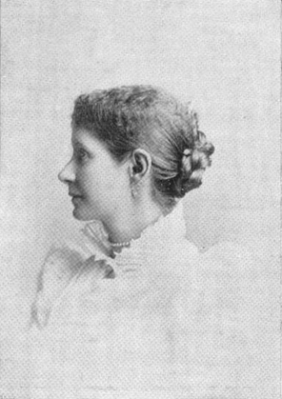
Parents: Henry Rutherford Bedinger (1812–1858) and Caroline Bowne Lawrence (1827–1869).
Spouse: Adam Stephen Dandridge (1844–1924).
Children: Serena Katherine “Violet” Dandridge (1878–1956), Stephen J. Dandridge (1878–1897), and Dorothea Spottiswoode Dandridge (1896–1907).
Kinship: Third cousin three times removed of post-World War II Smith generation.

Early Life and Family Background
Caroline “Danske” Bedinger was born on 19 November 1854 in Copenhagen, Denmark, where her father served as the first United States minister to Denmark, appointed by President James Buchanan. Her father was also a poet, publishing verse in The Southern Literary Messenger. Her mother, Caroline Lawrence Bedinger, was a granddaughter of Eliza Southgate Bowne, whose letters provide a vivid portrait of early nineteenth-century New England society.
Danske was brought to the United States in 1857, and the family lived in Flushing, Long Island near her Lawrence relatives. After her father’s death shortly before the Civil War, her mother returned with her three children to Shepherdstown, then in Virginia. There she purchased an estate called Poplar Grove, renaming it “Rose Brake,” and the household aided wounded soldiers during the Battle of Antietam. Following her mother’s early death, Danske and her siblings were taken into the care of their maternal grandfather, Hon. John Watson Lawrence, in Flushing.
Education and Literary Formation
Frail in health and sensitive in temperament, Danske began writing verse in childhood but withheld publication until she believed her work had matured. She cultivated a lifelong habit of singing and close attention to rhythm and sound, which shaped the musical quality of her poetry.
Marriage and Domestic Life
On 3 May 1877, she married Adam Stephen Dandridge, Jr., a member of a prominent Shepherdstown family. The couple settled there, living on a farm and relying on the income from her husband’s agricultural machinery business. Limited means, recurring illness, and isolation from literary centers shaped the conditions under which she worked, often without easy access to books or even a dictionary.
Poetic Career
Dandridge resumed writing poetry in earnest in the early 1880s. Her first published poem, “Chrysanthemum,” appeared in Godey’s Lady’s Book in 1885. She soon followed with work in Lippincott’s Monthly Magazine, The New York Independent, and other periodicals, becoming a frequent contributor.
Her first collection, Joy, and Other Poems (1888), was widely praised for its delicacy, musicality, and sensitive treatment of nature. Reviewers emphasized her lightness of touch, lyrical grace, and imaginative refinement, while noting that her poetry avoided profundity or tragic weight. A second volume, Rose Brake (1890), named for her Shepherdstown home, confirmed her technical skill and nature imagery, though some critics felt it did not fully realize the promise of her debut.
Along with contemporaries Waitman T. Barbe and Thomas Dunn English, Dandridge came to be regarded as a leading poetic voice of late nineteenth-century West Virginia.
Garden Writing and Historical Work
From approximately 1891 to 1904, Danske largely set poetry aside to write more than two hundred garden essays for Forest and Stream, Garden and Forest, Gardening, and related journals. These pieces reflected both practical knowledge and literary sensitivity. In her later years, she turned to writing works of early American history.
Rose Brake and Daily Life
At Rose Brake, Dandridge created a notable garden, maintained with the assistance of Black gardeners Tom and Charity Devonshire. The garden became both a setting and a symbol of her inner life, and she frequently worked while resting in a hammock among its plantings.
Later Years and Death
The deaths of two of her three children deeply affected Danske and contributed to her increasing withdrawal. She died at her home in Shepherdstown on 3 June 1914. Contemporary speculation suggested suicide, but this was firmly denied by her family.
Legacy
Danske is remembered as a poet of refined lyricism and a significant literary figure in West Virginia’s cultural history, as well as an influential garden writer whose essays bridged literature and horticulture at the turn of the twentieth century.

Bedinger, Henry Rutherford (1812–1858)

Congressman and Diplomat
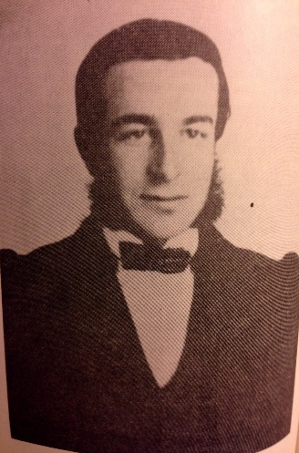

Parents: Gen. John Daniel Bedinger (1760–1817) and Sarah Rutherford (1771–1844).
Spouse: (1) Margaret Rust (1818–1843), (2) Caroline Bowne Lawrence (1827–1869).
Children: With Margaret Rust: George Rust Bedinger (1840–1863)–killed at Gettysburg, Virginia “Diddie” Bedinger (1842–1919), and Margaret Rust Bedinger (1843–1844); with Caroline Lawrence: Mary “Minnie” Bedinger (1850–1896), Henry Bedinger (1853–1935), and Caroline “Danske” Bedinger (1858–1914).
Kinship: Husband of the second cousin four times removed of the post–World War II Smith generation.
Early Life and Education)
Born at Bedford, the family estate near Shepherdstown, Virginia (now West Virginia), Henry Rutherford Bedinger was the fourth of five sons and the twelfth of thirteen children of Sarah Rutherford and Gen. John Daniel Bedinger. His maternal grandfather was the lower Shenandoah Valley’s first congressman. His paternal grandfather, the first Henry Bedinger (1729–1772), had emigrated from Alsace. His uncles Major Henry Bedinger (1753–1843) and George M. Bedinger served as patriots in the American Revolution—the former also representing Berkeley County in the Virginia House of Delegates and helping to found Mecklenburg (later Shepherdstown) in 1794.
Although his father died when Henry was five, he received a classical education at private academies in Shepherdstown and Frederick, Maryland. At eighteen, he entered public service as an assistant clerk in the Hampshire County clerk’s office in Romney, Virginia.

Legal and Political Career
Around 1832, Bedinger moved to Charles Town to read law under William Lucas, a prominent local attorney who would later become his political rival. Admitted to the Virginia bar in 1838, Bedinger established a practice in Shepherdstown with George Rust, his future brother-in-law.
Known for his eloquence—earning the nickname “The dreamy-eyed orator”—Bedinger entered politics as a Democrat. He defeated his former mentor, William Lucas, in 1844 and again in 1847 to represent Virginia's 10th District in the U.S. House of Representatives (1845–1849). In Washington, he was a staunch supporter of the Polk administration, endorsing the annexation of Texas as a slave state and the Walker Tariff of 1846, while opposing Nativist/Whig attempts to restrict the voting rights of Irish and German immigrants.
Diplomatic Career
After losing reelection in 1849, Bedinger resumed his legal practice, first in New York and later in Virginia. In 1853 President Franklin Pierce appointed him Chargé d’Affaires to Denmark, and in 1854 promoted him to Minister Resident.. At the court of King Frederick VII, Bedinger successfully negotiated the abolition of the Danish Sound Dues—tolls levied on ships passing between the North Sea and the Baltic.
The resulting 1857 treaty granted American vessels free passage in exchange for a modest contribution to Denmark’s lighthouse and channel-maintenance fund, making Bedinger effectively the first U.S. ambassador to Denmark.

Death and Legacy
Although his diplomatic work was praised, his salary scarcely covered his living expenses abroad. Bedinger resigned his post in 1858. He resigned in 1858 but remained until his successor’s arrival. Soon afterward he was appointed superintendent of the U.S. Armory at Harpers Ferry Upon his return to Shepherdstown, he was honored with a public celebration and barbecue on November 5, 1858. While delivering a speech in cold, wet weather, he contracted pneumonia. He died three weeks later, on November 26, 1858 at the age of 46.
He was buried in the family cemetery at the Bedford estate. His legacy continued through his children, particularly his youngest daughter, Danske Dandridge, who achieved fame as a poet and garden writer, and his eldest son, George Rust Bedinger, a Confederate captain who was killed in action at the Battle of Gettysburg.

Bedinger, George Rust (1840-1863)
Captain C.S.A.
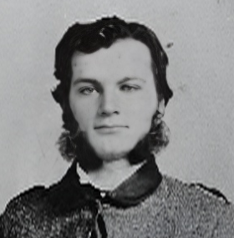
Parents: Henry Rutherford Bedinger (1812–1858) and Margaret Rust (1818–1843)
Spouse: None recorded
Children: None recorded
Kinship: Stepson of Caroline Bowne Lawrence (1827–1869), the second cousin 4 times removed of wife

Early Life and Education
Born near Shepherdstown, Jefferson County, Virginia (now West Virginia), George Rust Bedinger was the eldest son of Congressman Henry Bedinger. His mother died when he was only two years old, and his father passed away when George was eighteen.

He received a classical education and was a student at the University of Virginia (Class of 1859/1860). He left his studies or early career pursuits to enlist at the outbreak of the Civil War.

Military Career
Bedinger served in all three branches of the Confederate Army—infantry, artillery, and cavalry—displaying a pattern of seeking active combat or leadership roles.
- Enlistment: He mustered in at Harpers Ferry, Virginia, on May 15, 1861, as a Private in Company B, 2nd Regiment, Virginia Infantry.
- Artillery: On August 26, 1861, he transferred to the famous Rockbridge Battery, 1st Regiment, Virginia Light Artillery (part of the Stonewall Brigade), serving as a cannoneer.
- Cavalry: On April 28, 1862, he transferred to Company E, 3rd Regiment, Virginia Cavalry (known as Ashby’s Cavalry), engaging in the Valley Campaign.
- Infantry Commission: On August 11, 1862, by special order of General Robert E. Lee, he was commissioned Captain. He subsequently transferred on November 19, 1862, to command Company E of the 33rd Regiment, Virginia Infantry (part of the Stonewall Brigade).

Death at Gettysburg
Captain Bedinger led his company during the Gettysburg Campaign. He was killed in action on July 3, 1863, during the fierce fighting for Culp's Hill, where the Stonewall Brigade suffered heavy casualties attempting to storm the Union breastworks.

Ben Venue Laboratories
Ben Venue Laboratories was a pharmaceutical manufacturing company based in Bedford, Ohio (a suburb of Cleveland), specializing in sterile injectable drugs and contract manufacturing.
Raymond Templeton Smith was the executive vice-president of Pittsburgh Coal; he reported to Andrew Mellon. Smith wanted to have his own business. When his father-in law’s (Julian Kenendy) will was finally settled and the bequests disbursed, he had capital to finance a new venture.
One person approached him with the idea of extracting vitamins from alfalfa. Smith considered that, but a doctor from Cleveland Clinic approached him and said that it would be far more lucrative to produce pharmaceuticals. Smith chose to pursue that line. That the doctor was at the Cleveland Clinic explains why the company was established in 1938 in Cleveland, rather than Pittsburgh, where Smith lived.
Ben Venue pursued various lines of manufacture. It used the freeze-drying techniques (lyophilization) that had been invented at the beginning of the twentieth century . This enabled Ben Venue to be one of the few companies to freeze dry plasma for American soldiers during World War II; for this work, Smith was invited to the White House.
Ben Venue also specialized in processing human growth hormones. At that time, the source of such hormones was the urine of pregnant mares. Smith sister, Helen, helped by sewing diapers for mares. Once a company employee was driving a tanker filled with mare’s urine when the police stopped him. The police asked what was in the tank; when the driver told him, he arrested the driver. A call to the company was necessary to straighten out the matter.
When Kennedy Smith took over management, Ben Venue continued to specialize in small batches of hard to manufacture drugs, including experimental oncological drugs for the NIH. As Kennedy Smith’s health deteriorated, his son Edward C. Smith took over management. The company was known in the pharmaceutical industry for its devotion to quality and sterility.
In 1997, Ben Venue was purchased by the German pharmaceutical company Boehringer Ingelheim, becoming a key part of their operations for generic injectables and contract manufacturing services. The price was in the mid-nine figures.
Under Boehringer Ingelheim, Ben Venue grew into a significant facility with multiple manufacturing plants and a Quality and Development Center. At its peak, it employed around 1,100 people and contributed substantially to the local economy in Bedford (e.g., generating over 20% of the city's operating budget through taxes at one point). The company produced critical drugs, including injectables for cancer treatment and other therapies (notably involved in producing Doxil, a liposomal doxorubicin formulation).
However, the facility faced significant regulatory challenges starting in the 2000s. The FDA conducted numerous inspections (35 since 1997), identifying persistent current Good Manufacturing Practice (cGMP) violations related to quality control, sterility, contamination risks (e.g., reports of rusty tools, mold, and other issues), and product quality. This led to nearly 40 drug recalls since 2002, with several involving serious contamination concerns.
In late 2011, following severe FDA findings, Ben Venue voluntarily shut down manufacturing and distribution operations temporarily to address the issues. The company invested heavily (around $300 million) in remediation efforts, and limited production resumed in late 2012.
Despite these attempts, the problems persisted. In January 2013, a U.S. District Court entered a consent decree of permanent injunction against Ben Venue Laboratories, its parent Boehringer Ingelheim, and senior executives, mandating strict compliance measures due to ongoing noncompliance.
Ultimately, Boehringer Ingelheim decided the facility could not return to sustainable, compliant production. In October 2013, Ben Venue announced it would cease all production by the end of 2013, resulting in the layoff of approximately 1,100 employees (phased through 2014). Manufacturing fully halted in December 2013.
Post-closure:
- In 2014, Hikma Pharmaceuticals acquired substantially all assets of the Bedford site from Ben Venue/Boehringer Ingelheim, with plans to potentially reactivate parts for manufacturing and add R&D capabilities.
- In 2015, Hikma sold the facilities to Xellia Pharmaceuticals (a Danish company), which intended to reopen portions and bring back around 170 jobs. The site has since operated under new ownership, separate from the original Ben Venue entity.

Bernard, Joan Justice (1948– )
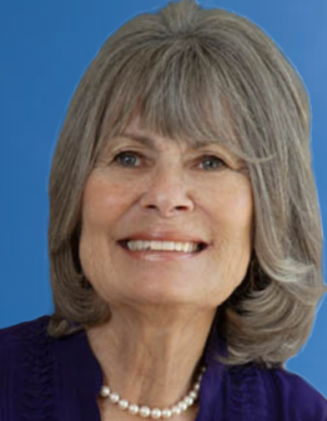

Parents: John T. Bernard (c.1914– ) and Katherine Louise Hamann (1919– 1991)..
Spouse: (1) George Alexandre Zara (1949– ), married September 1970; (2) Stephen Lakin Sharpe (1946–2015); (3) Dave Moskowitz.
Children: With George Zara: Katherine Cameron Zara (1976–1995), Elizabeth Alexandre Zara (1980– ), and Michael Thomas Zara (1980– ).
Kinship: Wife of George Alexandre Zara, the second cousin once removed of the post–World War II Smith generation.
Early Life and Education
Joan Justice Bernard was born in 1948, the daughter of John T. Bernard and his wife Katherine. She attended Marjorie Webster Junior College in Washington, D.C. and later the University of Denver, where she studied in the theater arts department and met her first husband, George Alexandre Zara.
Early Career in Special Education
Before attending the University of Denver, Joan worked as an aide with special needs children, a vocation that would become central to her life. While her husband completed his degree, she accepted a position as a special education teacher despite having had no formal coursework in education. When the Zaras later moved to Florida, she began a master’s degree in education while teaching students living in deep poverty. When George pursued graduate work in Pittsburgh, she also completed her own master’s in education. After their divorce, Joan continued teaching, first in an elementary school’s special education program and then in a specialized vocational high school serving students with disabilities.
Personal Tragedy and Resilience
The death of her daughter, Katherine Cameron Zara, in an automobile accident, followed years later by the death of her husband Stephen Lakin Sharpe, were profound personal losses. Yet Joan found healing in her continued work with special education students, often remarking that they helped her more than she helped them.
Literary Career as Jody Sharpe
Out of her experiences of loss and recovery, she began writing under the pen name Jody Sharpe, creating the Mystic Bay, California series—a cycle of novels expressing her belief that “synchronicities are angels among us.” On her website she writes that “writing about angels became healing after losing my daughter and then my husband. The valuable lessons I learned about moving forward and loving life in the now have set me on a mission to tell the stories with love, humor, and spiritual awakening.”
Her works include 20 Moon Road: An Angel’s Tale, which continues the series’ central theme that miracles still happen in the fictional town of Mystic Bay, where angels live among humans. The novel’s protagonist, Angel Ken, a former football coach, is guided by the spirit of his late friend, Madam Norma, who recounts her century-long life of helping others through her visions of angels. Through her story, Sharpe explores healing, compassion, and the possibility that divine assistance can appear in human form.
Later Life
Joan (Jody Sharpe) continues to write and advocate for spiritual awareness through fiction, speaking about her experiences of grief, teaching, and faith. Her Mystic Bay series reflects a lifelong commitment to hope and the quiet presence of grace in ordinary lives.

Big House, The, also known as The Meeting House and The Library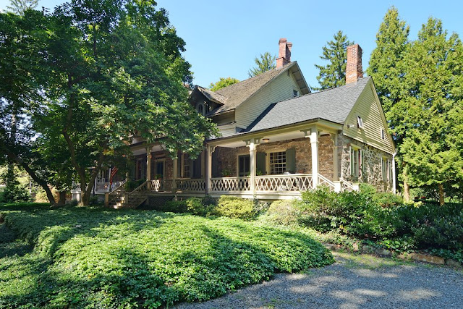
Location: 201 Route 9W, Palisades (Snedens Landing), Rockland County, New York
Built: 1735-1738 with many later additions.

Overview
The Big House—also historically known as the Meeting House and later as the Old Library—is the oldest surviving dwelling in Palisades and the only extant structure from the hamlet’s formative eighteenth-century settlement. Built principally in the mid-1730s, it is a large stone house whose appearance reflects successive architectural layers rather than a single stylistic category. Although sometimes described in modern real-estate listings as an “English manor,” the house is more accurately understood as a Hudson Valley stone house built in the Dutch vernacular tradition, later altered in the nineteenth century with Victorian rooflines and verandas that give it a manor-like aspect.
The house is listed on the National Register of Historic Places and occupies a prominent position within the Snedens Landing Historic District overlooking the Hudson River corridor.
Construction and Architectural Character
The core structure dates to approximately 1735–1738, with dendrochronological analysis of foundation timbers establishing a firm construction window within those years. The house was built of locally quarried red sandstone, with walls measuring up to 23 inches thick. The original form was a long, deep, one-and-a-half-story masonry dwelling with a gable roof, linear plan, multiple entrances, and a central hall flanked by two rooms on each side.
Interior features surviving from the eighteenth century include massive hand-hewn ceiling beams, wide board floors, multiple fireplaces, and important white pine paneling, particularly in the principal living room. Ceiling heights are unusually tall for a house of this period, contributing to its later mischaracterization as an “English manor.”
An eastern service wing, traditionally associated with the kitchen, contains an early fireplace with a beehive oven and a garret that originally functioned as a sleeping loft. Local tradition once assigned this wing a seventeenth-century date (as early as 1684 or 1685), but no physical evidence supports continuous survival from that period. If a seventeenth-century structure existed on the site, it belonged to an earlier building now entirely lost.
Early Ownership and Site History
The house is traditionally attributed to Henry Ludlow, whose family held extensive lands in the region during the early eighteenth century. Ludlow’s father-in-law, Captain John Corbett, is documented as owning approximately 3,410 acres “more or less” in the area, underscoring the house’s origins within a large landed estate.
The property later passed into the hands of Jonathan Lawrence (ca. 1695–1777), known as Jonathan Lawrence the Elder, who purchased the house and approximately 504 surrounding acres from the Ludlow family in 1749. This acquisition marked the Lawrence family’s principal establishment in Snedens Landing.
The Lawrence Family and Eighteenth-Century Expansion
Around 1770, Jonathan Lawrence substantially enlarged and improved the house, transforming it from a substantial farmhouse into a prominent residence appropriate to the family’s standing. The house remained associated with successive generations of the Lawrence family throughout the late eighteenth and early nineteenth centuries.
Among its occupants was Jonathan Lawrence Jr. (1759–1802), a Revolutionary War veteran sometimes styled “Captain Lawrence,” who is most often associated with the house’s Revolutionary-era traditions. Through the Lawrences, the Big House became a focal point of political, military, and social life in Snedens Landing.
Revolutionary War Associations
During the American Revolution, Snedens Landing occupied a strategic position along the Hudson River, with ferry crossings and roads connecting Tappan, Closter, Sparkill, and the riverfront. According to long-standing and well-documented local tradition, General George Washington and the Marquis de Lafayette dined at the Big House in the summer of 1780 while Washington was headquartered in nearby Tappan. Baron von Steuben is sometimes included in these accounts.
According to the Historical Society of Rockland County, the generals were awaiting developments related to the trial of British Major John André, held in nearby Tappan. Martha Washington is also said to have visited the house on a separate occasion, stopping for tea while traveling to meet her husband. While such visits cannot be conclusively documented in surviving military correspondence, they are consistent with Washington’s known movements and the strategic importance of the site.
A round table traditionally believed to be the one at which Washington and Lafayette dined later stood in the house during its period as the Palisades Library.
Nineteenth-Century Alterations
Following American independence, the house passed through multiple owners. Significant architectural changes occurred in several phases:
- In 1820–1821, a matching single-story wing was added to the west end, balancing the earlier eastern service wing.
- In 1867, the roof was raised approximately three feet, steeply pitched gables were added, and a full second story was created.
- A broad veranda with grooved posts and Gothic-inspired brackets was constructed along the southern façade, dramatically altering the house’s exterior appearance.
These nineteenth-century alterations account for much of the building’s “Victorian” or “manor house” character and led at least one contemporary observer to lament the loss of “much of the quaint look the house had in early days.”
Palisades
In 1898, Lydia Green Underhill Lawrence (1830-1913) —whose husband Henry Effingham Lawrence was distantly related to the earlier Lawrence family—purchased the house for use as the Palisades Library. To accommodate this function, interior changes were made, including the opening of an archway between two large downstairs rooms and the cutting of additional windows through the stone walls to increase daylight.
Library Use and Twentieth-Century Preservation
In 1898, Lydia Green Underhill Lawrence (1830-1913) —whose husband was distantly related to the earlier Lawrence family—purchased the house for use as the Palisades Library. To accommodate this function, interior changes were made, including the opening of an archway between two large downstairs rooms and the cutting of additional windows through the stone walls to increase daylight.
The Palisades Library remained in the Big House for forty-five years, from 1899 until 1943, before relocating first to the Old School (now the Community Center) and later to its present location in 1951.

Bogert Family
Origin: Dutch Reformed family of New Amsterdam, later New York.
Allied Families: Lawrence, Townsend, Bowne, Osgood, and related New York–Long Island mercantile lines.
Early History
The Bogert family (originally Boogert, sometimes Van den Boogaert or Bogardus) was of Dutch origin and among the early settlers of New Amsterdam in the seventeenth century. The name derives from the Dutch boogerd, meaning “orchard” or “enclosed field.” The progenitor of most New York Bogerts was Jan Laurensz Bogert (1624–1703), born in Schoonrewoerd, Holland, who emigrated to New Netherland about 1652. He married Cornelia Everts in 1654 at the Dutch Reformed Church of New Amsterdam. Their descendants settled in Manhattan, Harlem, Bergen County (New Jersey), and later in Westchester and Long Island.
Jan Laurensz served as a smallholder and carpenter in New Amsterdam and was later one of the patentees of Harlem in 1662. His sons and grandsons were active in the civic and religious life of the Dutch Reformed congregations of Harlem, Hackensack, and Schraalenburgh. Over the eighteenth century, the family Anglicized its name to Bogert and became part of the English-speaking mercantile and professional class of New York.
Eighteenth and Nineteenth Century Descendants
By the late eighteenth century, several branches of the Bogerts were established in Manhattan, Brooklyn, and Bergen County. Among them was Nicholas Bogert (1746–1823), a merchant and vestryman of Trinity Church, whose descendants intermarried with the Lawrence and Bowne families—two of the most prominent Quaker and mercantile families of New York.
Later Members and Legacy
The Bogerts produced lawyers, clergymen, and scholars who were active in New York civic life well into the twentieth century. Members of the family were associated with Columbia College, Trinity Church, and the New York Historical Society. Henry Lawrence Bogert, noted for his long legal career, served as a trustee of the Collegiate Reformed Church. His descendants continued to intermarry with other distinguished New York families, including the Bownes and Schieffelins.
Character and Reputation
Throughout their history, the Bogerts maintained a reputation for education, public service, and refinement. Their successive alliances with the Lawrences and Bownes illustrate the enduring cohesion of New York’s early Dutch and English colonial elite, whose descendants formed the backbone of the city’s nineteenth-century professional and philanthropic class.
______________________________________________________________________________

Bogert, Edward Osgood (1894-1956)
Captain, U. S. Marine Corps
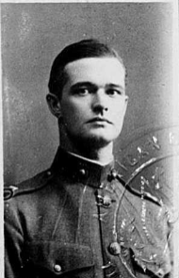
Parents: Henry Lawrence Bogert (1857–1933) and Carrie Lawrence Osgood (1859–1924). Spouse: (1) Esther Jean Bochman; (2) Elizabeth Ames Wood (1898-1985).
Children: With Esther Bochman: Cynthia Lawrence Bogert (1926–1991); with Elizabeth Wood: Elizabeth Ames Bogert (1934– ).
Kinship: Fourth cousin twice removed of the post–World War II Smith generation.

Early Life and Military Beginnings
Edward Osgood Bogert was born on January 9, 1894, in Flushing, New York. Like many young men of his social standing in New York, he joined the National Guard early, enlisting in Troop C of the 1st Cavalry ("Squadron A").

His first taste of active service came during the border tensions with Mexico. He mustered in with the Machine Gun Troop of Squadron A on June 30, 1916, and was stationed at Camp McAllen, Texas, with the New York Division. He returned to New York in December 1916 and was discharged from the Squadron in February 1917.

World War I and Marine Corps Service
When the United States entered World War I, Bogert enlisted in the United States Marine Corps on May 23, 1917. He was commissioned as a Second Lieutenant on July 6, 1917, and assigned to the 10th Regiment Field Artillery. He rose quickly through the ranks, receiving promotions to First Lieutenant in August 1917 and Captain on October 15, 1917.

He deployed to France aboard the USS Henderson in August 1918. In France, he saw combat with Company B, 5th Regiment USMC (part of the famous 2nd Division, AEF). During the Meuse-Argonne Offensive—the largest operation of the American Expeditionary Forces—he was wounded by machine gun fire on November 1, 1918, just days before the Armistice.

Post-War Service in China
Bogert survived his wounds and returned to the United States in February 1919. Unlike many of his peers who demobilized immediately, he remained in the Marine Corps. He was subsequently stationed in Peking (Beijing), China, as part of the American Legation Guard. It was during this posting that his engagement to Miss Esther Jean Bochman of Philadelphia was announced. He resigned his commission on August 15, 1923.

Death
Edward Osgood Bogert died on May 4, 1956. His obituary appeared in the East Hampton Star, noting his service in Squadron A and the Marine Corps.

Bogert, Henry Augustine (1827-1905)
Parents: Henry Kneeland Bogert (1801–1875) and Mary Elizabeth Bogert (1804–1891).
Spouse: Mary Bowne Lawrence (1830–1898).
Children: Mary “Minnie” Lawrence Bogert (1855–1893), Henry Lawrence Bogert (1857–1933), John Lawrence Bogert (1857–1956), Emily Lawrence Bobert (1860–1864), Edward Ludlow Bobert (1862–1863), Walter Lawrence Bogert (1864–1959), James Lawrence Bogert (1867–1867), Marston Taylor Bogert (1868–1954), Francis Lawrence Bogert (1869–1870), Frances Lawrence Bogert (1870–1947), and Theodore Lawrence Bobert (1875–1947).
Kinship: Husband of Mary Bowne Lawrence, the second cousin four times removed of the post–World War II Smith generation.

Early Life and Education
Henry Augustine Bogert was born in New York City in 1827, the son of Henry Kneeland Bogert and Mary Elizabeth Bogert. He was a member of one of the oldest Dutch-descended families of New York, long associated with the Reformed Dutch and Episcopal congregations of Manhattan and Queens. Educated at St. Thomas Hall in Flushing, he entered Columbia College, where he earned his A.B. in 1846 and A.M. in 1849. His education placed him in the tradition of the professional class of mid-nineteenth-century New York.
Legal and Professional Career
Having studied law in his father’s office, Bogert was admitted to the New York bar and established a successful legal practice. In 1867 he was appointed counsel for the New York Life Insurance Company, a position he held for twenty-five years. He was recognized as a meticulous title examiner and a legal authority on property and insurance law. His reputation for integrity and caution led to his frequent consultation on trust and estate matters.
A resident of Flushing, he helped found the Queens County Savings Bank, serving as both counsel and director. Through his marriage to Mary Bowne Lawrence, he was closely connected to the historic Bowne and Lawrence families, and his work contributed significantly to the financial and civic development of Flushing during its transition from a rural township to a suburban community connected to New York City.
Civic and Religious Activities
An active Republican, Bogert served as secretary of the first Republican club organized in Flushing after the Civil War. He was also a vestryman of St. George’s Episcopal Church, where he taught Sunday School for many years, before later transferring his membership to the local Congregational Church. His civic and religious involvements reflected the broader social conscience of the professional classes of postbellum New York.
Family and Education Legacy
Education was a defining theme in the Bogert family. Several of Henry’s sons followed him to Columbia: John Lawrence Bogert (A.B. 1878), Henry Lawrence Bogert (A.B. 1878), Marston Taylor Bogert (A.B. 1890)—later a distinguished chemist and Columbia professor—and Theodore Lawrence Bogert (A.B. 1897). Their shared connection to Columbia underscores the family’s multi-generational engagement with the city’s intellectual and professional life.
Death
Henry Augustine Bogert’s life ended tragically on July 12, 1905 1905 when he was struck and fatally injured by an electric cab on Broadway in New York City. He was remembered as a man of deep moral principle, civic generosity, and quiet scholarship—a representative of the conscientious nineteenth-century New York professional class.

Bogert, Henry Lawrence (1857-1933)
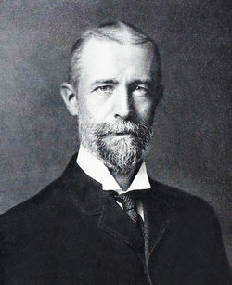

Parents: Henry Augustine Bogert (1827–1905) and Mary Bowne Lawrence (1830–1898).
Spouse: Carrie Lawrence Osgood (1859–1924).
Children: Caroline Lawrence Bogert (1881–1942), Henry Lawrence Bogert Jr. (1883–1965), and Edward Osgood Bogert (1894–1956).
Kinship: In addition to being descended from the Lawrences, he is the husband of Carrie Lawrence Osgood, the third cousin three times removed of the post–World War II Smith generation.
Early Life and Education
Henry Lawrence Bogert was born in New York City in 1857, a member of the long-established Dutch–English professional families that formed the civic elite of nineteenth-century New York. He was educated at the Flushing Institute, one of the leading private academies of Queens County, and entered Columbia College, where he received his A.B. in 1878. At Columbia he was a member of the Psi Upsilon fraternity and active in student literary and debating societies, as were several of his Bogert and Lawrence cousins.
Legal Career
After graduation, Bogert read law in the office of his father, Henry Augustine Bogert, counsel for the New York Life Insurance Company and a leading figure in the Queens County bar. Admitted to practice in New York, Henry Lawrence developed a specialty in trust, title, and insurance law, continuing the family’s professional association with New York Life and serving as both counselor and trustee to several financial institutions.
His work was characterized by the meticulous research typical of the Bogert legal tradition; he was known for his knowledge of land titles and estate law, which were essential to the city’s expanding urban property system in the late nineteenth and early twentieth centuries.
Civic and Religious Involvement
A lifelong resident of Flushing, Henry Lawrence Bogert was active in local affairs, serving on boards related to education and church life. Like his father, he was a vestryman of St. George’s Episcopal Church, Flushing, where generations of the Bogert and Lawrence families were baptized and buried. He later became affiliated with the Collegiate Reformed Church of New York, maintaining the family’s ancestral connection to the Dutch Reformed tradition. He was also a dedicated member of the Holland Society of New York, serving as an officer and helping to preserve the history of the city’s early Dutch settlers.
Marriage and Family Connections
In 1880, he married Carrie Lawrence Osgood (1859–1924), daughter of Edward Osgood and Caroline Lawrence, further intertwining the Bogert, Osgood, and Lawrence families. Their daughter, Caroline Lawrence Bogert (1881–1942), continued the pattern of family alliances. Their eldest son, Henry Lawrence Bogert Jr. (1883–1965), followed the family professional path as an attorney and civic leader. Their youngest son, Edward Osgood Bogert (1894–1956), served as a Captain in the U.S. Marine Corps during World War I.
Later Life and Legacy
Henry Lawrence Bogert maintained his law practice into the early 1930s, remaining active in Columbia alumni affairs and professional societies. He was remembered for his quiet dignity, professional integrity, and devotion to education and public service—traits that had characterized his family for generations.
He died on March 5, 1933, and was interred with his family in Flushing Cemetery.

Bogert, Henry Lawrence Jr. (1883–1965)
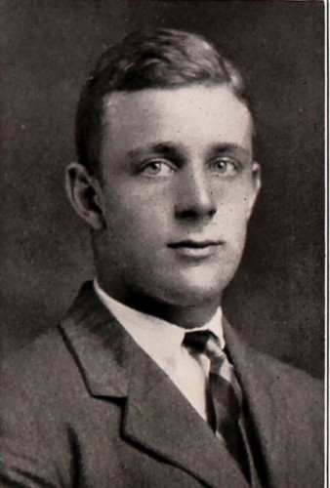
Parents: Henry Lawrence Bogert (1857–1933) and Carrie Lawrence Osgood (1859–1924).
Spouse: Elizabeth Blodgett Sanford (1888–1959).
Children: Henry Lawrence Bogert III (1911–1992), Cardine Elizabeth Bogert (1916–1991), Caroline Bogert (1921–1977), and Lucretia Leland Bogert (1932–1986).
Kinship: Fourth cousin three times removed of the post–World War II Smith generation.

Early Life and Education
Henry Lawrence Bogert Jr. was born on May 7, 1883, in Flushing, New York, the eldest son of Henry Lawrence Bogert (1857–1933) and Carrie Lawrence Osgood (1859–1924). While his father was a prominent attorney, Henry Jr. was raised in an environment that valued both professional diligence and social standing. He followed family tradition by attending Columbia College, where he graduated with his A.B. in 1904.

Professional Career
Unlike his father, who practiced law, Henry Jr. pursued a career in high finance. He became a well-regarded investment banker in New York City. He spent a significant portion of his career as a partner at Eastman, Dillon & Co., a major securities and investment banking firm. His work established him as a key figure in New York’s financial district during the early-to-mid 20th century.

Marriage and Family
On June 18, 1910, he married Elizabeth Blodgett Sanford (1888–1959) in Nassau, New York. She was the daughter of George Baylies Sanford. The couple had four children: Henry Lawrence Bogert III (1911–1992), who followed his father into the financial sector; Cardine Elizabeth Bogert (1916–1991), later Mrs. Thomas Hildt; Caroline Bogert (1921–1977), later Mrs. Donald McVickar; Lucretia Leland Bogert (b. 1932), later Mrs. Abbott.

Death and Burial
Henry Lawrence Bogert Jr. died on March 5, 1965. Jr. is interred at Oak Grove Cemetery in Fall River, Massachusetts, in the Sanford family plot alongside his wife.
___________________________________________________

Bogert, Henry Lawrence III (1938–2025)
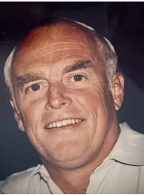
Parents: Henry Lawrence Bogert Jr. (1911-1992) and Margaret Milbank (1914–2002).
Spouse: (1) Bridget Lee Cunningham (1943–1999), married June 5, 1965; (2) Eleanor Perine Wheeler (1940–2021), married 1991.
Children: Hilary Bogert (1967– ) and Cyrena Bogert (1968– ) .
Kinship: Fourth cousin three times removed of the post–World War II Smith generation.

Early Life and Education
Henry Lawrence Bogert —known as Larry—was born in New York City on July 11, 1938, the elder son of investment banker H. Lawrence Bogert Jr. and Margaret Milbank Bogert. He grew up in Manhattan and on Fishers Island, New York.

He attended The Buckley School, where he was noted as a champion gymnast who held the school’s hand-walking record for three years, and then St. Paul’s School in Concord, New Hampshire. He entered Yale University, following a family tradition that extended through three generations, and graduated with the Class of 1960. At Yale he played varsity lacrosse, continuing his strong interest in athletics.

Career
After Yale, Bogert entered finance, beginning at Spencer Trask & Co., moving to Shearson Lehman American Express, and later joining Wellington Shields & Co., where he spent the remainder of his professional life as an investment adviser. Colleagues and clients remembered him for his attentiveness and discretion, qualities that reflected the professional ethic of the Bogert family’s long involvement with New York’s legal and financial institutions.

Personal Life
Bogert married Eleanor (Peri) Wheeler, with whom he shared three decades of marriage until her death in 2021. They lived primarily in Southampton and Water Mill, New York, near Mecox Bay, where Bogert was deeply involved in community and recreational life. A lifelong sailor and tennis player, he was known on Fishers Island for spearfishing and competing in bullseye sailing races. Friends remembered his conviviality, love of dancing, and attachment to the sea.

Death and Legacy
Henry Lawrence Bogert III died on March 14, 2025, after a brief illness, surrounded by his daughters and granddaughters. He was survived by his brother Jeremiah M. Bogert, his daughters Hilary Bogert McKown and Cyrena Bogert Fink, and granddaughters Brigitte, Chloé, and Charlotte Fink. Burial was private, and a memorial service was planned for spring 2024.

Assessment
Henry Lawrence Bogert III embodied the modern continuation of a New York family distinguished in law, finance, and civic service since the early nineteenth century. His combination of professional integrity, athletic vigor, and sociable charm linked the city’s historical Dutch-English patriciate to the contemporary financial world.
___________________________________________________
Bogert, Marston Taylor (1868–1954)
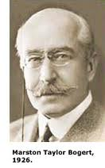
Parents: Henry Augustine Bogert (1827–1905) and Mary Bowne Lawrence (1830–1898).
Spouse: Charlotte Elizabeth Hoogland (1870–1951), married September 12, 1893.
Children: Annette Bogert (1996–1976) and Charlotte Elise Bowdoin Bogert (1904–1972).
Kinship: Third cousin three times removed of the post–World War II Smith generation.
Early Life and Education
Marston Taylor Bogert was born in Flushing, New York, on April 18, 1868, into a family with deep roots in colonial New York. He continued the family tradition of attending Columbia College, where he was a standout student. Unlike the timeline in your previous draft, Bogert did not initially earn a Ph.D.; rather, he received his A.B. in 1890 and a Ph.B. (Bachelor of Philosophy) in 1894 from the Columbia School of Mines, which was then the center of scientific training at the university. He later received an honorary Sc.D. from Columbia in 1929.
Career at Columbia
Bogert spent his entire academic career at Columbia University, rising from assistant in organic chemistry (1894) to full Professor (1904), a position he held until his retirement as Professor Emeritus in 1939. As a teacher, Bogert was instrumental in adopting the German model of scientific education at Columbia, insisting on original laboratory research as the core of the curriculum. He built the university's organic chemistry research program from the ground up, developing new synthetic methods and supervising more than one hundred doctoral dissertations—helping make Columbia the nation's leading producer of chemistry Ph.D.s during his tenure.

He was a pioneer in the field of synthetic organic chemistry, specifically researching quinazolines and thiazoles. His laboratory produced hundreds of papers that helped lay the groundwork for the modern American chemical industry, particularly in the fields of dyes, perfumes, and pharmaceuticals.

Service to the Nation and the World
Bogert was often referred to as a "statesman of science" for his leadership roles.
- American Chemical Society (ACS): He served as President during 1907–1908
- International Leadership: He was a central figure in global science, serving as the President of the International Union of Pure and Applied Chemistry (IUPAC) from 1938 to 1947, guiding the organization through the difficult years of World War II.
- Military Service: During World War I, he served as a Colonel in the Chemical Warfare Service, organizing the Division of Gas Defense.
- Awards and Recognition His contributions were recognized with the highest honors in his field, including the Nichols Medal (1905) and the Priestley Medal (1938)—the highest award bestowed by the American Chemical Society.
Personal Life
In 1893, he married Charlotte Elizabeth Hoogland. They had two daughters: Annette Hoogland Bogert (later Mrs. Frank B. Tallman) and Charlotte Elise Bowditch Bogert. The family resided for many years near the university in Manhattan and maintained their connection to Long Island.

Marston Taylor Bogert died on March 21, 1954, in Islip, New York, after a long illness. He is interred in the family plot at Flushing Cemetery.
________________________________________________
Bogert, Walter Lawrence (1864–1959)
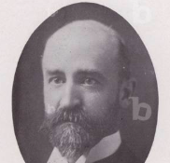
Parents: Henry Augustine Bogert (1827–1905) and Mary Bowne Lawrence (1830–1898).
Spouse: None recorded.
Children: None recorded.
Kinship: Third cousin three times removed of the post–World War II Smith generation.
Early Life and Education
Walter Lawrence Bogert was born in Flushing, Queens, in 1864, the seventh surviving child of Henry Augustine and Mary Bowne (Lawrence) Bogert. Though he was lame from childhood, he lived the longest of his siblings and maintained an active intellectual and musical life. The Bogerts were a cultivated and musical family: in an 1887 letter, his mother described an evening of family music—“Harry at the piano, Walter with the violin, Marty with the flute, and John with the horn, interspersed with singing, etc. Quite a merry time, and good music too.”
Walter’s musical inclination was apparent early, if also a financial strain. In 1886 his mother recorded in her correspondence the cost of “a $300 violin for Walter” and “singing lessons for Walter last winter $150 more.” That same correspondence reveals her anxiety over his future: writing to him in 1890, when he was traveling in Europe, she warned her 26-year-old son against an impulsive marriage—“A beautiful society girl rarely makes a good wife, and it behooves one to choose wisely and deliberately… rather than blindly as John did.” Walter, taking her counsel seriously, never married.
Educated first at local schools in Flushing, he entered Columbia College, receiving his A.B. in 1888 and A.M. in Political Science in 1889. He then enrolled in the Columbia Law School in 1888, though his studies were delayed when the program was extended for an additional year. Members of that class did not graduate formally, but in 1925 Columbia granted them a Certificate in Law, and Bogert later received the Bachelor of Laws (LL.B.) in 1934. However, the law was never his primary passion; during this period he also studied harmony and orchestration at the National Conservatory of Music and the Institute of Musical Art (later Juilliard).
Musical Career
As a student, Bogert was active in Columbia’s musical and theatrical life. He served as musical director and orchestra conductor of the Columbia College Dramatic Club, known for its witty burlesques and comic operas. In February 1893, he conducted the orchestra for The Strollers, a satirical musical staged by Columbia students.
By the turn of the century, Bogert had devoted himself fully to music. He built a reputation as a baritone, giving over 500 recitals. He became known as a music teacher, conductor, and lecturer on the history and appreciation of music. In 1903, he served as a guest conductor for the United States Marine Band in Washington, D.C. By 1920 he had been appointed Lecturer in Music History and Appreciation at Yale University, where his lectures attracted students of both music and general humanities. His approach combined historical context with aesthetic analysis, reflecting the influence of German Romantic scholarship that was then shaping American musicology.
He was deeply embedded in New York’s musical infrastructure, serving as Secretary of "The Bohemians" (the New York Musicians Club), a director of the Russian Symphony Society, and a director of the MacDowell Club. He was also a member (and later officer) of the American Academy of Teachers of Singing and the National Association of Teachers of Singing. From his apartment at 25 Claremont Avenue, he conducted private classes for singers and speakers, emphasizing diction and interpretation.
Later Career and Honors
In 1939 Bogert served as President of the Alumni Association of the Columbia Graduate Schools, a role that reflected his long-standing loyalty to his alma mater. Though he never practiced law, his name continued to appear in alumni records as both lawyer and musician—an unusual dual identity typical of the Bogert family’s breadth of education and accomplishment.
Death and Legacy
Walter Lawrence Bogert died on August 13, 1959, aged ninety-five. Remembered for his gentle wit, exacting musical standards, and lifelong devotion to Columbia and Yale, he exemplified the cultivated, civic-minded tradition of his family. His life joined three characteristic New York pursuits of the late nineteenth century—law, music, and education—and he maintained the Bogert presence in the intellectual and artistic life of the city long after his brothers’ generation had passed.
__________________________________________________________________________
Bowne Family
Pioneers of Liberty and Commerce

The Bowne family of Flushing, Long Island, ranks among the oldest and most distinguished Quaker families in America. Originating in Derbyshire, England, the Bownes became known from the seventeenth century onward for their steadfast defense of liberty of conscience, their long engagement in commerce and civic life, and their close intermarriage with other leading New York families, including the Lawrences, Murrays, Parsons, and Bogerts.
English Origins and Immigration
The family’s earliest known ancestor was Thomas James Bowne (1595–1677) of Matlock, Derbyshire, who emigrated to New England with his son John Bowne in the mid-seventeenth century. They were English Puritans by background, but the younger Bowne soon embraced the tenets of the Society of Friends (Quakers), a radical new movement emphasizing inner light, simplicity, and equality.
Establishment at Flushing
By 1661, John Bowne (1627–1696) had settled in Flushing, Long Island, then under Dutch rule. With his wife Hannah Feake, he opened his home for Quaker meetings in defiance of Governor Peter Stuyvesant’s edict against unauthorized religious gatherings. His subsequent arrest, imprisonment, and deportation to Holland led to his celebrated appeal before the directors of the Dutch West India Company in Amsterdam. Their ruling in 1663 ordered that “the consciences of men ought to remain free and unshackled,” effectively establishing freedom of worship in New Netherland.
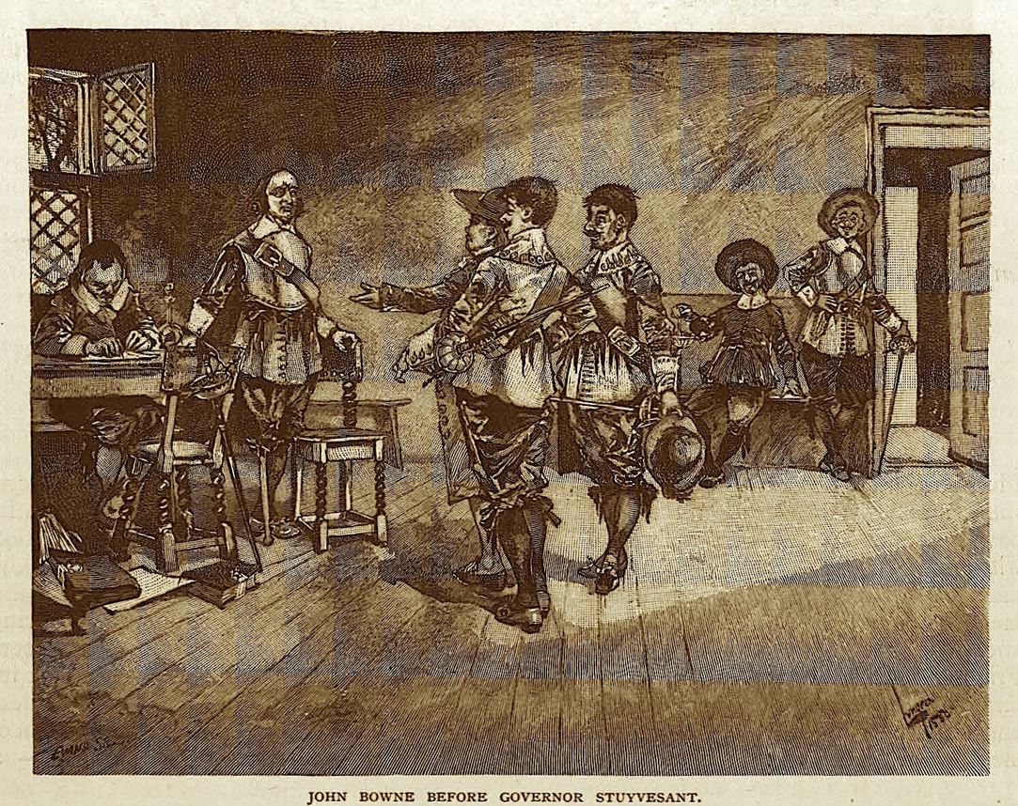
John Bowne before Governor Stuyvesant
This act made John Bowne a foundational figure in the history of American religious liberty. The house he built in Flushing around 1661 still stands as a museum and National Historic Landmark.
Growth and Prominence in the Eighteenth Century
John’s descendants continued to live in Flushing and remained faithful members of the Society of Friends. His son Samuel Bowne (1667–1745) became a Quaker minister and was remembered for his hospitality to traveling Friends. The family’s influence extended through Samuel’s sons and grandsons, who intermarried with the Lawrences and other prominent Quaker lines.
During the eighteenth century, the Bownes combined their religious devotion with business enterprise. Robert Bowne (1744–1818), a great-grandson of John I, founded Bowne & Co., printers, in 1775—now the oldest continuously operating commercial firm in New York. He was also a founder of the Bank of New York (1785) and a leader in the New York Manumission Society (1785), which worked for the abolition of slavery and established the African Free School.
Public Service and the Nineteenth Century
The family remained active in public and civic life after the Revolution. Walter Bowne (1770–1846), a descendant of Robert’s branch, served as mayor of New York City from 1829 to 1833, guiding the city through the 1832 cholera epidemic and overseeing major municipal improvements. His estate, Bowne Park in Flushing, preserves part of the original family lands.
Other members carried forward the family’s humanitarian traditions. Mary Bowne Parsons (1784–1839) and her husband, Samuel Parsons, were leading Quaker abolitionists, and their children participated in the Underground Railroad. Samuel Bowne Parsons Sr. (1819–1906) and Samuel Bowne Parsons Jr. (1844–1923) developed the Parsons Nursery in Flushing, introducing new ornamental plants and contributing to the design of Central Park and other public landscapes.
Allied Families
Through marriage, the Bowne family became intertwined with several other historically significant New York families:
- The Lawrences of Flushing and Bayside, with whom they shared Quaker convictions and civic leadership.
- The Parsons, prominent horticulturists and abolitionists.
- The Bogerts, connected through the Bowne–Lawrence marriages.
- The Murrays and Franklins, linked by the eighteenth-century alliance between Catherine Bowne Murray and Robert J. Murray Jr.
These intermarriages reinforced a network of Quaker and reform-minded families who helped shape the social and moral culture of early New York.
Legacy
For more than three centuries, the Bownes have represented continuity of principle and public service. From John Bowne’s defense of liberty of conscience in 1662 to the family’s later involvement in education, abolition, and horticulture, the name has stood for a blend of faith, enterprise, and civic responsibility.
The Bowne House in Flushing remains the chief memorial to the family’s enduring influence. It is maintained by the Bowne House Historical Society as a museum of religious freedom and early Quaker life in America.
___________________________________________________
Bowne, Hannah Feake (1637–1677)
Quaker Minister

Parents: Robert Feake (1602–1648) and Elizabeth Fones Winthrop Feake (1609–c.1673).
Spouse: John Bowne I (1627–1696), married May 7, 1656.
Children: John Bowne II (1657–1673), Elizabeth Bowne (1658–1721), Mary Bowne (1660–1727), Abigail Bowne (1662–1688), Hannah Bowne (1665–1707), Samuel Bowne (1667–1745), Dorothy Bowne (1669–1690), and Martha Joanna Bowne (1673–1750)
Kinship: Eighth great-grandmother of the post–World War II Smith generation.
Family Background and Early Life
Hannah Feake was born in 1637 in Watertown, Massachusetts Bay Colony, the daughter of Captain Robert Feake and Elizabeth Fones Winthrop Feake. Her mother was the niece of Governor John Winthrop of Massachusetts and cousin of Governor Robert Winthrop of Connecticut, placing Hannah within one of the most prominent Puritan families in New England.
The Feakes settled in Greenwich, Connecticut, where family tensions and religious controversies drew them into disputes with colonial authorities. Elizabeth Fones Feake, an independent-minded woman whose remarriage without formal approval caused scandal among Puritan leaders, exposed her daughter to unorthodox and tolerant religious circles. This early atmosphere of dissent shaped Hannah’s spiritual outlook.
Marriage and Settlement in Flushing
In 1656 Hannah married John Bowne, an English-born merchant recently arrived in New England. They first lived in New Amsterdam and soon afterward in Flushing, Long Island, a mixed Dutch and English settlement under the control of the Dutch West India Company. By the early 1660s, both Hannah and John had become convinced Friends (Quakers), at a time when the movement was still proscribed by both Dutch and English colonial governments.
Their home in Flushing became a center for worship among the local Quaker community. The meetings were often attended by traveling ministers from England, and Hannah herself became recognized as a gifted preacher.
Quaker Convincement and Ministry
Hannah Feake Bowne was among the earliest female Quaker ministers in the American colonies. Contemporary correspondence and later Quaker journals refer to her as “a tender woman in the Truth,” whose speech and conduct influenced many. Family and meeting records indicate that she was active in visiting nearby meetings in Oyster Bay, Westchester, and the mainland colonies.
It was through her witness that her husband John was fully convinced of the Friends’ faith. Their partnership was both spiritual and practical: while John provided their home for worship, Hannah ministered among the small group of early Friends in Flushing, strengthening them amid persecution.
Persecution under Stuyvesant
Governor Peter Stuyvesant’s 1656 ordinance forbidding unauthorized religious meetings targeted the growing Quaker presence on Long Island. In 1662, after Hannah had been holding meetings in their house for several years, John was arrested and imprisoned for defying the edict. Quaker tradition and several later accounts credit Hannah’s calm and steadfast support as decisive during this crisis.
While John was imprisoned in New Amsterdam and later deported to the Netherlands for trial, Hannah maintained their household and continued to host meetings. Friends’ correspondence from England and Holland refers to her hospitality and her “faithfulness in tribulation.”
Later Years and Death
After John’s return in 1663, vindicated by the Dutch West India Company’s decree guaranteeing religious freedom, Hannah continued her ministry quietly in Flushing. She bore eight children, all raised within the Quaker faith.
In 1675, Hannah felt called to undertake a religious visit to England. She traveled to London and later to Ireland and the Netherlands, preaching and visiting Friends. John joined her in Europe in 1676. While in London, she fell ill and died on January 31, 1677/8 (Old Style), at the home of John and Mary Elson. She was forty years old.
She was buried in Bunhill Fields in London, a notable burial ground for nonconformists where George Fox is also interred. er example as a minister, wife, and mother left a deep impression on early Quaker memory; later Friends viewed her as one of the spiritual foremothers of their movement in America.
Legacy
Hannah Feake Bowne’s life illustrates the intersection of Puritan lineage and Quaker conviction. Through her courage and teaching, she helped plant the Society of Friends in New Netherland and embodied the Quaker belief in the equality of women in ministry. The religious liberty secured through her husband’s trial owed much to her faith and persistence.
____________________________________________________
Bowne, John I (1627–1695)

Parents: Thomas Bowne (1595–1677) and Mary [surname not recorded].
Spouse: (1) Hannah Feake (1637–1677), married May 7, 1656; (2) Hannah Bickerstaff (1658–1690), married February 2, 1679/80; (3) Mary Cock (1655-1732), married June 26, 1693.
Children: With Hannah Feake: John Bowne II (1657–1673), Elizabeth Bowne (1658–1721), Mary Bowne (1660–1727), Abigail Bowne (1662–1688), Hannah Bowne (1665–1707), Samuel Bowne (1667–1745), Dorothy Bowne (1669–1690), and Martha Joanna Bowne (1673–1750). With Hannah Bickerstaff: Sarah Bowne (1680–1681), John Bowne (1683–1683), Thomas Bowne (1684–1684), John Bowne (1686–1757), and Abigail Bowne (1688–1688).
Kinship: Eighth great-grandfather of the post–World War II Smith generation.\

Early Life and Migration
John Bowne was born in Matlock, Derbyshire, England, in 1627. He emigrated with his father, Thomas James Bowne, to Boston in 1649, part of a wave of English settlers seeking opportunity and religious toleration in the New World. In 1656 he married Hannah Feake, daughter of Elizabeth Fones Winthrop Feake, niece of Governor John Winthrop of Massachusetts and cousin of Governor Robert Winthrop of Connecticut. The couple settled in Flushing, Long Island, in the Dutch colony of New Netherland, where a small English-speaking community had taken root.
Through family ties and marriage, Bowne was connected to many of the region’s most influential colonial families—the Feakes, Winthrops, and Underhills—and became a prosperous merchant and landowner.
Conversion to Quakerism and Conflict with Authority
Bowne and his wife Hannah became adherents of the Society of Friends (Quakers), a movement then suffering harsh persecution in both England and New England. By 1661, the couple had begun hosting Quaker meetings for worship in their home in Flushing. Their quiet defiance brought them into conflict with the Dutch governor, Peter Stuyvesant, who in 1656 had issued an edict forbidding any religious assemblies not sanctioned by the Dutch Reformed Church.
Hannah Feake Bowne was a Quaker minister in her own right, and family correspondence indicates that she was instrumental in her husband’s conversion. John’s house on what is now Bowne Street soon became the focal point for Quaker gatherings in the colony.
The Arrest and Deportation of 1662
In 1662, Stuyvesant ordered Bowne’s arrest for permitting illegal religious meetings. The sheriff, Resolved Waldron, seized him and brought him to Fort Amsterdam (now lower Manhattan), where he was tried and imprisoned. Offered release upon payment of a fine and public recantation, Bowne refused, stating that his conscience did not permit obedience to laws that violated liberty of worship.
After several months’ confinement, Stuyvesant deported him to the Netherlands aboard the ship Fox. There he appealed directly to the directors of the Dutch West India Company in Amsterdam. Bowne cited the 1645 Charter of Flushing, which guaranteed “liberty of conscience” to settlers.
Vindication in Amsterdam
The directors of the Dutch West India Company heard Bowne’s petition in early 1663. His defense of religious liberty persuaded them to reprimand Stuyvesant and order him to allow freedom of worship within the colony. Their letter of April 16, 1663, instructed: “The consciences of men ought to remain free and unshackled. Let everyone remain free as long as he is modest, moderate, his political conduct irreproachable, and as long as he does not offend others or oppose the government.”
Bowne returned to Flushing later that year, greeted by the Quaker community as a hero of conscience. His victory effectively ended religious persecution in New Netherland and established one of the first successful legal precedents for religious freedom in the New World.
Later Life and Descendants
After his return, Bowne prospered as a farmer and merchant. He built the house that still bears his name around 1661–1662; it remains one of the oldest surviving domestic structures in New York City. He continued to serve as a leading member of the Flushing Meeting and as an advocate for fair treatment of Native Americans and enslaved persons.
His second marriage, to Hannah Bickerstaff, produced several children who carried the Bowne name into the eighteenth century. His son Samuel Bowne became a prominent Quaker minister, and through his descendants the family was connected to the Lawrences, Parsons, and Bogerts of later generations.
John Bowne died on December 20, 1695.and was buried in the Quaker burial ground at Flushing. His house stands today as a National Historic Landmark, commemorating his defense of liberty of conscience—a principle later enshrined in the First Amendment to the United States Constitution.
_________________________________________________
Bowne, Mary (1784–1839)

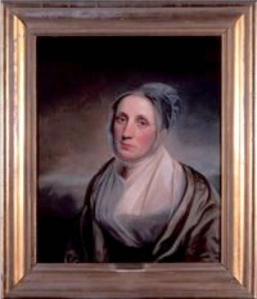
Parents: John Bowne IV (1742–1804) and Ann Field (1760-1843)
Spouse: Samuel Parsons (1774–1841).
Children: James Bowne Parsons (1809–1894), Mary Bowne Parsons (1813–1813), John Bowne Parsons (1815–1830), Robert Bowne Parsons (1817–1898), Samuel Bowne Parsons (1819–1906), William Bowne Parsons (1823–1856), Anna Parsons (1824–1825), and Jane Parsons (1826–1852).
Kinship: Second cousin six times removed of the post–World War II Smith generation.
Early Life and Marriage
Mary Bowne was born in Flushing, Queens County, in 1784, the daughter of John Bowne IV, a descendant of John Bowne I, the seventeenth-century defender of religious liberty. The Bowne family’s Quaker convictions and civic engagement shaped her outlook from an early age.
In 1806 she married Samuel Parsons, a fellow Friend and Quaker minister. The Parsons and Bowne families shared religious and moral ideals—simplicity, equality, and social reform. Mary and Samuel established their household in Flushing, where they raised eight children and remained active in both the Flushing and New York Monthly Meetings.
Quaker Ministry and Reform Work
Both Mary and her husband were active in ministry and in the moral reform causes that characterized early nineteenth-century Quakerism. Their household became known for hospitality, religious devotion, and commitment to education and abolition.
The Parsons home, located near the Bowne House, became a gathering place for Friends engaged in anti-slavery work. Family letters and meeting records preserved in the Bowne House and Parsons family archives show that Mary and several of her children were directly involved in the operations of the Underground Railroad.
Abolitionist Activity and the Underground Railroad
Mary’s sons Robert, William, and Samuel Parsons continued their parents’ abolitionist mission. A significant piece of evidence linking the family to the Underground Railroad is a letter dated September 28, 1850—shortly after the passage of the Fugitive Slave Act. Addressed to William Bowne Parsons, the letter requests help in concealing a “colored man” whose escape from slavery required “great care and caution.”

For years, the letter was attributed to an unknown "L. I. Jocelyn," but recent scholarship has confirmed the signature is that of Simeon S. Jocelyn (1799–1879), the noted abolitionist minister and co-founder of the Amistad Committee. The shaky signature was the result of an arm injury Jocelyn sustained in a railroad accident. The letter explicitly asked if the fugitive might be kept “perfectly unobserved” in the Flushing area, which was considered safer than Williamsburg, Brooklyn.

The obituary of another son, Samuel Bowne Parsons Sr., later recorded “his boast that he assisted more slaves to freedom than any other man in Queens County.” These accounts confirm that the Parsons and Bowne homes in Flushing served as active stations on the Underground Railroad, sheltering fugitives seeking freedom in the North.
Family and Philanthropy
Mary’s three sisters—Ann, Elizabeth (“Eliza”), and Catharine Bowne—remained unmarried and lived at the Bowne House throughout their lives. In 1814, Ann and Catharine were among the founders of the Flushing Female Association, established to educate poor children, particularly those of African descent, at a time when no public schools existed in the town. Although not a founding member, Eliza later joined the effort.
The school initially admitted students of all races and faiths. In 1837, the Association received two large gifts, including a fund established by a Quaker donor to provide education for the children of formerly enslaved parents. After 1847, as Flushing introduced segregated public schools, the Association’s school continued specifically for African-American students, supported in part by public funds.
Death and Legacy
Mary Bowne Parsons died on June 23, 1839, on the island of St. Croix, where she had traveled in an attempt to recover her health. Friends’ records describe her as “a woman of meek and steady faith, charitable to all, and zealous for righteousness.” Through her children’s work in education and the Underground Railroad, she and her husband carried forward the Bowne family’s long-standing witness to human equality and freedom of conscience.
Her descendants continued to influence social and civic life in Queens and New York through philanthropy, education, and horticulture, preserving the Bowne–Parsons legacy well into the twentieth century.
____________________________________________________
Bowne, Robert (1744–1818)
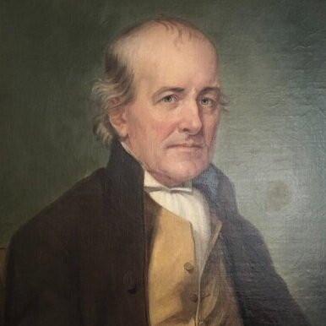

Parents: John Bowne (1698–1757) and Dinah Underhill (1705–1770).
Spouse: Elizabeth Hartshorne (1750–1837).
Children: Mary Bowne (1774–1852), Robert Hartshorne Bowne (1776–1843), John Lawrence Bowne (1779–1847), Sarah Bowne (1781–1862), Hannah Bowne (1784–1860), Elizabeth Bowne (1787–1787), Elizabeth Bowne (1789–1793), Jane Bowne (1792–1843), and William Hartshorne Bowne (1794–1815.
Kinship: First cousin seven times removed of the post–World War II Smith generation.

Early Life and Family Background
Robert Bowne was born in Flushing, Queens County, in 1744, a great-grandson of John Bowne (1627–1695), the seventeenth-century defender of religious liberty in colonial New York. The Bowne family remained one of the most respected Quaker households in the province, known for their integrity in business and their leadership in reform movements.
Robert’s upbringing combined the Quaker virtues of simplicity, honesty, and moral conscience. He came of age during the years before the American Revolution, when New York was emerging as the principal commercial and financial center of the new nation.
Merchant and Financier
Robert Bowne became one of New York’s most prominent merchants and financiers. In 1775 he founded Bowne & Company, a firm specializing in the printing of financial documents. Its emphasis on accuracy, discretion, and reliability quickly made it indispensable to New York’s growing mercantile and financial sectors. Bowne & Co. continued to operate for over two centuries, becoming the oldest continuously active company in the city.
In 1784 Bowne was among the founders of the Bank of New York, serving on its first board of directors with Alexander Hamilton. Two years later, in 1787, he helped organize the Mutual Assurance Company, the city’s first fire insurance firm. He also played a key role in infrastructure, helping to organize the Inland Lock Navigation Company in 1791, a venture that paved the way for the later development of the Erie Canal.
Abolitionist Leadership and the Manumission Society
Robert Bowne’s most enduring public contribution was his work as an abolitionist. In 1785 he joined with Alexander Hamilton, John Jay, Thomas Eddy, and Governor George Clinton in forming the New York Manumission Society, an organization devoted to the gradual abolition of slavery and to the protection of free Black residents of New York from kidnapping and re-enslavement.
The Society’s founders pledged to manumit enslaved people in their own households and to promote legislation limiting slavery’s expansion. Two years later, in 1787, the Society established the African Free School to educate the children of free Black families, one of the earliest such schools in the United States.
Robert Bowne worked closely with other Quakers and reformers, including members of the Murray family, who were connected to the Bownes through marriage. Robert J. Murray Jr., father-in-law of Catherine Bowne Murray, served as a trustee and treasurer of the Manumission Society for many years.
Civic and Philanthropic Work
In addition to his financial and reform activities, Bowne participated in a wide range of philanthropic endeavors. He was a founder and served as a Governor of the New York Hospital for thirty-four years. He was also a leading member of the American Chamber of Commerce. These efforts reflected his conviction that commercial success must be linked to civic responsibility and moral purpose, a view consistent with his Quaker beliefs.
He also contributed to charitable societies concerned with public health and education, helping to establish institutions that supported the social fabric of the rapidly expanding city.
Death and Legacy
Robert Bowne died on August 2, 1818, leaving a legacy that combined integrity in business with a lifelong commitment to moral reform. His name remained associated with honesty, reliability, and public service—qualities that defined the early Quaker contribution to New York’s commercial life.
Through his work in the Manumission Society, Bowne helped lay the groundwork for the abolition of slavery in New York in 1827. The enduring survival of Bowne & Co. stands as a monument to his vision of commerce guided by conscience.
___________________________________________________
Bowne, Samuel I (1667–1745)
Quaker Minister

Parents: John Bowne (1627–1696) and Hannah Feake (1637–1677).
Spouse: (1) Mary Becket (1673–1707), married October 4, 1691; (2) Hannah Smith (1682–1733), married December 8, 1709’(3) Grace Burling (Copperthwaite) (1676-1760), married November 14, 1744.
Children: With Mary Becket: Samuel Bowne II (1692–1762), Thomas Bowne (1694–1761), Hannah Bowne (1697–1748), Mary Bowne (1699–1773), Robert Bowne (1700–1743), William Bowne (1702–1702), Elizabeth Bowne (1704–1748), and Benjamin Bowne (1707–1707); with Hannah Smith: Sarah Bowne (1710–1787), Joseph Bowne (1711–1753), Amy Bowne (1715–1780), Benjamin Bowne (1717– ), and Elizabeth Bowne (1720–1748).
Kinship: Seventh great-grandfather of the post–World War II Smith generation through his son Joseph Bowne (1711–1753), who married Sarah Lawrence (1712–1740).
Early Life and Marriages
Samuel Bowne was born in 1667 at Flushing, Long Island, the son of John Bowne and Hannah Feake, pioneers of religious liberty in colonial New York. Raised in the Quaker faith, Samuel inherited both the family’s commitment to freedom of conscience and its prosperity. His father had received a grant of one thousand acres in Bucks County, Pennsylvania, from William Penn, part of a settlement intended to encourage Quaker colonization. During a visit to that region, Samuel met Mary Becket, whom he married soon afterward. The couple returned to Flushing to live in the family homestead.
After Mary’s death in 1707, Samuel married Hannah Smith of Long Island, with whom he had five additional children. His numerous descendants became central figures in the Quaker community of Flushing and intermarried with the Lawrences, Hickses, and other leading families of Long Island and Westchester. following Hannah's death in 1733, Samuel married for a third time late in life. In November 1744, he wed Grace Burling (Cowperthwaite), though the union was short-lived as Samuel died the following year.
Religious Life and Ministry
Like his father, Samuel Bowne was a minister in the Society of Friends. He was known for his hospitality to traveling ministers and his steadfast adherence to the testimonies of simplicity and peace. The records of the Flushing Meeting frequently mention his leadership and the use of his home for worship and fellowship. His ministry extended beyond Long Island to Pennsylvania and New Jersey, where he visited other Quaker meetings and assisted in the organization of schools and relief committees.
An entry in the death register of the Flushing Meeting preserves the community’s view of him:
“Samuell Bowne of fflushing Deceased at his hous in ye 3 mo: ye 30 dy: 1745 in ye 78 year of his age a man Serviseable in his Day bore a publick testemony in meetings & his hous always open for ye Entertaining of ffriends.”
This epitaph—simple, dignified, and affectionate—encapsulates the character of the early Quaker ministry: a life of quiet constancy and service.
Death and Legacy
Samuel Bowne died at his home in Flushing on May 30. 1745 1745 and was buried in the Quaker Meeting burial ground there. His descendants continued his tradition of religious leadership and public service for more than two centuries. The line through his son Joseph Bowne linked the family with the Lawrences of Flushing, uniting two of the most enduring Quaker families in colonial New York.
_________________________________________________________________________
Bowne, Walter I (1770–1846)
Mayor of New York City
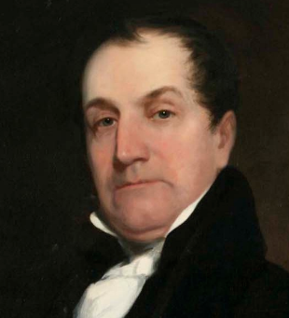

Parents: James Bowne (1728–1793) and Caroline Rodman (1734–1818)
Spouse: Elizabeth “Liza” Southgate (1783–1809).
Children: Walter Bowne II (1806–1877) and Mary King Bowne (1808–1874)
Kinship: Father-in-law of John Watson Lawrence (1800–1888), the first cousin five times removed of the post–World War II Smith generation
Early Life and Family
Walter Bowne I was born in Flushing, Queens, on September 26, 1770, the son of James Bowne and Caroline Rodman, descendants of early Quaker settlers of Long Island. In May 1803, he married Elizabeth Southgate, daughter of Dr. Robert Southgate of Scarborough, Maine, and Mary King. The marriage produced two children, Walter II and Mary King Bowne. His daughter Mary married John Watson Lawrence, uniting two prominent New York mercantile and Quaker-descended families.
Political Career
Bowne entered public life as a young man, first serving in the New York State Senate from 1816 to 1822 and again from 1823 to 1824. He was active in the Democratic Party and a member of the powerful Tammany Hall political organization. He was also a founder, in 1792, of the Union Engine Company No. 18 at John and Pearl Streets—nicknamed the “Shad Belly”—a volunteer fire company typical of civic-minded New Yorkers of the period.
In 1829, Bowne was elected mayor of New York City, serving four one-year terms until 1833, a period when the city’s population approached 200,000. His administration was marked by ambitious infrastructure and civic projects but also by the political patronage that characterized Jacksonian-era urban politics. Contemporary observers accused him of securing his second term through extensive bribery, a charge not unusual for Tammany politicians of the period.
Public Health and the Cholera Epidemic of 1832
One of the greatest challenges of Bowne’s mayoralty was the cholera epidemic of 1832, which struck New York with devastating force. Following prevailing medical theory, which attributed cholera to contagion through contact rather than to contaminated water, Bowne imposed strict quarantine measures. These proved tragically ineffective; more than 3,500 New Yorkers died. Although Bowne’s policies did little to stop the disease, his administration’s energetic, if misguided, response reflected the limited medical knowledge of the time.
Civic Improvements
Bowne was instrumental in overseeing several key urban projects. His administration widened downtown streets, renamed Marketfield Street as Battery Place, opened Jefferson Market, and erected Tompkins Market. He also oversaw the expansion of Union Square Park and supported the early construction of the New York and Harlem Railroad, which would become part of the modern Metro-North line.
Recognizing the city’s desperate need for a reliable water supply, Bowne advocated for a reservoir and aqueduct system, though the project proved beyond the city’s financial reach during his tenure. His successor—John Watson Lawrence’s relative—would see the project realized in the form of the Croton Aqueduct.
Bowne also continued the mayoral duty of acknowledging Manumission Certificates, formalizing the freedom of enslaved persons under New York’s gradual abolition laws, which reached full effect in 1827.
Death and Legacy
Walter Bowne retired from public life after his mayoralty and died on August 31, 1846. 1846. His home in Flushing, Bowne House, remained a symbol of the family’s civic service and Quaker heritage. Though his administration was often criticized for political corruption, his tenure as mayor bridged the Federalist and Jacksonian eras and reflected the growing complexity of urban governance in a rapidly expanding New York City.

Bowne House
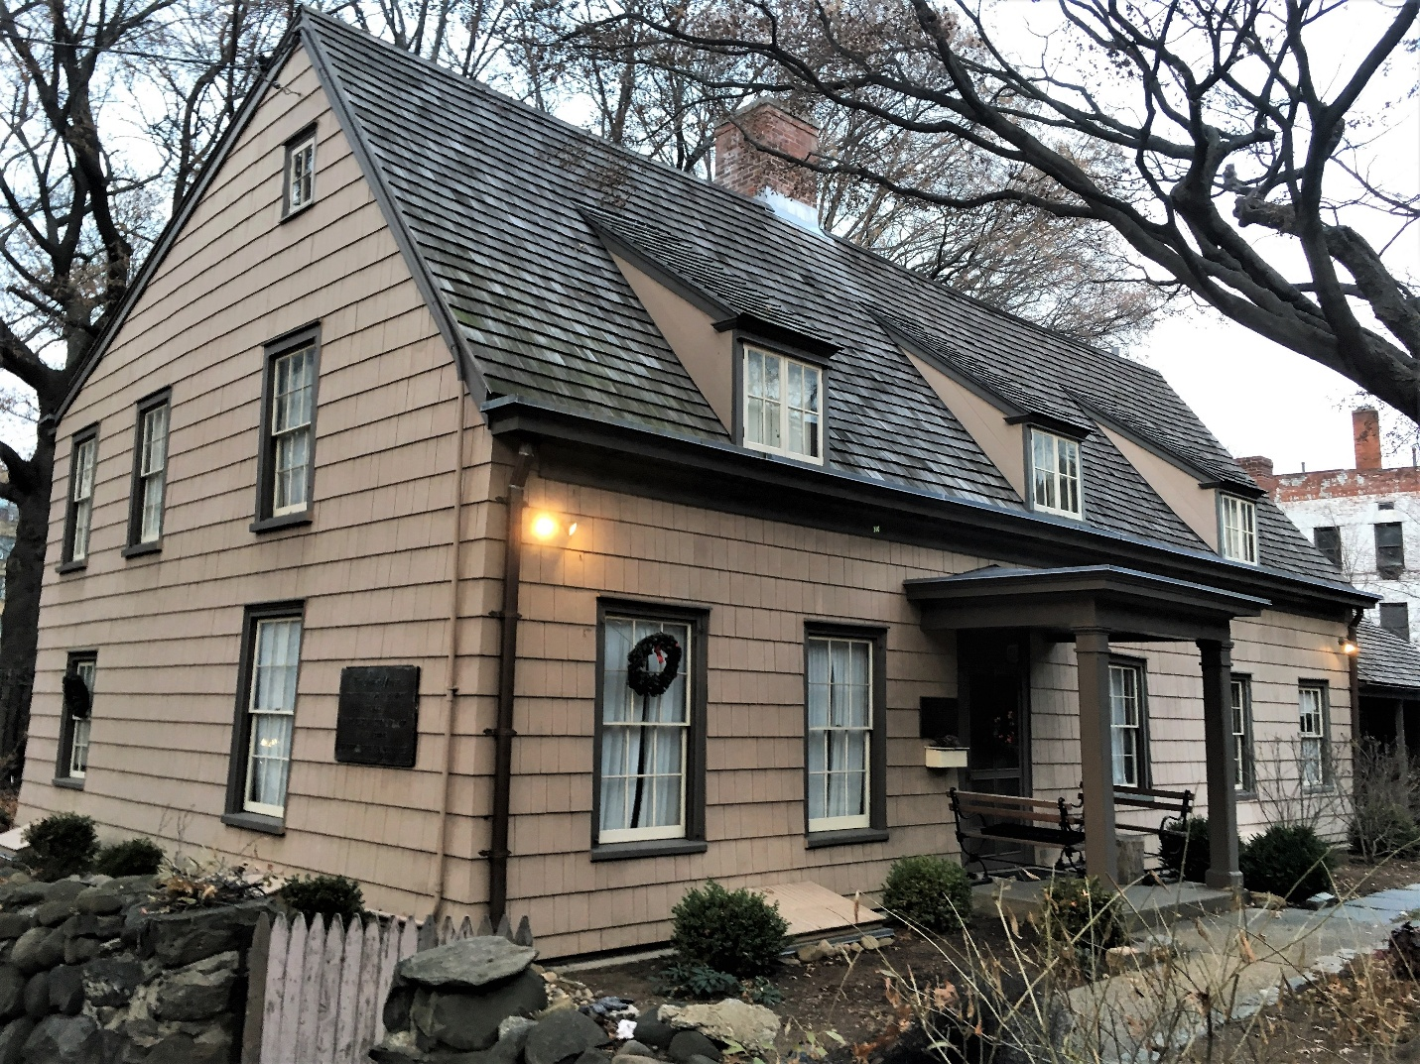

Location: 37-01 Bowne Street, Flushing, Queens, New York City.
Built: c. 1661.

Architectural Description
The Bowne House is a wood-frame Anglo-Dutch vernacular saltbox, widely regarded as the best-preserved example of its type in the United States. Its original core was a modest single-room dwelling, laid out according to Dutch spatial conventions but constructed with English framing techniques. The steeply pitched roof, shingle siding, and later dormers reflect practical adaptations to climate and evolving domestic needs. As the Bowne family grew and prospered, the house was expanded in 1669 and 1680, with further alterations over the eighteenth century; its present footprint was largely fixed by 1815, with minor nineteenth-century updates. An 1825 engraving shows the house in its mature form, surrounded by grounds animated by family life.

.
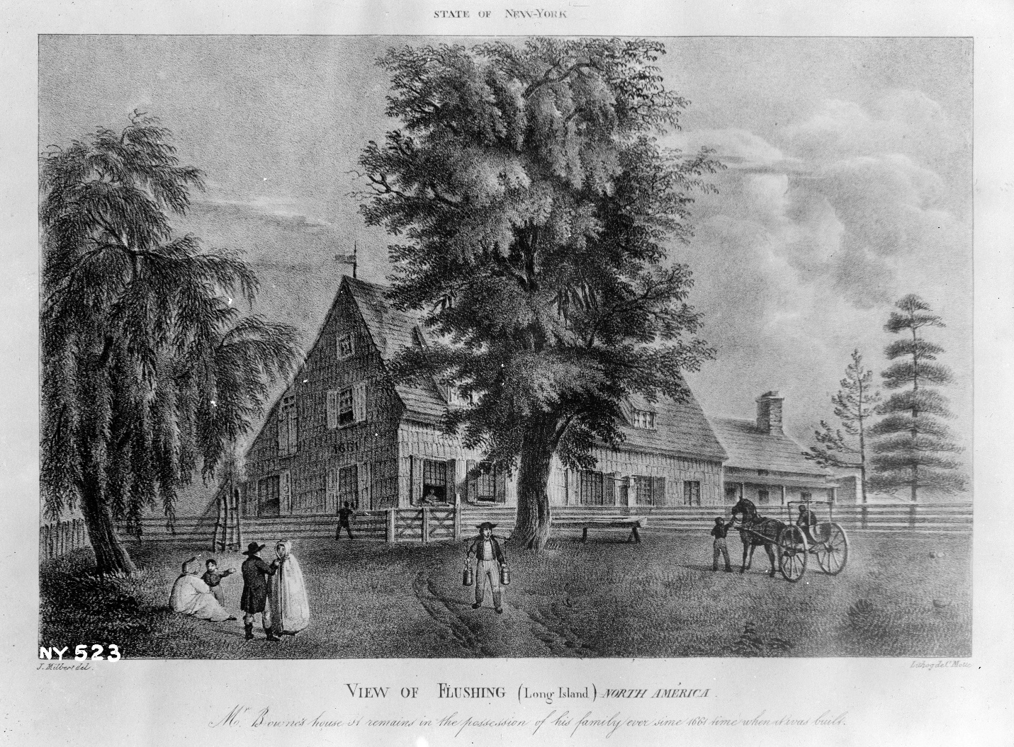
History
The Bowne House is one of the oldest surviving buildings in New York City and the oldest standing structure in the Borough of Queens, distinguished by its continued presence on its original site in Flushing. The house stands within a historically significant area associated with early English settlement and civic life, near the former location of the celebrated Weeping Beech. It was built about 1661 by John Bowne, an English immigrant from Matlock, Derbyshire, who emigrated to Boston in 1649 and settled in Flushing in 1651, when the region was still part of the Dutch colony of New Netherland.

The historical significance of the Bowne House is inseparable from its role in the development of religious liberty in America. In 1662, John Bowne, a recent convert to Quakerism, hosted a Friends’ meeting in the house in defiance of restrictions imposed by Director-General Peter Stuyvesant, who sought to enforce Dutch Reformed religious conformity. Bowne was arrested, fined, imprisoned, and banished to Holland, but he successfully appealed to the Dutch West India Company. In 1663 the company ruled in his favor, affirming liberty of conscience and reinforcing principles first articulated in the Flushing Remonstrance of 1657, principles that later influenced American constitutional protections for freedom of religion, speech, and assembly.
The Bowne House was occupied continuously by nine generations of the Bowne family over more than three hundred years. John Bowne and his wife Hannah Feake Bowne raised eight children there, and later descendants were active in American commercial, civic, and reform movements. John Bowne’s great-grandson Robert Bowne was a co-founder of the New York Manumission Society in 1784, working alongside Alexander Hamilton to promote the abolition of slavery. In the mid-nineteenth century, resident William B. Parsons assisted freedom seekers through the Underground Railroad, a legacy that has led to the house’s inclusion in the National Underground Railroad Network to Freedom.

In 1945 the last family residents, the Parsons sisters, descendants of the Bowne line through the female branch, deeded the property to the Bowne House Historical Society. After restoration and archaeological investigation, the house opened to the public as a museum in 1947. It was designated a New York City Landmark in 1966 and added to the National Register of Historic Places in 1977. Preserved largely as it evolved over centuries, the Bowne House stands today as a rare and tangible record of early colonial architecture, long family continuity, and the historical struggle for civil and religious liberties in America

Boyce Family
Merchants, Theologians, and Industrialists

The Boyce family of South Carolina rose from modest Scots-Irish Presbyterian origins in the backcountry to become one of the most prominent mercantile, political, and religious dynasties of the antebellum South. From the early nineteenth century onward, the Boyces exerted wide influence in commerce, education, theology, and philanthropy.

Origins and Early Generations
The Boyces were of Scots-Irish descent, arriving in the Carolina upcountry before the American Revolution. Settling near Newberry, they became small farmers and merchants within the Presbyterian tradition that had shaped much of the South Carolina frontier. Their emphasis on education, frugality, and independence would mark the family’s later rise.

Ker Boyce and the Rise of a Southern Financier
The family’s fortune began with Ker Boyce (1787–1854), who moved from Newberry to Charleston in 1817 and quickly established himself as a commission merchant and banker. Through careful management, he survived the financial crises of the 1820s and 1830s and by mid-century had become the wealthiest man in South Carolina.

He served as president of the Bank of Charleston, founded several manufacturing and insurance enterprises, and helped finance William Gregg’s Graniteville textile mill, one of the earliest industrial projects in the South.
Ker Boyce’s combination of business acumen and philanthropy typified the Southern civic ideal of his era. Upon his death, he left bequests to the Charleston Orphan House, the College of Charleston, and a home for the poor in Graniteville, endowing scholarships for students of limited means.

Religious Conversion and the Baptist Connection
The family’s religious trajectory shifted through Ker’s marriages to two sisters, Nancy Johnston (1795–1823) and Amanda Caroline Johnston (1806–1837). Because the second marriage was forbidden by Presbyterian law, the family aligned with the Baptists. Amanda was converted under the preaching of the Baptist minister Basil Manly Sr. in Charleston.
Her conversion marked the family’s lasting connection to the Baptist denomination. This legacy was solidified not only by her son James Petigru Boyce (1827–1888) but also by her daughter Nancy Johnston Boyce (1828–1888), who married Rev. Henry Allen Tupper, a distinguished leader who served for decades as the Secretary of the Foreign Mission Board of the Southern Baptist Convention.

James Petigru Boyce: The Theologian and Educator
Educated at Brown University and Princeton Theological Seminary, James P. Boyce combined intellectual rigor with evangelical zeal. He served as pastor of the Baptist Church in Columbia and later as professor and founder of the Southern Baptist Theological Seminary (1859), whose Abstract of Principles became the enduring doctrinal standard of Southern Baptists. Boyce’s Abstract of Systematic Theology (1887) remains in print.

Though a slave owner before the Civil War, Boyce’s later writings reveal a conscience troubled by the moral failures of the South. He saw the defeat of the South as God’s judgment on the white Southerners’ failure to respect the Black family. After the war he rebuilt the seminary in Louisville, Kentucky, and guided it through financial hardship, shaping the education of Baptist ministers for generations.

New York Connections
Ker Boyce’s daughter Elizabeth Miller Boyce (1835–1894) married Frederick Newbold Lawrence of Bayside, New York, thus joining the Boyce family to the long-established Lawrence and Bowne lines of Queens County. This marriage represented the cultural and commercial ties between the Charleston mercantile elite and New York financiers in the mid-nineteenth century. Later descendants carried the family’s intellectual and religious legacy into the twentieth century.

Faith, Commerce, and the Southern Ethos
The Boyce family embodied a characteristic Southern synthesis of entrepreneurship, learning, and faith. Their commercial ventures were marked by civic-minded philanthropy, and their religious contributions—especially through James P. Boyce and his collaboration with the Manly family—helped define the theological direction of the postbellum Baptist South. They stood at the intersection of the older Presbyterian moralism of the upcountry and the evangelical dynamism of the Baptist revival.

Legacy
The influence of the Boyce family endures in both material and spiritual form. The granite mills of Graniteville testify to their early industrial vision, while Boyce College in Louisville continues the educational mission of James P. Boyce. Across two centuries, the family’s name has remained associated with intelligence, devotion, and public responsibility—an enduring example of the civic and religious ideals of the South Carolina Lowcountry.
__________________________________________________
Boyce, Elizabeth Miller (1835–1894)
Southern Matriarch of Bayside
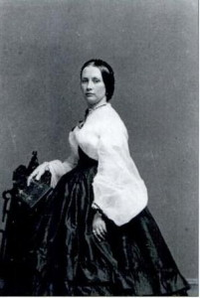

Parents: Ker Boyce (1787–1855) and Amanda Caroline Johnston (1806–1837).
Spouse: Frederick Newbold Lawrence (1834–1916), married December6, 1855.
Children: Lydia Ann Lawrence (1857–1920), Mary Lawrence (1860–1942), Elizabeth Boyce Lawrence (1862–1906), and Virginia Lee Lawrence (1864–1891).
Kinship: Second great-grandmother of the post–World War II Smith generation.
Early Life and Family Background
Elizabeth Miller Boyce was born in Charleston, South Carolina, in 1835, into one of the city’s most prominent mercantile and banking families. Her father, Ker Boyce, was a self-made financier who rose to great wealth through shipping, cotton brokerage, and railroad investment, and was instrumental in founding the Bank of Charleston and the South Carolina Railroad. The Boyces were of Scots-Irish ancestry and represented the new class of entrepreneurial Southerners who linked the region’s plantation economy to national and international markets.
Charleston in Elizabeth’s youth was a cosmopolitan port city, where trade with New York and Liverpool was constant. Although the Boyces were slaveholders, they also participated in the broader Atlantic commercial world, which connected Southern cotton with Northern finance and British industry. Elizabeth’s mother, Amanda Caroline Johnston, died when Elizabeth was still a child, and she grew up in a large blended family with several half-siblings from her father’s two marriages.
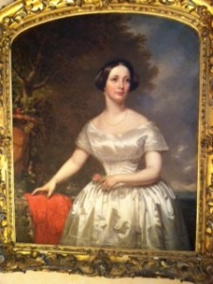
Marriage and Move to New York
In the antebellum period, social and economic connections between Charleston and New York were exceptionally close. New York shipyards built vessels for the Southern trade, and Manhattan bankers and insurers underwrote much of the cotton and slave economy. It was through this commercial and social network that Elizabeth met Frederick Newbold Lawrence (1834–1916), a member of the old Quaker-descended Lawrence family of Flushing and Bayside, Queens. The Lawrence and Boyce wharves were adjacent on the Charleston waterfront.
They were married on December 6, 1855, and settled at Bayside, Queens, where the Lawrences maintained extensive estates. The marriage symbolized both the cultural interchange and the tensions between North and South on the eve of the Civil War.
Marriage portrait
Life in Bayside and Family Traditions
The Lawrences were no longer strictly Quaker by the mid-nineteenth century, but they retained a deep family memory of the Society of Friends and its ethical traditions. While not abolitionists, some Lawrence relatives had supported manumission and were connected to families such as the Bownes and Murrays who were active in the Underground Railroad.
Family tradition preserves a story that when Elizabeth moved north, she brought with her a household servant who had been enslaved in Charleston. Under New York law, she was required to emancipate the woman, which she did, continuing to pay her wages. When the servant died, she reportedly left her savings to Elizabeth and asked to be buried at her mistress’s feet in the Lawrence family cemetery. The tale—though impossible to verify—reflects both the lingering human complexities of slavery and the personal relationships that sometimes bridged it.
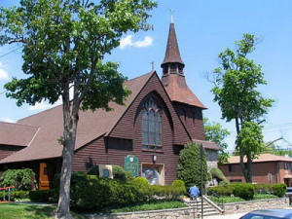
Civil War and Reconstruction Era
During the Civil War, the Boyce and Lawrence families stood on opposite sides. Elizabeth’s husband Frederick served as colonel of a New York state militia regiment based in Flushing, while her brothers fought for the Confederacy. Letters from the period show that family relations were strained but not broken, a circumstance mirrored in many interregional marriages of the time.
After the war, Elizabeth and Frederick continued to live at Bayside, where they became noted for their hospitality and philanthropy. In 1891, Elizabeth donated the land for All Saints Episcopal Church (left), which remains one of Bayside’s most enduring landmarks.

Death and Burial
Elizabeth Miller Boyce Lawrence died on June 26, 1894. She was buried in the Lawrence family cemetery in Flushing, the traditional resting place of the extended Lawrence, Bowne, and Parsons families. Her life embodied the convergence of two powerful regional traditions—the mercantile aristocracy of Charleston and the civic-minded Quaker heritage of Long Island.

Boyce, James Petigru (1827–1888)
Baptist Minister
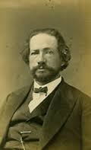

Parents: Ker Boyce (1787–1855) and Amanda Jane Caroline Johnston (1806–1837).
Spouse: Elizabeth Llewellyn Ficklen (1828–1894), married December 20, 1848.
Children: Frances Wingfield Boyce (1852–1940), Elizabeth Ficklen Boyce (1855–1935), and Lucy Garnsey Boyce (1865–1958).
Kinship: Second great-uncle of the post–World War II Smith generation.
Early Life and Family Background
James Petigru Boyce was born in Charleston, South Carolina, in 1827, the son of the financier Ker Boyce and Amanda Jane Caroline Johnston. He was named for Ker’s political friend James Louis Petigru, a Unionist Democrat noted for his wit and moderation. The Boyces were of Presbyterian heritage, but when Ker married Amanda, his late wife’s sister, the Presbyterians refused to recognize the marriage, and the Baptists—more lenient in such matters—performed the ceremony. Though Ker never joined the Baptist church, he was sympathetic to its teaching, and Amanda became a devout Baptist after hearing a sermon by Basil Manly, Sr., which he gave on the death of her child.
Ker Boyce became the wealthiest man in South Carolina, and James grew up in comfort, receiving an excellent education and cultivating refined artistic and literary tastes. Heavy in build, he was unable to participate in vigorous sports but excelled at chess, archery, and billiards. A gifted humorist, he was also known for his fondness for practical jokes.
Education and Religious Formation
As a teenager, Boyce worked in his father’s dry goods business, gaining practical experience in commerce. In May 1845, though not yet a church member, he attended the Augusta, Georgia convention that organized the Southern Baptist Convention after a split with Northern Baptists over slavery. The meeting left a deep impression on him.
Boyce entered Charleston College in 1843 and then transferred to Brown University, a Baptist institution under President Francis Wayland, noted for both its piety and its opposition to slavery. During a sea voyage home to Charleston in the spring of 1846, Boyce read the Bible and came under conviction of sin. He was baptized on April 22, 1846, and on returning to Brown, worked for revival among the students. He graduated in 1847, determined to become a minister.
In 1848 he became editor of The Southern Baptist, and that December he married Elizabeth Llewellyn Ficklen, whom he had met at a wedding in Washington, Georgia. From 1849 to 1851 he studied theology at Princeton Seminary under Charles Hodge, whose Calvinist teaching would profoundly shape his thought.
Ministry and Theological Work
Boyce was ordained in 1851 and called as pastor of the Baptist Church of Columbia, South Carolina. There he introduced a melodeon and choir to the service—innovations that aroused controversy among traditionalists. His father died in 1854 while visiting him, and Boyce became executor of the large estate. He resigned his pastorate to become professor at Furman University (1855–1857) but continued to assist the Columbia church, donating $10,000 for a new sanctuary. At its dedication, he urged that the building be used solely for worship, “for the sake of religious taste and the sacredness of Christian worship.”
The Founding of the Southern Baptist Theological Seminary
Boyce’s enduring achievement was the creation of the Southern Baptist Theological Seminary in Greenville, South Carolina, in 1859. He envisioned a seminary that combined theological orthodoxy with academic rigor and offered two tracks of study: one practical and one scholarly.
In 1858, Boyce, Basil Manly Sr. and Jr., and John Broadus drafted the Abstract of Principles, the first formal confession of faith adopted by Southern Baptists. The first article affirmed the divine inspiration and authority of Scripture; the fifth addressed election as God’s eternal choice “not because of foreseen merit…but of His mere mercy in Christ.” The document’s Calvinist tone reflected Boyce’s conviction that God’s sovereignty and human evangelism were complementary truths.
The seminary prospered briefly but was forced to close in 1862 when its students were conscripted into the Confederate Army.
The War and Reconstruction
Boyce owned twenty-three slaves and defended slavery as a legitimate institution provided masters gave moral and religious instruction and preserved family bonds. Yet he later acknowledged that the South’s sins in this regard had invited divine judgment. Writing to his brother-in-law Henry Allen Tupper, he said: “I believe I see in all this the end of slavery…our sins as to this institution have cursed us…God is going to sweep it away.”
He served six months as a Confederate chaplain and was elected to the South Carolina legislature in 1862 and 1864. His wartime correspondence reveals growing disillusionment with slavery and a theological acceptance of its demise.
At war’s end, Union soldiers ransacked his home in Greenville, sparing his life only after he refused, under threat, to reveal where his valuables had been sent for safekeeping.
Theological Positions
Boyce’s theology was deeply Calvinist yet balanced. In his Abstract of Systematic Theology (1887), he rejected both the rigid determinism of hyper-Calvinism and the human-centered optimism of Arminianism. “God’s own nature,” he wrote, “is to Him the law of what He does, as well as what He wills and what He is.” God, he maintained, “is not just and holy because He wills to be so, but He wills to be just and holy because He is so.”
He upheld the liberty of conscience and the separation of church and state: “God alone is Lord of the conscience…civil magistrates being ordained of God, subjection in all lawful things commanded by them ought to be yielded.”
Rebuilding the Seminary
After the war, Boyce worked tirelessly to reestablish the seminary, moving it to Louisville, Kentucky, where it ultimately thrived. Though impoverished by the collapse of his family’s fortune, he raised funds and secured the school’s survival. His struggle with higher criticism came to a head in 1879 when C. H. Toy, a close friend, resigned after teaching Darwinism and nonliteral interpretations of Scripture. Boyce accepted the resignation with sorrow, valuing truth and friendship equally but refusing compromise.
Later Years and Death
In failing health, Boyce traveled to Europe in 1886 but did not recover. He died in Pau, France, on December 28, 1888.
Legacy and Continuing Influence
Boyce’s model of theological education, combining scholarship with evangelism, continues to define Southern Baptist training. The Abstract of Principles remains the seminary’s doctrinal standard, reaffirmed during the 1990s conservative resurgence under President R. Albert Mohler Jr. Boyce’s concern to preserve orthodoxy while avoiding anti-intellectualism helped Southern Baptists resist both modernism and fundamentalism.
A cultured man who valued beauty in worship, Boyce also raised aesthetic standards in Baptist church architecture and music. In recognition of his influence, the seminary’s liberal arts college bears his name—Boyce College.

Boyce, Ker (1787–1854)
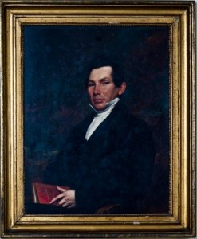

Parents: John Boyce (1745-1805) and Elizabth Miller (1756-1797)
Spouse: (1) Nancy Johnston (1795–1823), married June 28, 1815; (2) Amanda Caroline Johnston (1806–1837), married October 25, 1825.
Children: With Nancy Johnston: John Johnston Boyce (1816–1849), Samuel Boyce (1820– ), and Mary Caldwell Boyce (1822–1888); With Amanda Caroline Johnston: James Petigru Boyce (1827–1888), Nancy Johnston Boyce (1828–1888), Charlotte Rebecca Boyce (1830–1909), Ker Boyce Jr. (1834–1891), Elizabeth Miller Boyce (1835–1894), and Amanda Jane Boyce (1836–1836).
Kinship: Third great-grandfather of the post–World War II Smith generation

Early Life and Character
Ker Boyce was born in the upland district of Newberry, South Carolina, in 1787, of Scotch-Irish Presbyterian ancestry. His early life revealed both energy and humor; he was described as “mirthful and mischievous.” From modest beginnings, he rose through intelligence and perseverance to become one of the wealthiest and most influential men in the antebellum South.
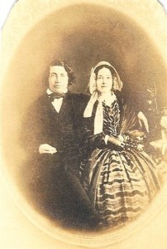
During the War of 1812, with maritime trade blocked by the British navy, Boyce began an overland commerce route with Philadelphia, carrying southern goods northward and bringing back manufactured products. In 1817 he moved to Charleston, then the principal commercial center of the South Atlantic states, and established himself as a commission merchant and lender to planters. He weathered the financial panic of 1825, showing the business acumen that would later make him one of South Carolina’s foremost financiers.
Marriage and Religious Influence
Boyce married first Nancy Johnston, and after her death in 1823 married her sister, Amanda Caroline Johnston. Because such a marriage was barred by Presbyterian discipline, it was solemnized by Baptists, who saw no theological impediment. Ker himself never joined the Baptist church but remained sympathetic; Amanda, after hearing a moving sermon by the young preacher Basil Manly Sr. on the death of his child, was converted and became a devout Baptist. Her conversion would deeply affect their son, James Petigru Boyce, who became a leading Baptist theologian.
Ker and Amanda
Commerce and Industry in Charleston
By the 1830s Ker Boyce was one of the most powerful figures in Charleston’s economy. He served as president of the Bank of Charleston and helped found several other enterprises that advanced the industrial and financial modernization of South Carolina. In 1836 he purchased and revitalized a failing sugar company, renaming it the Charleston Sugar Refining Company. He also presided over the South Carolina Paper Manufacturing Company and held directorships in the South Carolina Railroad, the South Carolina Insurance Company, and the Charleston Gaslight Company.
Boyce invested heavily in manufacturing and infrastructure, holding shares in more than twenty companies and serving as president of the Charleston Chamber of Commerce. In that role he toasted the retirement of the British consul in 1845 with the sentiment: “Commerce—the parent of civilization, the nursery of arts, the bond of universal peace.”
Industrial Development and Social Vision
Boyce was among the first Charleston leaders to support industrial diversification. He purchased 9,000 acres near Aiken and became an early investor in William Gregg’s Graniteville manufacturing venture, built partly on Boyce’s land. Gregg, influenced by Northern industrial models, argued that South Carolina must transform its economy from exporting raw cotton to producing finished goods. Boyce’s financial support reflected both philanthropic concern and pragmatic vision: he saw industrialization as a means to employ impoverished whites and retain Southern capital within the state.
Gregg’s plan to employ poor white laborers rather than slaves was controversial among Charleston’s planter elite, but Boyce recognized the long-term advantage of creating a balanced economy not wholly dependent on plantation agriculture. Graniteville thus became one of the South’s first industrial communities, foreshadowing the postwar “New South” ideal.
Public Life and Politics
A Unionist Democrat by conviction, Boyce opposed the early movement toward secession. He served in both the South Carolina House and Senate and corresponded with national leaders, including John C. Calhoun. In an 1848 letter to Calhoun, he lamented Northern hostility toward the South: “They have no respect for us and their only object is to see the Negroes cut our throats.” Yet he expressed confidence in Zachary Taylor as president, “as he must be sound on the Main Question [i.e., slavery]. His being a Southern man and a slaveholder give assurances beyond doubt.”
Philanthropy and Death
At his death in 1854, Boyce left an estate valued at approximately two million dollars (equivalent to about $57 million in modern currency). His will reflected both his wealth and his social conscience: he gave $10,000 for a house for the poor in Graniteville, $20,000 to the Charleston Orphan House, and $30,000 to the College of Charleston for scholarships for needy students. The remainder was placed under the trusteeship of his son, James Petigru Boyce.
He was buried in Magnolia Cemetery, Charleston, among the city’s most prominent citizens.
Legacy
Ker Boyce’s life embodied the transition of the South Carolina economy from mercantile to industrial capitalism. Though a defender of slavery, he also promoted local enterprise, social philanthropy, and education. His descendants—especially his son James Petigru Boyce—carried forward his combination of intellect, piety, and civic vision.
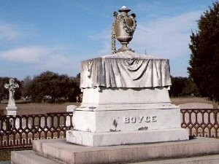
Ker Boyce’s monument

Bradish Johnson House
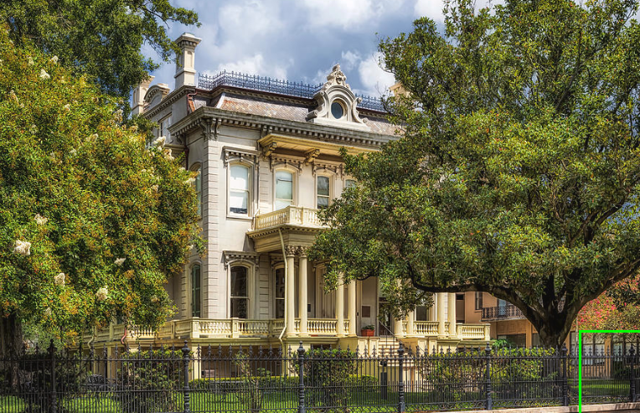
Location: 2343 Prytania Street, Garden District, New Orleans, Louisiana.
Built:1874.
Architect: attributed to Lewis E. Reynolds.

Architect
Lewis E. Reynolds (active c. 1868–1885) was a New Orleans architect best known for his technically sophisticated interior planning and his mastery of stair design during the post–Civil War period. His birth and death dates are not firmly documented, but his professional activity is well attested in New Orleans architectural records from the late 1860s through the mid-1880s. Reynolds is believed to have received formal architectural training, possibly including exposure to European or academic design principles, which is reflected in his fluent handling of French Second Empire and Beaux-Arts–influenced forms. He is particularly associated with advanced stair construction and circulation planning; in 1875 he published A Handbook of Stair-Building, a nationally circulated technical manual that established him as an authority on the subject and influenced American builders well beyond Louisiana. In New Orleans, Reynolds designed a number of substantial residences for elite clients during the Reconstruction and early Gilded Age years, including the Bradish Johnson House at 2343 Prytania Street, where the grand circular stair is a defining feature. His work is characterized by careful structural logic, refined interior composition, and a restrained but confident use of ornament. Although less widely known today than contemporaries such as James Freret, Reynolds is increasingly recognized by architectural historians for his technical contributions and for designs that combine academic sophistication with practical construction expertise.

Architectural Description
The Bradish Johnson House is a monumental Second Empire mansion distinguished by its concave mansard roof crowned with ornate iron cresting, tall pedestal chimneys, and a prominent bull’s-eye dormer centered above the principal façade. The exterior is organized around a raised basement and grand central stair leading to a columned portico with Corinthian columns and an upper balcony. A heavy bracketed cornice, molded window surrounds, and symmetrical massing reinforce its formal, cosmopolitan character. The interior historically featured an elaborate circular staircase, a design element closely associated with Lewis E. Reynolds, who published a contemporary handbook on stair construction.
Original Ownership and Use
The house was built as a private residence for Bradish Johnson, a wealthy sugar planter and industrialist originally from New York, and his wife, Louisa Ann Lawrence. Johnson owned multiple Louisiana sugar plantations and operated a New York distillery, dividing his time between New Orleans, Long Island, and New York City. The mansion served as a post–Civil War statement of wealth and status in the rapidly developing Garden District and reportedly cost approximately $100,000 to construct, a very large sum for the period.
Later History
Following Bradish Johnson’s death in 1892, the house passed through several owners, most notably Walter Denegre, who occupied the residence until 1929. That year the property was acquired by the Louise S. McGehee School, a private all-girls school founded in 1912. The mansion became the school’s principal building and remains its architectural centerpiece. Over time, the school expanded its campus across much of the 2300 block of Prytania Street by incorporating adjacent historic house

Breese Family
The Breese family occupies a colorful and complex place within the larger Lawrence family network—distinguished by artistic brilliance, scientific and engineering innovation, and, in some cases, reckless extravagance. The connection between the two families was established when Josiah Salisbury Breese (1812–1865) married Augusta Eloise Lawrence (1829–1907), a descendant in the fifth generation of William Lawrence the Settler (1622–1680). Through this marriage, the Breeses became entwined with one of New York’s oldest and most influential families. Augusta was the fourth cousin five times removed of the post–World War II Smith generation.
All the Breeses included in this section descend from Josiah and Augusta. The family’s trajectory, from early mercantile and clerical respectability to artistic daring and mechanical genius, reflects both the opportunities and the excesses of the American Gilded Age and its aftermath.

Family Origins and Notable Relations
The family’s American branch descends from Colonel Samuel Breese, a Revolutionary War officer who married Rebecca Hall Finley. Their daughter, Elizabeth Ann Breese, married the Reverend Jedidiah Morse, the geographer and Congregational clergyman. Their son was Samuel Finley Breese Morse (1791–1872)—the polymath who invented the telegraph and Morse Code. Though now chiefly remembered as a scientist, Morse was first and foremost a painter and served as Professor of Painting and Sculpture at the University of the City of New York (now New York University).
The Breeses inherited both sides of Morse’s divided genius—the aesthetic and the inventive. Across several generations they produced photographers, sculptors, architects, automobile designers, engineers, and aviators, as well as patrons and friends of leading artists from Alfred Stieglitz to Georgia O’Keeffe. Yet, like Morse himself—whose strident anti-Catholicism and political fervor scandalized even his allies—they often mixed artistic inspiration with controversy and self-destruction.

Artistry and Innovation
The Breese family’s creativity found expression in almost every field of modern art and technology.
- James Lawrence Breese (1851–1934), stockbroker, engineer, and pioneering photographer, was one of the first amateurs to work successfully in color photography and carbon printing. He built the celebrated “Carbon Studio” on East 16th Street, where he photographed leading society figures and artists such as Ruth St. Denis. His notorious midnight parties, however, became infamous for their decadence and ultimately linked him with the scandal surrounding Stanford White’s “Pie Girl” dinner.
- His brother Sydney Salisbury Breese (1883–1974) co-founded the BLM Company, which produced some of the earliest American sports cars and later contributed to naval aviation experiments with Alexander Graham Bell.
- James Lawrence Breese II (1884–1959) carried the inventive tradition into the 20th century, serving as engineer and co-pilot of the NC-4—the first aircraft to cross the Atlantic—and later inventing the thermostatically controlled “Breese Burner.”
- His descendants continued this inventive and artistic lineage: his daughter Ann Breese (1922–2019) became a painter of distinction in Santa Fe and Denver; his granddaughter Gretchen Elizabeth Breese (1954–2016) was a sculptor, philosopher, and art theorist who taught at the New England Conservatory.

Social Standing and Excess
The Breeses moved in elite New York and Southampton circles, often intertwined with the Lawrences, Alexandres, and other Gilded Age dynasties. They were patrons of art, music, and architecture, associated with John Singer Sargent, Louis Saint-Gaudens, and Will Shuster. Yet their lives also reflected the era’s moral volatility. The lavish entertainments of James Lawrence Breese, the eccentricities of Frances Tileston “Tanty” Breese, and the turbulent marriages that linked the family to British aristocracy (notably through Eloise Lawrence Breese, Countess of Ancaster, and Anne Parsons Breese, Lady Innes-Ker) illustrate the blend of glamour and instability that characterized their social world.

Scientific and Humanitarian Legacy
Later generations turned the family’s energy toward science, exploration, and public service. William Lawrence Breese II (1882–1915), educated at Harrow and Cambridge, renounced his U.S. citizenship to join the British Army and was killed testing an experimental mortar in France. His son, William Lawrence Breese III (1909–2000), became a diplomat and humanitarian, founding the Longview Foundation for Education in World Affairs. Sydney Salisbury Breese Jr. (1922–2006) pursued viral research at Walter Reed and Plum Island, contributing to early studies in animal virology.

Character and Reputation
The Breeses were remembered, even by their contemporaries, as a family of extravagant contrasts—visionary artists and engineers, daring aviators and social provocateurs, philanthropists and scandal-makers. They embodied both the brilliance and the moral ambiguity of America’s transformation from the genteel nineteenth century to the modern age. Their story is that of invention and audacity, a lineage where beauty, intellect, and excess were inextricably bound.

___________________________________________________
Breese, Ann (1924–2019)

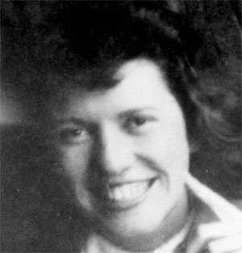

Parents: James Lawrence Breese II (1884–1959) and Marjorie Howard Gorges (1894–1948).
Spouse: (1) Charles S. Sink (1923–2013), married 1948; (2) Edward White, married c. 1975.
Children: With Charles Sink: Carol Sink, Jennifer Sink (1953–), and Mark Breese Sink (1958–).
Kinship: Seventh cousin twice removed of the post–World War II Smith generation.

Early Life and Artistic Influences
Ann Breese was born on May 27, 1924. She began drawing and painting at an early age, her artistic life shaped by growing up in Santa Fe amid the city’s flourishing early-twentieth-century art colony. Family friends and neighbors included Randall Davey, who introduced her to polo and painting, and Andrew Dasburg, the American modernist. She admired the work of the printmaker Gustave Baumann, a family friend whose daughter Ann was her close childhood companion. Through these connections she was acquainted with many Santa Fe and Taos artists, including Mabel Dodge Luhan and her husband, Tony, to whom she once taught the jitterbug.

She recalled that Santa Fe artist Will Shuster designed the Breese family’s Christmas cards, and that as a teenager she occasionally encountered Georgia O’Keeffe painting near Abiquiú—O’Keeffe’s brusque attempt to shoo her away with a candy bar left an indelible memory rather than a discouragement.

Life at Los Vientos and Santa Fe Society
In later recollections, Ann vividly described her childhood at Los Vientos, the family’s ranch on Upper Canyon Road, and her friendships with other Santa Fe families such as the Packs of Ghost Ranch. Her account of early Santa Fe life captured the world of artists, architects, and eccentrics—John Gaw Meem, whose Pueblo Revival architecture helped define the city’s appearance; Faith Weight and Charles Mintun, who ran experimental schools; and colorful figures like Brian Behru Dunne, the self-made town character and newspaper columnist.
She remembered her family’s casual exchanges of art for their own inventions—“a Breese Burner in exchange for a painting”—and the camaraderie of artists like the Baumanns, whose marionette plays she recalled with affection.

Education and Study with Diego Rivera
Ann experienced progressive education at a school run by Charles Mintun ("Uncle Charlie") and Faith Weight on Palace Avenue. The curriculum emphasized "learning by doing" over rote academics: making pottery, learning steps from Indian dances (her specialty was the Eagle dance), and visiting nearby pueblos. This lack of formal schooling was balanced by deep exposure to indigenous culture. As she later reflected:
"I don't think I would have had as much appreciation for pueblo cultures if there had not been that early exposure... All the dances are a fascinating integration of the native American religions and the Christian teachings brought by the Spanish missionaries."
Faith was an early health food enthusiast, and our meals were mainly fresh fruit, vegetables, nuts, granola, and whatever else she considered wholesome. Desserts were for bidden. There seemed to be no schedule. When they were tired after supper, boarders were asked what room they felt like sleeping in that night. Boys sometimes shared quarters with girls, and no one seemed to think it odd.”

Ann attended the Sandia School in Albuquerque, designed by Meem and founded by Ruth Hanna McCormick Simms, where she studied art with Raymond Jonson, one of the New Mexico Transcendentalists, and Kenneth Adams, artist-in-residence at the University of New Mexico.

She then entered Bennington College in Vermont in 1943, drawn to its modern educational philosophy that integrated studio art with liberal studies. Under the guidance of Paul Feeley, she explored abstract painting and nonrepresentational form. During her Non-Resident Term she studied with Diego Rivera in Mexico City, assisting in his studio on a mural depicting burros in the desert and meeting Frida Kahlo, whose fragile health made a lasting impression.

Marriage, Travel, and Artistic Development
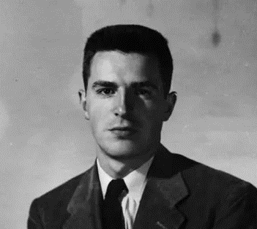
After graduating from Bennington in 1947, Ann returned to Santa Fe, where she met the young architect Charles Sink (right), a Harvard graduate who had studied under Walter Gropius alongside I. M. Pei. They married and lived in Caracas, Venezuela, where he opened the city’s first architectural office, and she pursued painting.

Returning to the United States, they settled in Denver, and for a time in New York, where Charles worked with I. M. Pei and William Zeckendorf. Exposure to New York’s Abstract Expressionist scene deeply influenced her artistic development; she knew family friend Adolph Gottlieb and viewed major exhibitions of the movement.

In the latter 1950s, along with raising her young family in Denver, Ann began painting oils on canvas and board in the styles of pure and referential abstraction. While she and her family lived in New York, she saw Abstract Expressionism in the exhibitions of its artists, including family friend Adolf Gottlieb. Her firsthand contact with the movement informed her striking and large untitled canvas in the late 1950s. Other pure abstracts from the 1960s show her attachment to Color Field painting. At the same time, she applied referential abstraction to other paintings basing their imagery on New Mexico landscape and the large Native American pueblo in Taos, which she visited while growing up in Santa Fe. The cubistic structure of the several-storied adobe pueblo appealed to her and was a very familiar subject. She likewise applied referential abstraction to still lifes, a subject close at hand, whose bright palettes recall those of Arthur B. Carles.

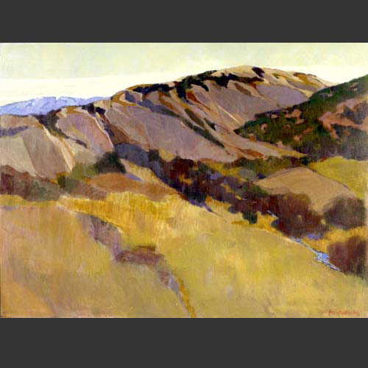
By the early 1960s she began painting acrylics which had become commercially available and used by a number of New York-based Abstract Expressionists. She increasingly preferred them to oils because they dried quickly and were practically odorless.

Providing limitless expression and creativity, they allowed artists to achieve different textures, consistencies and color depths. Ann applied the medium to modernist landscapes on canvas and paper of Colorado, New Mexico, Arizona and Montana, as well as of Mexico, Greece, and other locales she visited with her second husband, Ed White. Some of these same places appear in her watercolors and watercolors combined with pastel.

Artistic Work and Exhibitions
With her husband she co-founded the Alliance for Contemporary Art in Denver, under the auspices of the Denver Art Museum, to promote modern and abstract art in the region. She later received the museum’s Cile Bach Award and its Fifty-Year Award for her service.

Active in civic causes, she joined the Colorado Coalition for the Prevention of Nuclear War and painted Peace March at Nevada Test Site after joining a protest in 1987. She exhibited in Denver galleries and regional shows and was a founding member of The Nine, an independent association of women artists active from 1963 to 2000. A signature member of the Colorado Watercolor Society, she exhibited regularly in juried shows.

Teaching and Later Career
Ann earned a teaching certificate in art education at the University of Denver in 1969 and taught in summer programs, museums, and schools throughout the city. In the 1970s she managed the Scholastic Art Awards in Denver and served as a regional editorial consultant in design and architecture for national publishers.

After her divorce from Charles Sink, she married architect Edward White of Denver, a preservationist who helped found the Denver Landmark Preservation Commission and restored many of the city’s historic buildings. His civic legacy was honored with major preservation awards.

Retrospective and Legacy
In 2000 her son, the photographer Mark Sink, organized a fifty-year retrospective, Ann White, 1950–2000, at Gallery Sink in Denver, which surveyed her abstract and representational works—distinguished by clarity of structure, expressive color, and a lifelong dialogue between modernism and the New Mexican landscape.
__________________________________________________________________________
Breese, Anne Parsons (1889–1959)
Lady Alastair Innes-Ker
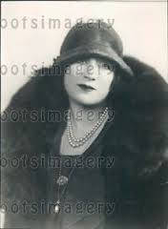

Parents: William Lawrence Breese (1853–1888) and Mary Louise Parsons (1857–1948).
Spouse: Alastair Robert Innes-Ker (1880–1936).
Children: Alastair James Innes-Ker (1908–1944), David Charles Innes-Ker (1910–1957), and Eloise Jena Innes-Ker (1915–1996).
Kinship: Sixth cousin three times removed of the post–World War II Smith generation.

Early Life and Marriage
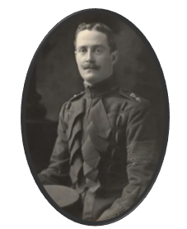
Anne Breese was born in 1889, the daughter of William Lawrence Breese and Mary Louise Parsons. After the death of her father, her mother married Henry Vincent Higgins, impresario of Covent Garden, and the family settled in England.

Like her sister Eloise, Anne entered the British aristocracy through marriage. On October 10, 1907, she wed Alastair Robert Innes-Ker (left), the younger brother of the then-childless 8th Duke of Roxburghe.

Although Lord Alastair came from one of Britain’s oldest noble families, he was not wealthy, and neither was Anne. Newspapers of the time emphasized the sincerity of the match, calling it “the culmination of a genuine love affair.” \
A contemporary report noted:
“Lord Alastair, though belonging to one of the noblest families of England, is by no means wealthy. The bride is not wealthy either, and the young people will have to live quietly, but, it is said, the Duchess of Roxburghe, who was Miss May Goelet of New York, will give them a small but completely furnished house in Mayfair.”

Family and Royal Connections
In October 1908, Anne gave birth to her first child, Alastair James Innes-Ker. As the Duke of Roxburghe had no children at the time, Anne's son was the heir presumptive to the dukedom and the vast Roxburghe estates, including Floors Castle.

However, when the Duchess of Roxburghe gave birth to a son, George Innes-Ker, in 1913, the succession passed to the new heir. Anne took the change in good humor; the press reported that she was “among the first to proffer congratulations” and had “frankly declared she considered the Goelet millions really necessary to maintain such a palatial residence as Floors Castle.”

Military Life and Losses
Lord Alastair Innes-Ker had a distinguished military career. He served in the Boer War, receiving both the King’s and Queen’s medals, and was later awarded the Distinguished Service Order in November 1914 for bravery in the First World War. After continuing his service into the interwar period, he retired from the army in 1930 and died in 1936 at the age of fifty-five.

Their eldest son, Alastair James Innes-Ker, followed his father’s path in military service. He was killed in action in Normandy on July 6, 1944, when his tank was destroyed by fire. His body was never recovered, and he is commemorated on the Bayeux Memorial in France.

Later Life
Anne Breese lived quietly in England after her husband’s death. Two of her children, David Charles Innes-Ker and Eloise Jena Innes-Ker, survived her. She died in 1959, having witnessed both the triumphs and the tragedies of a family entwined with the British nobility and the turbulent first half of the twentieth century.
_____________________________________________________________________________
Breese, Eloise Lawrence (1857–1921)

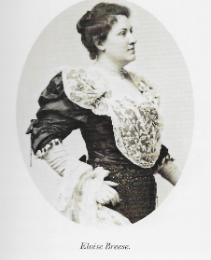

Parents: Josiah Salisbury Breese (1812–1865) and Augusta Eloise Lawrence (1828–1907).
Spouse: Adam Gordon Norrie (1862–1927), married November 1906.
Kinship: Fifth cousin four times removed of the post–World War II Smith generation.

Neighborly Problems and Public Life
Eloise Lawrence Breese, known as E. L. Breese, was a prominent New York socialite whose wealth, independence, and eccentricity drew much public attention. Her country home, Nundao, a nine-bedroom house in Tuxedo Park, was often the scene of weekend gatherings. In June 1904 she made the newspapers when her chauffeur, driving her French motorcar with several guests, accidentally struck and killed a boy cyclist named Joseph Mutzs. Though the police determined the accident was the boy’s fault, the local chief urged Miss Breese to leave quickly, fearing reprisals from the boy’s Italian neighbors.

Her town house at 35 East Twenty-Second Street was equally well known, not only for its lavish concerts and soirées but for her long feud with her next-door neighbor, Mrs. Elizabeth B. Grannis of No. 33. Mrs. Grannis, president of both the Woman’s Social Purity League and the National League for the Protection of Purity, waged campaigns against fashionable dress and modern dancing. “The décolleté gown,” she told The Evening World in 1894, “and the round dance are the twin evils corrupting society.” Eloise, whose daring gowns and fondness for the waltz symbolized the very world Mrs. Grannis sought to reform, became her frequent adversary.

After years of complaints and disputes—Eloise about “smells” and fires from next door, Mrs. Grannis about moral decay—Eloise finally purchased her neighbor’s house in 1902 “with the understanding that it was to be pulled down,” The Sun reported. Instead, she transformed it into a boarding house decorated “with bows and arrows of primitive peoples and the heads of savages in war paint”. The following year she sued Mrs. Grannis for $249 for removing “a bathtub and the chandeliers.” The reformer retorted, “It is my personal, individual tub… Of course I took it with me.”

The former Grannis home no longer survives, but Eloise’s adjoining carriage house, at what is now 150 East 22nd Street, remains in altered form.

Society, Interests, and Marriage

Eloise Breese was celebrated for her independence and unconventional tastes. She was the only female member of the New York Yacht Club, owning the steam yacht Elsa, whose swan-shaped prow recalled Wagner’s Lohengrin. A devoted opera enthusiast, she used the yacht to attend society events such as the 1901 Newport Harbor fête honoring Admiral Higginson’s North Atlantic Squadron.

Long known as a bachelorette, Eloise married late in life, in 1907 at the age of fifty, to Adam Girdin Norrie, a widower. She maintained her strong connections with New York’s cultural institutions; her box at the old Metropolitan Opera was Number 45. When her nephew William Lawrence Breese was killed in battle in 1915, she donated an ambulance in his memory.

Patronage and Legacy
Eloise Breese’s patronage extended to the arts as well as society. Upon her death on January 28, 1921, she bequeathed two major paintings to the Metropolitan Museum of Art—one by Rousseau and another by Corot, The Wheelwright’s Yard on the Bank of the Seine—along with an extraordinary set of seventeenth-century Audenarde tapestries depicting the story of the Sabine women.

These works remain among the museum’s most distinguished gifts from the early twentieth century, emblematic of the taste and flamboyance of a woman who delighted in defying convention.

Breese, Eloise Lawrence (1882–1953)
COUNTESS OF ANCASTER
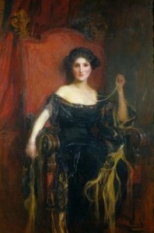

Parents: William Lawrence Breese (1854–1888) and Mary Louise Parsons (1857–1948).
Spouse: Gilbert Heathcote-Drummond-Willoughby (1867–1951), later 2nd Earl of Ancaster, married December 6, 1905.
Children: Lady Catherine Mary Clementina Heathcote-Drummond-Willoughby (1906–1996), James Heathcote-Drummond-Willoughby, 3rd Earl of Ancaster (1907–1983), Lady Priscilla Heathcote-Drummond-Willoughby (1909–2002), Hon. John Heathcote-Drummond-Willoughby (1914–1970).
Kinship: Sixth cousin three times removed of the post–World War II Smith generation.

Early Life
Eloise Lawrence Breese was born into a prominent American family with deep colonial roots. Her father, William Lawrence Breese, died when she was a child, and in 1893 her widowed mother married Henry Vincent Higgins (1856–1928), a solicitor and manager of Covent Garden. After this marriage, the family relocated to London, where Eloise studied singing under Signor Allenesi.

Marriage to Lord Willoughby de Eresby
Like many wealthy American heiresses of her era, Eloise Breese married into the British aristocracy. On December 6, 1905, she wed Lord Gilbert Heathcote-Drummond-Willoughby, Baron Willoughby de Eresby—twenty-three years her senior—at St. Margaret’s Church, Westminster. Both bride and groom were wealthy, and the match was celebrated as a triumph of Anglo-American society.

The wedding was a spectacular social event attended by leading figures of the British court and the American colony in London. Among those present were the Duke and Duchess of Connaught, Princess Patricia of Connaught, Ambassador Whitelaw Reid and Miss Reid, Prince Francis of Teck, and the Ladies Dartmouth and Cheylesmore. A detachment of the Lincolnshire Yeomanry lined the aisles.

The New York Times reported: “The church was crowded with a fashionable throng that included nearly all the prominent members of the American colony and royalty. Seldom has been seen a more beautiful dress than that worn by the bride. It was made of ivory satin, with full Court train of Brussels lace chiffon. The bridesmaids looked remarkably pretty in lavender gowns trimmed with sable, and picture hats.”

The Ancasters for some reason inspired Americans to claim their properties: “there is no Peer of the British realm whose properties, especially the Drummond estates, have been more frequently claimed by people hailing from America.” Another claimant was the daughter of the late Earl of Perth. She resided for many years in Brooklyn. Lord Drummond died in St. Luke’s Hospital after having earned his living for a time in New York as ticket chopper on the elevated railroad and as a reporter of one of the leading metropolitan daily newspapers.

At the ceremony, Eloise’s stepfather, Henry Vincent Higgins, gave her away. Her attendants included her sister, Miss Anne Breese (later Lady Alastair Innes-Ker), and the Ladies Alice Willoughby, Dorothy Onslow, Gladys Fellowes, Blanche and Diana Somerset, Moyra Goff, and Peggie Cavendish.

The Title and Estates
When Eloise’s father-in-law died on Christmas Eve in 1910, her husband succeeded to the title, and she became the Countess of Ancaster. The inheritance included three grand estates: Grimsthorpe Castle in Lincolnshire, Normanton Park near Stamford, and Drummond Castle in Perthshire, Scotland.

The family lineage of the Earls of Ancaster combined the fortunes and titles of several distinguished houses—the Heathcotes, Drummonds, and Willoughbys de Eresby. Drummond Castle, with its sixteenth-century towers, vast parklands, and formal gardens, had been the seat of the Drummond family since 1491 and was renowned for its royal associations. Mary, Queen of Scots, James VI and I, and the Jacobite Pretender had all visited or stayed there.
The New York Times delighted in recounting the colorful history of the family, tracing its descent from Gilbert Heathcote, Lord Mayor of London in the reign of Queen Anne, and from the medieval Drummonds, who claimed descent from the ancient kings of Hungary.

Social Life and Character
Before her marriage, Eloise had been one of the few female flag members of the New York Yacht Club and also belonged to the Seawanhaka Corinthian Yacht Club. Her enthusiasm for yachting, automobiling, and field sports continued after her marriage. The Times described her as “handsome, of classic type, witty, and cultivated.” She was an accomplished salmon fisher and often praised for her elegance and charm.

Lord Willoughby de Eresby—later the 2nd Earl of Ancaster—had served as a Conservative member of Parliament for the Horncastle Division of Lincolnshire. After his father’s death, he divided his time between the family’s estates and their London home in Chesterfield Gardens.

Family and Later Years

Eloise and her husband had four children: two sons and two daughters. Her eldest son, James, succeeded as the 3rd and last Earl of Ancaster. Her younger son, John, died unmarried in 1970.

The Countess suffered a personal tragedy during World War I when her brother, William Lawrence Breese, who had become a naturalized British subject and joined the British Army, was killed in action in France in 1915.

Eloise and her husband had one surviving son, James Heathcote Drummond Willoughby (1907–1983), who succeeded as the 3rd and last Earl of Ancaster. His own son and heir, Timothy Gilbert Willoughby, was lost at sea in 1963, and the earldom became extinct upon James’s death.

Eloise, Countess of Ancaster, lived amid the grandeur of the British landed aristocracy, bridging the worlds of American wealth and English nobility. She died in 1953, two years after her husband, leaving behind a lineage that united two nations and a legacy emblematic of the great transatlantic marriages of the Gilded Age.

Breese, Frances Tileston “Tanty” (1893–1985)

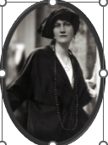
Parents: James Lawrence Breese (1855–1934) and Frances Tileston Potter (1858–1917).
Spouse: (1) Lawrence McKeever Miller (1889–1970); (2) Arsene Marius (1915–).
Children: Edith Breese Miller (1916–1998), George McCulloh “Cully” Miller III (1920–2002), and Lawrence McKeever Miller Jr. (1920–2007).
Kinship: Sixth cousin three times removed of the post–World War II Smith generation.

Early Life and Relationship with Father
Frances Tileston “Tanty” Breese had a colorful and unconventional life—an unsurprising outcome given her father’s reputation for exuberance and eccentricity. As an infant she moved with her family to The Breeses in Tuxedo Park, but they did not remain long; her father had scandalized the local country club by starting a craze for tobogganing down its grand staircase on silver tea trays.

At five, Tanty moved with her family to The Orchards, a fifty-acre estate in Southampton surrounded by gardens. Raised by a French governess, she spoke French more fluently than English. Her relationship with her father was complex; he was both her champion and a source of disillusionment. He delayed sending her to school until she was ten but gave her an early education in mechanics. She later recalled, “Of me, he was known to say, ‘Frances is the best of my boys,’ and he liked to show me off. As soon as I was tall enough to sit behind the wheel of a car, he put me in the driver’s seat and taught me to shift gears and manipulate the hand throttle.”

However, her father’s flagrant philandering and financial volatility strained their bond. Frances penned a poem about him that, while playful on the surface, revealed a daughter’s cynical awareness of her father’s indiscretions

A Poem for Her Father

Tanty, his youngest child
How well do I remember
The year of ninety-three
when Father and my Mother
Had just created Me.
T’was from my painted iron crib
while blowing bubbles in my bib
I used to look with wonder on
The costumes that my Pa would don.
For fancy dress at every party
Was much the vogue if you were “arty”
In the eighties and the nineties
And the naughty nineteen oughties
Then later, when a little tot,
(You may believe I was, or not)
I used to watch and have much fun
When Jimmy made his horses run.
For trotting then was much the fad
And moving slow was not for Dad.
Give him action, give him speed,
He likes them fast… yes Sir, indeed.
In horses, women, games and sport
Slow movers never were his sort.
(Of course all this is merely heresay,
But rumors sometimes reach the nursray.)
So, by the time I could count ten
I’d heard a thing or two. For instance when
A little fairy flitting by
Told me the tale about the Pie.
She said no crows came out that night.
Instead, a vision of delight;
A fancy from the brain of him
Who all my friends call Uncle Jim.
But in the fear that I might tell
Too much, it would be well
Only to mention with a word
Some of the things that I have heard.
About his prowess and his skill;
The birds he’s shot, the fish he’s killed,
The boats he’s sailed, the cars he’s driven,
And his immense success with women.
So if you lesser men are spurned
Because as yet you haven’t learned
To charm the birds from off the trees,
You’d best tune in on Jimmy Breese.

Education and Adolescence
When Tanty was about twelve, her father’s fortunes—soaring and collapsing with market fluctuations—fell sharply. The family sold their Manhattan townhouse, leased The Orchards to tenants, and moved to a run-down Maryland farm. Her father embraced farming with typical gusto, donning overalls and learning to drive a tractor. For Frances, the change was lonely and disorienting. With little money for tuition, she attended a Baltimore day school, making an exhausting daily commute, and later an all-boys school where she felt isolated. Her dogs and the freedom to drive on country roads were her chief comforts.

By the time she was sixteen, her father had recouped enough wealth to send her to school in Paris. Before leaving, she proved her driving prowess. “A memorable occasion for me,” she wrote, “was the day in my fifteenth year that my father and I had set out from New York for eastern Long Island in our six-cylinder Pierce Arrow.” Once across the Queensboro Bridge, he allowed her to take the wheel. “I was filled with pride when my father opened his newspaper to look at the stock market reports instead of watching my driving.”

She was the model for the BLM (Breese-Lawrence-Moulton) sports car poster (left); her brother Sydney Breese was involved in that business. After her stay in Paris, she bought herself a Hupmobile.

Coming Out and Early Adulthood
After returning from Paris, Tanty had a modest coming out, but it included excitement and notoriety. She and a friend performed a “snake dance” at a charity benefit, consulting the modern dancer Ruth St. Denis about their costumes and painting their arms green to complement their reptile-skin ensembles.

Her volunteer work with the Junior League brought her into contact with New York’s less privileged classes. She taught dancing at settlement houses and visited foster homes for the Children’s Aid Society, where she observed poverty firsthand.

Marriage and War Years
At the end of her second winter in New York, Tanty in a moment of weakness behaved conventionally. She became engaged to Lawrence McKeever Miller, a young man from a family long associated with Tuxedo Park and Southampton. Her father approved, pleased to have a son-in-law conversant with finance.

During World War I, she trained with the Red Cross, drilled at the Armory, and learned typing and automobile repair. When her husband returned from France, she was, as she wrote, “a different woman”—a transformation typical of her generation’s wartime experience.

Later Life and Artistic Pursuits
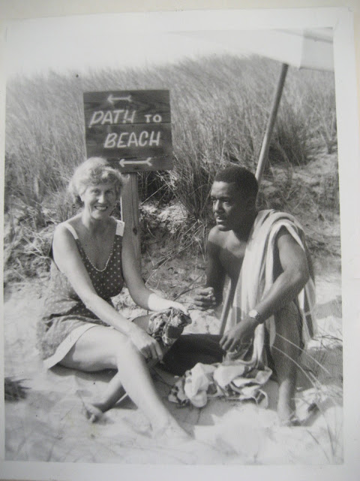
After the war, the Millers lived in Hewlett, Long Island, though Tanty found suburban life frustrating. She cherished summers at Southampton, and after her father remarried Grace Lucille Momand, a woman near Tanty’s own age, she and her husband rented their own house.

Encouraged by artist Rachel Hartley to paint, she began to work seriously, but her husband disapproved, and she gave up the pursuit. A nervous breakdown preceded their eventual divorce in 1930.

She built a modern house in Bridgehampton known as The Sandbox and began painting again. Later she moved to Haiti, where she married a Haitian artist, Arsene Marius (right). They relocated to Mexico but eventually divorced.

Returning to Long Island in 1957, she devoted herself to art, design, and dance. In 1939 she designed the carpet for the United States Building at the Chicago World’s Fair, an acknowledgment of her modernist sensibility.

Final Years
Frances Tileston Breese Miller spent her later years at The Sandbox, painting and entertaining friends in the free-spirited manner that had always defined her. She died there on June 19, 1985, at the age of ninety-one. Her beloved house was later sold and demolished.

Adapted from “High Style in the Gilded Age: Frances Breese Miller” by Mary Cummings.
______________________________________________________________________________
Breese, Frances Potter (1916–1998)
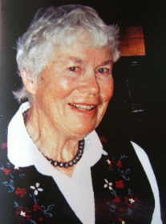

Parents: James Lawrence Breese (1884–1959) and Marjorie Howard Gorges (1894–1948).
Spouse: (1) Peter Houston Kilham (1905–1992); (2) David Cabot Forbes (1908–1994).
Children: With Peter Kilham: Robin Breese Kilham (1936–2010), Ann Kilham (1937–), Lawrence Breese Kilham (1941–), and Susan Gorges Kilham (1944–).
Kinship: Seventh cousin twice removed of the post–World War II Smith generation.

Early Life
Frances Potter Breese grew up in Santa Fe, New Mexico, at the family’s home on Canyon Road, surrounded by the city’s vibrant artistic community. Her early years were spent among the artists, writers, and architects—such as her father’s friends John Gaw Meem and Will Shuster—who made Santa Fe one of the cultural capitals of the Southwest.

Marriage and Career
In 1935 she married Peter Houston Kilham of the Santa Fe Iron Works. The couple moved east during World War II, where Peter designed gunsights for the military. Frances continued to paint and illustrate, drawing inspiration from both New England and the American Southwest.

After their divorce in 1962, she married David Cabot Forbes (1908–1994). Forbes was a member of the prominent Boston Brahmin family. They settled in Boston and Sherborn, Massachusetts, where she continued her work as an artist and preservationist. Following her husband’s death in 1994, she returned to Santa Fe.

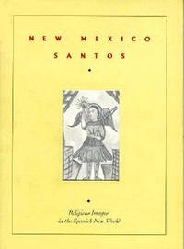
Artistic and Preservation Work
Frances Breese devoted her later years to the preservation and celebration of New Mexico’s religious and artistic heritage. She helped restore village churches and moradas—the humble meeting places of the Penitente Brotherhood—and painted historical murals at the Philmont Scout Ranch in Cimarron.

She also illustrated New Mexico Santos: How to Name Them (1966) by E. Boyd, a foundational text in the study of Hispanic religious art of the Southwest. Her illustrations, sensitive to the devotional simplicity of the santeros’ style, remain an enduring contribution to the documentation of New Mexican sacred art.
A lifelong artist and cultural advocate, Frances Potter Breese united the aesthetic traditions of Santa Fe with a deep respect for its history and people. She died on April 2, 1998.

Breese, Gretchen Elizabeth (1954–2016)
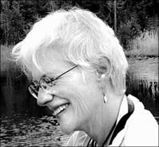

Parents: James Lawrence Breese III (1927–2009) and Eunice Robbins “Terry” Gehr (1929–2020).
Spouse: Tom Joaquin.
Children: None recorded.
Kinship: Eighth cousin once removed of the post–World War II Smith generation.

Education
Gretchen Breese’s education reflected her broad and integrative intellectual curiosity. She earned her B.A. in Art from the University of California’s College of Creative Studies in Santa Barbara in 1976, followed by an M.F.A. in Sculpture from the Rhode Island School of Design in 1984.
Pursuing her growing interest in the relationship between art, philosophy, and architecture, she earned a Master’s in Environmental Design in architectural theory from Yale University’s School of Architecture in 1987, where she held a full fellowship.

At Yale, she also received a second fellowship to pursue doctoral studies in Religious Studies. She completed the coursework for her Ph.D., focusing on theological aesthetics, Neoplatonism, and comparative mysticism, before devoting herself fully to teaching and creative practice.

Academic and Artistic Career
Gretchen Breese’s career spanned both the visual arts and philosophy. As a sculptor, she exhibited her work in numerous solo and group shows on both coasts of the United States, exploring the intersections of form, material, and metaphysical symbolism. In 1986 she received a National Endowment for the Arts (NEA) grant for her innovative work in architectural theory—a rare recognition for a sculptor-philosopher whose work bridged the disciplines of fine art and design.

Her academic interests were wide-ranging, encompassing Buddhist and feminist philosophy, Neoplatonism, and theological aesthetics. She taught philosophy at Ripon College from 1994 to 1998. In 1998, she joined the faculty of the New England Conservatory in Boston, where she taught liberal arts courses in philosophy, sculpture, and film studies. Her classes were known for their depth, intellectual rigor, and personal engagement. Gretchen believed that studying philosophy could transform lives, and she sought to cultivate in her students both critical thought and humane understanding.

Illness and Final Years
In 2013 Gretchen was forced to retire due to the debilitating effects of cancer and its treatment. True to her philosophical temperament, she refused to frame her illness as a battle or moral contest. Instead, she regarded it as a natural biological process—morally neutral, to be studied and understood. She applied her characteristic curiosity to learning everything she could about the biochemistry and genetics of her disease, actively collaborating with her physicians and the Dana-Farber Cancer Institute research team in shaping her treatment.

Legacy
Gretchen Breese died on June 9, 2016, at the age of 61. She was remembered as a rare figure of intellectual intensity and creative generosity—a teacher who inspired thought, a sculptor who sought meaning in form, and a philosopher who found beauty in inquiry. Her life embodied the unity of art and contemplation, intellect and compassion, and she left behind a legacy of teaching and art that continues to influence those who studied with her and knew her work.
______________________________________________________________________________
Breese, James Lawrence (1854–1934)

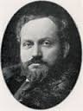

Parents: Josiah Salisbury Breese (1812–1865) and Augusta Eloise Lawrence (1829–1907).
Spouse: (1) Frances Tileston Potter (1858–1917); (2) Grace Lucille Momand (1894–1946).
Children: With Frances Tileston Potter: Sydney Salisbury Breese (1883–1974), James Lawrence Breese II (1884–1950), Robert Potter Breese (1887–1958), and Frances Tileston Breese (1893–1985)..
Kinship: Fifth cousin four times removed of the post–World War II Smith generation.

Early Life and Career
James Lawrence Breese, known to family and friends as “Jim” or “Jimmy,” was born into a prominent New York family descended from the Breeses of Trinity Churchyard and related to the Lawrences and the Sidneys. He studied engineering at Rensselaer Polytechnic Institute but soon turned to finance, founding the brokerage firm Breese and Smith. Between 1909 and 1916 he reportedly earned over $2,000,000—equivalent to roughly $50 million in modern terms. His firm’s discretion in business affairs contrasted sharply with his notoriety in private life.

The Carbon Studio and Photography
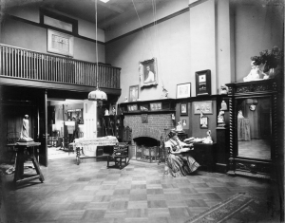
Breese was a passionate amateur photographer who mastered the difficult and exacting carbon printing process, producing richly pigmented, archival photographic images. His work was of sufficient technical and artistic quality to attract serious attention: he collaborated with Rudolf Eickemeyer and was one of only two Americans—along with Alfred Stieglitz—invited to exhibit at the Vienna International Photographic Exhibition of 1893, where he won first prize.
At his New York home at 5 East 16th Street, Breese built an elaborate studio, dubbed The Carbon Studio (right), where he photographed New York’s fashionable society and theatrical figures. He was among the earliest amateurs to experiment with color photography. His studio also became infamous for its after-hours entertainments and erotic photography.

The Photographs

Breese photographed adults but preferred young girls, both as models and perhaps as more than models.

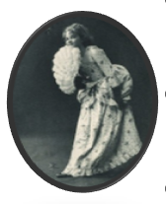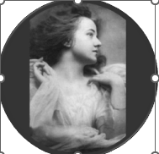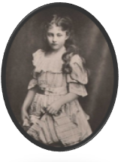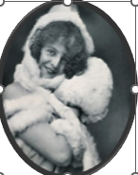

Costumes

Costume parties were favored by the moneyed classes. It enabled them to dress outlandishly, and Breese loved nothing more than to be outlandish.

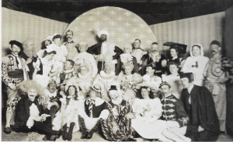

0

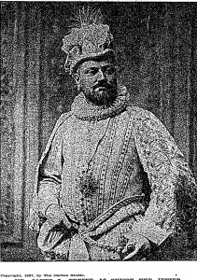
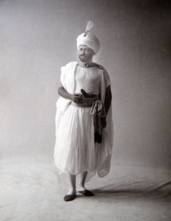

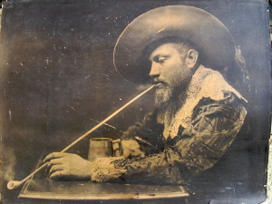
One nearly ended in disaster. A descendant of James Breese, Otto Dittenhoffer, wrote; “Perhaps the most celebrated of the “1001 Nights” costume parties took place on December 17, 1896. It involved a pyrotechnic mishap that captured the attention of the press and the public at large.

In the words of a society columnist of the day: “The host received his guests in the costume of an Arab sheik. He is a man of commanding presence, with a dark beard and looked the part very well, indeed. Mrs. Breese, made up as a Spanish dancing girl, helped him to welcome the guests.

“They were a gay and a picturesque horde who invaded the studio as the clock struck twelve. James J. Van Alen and Hermann Oelrichs impersonated Dutch burghers; Winthrop Chanler and Miss Wilmerding posed as members of the Salvation Army and rattled their tambourines incessantly; James Gerard, Jr. was a handsome Hungarian hussar: Craig Wadsworth and Willie Tiffany were court jesters; Miss ‘Birdie’ Fair wore the ruff of Folly; Cooper Hewitt and Whitney Warren were turbaned Turks; Creighton Webb’s well-known legs were displayed to advantage beneath a long Spanish cloak; Dickie Peters was as proud of his appearance in a suit of pajamas and a high hat as if he had uttered an epigram ….

“The presence of so many costumed guests provided Breese with an opportunity to take individuals aside and pose them for a portrait….

“On this particular December night, the cold winter wind may have been blowing outside, but within the sanctum of the Breese studio, a good time was being had by all. Then things began to go awry. The gaiety had kicked into high gear when Mrs. Clinch Smith, wearing a loud plaid calico dress and a huge hat, unrecognizable in cork ‘black face,’ commanded center stage with her spirited version of a ‘cakewalk.’ Mrs. Cadwalader, wearing loose, loud checked trousers, big shoes, and a red necktie, took the part of Sambo. The two otherwise reserved and proper ladies brought down the house to the accompaniment of a group of ‘genuine negro banjo players.’
“Somewhere along the way a mischievous guest began tossing lit matches in a negligent manner. Suddenly Mrs. George B. de Forest, who was dressed in a light and gauzy Oriental costume, began to scream as flames lept from her attire. No water being readily available, a quick thinking guest seized a champagne bottle from an ice bucket, knocked off its neck against the wall, and sprayed the contents onto the flaming dress. Several other champagne bottles were similarly employed.

“Sobbing and trembling, with her charred skirts clinging to her body, Mrs. de Forest was led to Mrs. Breese’s apartments to ‘recover her composure.’”

The “1001 Nights” Parties
Breese’s Wednesday-night gatherings, known as the “One of 1001 Nights” parties, drew artists, architects, actors, and members of the Gilded Age elite, including John Singer Sargent, Louis Saint-Gaudens, Dana Gibson, and his intimate friend Stanford White. Guests appeared in elaborate costume, drank champagne from silver buckets, and mingled amid what one reporter described as “a bacchanal of bohemian New York.”
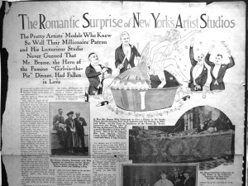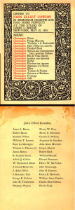
The parties reached their scandalous height on December 17, 1896, when a pyrotechnic mishap nearly burned one of the guests alive, and again with the notorious “Pie Girl Dinner.” 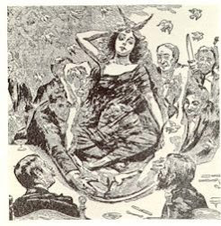
At that event, held near dawn in the Carbon Studio, four Black servants carried in an enormous papier-mâché pie, from which emerged a fifteen-year-old girl draped in black gauze, releasing live canaries as the orchestra struck up “Sing a Song of Sixpence.” Stanford White lifted the girl from the pie—an episode later woven into the Thaw–White murder case when Harry K. Thaw shot White atop Madison Square Garden in 1906.

The young girl, a model, then 15 years old, lived with her mother, but on the night of the banquet she disappeared, and remained in hiding for two years. Efforts of the police to find her were unsuccessful. At last she returned, to tell a story of revolting mistreatment and desertion by the man who met his death at the hands of Harry Thaw. “When I was lifted from the pie to a seat at the table I found myself queen of the revel,” she said. “It was dazzling at first,” she said, “but in the end it became a sad queendom. “Mr. White was kind for a time, but when he went to Europe he instructed his clerks to get rid of me with as little trouble as possible. I never saw him again.” Turned into the street to live as she might, this girl, not yet 18, finally married, but her husband, when he learned of her part in the “pie” banquet, brooded over the affair, and deserted his girl wife without attempting to avenge her wrongs. She died soon afterward. (see The Great Harry Thaw Case by Benjamin Atwell). Some say she committed suicide.

Newspapers like Joseph Pulitzer’s World denounced the event as “a bacchanalian revel,” accusing Breese and his circle of corrupting young women. Others, such as the painter Edward Simmons, sought to minimize the scandal as “very moral and dignified”—a claim few believed. The affair shattered reputations, and most of those involved, including Breese, left New York temporarily to avoid further scrutiny.

Another way James Breese sought thrills was through the new sport of automobile racing.
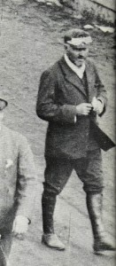
At the 1904 Vanderbilt Cup Race, James Breese walking on the Jericho Turnpike Course (left)
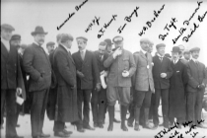
James Breese, William K. Vanderbilt, Jr., and other participants of the 1904 Daytona-Ormond Beach Automobile Races. (above)
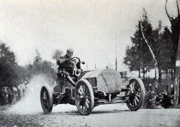
James Breese at the Eagle Rock Hill Climb
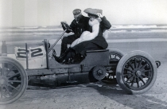
James Breese at the 1905 Daytona-Ormond Automobile Races.
On August 9, 1904 at 2 P.M. James Breese arrived at St. Louis for the World’s Fair. He had driven his forty-horsepower touring car from Buffalo to St. Louis in 36 hours, averaging 25 mph. His son James Breese Jr., his valet, and a machinist accompanied him. The others in the race arrived a day later.

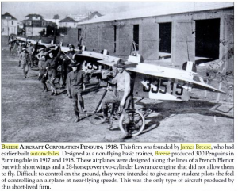
James also used his engineering knowledge to experiment with the manufacture of planes.
Penguin (right) was a non-flying trainer.

Residences
In addition to his houses The Breezes and The Orchards, James had an apartment at the Hotel des Artistes in Manhattan: “The living room is 60 feet by 30 feet. Its furniture includes some enormous pieces of old English silver. Venetian columns of red, blue, and gold lend indescribable richness to the walls. Mr. Breese finds comfort on a divan covered with old Spanish brocade. One of his many fancies is to “have his fire screen decorated with live smilax, fresh every day, all year ’round.

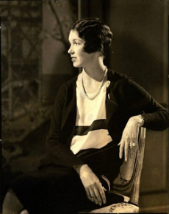
The Last Act
After his first wife died, at age 64 he married the Southern belle Grace Lucile Momand (1894-1946), who was 23. They married in 1919; she divorced him in 1927 and immediately became the second of the three wives of Harry Payne Bingham.

Breese provided endless copy for the scandal sheets.

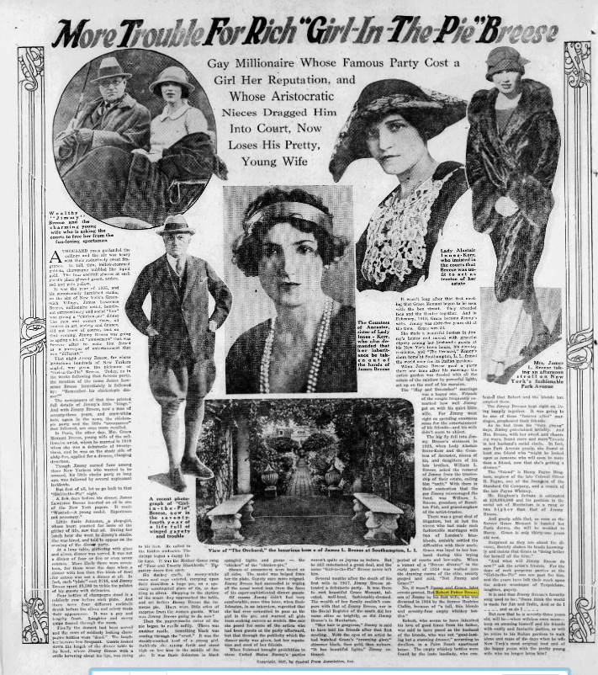

The Denouement
James’s daughter Frances reminisces: “In 1935 [actually, 1934] he lost his last fortune, and The Orchard, our summer home in Southampton, was sold to Charles Merrill. Papa took an around the world trip by steamer, became a short-wave radio enthusiast, and on his return built a two-bedroom house that he called “Breese In” on Hill Street, next to his former home. He did much of his own cooking, and old Mrs. Raccosta, who had been with our family for many years, cleaned house for him. Even though Papa was in his late seventies, the change in circumstances did not phase him. He was still attractive to women, and, when he could no longer drive a car, he acquired a beautiful young companion-housekeeper-chauffeur and toured the country with her. When he died at the age of eighty, she committed suicide.”
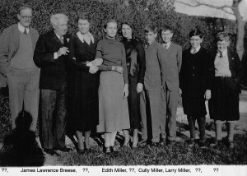
James Breese and his grandchildren

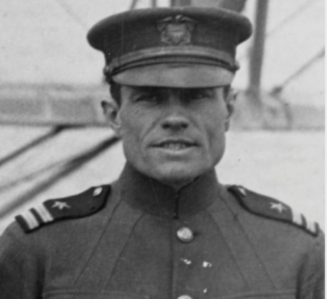
Breese, James Lawrence II (1884–1959)

Parents: James Lawrence Breese (1851–1934) and Frances Tileston Potter (1858–1917).
Spouse: (1) Marjorie Howard Gorges (1894–1974); (2) Sarah Spencer Morgan Gardner, granddaughter of J.P. Morgan (1893–1949); (3) Irene Rich (Anna Josefa Irine Sobczyk) (1902–1989); (4) Florence Welch Wagner (1883–1971)..
Children: With Marjorie Howard Gorges: James Lawrence Breese III (1921–2009), Anne Breese (1922–2019), Frances Potter Breese (1916–1998), and Mary NC Breese (1919–1991).
Kinship: Sixth cousin three times removed of the post–World War II Smith generation.

Education and Early Life
James Lawrence Breese II, often called “Jim,” inherited both the technical aptitude and the flair for adventure of his father, the society photographer James Lawrence Breese. He attended Groton, where he was a schoolmate of Franklin Delano Roosevelt, and graduated from Princeton University in 1909. His education and connections later proved significant when Roosevelt, as Assistant Secretary of the Navy, helped secure Breese’s participation in a pioneering aviation event.

The Aviator
In 1919 Breese served as engineering officer and co-pilot of the NC-4, the Curtiss flying boat that completed the first successful transatlantic flight—from New York to Lisbon—years before Charles Lindbergh’s solo crossing.

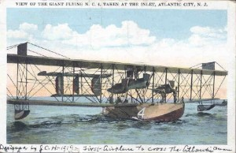
The NC-4, one of four Navy Curtiss flying boats built for long-distance experimentation, departed from Naval Air Station Rockaway on May 8, 1919, stopping at Halifax and Newfoundland before attempting the longest leg of the journey to the Azores. Escorted by a line of Navy destroyers lighting the night sea with searchlights, the NC-4 reached Horta, Faial Island, after fifteen hours in the air. It was the only one of the three planes to survive the entire crossing; NC-1 sank after damage at sea, and NC-3 was forced down by fog and mechanical problems.

After repairs in the Azores, the NC-4 continued to Lisbon on May 27, completing the first flight ever made across any ocean—a historic milestone in aviation. The crew was celebrated worldwide, and Breese received the Navy Cross and the Congressional Gold Medal for his role. His daughter Mary NC Breese was named for the aircraft that had carried him into history.

The Inventor
After the war, Breese’s interests turned toward engineering and invention. Having learned mechanics from his father and aviation from the Navy, he initially joined a firm that produced experimental steam automobiles. From his work on the steam car’s oil burner, he developed an idea that revolutionized domestic heating.

Studying the combustion of a candle flame, he designed a burner that maintained a steady temperature without producing smoke. Adapting this principle, he invented the first thermostatically controlled oil burner for home furnaces—the “Breese Burner.” Manufactured worldwide, it became one of the most widely distributed heating units of the mid-twentieth century, with over three million sold by 1954. The U.S. Army used Breese Burners to heat barracks during wartime.

Santa Fe Years
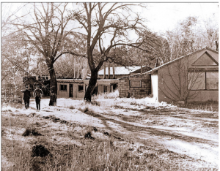
Breese’s first encounter with Santa Fe was accidental. While piloting a Ford Trimotor to Winslow, Arizona, he ran low on fuel and followed an arrow painted on a rooftop that guided him to a small landing strip outside Santa Fe. Captivated by the landscape, he bought property on Upper Canyon Road and built a house. There he continued to refine and test the Breese Burner while overseeing manufacturing partnerships around the country.

The factory building on Upper Canyon Road later became part of Santa Fe Preparatory School. Breese became a well-known local figure, equally at home among engineers, pilots, and the artists and architects who frequented Santa Fe’s growing cultural circle. During World War II he served in the Civil Air Patrol.

Personal Life

Breese’s first marriage to Marjorie Howard Gorges produced four children—Frances, Anne, Mary NC, and James III—but ended in divorce. In 1935, he married Sarah Spencer Morgan Gardner, a widow and granddaughter of financier J.P. Morgan; this marriage also ended in divorce. In 1940, he married Irene Rich (born Anna Josefa Irine Sobczyk), a nurse; they divorced in 1948. His final marriage was to the journalist and editor Florence Welch Wagner, widow of writer Robert Wagner, founder of Rob Wagner’s Script, the literary magazine that first published the young Ray Bradbury.

Later Life and Legacy
Breese’s later years were divided between New Mexico and California. In San Diego, where he died on April 1, 1959, he remained active as an inventor and aviation enthusiast.
His career spanned the age of steam, flight, and postwar industrial expansion. From pioneering transatlantic aviation to revolutionizing home heating, James Lawrence Breese II exemplified the inventive, adventurous spirit of early-twentieth-century American engineering.

Breese, James Lawrence III (1921–2009)
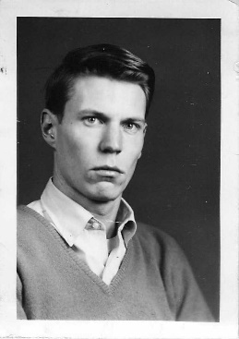

Parents: James Lawrence Breese II (1884–1959) and Marjorie Howard Gorges (1894–1948).
Spouse: Eunice Robbins Gehr Berman (1929–2020).
Children: Gretchen Elizabeth Breese (1954–2016).
Kinship: Seventh cousin twice removed of the post–World War II Smith generation.

Early Life and Education
James Lawrence Breese III was born on July 15, 1921, in Lake Forest, Illinois, and raised in Santa Fe, New Mexico, where his family had settled when he was a child. In the last days of World War II, at age eighteen, he served in the U.S. Air Force in Germany and reported on the Nuremberg Trials. After returning to the United States, he graduated from the University of New Mexico in 1951.

Career
Following his graduation, Breese worked at Los Alamos on the MANIAC (Mathematical Analyzer, Numerical Integrator, and Computer) project, one of the earliest American efforts in large-scale digital computation. His work placed him at the intersection of engineering and the emerging field of computer science. As one of the earliest electronic computers, the MANIAC was pivotal in thermonuclear calculations, placing Breese at the forefront of the dawn of the computing age.

In 1959, he moved to San Francisco, where he and his wife settled in a small apartment on Telegraph Hill overlooking the Bay. There he established an engineering consulting firm specializing in heating and air-conditioning systems design. For many years he worked as a manufacturers’ representative, developing technical systems for large commercial buildings and hotels.

Breese was known for his methodical intelligence and quiet humor, though in later life he suffered a series of personal and financial misfortunes. A contract for a major hotel renovation was derailed by the collapse of a subcontractor, Western Plumbing and Heating. In October 2003, the owner of Western Plumbing, Victor Bach, was bludgeoned to death in his office. The subsequent investigation revealed that Bach’s wife had been embezzling millions from the company, leading to its collapse. The firm's sudden bankruptcy derailed Breese’s contract, contributing to the financial difficulties he faced in his final years.

Later Years and Death
In his later years Breese’s health worsened, and he became increasingly reclusive after further setbacks during the 2008 financial crisis.. His nephew, Lawrence Kilham, son of his sister Frances, recalled that his once tidy apartment on Telegraph Hill had fallen into disrepair and that he appeared weary and overweight, a marked change from his former athletic vigor. Breese died of cardiovascular disease on March 14, 2009, at the age of eighty-one.

Interests and Character
James Breese’s lifelong interests reflected the intellectual range of his family heritage. He studied and wrote about physics, mathematics, and philosophy, combining a scientific temperament with a reflective curiosity about the nature of reality and the human mind. Above all, he was devoted to his daughter Gretchen Elizabeth Breese (1954–2016), a philosopher and sculptor who inherited his intellectual discipline and artistic imagination.
Breese’s life, though marked by both achievement and adversity, exemplified the Breese family tradition of technical innovation, independence of spirit, and unpretentious intelligence.
____________________________________________________

Breese, Mary NC “Ency” (1919–1999)
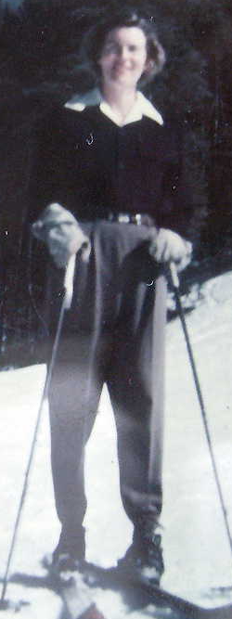

Parents: James Lawrence Breese II (1884–1959) and Marjorie Howard Gorges (1894–1974).
Spouse: (1) William Kingsbury Pitcher (1919–1977); (2) Nelson Dean Jay Jr. (1911–1993).
Children: With Nelson Jay: Wendyl Breese Jay (1952–).
Kinship: Seventh cousin twice removed of the post–World War II Smith generation.

Early Life

Mary NC Breese—affectionately called “NC” or “Ency”—bore one of the most unusual names in the family tree. She was named in honor of the NC-4, the Navy Curtiss flying boat on which her father served as engineer and pilot during the first successful transatlantic flight in May 1919, just months before her birth.

Born on January 28, 1919, in Washington, D.C., she spent her early childhood in the adventurous household of James and Marjorie Breese. The family moved to Santa Fe, New Mexico, in 1928, settling on Upper Canyon Road, which would remain her base for much of her life.

Skiing Pioneer

NC became known as a talented horsewoman and one of Santa Fe’s pioneering skiers. In the 1930s, as a teenager, she participated in the early development of the Hyde Park Ski Area, helping to introduce organized recreational skiing to northern New Mexico.

Marriage and Wartime Service
During World War II she married William Kingsbury Pitcher (1919–1977), a Stanford-educated skier and instructor at Sun Valley, Idaho. There, NC joined the wartime rehabilitation efforts at the resort, helping convalescing servicemen recover through recreation and physical training. Pitcher served as a pilot and training officer in the U.S. Army Air Corps, and after the war he established a flight school in Santa Fe. The marriage ended in divorce.
Life with Nelson Dean Jay Jr.
In 1951, NC married Nelson Dean Jay Jr. (1911–1993), the son of a prominent banker. The couple resided on the Breese family property on Upper Canyon Road while maintaining additional homes in Aspen, Colorado, and Peña Blanca, New Mexico. They were married for 42 years until Nelson's death in 1993.

Together they raised their daughter, Wendyl Breese Jay (born 1952). NC also had three stepchildren from Nelson's previous marriage: George, Susan, and Richard Dana Jay.
\
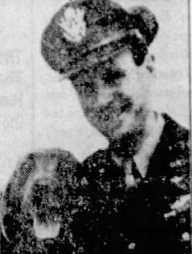
Nelson D. Jay and Kudoo of the WAGS

Later Life
Nelson died in 1993 while sailing around the world, fulfilling a lifelong dream. Mary NC Breese Jay died on August 21, 1999, in Santa Fe, at the age of 80.

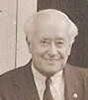
Breese, Robert Potter (1887–1958)

Parents: James Lawrence Breese (1851–1934) and Francis Tileston Potter (1858–1917).
Spouses: (1) Agnes Beatrice Claflin (1891–1967); (2) Ethel Johnson (1892–1947); (3) Agnes L. Packard, probably identical with Agnes Paszkiewicz (1905–2000).
Children: With Agnes Clafin: Beatrice Lawrence Breese (1916–2002).
Kinship: Sixth cousin three times removed of the post–World War II Smith generation.

Education and Early Career
Educated at Harvard, Robert Breese enjoyed the life of the jeunesse dorée. His specialty was “the negro group,” i.e., minstrel entertainment, and he worked on social and entertainment committees with J. Henry Alexandre. Before the First World War, he crossed the Atlantic to work for the Peugeot Frères Sigma Auto Company in France as an assistant engineer (1909–1911).

The Breese Automobile
Sensing an opportunity in the growing automobile market, Breese set off on his own to produce a lightweight sporting roadster, intending to build cars in France for export to the United States. He built the 1911 Breese Paris Roadster, a teardrop roadster and a light speedster powered by four-cylinder Ballot and Fivet engines. Approximately sixty-five Breese roadsters were produced during 1911–1912, an only two known to survive today.

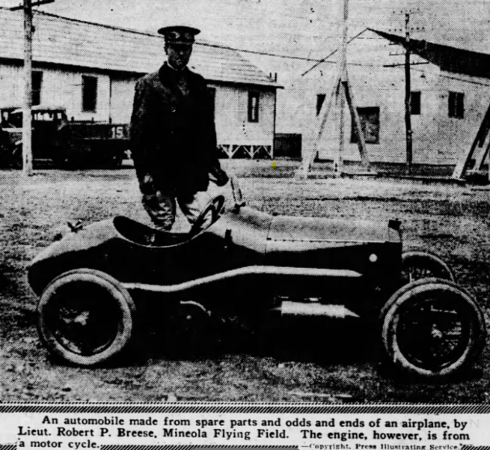
At the outbreak of war Breese joined the American Ambulance Corps, later transferring to the U.S. Aviation Service, where he attained the rank of lieutenant. Returning to New York in 1916, he became the Manhattan distributor for the Philadelphia-built Biddle automobile. His partner in Breese-Montant Motors was the French importer Louis Montant, and together they displayed custom-bodied Biddles at the 1917 New York Automobile Show.
That same year Breese announced his intention to manufacture the Breese Speedster (left), though production never materialized. Two years later he introduced another experimental automobile, a miniature racer powered by a 20-horsepower Harley-Davidson engine and built from surplus aircraft parts—a forerunner of the midget racers popular after the Second World War. When no investors were forthcoming, Breese turned to a steady engineering career with Bendix Aviation and later the General Bronze Corporation, holding several patents for power brakes and remote transmission controls.

Marriages and Personal Life
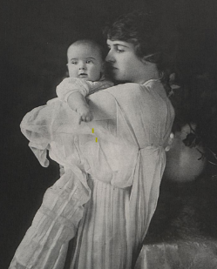
His first marriage, in 1915, was to Agnes Beatrice Claflin (1891–1967) (left). The ceremony took place in St. Andrew’s Dune Church, Southampton, at the same time that his sister was married in the library of their family home, The Orchards; the two couples shared a joint reception. Their only child, Beatrice Lawrence Breese, was born the following year.

The Breeses kept a winter home at Palm Beach, where their marriage ended in public scandal in 1928. Whenever one’s marital problems are given a full-page spread, one knows that divorce looms.

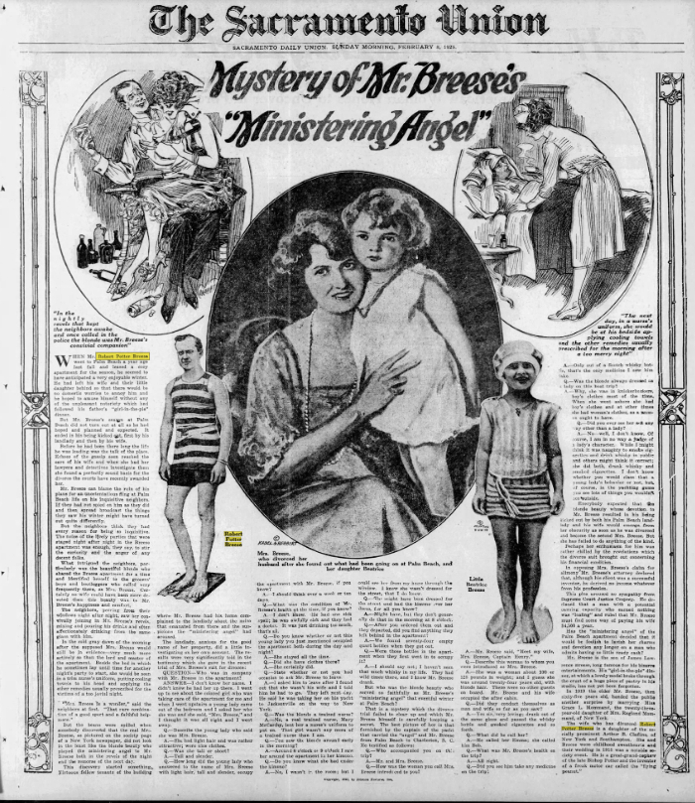

“Mystery of Mr. Breese’s ‘Ministering Angel’,” The Sacramento Union (Sacramento, Calif.), February 5, 1928. A full-page feature recounting the Palm Beach scandal that ended the marriage of Robert Potter Breese and Agnes Beatrice Claflin. The article described rumors of a “ministering angel,” a nurse or companion who attended Breese during an illness and was suspected of being more than a caregiver, prompting Mrs. Breese to leave Florida and file for divorce.
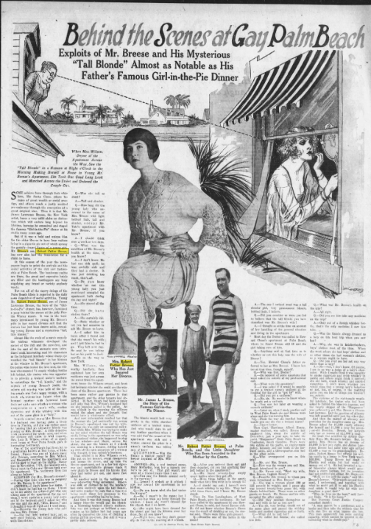
“Behind the Scenes at Gay Palm Beach: Exploits of Mr. Breese and His Mysterious ‘Tall Blonde’ Almost as Notable as His Father’s Famous Girl-in-the-Pie Dinner.” Syndicated feature article, early 1928. A companion piece to the earlier Sacramento Union story, it compared Robert Potter Breese’s Palm Beach scandal with the celebrated “Girl-in-the-Pie Dinner” once hosted by his father, James Lawrence Breese. The article portrayed Robert’s separation from his wife, Agnes Beatrice Claflin, and his association with a “tall blonde” as symbols of Palm Beach’s Jazz Age excess. Its illustrations—showing the mysterious woman, Breese and his daughter Beatrice in bathing suits, and a portrait of James L. Breese—made the family briefly notorious nationwide.
Agnes later married the Earl of Gosford, becoming Countess of Gosford. Breese subsequently married Ethel Johnson, the divorced wife of Dr. Eban Takashi Takamine (1893–1947), (son of the scientist Jokichi Takamine). In 1947, at the age of sixty-one, he married Agnes L. Packard (probably the same as Agnes Paszkiewicz).
Robert Breese Potter died in Freeport, Long Island, on September 12, 1958. He was 71 years old. He was interred in the family plot at Southampton Cemetery in New York, alongside his parents and siblings.
___________________________________________________
Breese, Sydney Salisbury I (1883–1974)
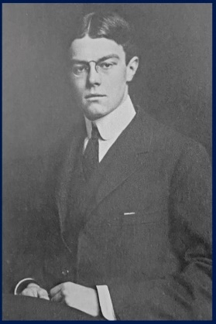

Parents: James Lawrence Breese (1851–1934) and Frances Tileston Potter (1858–1917).
Spouse: (1) Elizabeth Alexandra Morton (1883–1964); (2) Paula Augusta Matsner (1891–1977); (3) Barbara Patey Williams (1913–1997).
Children: With Paula Matsner: Sydney Salisbury Breese Jr. (1922–2006) and James Lawrence Breese (1923–2015).
Kinship: Sixth cousin three times removed of the post–World War II Smith generation.

Early Life and the BLM Company
Sydney Salisbury Breese, the eldest son of the flamboyant society photographer and inventor James Lawrence Breese, combined the family’s characteristic mechanical ingenuity with a more reserved, practical temperament.
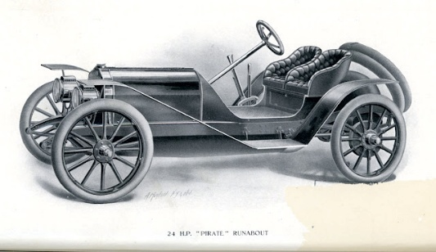
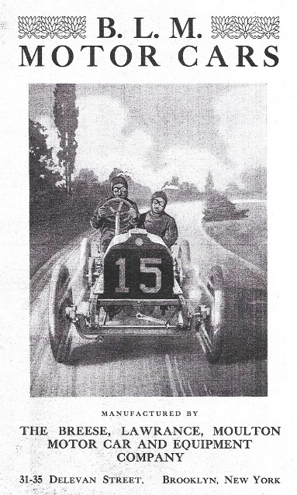
In 1906, together with his friends Charles Lanier Lawrance (of the French-descended Lawrence family) and Andrew Moulton, Sydney co-founded the BLM Company—their initials forming the name. The firm built small, high-performance automobiles, pioneering the use of the term “sports car.” Among their creations was the Pirate Runabout (below), assembled on the Lawrence estate for the youthful members of the Long Island “Pirate Club.”
Sydney’s sister, Frances Tileston “Tanty” Breese, an accomplished driver, was featured in an early advertisement for the Pirate, shown at the wheel with the family’s Southampton home, The Orchards, in the background. The BLM Company, though innovative, succumbed to the Financial Panic of 1907, which bankrupted many small ventures of the Gilded Age’s final decade.

Early Marriage and the War Years
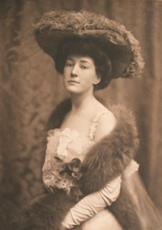
Sydney met Elizabeth Alexandra Morton (left) at dancing school—he was an accomplished clog dancer—and they married in 1907. Their union, though socially well-matched, ended in divorce in 1919. The press, always eager to find moral symbolism in the private lives of the well-born, suggested that Elizabeth preferred “a life of frivolous gaiety,” while Sydney, hardened by wartime service, had become more serious and introspective.

During World War I, Breese worked for the Naval Aviation Service in Washington in the Construction Division, and later in Nova Scotia, where he assisted Alexander Graham Bell with experimental work on hydroplanes. His technical innovations included a vector sight for aiming devices and a design for training torpedoes, both showing the mechanical creativity that ran in his family.

Marriage to Paula Matsner
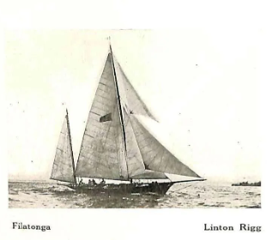
In 1921 Sydney married Paula Augusta Matsner, a Viennese-born classical dancer and humanitarian who had served as an ambulance driver for the Red Cross during the war. Their ceremony took place in the Ethical Culture Rooms in Manhattan, reflecting both partners’ humanist ideals. Paula had been educated at the Ethical Culture School and at Columbia University. After their marriage they spent the summer aboard Sydney’s yacht, the Filatonga, (right) cruising the Atlantic coast.

They had two sons: Sydney Salisbury Breese Jr. (1922–2006) and James Lawrence Breese (1923–2015).

Later Life and Legacy
After Paula’s death, Sydney married Barbara Patey Williams (1913–1997). He lived a long and varied life, bridging the worlds of early automotive experimentation, wartime aeronautics, and postwar technological development.

Sydney Salisbury Breese exemplified the inventive and exploratory spirit of the early twentieth century—an engineer, sailor, and sportsman whose quiet achievements balanced the flamboyance of his father’s generation.

Breese, Sydney Salisbury Jr. (1922–2006)

Parents: Sydney Salisbury Breese I (1883–1974) and Paula Augusta Matsner (1891–1977).
Spouse: Anna Elaine Higgins (1925–2015).
Children: Constance Breese (1957–), Jack Breese, and Peter Breese (1959–),
Kinship: Seventh cousin twice removed of the post–World War II Smith generation.

Education and Career
Sydney Salisbury Breese Jr. devoted his life to biomedical research and virology, contributing to the development of modern veterinary and comparative pathology. He worked at Walter Reed Research Hospital, a major center of medical research for the U.S. Army, where his early studies focused on viral pathology and electron microscopy.

He later joined the Plum Island Animal Disease Center, located off the eastern tip of Long Island, New York—an isolated government research facility dedicated to the study and control of highly infectious animal diseases. At Plum Island, Breese conducted pioneering research into viral morphology and transmission mechanisms in large mammals, particularly swine. His meticulous work under high-containment laboratory conditions contributed to understanding zoonotic and agricultural disease threats at a time when viral research was rapidly evolving.
Following his retirement from federal research service, Breese continued his scientific career at the University of Virginia Medical School, where he participated in studies on virus structure and replication, mentoring young researchers and publishing in the field of experimental pathology.

Research and Publications
Breese’s scientific output reflected his precision as a microscopist and his interest in the fundamental nature of viral processes. His published papers include:
- “Electron Microscope Observations of African Swine Fever”
- “Virus-Like Particles Occurring in Cultures of Stable Pig Kidney Cell Lines”
- “Basic Mechanisms in Animal Virus Biology”
These studies, published in leading virology and pathology journals, combined technical sophistication with biological insight and were part of the growing body of postwar research that clarified the mechanisms of viral infection at the cellular level.

Personal Life and Legacy
Sydney Jr. married Anna Elaine Higgins in 1950. The couple raised three children—Constance, Jack, and Peter—and shared a lifelong interest in science and education.
Remembered by colleagues as a quiet, methodical researcher and by family as a kind and thoughtful man, Sydney Salisbury Breese Jr. exemplified the Breese family’s tradition of scientific ingenuity, adapting the inventive spirit of his forebears to the exacting disciplines of modern medical research.

Breese, William Lawrence I (1853–1888)
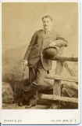

Parents: Josiah Salisbury Breese (1813–1865) and Augusta Eloise Lawrence (1828–1908).
Spouse: Marie Louise Parsons (1857–1948).
Children: William Lawrence Breese II (1882–1915).
Kinship: Fifth cousin four times removed of the post–World War II Smith generation.

Career and Family Connections
William Lawrence Breese I was part of the distinguished Breese–Lawrence lineage, descended through his grandmother, Catharine Livingston, from the prominent Livingston family of colonial and early national New York. Alongside his elder brother, James Lawrence Breese (1851–1934), he co-founded the New York stockbroking firm Breese & Smith, which prospered during the Gilded Age.

Like his brother, William moved in elite circles of New York society, where art, finance, and scandal frequently mingled. Both attended the notorious “Pie Girl Dinner” hosted by architect Stanford White, one of the most infamous society scandals of the 1890s (see entry for James Lawrence Breese).

He married Marie Louise Parsons (1857–1948), with whom he had one son, William Lawrence Breese II (1882–1915).

In the early 1880s he established a country place on Long Island. In 1883 he acquired the 290-acre Timber Point Farm on the west side of the Connetquot River at Great River, near Islip, a tract long associated with the Nicoll family. He developed Timber Point as a working estate and sporting retreat, part of the South Shore's emerging colony of country places. The property later became the nucleus of the Timber Point Country Club and, in time, county parkland, but it was Breese who first gave the site its name and early character as a gentleman's farm and riverside seat.

William died prematurely in 1888 at the age of thirty-five, leaving his wife a young widow. She later remarried Henry Vincent Higgins, the English impresario of Covent Garden, and moved with her son to England, where the younger William was educated.

Breese, William Lawrence II (1882–1915)
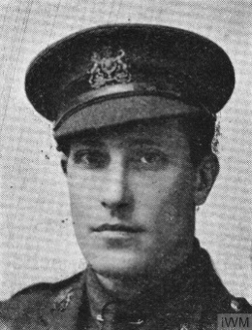

Parents: William Lawrence Breese (1853–1888) and Marie Louise Parsons (1857–1948).
Spouse: Julia Kean Fish (1884–1960).
Children: William Lawrence Breese III (1909–2000) and Hamilton Fish Breese (1910–1920).
Kinship: Sixth cousin three times removed of the post–World War II Smith generation.

Early Life and Education
Born in New York City on February 24, 1882, William Lawrence Breese II was raised partly in England after his widowed mother’s marriage to Henry Vincent Higgins, solicitor and Covent Garden manager. Educated at Bengo, Harrow, and briefly at Trinity College, Cambridge, William moved easily between Anglo-American society.0
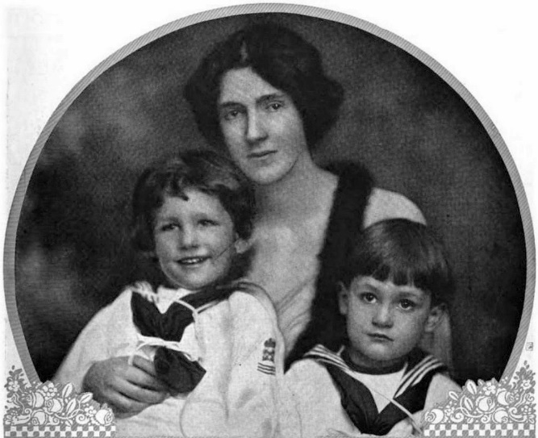
Julia Keen Fish
William II on left, Hnery on right

In 1909 he married Julia Kean Fish, daughter of Hamilton Fish Kean and granddaughter of Hamilton Fish (1808–1893), Governor of New York and U.S. Secretary of State under Ulysses S. Grant. The marriage allied the Breeses to one of the foremost families in American political history.

Diplomatic and Military Career
In 1913 William was appointed Secretary to the U.S. Ambassador to Great Britain, Walter Hines Page. When the United States passed the Neutrality Act, he resigned his post and in December 1914 took British citizenship in order to serve with the British Army—a symbolic and deeply personal act of loyalty to his adopted country during World War I.

Commissioned as Second Lieutenant, Royal Horse Guards (The Blues), he was soon attached to the Royal Engineers Experimental Section at St. Omer, France, assisting Lieutenant E. S. R. Adams in the development of the Stokes mortar, a new and vital weapon for trench warfare.

Death and Legacy
On March 14, 1915, during a weapons test at St. Omer, Breese was killed when a mortar exploded prematurely. At the court of inquiry, Adams attributed the accident to a defect in a component, though Breese was criticized for standing too close to the weapon despite prior warnings.

He was thirty-three years old. His widow, Julia, ordered his headstone to bear the inscription:
“He gave his life a ransom for many.”

His sacrifice was later commemorated by his mother and siblings in family memorials in both England and America.

Breese, William Lawrence III (1909–2000)
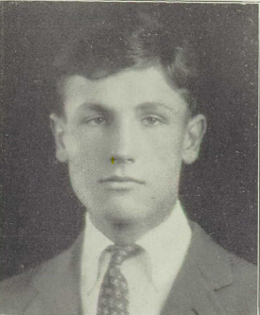

Parents: William Lawrence Breese II (1882–1915) and Julia Kean Fish (1884–1960).
Spouse: Nora Magee (1915–1980).
Children: Belinda Lawrence Breese (1941–), Peter Allan Breese (1946–), and Penelope Breese (1950–).
Kinship: Seventh cousin twice removed of the post–World War II Smith generation.

Early Life and Education
Born in France on the eve of World War I, William Lawrence Breese III spent his earliest years amid the turmoil of the European front. His father was killed in 1915 when he was a child, and his mother, Julia, volunteered with the French Ambulance Service, driving supply and medical vehicles along the war-torn roads of northern France.

After the war, William was educated in the United States, attending Harvard University, where he excelled in athletics and graduated in the 1930s.

Career and Public Service
A gifted tennis player, William won the Irish Tennis Championship and competed at Wimbledon, distinguishing himself among the best amateur players of his generation.

During World War II, he served in the Army Air Forces, with assignments in Brazil and Europe. After the war, he joined the U.S. State Department, working on UNESCO-relations staff and later assisting in postwar humanitarian efforts. He volunteered for Hungarian refugee resettlement in Vienna and Salzburg, applying his administrative skill and international experience to relief work.

In 1966 he founded the Longview Foundation for Education in World Affairs and International Understanding, based in Washington, D.C. As founder and chairman, he dedicated the foundation to advancing education about global interdependence and international relations for American students and teachers. The foundation remains active in educational initiatives today.

Legacy
William Lawrence Breese III’s life traced a full arc from the trauma of war to international reconciliation and cultural exchange. A Harvard scholar, athlete, and humanitarian, he exemplified the Breese family’s enduring commitment to innovation, service, and intellectual engagement across generations.
______________________________________________________________________________
Breeses, The
Location: 93 Tuxedo Road, Tuxedo Park, New York.
Built: 1887.
Architect: Robert Henderson Robertson.

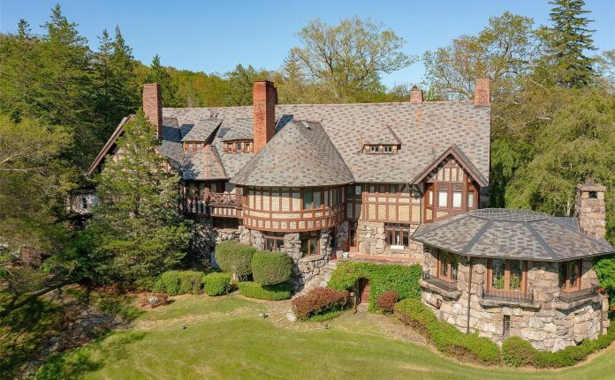
Architect
Robert Henderson Robertson (April 29, 1849 – June 3, 1919) was a prominent American architect based in New York City, celebrated for his versatile designs spanning Gilded Age residences, churches, institutional buildings, and pioneering early steel-frame skyscrapers. Born in Philadelphia to Scottish parents, he was educated partly in Scotland before graduating from Rutgers College in 1869. After early partnerships (including with William Appleton Potter), he established his own practice and became known for robust, often Romanesque-inspired brownstone work in the 1880s, as well as later contributions to tall commercial structures in Manhattan. Among his notable commissions was The Breezes (1887), the Tudor Revival mansion in Tuxedo Park for James Lawrence Breese, showcasing his skill in elegant country estates amid the era's elite enclaves.

Architectural Description
The Breezes is a large Tudor Revival mansion commanding one of the most dramatic sites in Tuxedo Park. The house features steeply pitched gables, varied rooflines, prominent chimneys, and richly textured exterior surfaces characteristic of the style. The building encompasses approximately 10,687 square feet and historically included nine bedrooms and numerous public rooms arranged to maximize views of Tuxedo Lake. The property boasts more than 600 feet of lake frontage, among the longest in the community. Interior features traditionally associated with the house include multiple fireplaces, elaborate period millwork, Tiffany windows, and crystal chandeliers, many of which have been carefully preserved or restored.

Interior Description
The interior of The Breezes is one of the most complete and evocative survivals of late nineteenth-century Gilded Age domestic architecture in Tuxedo Park. While the furnishings visible in the 2020 photographs are modern and not original to the house, the architectural fabric itself—plan, finishes, and decorative woodwork—remains largely intact and defines the character of the interiors.

The principal entrance opens into a large, double-height hall conceived as both a reception space and a social center. This hall is richly paneled in warm, dark-stained wood, with deeply molded panels, pilasters, and carved newel posts reflecting Robertson’s Tudor Revival vocabulary. Exposed structural beams cross the ceiling, emphasizing the horizontal articulation of the space and reinforcing its medieval English inspiration. Leaded and stained-glass windows admit filtered light, contributing color and pattern rather than panoramic views.
A broad, ceremonial staircase rises from the hall, its balustrade and stair posts elaborately carved with foliate and geometric motifs. The stair hall functions visually as a great hall in the English country-house tradition, signaling status and hospitality rather than mere circulation. Crystal chandeliers and wall sconces—some likely later replacements—hang from the beamed ceilings and illuminate the extensive woodwork.
Public rooms radiate from the central hall. The main living rooms are lined with full-height wood paneling and centered on large fireplaces with carved mantels, stone or tiled surrounds, and decorative overmantels. These fireplaces serve as architectural anchors, around which rooms are symmetrically composed. Ceilings vary by room, ranging from beamed and coffered to plaster with ornamental medallions, suggesting a deliberate hierarchy of spaces.
The dining room is among the most formal interiors, distinguished by a long axial arrangement, a monumental fireplace, and continuous wall paneling. Tall windows are dressed with elaborate surrounds, and the ceiling treatment reinforces the room’s ceremonial function within the house. Adjacent service and circulation spaces indicate the original separation between public display areas and domestic work areas typical of elite Gilded Age houses.
Several more intimate sitting rooms and libraries exhibit lighter finishes or painted paneling, particularly in upper or secondary spaces, softening the otherwise robust Tudor character. Upper-floor rooms retain decorative fireplaces, paneled walls, and carefully proportioned openings, indicating that architectural richness extended throughout the house rather than being confined to the principal floor.
Throughout the interior, the emphasis is on craftsmanship rather than ostentation: hand-carved woodwork, carefully proportioned rooms, and a coherent stylistic program. Although the movable contents have changed over time, the surviving architectural elements convey the original intent of The Breezes as a sophisticated country house—at once theatrical, masculine, and socially performative—designed to reflect both the personality of James Lawrence Breese and the elite, image-conscious culture of early Tuxedo Park.
History
The Breezes was constructed during the formative years of Tuxedo Park, the exclusive gated community founded in the 1880s by Pierre Lorillard as a rural retreat for New York’s social and financial elite. Houses in the enclave were commissioned from leading architects and reflected both wealth and social ambition. The Breezes stands among the earliest and most prominent of these Gilded Age country houses. Eloise Lawrence Breese also maintained a presence in Tuxedo Park, where she owned Nundao, a nearby cottage designed by McKim, Mead & White.
James Lawrence Breese was a civil engineer trained at Rensselaer Polytechnic Institute, a stockbroker who co-founded the firm of Breese & Smith, and a well-known social figure. He was also an amateur photographer and a close associate of architect Stanford White of McKim, Mead & White. Breese developed a reputation for flamboyant behavior and high-living antics that eventually clashed with the conservative social norms of Tuxedo Park society. By about 1900, he left the community and relocated to Southampton, Long Island, where he established The Orchard, a grand Colonial Revival summer estate designed and expanded by McKim, Mead & White.
After Breese’s departure, The Breezes passed through a succession of owners, including Charles Frederick Hoffman Jr. in the early twentieth century and, by about 1910, members of the Foster family. Unlike many large Gilded Age estates elsewhere, the house has remained standing and in use as a private residence. In recent years it has appeared periodically on the market, often described in listings as one of the architectural masterworks of Tuxedo Park, prized for its scale, craftsmanship, and unparalleled lakefront setting.

Brown Family
The Brown family of Baltimore, Maryland, forms the immediate ancestral background for Molly Pender Brown, Clifton Stevenson Brown Jr., and their brother Allen Tupper Brown. Their father, Clifton Stevenson Brown I (1880–1928), was a Baltimore attorney, a graduate of the University of Maryland, and president of the Whist Club. He was active in legal and civic circles and well known in Baltimore society. The family lived at 1015 North Calvert Street and spent summers at Fire Island, where the children learned to swim and sail.
Clifton Brown married Katherine Boyce Tupper (1882–1978), daughter of the Baptist minister and theologian Henry Allen Tupper Jr. and Marie Louise Pender. The marriage united a Maryland professional family with a Southern clerical and literary line. They had three children: Molly Pender Brown (1912–1997), Clifton Stevenson Brown Jr. (1914–1952), and Allen Tupper Brown (1916–1944).
In June 1928 Clifton Brown was shot and killed in his Baltimore office by a disgruntled client, Louis Berman, in one of the city’s most publicized tragedies of the period. His widow, left with three young children, moved north and continued to write and act professionally. Two years later, in 1930, she married Lt. Col. George C. Marshall, who later became U.S. Army Chief of Staff during World War II, Secretary of State, Secretary of Defense, and recipient of the Nobel Peace Prize.
The Brown children grew up within the Marshall household, combining the Southern and Baltimore traditions of their father’s family with the disciplined, civic-minded environment of their stepfather. Their early years reflect the social milieu of upper-middle-class Baltimore in the 1910s and 1920s, while their later lives trace the dispersal of that world into the broader national sphere shaped by war, public service, and postwar reconstruction.
Little is known about the earlier Maryland roots of Clifton Stevenson Brown I, though his parents were Sebastian Brown (1840–1909) and Susan Stevenson Clifton (1846–1897). The combination of the Stevenson and Clifton names suggests established Maryland and Virginia connections. The family’s standing, education, and urban residence indicate a professional class lineage well integrated into Baltimore society at the turn of the century.
_______________________________________________________________________
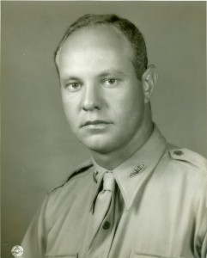
Brown, Allan Tupper (1916–1944)

\
Parents: Clifton Stevenson Brown (1880–1928) and Katherine Boyce Tupper (1882–1978).
Spouse: Margaret Goodman “Madge” Shedden (1916–2006).
Children: Allen Tupper Brown Jr. (1941–).
Kinship: Third cousin once removed of the post–World War II Smith generation.

Early Life
Allan Tupper Brown was born in Baltimore in 1916, the younger son of Clifton Stevenson Brown, a Maryland judge, and Katherine Boyce Tupper, who after her husband’s tragic murder in 1928 would later marry George C. Marshall, the future Chief of Staff of the U.S. Army and architect of the Marshall Plan.

When Allan was twelve, his father was killed by a disgruntled litigant. The loss marked the family deeply. In her memoir, Katherine recalled the first meeting between her sons and Colonel Marshall:

“The next summer I told my sons that I had asked Colonel Marshall to visit us at Fire Island as I wanted him to know them. Clifton said, ‘If it makes you happier, Mother, it is all right with me.’ But Allen, then twelve, said, ‘I don’t know about that—we are happy enough as we are.’ Early the next morning he came to my room. ‘It is all right, Mother, about your asking Colonel Marshall.’ That summer George told me that Allen had written him a most amusing letter: ‘I hope you will come to Fire Island. Don’t be nervous—it is OK with me. (Signed) A friend in need is a friend indeed. Allen Brown.’ And they were friends until the end.”

Education and Early Career
Allen attended Gilman School in Baltimore, then Woodberry Forest, and later the University of Virginia. After graduation he joined the promotion department of The New York Times in 1936. He married Margaret Goodman “Madge” Shedden, of Westchester County, New York, and they had one son, Allen Tupper Brown Jr. (born 1941). The family lived in a farmhouse near Poughkeepsie.

Military Service
In November 1942, Brown enlisted in the Armored Force of the U.S. Army and entered Officer Candidate School at Fort Knox, graduating as a Second Lieutenant in June 1943. Before shipping out for North Africa that August, he spent a final evening at the family home Dodona in Leesburg, Virginia, with his brothers Clifton and James Winn, both already in uniform. His mother later recalled a characteristic exchange:

“Jim, a Regular Army officer, and Clifton were a bit down in the mouth that Allen, the youngest and last in the service, was to be the first to get to the front. As we approached, Allen was saying, ‘Why shouldn’t I go over first? I’m a tanker, and the tanks lead the fight.’ Clifton broke in with, ‘Where would the tanks be without the Antiaircraft?’ and Jim came back, ‘Who clears the way for the tankers?—the Field Artillery.’”

That night, Katherine provided a farewell dinner of Allen’s favorite dishes. In a small ceremony afterward, he nailed a horseshoe above the garage door for good luck—at first upside down, until protests from the family led him to reverse it “so the luck would not run out.”

Italy and Anzio
Second Lieutenant Brown served with distinction in the 1st Armored Division, taking part in the Italian campaign. General Marshall, though deeply reluctant to use his position for personal influence, agreed to Allen’s request for combat assignment. “I feel quite differently about intervening when it is a move to the front rather than the opposite,” he wrote—allowing his stepson to go into action.

Allen fought at Monte Cassino and later commanded a Sherman tank platoon at the Anzio beachhead, one of the war’s most perilous fronts. From Italy he wrote home cheerfully: “I feel sorry for any German in Italy. The horseshoe has held my luck. I shall take it down this Christmas and keep it for the rest of my life.”

Death in Action
On May 29, 1944, near Campoleone, while leading his platoon in an assault west of Velletri, Allen stood up in his turret to survey the terrain with his field glasses and was killed instantly by a sniper’s bullet—some reports say by a grenade. He was twenty-eight years old.

His brother Clifton Brown, also serving in Italy, arrived at the scene only hours later. He collected Allen’s effects and attended the field funeral on Decoration Day, gathering wildflowers to place on the grave “for Madge and Mother.”

Here is the last letter that his mother wrote to Allen. It is marked “return to sender.”
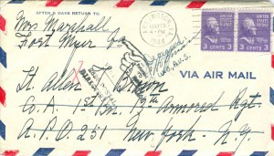

Aftermath and Remembrance
When news reached Washington, General Marshall went home from his office to tell Katherine in person. Hundreds of condolence letters arrived; he answered them all himself, sparing her the task. One note that comforted her read:

“Your son will always be young and unafraid; he will never have to grow old, he will never know such grief as yours.”

In June 1944, while in Italy, General Marshall visited Allen’s grave at the Anzio Military Cemetery and later returned there with Katherine during his 1948 visit to Rome and audience with Pope Pius XII.

Allen’s mother found among his old belongings a black Woodberry Forest sweater and a box of childhood medals, including a small gold football inscribed with his name. These mementos remained her most cherished possessions.

Reflections and Legacy
In July 1937, seven years before his death, the twenty-one-year-old Allen had written a letter to The New York Times:

“When a man becomes of importance to the world, is it necessary for him to forget the common decencies of life? Should a man become so great that, encountering opposition to a cause that is of greatest interest, his feelings should be so contorted as to let him dwarf the death of a friend and supporter beside an issue of political importance? Should any man become so great that into his personality creeps a stubbornness and a touch of ego that unbends to nothing—not even to death? How great is a great man?”

His words foreshadow the integrity and moral clarity with which he lived and died.

Allen’s wife Madge endured a double wartime loss—her own brother, Lt. Robert L. Shedden, was killed on a bombing mission over Europe in 1943. She later married John White Pendleton (1908–1971), a VMI graduate and Rhodes Scholar.

Allan Tupper Brown rests in the Sicily–Rome American Cemetery at Anzio, remembered by his family and country as a brave, idealistic young officer who died leading his men in battle.

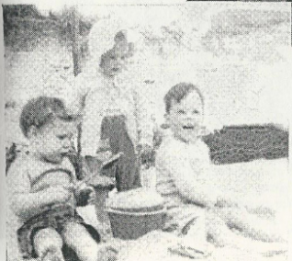
Brown, Allen Tupper Jr. (1941– )

Tupper Jr. on left, with his cousins Kitty and Jimmy Winn

Parents: Allen Tupper Brown (1916–1944) and Margaret Goodman Shedden (1916–2006).
Spouse: Sandra Mary Slattery (1942– ).
Children: Allen Brown, Elizabeth Brown, John Michael Brown, and Margery Brown.
Kinship: Fourth cousin of the post–World War II Smith generation.

Early Life and Education
Allen Tupper Brown Jr., known as Tupper, was the only son of World War II officer Allen Tupper Brown and his wife Madge Shedden Brown Pendleton. He grew up with a strong sense of family history—his father’s wartime death and his step-grandfather General George C. Marshall’s prominence as Chief of Staff and Secretary of State were ever-present influences.
He attended the Lawrenceville School, Yale University, and Yale Law School, following the family tradition of professional distinction and public service.

Career and Later Life
Tupper Jr. pursued a legal career and established his residence in Greenfield, Massachusetts, where he has long been active in civic and community affairs.

A surviving photograph shows Tupper Jr. on the left with his cousins Kitty and Jimmy Winn, reflecting the close bonds among the extended Marshall, Brown, and Winn families.
____________________________________________________________________________
Brown, Clifton Stevenson I (1880–1928)
Parents: Sebastian Brown (1840–1909) and Susan Stevenson Clifton (1846–1897).
Spouse: Katherine Boyce Tupper (1882–1978).
Children: Molly Pender Brown (1912–1997), Clifton Stevenson Brown Jr. (1914–1952), and Allen Tupper Brown (1916–1944).
Kinship: Husband of the second cousin twice removed of the post–World War II Smith generation.

Career and Family Life
Clifton Stevenson Brown was a well-known Baltimore attorney, distinguished both for his professional skill and his genial social presence. He was an accomplished tennis player and served as president of the Whist Club, one of Baltimore’s leading social institutions. After his marriage to Katherine Tupper in New York, the couple settled at 1015 North Calvert Street. Katherine, who had some independent means, later purchased a summer cottage on Fire Island, where the family spent many happy seasons.

Murder and Trial
On June 4, 1928, tragedy struck. That afternoon, Katherine telephoned her husband’s office to say that the final papers for the Fire Island property had arrived, but there was no answer. At that very hour, Clifton was shot and killed in his office by a disgruntled client, Louis Berman, in one of Baltimore’s most sensational crimes.

Brown had represented Berman in settling a $300,000 estate, from which Berman received $36,000. Brown’s legal fee was $2,500, but when Berman refused to pay and Brown sued, Berman became obsessed and violent. He waited for Brown at his office in the Calvert Building, shot him twice, pursued him down the corridor, and fired three more times. Brown was taken to Mercy Hospital, where he died within minutes.

Berman was tried in September 1928. His attorney sought an insanity defense, producing medical “alienists” to testify, but even they agreed that Berman was sane. The jury convicted him of first-degree murder and sentenced him to life in prison.

Aftermath and Legacy
Berman then began an extraordinary series of habeas corpus petitions, filing one each time a new judge was appointed. Over the years, he filed more than one hundred such petitions, each time arguing that his psychiatric examination had been inadequate. His persistence so clogged the courts that the Maryland legislature eventually enacted a law forbidding repetition of claims once adjudicated—a legal reform directly inspired by the case.

The murder left Katherine a widow at forty-six with three young children—thirteen, eleven, and nine. The shock of the event shaped the rest of her life. Three years later, while visiting Fort Benning, she met Colonel George C. Marshall, whom she married in 1930. Through that marriage, the Brown children entered the Marshall household, and the youngest, Allen Tupper Brown, would later die heroically in World War II.

Clifton Stevenson Brown was remembered as a man of promise, charm, and integrity whose life was cut short by senseless violence. His example endured in the courage and character of his wife and children.
___________________________________________________________________________
Brown, Clifton Stevenson I (1880–1928)
Parents: Sebastian Brown (1840–1909) and Susan Stevenson Clifton (1846–1897).
Spouse: Katherine Boyce Tupper (1882–1978).
Children: Molly Pender Brown (1912–1997), Clifton Stevenson Brown Jr. (1914–1952), and Allen Tupper Brown (1916–1944).
Kinship: Husband of the second cousin twice removed of the post–World War II Smith generation.

Career and Residence
Clifton Brown was a Baltimore attorney, a champion tennis player, and president of the Whist Club. After his marriage in New York he returned to Baltimore and lived at 1015 North Calvert Street. His wife Katherine had some independent means and purchased a summer cottage on Fire Island, where the family spent their holidays.
Murder and Aftermath
On June 4, 1928, Katherine called her husband’s office to tell him that the final papers for the Fire Island cottage had arrived, but there was no answer. That same afternoon Clifton Brown was shot and fatally wounded in his office in the Calvert Building by a disgruntled client, Louis Berman.
Brown had represented Berman in the settlement of the $300,000 estate of his father, Philip Berman, for which Louis had received $36,000. Brown’s fee for the work was $2,500; when Berman refused to pay, Brown sued him. Berman lay in wait for Brown on the seventh floor of the Calvert Building, shot him twice, and then pursued him down the corridor, firing three more times. Brown was taken to Mercy Hospital, where he died within minutes. Katherine was left a widow with three children, aged thirteen, eleven, and nine.
Trial of Louis Berman
Berman was indicted and tried in September 1928. His attorney sought to establish an insanity defense and had several “alienists” examine him, but even the defense’s experts testified that Berman was sane and knew right from wrong. The lawyer then attempted to discredit his own witnesses. The jury found Berman guilty of first-degree murder, and he was sentenced to life in prison.
During his imprisonment, Berman repeatedly filed writs of habeas corpus—reportedly over a hundred—claiming that his hour-and-a-half psychiatric evaluation had been inadequate. Each time a new judge took office in Maryland, Berman filed again and instructed other inmates how to do likewise, requiring the state to transport him to hearings throughout Maryland. Eventually, the legislature passed a law stipulating that once a judge had ruled on a point, it could not be raised again, effectively ending Berman’s legal campaign.
Context
The murder of Clifton Stevenson Brown brought an abrupt and tragic end to one of Baltimore’s most promising legal careers and left a deep mark on the family’s history. His widow, Katherine, soon left Baltimore to rebuild her life with her three young children. Her meeting and later marriage to General George C. Marshall in 1930 profoundly changed the family’s trajectory, connecting the Browns and Tuppers with one of the leading figures of the mid-twentieth century. The memory of Clifton’s death, and the resilience with which Katherine faced it, remained a defining element in the family’s story for generations.
___________________________________________________________________________
Brown, Clifton Stevenson Jr. (1914–1952)
Parents: Clifton Stevenson Brown I (1880–1928) and Katherine Boyce Tupper (1882–1978).
Spouse: M. Bowles Locker (1916–2015) in 1945.
Children: Carter Boardman Brown (1949–), who also used the name of her stepfather, Alsop.
Kinship: The third cousin once removed of the post–World War II Smith generation.
Clifton attended Gilman School in Baltimore and Woodberry Forest School in Virginia. He made the newspapers at an early age: in August 1922, “Sunnyboy,” as the seven-year-old Clifton was then known, was put in charge of two three-year-olds, Jimmy Aldrich and Caroline Tarbell Tupper. Jimmy, the nephew of Ida M. Tarbell, and the others were staying at Tarbell’s country house near the Housatonic. While throwing rocks into the river from a bridge, Jimmy lost his balance and fell in, striking his head and becoming trapped among sticks and weeds. Clifton dove in, pulled him out, and administered artificial respiration. He had learned to swim at Fire Island, where his parents maintained a summer house.
Before World War II Clifton worked in banking and advertising in Washington, D.C. During the war he served as a lieutenant colonel in antiaircraft artillery, seeing action in Africa, Sicily, Italy, France, and Germany. After the war he joined the Louis Marx Company, a toy manufacturer, and later worked for IBM.
He died in 1952 following a lung operation at Walter Reed Hospital.

Brown, Molly Pender (1912–1997)
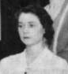

Parents: Clifton Stevenson Brown I (1880–1928) and Katherine Boyce Tupper (1882–1978).
Spouse: James Julius Winn (1907–1990).
Children: James Julius Winn (1941–), Katherine Winn (1944–), and Ellene Westmoreland Winn (1948–).
Kinship: The third cousin once removed of the post–World War II Smith generation.

Education and Early Life
Molly attended Bryn Mawr in Baltimore and later studied in Florence. She made her social debut at Fort Benning. Her godmother was Mrs. William Randolph Blanchard, in whose home Molly’s mother, Katherine Tupper Brown, met George C. Marshall at a dinner party that would profoundly shape their family’s history. In 1930, while Molly was still at school in Florence, her mother married Lt. Col. Marshall.
Marriage and Family Life
In 1940 Molly married Captain James Julius Winn. Her mother, Katherine Marshall, described the event vividly:
“Molly’s wedding on Christmas Day in Quarters Number One at Fort Myer was the first wedding, I believe, ever to take place in that house. She came down the stairway on George’s arm, followed by her maid of honor, Mary Winn. They passed through the drawing-room and were met by Captain Winn and his groomsmen at the altar which had been constructed at the far end of the oval dining room. The bride’s path was flanked on each side by white chrysanthemums and tall standards holding white candles. Her gown was of cream satin with an extremely long train, and her cap and veil were of Rosepoint lace. She kept her eyes steadily on Captain Winn and his were on her. She said afterwards that this was pre-arranged to keep her from trembling. After the ceremony they walked out beneath the crossed swords of the groomsmen, while the orchestra played Lohengrin’s Wedding March. As soon as the reception was over, they left for Panama and I did not see Molly again until she came home a year and a half later with her baby son.”
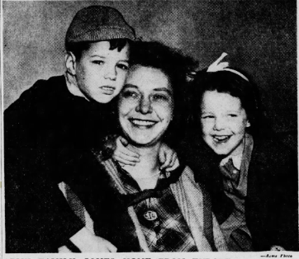
James, Molly, and Ellene
World War II and Later Years
In May 1944, while stationed with her husband at Fort Rucker, Alabama, Molly learned that her brother, Allen Tupper Brown, had been killed in action. After the war, the Winn family returned from Europe in 1949 and settled in Leesburg, Virginia.
Publications and Civic Involvement
In 1976 Mrs. Winn edited and published the World War I Diaries of General George C. Marshall under the title Memoirs of My Service in the World War, 1917–1918. She was a member of the Colonial Dames of New York, the Leesburg Garden Club, and the Episcopal Church of Our Savior in Oatlands.

The Burling Family
The Burling family was among the earliest and most influential Quaker families in colonial New York, their story illustrating the transformation of the Society of Friends from a persecuted sect of English dissenters to a community that shaped the moral and commercial foundations of early America. The family’s origins lie in Barking, Essex, from which Edward Burling (1639–1697) and his wife Grace Norington (c.1651–1715) emigrated around 1680 to Flushing, Long Island. There they joined the newly established Flushing Meeting, a gathering noted for its defense of religious liberty and its role in the famous Flushing Remonstrance of 1657, one of the earliest declarations of freedom of conscience in the colonies.
From the beginning, the Burlings embodied the Quaker virtues of integrity, diligence, and quiet enterprise. Edward’s sons Edward (1674–1749) and William (1678–1743) represented two sides of the Quaker experience: one practical and mercantile, the other spiritual and reforming. Edward became one of New York’s early merchant shipowners, developing what became Burling Slip near present-day South Street Seaport and linking the family’s name permanently to the city’s maritime commerce. His brother William, meanwhile, emerged as a pioneering Quaker minister and early opponent of slavery, denouncing the practice decades before John Woolman and Anthony Benezet and calling Friends to live consistently with their testimony of equality.
By the mid-eighteenth century, the Burlings were firmly established in both Flushing and New York City, maintaining their Quaker identity while participating in the growing civic and economic life of the province. Their marriages connected them to other prominent Quaker families—the Lawrences, Titus, Rodmans, Embree, and Townsend families—creating an extended network of kinship that united Long Island, Westchester, and Manhattan.
The next generation, represented by Ebenezer Burling (1717–1758) and his son Thomas Burling (1746–1831), carried the family into the world of industry and craft. Ebenezer, a miller and landowner in Eastchester, combined Quaker simplicity with entrepreneurial skill, while his son Thomas rose to national prominence as one of early America’s finest cabinetmakers. Thomas Burling’s craftsmanship adorned the first presidential mansion in New York and furnished the homes of George Washington and Thomas Jefferson, linking Quaker artisanship to the civic ideals of the new Republic.
Across generations, the Burlings’ story traces the evolution of American Quakerism—from humble English immigrants to influential participants in the religious, economic, and artistic life of the colonies and early nation. Their legacy endures in the surviving records of the Flushing and New York Meetings, in the continuing presence of Burling Slip on Manhattan’s map, and in the moral and artistic contributions their family made to the formation of American society.
For information on the Burling family, see Jane Thompson-Stahr’s The Burling Books: Ancestors and Descendants of Edward and Grace Burling, Quakers, 2 Vol. (Gateway Books, Inc.: Baltimore. Maryland, 2001).
_____________________________________________________________________________
Burling, Ebenezer (1717–1758)
Parents: William Burling (1678–1743) and Rebecca Slocum (1682–1729)
Spouse: Mary Lawrence (1718–1776)
Children: Rebecca Burling (1737–1743), Hannah Burling (1739– ), Ebenezer Slocum Burling (1741– ), Rebecca Burling (1743– ), Thomas Burling (1746–1831), Grace Burling (1749– ), Lydia Burling (1749 [twin]– ), Mary Burling (1752– ), and Sarah Burling (1755– ).
Kinship: Husband of the fifth great-grandaunt of the post–World War II Smith generation.
Early Life and Marriage
Ebenezer Burling was born in 1717, the son of William Burling, a Quaker minister of Flushing, Long Island, and Rebecca Slocum, who came from another well-known Quaker family. The Burlings were part of the network of English and Dutch Quaker settlers who shaped early colonial Queens County, noted for their integrity, literacy, and skill in trade. The union of the Burling and Lawrence families began with the marriage of Ebenezer and Mary. Two of the siblings of Mary Lawrence, Ebenezer’s wife, also married Burlings. In 1754 Caleb Lawrence (1723–1799) married Sarah Burling (1729-1809), Ebenezer’s first cousin. John Lawrence (1731–1794) married Ann Burling (1735-1821), also a first cousin of Ebenezer.
In 1736, at age twenty, Ebenezer married Mary Lawrence (1718–1776) of the prominent Lawrence family of Flushing. Both were members of the Society of Friends. Their courtship, however, attracted the attention of their meeting. The records of the Flushing Monthly Meeting for 1737 record the following admonition:
“At a Monthly Meeting at ye Meeting house in fflushing ye 6th day of ye 8th month 1737…a paper subscribed by Ebenezer Burling & his wife Signifying their sorrow for & condemnation of their having been too fflamiliar with each other before marryage being read is ordered to be read publicly next first day after Meeting.”
This public repentance for “undue familiarity before marriage” was a standard form of Quaker discipline at the time and reflected the Society’s insistence on moral accountability. Despite the episode, Ebenezer and Mary remained respected members of their meeting, and their long marriage was marked by prosperity and numerous children.
Career and Property
Ebenezer Burling established himself as a miller and landowner in Eastchester, then part of Westchester County, New York. He purchased a grist mill and adjoining acreage, integrating agricultural and commercial activity typical of Quaker entrepreneurs of the Hudson Valley. His business was evidently successful, and he became part of the growing network of Friends who combined conscientious religious life with practical enterprise.
The family’s Quaker faith shaped their daily conduct: the Burlings avoided oaths, military service, and extravagance, and they maintained close ties with the Friends’ meetings of Flushing, Purchase, and Westbury. Ebenezer’s name appears in the Records of the Westchester Monthly Meeting as a contributor to relief funds and as an overseer of property disputes.
Death and Descendants
Ebenezer Burling died in 1758 at the age of forty-one, leaving his widow Mary Lawrence Burling with several young children. Their son Thomas Burling (1746–1831) became a cabinetmaker and craftsman in New York City, continuing the family’s reputation for industriousness and integrity. Through the marriages of the Burling daughters into the Lawrence and Rodman families, the Burlings were connected to a wide Quaker kinship circle extending from Flushing to Philadelphia. Two of the siblings of Mary Lawrence, Ebenezer’s wife, also married Burlington. In 1754 Caleb Lawrence married Sarah Buring, Ebenezer’s first cousin. John Lawrence married Ann Burling, also a first cousin of Ebenezer.
Legacy
Ebenezer Burling’s life reflects the disciplined but humane spirit of colonial Quaker society. His family’s records—preserved in the minutes of the Flushing Meeting—illustrate the communal and moral standards that governed early Friends’ conduct, and his establishment in Eastchester shows the migration of Long Island Quakers northward in search of land and opportunity.

Burling, Edward (1674–1749)
Parents: Edward Burling (1639–1697) and Grace Norington (c.1651–1715)
Spouse: Abigail Titus (1678–1733)
Children: Samuel Burling (1700–1760), Edward Burling Jr. (1703–1770), Mary Burling (1705– ), Sarah Burling (1708– ), and others
Kinship: Seventh great-grandfather of the post–World War II Smith generation
Early Life and Family
Edward Burling was born in Barking, Essex, in 1674, the eldest surviving son of Edward Burling (1639–1697), a wheelwright and tradesman, and his wife Grace Norington. Around 1680 his parents emigrated to the Colony of New York, joining the early Flushing Meeting of the Society of Friends (Quakers). Like his younger brother William Burling (1678–1743), Edward was raised in a community that prized religious liberty, simplicity, and industriousness.
In the 1690s Edward established himself as a merchant and shipowner in New York City, then a small but rapidly expanding port. He married Abigail Titus, daughter of Quaker settlers from Westbury, Long Island, linking two prominent Long Island Quaker families.
Merchant and Early New York Development
By 1702 Edward Burling had joined the New York Monthly Meeting and was listed among its “men Friends of note.” His commercial activity centered on the growing Atlantic trade between New York, the West Indies, and England. He was one of the first Quakers in the city to transition from artisan to merchant, helping to shape the commercial and civic life of early eighteenth-century Manhattan.
Burling’s name became permanently associated with Burling Slip, a wharf he helped develop near what is now John Street, at the eastern edge of lower Manhattan. In 1733 he purchased adjoining lots for warehouses and wharfage, and by mid-century the area was known as Burling Slip or Burling’s Wharf, an important docking point for sloops and coastal traders. The slip gave rise to Burling Street (later Burling Slip), still identifiable near present-day South Street Seaport.
Although the Burlings were Friends by origin, Edward’s mercantile success gradually integrated him into the civic life of the Anglican establishment. He served as assessor for the East Ward, was a freeman of the City of New York, and contributed to civic improvement projects such as street paving and fire prevention.
Religious and Community Activity
Edward maintained ties with the Quaker community throughout his life, donating to the upkeep of the New York Meeting House on Little Green Street (later Pearl Street) and subscribing to the New York Monthly Meeting School, which evolved into Friends Seminary. He also gave financial support to the poor and to visiting ministers of the Society of Friends.
Family and Descendants
Edward and Abigail’s descendants continued the family’s dual identity as Friends and civic leaders. Their son Samuel Burling (1700–1760) developed the family’s East River wharf property and became one of New York’s leading ship-chandlers and importers. Another son, Edward Jr. (1703–1770), served as vestryman of Trinity Church and was among the first generation of Quakers to join the Anglican communion. Through their descendants, the Burlings became connected to the Lawrence, Embree, and Townsend families of Flushing and to the Parsons family of Queens County.
Death and Legacy
Edward Burling died in 1749, having witnessed New York’s emergence as one of the principal ports of the Atlantic world. The Burling Slip and Burling Street retained his name for more than two centuries, a testament to the family’s early role in the city’s maritime economy.
His career exemplifies the transformation of the colonial Quaker community from agrarian simplicity to urban commercial prominence, a transition that shaped the development of both New York’s economy and its culture of religious tolerance.

Burling, Thomas (1746–1831)
Parents: Ebenezer Burling (1717–1758) and Mary Lawrence (1718–1776)
Spouse: Susanna Carter (m. 1767)
Children: Ebenezer Burling (1768-1831), Samuel Burling (1770-1843), (1772-1811), Lydia Burling (1775-1844), Anne Burling (1776-1874), William Slocum Burling (1777-1863), Elizabeth Burling Susan Burling (1781-1829), Maria Burling (1789-1781), Thomas Burling (1795-1810)
Kinship: First cousin six times removed of the post–World War II Smith generation
Early Life and Apprenticeship
Thomas Burling was born in 1746, the son of Ebenezer Burling and Mary Lawrence, members of the Society of Friends. The Burlings were part of a closely knit Quaker community in Flushing and New York that included craftsmen, merchants, and clockmakers. Thomas was the first cousin of the noted Quaker clockmaker Effingham Embree, and the two may have collaborated, with Thomas crafting the fine mahogany cases for Embree’s longcase clocks.
Burling trained as a cabinetmaker under Samuel Prince, a leading New York artisan whose workshop produced some of the city’s finest furniture in the English taste. Under Prince’s influence, Burling acquired the technical and aesthetic skill that would soon make him one of the foremost cabinetmakers in the early United States.
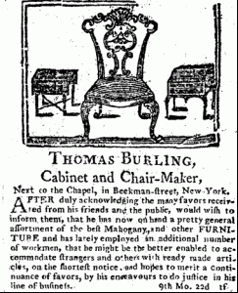
Cabinetmaker to the New Republic
By the 1780s Burling had established his own shop on Beekman Street in lower Manhattan, where he produced high-quality mahogany furniture for New York’s mercantile elite. His reputation for craftsmanship and design brought him to national attention in 1789 when Congress leased the Samuel Osgood house at 3 Cherry Street to serve as the first presidential residence.
The furnishings for the residence were purchased locally, and Burling’s workshop supplied much of the mahogany furniture. According to the records of the U.S. Treasury and later summarized by the Mount Vernon Ladies’ Association, “With the exception of the upholsterer’s charges, the greatest sum for furnishings was paid to Thomas Burling for ‘mahogany furniture,’ which contributed to what Martha Washington called a ‘handsomely furnished house.’” In all, Congress spent approximately $8,000 preparing the house for the Washingtons—an enormous sum for the time, and a testament to Burling’s reputation.

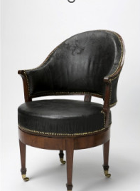
The “Uncommon Chair” for George Washington
Among Burling’s most celebrated creations was the so-called “Uncommon Chair,” commissioned by George Washington in 1790. On April 17 of that year, Washington paid Burling £7 for a uniquely engineered armchair combining the curved, upholstered design of a French bergère en gondole with an innovative swivel seat mounted on four bone rollers.
Washington valued the chair’s comfort and practicality, using it throughout his presidency and later in his study at Mount Vernon. The chair remains in the Mount Vernon collection, where it is regarded as one of the earliest examples of American ergonomic furniture.
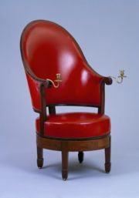
Jefferson’s Commissions
In the same year, Thomas Jefferson, then Secretary of State, also ordered furniture from Burling while living in New York. Jefferson’s Memorandum Book records two payments totaling £143 to Burling in July and August 1790, apparently for a sofa and a revolving chair similar to Washington’s. Jefferson’s version, now at Monticello, provoked Federalist satire: Representative William Loughton Smith derided Jefferson’s “wonderful Whirligig Chair, which had the miraculous quality of allowing the person seated in it to turn his head without moving his tail.”
These commissions linked Burling to two of the most influential founders of the United States and placed his work at the heart of early American design.
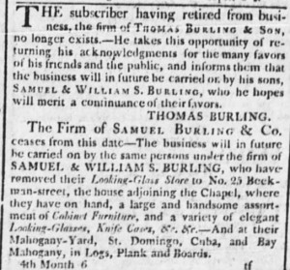
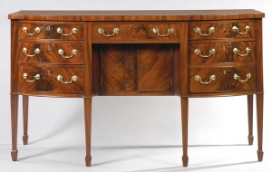
Later Career and Retirement
Burling’s furniture continued to be sought after by New York’s wealthy families during the Federal period. His style reflected the transition from late Chippendale to early Federal neoclassicism, characterized by fine veneers, delicate proportions, and restrained ornament. His mahogany chairs, sideboards, and cabinets were known for precise joinery and elegant symmetry.
In April 1802, after more than three decades in business, Thomas Burling retired and turned his shop over to his sons Samuel and William Burling, who continued the family’s furniture-making tradition into the early nineteenth century.
Death and Legacy
Thomas Burling died in 1831. His surviving furniture—particularly the Washington and Jefferson chairs—represents the intersection of craftsmanship, innovation, and the civic aspirations of the early Republic. His name endures among collectors and historians as one of the premier artisans of the Federal era.
______________________________________________________________________________
Burling, William (1678–1743)
Parents: Edward Burling (1639–1697) and Grace Norington (c.1651–1715).
Spouse: (1) Rebecca Slocum (1682–1729), (2) Amy Doughty (1695-1747).
Children: Mary Burling (1706–1727), Benjamin Burling (1708–1745), William Burling Jr. (1708–1745), Rebecca Burling 1711–1736), Hannah Burling (1713–1777), Sarah Burling (1715–1762), Ebenezer Burling (1717–1758), Amy Burling (1724-1741).
Kinship: Seventh great-granduncle of the post–World War II Smith generation, who are descended from his brother Edward Burling (1674–1749).
Early Life and Family
William Burling was born in 1678 in Barking, Essex, into a family of English Quakers who endured periods of persecution for their nonconformity. His father, Edward Burling, was a wheelwright and tradesman who, with his wife Grace Norington, emigrated to the Colony of New York around 1680. The Burlings settled in Flushing, Long Island, a community notable for its religious diversity and its early defense of liberty of conscience, as expressed in the 1657 Flushing Remonstrance.
William grew up within this climate of principled dissent. The family joined the Flushing Meeting of the Society of Friends, one of the oldest Quaker congregations in North America, established in 1672. Like many Friends of the period, the Burlings pursued modest trades and lived by the values of simplicity, equality, and peace.
Ministry and Witness against Slavery
William Burling became a minister among Friends and was one of the first American Quakers known to have spoken publicly and persistently against slavery. His moral awakening occurred early: as he later wrote, “the Lord by his Spirit manifested the evil to me before I was twelve years of age.”
At a time when many prominent Friends in New York and Pennsylvania still held enslaved Africans, Burling’s protests were remarkable for both their clarity and courage. As early as 1718, he circulated a tract entitled An Address to the Elders of the Church, in which he challenged his fellow Quakers to examine the inconsistency between their profession of spiritual equality and their ownership of human beings.
He wrote:
“A weighty concern from the Lord is and hath been at times for many years on my spirit, in consideration of this un-Christian liberty being indulged in the church—for it is in itself none of the least of the world’s corruptions... The Lord by his Spirit manifested the evil to me before I was twelve years of age, and since from time to time I have had drawings in mind to reprove and testify against it. Nor have I been altogether silent, although much discouraged by reason of its being practiced by so many Friends—yea, elders too.”
He acknowledged that formal condemnation of slavery within the Society would be slow and difficult, but he urged his readers to persist “that the judgment of Truth may be brought forth into victory.”
Influence and Legacy
William Burling’s testimony predates the more widely known anti-slavery writings of John Woolman and Anthony Benezet by several decades. His Address circulated in manuscript form among New York and Pennsylvania Friends, helping to prepare the ground for later corporate actions by the Society of Friends against slavery.
The Flushing Meeting records note his consistent “tenderness and uprightness,” and later Quaker historians recognized him as one of the earliest voices to denounce the moral evil of human bondage within the American colonies. By the mid-eighteenth century, the Yearly Meetings of Philadelphia and New York would take formal stands against slaveholding, developments that owed much to Burling’s early prophetic witness.
He remained active in the Flushing Meeting until his death in 1743.
Historical Setting
The Flushing Meeting House, built in 1694 and still standing, was the spiritual center of Burling’s life. Its members were a diverse group of English, Dutch, and West Indian settlers united by the Quaker vision of the Inner Light. The meeting’s early tolerance extended to its protection of Jews, Anabaptists, and dissenters of all kinds—a radical position in colonial America. Burling’s voice emerged from this environment of conscience, compassion, and principled resistance to worldly injustice.

Burling, William Slocum (1777–1863)
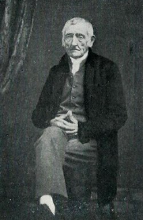
Parents: Thomas Burling (1746–1841) and Susanna Carter (1749–1831).
Spouse: Elizabeth Earle (1778–1861).
Children: Mary Lawrence Burling (1801–1877), and Joseph Burling (1815–1857)
Kinship: The sixth great-granduncle of the post–World War II Smith generation.

William Slocum Burling was born 12 July 1777 in Orange County, New York, where his parents had taken refuge during the British occupation of New York City. A lifelong member of the Society of Friends, he later settled in Canandaigua, Ontario County, and became a respected member of the Farmington Meeting. His obituary in the Ontario Republican Times (March 18, 1863) recalled that he had witnessed the evacuation of New York by the British in 1783, the inauguration of George Washington in 1789, and the earliest Hudson River steamboat trials in 1807. He also took part in the establishment of the first free school in New York City.
In Canandaigua he was remembered for his courtesy, energy, and charity. The obituary described his “light step, animated aspect, and cheerful greeting,” qualities that endured well into his eighties. He died there on 15 March 1863, aged 85. Funeral services were held at his home on Gibson Street and at the Farmington Friends Meeting House. He was buried in the Friends Cemetery at Farmington beside his wife, Elizabeth Earle Burling (1778–1861).

