C

Caldwell Family
The Caldwell family embodied a curious and often contradictory fusion of theatricality, enterprise, and instability. Originating with James Henry Caldwell (1793–1863)—actor, impresario, and gas-lighting magnate—the family stood at a crossroad of artistic sensibility and commercial innovation, a blend that brought both wealth and emotional turbulence to succeeding generations.

Character and Temperament
The Caldwells inherited from their founder a restless intelligence and a tendency toward dramatic expression in both public and private life. James Henry’s career in the antebellum South joined idealism with self-assertion: he could inspire civic progress while embroiled in personal scandal. His descendants repeated this pattern. They were often gifted, imaginative, and public-spirited, but inclined toward excess—toward the extravagant gesture, the impulsive marriage, or the consuming quarrel. Theatrical temperament, literal and figurative, ran deep.

Fortune and Decline
The family fortune, based on early gas-lighting contracts in New Orleans, Mobile, and Cincinnati, provided the means for comfort and social ascent but also fostered dependency and mismanagement. The Caldwells were adept at founding enterprises but poor at maintaining them. The technical and managerial ability of James Henry Caldwell (1865–1931), who built the Ludlow Valve Company into a national concern, was an exception that proved the rule. Most others, born to inheritance rather than struggle, drifted into genteel leisure, their capital dissipating across generations.

Religion and Contradiction
Religious tension marked the family’s history. The elder Caldwell was a Protestant who admired moral order but lived irregularly; his legitimate and illegitimate offspring oscillated between worldliness and devoutness. His grandson William Shakespeare Caldwell converted to Catholicism, and his pious daughters became the celebrated and tragic Caldwell sisters, patrons and later critics of the Catholic University of America. Their spiritual enthusiasms turned to disillusionment, leaving behind an enduring monument—Caldwell Hall—and a cautionary tale of misplaced trust. Other branches, such as that of Sarah Woodruff Caldwell Reynal, reverted to moderate Episcopalianism and cultivated a quieter, civic-minded piety.

Social Mobility and Adaptation
Across the nineteenth and early twentieth centuries, the Caldwells exemplified Southern-born families who reinvented themselves in the industrial North. From New Orleans to Mobile, from Louisville to Troy, New York, they followed the trajectory of the American economy. They moved from gasworks and municipal lighting to modern engineering and manufacturing, then into the genteel professions of banking, education, and the arts. Yet even as they adapted outwardly, they remained haunted by the instability of their origins—by irregular marriages, early deaths, and the tensions of class and creed.

Family Problems and Patterns
The recurring difficulties within the family—premature mortality, marital discord, religious crisis, and financial volatility—were not merely private misfortunes but the expression of their inherited contradictions. Their wealth insulated them from want but not from anxiety; their religiosity sought moral structure yet often led to rebellion. In successive generations, from the actor-entrepreneur to the widowed philanthropists and disillusioned heiresses, one perceives the same alternating currents of ambition and self-destruction, idealism and disillusionment, order and theatricality.

Legacy
Despite decline and scandal, the Caldwells contributed enduringly to American cultural and civic life. They helped illuminate the streets of the antebellum South, endowed a national Catholic university, and shaped industry and education in Troy, New York.
____________________________________________________
Caldwell, Edward Holland (1844–1872)
Parents: James Henry Caldwell (1793–1863), the actor, and Margaret Abrams (1816–1848), his mistress.
Married: Caroline Amelia Shields (1856–1934), a native of Mobile, Alabama.
Children: James Henry Caldwell (1865–1931), Edward Shields Caldwell (1867–1925), and Sarah Caldwell (1870–1947).
Kinship: Second great-grandfather of the post–World War II Smith generation.

Early Life
Edward Holland Caldwell was the son of James Henry Caldwell, an English-born actor and theater manager who became one of the leading figures in the cultural life of early New Orleans. His father had two sons, including Edward, by his mistress Margaret Abrams, and later secured their legitimacy through an act of the Louisiana legislature so that they might inherit his estate. Edward was educated at Spring Hill College in Mobile in 1856, though he did not complete his studies.

Career and Public Life
After a brief period in the jewelry business, Edward succeeded his late brother James Henry Caldwell Jr. as president of the Mobile Gas Light and Coke Company. He made his residence in Mobile, where he lived as a prosperous Southern gentleman. He was active in the Democratic Party and held several important offices in Mobile, exerting considerable local influence.

Religion and Affiliations
The Caldwells were generally Catholic, but Edward, following his father’s example, adhered to Protestantism. He was a prominent Mason, attaining the thirty-second degree in the Scottish Rite. His Masonic jewels are preserved as family heirlooms.
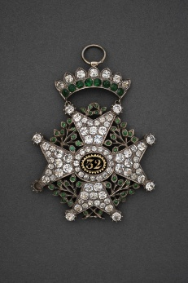
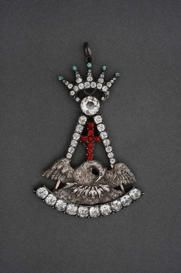

Caldwell, Edward Shields (1867–1925)
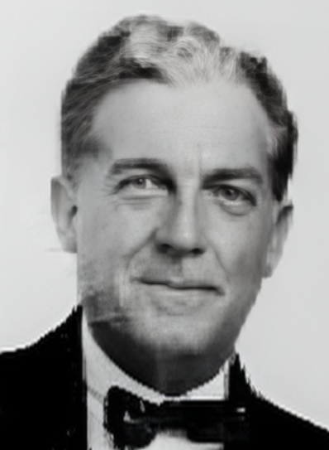
Parents: Edward Holland Caldwell (1844–1872) and Caroline Amelia Shields (1856–1934).
Married: (1) Stella Peter (1882–1923); (2) Adelaide Hodapp (1895–1985).
Kinship: Great-granduncle of the post–World War II Smith generation.

Early Life
Edward Shields Caldwell was born in 1867, the son of Edward Holland Caldwell and Caroline Amelia Shields of Mobile, Alabama.

Career and Residences
He lived intermittently in Santa Barbara, California, where he managed the Red Cross salvage shop and enjoyed a comfortable social life. He frequently entertained his relatives, the Reynals, who visited by private railway car.

Marriages and Personal Life
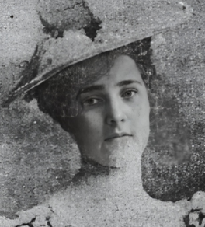
In 1916, in Paris, Caldwell married Stella Peter (1882–1923)0 (left), who had been twice widowed. Their marriage was marked by affection but also by tragedy. Stella, despondent, took her own life in Montecito, leaving a note to her husband that read, “Life is stupid…. I am opening a new chapter for you, may it be a happy one.”

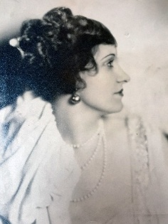
Shortly before her death, she had revised her will, granting Caldwell a life interest in her considerable estate—much of which had come from her two previous husbands—with the remainder to pass after his death to her brother, John Jay Peter, and to an aunt.

Following Stella’s death, Caldwell planned to marry Adelaide Hodapp (1895–1985) (right), the former wife of his late wife’s brother, John Jay Peter. While in declining health and under the care of a nurse, he traveled to Seymour, Indiana, where Adelaide’s divorce was finalized. They married a few days later.

Death
Edward Shields Caldwell died on April 11, 1925, in Lexington, Louisiana, while en route to Mobile, Alabama.
______________________________________________________________________________
Caldwell, James Henry, Sr. (1793–1863)
The Actor

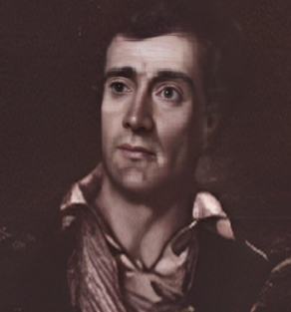
Parents: Edward Henry Caldwell (1759–1802) and Margaret Bolton (1769–1857).
Married: (1) Maria Carter Hall Wormeley (1790–1859); (2) Josephine Rowe (1829–1857).
Other Relationships: Jane Placide (1804–1835); Margaret Abrams (1816–1848).
Children: With Maria Carter Hall Wormley: William Shakespeare Caldwell (1821–1874), Sophia Caldwell (1824–1872); with Josephine Rowe: Harry Stroud Caldwell (1855-1860); with Margaret Abrams: James Henry Caldwell Jr. (1839–1870), Edward Holland Caldwell (1844–1872.
Kinship: Third great-grandfather of the post–World War II Smith generation.

Early Life and Theatrical Beginnings
James Henry Caldwell was born in England in 1793, the son of Edward Henry Caldwell and Margaret Bolton. One newspaper claimed that his father was an umbrella maker, though this may have been a slur rather than fact. As a child actor in England, Caldwell began performing at an early age and came to the United States in 1816 with a Shakespearean troupe.

In 1819, while managing a small theater in Fredericksburg, Virginia, he met Maria Carter Hall Wormeley, a member of the First Families of Virginia and a niece of King Carter. Their marriage that year produced two children. Although they later separated, they remained on civil terms and were not divorced until 1850.

Relationships and Family
Caldwell’s personal life was notably complex, involving several women over the course of his life:
- Maria Carter Hall Wormeley (1790–1859) — His first wife, widow of Warner Lewis Wormeley (1785–1815). Their children were William Shakespeare Caldwell and Sophia Caldwell.
- Jane Placide (1804–1835) — A New York–born actress and businesswoman, she collaborated with Caldwell in numerous theatrical ventures. The precise nature of their relationship remains uncertain, though they were close professional and possibly personal partners.
- Margaret Abrams (1816–1848) — Caldwell’s mistress, with whom he had two illegitimate sons later legitimized by an act of the Louisiana Legislature: James Henry Caldwell Jr. and Edward Holland Caldwell.
- Josephine Rowe (1829–1857) — An actress from a theatrical family, whom Caldwell married in 1850 when he was fifty-seven and she was twenty-one. They had one child, Harry Stroud Caldwell.

Career and Achievements
Caldwell became the leading actor, theater manager, and impresario in the antebellum South. His charisma and managerial skill transformed the cultural life of New Orleans and other Southern cities. His theatrical enterprises led to a series of civic and commercial ventures that secured both his wealth and reputation.

He built theaters in New Orleans, Cincinnati, Mobile, and St. Louis, and even operated a public bath and spa in New Orleans. While performing in Baltimore’s Holliday Street Theatre, Caldwell encountered gas lighting—a technology that inspired his most profitable innovation.
By 1833, he had obtained contracts to light the streets of New Orleans, Mobile, and Cincinnati with gas. This business became the foundation of the Caldwell family fortune and directed his descendants toward careers in engineering and commerce.

Public Office and Political Views
Caldwell parlayed his prominence into political influence. He served as member and recorder of the Second Municipality Council of New Orleans, alderman and president of the Board of Aldermen, and as a representative in the Louisiana legislature.

His politics were staunchly Southern and pro-slavery, as illustrated in a 1835 resolution he sponsored condemning Northern abolitionists. It included such phrases as:
“We have every reliance upon our northern brethren that they will prostrate these vile disturbers of our public peace…these disseminators of dreams in the face of our great rights and truth…these distributors of vile and rash lies and visionary trash.”

Later Life and Death
With the onset of the Civil War, Caldwell left New Orleans in 1862, living for a time in Cincinnati and then in New York City. In failing health, he died there on September 11, 1863. Funeral services were held at St. Patrick’s Cathedral on September 14, and his body was transported to New Orleans for a second service at the Dead Church on Rampart Street. He was buried in Fireman’s Cemetery.

Legacy
James Henry Caldwell was a pioneering figure in the development of American theater and civic enterprise in the South. His entrepreneurial ventures—particularly the introduction of gas lighting—ensured both his fortune and the prominence of his descendants. Despite the turbulence of his personal life, he remains a central figure in the cultural history of nineteenth-century New Orleans.

Caldwell, James Henry (1865–1931)
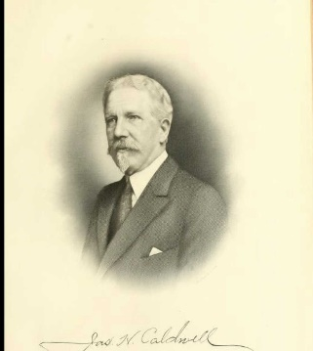

Parents: Edward Holland Caldwell (1844–1872) and Caroline Amelia Shields (1856–1934).
Married: Marguerite Josephine Christie (1865–1919).
Children: Marguerite “Margery” Josephine Caldwell (1889–1959), John Christie Caldwell (1893–1923), and Carolyn Christie Caldwell (1899–1950).
Kinship: Second great-granduncle of the post–World War II Smith generation.

Early Life and Education
James Henry Caldwell, the eldest son of Edward Holland Caldwell and Caroline Amelia Shields Caldwell, was born in Mobile, Alabama, on March 21, 1865. He grew up amid the wealth and prominence that his grandfather, the actor and industrial pioneer James Henry Caldwell (1793–1863), had established through the gas lighting enterprises of the family. His father, Edward Holland Caldwell, managed the Mobile Gas Light and Coke Company until his premature death in 1872, leaving Caroline a young widow with three children.

James received his early education in private schools in Maryland and New York City, environments that reflected both the refinement and the ambition of his family. In 1882, at the age of seventeen, he entered the Rensselaer Polytechnic Institute in Troy, New York—then the leading engineering school in the United States—and graduated with the Bachelor of Science degree in 1886.

Engineering Career and Early Business Work
Following graduation, Caldwell returned to Mobile, where he applied his training as a civil engineer with the Mobile Gas Light Company, helping design and oversee the construction of an electricity-generating plant. His aptitude for both engineering and management soon led him to higher positions: by 1888 he was vice-president, and later president, of both the Mobile Gas Light and Coke Company and the Mobile Electric Light Company—two of the key properties held by the Caldwell estate.

Move to New York and Industrial Leadership
In 1887–1888, after several years of professional success in Mobile, Caldwell undertook extensive travels in the United States and Europe, broadening his technical and business perspective. In 1888 he joined the Ludlow Valve Manufacturing Company of Troy, New York, a firm specializing in the production of industrial valves and hydrants. His rise within the company was rapid. In 1892 he was elected vice-president, and in 1893 also assumed the duties of general manager. By 1909 he became president of the company, a position he held until his death. Under his leadership, Ludlow Valve expanded into one of the premier manufacturers in its field, known for precision engineering and for supplying major municipal water and gas systems throughout the United States.

Banking, Corporate, and Financial Roles
Caldwell’s interests extended well beyond manufacturing. He was one of the organizers of the Troy Trust Company and served as its first president for eight years. He later became vice-president and trustee of the Troy Savings Bank, and a director of the National State Bank of Troy. He served as president of the Commercial Telephone Company until its absorption into the American Telephone and Telegraph Company, and was also president of the Van Rensselaer Hotel Company, treasurer of the Rensselaer Improvement Company, and trustee of the Troy Gas Company.

His reputation for managerial efficiency and civic-mindedness made him a sought-after board member and adviser. At the time of his death, he was a director of several other corporations across the northeastern United States.

Civic, Educational, and Philanthropic Activities
Caldwell was deeply engaged in civic and charitable life in Troy. He served as president of both the Troy Public Library and the Troy Chamber of Commerce, and was vice-president and trustee of Rensselaer Polytechnic Institute, maintaining a lifelong devotion to his alma mater. He was one of the founders, as well as president and trustee, of the Samaritan Hospital in Troy, a charitable institution serving the industrial and working population of the city. He also served as trustee of the Day Home Nursery, reflecting his interest in social welfare and public health.

Professional and Social Affiliations
Caldwell’s professional affiliations reflected his national stature within the engineering community. He was a member of the American Society of Mechanical Engineers, the American Water Works Association, the American Gas Institute, the Illinois Gas Association, and the National Founders’ Association. His intellectual curiosity led him also into scientific societies such as the American Geographical Society, the National Geographic Society, and the American Museum of Natural History.
He maintained an active social life through a number of clubs: the University, Engineers, Machinery, and Recess Clubs of New York City, and the Troy Club and Elks of Troy. His fraternity at Rensselaer was Delta Phi.

Religious Life and Personal Character
Caldwell was an Episcopalian, serving as senior warden of St. Paul’s Church in Troy. Contemporaries described him as energetic, urbane, and methodical—a man of integrity who combined technical mastery with civic conscience. His career linked the industrial vigor of the late nineteenth century with the civic reform movements of the early twentieth.

Caldwell, John Christie (1893–1923)
Parents: James Henry Caldwell (1865–1931) and Marguerite Josephine Christie (1865–1919).
Married: Helen Greatsinger Farrell (1898–1970).
Children: None recorded.
Kinship: First cousin twice removed of the post–World War II Smith generation.

Early Life and Education
John Christie Caldwell was born in Troy, New York, on April 3, 1893, the only son of James Henry and Marguerite Josephine Christie Caldwell. He grew up in one of Troy’s most prominent families, his father being president of the Ludlow Valve Manufacturing Company and a civic leader in both business and philanthropy. The Caldwells occupied a position of considerable distinction in Troy society, with ties to New York and New England industrial circles.
He was educated first at the Troy Academy, a preparatory institution founded by members of the city’s professional elite, and later at St. Mark’s School in Southborough, Massachusetts, one of the leading Episcopal boarding schools of the day. He entered Rensselaer Polytechnic Institute, his father’s alma mater, where he studied chemical engineering and graduated in 1916 with a Bachelor of Science degree.

Early Career and Military Service
After graduation, Caldwell accepted a position with the Robert W. Hunt Company in Chicago, an engineering and inspection firm specializing in materials testing and industrial quality control. His work there reflected both his technical training and the expanding importance of engineering expertise in early twentieth-century industry.
In 1917, following the entry of the United States into the First World War, Caldwell enlisted in the United States Marine Corps. While training at Parris Island, his leadership and technical ability led to his transfer to the U.S. Army Corps of Engineers, where he accepted a commission as second lieutenant. He was stationed first at Fort Myer, Virginia, and later sent to Cambridge, Massachusetts, for training at the Army’s new flying school under the Signal Corps Aviation Section. His aptitude as an instructor resulted in a transfer to Miami, Florida, where he was appointed commandant of cadets in the aviation program. He was honorably discharged in February 1918.

Professional Life
After the war, Caldwell returned to Troy and joined the Ludlow Valve Manufacturing Company as purchasing agent and assistant to his father. The firm, one of the largest valve and hydrant manufacturers in the United States, had expanded its wartime production and was an important supplier to municipal and industrial clients nationwide. Caldwell’s position placed him in line for a significant role in the company’s management, and he was viewed as his father’s natural successor.

Illness and Death
In the early 1920s his health began to decline, and it was reported that he suffered from tuberculosis or another respiratory illness. Seeking a milder climate, he traveled to Augusta, Georgia, and took rooms at the Hotel Bon Air Vanderbilt, a luxury winter resort frequented by northern industrialists.

On the night of February 18, 1923, while smoking in bed, he accidentally ignited the bedclothes. The fire spread rapidly, and he was fatally burned. His death was widely reported in Troy and Albany newspapers, which emphasized the tragic loss of a young man of promise from one of the city’s leading families.

Legacy
Although his life was brief, John Christie Caldwell represented the third generation of Caldwells who combined engineering accomplishment with civic standing. Educated in the best schools and active in both industry and military service, he exemplified the family’s tradition of technical innovation and public responsibility. He was buried in Troy, New York, near his parents and other members of the Caldwell family. His widow, Helen Greatsinger Farrell Caldwell, survived him by many years.
______________________________________________________________________________
Caldwell, Marguerite “Margery” Josephine (1898–1959)
Parents: James Henry Caldwell (1865–1931) and Marguerite Josephine Christie (1865–1919).
Married: Livingston Waddell Houston (1891–1977).
Children: Margery Christie Houston (1917–2004) , Nancy Evans Houston (1918–2003), Mary Evans Houston (1919– ), Carol Caldwell Houston (1929–1923).
Kinship: Second cousin once removed of the post–World War II Smith generation.

Early Life and Family
Marguerite “Margery” Caldwell was born in 1898 into the Caldwell family of Troy, New York, then prominent both industrially and socially. Her father, James Henry Caldwell, was long active in engineering, business, and civic life. She was raised in a milieu of intellectual, artistic, and cultural engagement, with access to the institutions of Troy and the wider Northeastern United States.

In 1916 she married Livingston Waddell Houston, whose later service as president of Rensselaer Polytechnic Institute tied her to one of Troy’s foremost educational and civic institutions.

Artistic Pursuits
Margery Houston was active as a painter. She is documented in the regional art historical record as one of the Troy and Rensselaer County artists, and her name appears in artist files held by the Albany Institute of History & Art under local artist rosters. Her involvement in the Troy art milieu included exhibiting work locally; she is listed in historical artist directories of the region, indicating that she was an exhibiting artist, though full catalogues of her shows are less commonly available in published form.

Later Years and Legacy
She lived in Troy during her husband’s academic and institutional career, supporting community and cultural organizations. Her daughters, Margery Christie Houston and Nancy Evans Houston, inherited the legacy of two significant civic families. Margery Caldwell Houston is remembered not just as the wife of a prominent educational leader, but as one of Troy’s early twentieth-century women artists, bridging the intellectual, industrial, and cultural traditions of her era.

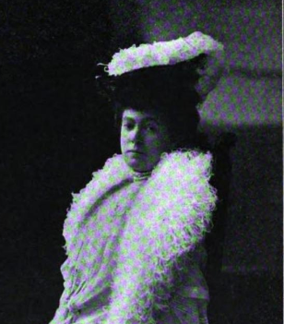
Caldwell, Mary Elizabeth Breckenridge Byrd “Lina” (1865–1910)

Parents: William Shakespeare Caldwell (1821–1874) and Mary Elizabeth Grayson Breckenridge (1833–1867).
Married: Moritz Kurt, Baron von Zedtwitz (1852–1896).
Children: Waldemar Conrad von Zedtwitz (1896–1984).
Kinship: First cousin three times removed of the post–World War II Smith generation.

Early Life
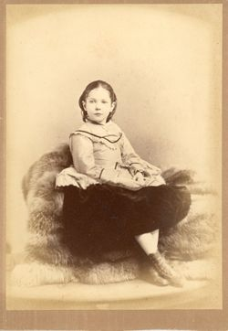
Mary Elizabeth Breckenridge Byrd Caldwell, known as “Lina,” was born in 1865 into one of the most prominent Catholic families in postbellum America. Her father, William Shakespeare Caldwell, was the son of James Henry Caldwell, the actor and entrepreneur who established the family’s fortune through gas-lighting enterprises in New Orleans and Mobile. Her mother, Mary Elizabeth Grayson Breckenridge, was a granddaughter of U.S. Senator and Attorney General John Breckinridge of Kentucky, connecting Lina to one of the most distinguished political families of the South.

Patronage and the Caldwell Chapel
Lina Caldwell was closely associated with her elder sister, Mary Gwendoline Caldwell (1859–1909), the philanthropist who founded the Catholic University of America in Washington, D.C. The sisters endowed the university’s Caldwell Hall and its chapel, both designed to symbolize the presence of women’s patronage in the growing American Catholic educational movement. Lina personally funded the construction of Caldwell Chapel, where she was later married.

Marriage and Tragedy
In Caldwell Chapel, with Bishop John Lancaster Spalding of Peoria officiating, Lina married Baron Moritz Kurt von Zedtwitz, a German nobleman and yachtsman, in a ceremony that attracted considerable public attention. The marriage linked her to the European aristocracy, and for several years the couple lived abroad.

In 1896 Baron von Zedtwitz was killed in a regatta when Kaiser Wilhelm II’s yacht collided with his own. The accident left Lina widowed with an infant son, Waldemar Conrad von Zedtwitz, then only four months old. She returned to the United States, where Bishop Spalding became the child’s guardian.

Later Life and Controversy
Lina’s later years were marked by controversy surrounding her relationship with Bishop Spalding and the Catholic hierarchy. She publicly accused the bishop of misconduct, as had her sister Mary Gwendoline, whose later life was marked by disillusionment with the Church she had once so generously supported. The sisters’ accusations drew widespread attention in the Catholic and secular press, as both women had been prominent benefactors whose fortunes had endowed major Church institutions.

Legacy
Mary Elizabeth Caldwell von Zedtwitz died in 1910. Her son, Waldemar von Zedtwitz, became internationally famous as a bridge player and theorist and was later regarded as one of the founders of modern contract bridge. The Caldwell name endures through the Caldwell Chapel at the Catholic University of America, which remains a lasting memorial to the family’s early devotion to Catholic education and philanthropy.

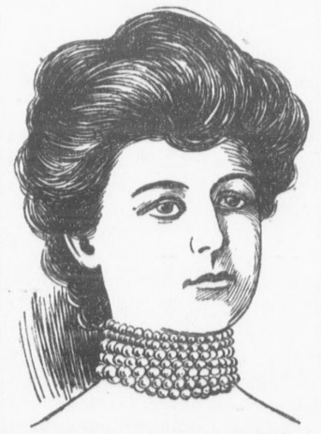
Caldwell, Mary Gwendolyn [Gwendolin] “Mamie” Byrd (1863–1909)

Parents: William Shakespeare Caldwell (1821–1874) and Mary Elizabeth Grayson Breckenridge (1833–1867).
Married: François Jean Louis, Marquis des Monstiers-Mérinville (1847–1919).
Children: None known.
Kinship: First cousin three times removed of the post–World War II Smith generation.

Early life and inheritance
Mary Gwendolyn Caldwell was born in Louisville, Kentucky, in 1863. After her mother’s death (1867) and her father’s death (1874), she and her younger sister, Mary Elizabeth (“Lina”), inherited a very large fortune derived from the Caldwell gas-lighting enterprises. She was educated at the Academy (Convent) of the Sacred Heart, Manhattanville, New York.

Founding benefactor of The Catholic University of America
Upon attaining her majority, and in consultation with John Lancaster Spalding (then a priest and later bishop of Peoria), Caldwell offered to endow a national Catholic university. Her benefactions included the site in Washington, D.C., and the erection and early maintenance of the first buildings; Caldwell Hall (dedicated May 24, 1888) bears her name. An official university page notes the papal approval letter of April 10, 1887 sealed in the cornerstone and identifies her as the first donor.

In recognition of these benefactions she received high honors: the Laetare Medal (1899) from the University of Notre Dame, and a papal decoration (contemporary accounts describe a medal specially struck by Pope Leo XIII).

Engagement, marriage, and separation
In 1889 she briefly became engaged to Prince Murat; the engagement ended over financial terms. In Paris on October 19, 1896, she married the Marquis des Monstiers-Mérinville. The couple separated in 1905; contemporary reports indicate she paid him an annual stipend to avoid divorce while retaining her title.

Allegations concerning Bishop John Lancaster Spalding
Beginning in 1901, private and later public statements by the Caldwell sisters alleged long-standing sexual misconduct by Spalding; the claims, their reception, and the archival treatment of related materials have been debated by historians. The standard scholarly defense of Spalding is C. Walker Gollar’s “The Double Doctrine of the Caldwell Sisters” (Catholic Historical Review, 1995), which questions the sisters’ reliability and attributes their accusations to illness, unhappy marriages, and ecclesiastical disputes (e.g., an annulment).
A later methodological review by Gollar discusses how earlier Spalding scholarship (notably under John Tracy Ellis) handled and, at points, omitted or minimized sensitive correspondence, reflecting broader archival and historiographical issues surrounding the case. (This article analyzes editorial practice and transmission of documents rather than adjudicating facts of the alleged relationship.)
Counter-narratives exist in modern commentary arguing that church officials privately took the sisters’ claims seriously enough to affect Spalding’s prospects for promotion, though these accounts rely on correspondence and summaries not all of which are publicly reproduced in full; they should be treated cautiously and weighed against the peer-reviewed literature.

Lina Caldwell (Mary Elizabeth) and the public break with Rome (context)
Her sister Lina funded Caldwell Chapel at the university and later published The Double Doctrine of the Church of Rome (1906), a polemical work critiquing Jesuit casuistry and “probabilism,” reflecting the sisters’ break with Catholic authorities in the early 1900s.

Later years and death
Caldwell suffered from chronic illness in her last years. She died aboard the German liner Kronprinzessin Cecilie while it waited to dock in New York Harbor on October 5, 1909; bright’s disease was reported as the cause of death. She was buried in Cave Hill Cemetery, Louisville.

Legacy
As the initiating benefactor of The Catholic University of America, Caldwell played a decisive role in creating a national center for Catholic higher education in the United States; Caldwell Hall and the early history of the university remain linked to her patronage. Her Laetare Medal recognized that contribution at the national Catholic level.
She and her sister both renounced the Catholic Church. The Caldwell sisters were buried in a secular cemetery, not in their father’s grave in the Catholic cemetery in Louisville. On their monument stands the inscription: You shall know the truth, and the truth shall set you free.
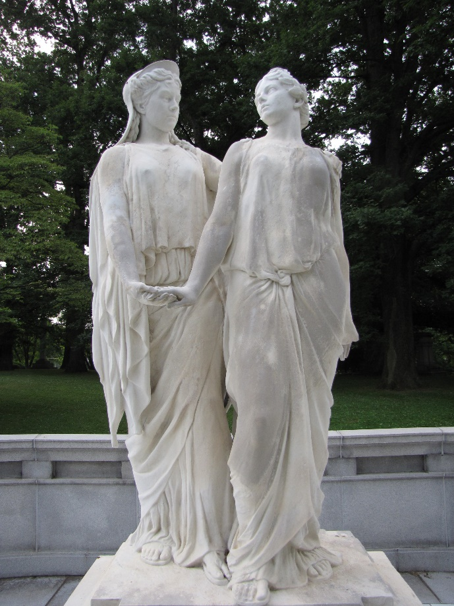
The monument was restored with funds from the Catholic University of America.
____________________________________________________________

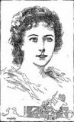
Caldwell, Sarah Woodruff (1870–1947)

dren, Nathalie Florence and Nathaniel Jules Reynal.
Sarah Woodruff Caldwell Reynal survived her husband by nearly two decades. She died in 1947, remembered by her descendants for her refinement, generosity, and quiet piety. Through her marriages to Rutter and Reynal she united three families—Caldwell, Rutter, and ReynalParents: Edward Holland Caldwell (1844–1872) and Caroline Amelia Shields (1856–1934).
Married: (1) Nathaniel Enzie Rutter (1863–1891); (2) Nathaniel Claude Reynal (1871–1928).
Children: With Nathaniel Rutter: Nathaniel Edward Caldwell Rutter (1890–1947); with Nathaniel Reynal: Nathalie Florence Reynal (1902–1968), Nathaniel Claude Reynal Jr. (1903–1905), Nathaniel Jules Reynal (1903–1950), and Amelie Reynal (1909–1917).
Kinship: Great-grand-aunt of the post–World War II Smith generation.

Early Life and First Marriage
Sarah Woodruff Caldwell was born in 1870, the youngest child of Edward Holland Caldwell and Caroline Amelia Shields of Mobile, Alabama. Her father’s early death in 1872 left her mother a widow with three young children, who were raised partly in the South and partly among relatives in the Northeast.

In 1888 Sarah married Nathaniel Enzie Rutter, a young businessman. Their marriage was short-lived: Rutter died in 1891, leaving Sarah with one infant son, Nathaniel Edward Caldwell Rutter (1890–1947). She subsequently made her home in New York, where she moved within the social circles of other Southern families established in the city.

Conversion and Second Marriage
Sarah converted to Catholicism in 1898, her sponsor being the sister of Nathaniel Claude Reynal, a member of a French-American banking and mercantile family active in New York. Three years later, in 1901, she married Reynal, thereby joining another family prominent in the city’s commercial and cultural life.

The couple had four children between 1902 and 1909, two of whom survived to adulthood. The family divided its time between their New York City residence and their country estate, Rocky Dell, in Westchester County, where they spent the summers. The house, set amid rolling land near the Hudson, was noted in contemporary society columns for its hospitality and gardens (see Houses and Estates).

Later Life and Estate
Nathaniel Claude Reynal died in 1928, leaving an estate valued at approximately $1 million in today’s currency. Sarah received $300,000 outright and shared in the residue of the estate with her surviving chil—that maintained both Southern and New York affiliations well into the twentieth century.

Caldwell, William Shakespeare (1821–1874)
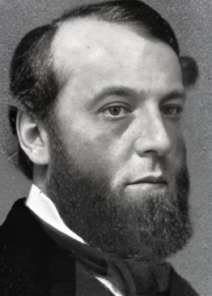
Parents: James Henry Caldwell, the actor (1793–1863), and Maria Carter Hall (1790–1859).
Married: Mary Elizabeth Grayson Breckenridge (1833–1867), of the Kentucky Breckenridge family.
Children: Mary Gwendolin Caldwell (1863–1909) and Mary Elizabeth Breckenridge Byrd Caldwell (1865–1910).
Kinship: Second great-granduncle of the post–World War II Smith generation.

Early Life and Education
William Shakespeare Caldwell—known in the family as “Shakes”—was born in 1821, the legitimate son of the actor and impresario James Henry Caldwell and his wife Maria Carter Hall of the Virginia gentry. His given names reflected his father’s theatrical background and admiration for Shakespearean drama. Educated as a youth in the South, he later attended the University of Virginia, where he studied the liberal arts before returning to New Orleans to join his father in theatrical ventures.

Career
Although he initially attempted a career in acting and theater management, continuing the family tradition, he soon turned to real estate and business. After inheriting a portion of his father’s considerable fortune, he moved to Louisville, Kentucky, where he developed a number of properties and engaged in civic philanthropy. His most enduring charitable legacy was the founding of Sts. Mary and Elizabeth Hospital in Louisville, established in memory of his wife. He also played a key role in bringing the Little Sisters of the Poor to Richmond, Virginia, supporting their work before his own conversion to Catholicism.

Marriage and Family
In 1859 William married Mary Elizabeth Grayson Breckenridge, a member of the distinguished Breckenridge family of Kentucky, whose most prominent member, John Cabell Breckenridge, served as Vice President of the United States under James Buchanan and later as Confederate Secretary of War. Mary Eliza had been educated by the Sisters of Nazareth in Kentucky and maintained strong sympathies with Catholic religious life.

The couple longed for children and prayed to the Virgin Mary for this blessing. In gratitude when their prayers were answered, both of their daughters were christened with the name Mary: Mary Gwendolin (born 1863) and Mary Elizabeth (“Lina”) (born 1865).

Religion and Death
Though raised Protestant, William Caldwell was not hostile to Catholicism. His wife’s example and their shared piety drew him gradually toward the Church. After her early death in 1867, he continued to support Catholic charitable institutions. He delayed formal conversion until just before his own death in 1874, when he was baptized into the Catholic Church.

Before his death, Caldwell entrusted the care and education of his two young daughters to Irish Catholic acquaintances he had met in New York. These guardians, in turn, placed the girls under the spiritual direction of the thirty-two-year-old Father John Lancaster Spalding, nephew of Archbishop Martin Spalding of Baltimore. At the time, Mary Gwendolin was eleven and Mary Elizabeth nine—a decision that would later have momentous and tragic consequences for the Caldwell family.

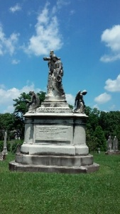
Legacy
William Shakespeare Caldwell’s wealth and pious intentions laid the foundation for one of the most striking episodes in American Catholic history: the philanthropic rise—and later disillusionment—of his two daughters, whose fortunes endowed the Catholic University of America. His name endures in the hospital he founded in Louisville and in the enduring if troubled legacy of the Caldwell sisters’ benefactions to the Church.

Chisholm Family of South Carolina, New York, and Pennsylvania
The Chisholm family represented here descends from the South Carolina Edings–Chisholm line that migrated north after the Civil War and married into the Muhlenberg, Rogers, and Lawrence families. Through these alliances they became part of the extended social and ecclesiastical network of the Episcopal reformer Rev. William Augustus Muhlenberg and the Long Island philanthropic communities associated with St. Johnland, College Point, and Morristown.

The Edings–Chisholm Line of South Carolina
The Chisholms of Charleston and Edisto Island were interwoven with the Edings family, a prominent planter line noted for ties to the Episcopal Church and Lowcountry political life. William Edings Chisholm (1823–1895), father of George Edings I, appears to descend from the Chisholms of St. Paul’s Parish (Edisto/Colleton counties), though collateral branches also lived in Charleston proper. Typical occupations in the antebellum generation included rice planting, legal work, and mercantile activity.

The Muhlenberg–Rogers–Chisholm Connection
Mary Ann Catherine Muhlenberg Rogers (1827–1913), George’s mother, was related to:
• Rev. William Augustus Muhlenberg (1796–1877), rector of the Church of the Holy Communion, founder of St. Luke’s Hospital, St. Johnland, and a leading figure in the Episcopal Church’s mid-nineteenth-century social-reform movement.
• The New Jersey Rogers family of Morristown, prominent in local civic and religious affairs.
These connections positioned the Chisholms firmly within the institutional networks of New York Episcopal philanthropy.

The Lawrence Connection
Through Edith Lawrence, the Chisholms joined the extensive Lawrence–Townsend–Hicks–Willets network of early Long Island Quaker and post-Quaker families. This alliance further associated them with the mercantile and civic elite of nineteenth-century New York.

Chisholm, George Edings I (1858–1938)
Parents: William Edings Chisholm (1823–1895) and Mary Ann Catherine Muhlenberg Rogers (1827–1913).
Married: Edith Lawrence (1861–1934).
Children: John Rogers Chisholm (1896–1949), Henry Lawrence Chisholm (1898–1949), Donald Muhlenberg Chisholm (1900–1974), and William Edings Chisholm (1904–1972).
Kinship: Husband of Edith Lawrence, the third cousin three times removed of the post-World War II Smith generation.

Early Life and Marriage
Born 13 June 1858 in College Point, Long Island—at the family’s residence later known locally as the Chisholm Mansion—George was the fourth surviving child of William Edings Chisholm of Charleston and Mary Ann C. Muhlenberg Rogers of Morristown, New Jersey.

He married Edith Lawrence, daughter of Henry E. Lawrence, on 18 November 1890.

Civic and Philanthropic Connections
George’s maternal family were close to the Episcopal reformer Rev. William Augustus Muhlenberg (1796–1877), who founded St. Johnland in Kings Park, Long Island. The family’s connection to St. Johnland is documented in period sources: in 1888 George’s father, William E. Chisholm, is listed among the Society of St. Johnland’s trustees at its 18th annual meeting held at St. Luke’s Hospital, New York. (This demonstrates a direct Chisholm role in the institution’s governance during George’s adulthood.)

Residences and Interests
Contemporary accounts place the family in Morristown, New Jersey, and at College Point/Queens, reflecting ties to New York business and church circles. George’s activities are described in family and local histories as centering on real estate and club/yachting circles.
______________________________________________________________________________
Chisholm, George Edings II (1932– )
Parents: Henry Lawrence Chisholm (1898–1949) and Rosalin Robinson (1902–1987).
Married: Mary-Burr “Binkie” Chaput (1933–2012)
Children: George Edings Chisholm IV (1955- ), Mary-Burr “Missy” Fortune (1956– ), Kent Muhlenberg Chisholm (1959– ), Andrew Fraser Chisholm (1961– ), Melissa Louise Chisholm (1964– ), and Jessica Ann Chisholm (1964– ).
Kinship: The fifth cousin once removed of the post–World War II Smith generation.
Chisholm attended the Naval Academy and graduated in 1954. On June 13, 1954, Ensign Chisholm married Mary Chaput, and all the males of the wedding party were also ensigns, so the newspapers highlighted this “all-white wedding.”
In 1966 Chisholm was the operations officer of the nuclear frigate U. S. S. Bainbridge, and accepted a gift od silverware from the city of Bainbridge, Georgia.
Chisholm retired from the U.S. Navy in 1974 with the rank of Commander. He lived in State College, Pennsylvania.

Chisholm, George Edings IV (1955– )
Parents: George Edings Chisholm II (1932– ) and Mary-Burr Chaput (1934–2012).
Married: Vanessa (1955– ).
Children: George Edings Chisholm IV (per family record provided).
Kinship: The sixth cousin of the post–World War II Smith generation.

Scientific work (yeast nitrogen metabolism and gene regulation)
Chisholm’s published research (largely with T. G. Cooper) focused on regulation of the allantoin/urea catabolic pathway in Saccharomyces cerevisiae, especially transcriptional control of DUR1,2 (urea amidolyase) and the effects of mobile genetic elements on gene expression:
- Constitutive allantoin-pathway mutants (1982): Identified and characterized mutants that constitutively produce the allantoin-degrading enzymes, helping establish the role of DAL80 as a negative regulator and clarifying induction/repression logic for the pathway.
- cis-Dominant DUR1,2 upregulation (1984): Described cis-dominant mutations that dramatically enhance DUR1,2 expression while leaving normal induction and nitrogen catabolite repression intact—evidence for promoter-proximal control elements modulating urea amidolyase expression.
- Discovery of a repeated DNA element, tau (1984): Reported tau, a 371-bp repeated element in yeast with inverted repeats, adding to the catalog of repetitive elements (alongside sigma/delta) that influence genome structure and transcription.
- Ty retrotransposon effects on DUR1,2 (1992): Showed that Ty insertions upstream vs. downstream of native DUR1,2 promoter elements generate distinct expression patterns (enhanced yet regulated vs. ROAM-type deregulation), directly linking transposable-element position to regulatory outcomes.
These works are frequently cited in later syntheses of yeast nitrogen regulation and urea/amidolyase genetic

Chisholm Mansion
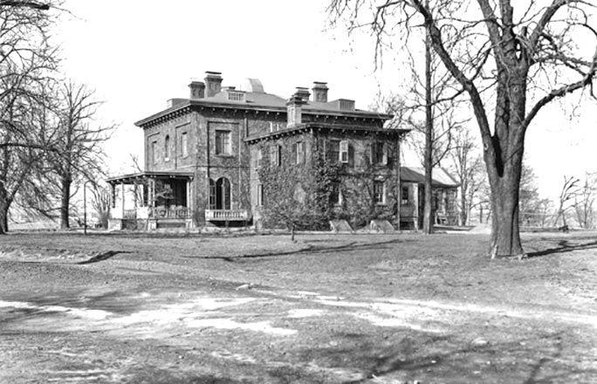

Location: now Hermon A. MacNeil Park. Queens, New York.
Built: c. 1848.

Architectural Description
The Chisholm Mansion was a substantial mid-nineteenth-century stone country house prominently sited on high ground overlooking the East River at the northern tip of College Point. Built of locally quarried bluestone, the house presented a compact but imposing rectangular mass with a low hipped roof, deep eaves, and multiple chimneys. Its elevations were regular and restrained, with tall rectangular windows and a central entrance accented by classical detailing. A broad porch on the river-facing side softened the severity of the stone walls and oriented the principal rooms toward expansive water views stretching toward Manhattan, the Bronx, Rikers Island, and, later, the site of the Whitestone Bridge. Set within approximately twenty to twenty-eight acres of landscaped grounds, the mansion combined solidity with picturesque siting, emphasizing prospect and elevation rather than ornament.

History
The origins of the estate date to 1835, when Reverend William Augustus Muhlenberg, an Episcopal clergyman and founder of St. Paul’s College, purchased the land for a planned stone seminary. Construction began, but the Panic of 1837 abruptly ended the project, leaving unused stone on the site. The property was subsequently acquired by Muhlenberg’s sister, Mrs. John Rogers, who repurposed the abandoned materials to build a private residence. Completed around 1848 on the highest point of the grounds, the house was given as a wedding gift to her daughter, Mary Ann Rogers, upon her marriage to William Edings Chisholm, a real-estate broker and developer who had attended St. Paul’s College.

The Chisholm family occupied the mansion for several generations, raising three children there—George, Margaret, and Benjamin—and establishing the house as a long-term family seat rather than a seasonal retreat. Contemporary descriptions emphasized its commanding river views, extensive grounds, and sense of seclusion despite proximity to New York City. Some later accounts suggest the house may have served as a refuge for fugitive slaves before the Civil War, though documentation is limited. By the late nineteenth and early twentieth centuries, the property was widely known locally as Chisholm’s, and the surrounding shoreline parkland took its name from the estate.

In 1930, amid changing economic circumstances following the stock market crash of 1929, the Chisholm family sold the property to the City of New York for use as a public park. In a brief and unusual chapter of its history, Mayor Fiorello La Guardia used the mansion as a “Summer City Hall” in 1937, conducting municipal business there during the hottest months. Despite this high-profile use, Parks Commissioner Robert Moses regarded the aging structure as impractical to maintain or adapt. Between 1939 and 1941, the mansion was demolished as part of a Works Progress Administration project to redevelop the site with playgrounds, athletic fields, and recreational facilities.

Today, the former estate is preserved as Hermon A. MacNeil Park, a popular waterfront green space. A flagpole marks the approximate location of the mansion.

Clark Family
The Clark family occupies a distinctive place in the social and professional history of New York from the late nineteenth through the mid-twentieth century, representing a convergence of architectural achievement, mercantile success, and prominent marriage alliances that connected them to many of the city’s leading families. The line originated in the mercantile circles of Manhattan and Brooklyn during the post–Civil War decades, producing successive generations of educated professionals who combined inherited affluence with civic engagement and an enduring sense of social responsibility.

Origins and Early Generations
The family’s known patriarch in this branch, John Snowden Henry Clark (1850–1907), married Mary Eliza Davenport (1852–1913), uniting the Clark line with one of New York’s early commercial families. Their children were raised in an atmosphere that valued education, travel, and the arts. Among them, Samuel Adams Clark (1875–1931) emerged as the most prominent figure of his generation.

Architectural and Cultural Influence
Educated at Yale, Samuel Adams Clark (1875-1931) trained as an architect and joined the respected New York firm Warren & Clark, which succeeded the partnership of Warren & Wetmore—designers of Grand Central Terminal. His career flourished during the early twentieth century, a period when architecture was both a social art and a technical profession. Clark’s work, notably the 1928 Saratoga Racecourse Clubhouse, epitomized the transition from ornate Victorian design to the restrained, functional elegance of the interwar years.

His marriage to Gertrude Jerome Alexandre, daughter of financier J. Henry Alexandre, brought the family into the sphere of the Alexandre and Whitney circles, prominent in Gilded Age philanthropy and finance. The Clarks’ lives, straddling art, architecture, and high society, exemplified the cultivated professionalism that marked the American upper class in the years between the Gilded Age and the Depression.

The Next Generation
Their sons, Samuel Adams Clark Jr. (1910–1998) and Francis Adams Clark (1914–2002), came of age in the interwar period. While their lives were less public than those of their parents, they continued the family’s tradition of education and service. Samuel Jr. attended private schools in New York, served in the U.S. Army during World War II, and later worked as an executive with IBM, eventually retiring to California. His brother Francis pursued a quieter business career and maintained the family’s social ties in New York.

The Alexandre Connection and Social Legacy
Through Gertrude Alexandre, the Clarks were related to one of the most visible New York families of the early twentieth century. The Alexandres were known for their shipping enterprises, their art patronage, and their presence in Newport and Long Island society. This connection linked the Clarks to a network that included the Whitneys, Paynes, and Breeses—families who collectively defined the American establishment of the era.

Later Years and Continuity
By the mid-twentieth century, the Clark descendants had dispersed geographically but maintained an unbroken record of professional engagement, cultural interest, and public-mindedness. Their marriages extended the family’s connections across the country—from New York and New England to California—reflecting the mobility of the postwar professional class.
The Clarks’ story is one of adaptation within continuity. Rooted in nineteenth-century New York but extending into modern America, they embody the evolution of an educated, civic-minded lineage that moved easily between art and enterprise, city and countryside, private accomplishment and public life.

Clark, Samuel Adams (1875–1931)
Parents: John Snowden Henry Clark (1850–1907) and Mary Eliza Davenport (1852–1913).
Married: Gertrude Jerome Alexandre (1879–1949).
Children: Samuel Adams Clark Jr. (1910–1998) and Francis Adams Clark (1914–2002).
Kinship: Husband of the grandaunt of the post–World War II Smith generation.

Early Life and Education
Samuel Adams Clark was born in New York City in 1875 into a prosperous family with long-established mercantile and professional connections. He attended Yale University, where he studied architecture and was active in campus artistic circles and architectural societies. His education coincided with the flowering of the Beaux-Arts style in the United States, an influence that shaped his later professional work.

Architectural Career
After his graduation from Yale, Clark joined the New York architectural firm of Warren & Clark, successors to Whitney Warren & Charles D. Wetmore, who had designed Grand Central Terminal. The firm undertook numerous private and public commissions during the 1910s and 1920s, emphasizing a refined, restrained classicism adapted to modern needs.

One of Clark’s most noted projects was the new clubhouse at the Saratoga Racecourse, completed in 1928 to replace the picturesque but undersized 1892 structure. The new building, 211 feet long and 44 feet wide, greatly expanded the track’s capacity with 1,200 box seats and total accommodations for 3,000 patrons. It included amenities that were considered luxurious for its time, among them an electric elevator—an innovation in American racecourse design. Critics observed that, while the new clubhouse lacked the romantic charm of its Victorian predecessor, it reflected a more functional and modern aesthetic suited to contemporary tastes.

The Saratoga project remains the best-documented example of Clark’s work. His professional style reflected the architectural transition of the interwar period: classical in proportion, but increasingly stripped of ornament and adapted to emerging technologies in construction and comfort.

Personal Life and Social Connections
Clark married Gertrude Jerome Alexandre, daughter of shipping magnate J. Henry Alexandre, uniting two prominent New York families with strong ties to finance and industry. The couple lived in Manhattan and maintained a country home, where they entertained a circle that included figures from the arts, business, and politics.

Clark’s long friendship with Payne Whitney, the financier and philanthropist, was well known. When Whitney died in 1927, he left Clark a bequest of $1,300,000—equivalent to about $26 million in 2023 dollars—from an estate valued at more than $100 million. The gesture suggests both personal affection and Clark’s position within Whitney’s intimate social circle.

Mrs. Clark’s Philanthropy
After her husband’s death in 1931, Gertrude Alexandre Clark became known for her energetic and sometimes unconventional charity work. During the Depression years she organized events to raise funds for cancer research and unemployment relief.
In 1933 she and her assistants staged a “beer debut” at the River Club, offering imported Munich beer to benefit cancer patients. The Daily News reported that George F. Baker, among the guests, enjoyed the product so much that he ordered a supply for his yacht, Viking. Mrs. Clark’s ventures blended high society with humor: she auctioned off the notorious beret with visor that Mayor Jimmy Walker had worn on the Riviera, and in 1930 she hired a monoplane to fly over downtown Manhattan, broadcasting appeals by loudspeaker for an unemployment fund.

Legacy
Samuel Adams Clark’s architectural career, though cut short by his death at fifty-six, linked Gilded Age classicism to early twentieth-century modernism. His wife’s lively philanthropy kept the family name before the public for two more decades, while their sons continued the family’s engagement with New York civic life.

Clark, Samuel Adams Jr. (1910–1998)
Parents: Samuel Adams Clark (1875–1931) and Gertrude Jerome Alexandre (1879–1949).
Married: (1.) Elizabeth Lanier Fenno (1916–1969); (2.) Caroline Agnes Franklyn (1924–1981); (3.) Meredith Marie Dunlap (1917–2000).
Children: None recorded.
Kinship: First cousin once removed of the post–World War II Smith generation.

Early Life
Samuel Adams Clark Jr. was born in New York City in 1910, the elder of two sons of the architect Samuel Adams Clark and Gertrude Jerome Alexandre. He grew up in a household connected to both New York’s architectural elite and its Gilded Age social world, and was educated in the private schools typical of that circle.

Marriage and Wartime Service
In 1936 Clark married Elizabeth Lanier Fenno (1916–1969), daughter of Mr. and Mrs. John Brooks Fenno of New York and Lenox, Massachusetts. Their wedding took place in the gardens of Three Acres, the Lenox estate of Elizabeth’s mother, a frequent setting for social events reported in the New York Times. The marriage lasted four years; the couple divorced in 1940.
During the Second World War, Clark served in the United States Army from 1942 to 1945. Details of his service are sparse, but military records confirm his enlistment and honorable discharge near the war’s end.

Later Career and Life
Following the war, Clark entered civilian employment as an accounts manager with IBM, a position he held for many years. His postwar life was largely private and unpublicized, in marked contrast to the prominence of his parents and his first wife. In later life he relocated to Merced, California, where he retired.

Later Marriages and Death
After his first marriage ended, Clark married Caroline Agnes Franklyn (1924–1981), and later Marie Dunlap Meredith (1917–2000). He lived quietly in California until his death in 1998.\

Note
Although Samuel Adams Clark Jr.’s life attracted little public attention, his first wife, Elizabeth Lanier Fenno, later the subject of various society-page stories and legal notices, ensured that his name appeared periodically in the newspapers of his time.

Cliffside
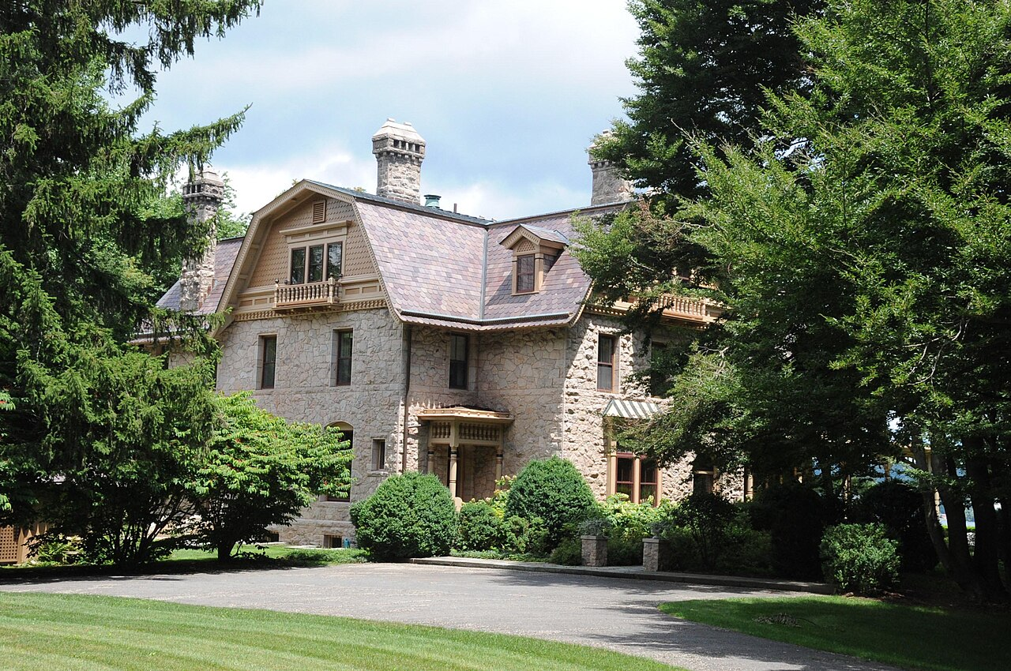
Location: 24 Lawrence Lane, Palisades, New York.
Built:1876.
Architect: Josiah Cleveland Cady.

Architect
Josiah Cleveland Cady (1837–1919) was a leading New York City architect of the late 19th and early 20th centuries, celebrated for his mastery of Victorian-era styles, including High Victorian Gothic and Ruskinian Gothic. Born in Providence, Rhode Island, he briefly studied at Trinity College in 1857 before apprenticing in architecture, likely in New York, and establishing his own practice in 1868. His firm, evolving into Cady, Berg & See by the early 1870s, produced an extensive portfolio of public and institutional buildings, such as the original Metropolitan Opera House (1883–1890), the south range of the American Museum of Natural History (1877), and multiple structures at Yale University—including the Law School and Peabody Museum—as well as buildings at Wesleyan, Trinity, and Williams Colleges. Cady’s work often emphasized robust, textured forms and integration with natural surroundings, reflecting his training and the era’s emphasis on picturesque compositions.
Architectural Description
Cliffside is a substantial two-story, L-shaped stone country house designed in the Flemish Colonial Revival style. Built of random rubble stone, the house is capped by a steep cross-gambrel roof punctuated by dormers and multiple tall stone chimneys, giving it a strong vertical profile when viewed against the wooded Palisades. A one-story wraparound verandah with balustrades extends along the principal elevations, mediating between the interior rooms and the surrounding landscape. The composition emphasizes solidity and picturesque massing rather than strict symmetry, with carefully varied rooflines and fenestration. Sited high above the Hudson River, the house commands long views across the water toward Dobbs Ferry and the eastern shore.
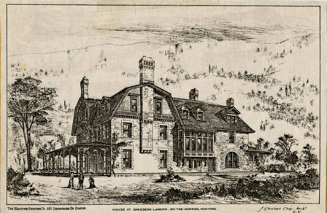
The estate’s landscape features a park-like setting with original plantings from 1876, including specimen trees imported by owner Henry Effingham Lawrence, an amateur horticulturist, who collaborated with neighbor Winthrop S. Gilman, Jr., to introduce rare varieties from Europe and the Orient, often planted in symmetrical pairs to frame vistas and define the grounds.
Interior Description
The interior of Cliffside was designed to support both family life and cultivated leisure. A central stair hall organizes circulation, rising through the house and lit by a large stained-glass window. Principal reception rooms were arranged to take advantage of river views and natural light. The drawing room was notable for housing a pipe organ, an unusual feature in a private residence, reflecting the owner’s interest in music and social gatherings. Extensive wainscoting and wood paneling provided warmth and enclosure, consistent with late nineteenth-century taste. The house also contained Henry Effingham Lawrence’s collection of Hudson River School paintings, reinforcing the close relationship between the interior spaces and the surrounding landscape. Service and storage areas in the basement included practical systems such as spring-fed cooling for food storage.
History
Cliffside was built in 1876 for Henry Effingham Lawrence (1829–1900). Lawrence and his family had long summered at a nearby farm known as Arcadia at Snedens Landing, opposite Dobbs Ferry. In 1870, Lawrence began assembling a large tract of land along the Hudson River, eventually acquiring more than a mile of waterfront. Cliffside marked a decisive transition from farm-based summering to a purpose-built country seat.
Following Henry E. Lawrence’s death on July 10, 1890, the property passed to his wife, Lydia Underhill Lawrence, who inherited the house along with surrounding riparian lands exceeding a mile of Hudson River frontage. Under her stewardship, Cliffside evolved as a family compound, with Lydia exerting control over local development and contributing to community institutions, such as donating 1,100 books in 1891 to establish Palisades’s first library in The Big House. Key modifications during this period included enhancements to the estate’s park-like grounds, where Lawrence family members, including Henry as an amateur horticulturist, imported rare trees from Europe and the Orient, often in symmetrical pairs, in collaboration with neighboring landowner Winthrop S. Gilman, Jr. A surviving carriage house north of the main structure, built as part of these expansions, complemented the original design by architect J. Cleveland Cady.
By the early 20th century, ownership transitioned within the family to their daughter, Mary Trimble Lawrence Tonetti (1868–1945), a noted sculptor who married fellow artist François Tonetti. Mary expanded the estate’s role as a creative hub, acquiring additional properties in the Snedens Landing area and leasing improved houses at modest rents to artist friends, effectively transforming the surrounding enclave into an informal community while retaining Cliffside as the family’s anchor (see Snedens Landing). This period marked a subtle shift toward seasonal and communal use among heirs, though the property continued under direct family oversight without sale to outsiders.
Cliffside remained in the Lawrence family until just after World War II. It survives as one of the most important nineteenth-century country houses in the Palisades.

Cranmer Hall
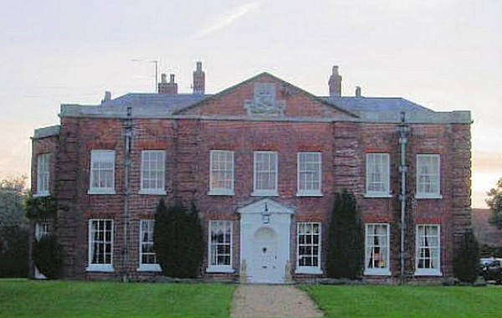
Location: Sculthorpe, near Fakenham, North Norfolk, England
Built: c. 1721

Architectural Description
Cranmer Hall is a substantial early eighteenth-century country house set at the center of a small estate in rural North Norfolk. Constructed primarily of red brick with a slate roof, the house presents a restrained Georgian façade softened by later alterations. The principal front is seven bays wide, with a central three-bay pedimented section articulated by doubled rusticated brick quoins, flanked by outer bays with single rusticated quoins. Although originally three storeys, the house was later reduced to two.

The entrance is marked by an elegant Roman Doric wooden doorcase of the later eighteenth century, with pilasters, entablature, and pediment. The windows are timber sash windows with glazing bars set beneath flat rubbed-brick arches. A prominent south-facing, three-sided bay window of two storeys was added in the later eighteenth century, providing light and views over the grounds.
To the west stands a two-storey, three-bay wing in a consciously neo–seventeenth-century classical style, attributed to Philip Webb. The house is surrounded by lawns and ancillary buildings, including a mid-eighteenth-century barn and formal entrance gates and piers, all contributing to the estate’s architectural coherence.
Interior
Philip Webb, one of the most important figures of the Arts and Crafts movement, carried out additions and alterations around 1880. His work at Cranmer Hall includes the west wing and interior elements executed in a restrained neo–seventeenth-century idiom, emphasizing craftsmanship, proportion, and continuity with earlier English domestic architecture.
Interior features include a north-facing paneled room of relatively plain character; a west-side staircase with paneled dado and detailing characteristic of Webb’s historical revival style; and a first-floor south-facing room that echoes ground-floor proportions through its chimney breast and cornice treatment.

History
The main house dates to about 1721 and was likely built for Robert Donne. In 1751 it passed to the Jones family, who made Cranmer Hall their seat. The estate remained in the possession of the Jones family—and later the Lawrence-Jones family—until 1945.

Cranmer Hall is best known through the memoirs of Sir Lawrence Evelyn Lawrence Jones, who grew up there in the later nineteenth century. In A Victorian Boyhood (1955) and Edwardian Youth, Jones offers a bleak and unsentimental account of life at the hall. Rather than nostalgia, his recollections emphasize emotional austerity, social stagnation, and the pervasive effects of rural decline. His writings situate Cranmer Hall within the broader context of the prolonged agricultural depression that afflicted rural England from the late 1840s until recovery began during the Second World War.
He wrote: “Norfolk is bursting with local memoirists insisting ‘we was poor but we was happy.’ “Jones (who was knighted for his legal work) looks back with some horror at his childhood world - a place of miserable poverty for most, genteel poverty for him, and numbing complacency. It is often forgotten that, from the late 1840s, rural England was gripped by chronic recession, an agricultural depression that took vast areas of land out of cultivation and reduced people to desperation: Recovery only began with the Second World War. Idyllic it was not.”
A recent commentator said: “There is a definite atmosphere at Cramner. The house is at the centre of a small estate with traces of Roman occupation: there is a curious claustrophobia about it - an incestuous sense of over-ripe decay and neglect. Jones makes it apparent that this was not really a happy house - and I think one can feel it.”

The master of the house was Sir Lawrence Evelyn Lawrence Jones, the president of the Society for Psychical Research in 1928-1929.
The Jones family’s tenure ended in 1945, closing nearly two centuries of continuous occupation.

