D

Dandridge Family
Origins in England and Virginia Settlement
The Dandridges were an English family of professional and naval background who established themselves in Virginia in the early eighteenth century. The American line descends from Colonel William Dandridge (1689–1743), born in Oxfordshire, the son of John Dandridge and Bridget Dugdale. Trained for the Royal Navy, he came to Virginia about 1715 and served as a naval officer on the James River. By 1733 he had been appointed a member of the Governor’s Council and acquired the plantation known as Elsing Green in New Kent County, which became the family seat. A near kinsman, John Dandridge (1700–1756), followed him to Virginia and established Chestnut Grove in the same county. These two men founded the principal branches of the family: the Elsing Green branch descended from Colonel William and the Chestnut Grove branch from John, whose daughter Martha Dandridge later became the wife of George Washington.
Colonial and Revolutionary Generations
Members of both branches held positions of public trust and served in the militia and the colonial church. Colonel William Dandridge married Unity West, granddaughter of Governor John West and descendant of Thomas West, Lord De La Warr. Their sons included Captain John Dandridge (1715–1776) and Captain Nathaniel West Dandridge (1729–1784), the latter a burgess from Hanover County and a militia officer in the Revolutionary War. Another member of the family, Bartholomew Dandridge (1750–1798), served as private secretary to George Washington during his presidency and afterward as judge of the General Court of Virginia. From Captain Nathaniel West Dandridge descended the later Hanover and Louisa County lines, including William Dandridge (1810–1884), Lemuel Dandridge (1842–1919), and Bishop Edmund Pendleton Dandridge (1880–1959).
Relationship to George Washington
The family’s most celebrated connection was through Martha Dandridge (1731–1802), daughter of John Dandridge of Chestnut Grove and Frances Jones. She married Colonel Daniel Parke Custis in 1750 and, after his death, George Washington in 1759. The Elsing Green Dandridges, from whom the later Hanover and Tennessee families descend, were collateral kin to her line, first cousins once removed through the brothers William and John Dandridge. Their relationship to Washington was therefore one of cousinship by marriage rather than direct descent.
The Dandridge–Pendleton Alliance
In 1839 William Dandridge of Hanover married Mary Elizabeth Pendleton of Louisa County, uniting the Dandridges with the Pendletons, another of Virginia’s historic families. Their son Lemuel Dandridge (1842–1919) served in the Confederate army and afterward removed to New York, where he married Isabella Lawrence (1846–1914), granddaughter of John Watson Lawrence of Flushing. This marriage joined the old Virginia gentry to the Quaker mercantile families of New York and produced Edmund Pendleton Dandridge (1880–1959), later Bishop of Tennessee.
Character and Legacy
The Dandridges typified the Anglican gentry of colonial and early republican Virginia: educated, hierarchical, and devoted to public service. They produced councillors, planters, jurists, and clergymen over two centuries. Through Martha Dandridge Custis Washington the name became part of the national story, while through the Elsing Green descendants it continued quietly in church and professional life into the twentieth century. The family’s history reflects the transformation of the Virginia gentry from colonial service and plantation life to modern professions and ecclesiastical leadership.

Dandridge, Edmund Pendleton (1880–1959)
Bishop of the Episcopal Church

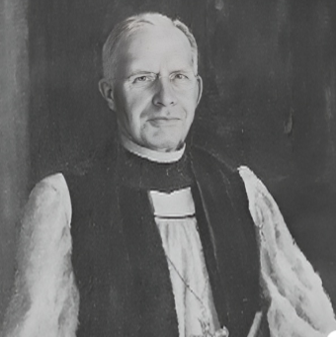
Parents: Lemuel Dandridge (1842–1919) and Isabella Lawrence (1846–1914), daughter of John Watson Lawrence (1800-1888).
Spouse: Mary Robertson Lloyd (1881–1951).
Children: Edmund Pendleton Dandridge Jr. (1912–1989) and Elizabeth Lloyd Dandridge (1914–1996).
Kinship: Third cousin three times removed of the post–World War II Smith generation.
Early Life and Education
Edmund Pendleton Dandridge was born in Flushing, Queens, New York, in 1880, a descendant of the distinguished Virginia Dandridges and the Lawrences of Flushing. His mother was Isabella Lawrence (1846–1914), daughter of John Watson Lawrence (1800–1888).
He attended the University of Virginia, earning the Bachelor of Arts degree in 1902 and the Master of Arts in 1903. He pursued theological studies at Oriel College, Oxford, receiving the Bachelor of Arts in Theology in 1908. He was later awarded honorary Doctor of Divinity degrees by the Virginia Theological Seminary (1921) and the University of the South at Sewanee (1938).
Ordination and Early Ministry
Dandridge was ordained deacon in June 1906 by William Loyall Gravatt, Coadjutor Bishop of West Virginia, and priest in December 1908 by Bishop George William Peterkin. His early service was in parishes of the Diocese of West Virginia, after which he was called to Christ Church, Nashville, Tennessee, where he served for many years as rector. His preaching combined the intellectual discipline of Oxford with the pastoral warmth characteristic of the Episcopal South.
Episcopate
On April 20, 1938, Dandridge was elected Coadjutor Bishop of Tennessee and was consecrated on September 20, 1938, by Presiding Bishop Henry St. George Tucker, assisted by Bishops James D. Wingfield and George L. Bartlett. Upon the retirement of Bishop James M. Maxon, Dandridge succeeded as the fifth Bishop of Tennessee on January 5, 1947. His episcopate, which extended until his resignation on September 20, 1953, was marked by an emphasis on clerical education, parish self-sufficiency, and the maintenance of Anglican tradition in a rapidly modernizing postwar society.
Personal Life and Character
Known for his dignity, erudition, and calm authority, Bishop Dandridge was respected across denominational lines. A 32nd-degree Mason and an active Rotarian, he believed in the compatibility of civic service and religious vocation. His private life reflected the restraint and formality of his generation. He and his wife, Mary Robertson Lloyd, were remembered for their gracious hospitality and quiet generosity to clergy and students.
Later Years and Death
After his resignation, Bishop Dandridge lived in partial retirement, continuing to preach and counsel young clergy. He died in 1959, closing a long life that bridged the genteel Episcopal world of the early twentieth century and the new ecumenical spirit of the postwar church.

Dandridge, Lawrence Effingham (1888–1920)
Parents: Lemuel Dandridge (1842–1919) and Isabella Lawrence (1846–1914).
Spouse: None recorded
Children: None recorded
Kinship: The fourth cousin three times removed of the post–World War II Smith generation.
Lawrence Effingham Dandridge was born in 1888, the younger son of Lemuel Dandridge of Hanover County, Virginia, and Isabella Lawrence of Flushing, New York. Through his father he descended from the Virginia Dandridges of “Elsing Green,” collateral to Martha Dandridge Custis Washington, and through his mother from the Lawrences and Bownes of Flushing, one of the oldest Quaker families of colonial New York.
He is included here to show the persistence of the name Effingham in all the related families.

Dandridge, Lemuel (1842–1919)

Captain, C.S.A.

Parents: William Dandridge (1810–1884) and Mary Elizabeth Pendleton (1818–1891).
Spouse: Isabella Lawrence (1846–1914)
Children: Edmund Pendleton Dandridge (1880–1959) and others who died in infancy.
Kinship: Husband of the second cousin four times removed of the post–World War II Smith generation.

Early Life and Ancestry
Lemuel Dandridge was born at Elm Hill, Hanover County, Virginia, in 1842, into one of the state’s historic landed families. His father, William Dandridge (1810–1884), was a descendant of Col. William Dandridge of “Elsing Green” (1689–1743), a member of the Virginia Governor’s Council and brother of John Dandridge of Chestnut Grove, father of Martha Dandridge Custis Washington. His mother, Mary Elizabeth Pendleton, belonged to the distinguished Pendleton family of Louisa County and was a great-niece of the Revolutionary jurist Edmund Pendleton (1721–1803)
Education and the Civil War
Educated privately and at the Hanover Academy, Lemuel entered the University of Virginia in 1859 to read law. His studies were interrupted by the outbreak of the Civil War. In May 1861 he enlisted in the 15th Virginia Infantry (Company D), “Hanover Dragoons,” serving throughout the conflict under Generals Pickett and Mahone. He participated in the Peninsula Campaign, Cold Harbor, and the siege of Petersburg, attaining the rank of captain before surrendering at Appomattox Court House in April 1865.
Postwar Career and Removal to New York
Following the war, Dandridge readmitted himself to the bar but found the practice of law in postwar Virginia unremunerative. In 1871 he removed to New York City, where family and business connections offered new prospects. By the mid-1870s he was employed as a legal adjuster and insurance underwriter for the New York Mutual and later the Atlantic Fire Insurance Company, maintaining offices on Cedar Street, Manhattan. He became active in the Episcopal Church and in Southern expatriate circles, frequently contributing to the Southern Churchman on church affairs and reconciliation.
Marriage and Family
On November 16, 1876, at Flushing, Long Island, he married Isabella Lawrence (1846–1914), daughter of John Watson Lawrence (1812–1888) and Elizabeth Bowne (1815–1891), thereby
uniting two prominent colonial lines. The Lawrences were an old Quaker mercantile family descended from John Lawrence (1618–1699), one of the founders and later mayor of New York, and from the Bownes and Townsends of Flushing. Their marriage symbolized the reconciliation of Northern and Southern elites after the Civil War — Virginia gentry meeting New York Quaker merchants through shared education, Anglican worship, and civic standing.
Their only surviving child, Edmund Pendleton Dandridge (1880–1959), educated at Virginia, Oxford, and Sewanee, became Bishop of Tennessee (1938–1953). Lemuel’s piety, reserve, and sense of duty deeply influenced his son’s clerical vocation.

Ancestry and Family Connections
The Dandridge family descends from John Dandridge (1700–1756) of “Chestnut Grove,” New Kent County, Virginia, and his wife Frances Jones (1710–1785), whose daughter Martha Dandridge married George Washington in 1759. The branch from which Bishop Dandridge descended stemmed from William Dandridge (1699–1743), brother of John, who settled at “Elsing Green” on the Pamunkey River. Members of this collateral line removed to western Virginia and, by the early nineteenth century, to New York and New Jersey.
His mother’s family, the Lawrences of Flushing, descended from John Lawrence (1618–1699), an early mayor of New York and brother of Thomas and William Lawrence, founders of the family’s numerous American branches. Through his maternal grandfather John Watson Lawrence (1812–1888), a prominent Flushing Quaker merchant, Bishop Dandridge was related to the Lawrence, Bowne, and Townsend families, whose marriages interlinked the leading Quaker mercantile clans of Long Island and New York City.

Davis & Lawrence Company
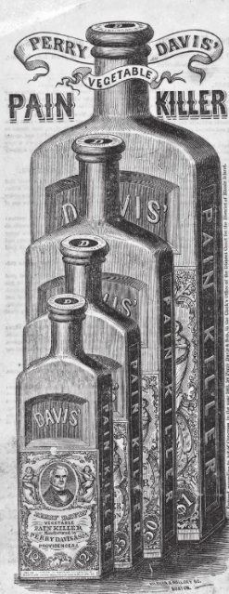
The Davis & Lawrence Company (often styled as Davis & Lawrence Co.) was a prominent 19th-century patent medicine firm, best known for manufacturing and distributing Perry Davis' Vegetable Pain Killer (commonly called Perry Davis Pain Killer or simply Pain Killer).

Origins with Perry Davis

Perry Davis (1791–1862), a Rhode Island entrepreneur from Providence, published a book Nursing the Sick, which achieved mention in Culinary Landmarks: A Bibliography of Canadian Cookbooks 1825–1949. This was not, however, the foundation of his

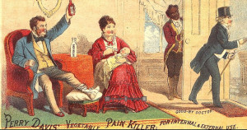
success.
In 1849, Perry Davis, suffering from severe pain himself, Davis created a "vegetable elixir" formula — primarily a high-alcohol base (around 89-90% ethanol) mixed with opium (opiates), herbs, and other ingredients. He introduced it as Perry Davis' Vegetable Pain-Killer, patented in 1845. It was marketed as a versatile remedy for virtually any pain (internal or external), including ailments like cholera, dysentery, toothaches, bruises, sprains, and more — revolutionary at the time for promising broad "pain relief" rather than targeting specific diseases.
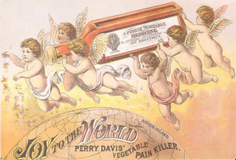
Davis and his son Edmund (Perry Davis & Son) built the business in Providence, RI, turning it into one of the era's early global patent medicines through aggressive advertising, including almanacs, testimonials, and international distribution. It became a household name, with millions of bottles sold over decades, and helped popularize modern brand marketing tactics in the patent medicine industry.

Transition to Davis & Lawrence Company
By the later 19th century, the business expanded into Canada. William Van Duzer Lawrence (1842–1927), a New York-born entrepreneur, became involved after moving to Montreal. He joined the wholesale drug operations tied to Perry Davis' product, initially through Perry Davis & Son's Canadian interests.

Around the 1880s, it was reorganized as the Davis & Lawrence Company, with operations based in Montreal, Canada. Lawrence rose quickly, becoming a partner and managing the Canadian side. The firm continued producing and marketing the Pain Killer (labeled under Davis & Lawrence Co. in many surviving bottles and artifacts), along with other remedies. It was a key player in the North American patent medicine trade, publishing almanacs and distributing widely.

Lawrence's involvement proved highly profitable — the company paid strong dividends (often over 20% on capital), contributing significantly to his personal fortune.

Later Developments and Legacy
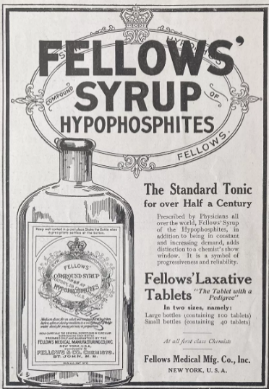
In 1888, Lawrence left the Montreal operation to return to New York City, where he took over and managed another patent medicine firm he had helped organize: Fellows Medical Manufacturing Company (known for Fellows' Syrup of Hypophosphites, which included ingredients like strychnine). His wealth from Davis & Lawrence and Fellows funded major philanthropic and real estate ventures, including developing Lawrence Park in Bronxville, New York, founding Lawrence Hospital, and establishing Sarah Lawrence College in 1926 (named after his wife).

The Davis & Lawrence Company itself continued into the early 20th century (with family members like A.W. Lawrence involved as president by the 1920s–1930s), though like many patent medicine firms, it faced declining relevance after regulations tightened (e.g., the 1906 Pure Food and Drug Act in the US exposed addictive ingredients like opium and high alcohol content). The Pain Killer's heyday was in the mid-to-late 1800s, when it was a blockbuster "global brand" in the unregulated era of patent medicines.
Today, surviving bottles and labels from Davis & Lawrence Co. appear in museum collections (e.g., Smithsonian, various historical pharmacy exhibits), serving as artifacts of 19th-century medicine, marketing, and the opioid/alcohol-based “cure-all” phenomenon.

Ding Dong House
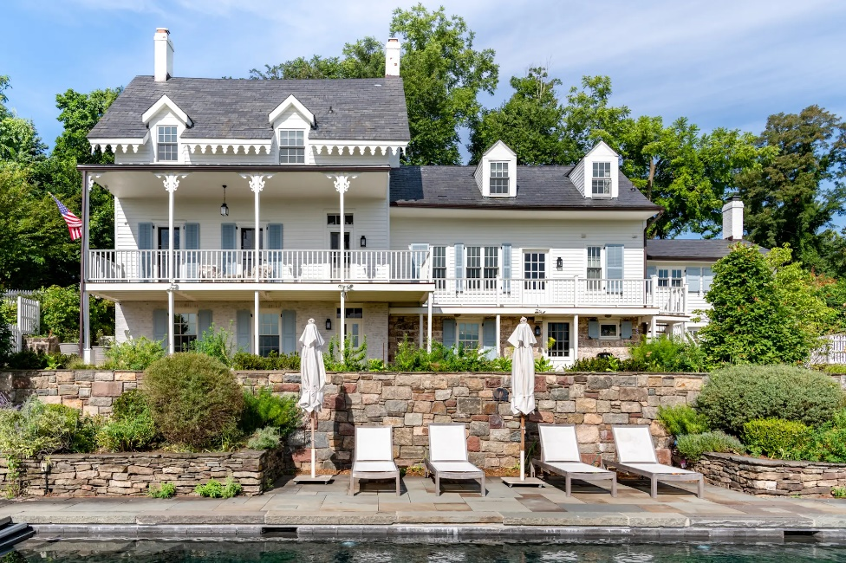
Location: 35 Washington Spring Road, Palisades, New York.
Built: 1750 and later additions.

Architectural Description
The Ding Dong House is rooted in the vernacular tradition of the Hudson River Valley Dutch farmhouse. The original mid-eighteenth-century section was built for durability and practicality, with simple massing and restrained detailing appropriate to a rural riverside settlement.

The nineteenth-century additions enlarged the house without overwhelming the original core, resulting in a layered structure that reads as historically evolved rather than formally planned. In later descriptions, the house has sometimes been characterized as a bracketed farmhouse, reflecting modest decorative embellishments added during the Victorian period.

History
The oldest portion of the Ding Dong House was built around 1750 by John Sneden, a member of the family that founded and operated Sneden’s Ferry, a vital Hudson River crossing that gave its name to Snedens Landing. The Sneden family played a central role in the early development of the hamlet, which remained a small, semi-isolated riverside community well into the nineteenth century.

The Sneden family occupied the house for nearly two centuries. During its early history, the house also served a communal role; local tradition holds that it functioned at one time as the settlement’s first library, reinforcing its place as a social as well as domestic center.
In the mid-nineteenth century, around the 1860s, the house was substantially expanded, enlarging its footprint while retaining the character of the original structure. These additions reflect the gradual prosperity and changing domestic needs of the period rather than any single comprehensive redesign.
In the twentieth century, the Ding Dong House became part of the artistic and intellectual milieu for which Snedens Landing became known. The hamlet attracted writers, musicians, actors, and visual artists seeking privacy and inspiration within easy reach of New York City. Among the notable figures associated with the house at various times were composer Aaron Copland, choreographer Jerome Robbins, and actress Margot Kidder. In the late twentieth and early twenty-first centuries, it was owned jointly by actors Uma Thurman and Ethan Hawke.
Mary Trimble Lawrence Tonetti also lived in the Ding Dong House, adding the property to the network of residences associated with the Lawrence family and its descendants along the Hudson River.

Dwight Family
Origins and Colonial Settlement
The Dwights were among the most prominent and long-established families of colonial New England. Their American progenitor was John Dwight (1601–1660), born in Dedham, Essex, England, who emigrated to Massachusetts Bay in 1634 and was one of the founders of Dedham, Massachusetts. He was a selectman, deputy to the General Court, and one of the organizers of the first town school in America. Through his sons Timothy and Nathaniel, he became the ancestor of two distinguished lines that contributed for more than three centuries to American education, religion, and public life.
The Connecticut Valley Dwights
By the late seventeenth century the family had become centered in the Connecticut River Valley, especially in Northampton and Springfield. Captain Henry Dwight (1676–1732) of Hatfield, grandson of the immigrant, established the branch later known as the “Dwights of Springfield.” His sons were merchants, lawyers, and judges, and they intermarried with the families of Pynchon, Williams, Strong, and Stoddard, forming part of the clerical and mercantile elite of western Massachusetts. Among his descendants were Major Josiah Dwight (1703–1768) of Springfield and Timothy Dwight (1726–1777) of Northampton, the latter a Continental Congress delegate and father of President Timothy Dwight IV (1752–1817) of Yale College.
(Sources: B. W. Dwight, Descendants of John Dwight, I:194–317; New England Historical and Genealogical Register, vol. 18 [1864].)
Education, Ministry, and Public Service
The Dwights produced an exceptional number of clergymen, educators, and public servants. Timothy Dwight IV, a Calvinist theologian and poet, served as chaplain to the Continental Army and later as President of Yale College (1795–1817), where he was a leading figure in the intellectual revival of the Federalist era. His grandson Timothy Dwight V (1828–1916) also became President of Yale (1886–1899), while other members of the extended family founded or taught at Williams, Hamilton, and Amherst Colleges. From the eighteenth through the nineteenth centuries the Dwights ranked with the Edwardses, Stoddards, and Mathers among New England’s dynasties of education and faith.
Industrial and Professional Expansion
During the nineteenth century the Dwights diversified into commerce and engineering. Jonathan Dwight III (1799–1856) and his son Jonathan Dwight IV (1831–1910) of Springfield and New York were civil engineers and industrialists who participated in the great age of railroad construction. Jonathan IV, a Harvard and West Point graduate, built bridges for the New York Central and supervised the foundations of the Statue of Liberty and early subway works in New York. His son Jonathan Dwight V (1858–1929) combined scientific and medical training with a passion for natural history, becoming president of the American Ornithologists’ Union and assembling one of the largest bird collections in North America, later donated to the Smithsonian Institution.
Character and Influence
Throughout their history the Dwights exemplified the classical New England virtues of learning, piety, and civic responsibility. Their family alliances linked them with the Edwards, Stoddard, and Lawrence families, and later with the Caldwells and Rutters of New York and Maryland. As theologians, educators, and scientists, they helped shape American intellectual and moral life from the colonial period through the early twentieth century.

Dwight, Jonathan IV (1831–1910)

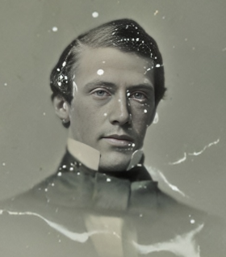
Parents: Jonathan Dwight III (1799–1856) and Ann Bartlett Eich (1798–1884).
Spouse: Julia Lawrence Hasbrouck (1838–1914), daughter of Garrett DuBois Hasbrouck (1810–1888) and Julia Lawrence (1809–1873).
Children: Jonathan Dwight V (1858–1929) and Arthur Dwight (1863–1885).
Kinship: Husband of the second great-granddaughter of the sixth great-granduncle of the post–World War II Smith generation.
Family Background and Education
The Dwights were an old New England family of considerable distinction, long settled in Massachusetts and Connecticut and noted for their connection with Yale College. Jonathan Dwight IV was a second cousin of Timothy Dwight (1752–1817), the celebrated theologian and president of Yale. Born in 1831, Jonathan IV attended Harvard College, where he graduated with the class of 1852. While an undergraduate he took part in the first intercollegiate athletic contest in American history—the Harvard–Yale rowing race on Lake Winnipesaukee, held on August 3, 1852. He rowed in the Harvard boat Oneida, which won the race.
Dwight’s Harvard years were not without incident. He was suspended—or, in the collegiate phrase of the time, “rusticated”—for seventeen months for what he later described as “the expression of my love to a certain College officer.” After leaving Harvard he entered the United States Military Academy at West Point to study civil engineering, laying the foundation for his later professional career.
Marriage and European Travel
In 1857 Dwight married Julia Lawrence Hasbrouck, whose mother, Julia Lawrence, was of the prominent Lawrence family of New York and a descendant of the Flushing Quakers. Soon after their marriage the couple spent two years travelling in Europe, a tour that reflected both their means and their cosmopolitan outlook.
Engineering Career
Dwight devoted his life to large-scale engineering and construction projects. He was active in railroad building during the great age of American expansion, specializing in bridges. He helped construct one of the first bridges over the Mississippi River and supervised many of the bridgeworks for the New York Central Railroad—a company later headed by his distant kinsman James Henry Rutter (1836–1885).
Dwight also played a notable part in several of the major public works of late nineteenth-century New York. He directed the construction of the foundations for the Statue of Liberty on Bedloe’s Island and later assisted in the early phases of the New York subway system. As chief engineer of the New York and New Haven Railroad, he supervised the complex operation of raising the railway to an elevated grade without interrupting service, managing the passage of some 120 trains daily without accident.
Later Life and Character
Jonathan Dwight’s combination of technical skill and administrative steadiness earned him a reputation among engineers as a man of quiet competence. His later years were clouded by the death of his younger son, Arthur, who died at twenty-one shortly after graduating from Columbia with honors in 1885. Friends observed that Jonathan never fully recovered from the loss. He continued to reside in New York until his death in 1910.

