A
Abrams, Margaret (1816–1848)
Parents: [Not yet identified]
Spouse: None reported.
Children: James Henry Caldwell (1838–1870); Edward Holland Caldwell (1844–1872).
Kinship: Mother of James Henry Caldwell, the third great-grandfather of the post–World War II Smith generation.
Early Life
Margaret Abrams was born in 1816, reportedly in New York City. Little is yet documented about her family background or early years, and further research may clarify her origins.
Relationship with James Henry Caldwell
Margaret became the companion of James Henry Caldwell (1793–1863), the New Orleans theatre impresario often called the “Father of the American Theatre” in the South. Their relationship began while Caldwell was still legally married to his first wife, Maria Carter Hall (1790–1859), the widow of Warner Wormeley. Although they never married, the relationship was lasting and produced two children.
Children and Legitimization
Margaret and James Henry had two sons: James Henry Caldwell, born in 1838, and Edward Holland Caldwell, born in 1844. Both were later legitimized, securing their legal and inheritance rights despite the circumstances of their birth.
The legitimization of James Henry Caldwell's two sons was required due to the specificity of Louisiana's Civil Law. At the time, children born outside of lawful wedlock, especially those born while their father was still legally married to another woman (classified as adulterous bastards), were severely restricted from inheriting property. Under the Louisiana Civil Code of 1825, such children had minimal rights, being virtually excluded from intestate succession in favor of the father's collateral relations. Since Caldwell could not marry Margaret Abrams to legitimize the boys, he secured their rights through a special legislative act, Act No. 121 of 1845, which officially declared them legitimate heirs, thereby bypassing the code's restrictions and securing their inheritance.
Death
Margaret Abrams died on March 4, 1848 at the age of thirty-two. Further details concerning the circumstances of her death and her burial location have not yet been verified.

Alexandre Family

Origins and Early History
The Alexandre family originated in the Channel Islands, where they were prosperous farmers. Although their names were French, they were Anglicans by religion—typical of Channel Islanders whose culture blended English and Norman elements. Descendants are often surprised to discover that they have a substantial share of Scandinavian genes. The family’s rise to prominence began with Frederick Francis Alexandre (1809–1889), who became the first member to emigrate to North America.

Frederick Francis Alexandre and the Alexandre Line
Frederick Francis Alexandre went to sea as a young man and became a ship’s captain by the age of twenty-one. After settling in New York, he founded a commission house that prospered and later established the Alexandre Line, a successful shipping company. The firm gained distinction when it secured a U.S. government contract to carry mail to Mexico. This connection with government service provided both credibility and financial stability, forming the foundation of the family’s wealth.

As was true of several mercantile families of the nineteenth century, the Alexandre fortune was built in part through such government contracts—not through favoritism, but through competence and reliability. The prestige of official association often led other firms to seek out the Alexandre company as a trusted business partner, thereby compounding its success.

Social Position and Alliances
A defining cultural shift occurred when Frederick Francis married a French Catholic; while he remained Anglican, his descendants were raised in the Catholic faith. This distinguished them as a leading family within New York's "Catholic Aristocracy," allowing them to form alliances with other prominent Catholic mercantile families while maintaining the French pronunciation of their surname as a mark of distinction.

The Alexandres were part of a transitional generation in New York society: they followed the early Dutch mercantile families such as the Roosevelts, yet they preceded the later industrial “Gilded Age” dynasties. By the late nineteenth century, they were regarded as part of the established “Old Money” elite. Their marriages reflected this position; they tended to ally themselves with French Catholic merchant families and maintained the French pronunciation of their surname as a sign of distinction.

The Sporting Life
As the family moved from making money to spending it, their culture became synonymous with high-end sports. They were avid yachtsmen and leaders in the American equestrian world. Family members were fixtures at the Coaching Club, the National Steeplechase, and Jerome Park. Later generations, particularly the descendants of James Henry Alexandre, were central to the North Shore, Long Island, sporting set, known for their participation in polo, drag hunting, and competitive shooting.

Decline and Transition
By the turn of the twentieth century, the Alexandre Line had been sold, and the family capital began to dissipate through division among heirs and the maintenance of lavish estates such as Shore Acres (Staten Island), Nirvana (Stamford), and Spring Lawn (Lenox) (see Houses and Estates Appendix). The family trajectory followed a classic pattern: the first generation built the fortune, the second and third consolidated social status through leisure and alliances.
0
The alliance between the Alexandre and Lawrence families was established when James Henry Alexandre (1848–1912), son of Frederick Francis Alexandre, married Elizabeth Boyce Lawrence (1862–1906). She raised his children by his earlier marriage to Gertrude Jerome, linking the Alexandres with one of New York’s historic Quaker-descended families, and perpetuating the family’s social prominence into the next generation.
The fourth and fifth generations transitioned into the professional class, serving primarily as stockbrokers, lawyers, and corporate executives.

Notable Characteristics
- The "Impulsive" Streak: While the founders were noted for steadiness, later branches (particularly the line of Jerome Alexandre) were noted in the press for impulsiveness, romantic elopements, and occasional tragedy.
- Philanthropy: The women of the family, such as Anna Remsen Alexandre and Marie Civilise Alexandre, were noted for their distinct service to French and British war relief efforts, reflecting their enduring trans-Atlantic consciousness.

Alexandre Line


The Alexandre Line—later formally styled the New York, Havana & Mexico Steamship Line—was a pioneering nineteenth-century maritime enterprise that established the first regular steamship service linking New York with Cuba and the Gulf ports of Mexico. Founded by Frederick Francis Alexandre (François Alexandre, 1809–1889), the company became an important participant in the growing commercial and passenger traffic between the United States, the Caribbean, and Mexico during the mid- and late nineteenth century.

Frederick Alexandre was born on the Island of Jersey in the Channel Islands to a farming family of French origin. After the death of his father when he was thirteen, English primogeniture laws left him little prospect of inheritance, and he chose a life at sea. Beginning as a common sailor, he rose rapidly through the ranks of the merchant marine and by the age of twenty-one had become a captain engaged in the Brazil trade, commanding vessels such as the Nina.

Around 1837 he settled in New York City, then one of the busiest ports in the Atlantic world. In 1838 he married Marie Civilise Cipriant and established a commission house and ship-chandler’s business on South Street and Washington Street, at the center of New York’s maritime district. Through this business he developed extensive commercial connections with merchants trading to the Caribbean and Gulf of Mexico.

In 1842 Alexandre expanded into shipping, establishing a line of sailing vessels operating between New York and Honduras. Within a few years the service was extended to Havana and the eastern ports of Mexico, including Veracruz, Campeche, Progreso, and Frontera. By the mid-1840s the Alexandre Line had become the first company to offer regularly scheduled sailings between New York, Cuba, and Mexico, an important innovation in an era when most maritime voyages operated on irregular freight schedules.

As American commerce with Mexico and the Caribbean expanded, the company flourished. By 1874 the Alexandre Line had secured a subsidy from the Mexican government to carry the mails between New York, Havana, and Mexican ports. During this period the firm began operating under the name New York, Havana & Mexico Steamship Line.

The Alexandres also promoted an early form of Caribbean tourism. Promotional pamphlets advertised “New and Varied Excursion to the Tropics for Invalids and Tourists,” encouraging northern travelers to visit the warm climates of Cuba and Mexico. The line advertised voyages of “about ten days” between New York and Veracruz, though weather conditions in the Gulf often made arrivals uncertain and delays were common.

During the 1870s the company expanded and modernized its fleet. By its peak the Alexandre Line owned as many as fourteen ships and began replacing sailing vessels with iron steamships, better suited for carrying passengers, freight, and government mail. Management of the company increasingly passed to Alexandre’s sons, who operated the business under the style F. Alexandre & Sons.

The principal family members involved in the enterprise were:

Frederick Francis Alexandre (1809–1889), founder of the line.
John Ernest Alexandre (1843–1913), son and partner in the firm.
Joseph Frederick Alexandre (1846–1910), son and partner in the business.
Henry William Alexandre (1853–1927), son and later manager of company operations.

Among the best-known vessels of the Alexandre Line were several steamships that served the New York–Havana–Mexico route.

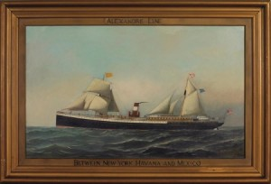

The City of Pueblo incorporated improvements in passenger comfort. Its saloon was furnished with small restaurant-style tables, allowing passengers to dine privately and at flexible hours rather than at large communal tables. This arrangement was unusual at the time and represented an early effort to provide a more refined passenger experience.

The City of Washington, launched on August 30, 1877, at Chester, Pennsylvania, represented the modern phase of the Alexandre fleet. The vessel accommodated about one hundred first-class passengers in seventy-five staterooms and carried additional steerage passengers and cargo. After the Alexandre Line was sold, the ship continued in service under the Ward Line. On February 15, 1898, when the American battleship USS Maine exploded in Havana Harbor, the City of Washington lay anchored nearby. Despite damage from flying debris, the crew immediately launched rescue efforts, lowering boats to aid survivors and converting the dining saloon into a temporary hospital. Later in its career the vessel was cut down and used as a coal barge. In 1917 it ran aground on a reef near Key Largo, Florida, and its wreck today forms a well-known diving site in the Florida Keys.

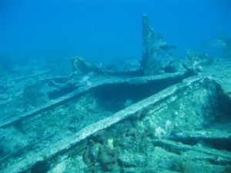
The City of Vera Cruz was lost during a violent hurricane off the coast of Florida on August 28, 1880. Lifeboats were destroyed before they could be launched and the ship quickly foundered. Survivors struggled for hours among floating wreckage; sixty-nine passengers and crew died, while eleven men eventually reached shore after more than a day in the water. The tragedy became one of the most dramatic maritime disasters associated with the Alexandre Line.

For several decades the Alexandre Line prospered in the growing trade between the United States, Cuba, and Mexico. However, its fortunes depended heavily on the Mexican mail subsidy. In 1887 the Mexican government transferred that contract to a heavily subsidized Spanish competitor. Without the subsidy the Alexandres found it difficult to compete with larger shipping companies, particularly the Ward Line (New York and Cuba Mail Steamship Company).

In 1888 Frederick Alexandre and his sons liquidated the enterprise and sold its vessels and routes to the Ward Line, which absorbed the Mexican service into its own operations. Frederick Alexandre died in New York on June 8, 1889, shortly after the sale of the fleet.

Although the company ceased to exist as an independent line, the Alexandre Line played an important role in nineteenth-century maritime commerce. It helped establish regular passenger and mail service between New York, Cuba, and Mexico, bridged the transition from sail to steam navigation, and contributed to the early development of Caribbean tourism.

Alexandre, Anna Remsen (1895–1984)

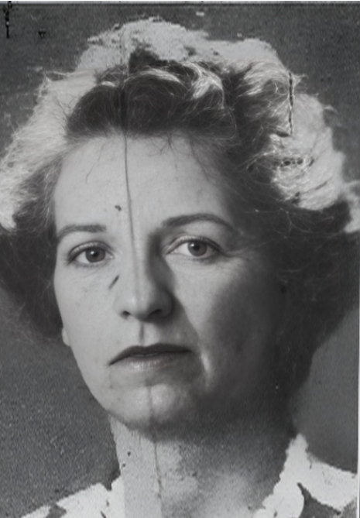
Parents: John Ernest Alexandre (1840–1910) and Helen Lispenard Webb (1859–1928).
Spouse: None recorded.
Children: None recorded.
Kinship: First cousin twice removed of the post–World War II Smith generation.

Early Life and Family Background Anna Remsen Alexandre was born in 1895 into a socially prominent New York family. She was raised in Manhattan and spent her summers in Lenox, Massachusetts, at the family residence known as The Gables (see Houses and Estates).
Residences and Lifestyle Anna lived for most of her adult life at 164 East 72nd Street in Manhattan. Summers were spent at The Gables and Strawberry House in Lenox, Massachusetts, where she enjoyed the seasonal social and cultural life of the Berkshires. As a young woman, she participated in winter sports in Lenox and suffered a sledding accident reminiscent of the one that inspired Edith Wharton’s Ethan Frome. According to The Berkshire Eagle, she was “hurt while coasting at the Lenox club,” sustaining facial injuries that fortunately did not result in lasting disfigurement.
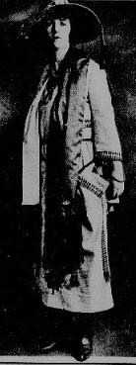
Social Activities and Public Life On January 20, 1920, Anna took part in a fashion show in Manhattan to benefit the American Committee for Devastated France. Her appearance was met with acclaim, and she brought the audience at the Commodore Hotel to its feet. The New York Herald reported that her outfit, called “The Dress of the Nations,” combined “the chic of France,” “the swagger of England,” “the finesse of Belgium,” and “the bold art of the Slavs,” featuring striped cartridge silk with Czechoslovakian-inspired motifs.
Interests and Philanthropy Anna inherited approximately $600,000 (about $11 million in 2025 dollars) from her mother in 1930. In Lenox, her hobbies included painting, flower arranging, golf, and bookbinding. During World War II, she headed the British War Relief effort in Lenox.
Anna had a long-time companion, Elsie G. Wulff (1893–1983), who was considered more like a protective sister and was known to be somewhat domineering. Anna was generous to her extended family and often invited younger relatives to luncheons at her East 72nd Street apartment. When her cousin, Mary Elizabeth Alexandre Smith, was a graduate student at Columbia University, Anna regularly hosted her and her Huxley cousins, providing meals to what she affectionately viewed as “starving graduate students.”
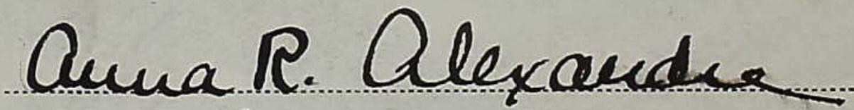
Later Years and Death Anna spent the last three years of her life in Lenox. She died on September 22, 1984, and left her estate to her grandnephews and grandnieces, the Huxleys and the Darwins.

Alexandre, Anthony “Tony” Joseph (1926–2021)

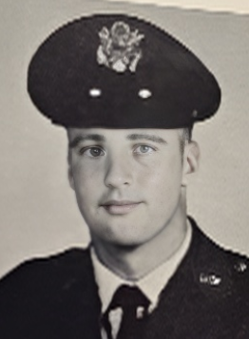
Parents: Frederick Francis Alexandre (1894–1968) and Regina Mathilde Saportas (1898–1957).
Spouse: Louisa Gilbert (1937–2019.
Children: Christopher Alexandre (1957– ), Michael Alexandre, and Catherine Corry Alexandre (1969– ).
Kinship: First cousin once removed of the post–World War II Smith generation.

Early Life and Education
Anthony “Tony” Joseph Alexandre was born in 1926, the son of Frederick Francis Alexandre and Regina Mathilde Saportas. He grew up on Long Island, where he formed friendships that lasted throughout his life. He attended the Canterbury School in Connecticut before enrolling at Princeton University, where he earned his degree.

Military Service
Following his graduation, Tony joined the U.S. Air Force and trained as a pilot, continuing a family tradition established by his older brother, Frederick “Freddy” Alexandre. His time in flight school proved momentous in another way: there he met the sister of his best friend, Louisa Gilbert, who would later become his wife. He served as a pilot in the U.S. Air Force during the Korean War era, attaining the rank of Captain.

Marriage and Family Life
Tony and Louisa Gilbert married on September 15, 1956.
and settled in New Canaan, Connecticut, where they raised their three children—Christopher, Michael, and Catherine. The family was known for its closeness, and Tony’s good humor and sociable nature made him a beloved figure among relatives and friends alike.

Later Years in Beaufort
In 1995, Tony and Louisa moved to Beaufort, South Carolina, following two of Tony’s sisters, Patricia “Pat” Claiborne and Mathilde Zara. Together they opened Cravings by the Bay, a specialty foods store that became a local favorite. Over time, other members of the extended Alexandre family also relocated to Beaufort, creating a vibrant family enclave. Several large reunions were held there, including gatherings of more than one hundred Alexandre relatives.

Death
Anthony Joseph Alexandre died on October 7, 2021.

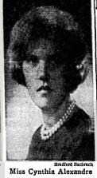
Alexandre, Cynthia Lenox Banks (1944– )

Parents: Dewitt Loomis Alexandre (1917–1982) and Cynthia Lenox Banks (1918–1991). Spouse: Edmund Pendleton Rogers III (1941– ).
Children: Edmund Pendleton Rogers IV (1972– ).
Kinship: Second cousin of the post–World War II Smith generation.

Early Life and Family Cynthia Lenox Banks Alexandre was born in 1944, the daughter of Dewitt Loomis Alexandre and Cynthia Lenox Banks. She belongs to the branch of the Alexandre family descended from the prominent New York shipping merchant Frederick Francis Alexandre.
Career and Activities A graduate of Smith College, she spent part of her professional life in London, where she was associated with the Alexandre family’s continuing international connections. During that period she attended the funeral of her distant relative, Sir Winston Churchill, as a representative of the Alexandre family.
Residences In later life, Cynthia Alexandre has made her home in Gulf Stream, Florida.

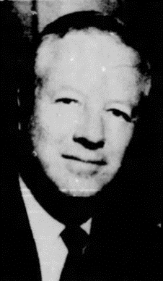
Alexandre, Dewitt Loomis (1917–1982)

Parents: James Henry Alexandre (1883–1956) and Anne Loomis (1890–1948).
Spouse: Cynthia Lenox Banks (1918–1991), marriedJune 14, 19411.
Children: Anne Lenox Alexandre (1942– ), Cynthia Lenox Banks Alexandre (1944– ), and Dewitt Loomis Alexandre II (1949– ).
Kinship: First cousin once removed of the post–World War II Smith generation.

Early Life and Education Dewitt Loomis Alexandre was born in 1917. He was educated at The Pomfret School and later at Harvard University.
Military Service During World War II he served in the U.S. Marine Corps as a bomber pilot in the Pacific theatre, stationed at Guadalcanal, completing 48 combat missions. He was awarded three Distinguished Flying Crosses and five Air Medals for his wartime service. He achieved the rank of Major.
Career and Civic Activities Following his military service, Alexandre embarked on a corporate career. He became senior vice-president of Engelhard Industries, the world’s leading producer and refiner of precious metals.
In his local community he served as president of the Somerset Hills Country Club in Bernardsville, New Jersey, and was a member of the Essex Fox Hounds and the Somerset Lake and Game Club.

Alexandre, Dewitt Loomis II (1949– )


Parents: Dewitt Loomis Alexandre (1917–1982) and Cynthia Lenox Banks (1918–1991). Spouse: (1) Priscilla Baker Hill (1952– ): (2) Kristin Kuhns Gerrity (1948– ).
Children: With Priscilla Hill: Priscilla Alexandre and Anthony Alexandre; with Kristin Kuhns: James Andrew Alexandre (1986– ) and Cynthia Lenox Banks Alexandre (1993– ).
Kinship: Second cousin of the post–World War II Smith generation.

Early Life and Education Dewitt Loomis Alexandre II was born in 1949, the son of Dewitt Loomis Alexandre and Cynthia Lenox Banks Alexandre. He attended Salisbury School in Connecticut and later graduated from the University of Denver.
Career He began his professional career in finance, serving as an associate with the investment firm Kidder, Peabody & Co., where he worked in corporate and securities analysis during the firm’s expansion years in the 1970s and 1980s.
Personal Life Alexandre first married Priscilla Baker Hill in 1976, with whom he had two children. After their separation, he married Kristin Kuhns Gerrity, a designer and arts philanthropist, with whom he has two more children.
Residences and Affiliations He has been associated with business and family circles in both New York and Florida and remains active in private investment and family ventures.

Alexandre, Frederick Francis (1809–1889)
Parents: Unknown, farmers of Saint Helier, Island of Jersey, Channel Islands.
Spouse: Marie Civilise Cipriant (1811–1882).
Children: John Ernest Alexandre (1840–1910), Francis Victor Alexandre (1842–1876), James Joseph Alexandre (1844–1894), and James Henry Alexandre (1848–1912).
Kinship: Second great-grandfather of the post–World War II Smith generation.

Early Life and Education
Frederick Francis Alexandre—also known as François Alexandre—was born on August 5, 1809, in Saint Helier, on the Island of Jersey in the Channel Islands. He was the son of a farmer and was raised in modest circumstances. When his father died, he renounced the family estate—his inheritance under English primogeniture laws—in favor of his sisters, an early sign of the independence and self-reliance that would mark his later life.

With an inclination for the sea, he went to sea “before the mast” at a young age and spent his early years acquiring an education wherever he could—attending schools while in port and reading during his spare time aboard ship. At the age of twenty-one, he took command of the Nina on a voyage from Liverpool to Rio de Janeiro, establishing himself as a capable and enterprising mariner.

Career and the Alexandre Line
Around 1838, Alexandre settled in New York City, where he married Marie Civilise Cipriant, a French Catholic. Although he remained Episcopalian, he regularly accompanied his wife to church. That same year, he opened a small chandler’s shop on Washington Street, paying an annual rent of only $25. His diligence and acumen soon allowed him to expand into shipping and commerce.

In 1842 he established a line of sailing vessels between New York and Honduras, later extending the service to Vera Cruz and other South American ports. By the 1860s he owned as many as fourteen ships and founded what became known as the Alexandre Line, which carried both freight and mail. In 1867, he replaced his sailing ships with steamers, securing a United States government contract to carry mail between New York, Havana, and Mexico—a partnership that lasted for nearly two decades.

Character and Reputation
According to his obituary, Alexandre “left his Channel Islands home with sixpence in his pocket and died a millionaire.” His career exemplified the classic nineteenth-century American success story: enterprise, perseverance, and integrity rewarded by prosperity. His dealings were described as honorable, and his ships were known for their reliability.

Religious and Personal Life
Though raised in the Church of England, Alexandre’s marriage brought him into close association with the Catholic faith. He never converted but was described as attending Mass regularly with his wife. Their household blended French and English traditions and formed the foundation of the Alexandre family’s later prominence in New York’s mercantile and social world.

Death
Frederick Francis Alexandre died in New York City on June 8, 1889. His obituary noted that he had been “a merchant, born in Jersey… who by energy, honesty, and ability, raised himself from humble beginnings to a commanding position in American commerce.” He was buried in the family plot in Greenwood Cemetery, Brooklyn.

Alexandre, Frederick Francis (1894–1968)


Parents: James Henry Alexandre (1848–1912) and Elizabeth Boyce Lawrence (1862–1906). Spouse: Regina Mathilde Saportas (1898–1957)..
Children: Elizabeth Lawrence Alexandre (1917–1964), Frederick Francis Alexandre Jr. (1920–1945), Mathilde Marie Alexandre (1921–2009), Joan Alexandre (1923–1984), Lawrence Armitage Alexandre (1924–1996), Anthony Joseph Alexandre (1926–2021), and Patricia Jane Alexandre (1928–2017).
Kinship: Granduncle of the post–World War II Smith generation.

Early Life and Education
Frederick Francis Alexandre was born in 1894, the son of James Henry Alexandre and Elizabeth Boyce Lawrence. He married Regina Matilde Saportas in 1916,and completed his degree at Princeton University after the war, graduating in 1921.

Military Service
During World War I he served as a lieutenant in the 304th Field Artillery Regiment, 77th Division of the U.S. Army, part of the generation of Alexandres who combined inherited affluence with active national service.

Career
After the war, Alexandre entered finance and became a senior partner at the New York brokerage firm Gude, Winmill & Co., where he remained for forty-six years. His long career in brokerage reflected both stability and social standing within the interwar and postwar financial community.

Equestrian and Club Life
Alexandre’s lifelong passion was the world of horses and coaching. He was a member of the Coaching Club, vice president of the United Hunt Association, and a member of the Turf and Field Club. He served on the board of the Rockaway Hunting Club in Lawrence, Long Island, and raced steeplechase horses during the 1930s. He and his wife Regina were noted figures in New York’s equestrian social circles and attended the 1938 Horse Show Ball, an important event in the metropolitan sporting calendar.

Family Gatherings and Social Standing T
he family’s hospitality was well known. The Brooklyn Daily Eagle reported on the Alexandres’ 1937 Christmas dinner:

Lawrence, Dec. 25 — Mr. and Mrs. Frederick F. Alexandre gave their annual family Christmas dinner today at their home on the Causeway. Among those in the company were Mr. Alexandre’s brother-in-law and sister, Mr. and Mrs. N. Edward C. Rutter of Lawrence and children, the Misses Mary, a debutante; Nancy, Virginia, and Theodore and John A. Rutter; Mrs. Samuel Adams Clark; Sr. Francis A. Clark; Mr. and Mrs. J. Henry Alexandre and sons, J. Henry Alexandre Jr., Dewitt and Jerome Alexandre; Miss Virginia Lawrence Alexandre; Mr. and Mrs. Martin B. Saportas and their children, Charles and Miss Marjorie Towers.

Death
Frederick Francis Alexandre died on May 1, 1968. He was remembered for his long financial career, his distinguished military service, and his leadership in the equestrian life of Long Island society.

Alexandre, Frederick Francis Jr. (1920–1945)

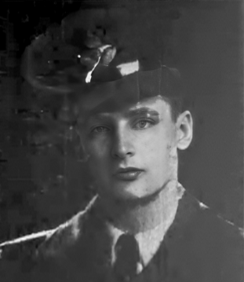
Parents: Frederick Francis Alexandre (1894–1968) and Regina Mathilde Saportas (1898–1957).
Spouse: None recorded.
Children: None recorded.
Kinship: First cousin once removed of the post–World War II Smith generation.

Early Life Frederick Francis “Freddy” Alexandre Jr. was born in 1920, the son of Frederick Francis Alexandre and Regina Mathilde Saportas. He was very active in the young set in socialite New York.

Military Service Before the United States entered World War II, he joined the Royal Canadian Air Force to train as a pilot. During the war he served as an American lieutenant flying with the Royal Air Force. On January 15, 1945, while flying a Mosquito during the raid on Leirvik, his aircraft went down in the North Sea. His body was not recovered.
Commemoration He is memorialized at the American Cemetery in Cambridge, England, where he was honored on Remembrance Day 2014.

Alexandre, Gertrude Jerome (1879–1940)

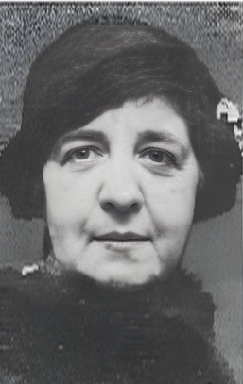
Parents: James Henry Alexandre (1848–1912) and Gertrude Jerome (1853–1883).
Spouse: Samuel Adams Clark (1874–1931).
Children: Samuel Adams Clark Jr. (1910–1998) and Francis Adams Clark (1914–2002). Kinship: Grandaunt of the post–World War II Smith generation.

Early Life Gertrude Jerome Alexandre was born in 1879, the daughter of James Henry Alexandre, a prominent New York shipping magnate, and his first wife, Gertrude Jerome. Her mother died when she was still a child, and Gertrude was raised by her stepmother, Elizabeth Boyce Lawrence Alexandre, who provided her with the advantages and refinement of the family’s well-connected social circle.
Marriage and Social Life Her marriage to Samuel Adams Clark in 1909 was described by contemporary society pages as “the largest and most fashionable country wedding of the season.” The ceremony was held at Shore Acres, her father’s estate on Staten Island, a frequent gathering place for the extended Alexandre and Lawrence families. The event symbolized the alliance of two established New York families and was attended by leading figures of the city’s social and mercantile world.
From the New York Times, November 10, 1899:
CLARK—ALEXANDRE The largest and most fashionable country wedding of the season, that of Samuel Adams Clark of Newark, N.J., and Miss Gertrude Jerome Alexandre, daughter of J. Henry Alexandre, was celebrated yesterday noon at the country house of the bride’s father, Shore Acres, near Fort Wadsworth, S.I. ... The bride’s mother, who died some years ago, was Miss Gertrude Jerome, a daughter of the late Thomas Jerome, and a sister of Mrs. Clarence Dinsmore. She has been brought up from a little girl by her stepmother, who was Miss Elizabeth Lawrence of Bay Side, L.I., a sister of Mrs. Lieut. McKinstry and Mrs. Foxhall Keene. ... The bride was attended by two maids of honor, her younger sister, Miss Virginia Alexandre, and her cousin, Miss Helen Alexandre.
Later Life and Family Gertrude and Samuel Clark lived primarily in the New York area, where they raised their two sons, Samuel Jr. and Francis. The Clarks maintained strong ties with the Alexandre and Lawrence families through shared social, equestrian, and philanthropic activities.
Death Gertrude Jerome Alexandre Clark died on January 10, 1940, remembered for her grace, family loyalty, and for preserving the cosmopolitan traditions of the Alexandre-Lawrence connection into the twentieth century.

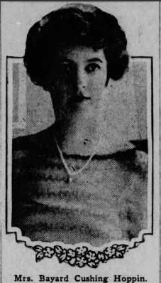
Alexandre, Helen Lispenard (1889–1953)

Parents: John Ernest Alexandre (1840–1910) and Helen Lispenard Webb (1859–1910).\ Spouse: Bayard Cushing Hoppin (1885–1956), married September 10, 1910.
Children: None recorded.
Kinship: First cousin twice removed of the post–World War II Smith generation.

Early Life Helen Lispenard Alexandre was born in 1889, the daughter of John Ernest Alexandre, a prominent New York shipping executive, and Helen Lispenard Webb, granddaughter of General Alexander S. Webb. She was raised in New York and Lenox, Massachusetts, among the circle of families linked by both commerce and social position.
Marriage and Residences She married Bayard Cushing Hoppin on September 10, 1910, in a Catholic ceremony at her parents’ residence, 28 West Thirty-eighth Street, Manhattan. Her father had died less than three weeks earlier, on August 22, 1910, but his expressed wish that the wedding proceed was honored. General Alexander Webb, the bride’s grandfather, gave her away. She wore a white silk gown covered with old lace that had been worn by both her mother and grandmother at their own weddings.
After their marriage, the Hoppins lived on Thirty-fifth Street in Manhattan and maintained a summer residence, Spring Lawn (see Houses and Estates), in Lenox, Massachusetts. They later resided at Halifax House in East Islip, Long Island. The marriage eventually ended in divorce.
Charitable Work Throughout her life, Helen Lispenard Alexandre Hoppin was active in charitable and community endeavors. She devoted much of her time to the South Side Hospital on Long Island, supporting its development and operations through volunteer service and fundraising.
Death Helen Lispenard Alexandre died in 1953, remembered for her family devotion, philanthropy, and continuation of the Alexandre–Webb tradition of civic and charitable engagement.

Alexandre, James Andrew (1986– )
Parents: DeWitt Loomis Alexandre Jr. (1949– ) and Kristin Kuhns (1948–2021).
Spouse: None recorded.
Children: None recorded.
Kinship: Second cousin twice removed of the post–World War II Smith generation.

Early Life and Family
James Andrew Alexandre was born in 1986, the son of DeWitt Loomis Alexandre II and Kristin Kuhns Alexandre. He descends from the long-established Alexandre family, whose roots trace to the Channel Islands and whose members were prominent in New York mercantile and financial circles through the nineteenth and twentieth centuries. He attended Full Sail University in Winter Park, Florida.

Entrepreneurial Activities
In 2011, Alexandre took a leave of absence from his university studies to pursue business opportunities in the Winter Park area. Demonstrating the commercial initiative characteristic of his family history, he acquired the New York Coin Laundry, a local small business. Working in consultation with his father, he executed a strategic expansion of the business, overseeing facility renovations and introducing new services such as pick-up and delivery options. His entry into local commerce was marked by a ribbon-cutting ceremony with the Winter Park Chamber of Commerce.

Alexandre, James Henry (1848–1912)
Parents: Frederick Francis Alexandre (1809–1889) and Marie Civilise Cipriant (1811–1882). Spouse: (1) Gertrude Jerome (1853–1883), married February 1, 1877; (2) Elizabeth Boyce Lawrence (1862–1906), married June 1, 1887; (3) Pauline Garcia de Oñativia Townsend (1871–1950), married May 24, 1910.
Children: With Gertrude Jerome: Gertrude Jerome Alexandre (1879–1949) and James Henry Alexandre Jr. (1883–1956); with Elizabeth Boyce Lawrence: Mary Virginia Alexandre (1888–1889), Virginia Lawrence Alexandre (1891–1960), and twins Frederick Francis Alexandre (1894–1968) and Mary Elizabeth Alexandre (1894–1970).
Kinship: Great-grandfather of the post–World War II Smith generation.

Early Life
James Henry Alexandre was born in 1848, the son of Frederick Francis Alexandre, founder of the Alexandre Line, and Marie Cipriant. He grew up in New York City and Staten Island, where he developed an early interest in horses and yachting. As a boy, he rode on the track at Jerome Park, the center of New York’s Gilded Age racing world.

Career and Sporting Life
Alexandre continued the family tradition of entrepreneurship and public prominence. He became vice president of the National Steeplechase and Hunt Association, governor of the Coney Island Jockey Club, director of the Saratoga Racetrack, and a member of the Jockey Club. His activities placed him among the most influential figures in late nineteenth-century American equestrian sports.

Residences and Lifestyle
In 1903, he purchased the townhouse at 35 East 67th Street in Manhattan (see Houses and Estates), a fashionable address among the city’s prominent merchant families. He also maintained a large estate, Shore Acres, on Staten Island, where the family hosted elaborate gatherings, including the 1909 wedding of his daughter Gertrude Jerome Alexandre.
He was an avid yachtsman, and his yacht, the Sappho, frequently carried him between Staten Island and Manhattan. A newspaper account in July 1902 described an incident in which the Sappho rescued a man who had fallen overboard from the liner Lucania while passing through the Narrows.

Marriages and Family
His first wife, Gertrude Jerome, died in 1883, leaving two young children. In 1898, Alexandre married Elizabeth Boyce Lawrence, linking the Alexandre family with the Lawrences of Bayside and Oyster Bay. After her death in 1906, he married Pauline Garcia de Oñativa Townsend, a woman of Spanish descent and social distinction.

Death
James Henry Alexandre died in 1912. He was remembered for his wealth, his leadership in the American racing world, and his embodiment of the social and sporting culture of New York’s prosperous merchant families at the turn of the century.

Alexandre, James Henry Jr. (1883–1956)
Parents: James Henry Alexandre (1848–1912) and Gertrude Jerome (1853–1883).
Spouse: (1) Anne Loomis (1890–1948), married November 29, 1913; (2) Olivia Dulaney Wheeler (1903–2001), married January 22, 1955.
Children: With Anne Loomis: James Henry Alexandre III (1915–1963), DeWitt Loomis Alexandre (1917–1982), and Lawrence Jerome Alexandre (1923–2001).
Kinship: Granduncle of the post–World War II Smith generation.

Early Life
James Henry Alexandre Jr. was born in 1883, the elder child of James Henry Alexandre and Gertrude Jerome. His mother died when he was an infant, and he was brought up largely under the influence of his stepmother, Elizabeth Boyce Lawrence Alexandre, connecting him closely with the Lawrence and Boyce families of Bayside and Staten Island.
Career and Activities
Alexandre worked at Effingham Lawrence & Co., a firm with deep family associations, reflecting the long-standing commercial ties between the Alexandres and the Lawrences. His professional life centered on finance and investment management, typical of his generation within these interrelated New York families.

Residences and Social Life
He owned Valleybrook, an estate in Glen Cove, Long Island, where he and his family were part of the North Shore social community. He was active in coaching and dancing circles, continuing the Alexandre family’s equestrian traditions.

Later Life
After the death of his first wife, Anne Loomis, in 1948, he married Olivia Dulaney Wheeler, a member of an old Maryland family. The couple maintained a quiet social presence during their later years, dividing time between Long Island and New York City.

Death
James Henry Alexandre Jr. died in 1956. He was remembered as a courteous and cultivated man who exemplified the quiet continuity of New York’s established mercantile families through the twentieth century.

Alexandre, James Henry III (1915–1963)

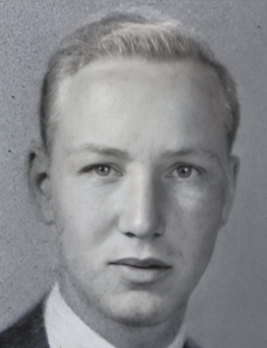
Parents: James Henry Alexandre Jr. (1883–1956) and Anne Loomis (1890–1948).
Spouse: (1) Catherine Holbrook Clark (1920–1982); (2) Florence Gilbert Tucker (1920–1998), formerly Mrs. Leslie Carlisle.
Children: With Catherine Holbrook Clark: James Henry Alexandre IV (1942–1976) and Andrew Wallace Alexandre (1946– ); with Florence Gilbert Tucker: Denise Evans Alexandre (1954– ).
Kinship: First cousin once removed of the post–World War II Smith generation.

Early Life and Education
James Henry Alexandre III was born in 1915, the eldest son of James Henry Alexandre Jr. and Anne Loomis. He was educated at the Pomfret School, Le Rosey in Switzerland, and Harvard University, where he continued to Harvard Law School. While at Harvard he was a member of the Hasty Pudding Institute of 1770 and the Iroquois Club.

Career
After graduation, Alexandre practiced law and later joined the firm of Fordyce and Alexandre, which represented several North Shore villages on Long Island. Earlier in his career he worked with American Cyanamid and the U.S. Synthetic Rubber Company. In 1947 he was one of a three-man legal delegation sent to the Philippines to help settle that country’s World War II claims, reflecting his growing reputation as a competent and internationally minded attorney.

Residences and Affiliations
His principal residence was Tuckaway in Huntington, Long Island, a home that reflected the family’s established position among the North Shore gentry. He was a member of the Piping Rock Club, the Harvard Club of New York, and the Pilgrims, a society promoting Anglo-American friendship.

Death
James Henry Alexandre III died in 1963. He was remembered for his legal acumen, cosmopolitan education, and public-spirited service during the postwar reconstruction era.

Alexandre, James Henry IV (1942–1976)

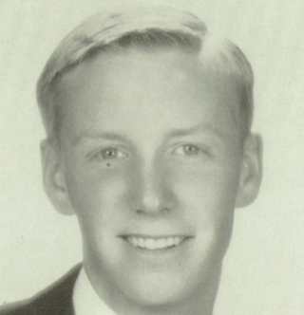
Parents: James Henry Alexandre III (1915–1963) and Catherine Holbrook Clark (1920–1982). Spouse: Nancy Maxwell Ott (1946– ).
Children: James Henry Alexandre V (1968– ), Jennie Jerome Alexandre (1966– ), and Catherine Mead Alexandre (c. 1971– ).
Kinship: Second cousin of the post–World War II Smith generation.

Early Life and Education
James Henry Alexandre IV was born in 1942, the son of James Henry Alexandre III and Catherine Holbrook Clark. He was educated at the Brooks School in North Andover, Massachusetts, and at Washington and Jefferson College in Pennsylvania.

Military Service
Following his graduation, Alexandre served as a lieutenant in the United States Army from 1964 to 1966, part of the generation whose early adulthood coincided with the Vietnam era.

Career
After completing his military service, he became an executive with the Aetna Insurance Company. His career reflected the family’s continuing involvement in business and professional life, particularly in the financial and corporate sectors.

Personal Life and Interests
Alexandre was active in New England sporting and social circles. He was a member of the Kittansett Yacht Club and the Duxbury Yacht Club, where he won the club’s gold championship. He was known for his energy, sociability, and love of outdoor competition.

Death
James Henry Alexandre IV died suddenly in 1976 while playing paddle tennis. His death at a young age was widely felt among family and friends, and he was remembered for his charm, athleticism, and promise.

Alexandre, James Henry V (1968– )
Parents: James Henry Alexandre IV (1942–1976) and Nancy Maxwell Ott (1946– ).
Marriage: None recorded.
Children: None recorded.
Kinship: Second cousin once removed of the post–World War II Smith generation.

Early Life and Education
James Henry Alexandre V was born in 1968, the son of James Henry Alexandre IV and Nancy Maxwell Ott. He represents the fifth generation of the Alexandre family to bear the name James Henry, a tradition reflecting both family continuity and respect for its mercantile and professional heritage.

Education and Affiliation
s He was a member of Sigma Alpha Epsilon fraternity, Louisiana Tau-Upsilon chapter, indicating college attendance in the southern United States.

Alexandre, Jerome (1886–1925)
Parents: James Joseph Alexandre (1844–1894) and Nathalie Edsall (1863–1944).
Spouse: (1) Violet Adelaide Oakley (1884–1918); (2) Helene Gertrude Jones (1893–1935). Children: With Violet Adelaide Oakley: Nathalie Alexandre (1907–2001), Adelaide Alexandre (1910–1910); with Helene Gertrude Jones: Jerome Alexandre Jr. (1920–1959).
Kinship: First cousin twice removed of the post–World War II Smith generation.

Early Life
Jerome Alexandre was born in 1886, the son of James Joseph Alexandre and Nathalie Edsall. After his father’s death, his mother married Paul Russell Bonner, a leather manufacturer who ran the firm Bonner & Barnewell on Cortlandt Street, Manhattan. The family lived at Nirvana, their mansion at Alexandre Point in Stamford, Connecticut.

Coming of Age and Fortune
On March 2, 1907, Nirvana was the scene of an unusual celebration. Despite a blizzard, the Alexandre coachman, Michael Mullin—employed by the family for more than forty years—organized a bonfire for the servants to honor Jerome’s twenty-first birthday, the day he “came into his own.” The event was described in the Philadelphia Inquirer as a raucous winter festival, complete with songs, dancing, and the servants throwing snow “like clouds of white confetti.” The article noted that the young heir inherited upwards of $1,500,000 from his father (equivalent to about $40 million in 2024 dollars), derived from the family’s ownership of the New York, Havana, and Mexican Mail Line of steamships.

Education and Marriage
Jerome was educated at Princeton, but dropped out during his sophomore year. While working briefly in his stepfather’s office, he met Violet Adelaide Oakley, a well-educated stenographer and office manager who had studied at a normal school and was the daughter of George Oakley, a real-estate dealer in Washington Heights. The meeting led to a sudden romance. On March 15, 1906, they eloped and were married at Calvary Methodist Episcopal Church on 130th Street in Manhattan.

His mother told the press: “Jerome is always so impulsive…. It is perfectly true that Jerome is married. Why he should not have told us first I don’t know. There was no occasion for keeping it secret, but he is an impulsive boy, and perhaps he thought it would be more romantic.”

She added, “I might have told him how difficult it is for a man when he marries out of his own set to have the society that knows him accept his wife.”

Mr. Bonner defended Violet, telling reporters that she was “a very fine young woman—a gentlewoman in every way estimable…remarkably well educated.”

Public Life and Notoriety
Jerome’s impulsive streak continued. In March 1907, only weeks after coming into his inheritance, he was arrested for speeding at 24 miles per hour along Riverside Drive, listing his occupation as “capitalist” and claiming District Attorney Jerome as his cousin. Later that year, he raced his Thomas automobile from New York to Cape Charles in a record 19½ hours. He also announced plans to “solve a family mystery” connected to Nirvana (see Houses and Estates).

Family Life and Tragedy
Jerome and Violet had two children: Nathalie Alexandre (1907–2001) and Adelaide Alexandre (1910–1910). Violet later suffered from influenza during the 1918 pandemic, followed by what her doctor described as “fits of melancholia.” On May 10, 1919, while visiting her mother-in-law at Nirvana, she ended her life with a revolver, leaving behind Jerome and their daughter Nathalie.

Second Marriage and Later Years
Jerome had earlier met Helene Gertrude Jones (1893–1935), daughter of Orlando Jones of Sea Gate. After Violet’s death, Helene wrote him a condolence letter; their friendship was renewed, and they married on December 11, 1919, at Our Lady of Solace Church in Sea Gate. They had one son, Jerome Alexandre Jr. (1920–1959).

Jerome served with Squadron “A” of the New York troops and enlisted as an aviator when border troubles with Mexico erupted. During World War I he was an aviation instructor in Texas. After his military service, he moved to Albuquerque, New Mexico, purchasing a ranch on Candelarias Road. Local newspapers described him as having “a pleasing manner and many friends” and an income of about $1,000 a month. However, his impulsive nature persisted—he was occasionally cited for drinking, and once found asleep in his car with the engine running.

Death
Separated from his wife Helene, Jerome planned a reconciliation in late 1925. On Christmas Day that year, he was found dead after a fire in a rooming house in Albuquerque. He had apparently fallen asleep while smoking; the cigarette ignited the mattress, and though he tried to escape, the door was barred, and he was suffocated.

The funeral mass was held at Immaculate Conception Church, and he was buried in Calvary Cemetery. Helene remained in Albuquerque for her health, remarried in 1926, and died in 1935, leaving her son Jerome Jr. in the care of his half-sister Nathalie Alexandre Biddle.

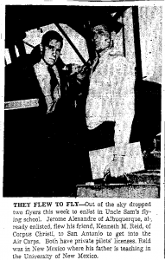
Alexandre, Jerome Jr. (1920–1959)

Parents: Jerome Alexandre (1886–1925) and Helene Gertrude Jones (1893–1935).
Spouse: Wanda Lucille Bright (1921–1991).
Children: Wanda Helene Alexandre (1939–2013), Jerome Alexandre (1940–2009), Suzanne Alexandre (1943– ), and Stephanie Ann Alexandre (1947–1998).
Kinship: Second cousin once removed of the post–World War II Smith generation.

Early Life
Jerome Alexandre Jr. was born in 1920, the son of Jerome Alexandre and Helene Gertrude Jones. His father’s death in 1925 left him an orphan at a young age, and he was raised primarily by his half-sister Nathalie Alexandre Biddle. He inherited a portion of his grandfather’s fortune, held in trust until his twenty-first birthday.

Youth and Restlessness
Jerome inherited the impulsive temperament of his father and grandfather. In 1936, at age sixteen, he ran away from the Webb School in Claremont, California, leaving behind a note telling his sister to sell his car—an unusual possession for a teenager during the Depression. His disappearance caused considerable alarm until he returned safely to Albuquerque. Two years later, in 1938, he was briefly in trouble for damaging municipal property when “swinging on a ground wire” caused an electric light to break; he told police he was “ready to settle with the city.”

Early Adulthood and Marriage
By May 1940, he was living in Santa Barbara, California, working at a filling station and studying photography. Although he had not yet received his inheritance of $139,118 (about $1 million in 2024 dollars), the court released $1,500 to him, noting that he was already married and had a child.

Military Service
In March 1942, Alexandre, then twenty-one and a licensed private pilot, flew from Albuquerque to San Antonio with his friend Kenneth M. Reid to enlist in the U.S. Army Air Corps. A newspaper photograph from the time shows the two young men standing beside their plane under the headline “They Flew to Fly.” He reported for duty as a lieutenant to Randolph Air Field, Texas, in June 1944.

Later Life and Business
After the war, Alexandre returned to New Mexico, where he operated various small businesses. In 1954 he moved to Farmington and established a bottling works, which he managed successfully for several years.

Death
Despite his outward stability, Alexandre struggled with depression. On April 24, 1959, he died from a self-inflicted gunshot wound to the head; the inquest ruled his death a suicide. He was thirty-eight years old. His life, like that of his father, reflected both the privileges and the burdens of a family whose fortune and temperament combined ambition, independence, and tragedy.

Alexandre, Lawrence Jerome “Jerry” (1923–2001)

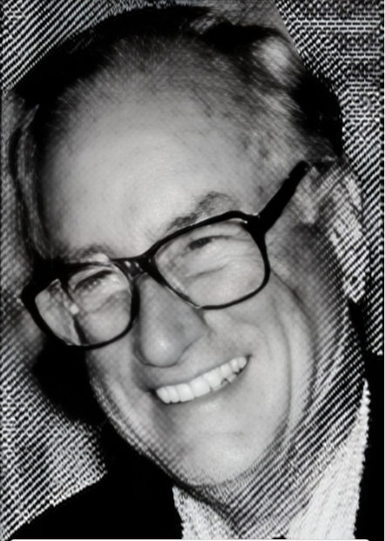
Parents: James Henry Alexandre III (1915–1963) and Anne Loomis (1890–1948).
Spouse: (1) Rhea Munroe Elliman (1934–1993), (2) Katharine Ward Dickinson Saunders (1929-1984); (3) Margot Edwards (1935–1996).
Children: With Rhea Munroe Elliman: Nicole Munroe Alexandre (1954– ), Margaret Lindsay Alexandre (1957–2012), and Cary Lawrence Alexandre (1962– ).
Kinship: Second cousin of the post–World War II Smith generation.

Early Life and Education
Lawrence Jerome “Jerry” Alexandre was born in Glen Cove, Long Island, in 1923, the youngest of the three sons of James Henry Alexandre III and Anne Loomis. He attended the Pomfret School, graduating in 1941, and then entered Harvard University. His studies were interrupted by the Second World War.

Military Service
During the war Alexandre joined the United States Army Air Forces and served as a bomber pilot in the Pacific Theater. His wartime service became an essential part of his life and reflected the longstanding Alexandre family tradition of military participation.

Career
After the war he became a cotton broker with Anderson Clayton & Co., one of the world’s major cotton merchants. He remained with the firm until his retirement in 1976, when he founded his own company, the Alexandre Fibre Co., Inc., continuing his career in textile and fiber trading.

Civic Service and Interests
Alexandre was a devoted outdoorsman who enjoyed hunting, fishing, and golf. He served for one year as national chairman of Ducks Unlimited and was a member of the Green Valley Country Club and Christ Church Episcopal.

Personal Life and Death
Alexandre was married three times. His first marriage, to Rhea Munroe Elliman, produced his three children. After their divorce in 1961 he married Katharine Dickinson Saunders, and later, in 1966, Margot Edwards of Spartanburg, who became stepmother to his children and remained his wife until her death in 1996. He died in Greenville, South Carolina, on December 17, 2001.

Alexandre, Leonie (1890–1992)
Parents: James Joseph Alexandre (1844–1894) and Nathalie Edsall (1863–1944).
Spouse: Francis Jenkins Danforth (1878–1950).
Children: Francis Jenkins Danforth (1912–2000), Leonie Jerome Danforth (1914–1986), and Virginia Danforth (1918–1987).
Kinship: First cousin twice removed of the post–World War II Smith generation.

Early Life and Charitable Activities
Leonie Alexandre was born in 1890, the daughter of James Joseph Alexandre, a steamship magnate, and Nathalie Edsall Alexandre. She grew up at Nirvana, the family estate on the Stamford waterfront, which became a setting for many Alexandre family gatherings and charitable events.

From an early age, Leonie displayed an artistic and philanthropic temperament. On March 20, 1909, she participated in a Chocolatière et Tableaux at the Plaza Hotel, a charity event at which “chocolate and other refreshments [were] sold by women and girls in chocolatière costumes after the famous painting in the Dresden Gallery.” The painting referred to was La Belle Chocolatière by Jean-Étienne Liotard. Later that same month she performed as an Egyptian dancer in another benefit for working girls’ dancing classes hosted by sculptor François Tonetti and his wife, Mary Trimble Lawrence Tonetti. In March 1910, Leonie took part in The Castle of Liguria during the Italian Carnival held at the Waldorf Astoria.
Marriage and Wedding Festivities
Leonie’s engagement to Francis Jenkins Danforth, an industrial engineer, was announced in the spring of 1911. Her fiancé gave his bachelor dinner at Delmonico’s on May 19, where, according to The New York Times, “a colored band” played. The couple was married on May 27, 1911, in St. John’s Episcopal Church in Stamford, Connecticut. The wedding, performed by the Rev. Charles Morris Addison, was followed by a reception at Nirvana, her mother’s estate, attended by about three hundred guests, most arriving from New York on a special train.
From the New York Times wedding report:
“Miss Alexandre’s brother, Jerome Alexandre, gave her in marriage. ... Miss Alexandre’s maid of honor was Miss Gertrude Slocum, her cousin, of New York. ... The bride’s gown was of white satin. She wore a lace veil and her flowers were lilies of the valley and gardenias. After a fortnight away Mr. and Mrs. Danforth will return to New York, and in the summer they will be at Nirvana.”
Inheritance and Celebration of Majority
Like her brother Jerome, Leonie inherited a considerable fortune—$1,500,000 (equivalent to about $40,000,000 in 2025 dollars)—upon reaching her majority. Yet her response to newfound wealth reflected her generous nature.
A contemporary newspaper account recorded:
“Mrs. Frank Danforth, who was Leonie Alexandre, adopted a novel method of celebrating the attainment of majority. Instead of giving a great dinner or a ball for her friends of social prominence, she called together the employees at her mother’s big estate, Nirvana, at Stamford, Conn., and told them to make preparations for a barn dance. ... There were present upward of 150 young men and young women, friends and acquaintances of the employees… Mrs. Danforth and her guests danced and ‘mixed’ with their employees until the affair ended at 3 in the morning.”
Later Life and Civic Engagement
Throughout her long life, Leonie Danforth continued to devote herself to charitable, artistic, and social causes. She helped organize and support numerous events, including Will Rogers’s benefit appearance in 1928, an exhibition of Edward VII’s coronation robes in 1937, and several productions by Snark, a New York amateur dramatic society, in 1939.
Death
Leonie Alexandre Danforth lived to the age of 101, dying on May 18, 1992. She was remembered as a gracious and public-spirited woman whose life spanned more than a century of Alexandre family history—from the steamship era of her grandfather’s time to the modern world of the late twentieth century.

Alexandre, Marie Civilise (1891–1967)
Parents: John Ernest Alexandre (1840–1910) and Helen Lispenard Webb (1859–1929).
Spouse: Frederic Schenck (1887–1919).
Children: Anna Remsen Schenck (1919–1993).
Kinship: First cousin twice removed of the post–World War II Smith generation.

Early Life
Marie Civilise Alexandre was born in 1891 into a family that combined mercantile achievement and social prominence. Her father, John Ernest Alexandre, had been a leading shipping merchant and founder of the Alexandre Steamship Line, while her mother, Helen Lispenard Webb, was a granddaughter of General Alexander S. Webb, president of the College of the City of New York and a Civil War hero. The family divided their time between their Manhattan residence and their summer estate, Spring Lawn, in Lenox, Massachusetts.

Marriage to Frederic Schenck
Marie Alexandre’s wedding to Frederic Schenck, instructor in English literature at Harvard University and son of Mrs. J. Frederick Schenck of Lenox, took place on June 30, 1917, in St. Anne’s Catholic Church, Lenox. The event was one of the season’s most distinguished ceremonies and reflected the wartime alliance of American and French intellectual circles.

A report described:
“A special dispensation from the Archbishop of Massachusetts was obtained for the afternoon wedding and because Mr. Schenck is not a member of the Catholic Church. A touch of the military activities of the day was given by the presence of the French officers who are at Cambridge training the Harvard regiment.”
The ushers included Professors and Harvard colleagues, among them Roger B. Merriam and Rev. Joseph T. Addison, as well as members of New York society—David M. Osborne, Fulton Cutting, Charles Lanier Lawrence, and T. Lawrence Riggs.
“The bride, who entered the church with her cousin, J. Harry Alexandre, who gave her in marriage, was in a regal gown of white and silver lace, entrainée. ... Mr. and Mrs. Schenck received on a covered terrace, with a background of greens and bay trees.”
Wartime and Later Activities
Tragically, the marriage was short-lived; Frederic Schenck died in 1919. Marie, left a widow at twenty-eight, turned her energy toward charitable and religious work. During the Second World War she became head of the American Committee for the Aid of British Catholics, a relief organization that supplied funds for mobile chapels, temporary altars, nurseries for evacuated children, and aid to priests and hospitals affected by bombings.

Death
Marie Civilise Alexandre Schenck died on September 25, 1967. She was remembered for her grace, her early participation in the distinguished social world of Lenox and New York, and her later devotion to humanitarian work during one of the most difficult periods of the twentieth century.

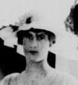
Alexandre, Mary Elizabeth (1894–1970)

Parents: James Henry Alexandre (1848–1912) and Elizabeth Boyce Lawrence (1862–1906).
Spouse: Nathaniel Edward Caldwell Rutter (1890–1947).
Children: Nathaniel Edward Caldwell Rutter Jr. (1918–2002), Mary Elizabeth Rutter (1920–2003), Nancy Rutter (1921–2013), John Alexandre Rutter (1922–2008), and Virginia Lawrence Rutter (1926–2015).
Kinship: Maternal grandmother of the post–World War II Smith generation.

Early Life
Mary Elizabeth “May” Alexandre was born in 1894, the twin sister of Frederick Francis Alexandre (1894–1968) and the youngest daughter of James Henry Alexandre and Elizabeth Boyce Lawrence. Her mother’s early death in 1906 and her father’s in 1912 left her and her siblings to be raised largely under the care of relatives, notably her aunt, Mrs. John E. Alexandre. She was educated in New York and was known for her charm and poise within the North Shore social circle.

Marriage to Nathaniel Edward Caldwell Rutter
Mary Alexandre married Nathaniel Edward Caldwell Rutter, son of Mrs. Nathaniel C. Reynal of White Plains, at St. Agnes’s Roman Catholic Church in Manhattan on January 18, 1917. The ceremony was conducted by Monsignor Henry A. Brann, assisted by the Rev. William A. Martin of St. Patrick’s Cathedral and the Rev. John J. Delaney. The New York Times noted that it was a small and quiet wedding owing to the recent death of her grandfather, Colonel Frederick N. Lawrence.

“Miss Alexandre walked up the nave with her brother, J. Henry Alexandre, who gave her in marriage. She wore a short frock of white chiffon, draped with old point lace, and the court train was also veiled with lace. She carried white orchids.”
Her sister, Virginia L. Alexandre, served as maid of honor, and her cousin Anna Remsen Alexandre was among the bridesmaids, alongside Justine Van Rensselaer Townsend, Katharine Greene, and Edith Wellman.
Later Life
Following their marriage, the Rutters lived in Glen Cove and later in Lawrence, Long Island. Mary was active in charitable and social affairs, often in association with her extended Alexandre and Lawrence relatives. The Rutter family maintained close ties with the Alexandres, regularly appearing at family gatherings and events in Lawrence and on the North Shore.

Death
Mary Elizabeth Alexandre died on August 2, 1970, closing a life that linked two prominent New York families—the Lawrences and the Alexandres—and whose descendants carried forward their intertwined social and civic traditions. She was remembered for her elegance, quiet strength, and the enduring family connections she helped maintain across generations.

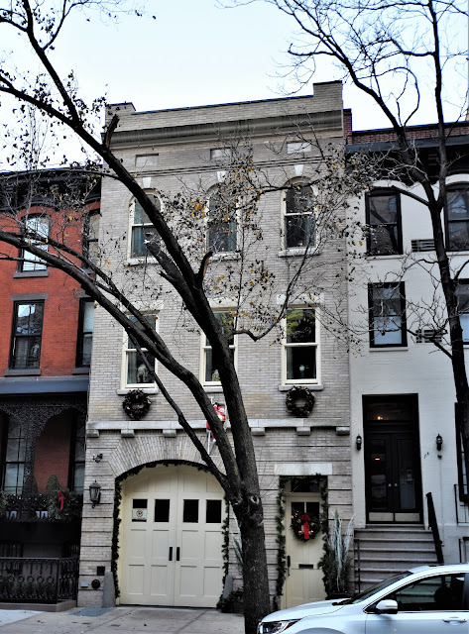
Alexandre Stables at 173 East 73rd Street,

Location: North side of East 73rd Street, between Third and Lexington Avenues, Upper East Side, Manhattan.
Built:1893
Architect: Hobart H. Walker

Architect
Hobart H. Walker (1869-1955), of Hobart. Walker & Johnston, was active in New York, primarily known for residential and carriage house designs in Brooklyn and Manhattan around the turn of the century and into the 1910s.

Early Development of the Site
In 1864, a uniform row of twenty-foot-wide Italianate townhouses was erected along this block of East 73rd Street. These brick-faced houses rose three stories above English basements and were distinguished by cast-iron verandas, reflecting the solidly respectable character of the neighborhood in the mid-nineteenth century. No. 173 was among these original houses. By 1879 it housed at least one boarder, a well-educated woman who sought to exchange instruction rather than cash for rent, advertising for “Board in exchange for music, German or English lessons,” an arrangement that suggests both the genteel nature of the household and the modest economics of the block at the time.
Transformation into a Stable Block
As Fifth Avenue north of Central Park filled with large mansions in the late nineteenth century, nearby side streets underwent a parallel transformation. Properties on blocks such as East 73rd Street were increasingly acquired for use as private stables and carriage houses, discreetly removed from elite residences yet close enough for convenience. By the end of the century, East 73rd Street had become one of these “stable blocks,” serving the transportation and service needs of New York’s wealthiest families.
Construction of the Carriage House (1893)
In 1893, the original row house at No. 173 was demolished and replaced by a purpose-built three-story stable designed by architect Hobart H. Walker. Executed in gray brick with limestone trim, the building represents a late and inventive interpretation of the Romanesque Revival style. Walker treated the ground floor brickwork to imitate rusticated stone and turned bricks on their sides to create a dramatic sunburst of voussoirs above the large arched carriage bays. The upper stories were more restrained, culminating in a brick parapet with recessed panels crowned by a projecting cornice. Though utilitarian in function, the building was given a carefully composed and dignified façade appropriate to its affluent owner.
Ownership by J. Henry Alexandre
The stable was owned by Gustave Reismon until his death, after which it was sold in April 1903 to J. Henry Alexandre, owner of the Alexandre Steamship Line and vice president of the National Hunt and Steeple Chase Association. Alexandre had purchased his primary Manhattan residence, a townhouse at 35 East 67th Street, just three months earlier. The East 73rd Street carriage house was ideally situated—close enough for daily use, yet sufficiently distant to avoid the odors and noise associated with horses and stable operations.
Alexandre and his wife, Elizabeth Lawrence Alexandre, had five children: J. Henry, Jr., Mary, Elizabeth, Virginia, and Frederick. Their country seat, Valleybrook Farm in Old Brookville, Long Island, maintained a stable of thoroughbred horses. Alexandre was not merely a casual sportsman but was deeply involved in elite equestrian pursuits, including both horse racing and the aristocratic sport of polo.
Life of the Stable
The active equestrian life associated with the property is reflected in contemporary advertisements. After Elizabeth Alexandre’s death on January 3, 1906, Alexandre’s stable manager placed a notice in the New-York Tribune seeking a coachman: “Young man; good driver and rider; understands polo ponies; 10 years’ experience.” The advertisement underscores the specialized skills required to manage the horses housed at No. 173 and the high standards expected in Alexandre’s service.
Later History and Conversion
J. Henry Alexandre died in 1912, but his family retained ownership of the carriage house for many years thereafter. In 1938, the Alexandres commissioned architect Irving Kudroff to adapt the former stable for commercial use. His plans provided for a three-car garage and shop on the ground floor, a shop and office on the second floor, and a one-family apartment on the third, marking the building’s transition from equestrian support structure to modern urban utility.

Ashton
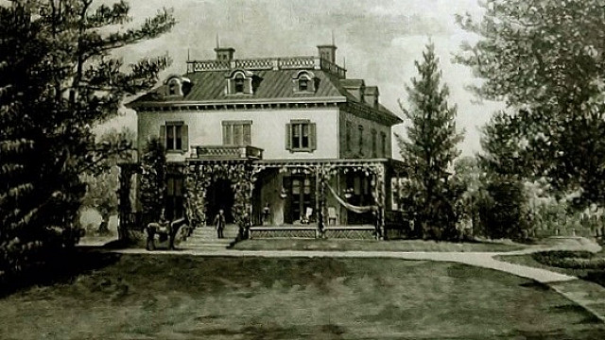
Location: Yonkers, New York.
Built: c. 1850.

Architectural Description
Ashton was a substantial mid-nineteenth-century country house, its exterior combining classical symmetry with the relaxed informality expected of a suburban retreat. The main block is two stories in height, capped by a low hipped roof punctuated with dormer windows, giving the house a broad, settled profile rather than a vertical emphasis. A deep, wraparound porch defines the principal façade, its slender posts and decorative brackets softening the formality of the masonry walls and encouraging outdoor living during the summer months. French doors and tall windows open the principal rooms to the grounds, visually and physically linking house and landscape.

History
Ashton served as the residence of Henry Maunsell Schieffelin (1808-1890), a prominent American merchant, philanthropist, and partner in the wholesale pharmaceutical firm W.H. Schieffelin & Fowler. He lived there with his second wife, Sarah Minerva Kendall (1834-1921), whom he married in 1859, and by 1870 they had made it their home. The estate functioned as a retreat from urban life in Manhattan (where Schieffelin also maintained a residence at 665 Fifth Avenue) and was used for family gatherings.

