

UNITED INTERNATIONAL UNIVERSITY
School of Science & Engineering
Dept. of Computer Science & Engineering (CSE)
Trimester: Summer 252, Course Code: EEE 2124
Course Title: Electronics Laboratory

PROJECT PROPOSAL
OptiWatt – Smart Energy Management System
Group: 07, Section: O
Submitted to:
Mr. Imran Hossain
Lecturer, Dept. of CSE, UIU
Name | ID
Diba Jabin Fariha Tithy | 0112330222
Hujaifa Islam Johan | 0112330149
Md. Toufiq Imroz Khealid Khan | 0112330984
M.M. Sayem Prodhan | 0112330411
Sadid Ahmed | 0112330154
Submitted by:

Date of Submission: 01.09.2025

Abstract
This project proposes the design and implementation of OptiWatt, a single-room smart energy management system with monitoring and control features. OptiWatt combines non-intrusive energy metering with occupancy-aware automation to reduce energy waste while preserving user privacy. Using an ESP32 microcontroller, PZEM-004T power monitoring modules, and dual-sensor occupancy detection (ultrasonic and PIR), the system can automatically disconnect non-critical loads when a room is vacant, while allowing manual override through a mobile application. The prototype targets power measurement accuracy within ±2% and occupancy detection reliability of at least 98%. By integrating real-time monitoring, historical usage tracking, and predictive analytics, OptiWatt demonstrates a scalable, cost-effective, and safety-focused approach to residential energy optimization.

Keywords: Smart Energy Management, Occupancy Detection, ESP32, Power Monitoring, Automation, IoT, Energy Efficiency

1. Introduction
Energy efficiency is increasingly important as rising demand and environmental concerns push households toward smarter consumption. Everyday habits—such as leaving lights, fans, or appliances running in empty rooms—cause significant waste. Existing automation solutions attempt to address this but are often costly, difficult to deploy, or intrusive.
OptiWatt offers a practical alternative: a low-cost, single-room smart energy management system that combines monitoring, automation, and control that combines real-time energy metering, occupancy-based automation, and mobile app control. Designed for simplicity and reliability, it shows how affordable microcontrollers and sensors can deliver measurable savings while laying the groundwork for future smart-home solutions.

2. Motivation
Electricity bills often reveal wasteful habits only after they occur, leaving little chance for correction. Simple oversights—like leaving fans or lights running in empty rooms—can create unnecessary costs. Existing smart energy systems are either costly, complex, or limited to monitoring without practical automation. Beyond reducing waste, another critical challenge is billing transparency. Electricity bills often fluctuate in ways that seem unexpected or even incorrect, leaving users with little control. This project addresses such concerns by enabling timely monitoring and corrective action whenever anomalies or miscalculations in energy usage appear.

OptiWatt is motivated by the need for an affordable, room-level solution that is easy to use and effective. By combining real-time measurement with occupancy-aware control, it reduces waste automatically while still giving users full authority through a mobile interface. This balance makes the system both practical for daily use and scalable for future expansion.

3. Project Overview
In residential settings, a large share of electricity is wasted by idle loads—appliances left running in unoccupied rooms. Studies suggest that 10–20% of household bills come from such avoidable use. Traditional awareness campaigns have had limited impact, as habits are difficult to change without technological support.
Existing smart-home systems address this issue but are often expensive, complex to install, or privacy-invasive through cameras or cloud reliance. There is a clear need for a solution that is:
- Low-cost, suitable for households in developing regions.
- Non-intrusive, avoiding imaging or voice surveillance.
- Automatic yet flexible, allowing user overrides.
OptiWatt meets this need by demonstrating a practical prototype that combines affordable components and embedded intelligence to cut waste while giving users greater visibility and control.
4. Component Descriptions

4.0 Component List
The proposed system requires the following key components:
- ESP32 Development Board (Wi-Fi Controller) (Fig. 01)
- PZEM-004T V3.0 (AC Energy Monitor) (Fig. 02)
- Ultrasonic Sensors ×2 (HC-SR04) (Fig. 03)
- PIR Motion Sensor (HC-SR501) (Fig. 04)
- Relay Module (Fig. 05)
- Power supply (5V/3.3V), fuse, terminal blocks, enclosure
- Wires, connectors, and breadboard for prototyping

4.1 ESP32 Development Board (Controller) (see Fig. 01)
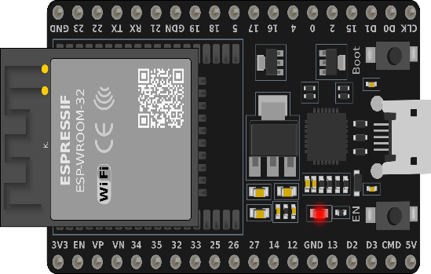
- Overview: The ESP32 is a powerful microcontroller that integrates dual-core processing with built-in Wi-Fi and Bluetooth modules. It has multiple GPIO pins, ADCs, DACs, UART, SPI, and I²C buses, making it versatile for handling various sensors and peripherals. It supports multi-tasking through FreeRTOS and has low-power modes, allowing it to efficiently handle sensor polling, decision-making, and wireless communication. Its UART capability allows direct communication with energy-monitoring modules like the PZEM-004T, while its GPIO pins can be configured for relay control and sensor interfacing.
- Purpose: Acts as the central brain of OptiWatt: acquires all sensor readings, fuses occupancy data, processes electrical measurements, makes power-cut decisions, and communicates with the mobile dashboard. Fig 01: ESP32 Development Board

4.2 PZEM-004T V3.0 AC Energy Monitor (see Fig. 02)
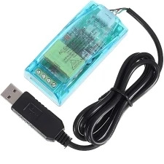
- Overview: The PZEM-004T is a digital energy-monitoring module designed for AC mains. It uses an internal measurement front end to calculate RMS voltage and current, computes active power, and integrates energy consumption over time. A current transformer (CT) measures current non-invasively, while voltage is measured directly. It communicates over a UART interface using a Modbus-like protocol, making it easy to integrate with controllers such as ESP32. It offers high accuracy for household-level monitoring and has the advantage of providing cumulative kWh values without requiring external computation.
- Purpose: Supplies accurate and real-time measurements of electrical parameters—voltage, current, power, and energy—which are essential for monitoring, logging, and bill estimation in OptiWatt. Fig 02: PZEM-004T V3.0 Energy Monitoring Module

4.3 Ultrasonic Doorway Sensor Pair (see Fig. 03)
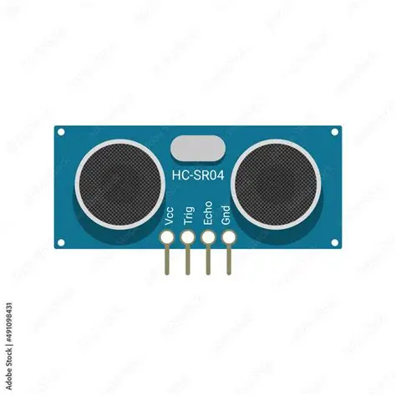
- Overview: The HC-SR04 ultrasonic sensor works by emitting ultrasonic pulses and measuring the time it takes for the echo to return after bouncing off an object. From this delay, the distance is calculated. When two such sensors are positioned across a doorway and triggered in sequence, they detect whether a person is entering or leaving. A state machine interprets these sequences to increment or decrement an occupancy counter. However, simultaneous crossings can cause errors, so placement and timing logic are critical to reliability.
- Purpose: Provides the primary mechanism for counting people entering or leaving a room, thus enabling the system to estimate real-time occupancy. Fig 03: HC-SR04 Ultrasonic Sensor

4.4 PIR Motion Sensor (see Fig. 04)
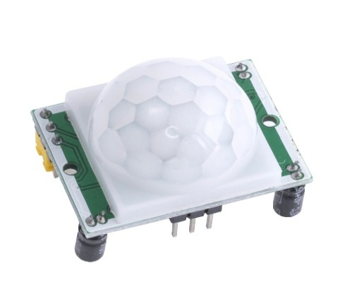
- Overview: Passive Infrared (PIR) sensors detect motion by measuring changes in infrared radiation emitted by warm objects such as humans. The HC-SR501 module includes a Fresnel lens to widen its detection field, a pyroelectric sensor, and circuitry that outputs a digital pulse when motion is detected. It cannot provide exact counts but is effective at confirming human presence and avoiding false negatives from the ultrasonic system.
- Purpose: Serves as a secondary confirmation sensor that ensures occupancy state is not prematurely set to vacant when motion is still present in the room.
Fig 04: HC-SR501 PIR Motion Senso
4.5 Relay Module (see Fig. 05)
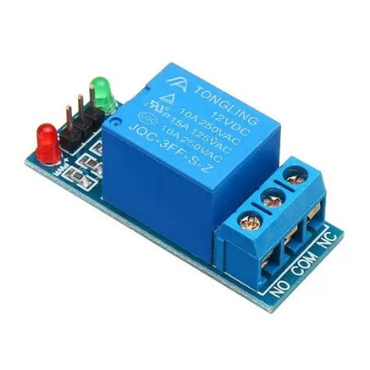
- Overview: The relay module consists of an electromechanical switch controlled by an opto-isolated driver circuit. When the low-voltage coil is energized, it creates a magnetic field that moves the switch contacts, connecting or disconnecting the high-voltage load. Opto-isolation ensures the ESP32 and low-voltage circuits are protected from AC mains. Relays are chosen with ratings higher than the expected appliance loads to ensure durability and safety.
- Purpose: Enables safe switching of non-critical appliances (e.g., lights, fans) under automatic control or manual commands from the app.
Fig 05: Relay Module for Appliance Control
4.6 Enclosure, Power & Safety
- Overview: A protective enclosure separates the low-voltage electronics from high-voltage AC wiring. It includes proper insulation, fuses, terminal blocks, and wire management. The enclosure ensures creepage and clearance distances are maintained, minimizing the risk of electric shocks or short circuits. It also provides strain relief for cables and organizes the internal layout for serviceability.
- Purpose: Ensures safe operation, prevents accidental contact with live parts, and provides a professional finish to the prototype.

5. Project Features

5.1 Real-Time Energy Monitoring
A measurement pipeline records voltage, current, power, and cumulative energy to a logger and dashboard.
- Continuous data from PZEM-004T (see Fig. 08).
- Dashboard shows live and historical data.
- Filtering applied to reduce noise and spikes.

5.2 Vacancy-Based Automatic Power Cut
Automated switching reduces waste when rooms are vacant.
- Ultrasonic + PIR fusion confirms occupancy (see Fig. 07).
- Configurable delay avoids false triggers.
- Critical loads bypassed for safety.

5.3 App Control & Manual Override
Users retain full control through the mobile app.
- Toggle each load on/off remotely (see Fig. 10).
- Override automation temporarily.
- Adjust system settings and notifications.

5.4 Monthly Usage Estimation & Goal Tracking
Tracks cumulative energy and compares against targets.
- Daily kWh values feed monthly projection (see Fig. 09).
- Alerts issued if usage trends exceed goals.
- This also helps users detect unusual billing patterns and take corrective measures promptly.
- Export logs for analysis.

6. Flow Descriptions
To better explain how OptiWatt works, we have designed several flowcharts. Each one shows the decision-making process of the system.

6.1 Occupancy Counting Flow (Fig. 06)
The occupancy detection process begins with both ultrasonic sensors positioned across the doorway. When an individual crosses, the order of sensor activation is checked. If the sequence follows Sensor A then Sensor B, it is interpreted as an entry and the occupancy counter is incremented. Conversely, if Sensor B triggers before Sensor A, it is registered as an exit and the counter is decremented. Safeguards prevent the counter from dropping below zero. To avoid misclassification during low activity, the PIR sensor continuously checks for motion inside the room. If motion is detected when the count is zero, the room is still considered occupied, ensuring reliable detection.
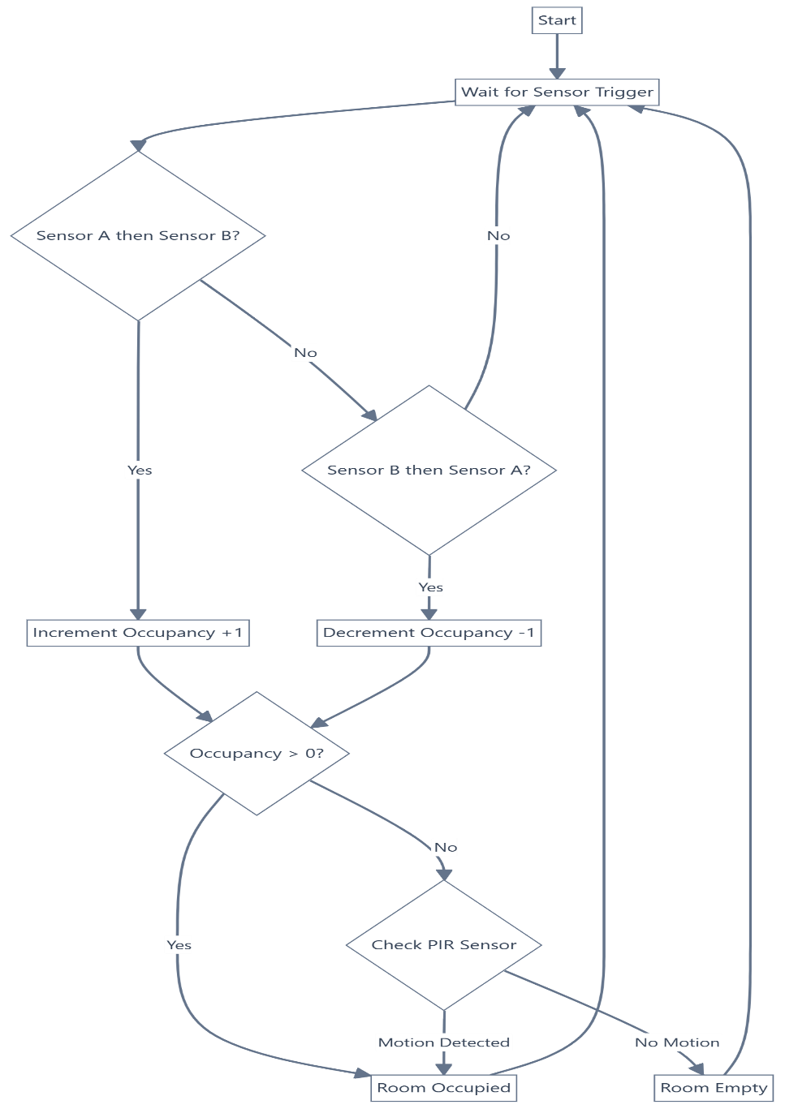

Fig 06: Occupancy Detection Flowchart
6.2 Power Cut Flow (Fig. 07)
The power cut decision begins once the occupancy count reaches zero. A delay timer starts, giving a buffer period in case someone re-enters immediately. During this delay, PIR activity is also monitored. If no movement is detected and the timer expires, the ESP32 sends signals to the relay module to disconnect all non-critical appliances. Appliances flagged as critical remain powered to ensure safety and convenience. If occupancy is detected again before the timer expires, the flow resets and loads remain powered.
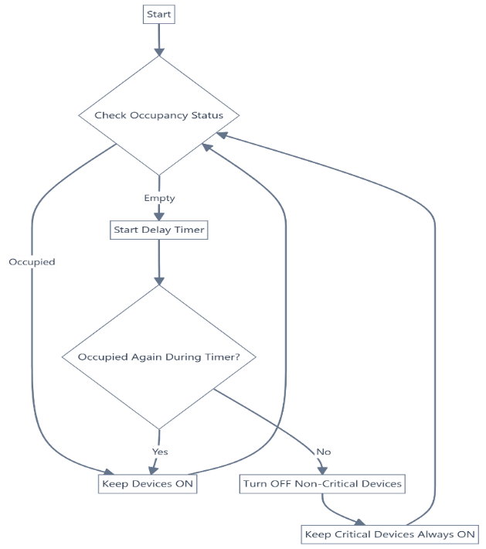

Fig 07: Automatic Power Cut Flowchart

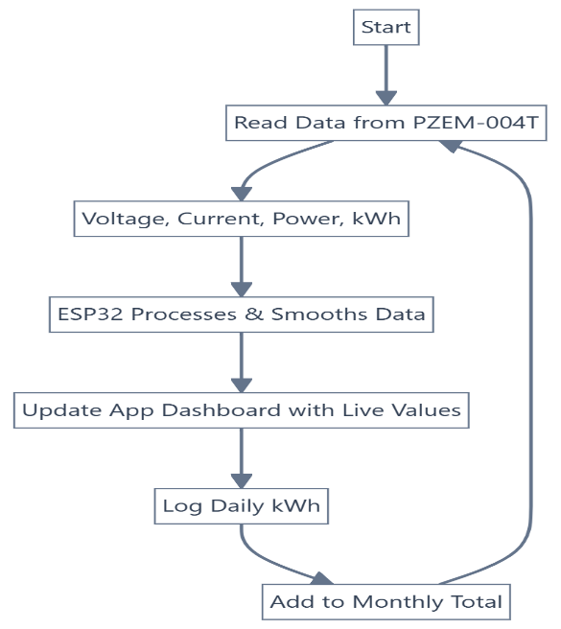
6.3 Energy Monitoring Flow (Fig. 08)
In this process, the ESP32 continuously polls the PZEM-004T energy monitor through UART communication. Each reading provides voltage, current, active power, and cumulative energy. To reduce noise and anomalies, a filtering algorithm such as a moving average is applied before storing or displaying the data. These values are then logged locally and transmitted to the mobile dashboard in real time. The dashboard visualizes both instantaneous readings and daily summaries, enabling users to monitor consumption effectively

Fig 08: Real-Time Energy Monitoring Flowchart

6.4 Monthly Estimation & Goal Tracking Flow (Fig. 09)
This flow builds on the energy monitoring data. Each day’s cumulative kWh usage is stored in the ESP32 memory or transmitted to the app database. The system then aggregates these daily values into a running monthly total. Based on this total, the app projects expected monthly consumption by extrapolating current usage trends. Users can set a monthly target, and the system compares the projected value against this goal. If the estimate exceeds the goal, the app issues notifications, encouraging corrective action to reduce consumption.
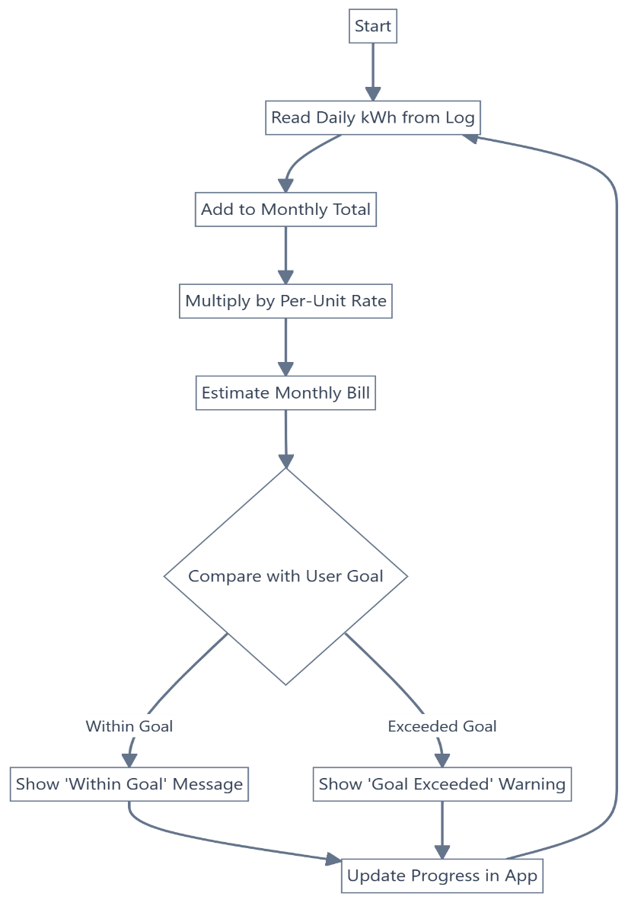

Fig 09: Monthly Estimation and Goal Tracking Flowchart

6.5 App Control & Manual Override Flow (Fig. 10)
The manual override flow ensures that users always retain authority over the system. The mobile app communicates with the ESP32 via Wi-Fi, allowing users to toggle appliances directly regardless of the automation logic. If a user manually turns on a device, the automation is temporarily suspended for that load until conditions stabilize. Once the user re-enables automation, the system synchronizes its state with the app to resume normal operation without conflicts. This flow guarantees both convenience and trust in the automation system.
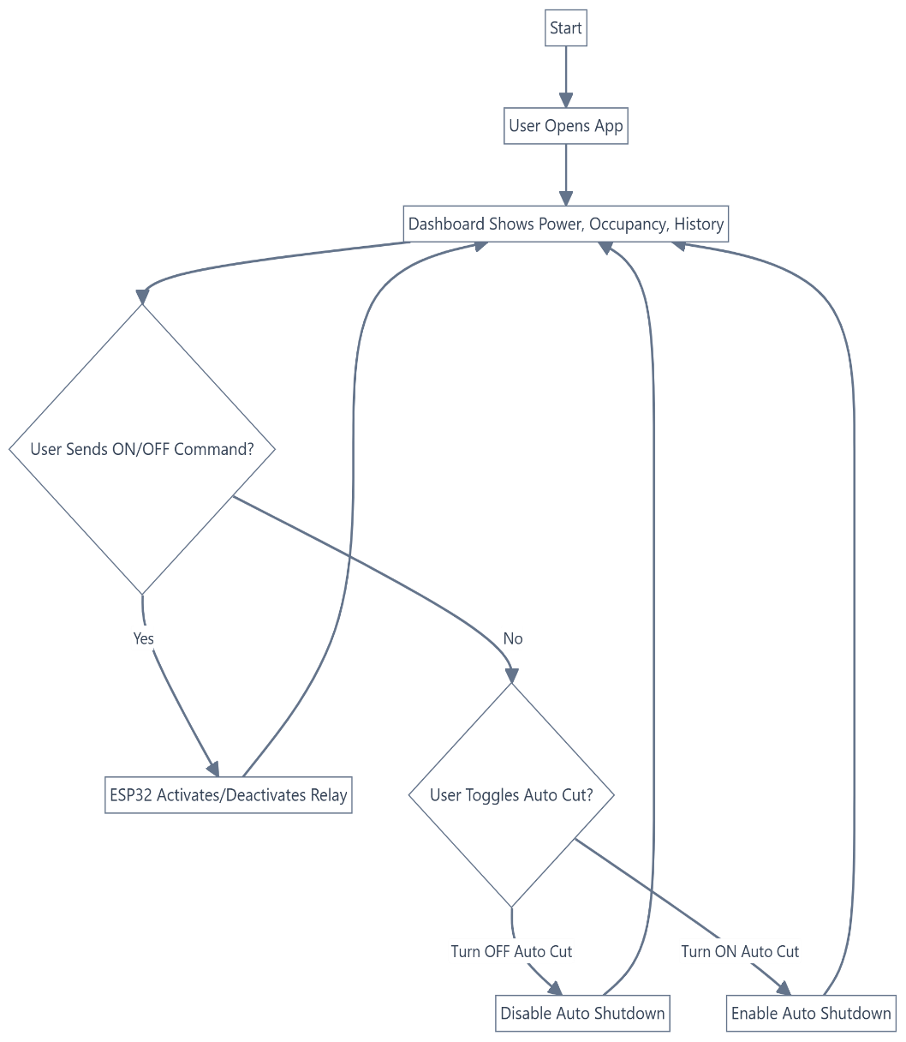

Fig 10: App Control and Manual Override Flowchart

7. Safety, Reliability & Ethics
- Fusing, isolation, and clearances to prevent hazards.
- Fail-safe defaults: automation does not switch critical loads on reset or fault.
- Privacy preserved: only non-imaging sensors used.

8. Approximate Cost (Estimate)
Item | Qty | Unit Cost (BDT) | Subtotal (BDT)
ESP32 board | 1 | 675 | 675
PZEM-004T V3.0 | 3 | 3,500 | 10,500
Ultrasonic sensors | 2 | 100 | 200
PIR motion sensor | 1 | 110 | 110
Relay modules | 3 | 100 | 300
Power supply, wires, terminals, enclosure | — | — | 1,500
Total |  |  | 13,285
Note: Prices are approximate.
9. Testing & Validation Plan
- Validate PZEM-004T accuracy against a reference meter.
- Test occupancy detection with different scenarios.
- Verify automation logic, delays, and override function.
- Run end-to-end trials to measure actual energy savings.

10. Future Scope

In the future, this prototype can be extended in several meaningful directions to enhance functionality, scalability, and usability:
- Multi-room integration with central dashboard: While the current system is designed for a single room, it can be expanded into a network of modules for each room in a house. These modules would synchronize with a central controller, enabling whole-home monitoring with per-room detail. This extension makes the system more scalable and practical for larger households.

- Advanced analytics and appliance profiling: Beyond aggregate consumption, algorithms could be introduced to identify specific appliance usage patterns using electrical signatures. Time-of-use awareness and predictive analytics would allow users to optimize appliance schedules and take advantage of off-peak tariffs.

- Integration with smart assistants and cloud services: Linking OptiWatt with voice assistants or cloud platforms would increase convenience and allow remote monitoring from anywhere. Cloud backup would also preserve historical data for long-term analysis and reporting.

- Hardware refinements and professional enclosures: Future iterations could replace breadboard prototypes with custom PCBs, ensuring proper isolation and reliability. Housing the system in DIN-rail enclosures with modular connectors would improve safety and make installation suitable for real-world deployment.

11. Discussion & Conclusion

The OptiWatt Smart Energy Management System prototype shows that low-cost hardware and straightforward automation can meaningfully cut household energy waste. By pairing real-time metering with occupancy-aware control, the system links behavior to cost and automatically turns off non-critical loads when a room is empty, while app control and manual overrides keep the user in charge. Reliability is strengthened through sensor fusion (dual ultrasonic plus PIR), delay timers, and basic signal filtering; privacy is preserved by using non-imaging sensors. Safety measures—fusing, isolation, and fail-safe defaults—support practical deployment. Key limitations include its single-room scope, possible miscounts during crowded or fast doorway crossings, and sensitivity to sensor placement and calibration. The planned tests (meter accuracy vs. a reference, varied occupancy scenarios, automation/override checks, and end-to-end savings trials) will quantify performance and guide tuning. Furthermore, OptiWatt reassures users against unpredictable or erroneous billing by providing visibility and control over their actual consumption.
Overall, OptiWatt offers a practical and scalable path to smarter home energy use. Its modular design can extend to multi-room setups and gain value from future additions such as appliance-level analytics, usage forecasting, cloud/assistant integration, and refined hardware (custom PCBs and enclosure). With these steps, the system can move from prototype to a safe, reliable, and user-friendly solution for everyday homes.
References
- Espressif Systems. (2023). ESP32 Series Datasheet. Espressif Systems. Retrieved from https://www.espressif.com/sites/default/files/documentation/esp32_datasheet_en.pdf
- Peacefair. (2019). PZEM-004T V3.0 AC Digital Power Meter Module – Technical Manual. Peacefair Electronics. Retrieved from https://github.com/olehs/PZEM004T
- Morgan, E. J. (2014, November 16). HC-SR04 Ultrasonic Sensor Datasheet. Retrieved from https://www.alldatasheet.com/datasheet-pdf/pdf/1132203/ETC2/HC-SR04.html
- HC-SR501 PIR Motion Sensor Datasheet. (n.d.). AllDatasheet.com. Retrieved from https://www.alldatasheet.com/datasheet-pdf/pdf/1131987/ETC2/HC-SR501.html

