

**Contents**

**Details:**

1. **Introduction**
   1. What is a calculator
   2. Dimension Calculator
2. **User guide**
   1. Displaying results
   2. The operators
      1. Addition
      2. Clear sign
      3. Division
      4. Equalization
      5. Multiplication
      6. Numeric values
      7. Positive/negative signs
      8. Subtraction
      9. Switching between forms
   3. Exceptions
   4. Conversions
      1. Standard calculator
      2. Exchange rate
      3. Interest rate
3. **Conclusion**

**Page number**

3

3

3

4

4

4

6

6

8

**Introduction:**

What is a calculator?

For the people who don’t know what a calculator is, it is a utility used frequently by officers, student, mathematicians and many others in order to solve a given mathematical sequence. A calculator functions with arithmetical operators that renders equations and then displays accurate results. Numeric keypads (values from the range of 0 to 9) are numbers which can be specified as integers or real numbers. Operators consists arithmetical symbols (e.g. +, -, *, / and =) to which they render commands within an equation thus initializing the result.

What is a Dimension Calculator?

A Dimension Calculator is the newly branded product that distinguishes itself from varies calculators. It is established in three categories: The standard calculator, the exchange rate and the interest rate. Each of them is designed to execute a differentiating result within their own fields to which will be shortly discussed.

**User Guide:**

1. Displaying results:

To be logic, it is evident that the user requires a display screen to see whatever she is inputting or whatever output is being displayed. Values, errors and operators are displayed on screen.

1. The operators:

As explained, operators are arithmetical notations that emphasize a command within an equation. These include: addition (+), the clear sign (CLR), division (/), equalization (=), multiplication (*), numeric values (from 0 to 9), positive/negative signs (+/-), and subtraction (-) and switching between forms (“E”, “C”, “I”). Each of these functions has important tasks to execute;

* + - 1. Addition (+):

This is defined as the process in adding two or more values or numbers together.



* + - 1. Clear sign (CLR):

This is to remove unnecessary information displayed on screen.

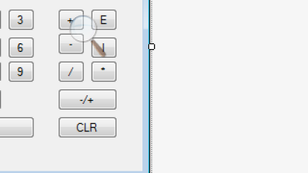

* + - 1. Division (/):

This is defined as separating or dividing a number from another number.

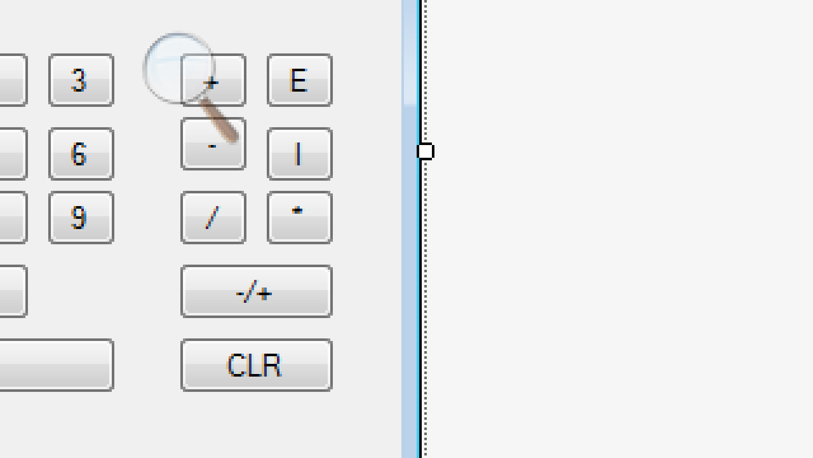

* + - 1. Decimal (.):

It is a dot that appears after a whole number. They represent fractions which evidently, are smaller values compared to a whole number. 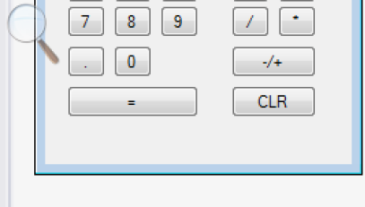

* + - 1. Equalization (=):

The process of resulting to an answer that gives the same amount, value and size within the equation.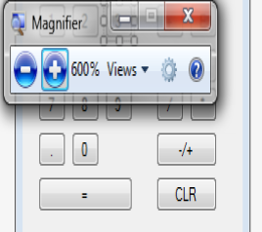

* + - 1. Multiplication (*):

They are numbers that contains factors or other numbers of an exact amount of times. 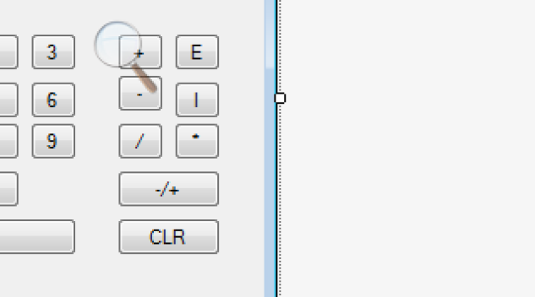

* + - 1. Numeric values (from 0 to 9):

These are numbers from the range of 0 to 9. They are used to establish an equation or method. Without these values or numbers, equations will become of no use to calculate. Instead, a calculator will become utterly worthless to utilize within that matter.

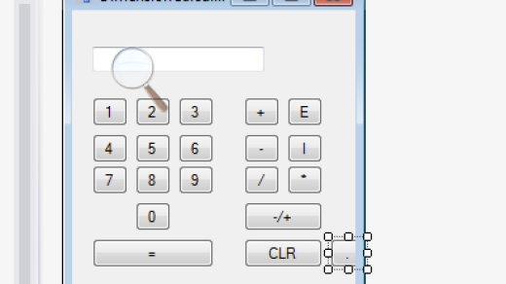

* + - 1. Positive/negative signs:

These are unique signs placed before a value to determine whether the value is less or more than 0. 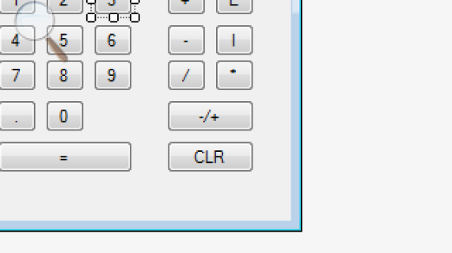

* + - 1. Subtraction (-):

This is defined as the process of deducting two or more values or numbers together. 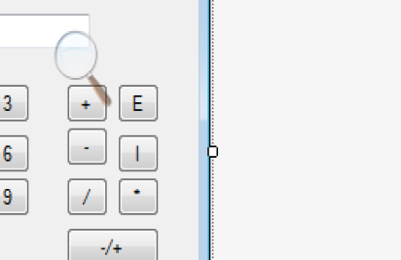

* + - 1. Switching between forms:

To switch between forms, buttons are represented to execute the method. There is a consistency of three buttons mounted on all three forms to which they are the calculator (“C”), the exchange rate (“E”) and the interest rate (“I”).

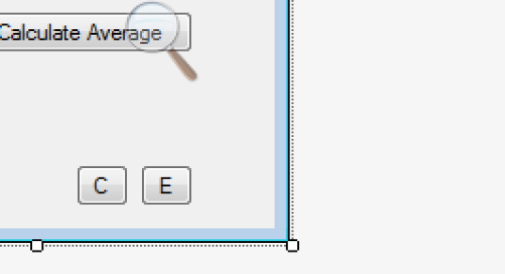  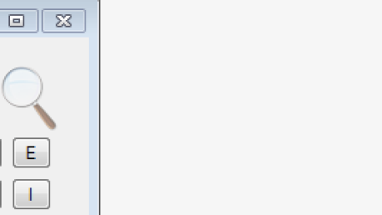

1. Exceptions:

This is defined as the state in which the system has indentified a mistake or an error. Whenever a mistake is committed an error message is displayed on screen encrypting “Syntax error”.

1. Conversions:

This entails the movement from one mode to another. These modes have been separated within three categories: The standard calculator, the exchange rate and the interest rate. To view them on screen, press the mode button.

1. Standard calculator;

This is the default setting of a calculator. Calculations are processed normally and outputs are displayed in its original or defaulted form. Basically this could be entitled as the origin or the starting point of the calculator.

How to use it?

Very basic and convenient, the standard calculator provides users with ease in utilizing it. By pressing on the numeric keypads or the operators, you are inputting a value or an arithmetic sign. Subsequently, they are displayed on the textbox to return a feedback to you.

1. Exchange rate;

Commonly known as the currency exchange rate, it is designed to convert one currency to another. The output display will show a currency symbol as well as a numeric value.

How to use it?

As you may have noticed, there are eight selective currencies separated within an equal proportion of groups of four. By selecting a currency in both groups, there will be a comparison between the two. Initially, type in a certain numeric value on the textbox and then press the button “Convert”. A result will appear at the bottom of the application which justifies the conversion of the inputted currency to the converted currency.

1. Interest rate;

As the name implies, an interest rate is defined as advancement initialized within the original value. Interest rates are solved by calculating the set value multiplied by a called – in percentage given by the user.

How to use it?

There are three textboxes shown. One is the principle start amount, the second, the annual duration (written as years) and the lastly, the set rate. Only numeric values, not characters (except the decimal), are permitted within the textboxes.

Henceforth, the interest rate will be displayed below.

**conclusion:**

Within modern days, as technology accumulates, calculators have become profoundly dependant by many people. Furthermore, they have been greatly enhanced, which thus creates an ease to users into solving very elaborate equations. It provides a benefit to our world shortening the amount of time we consume in calculating a given problem. Although, the drawback is calculators lately have been relatively cost-priced.