Contents

Create Firebase Account 2

Sign in to Firebase 2

Add Firebase to Android App 4

Download google-service.json file 5

Add Firebase to IOS Application 8

Download the GoogleServices-info.plist 11

# Create Firebase Account

## Sign in to Firebase

1. Sign in to the Firebase console application using below link.

<https://console.firebase.google.com/>

1. Enter your mail to login or create an account to Login.

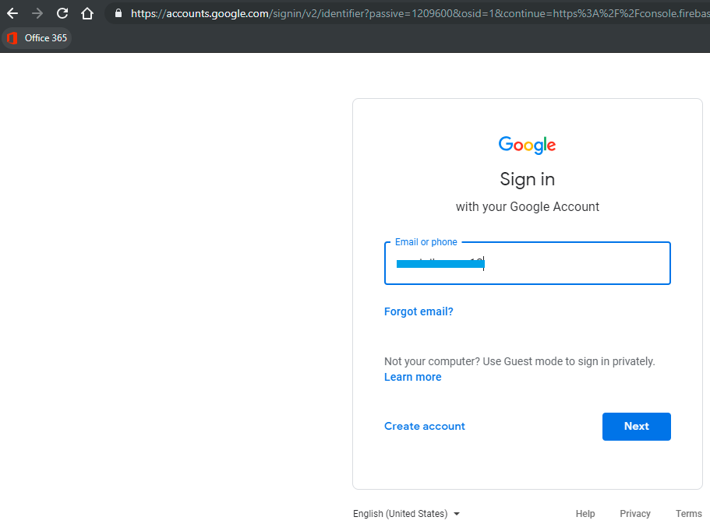

1. Enter your mail password and click Next.

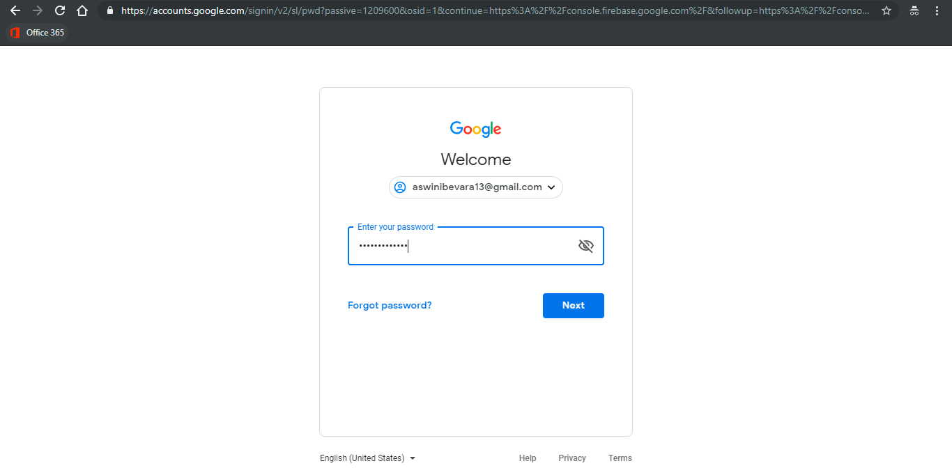

1. Create a new Firebase project if you don't have one. Click **Add project**.

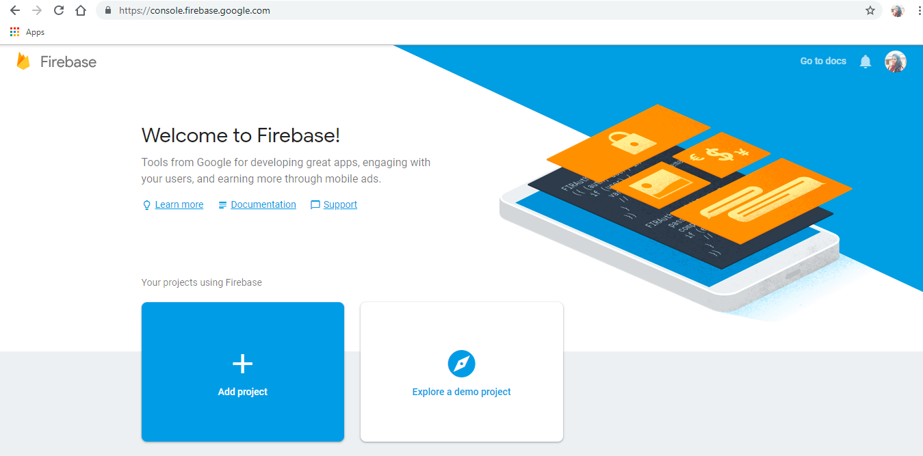

1. Enter **Project name** and check the terms & conditions agreement and click on **Create project**.

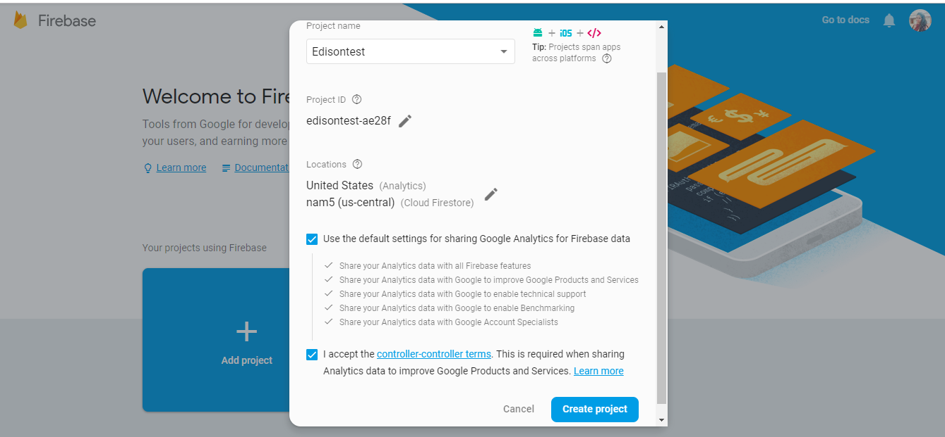

1. Click Continue.

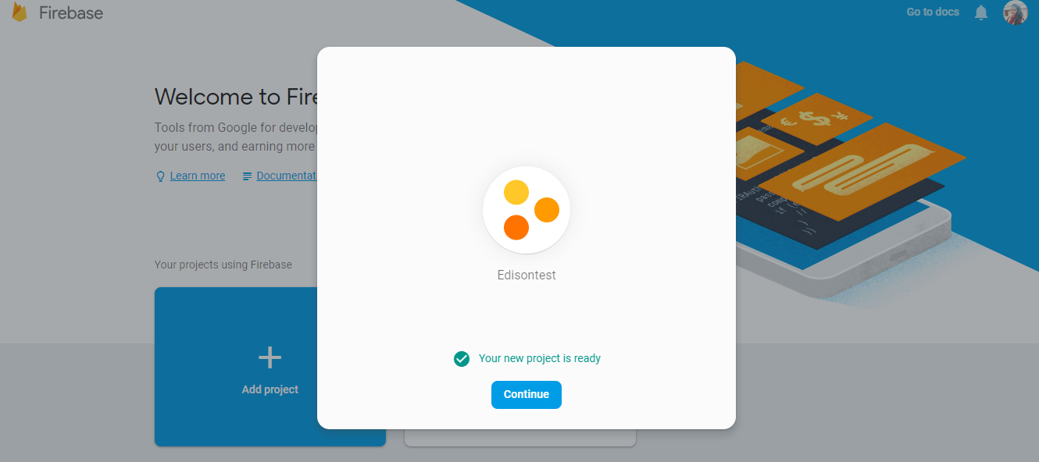

## Add Firebase to Android App

1. After you create your project, select **Add Firebase to your Android app**.

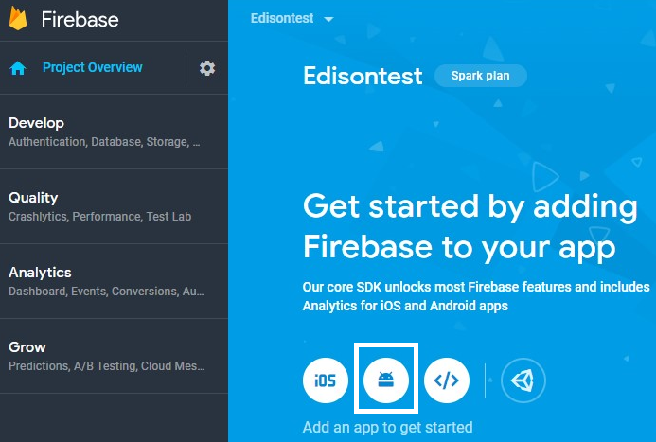

1. Enter android package name and click Register app.

Ex: com.<company name>.<app name>

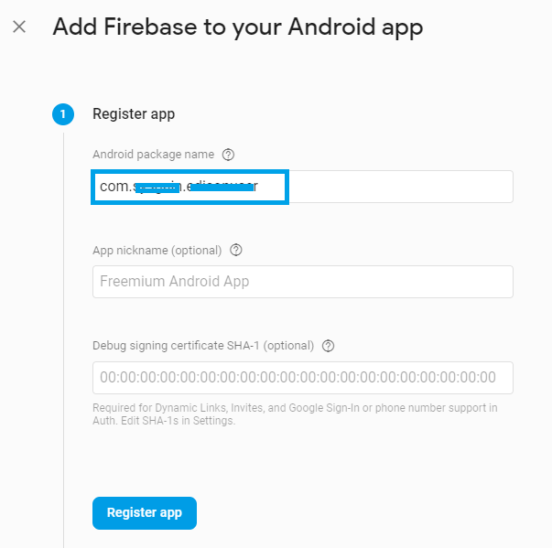

## Download google-service.json file

1. Click **Download googl-service.json** and save it in your local machine.

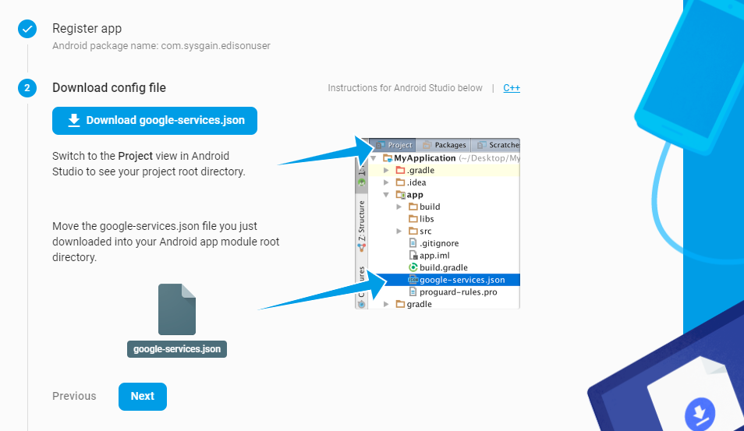

1. Click **Next**.

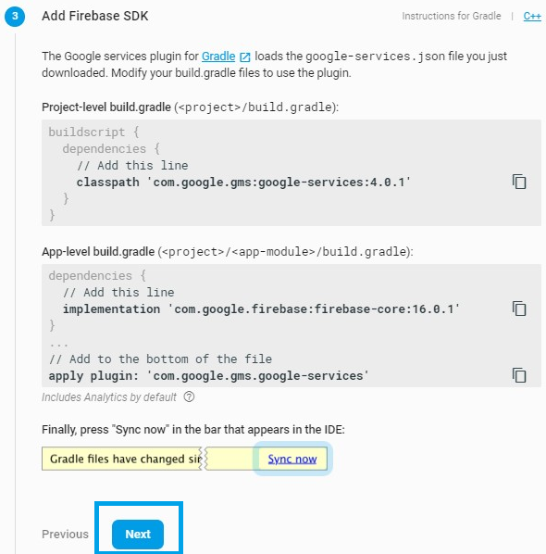

1. Select **Skip this step** on the page.

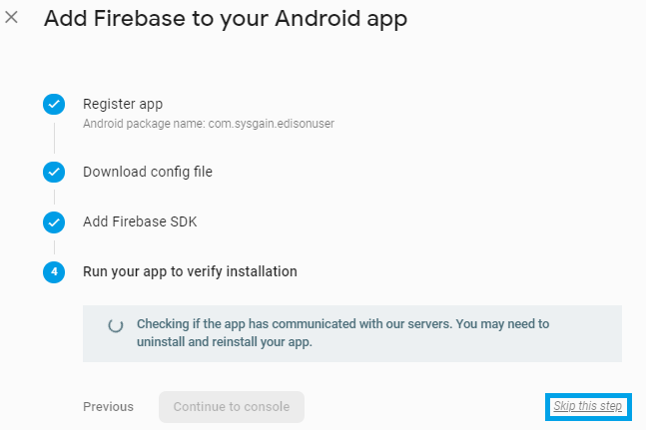

## Add Firebase to IOS Application

1. From the General menu scroll down to app section and click on Add App.

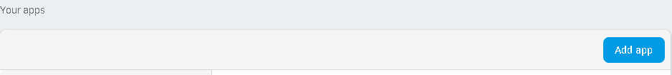

1. we will get one pop-up screen, select the IOS platform.

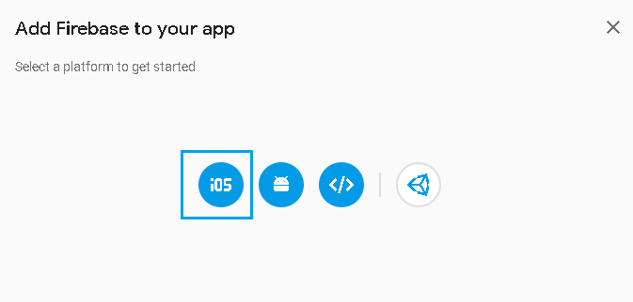

1. Provide the bundle id

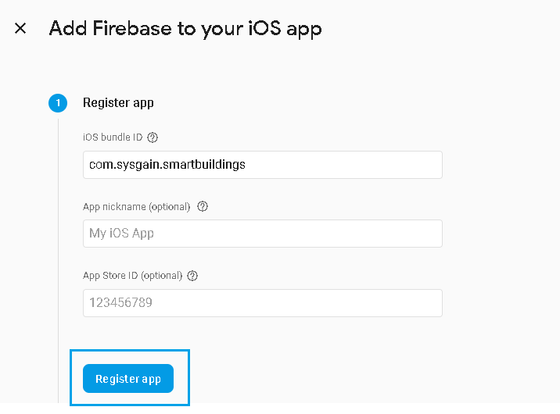

1. After clicking on the “Register app”, the below screen will get populated click on “Next”

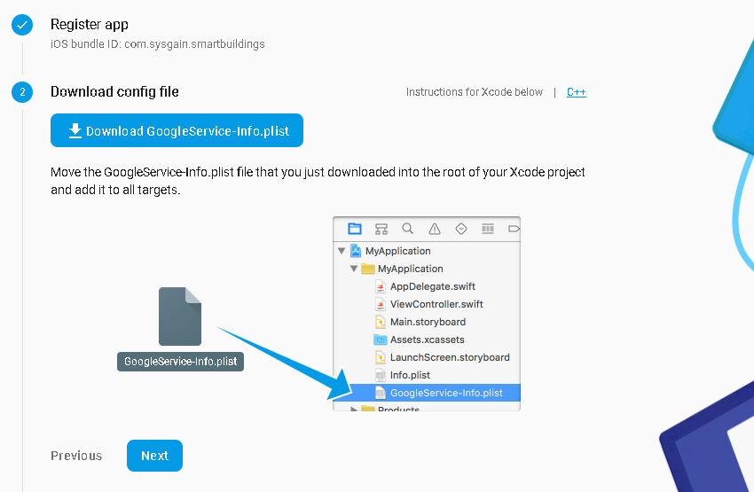

1. Click on “Continue to Console” to complete the setup.

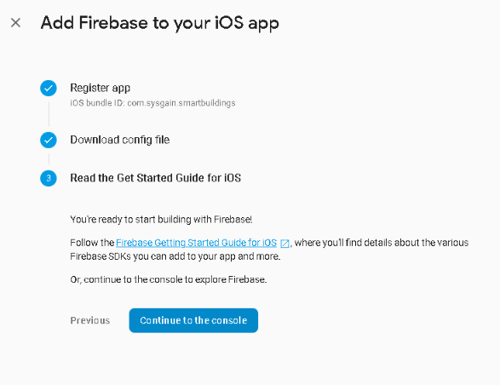

## Download the GoogleServices-info.plist

1. Download the **GoogleServices-info.plist** file by clicking on “General” menu of Firebase application

