Contents

2. Simulator Configuration 1

2.1. Clone the code 1

2.2. Update appsettings.json file 3

2.3. Run the Simulator 6

# 2. Simulator Configuration

## 2.1. Clone the code

1. Open Git Bash and run the below command to clone the Repo into your Remote Machine.

**git clone <git hub repo URL>**

**Ex: git clone** [**https://github.com/<xxxx>/<xxxxxx.git**](https://github.com/%3cxxxx%3e/%3cxxxxxx.git)**>**

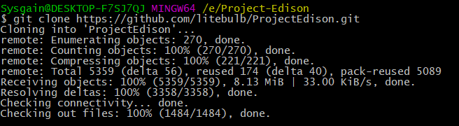

1. Find the solution called **Edison.Devices.sln**

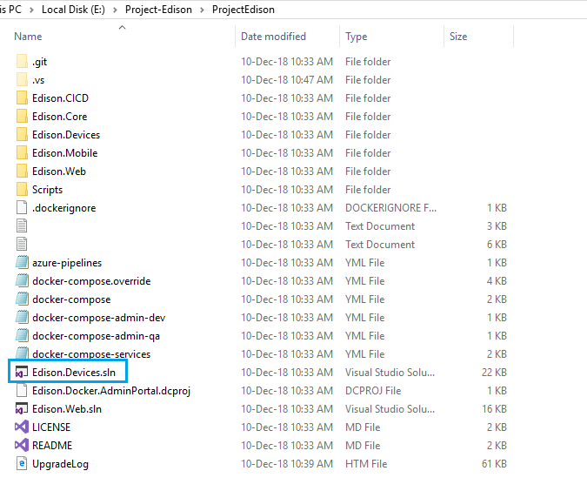

1. **Right** **click** and Open with **Visual studio 2017.**

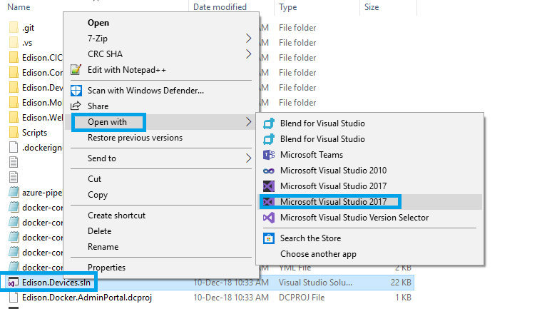

**Note:** Make sure that the **Microsoft.NETCore.App (2.1) SDK** was installed in your Visual Studio 2017.

## 2.2. Update appsettings.json file

1. Open **appsettings.json** from **Edison.Simulators.Sensors** Project**.**

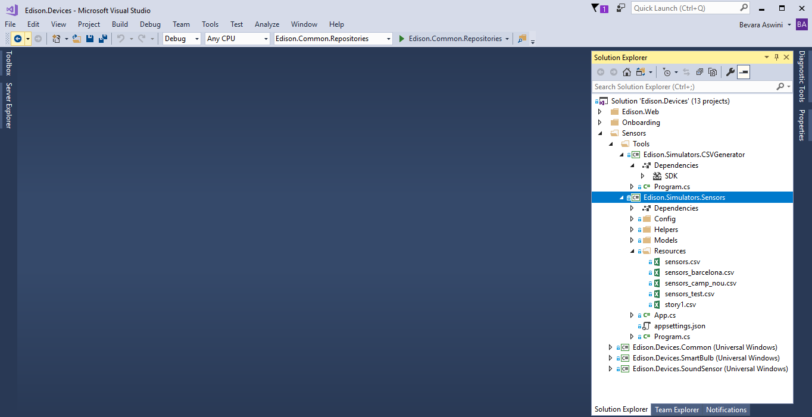

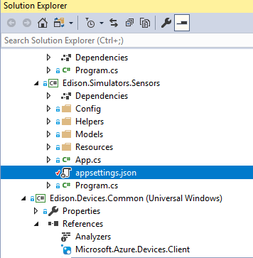

1. Fill in the values of all the necessary keys such as Cosmos DB, Service Bus, Tenant, IoT Hub, Bot details and save it.

**Note:** Please refer Deployment Guide for the above Endpoint values.

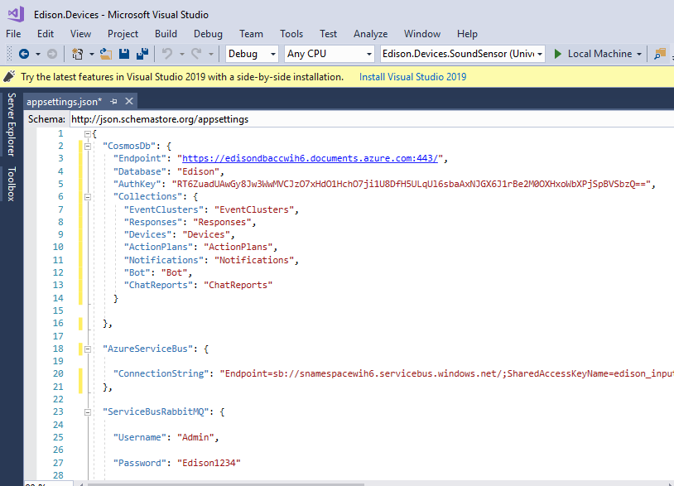

1. Select **Edison.Simulators.Sensor** from dropdown list to run the Simulator as shown in below screen.

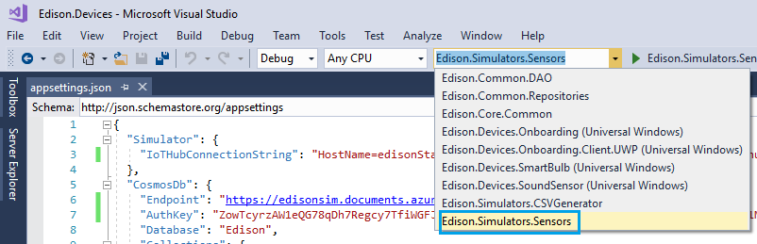

1. Select **Edison.Simulators.Sensors** Project and click **Properties Icon** as shown in below Screen.

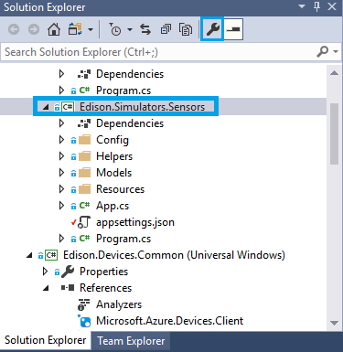

1. Make sure that the **Output type** of the application should be **Console Application,** toopen command promptafter successful built**.**

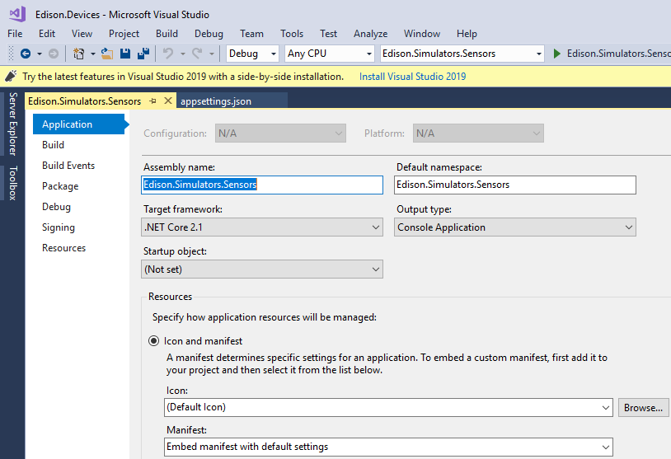

## 2.3. Run the Simulator

1. **Right click** on **Edison.Devices.Simulators** Project and click **Debug>Start new instance** torun the project in debug mode.

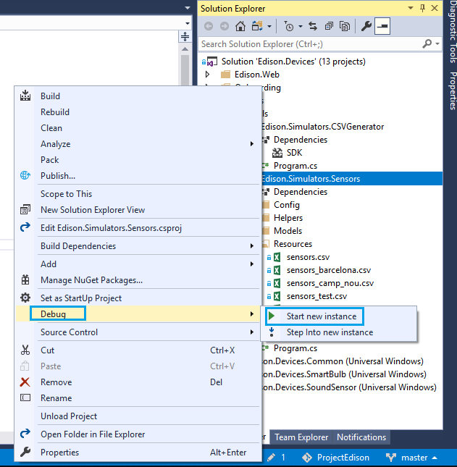

1. After successful build of the project, a command prompt screen will appear with list of events displayed after a while.

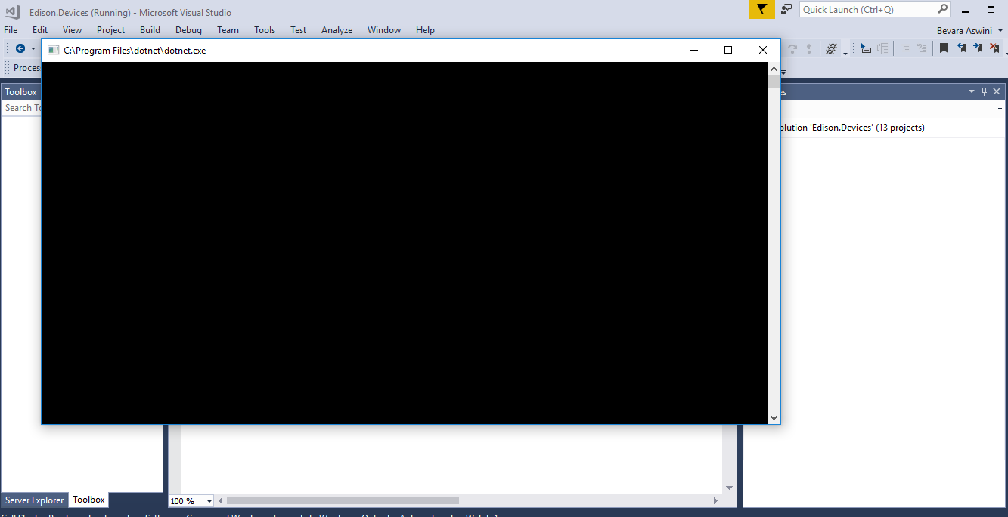

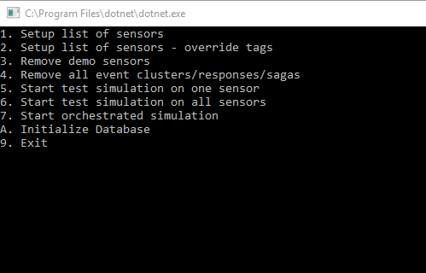

1. Choose the Corresponding event number relevant to your choice.

Run Command **A** in the terminal and Enter **Y** if you want to **Initialize the Database.**

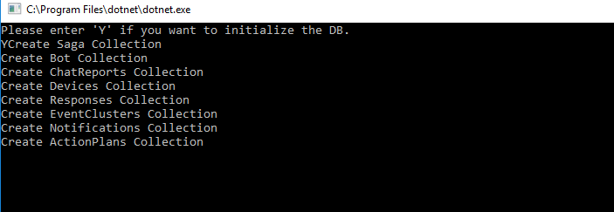

1. The respective database **Collections** will be created after successful initialization of Database.

Created Collections can be checked in Azure Cosmos DB.

Navigate to **Azure Portal>Resource Group> Azure Cosmos DB> Data Explorer** as shown in below screen.

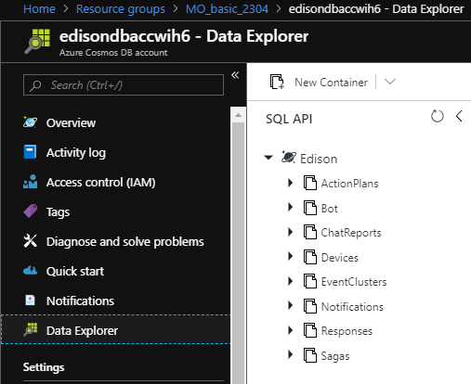

1. Use command **1** to generate some devices.

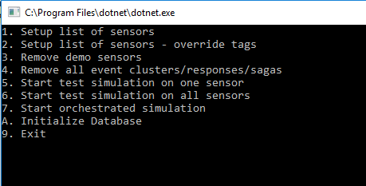

1. Enter the resources path **Ex:** **Resources/sensors_barcelona.csv** to generate some devices.

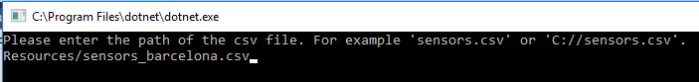

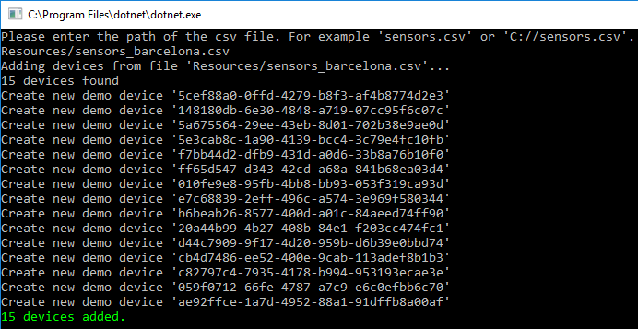

1. Navigate to **Azure Portal**> **IoT Hub> IoT devices** to check the created devices.

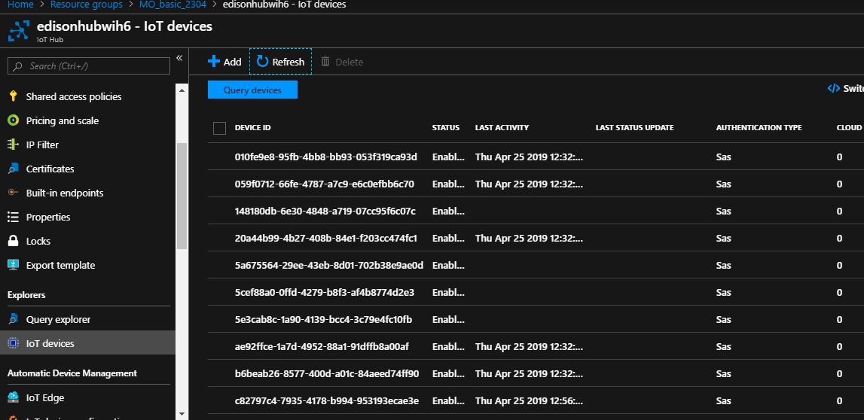

1. Use command **5** to trigger an event.



1. Type a number corresponding to the device to trigger.

