PhUSE CSS

Linked Data for Clinical Trials

An Interactive Hands-on Workshop

EXERCISES

Version 3.0

04 March 2018

|  |  |  |  |
| --- | --- | --- | --- |
|  |  |  |  |

|  |  |  |  |
| --- | --- | --- | --- |
|  |  |  |  |
|  |  |  |  |

Contents

[Introduction 2](#_Toc506557117)

[Laptop Preparation and Server Login 2](#_Toc506557118)

[Exercises 3](#_Toc506557119)

[1. Create a Study Graph 3](#_Toc506557120)

[1.1 Open the Graph Editor 3](#_Toc506557121)

[1.2 Add a Study, Study Phase, and Treatment Arms 4](#_Toc506557122)

[1.3 Add Persons and Treatments 6](#_Toc506557123)

[1.4 Add Demographics 6](#_Toc506557124)

[1.5 Add another Person 7](#_Toc506557125)

[1.6 Export to TTL 8](#_Toc506557126)

[1.7 Validate the Data 9](#_Toc506557127)

[1.8 Upload to Database 10](#_Toc506557128)

[2. Query Graph Data 11](#_Toc506557129)

[2.1 Show all triples 11](#_Toc506557130)

[2.2 How many people participateIn the study? 11](#_Toc506557131)

[2.3 Find the names of people who participate in the study. 12](#_Toc506557132)

[2.4 List the names of the people randomized to each treatment type. 12](#_Toc506557133)

[3. Ontology and Inference 13](#_Toc506557134)

[3.1 Review the Ontology 13](#_Toc506557135)

[3.2 Add the Ontology to the LDWStudy database 13](#_Toc506557136)

[3.3 Explore the data 13](#_Toc506557137)

[3.4 Find the names of HumanStudySubjects in your study. 14](#_Toc506557138)

[3.5 Write a reasoner-based query to find all types (classes) of People associated with the study (not just participants) 14](#_Toc506557139)

[4. Merge Studies 15](#_Toc506557140)

[4.1 Create the Data Pool 15](#_Toc506557141)

[4.2 List Drug1 studies by phase. 15](#_Toc506557142)

[4.3 How many HumanStudySubjects participated in all Drug1 studies? 16](#_Toc506557143)

[4.4 How many women received active treatment (non placebo) across all Drug1 studies combined? 16](#_Toc506557144)

[4.5 List all Persons in the studies. 16](#_Toc506557145)

[Appendix 1: Course Resources 18](#_Toc506557146)

# Introduction

Instructions in this document are specific to the PhUSE cloud server environment, Graph Editor application and workshop methods. The exercises represent one of many possible approaches to the material and make no claim to be best or recommended method. The instructor will complete the exercises during the session, along with the attendees.

Your feedback is welcomed and encouraged. Please send your comments to: **tim.williams@PhUSE.eu**

**Materials**

* Laptop with Remote Desktop capability
* Printed copies of the following will be supplied by the instructor:
  + Exercises (this document)
  + Info Sheet (unique to each person)
  + Graph Editor Reference
  + SPARQL Reference Sheet

**Symbols**

|  |  |
| --- | --- |
|  | Stop and wait. Do not proceed to the next section until instructed. |
| **!** | Cautions and warnings. Failure to follow these steps may lead to unanticipated problems. |
|  | The instructor presents important material. |
| IdeaIcon_clean_20mm | Helpful tips and advice. |
| Image result for information icon | Additional information. |

# Laptop Preparation and Server Login

Instructions assume MS Windows operating system.

1. On your laptop, ensure your screen resolution is set to a minimum of 1366 x 768. Higher resolutions are also acceptable.
2. 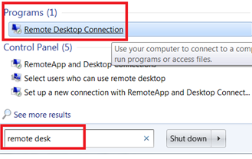In the search box on the taskbar on your laptop, type **remote desk,** then select **Remote Desktop Connection** from the Programs section.﻿
3. You may need to select **Show Options** to see the tabs in the next step.
4. 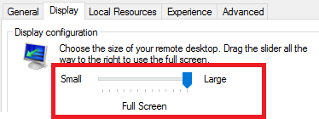Select the **Display** tab. Ensure the Display Configuration slider is all the way to the left for **Large,** Full Screen:

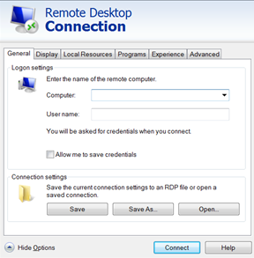

1. On the **General** tab, entering values in the **Computer:** and **User name:** supplied on your **Info Sheet**.
2. Click **Connect**.
3. When prompted, enter the password value from the **Info Sheet** and click **OK**.

|  |  |  |
| --- | --- | --- |
|  | Stop here and wait for the instructor.  Presentation follows |  |

# 

# Exercises

# Create a Study Graph

The PhUSE Cloud Server environment is used for all exercises.

# Open the Graph Editor

1. Open Google Chrome using the shortcut on the server's desktop.
2. Click on  in the shortcuts bar.
3. The Graph Editor opens and shows two nodes: One for **Drug1** and the other for the drug's name, **Serum114.**



**Ask for assistance if you do not see these nodes.**

|  |  |
| --- | --- |
| IdeaIcon_clean_20mm | If the Graph Editor does not load, click Cancel "x" and reload the page. Ask for assistance if the graph editor still fails to load. |

# Add a Study, Study Phase, and Treatment Arms

|  |  |
| --- | --- |
| **!** | Refer to the **Info Sheet** handout when instructions contain references to <Info Sheet:> . The sheet contains values unique to your graph. |

1. Create a **Study** node using the label value from your **Info Sheet**.

Node values:

|  |  |  |
| --- | --- | --- |
| **Prefix:** | eg |  |
| **Type:** | IRI |  |
| **Label:** | *<Info Sheet: Study>* | Image result for information icon*See Info Sheet for value* |

1. 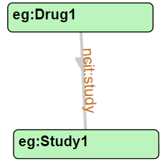Create link ***from*** **Drug1** ***to*** the **Study** node:

Link values:

|  |  |
| --- | --- |
| **Prefix:** | ncit |
| **Label:** | study |

1. Create a Study **Phase** node. You may choose any of these phases: **Phase2**, **Phase3**, **Phase4.**

Node values:

|  |  |  |
| --- | --- | --- |
| **Prefix:** | ncit |  |
| **Type:** | IRI |  |
| **Label:** | *<Input a value: Phase2 or Phase3 or Phase4, etc.>* | Image result for information icon*You choose a value for phase:* **Phase2, Phase3, Phase4**  *NO SPACE in the name!* |

1. Link ***from*** the **Study** ***to*** the Study **Phase**.

Link values:

|  |  |
| --- | --- |
| **Prefix:** | ncit |
| **Label:** | phase |

1. Create two Treatment Arm nodes for the **Study** using values from your **Info Sheet**.

Node values:

|  |  |  |
| --- | --- | --- |
| **Prefix:** | eg |  |
| **Type:** | IRI |  |
| **Label:** | *<Info Sheet: Treat Arm One>* | Image result for information icon*See Info Sheet for value.* |

Node values:

|  |  |  |
| --- | --- | --- |
| **Prefix:** | eg |  |
| **Type:** | IRI |  |
| **Label:** | *<Info Sheet: Treat Arm Two>* | Image result for information icon*See Info Sheet for value.* |

Ensure you have two Treatment Arm (**TrtArm***n-n*) nodes in your graph.

1. Link ***from*** the **Study** ***to*** each of the two Treatment Arm nodes. The relations have identical values.

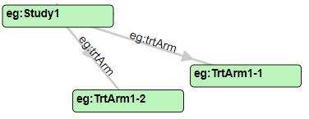Link values:

|  |  |  |
| --- | --- | --- |
| **Prefix:** | eg |  |
| **Label:** | trtArm | Image result for information icon*Note lowercase 't' for relation label* |

There should now be one ***eg:trtArm*** link to each of the Treatment Arm nodes.

1. Create two Treatment Type nodes to represent **PlaceboArm** and **ActiveArm** treatments

Node values:

|  |  |  |
| --- | --- | --- |
| **Prefix:** | eg |  |
| **Type:** | IRI |  |
| **Label:** | PlaceboArm |  |

Node values:

|  |  |  |
| --- | --- | --- |
| **Prefix:** | eg |  |
| **Type:** | IRI |  |
| **Label:** | ActiveArm |  |

1. Now join each Treatment Arm node (created in **Step 5**) to one of the Treatment Type nodes. It does not matter which is linked to the **PlaceboArm** or the **ActiveArm**. You will create two links, each with the same label:

Link values:

|  |  |  |
| --- | --- | --- |
| **Prefix:** | eg |  |
| **Label:** | trtArmType | Image result for information icon*Note lowercase 't' at start of label.* |

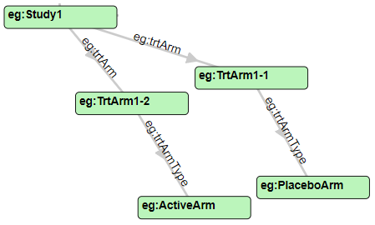

The Study and Treatment Arm portion of your graph should look similar to:

|  |  |
| --- | --- |
| IdeaIcon_clean_20mm | Click  to create a copy in case anything goes wrong in the next steps. |

|  |  |
| --- | --- |
| Image result for information icon | In these steps you defined two Treatment Arms that are unique to your study, then assigned those arms to one of two Treatment Arm Types: PlaceboArm, ActiveArm. These "type of arm" nodes are identical across the studies in the workshop and allow identification of "all persons who received active treatment." In a real application, the Treatment Arm would be further extended to include dosage and administration information unique to that study. This graph would be too complex for the workshop. |

# Add Persons and Treatments

1. Add two **Person** nodes using values from your **Info Sheet**.

Node values:

|  |  |  |
| --- | --- | --- |
| **Prefix:** | eg |  |
| **Type:** | IRI |  |
| **Label:** | *<Info Sheet: Person One>* | Image result for information icon*See Info Sheet for values.* |

Node values:

|  |  |  |
| --- | --- | --- |
| **Prefix:** | eg |  |
| **Type:** | IRI |  |
| **Label:** | *<Info Sheet: Person Two>* | Image result for information icon*See Info Sheet for values.* |

1. Create ***participatesIn*** relations ***from*** each of the two Person nodes ***to*** the Study node.

Link values:

|  |  |  |
| --- | --- | --- |
| **Prefix:** | eg |  |
| **Label:** | participatesIn | Image result for information icon*Note uppercase "I" .* |

1. Create a link ***from*** one of the Person nodes ***to*** one of the Treatment Arm (trtArm*n-n*) nodes using the ***randomizedTo*** relation.

Link values:

|  |  |  |
| --- | --- | --- |
| **Prefix:** | eg |  |
| **Label:** | randomizedTo | Image result for information icon*Note uppercase "T" .* |

1. Create a link ***from*** the second Person node ***to*** the other Treatment Arm (trtArm*n-n*) node using the ***randomizedTo*** relation.

Link values:

|  |  |  |
| --- | --- | --- |
| **Prefix:** | eg |  |
| **Label:** | randomizedTo | Image result for information icon *Note uppercase "T" .* |

Now the two Persons with ***participatesIn*** relations to the **Study** are also ***randomizedTo*** Treatment Arms.

# Add Demographics

1. Create a node for **Male** and a node for **Female .** Note that both use the **ncit** prefix.

Node values:

|  |  |  |
| --- | --- | --- |
| **Prefix:** | ncit |  |
| **Type:** | IRI |  |
| **Label:** | Male |  |

Node values:

|  |  |  |
| --- | --- | --- |
| **Prefix:** | ncit |  |
| **Type:** | IRI |  |
| **Label:** | Female |  |

1. Create links ***from***the two Person nodes ***to*** a Gender node using the ***gender*** relation. This relation also uses the ncit prefix.

Link values:

|  |  |  |
| --- | --- | --- |
| **Prefix:** | ncit |  |
| **Label:** | gender | Image result for information icon*Label is all lowercase.* |

1. Create one **Given Name** (First name) for each **Person** node in the graph. Note that these have Type: STRING because they are string literals.

Node values:

|  |  |  |
| --- | --- | --- |
| **Prefix:** | *NOT APPLICABLE* | Image result for information iconPrefix is not applicable to literals. You may ignore this field. |
| **Type:** | STRING |  |
| **Label:** | *<Any name you want>* |  |

1. Link ***from*** each **Person** node ***to*** their **Given Name** using the ***givenName*** relation. Note the use of the schema prefix.

Link values:

|  |  |  |
| --- | --- | --- |
| **Prefix:** | schema |  |
| **Label:** | givenName |  |

1. Create **Age** nodes for each Person as INT (integer) literals:

Node values:

|  |  |  |
| --- | --- | --- |
| **Prefix:** | *NOT APPLICABLE* | Image result for information iconPrefix is not applicable to literals. |
| **Type:** | INT |  |
| **Label:** | *<Any integer age value you want>* |  |

1. Link ***from***a Person ***to*** an age using the ***age*** relation.

Link values:

|  |  |  |
| --- | --- | --- |
| **Prefix:** | eg | Image result for information icon The eg: prefix is used because age calculation may be specific to this graph. |
| **Label:** | age |  |

# Add another Person

1. Add another **Person** node to the graph:

Node values:

|  |  |  |
| --- | --- | --- |
| **Prefix:** | eg |  |
| **Type:** | IRI |  |
| **Label:** | *<Info Sheet: Person Three>* | Image result for information icon*See Info Sheet for values.* |

***This node will represent you and your role in this study!***

1. Create a new node for your **Given Name** as a string literal.

Node values:

|  |  |  |
| --- | --- | --- |
| **Prefix:** | NOT APPLICABLE | Image result for information iconPrefix is not applicable to literals. You may ignore this field. |
| **Type:** | STRING |  |
| **Label:** | *<Your given (first) name>* |  |

1. Link ***from*** your new **Person** node ***to*** your **Given Name** using the ***givenName*** relation. Remember to use the **schema** prefix.

Link values:

|  |  |  |
| --- | --- | --- |
| **Prefix:** | schema |  |
| **Label:** | givenName |  |

1. Create a ***gender*** link ***from*** your Person node ***to*** your gender.

Link values:

|  |  |  |
| --- | --- | --- |
| **Prefix:** | ncit |  |
| **Label:** | gender | Image result for information icon*Label is all lowercase.* |

*The polite instructor will not ask you to create an age node and link. :)*

1. Your role in this study is Linked Data Expert. Create the ***LDExpert*** relation ***from*** your **Person** node ***to*** the **Study** node.

Link values:

|  |  |  |  |
| --- | --- | --- | --- |
| **Prefix:** | | eg |  |
| **Label:** | | LDExpert |  |
| **!** | | Congratulate yourself for becoming a Linked Data Expert, then Click  to save a copy of your graph. | | | |

|  |  |  |
| --- | --- | --- |
|  | Stop here and wait for the instructor.  As for the instructor or assistant to review your graph prior to taking the next steps. This will help prevent errors in later steps. |  |

# Export to TTL

1. Click on  to export the graph to TTL format.
2. If a "Download multiple files" message appears, click **Allow**.
3. Two files will appear at the bottom of the Chrome Window: **WhiteBoardTriples.TTL** and **whiteboard.json.**
4. **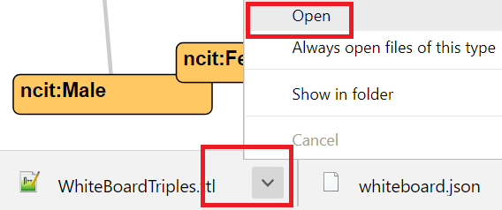**Click the dropdown arrow beside **WhiteBoardTriples.TTL** and select **Open.**
5. Follow along with the instructor's explanation of the TTL file content.
6. Find the various ***nodes*** and ***links*** you created in your graph.

|  |  |
| --- | --- |
| Image result for information icon | If you click Create TTL more than once, you will create new files that include a number in their name:  WhiteBoardTriples(1).TTL  WhiteBoardTriples(2).TTL  etc.  Make sure to use the highest numbered file in the next steps. |
| **!** | Leave the graph open in Chrome. You will refer to it in the next section when creating queries. Ask for assistance if you accidentally close or refresh the Graph Editor window. |

# Validate the Data

1. Double-click on this file to open it into RStudio:

C:/\_gitHub/LinkedDataWorkshop/CSS2018/scripts/R/**TTLValidation.R**

1. Run the code by clicking the Run App icon 

Load your TTL file in the application by clicking **Browse...** under **.TTL File** and navigate to the file **C:\Users\phuseldw\downloads\WhiteBoardTriples.TTL**

1. Double-click the file to load it into the app.

|  |  |
| --- | --- |
| **!** | Remember to load the most recent version of your TTL file, which may have a number in the name : WhiteBoardTriples(1).TTL, WhiteBoardTriples(2).TTL , etc. If in doubt, ask for assistance. |

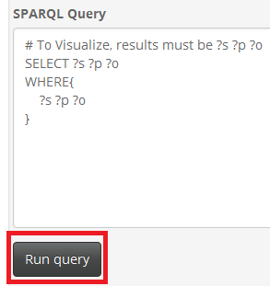

1. A default query is already available within the app. Click **Run query** to execute the query and view the result in the **Query Result:** area.
2. Review the values in the **Query Result** and compare them to your graph.
3. Click on the  tab. If the message "All QC checks passed", proceed to Step 4. Otherwise:
   1. Review the values listed and compare them to your graph. Do the values or their prefixes need to change to match the values given in the exercises?
   2. If the problem is not obvious, ask for assistance.
   3. Return the Graph Editor to find and correct any Nodes or Relations as needed.
   4. Export to TTL again using the steps in section 1.6 Export to TTL, then re-run the validation steps in this section.
   5. Repeat the these steps until you receive the message "All QC Checks passed" or the instructor approves any items displayed on the QC Check page.

|  |  |
| --- | --- |
| **!** | Unless advised by the instructor, do not proceed past this step until the QC Check page displays "All QC checks passed". Failure to validate at this step may cause errors in later exercises or a lack of coolness in later examples. |

1. Click on the  tab at the top of the app to view a network graph of the query result.
2. Use your mouse or touchpad to pan and zoom the graph.
3. Explore your graph by clicking on nodes. Mouse-over the links to show the relationship labels. You may also use the drop-down selections for highlighting node categories and groups.

|  |  |  |
| --- | --- | --- |
|  | Stop here and wait for the instructor. |  |

# Upload to Database

1. Open a new window in Google Chrome, **keeping your graph editor window open.**
2. Click the **Stardog** shortcut on the bookmarks bar.
3. If you are prompted for a username and password:
   1. On the login screen, enter the Username: **phuseldw**
   2. You can leave the Password field blank. Click **Sign in**.
4. In the Stardog application window, click **Databases** on the top menu.
5. 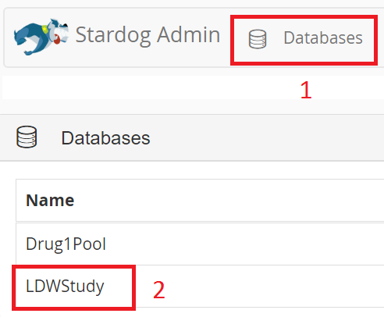Under Databases, double-click the row for **LDWStudy.**
6. In the upper left, click 

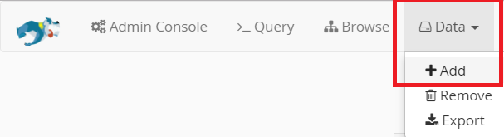

1. Select **Data | Add** from the Stardog menu:
2. Click **Browse** and navigate to, then select your WhiteBoard.TTL file:

C:\Users\phuseldw\Downloads\**WhiteBoardTriples.TTL**

1. Click **Upload**.
2. You should see the message: ***Success! Data added successfully.***

# Query Graph Data

Update the query scripts by following these steps:

1. 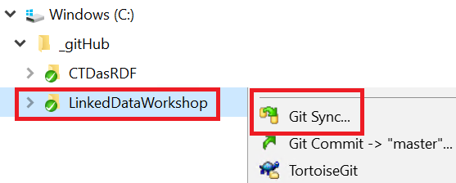Using Windows Explorer, right click on the folder C:\\_github\LinkedDataWorkshop
2. Select **Git Sync** from the menu.

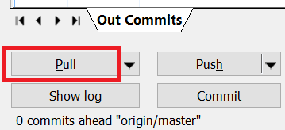

1. Click **Pull**
2. Click **Close** when the command completes. You have updated all content to the latest version as needed for the following exercises.

# Show all triples

Return to the Stardog menu in Chrome.

Find all Subject-Predicate-Object relations in your graph.

1. If the "Query Panel" is not displayed, click on the >\_Query menu item at the top of the Stardog display.
2. Select the Open Folder icon  in the Query Panel.
3. Navigate to the file C:\\_gitHub\LinkedDataWorkshop\CSS2018\scripts\SPARQL**\210-AllTriples.rq** and double-click on it to load it into the query window.
4. With the query loaded in to the window, click the  button. Scroll down to review the results.
5. Compare this view to what you expected after viewing the TTL file.

# How many people *participateIn* the study?

Find the number persons participating in your study by counting the number of ***participatesIn***relationships.

1. Load the SPARQL query **220-CountParticipants.rq**.
2. Examine the query while the instructor explains how it relates to your graph.
3. Execute the query.
4. Is this this result you expected?
5. Note how the ***LDExpert*** is not included in the count.

# Find the names of people who participate in the study.

In this example you want to select the **givenName** of the Persons who participate in the study. Refer back to the your graph in the Graph Editor while creating the query.

Try modifying the query from **Exercise 2.2** using the next steps as a guide. If you are new to SPARQL you can skip down to the SOLUTION at the end of this section.

1. Return the person's name (givenName) in the SELECT statement:

SELECT ?person\_name

1. In the WHERE statement, identify Person nodes that have the ***participatesIn*** relation:

?person eg:participatesIn ?study ;

1. Then follow from that same Person node using the ***givenName*** relation to find their name.

?person eg:participatesIn ?study ;

schema:givenName ?person\_name .

1. Execute your query and view the results. If you have trouble writing the query, load and execute the SOLUTION file:

SOLUTION: **230-NameParticipants.rq**

# List the names of the people randomized to each treatment type.

1. Modify the SELECT statement from **Exercise 2.3** to select treatment type in addition to person name variables.

SELECT ?trt\_type ?person\_name

1. Change the relation in the first line of the WHERE statement to use the ***eg:randomizedTo*** relation, as follows:

?person eg:randomizedTo ?trt\_arm ;

schema:givenName ?person\_name .

1. Refer to your graph in the Graph editor. You want to follow the path from **?trt\_arm** along the **eg:trtArmType** relation to the type of treatment ( **?trt\_type** ) .

?person eg:randomizedTo ?trt\_arm ;

schema:givenName ?person\_name .

?trt\_arm eg:trtArmType ?trt\_type .

1. You may wish to add an ORDER BY statement after the WHERE :

ORDER BY ?trt\_type ?person\_name

SOLUTION: **240-NamesInTreatmentType.rq**

|  |  |  |
| --- | --- | --- |
|  | Stop here and wait for the instructor.  Presentation on Ontologies and Reasoning |  |

# Ontology and Inference

In this section you will add an ontology to the data and employ a reasoner on your data.

# Review the Ontology

1. Double-click on the file C:\\_gitHub\LinkedDataWorkshop\CSS2018\data\**StudyOntology.TTL** to open into a text editor.
2. Follow along with the instructor's explanation of the file.

# Add the Ontology to the LDWStudy database

1. 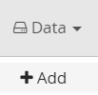Select **Data | Add** from the Stardog menu.
2. Click **Browse** and select the file:

C:\\_gitHub\LinkedDataWorkshop\CSS2018\**data\StudyOntology.TTL**

1. Click **Upload**.
2. You should see the message: **Success! Data added successfully.**

# Explore the data

1. Ensure reasoning is turned **OFF**.
2. 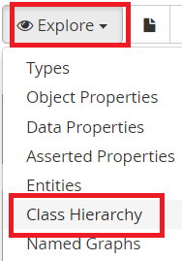Select **Explore | Class Hierarchy**
3. A SPARQL query appears in the window.
4. **Execute** the query and view the results.
5. Note the **types** and **supertypes** added to your data.



1. Turn on the reasoner by clicking the **Reasoning** button.
2. **Execute** the query again and view the results.
3. Scroll through the results to find where **HumanStudySubject** and **LinkedDataExpert** both types of **Person**. These are not part of your original study data but can now be used in queries to find these "types of things!"

# Find the names of HumanStudySubjects in your study.

*Remember: Your original data contained no definition of a HumanStudySubject.*

1. Review the ontology file for how a HumanStudySubject is *inferred* using the ontology.

|  |  |
| --- | --- |
| IdeaIcon_clean_20mm | In SPARQL the predicate **rdf:type** can be shorted to **a** and interpreted as "*is a*".  Example:  You read: eg:Person11 rdf:type eg:HumanStudySubject  as: "Person11 ***is a*** HumanStudySubject." |

Instead of querying on the **participatesIn** predicate, as in:

?person eg:participatesIn ?study ;

You can now query using the *inferred* entity **eg:HumanStudySubject**.

?person a eg:HumanStudySubject;

1. Open the query file **230-NameParticipants.rq** that you used in **Exercise 2.3** and modify the queryto find ?person "is a" Human Study Subject.
2. Ensure Reasoning is turned on, then execute the query.
3. Refer back to your graph in the Graph Editor and be amazed : there is no "Human Study Subject" defined in your graph.
4. What happens if you turn OFF the reasoner and execute the query? Don't forgot to turn the reasoner back ON!

SOLUTION: **340-NameHumanStudySubject.rq**

Bonus Question: How would you modify the query to select all Data Experts associated with the study?

Hint: What is the superclass of LinkedDataExpert?

SOLUTION: **341-NameDataExperts.rq**

# Write a reasoner-based query to find all types (classes) of People associated with the study (not just participants)

1. Write a query that uses the superclass of the HumanStudySubject and DataExpert classes.

CAUTION: The superclass prefix is not "eg" because the class you will use is not defined in the study ontology!

1. Return the following results: Person IRI, Given Name of the Person, and the Person Type

HINT: Use the "is a" relation: ?person a ?person\_type

SOLUTION: **350-NamesAllPeople.rq**

1. The result in query 350 returns all the "types of things" a Person is, not just their role in the study! You can return just the roles in the study by filtering on the http name space used for the Study graph.

FILTER ( strstarts(str(?person\_type), "http://example.org/LDWorkshop#") )

SOLUTION: **351-NamesAllPeople.rq**

FILTER ( strstarts(str(?person\_type), "http://example.org/LDWorkshop#") )

|  |  |  |
| --- | --- | --- |
|  | Stop here and wait for the instructor.  Presentation on Merging Data |  |

# Merge Studies

# Create the Data Pool

1. Click on Admin Console at the top of the Stardog application. 

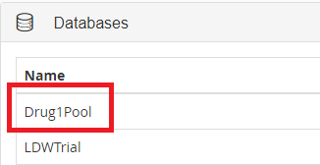

1. Click on **Drug1Pool** in the Databases panel.
2. In the upper right, click 
3. Open the query **410-PoolAllStudies.rq** into the query window an execute it. A blue progress line will display briefly at the top of the application while the query is executing.

|  |  |
| --- | --- |
| **!** | Having all attendees create the pool may cause bandwidth and connection issues. This happens, follow the alternative instructions provided by the instructor using the query:  **411-AltPoolCreator.rq**. DO NOT run this query unless advised by the instructor! |

1. After the query has completed, execute the query **415-PoolTripleCount.rq**. Note the number of triples and compare them to the number provided by the instructor to ensure you have the correct data.

# List Drug1 studies by phase.

1. Load the query **420-StudiesByPhase.rq** .
2. Execute the query and locate your study in the results.

BONUS Question: How would you alter the query to obtain the number of studies in each phase?

Hint: a) In the **SELECT** statement: **?phase** (**COUNT**(**?phase**) **AS** **?count**)

b) Use a **GROUP BY** after the **WHERE**.

SOLUTION: **425-StudyCountByPhase.rq**

# How many HumanStudySubjects participated in all Drug1 studies?

1. Ensure the Reasoner is turned On.
2. Load the query **430-Drug1CountHSS.rq** and examine the query.
3. Execute the query.

|  |  |
| --- | --- |
| IdeaIcon_clean_20mm | If the count is 0, you may need to turn ON the Reasoner. |

BONUS Question : Alter the query to count **all people** involved in Drug1 Studies (not just HumanStudySubjects).

HINT: a) What is the superclass of HumanStudySubject?

b) Ensure you are suing the correct prefix!

SOLUTION: **435-Drug1CountPeople.rq**

# How many women received active treatment (non placebo) across all Drug1 studies combined?

1. Use the graph of your study in the Graph Editor to determine the paths that need to be followed to obtain the solution.

HINT : follow the pattern: ?person -- gender -- **Female** ;

-- randomizedTo --- ?trt\_arm .

?trt\_arm -- treatmentArmType -- **ActiveArm**.

SOLUTION: **440-Drug1WomenActiveTreat.rq**

# List all Persons in the studies.

1. List all Person IRIs, their givenName, their assigned Study, and their role in that study (HumanStudySubject or Investigator).

*It is getting late so you may wish to skip directly to the Solution to see one way of solving this question.*

1. Review the results. Do you find anything surprising in the pooled results?

SOLUTION: **450-Drug1PersonsAllStudies.rq**

Congratulations! You've made to the

---- END OF THE EXERCISES ----

Before you leave, please Sign out from the server using **Windows | Person Icon | Sign out**.

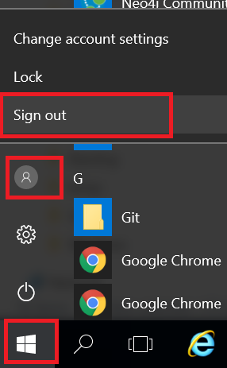

|  |  |  |
| --- | --- | --- |
|  | Stop here and wait for the instructor.  Presentation follows |  |

# Appendix 1: Course Resources

* [Introduction to Semantic Web](https://www-stage.cambridgesemantics.com/semantic-university/introduction-semantic-web)

https://www-stage.cambridgesemantics.com/semantic-university/introduction-semantic-web

* [What is Linked Data?](https://www-stage.cambridgesemantics.com/semantic-university/what-linked-data)

https://www-stage.cambridgesemantics.com/semantic-university/what-linked-data

* [Introduction to Linked data](https://www-stage.cambridgesemantics.com/semantic-university/introduction-linked-data)

https://www-stage.cambridgesemantics.com/semantic-university/introduction-linked-data

* [SPARQL in 11 minutes](https://www.youtube.com/watch?v=FvGndkpa4K0)

https://www.youtube.com/watch?v=FvGndkpa4K0

* [Learning SPARQL](http://www.learningsparql.com/)

http://www.learningsparql.com/

-------------------------------------------------------------------------------------------------------

[Hands-on Workshop Github Repository](https://github.com/phuse-org/LinkedDataWorkshop/tree/master/CSS2018)

Course content is available at:

https://github.com/phuse-org/LinkedDataWorkshop/tree/master/CSS2018