# Chapter 5: Testing

# Introduction

Testing is an important steps of software development process to verify and validate the correctness, quality and performance of the software. It is done for making sure that the code functions properly and expected results are producing by the software. It is an activity to ensure that the software is defect or error free. It includes execution of a system or software components to evaluate one or more properties of interest. Testing can be done automatically through tools or manually.

# Importance

Testing of software is important because failure in software can cause human and monetary loss as well and there are lots of examples of such things caused by a bugs or error in software. The importance of using testing in software development process are as follows:

* Any error or defects made during the development phase can be identified through testing.
* Testing increases products success as it helps in increasing quality and customer reliability on that software.
* Testing ensure that a high-quality product is delivered as lots of expenses is spend on product development.
* A well-tested product causes less maintenance cost and so the results delivered are more accurate, consistent and reliable.
* Testing ensures that an application does not results any failure in early days of products life cycle.

# Types of Testing

There are different basics as well as essential software testing techniques that should be followed before deploying software to client. Some of the testing are as follows:

1. Unit Testing
2. Black Box Testing
3. White Box Testing
4. Grey Box Testing
5. Integration Testing
6. Beta Testing
7. Alpha Testing
8. Performance Testing

From the above different types of testing, I have chosen two of them for this project. They are:

**Unit Testing**

Unit Testing focuses on the small unit of a project. It is done by a developer using sample inputs and observing its corresponding outputs. Individual units or inter-related units are tested in this testing.

**Test Name: Check User Register**

|  |  |  |  |  |  |
| --- | --- | --- | --- | --- | --- |
| **Test ID** | **Test Scenario** | **Test Input Data** | **Expected Result** | **Actual Result** | **Result**  **(Pass/Fail)** |
| 1 | Insert User details and check it works or not | User Details | User should be provided message box for success | Message box showed without any error | Pass |

Figure : Register User Test

Figure : Register Test Passed

**Test Name: Check Login**

|  |  |  |  |  |  |
| --- | --- | --- | --- | --- | --- |
| **Test ID** | **Test Scenario** | **Test Input Data** | **Expected Result** | **Actual Result** | **Result**  **(Pass/Fail)** |
| 2 | Insert login details and check it works or not | Login Details | User should be directed to dashboard | Dashboard opened without any error | Pass |

Figure : Login Unit Test Passed

**Test Name: Check Employee Insert**

|  |  |  |  |  |  |
| --- | --- | --- | --- | --- | --- |
| **Test ID** | **Test Scenario** | **Test Input Data** | **Expected Result** | **Actual Result** | **Result**  **(Pass/Fail)** |
| 3 | Insert Employee details and check it works or not | Details of an employee | Message box should be shown about employee updated successfully | Message box shown without any error | Pass |

Figure : Insert Employee Test

Figure : Insert Employee Test Passed

**Test Name: Check Product Insert**

|  |  |  |  |  |  |
| --- | --- | --- | --- | --- | --- |
| **Test ID** | **Test Scenario** | **Test Input Data** | **Expected Result** | **Actual Result** | **Result**  **(Pass/Fail)** |
| 4 | Insert details of product and check it works or not | Product Details | Product updated successfully message box should be shown | Message box shown without any error | Pass |

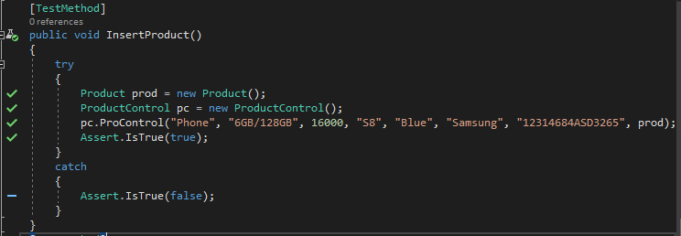

Figure :Insert Product Test

Figure : Insert Product Test Passed

**Test Name: Check Customer Insert**

|  |  |  |  |  |  |
| --- | --- | --- | --- | --- | --- |
| **Test ID** | **Test Scenario** | **Test Input Data** | **Expected Result** | **Actual Result** | **Result**  **(Pass/Fail)** |
| 5 | Insert Customer details and check it works or not | Customer Details | Customer details updated successfully dialog box | Message box shown without any error | Pass |

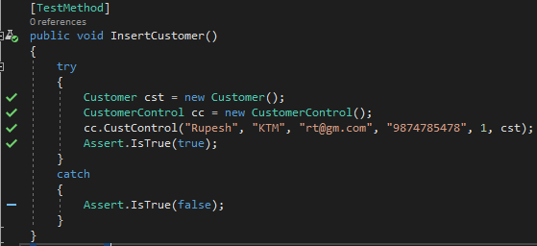

Figure : Insert Customer Test

Figure : Insert Customer Test Passed

**Test Name: Check Bill Insert**

|  |  |  |  |  |  |
| --- | --- | --- | --- | --- | --- |
| **Test ID** | **Test Scenario** | **Test Input Data** | **Expected Result** | **Actual Result** | **Result**  **(Pass/Fail)** |
| 6 | Insert Bill details and check it works or not | Bill Details | Bill details added success message box | Message box shown without any error | Pass |

Figure : Bill Insert Test

Figure : Bill Insert Test Passed

**Test Name: Check Username**

|  |  |  |  |  |  |
| --- | --- | --- | --- | --- | --- |
| **Test ID** | **Test Scenario** | **Test Input Data** | **Expected Result** | **Actual Result** | **Result**  **(Pass/Fail)** |
| 7 | Insert username details and check for duplicate in database | username | Message box should not be shown | No message box shown, and no error occurred | Pass |

Figure : Check Duplicate Username Test

Figure : Check Username Test Passed

**Test Name: Check Email**

|  |  |  |  |  |  |
| --- | --- | --- | --- | --- | --- |
| **Test ID** | **Test Scenario** | **Test Input Data** | **Expected Result** | **Actual Result** | **Result**  **(Pass/Fail)** |
| 8 | Insert Email and check for its validity | Valid Email | Message box should not be shown | No message box shown, and no error occurred | Pass |

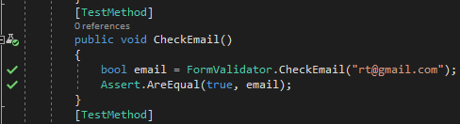

Figure : Check Valid Email Test

Figure : Check Email Test Passed

**Test Name: Check Password**

|  |  |  |  |  |  |
| --- | --- | --- | --- | --- | --- |
| **Test ID** | **Test Scenario** | **Test Input Data** | **Expected Result** | **Actual Result** | **Result**  **(Pass/Fail)** |
| 9 | Insert Password and check for its length | Greater than Six length password | Message box should not be shown | No message box shown, and no error occurred | Pass |

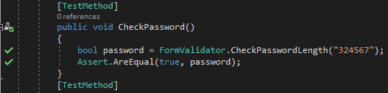

Figure : Check Password Length Test

Figure : Check Password Test Passed

**Test Name: Check Two Password**

|  |  |  |  |  |  |
| --- | --- | --- | --- | --- | --- |
| **Test ID** | **Test Scenario** | **Test Input Data** | **Expected Result** | **Actual Result** | **Result**  **(Pass/Fail)** |
| 10 | Insert two Password and compare for same detail | Greater than Six length password | Message box should not be shown | No message box shown, and no error occurred | Pass |

Figure : Check Two Password Test

Figure : Compare Two Password Tests Passed

**Test Name: Check Phone Length**

|  |  |  |  |  |  |
| --- | --- | --- | --- | --- | --- |
| **Test ID** | **Test Scenario** | **Test Input Data** | **Expected Result** | **Actual Result** | **Result**  **(Pass/Fail)** |
| 11 | Insert phone and check length | Greater than five length phone number | Message box should not be shown | No message box shown, and no error occurred | Pass |

Figure : Check Phone Length Test

Figure : Check Phone Length Test Passed

**Black Box Testing**

It is a behavioral testing in which the internal structure or item being tested is not known to the tester. Black box testing just focus on inputs and outputs of the software system without focusing about implementation code or internal knowledge of software program.

**Test Name: User Registration Test**

**Pre-Condition: User Should be registered in the system**

|  |  |  |  |  |  |
| --- | --- | --- | --- | --- | --- |
| **Test No** | **Test Scenario** | **Test Input Data** | **Expected Result** | **Actual Result** | **Result**  **(Pass/Fail)** |
| 1 | To check if the detail is inserted or not | First Name: Rupesh  Last Name: Thapa  Phone: 9876543210  Gender: Male  Email: [rt@gmail.com](mailto:rt@gmail.com)  Username: rupesh  Password: 123456 | Success message box should be shown to user | Success Message box shown, and data saved in database | Pass |

Figure : User Data Added

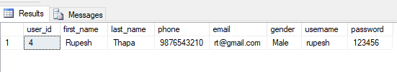

Figure : User Added in database

**Test Name: Login Test**

**Pre-Condition: User Should be directed to dashboard**

|  |  |  |  |  |  |
| --- | --- | --- | --- | --- | --- |
| **Test No** | **Test Scenario** | **Test Input Data** | **Expected Result** | **Actual Result** | **Result**  **(Pass/Fail)** |
| 2 | To check details inserted is correct and login working or not | Username: rupesh  Password: 123456 | User should be directed to the dashboard | User is provided access with dashboard | Pass |

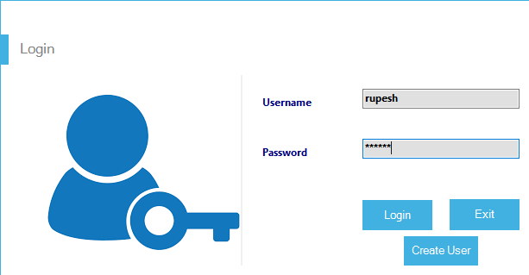

Figure : Login Detail filled

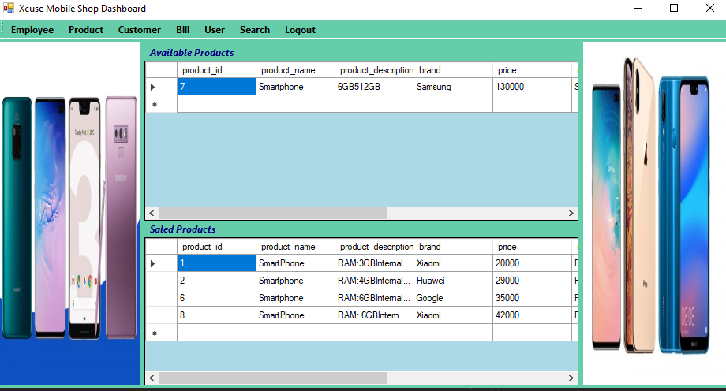

Figure : Login success and Dashboard Shown

**Test Name: Employee Insert Test**

**Pre-Condition: Employee information should be added in system**

|  |  |  |  |  |  |
| --- | --- | --- | --- | --- | --- |
| **Test No** | **Test Scenario** | **Test Input Data** | **Expected Result** | **Actual Result** | **Result**  **(Pass/Fail)** |
| 3 | To check if employee detail is inserted or not | Name: John  Address: Pokhara  Gender: Male  Phone: 9874561230  Email: [john@gmail.com](mailto:john@gmail.com)  Salary: 18000 | Success message box should be shown to user | Success Message box shown, and data saved in database | Pass |

Figure : Employee Details Added

Figure : Employee Details in Database

**Test Name: Product Insert Test**

**Pre-Condition: Product information should be added in system**

|  |  |  |  |  |  |
| --- | --- | --- | --- | --- | --- |
| **Test No** | **Test Scenario** | **Test Input Data** | **Expected Result** | **Actual Result** | **Result**  **(Pass/Fail)** |
| 4 | To check if product detail is inserted or not | Product Name: Smartphone  Description: Ram 6GB/ Internal 32GB  Model: Galaxy A70  Brand: Samsung  Color: Navy Blue  Price: 28990  IMEI:978654789547851 | Success message box should be shown to user | Success Message box shown, and data saved in database | Pass |

Figure : Product Data Added

Figure : Product added In Database

**Test Name: Customer Insert Test**

**Pre-Condition: Customer information should be added in system**

|  |  |  |  |  |  |
| --- | --- | --- | --- | --- | --- |
| **Test No** | **Test Scenario** | **Test Input Data** | **Expected Result** | **Actual Result** | **Result**  **(Pass/Fail)** |
| 5 | To check if customer detail is inserted or not | Name: Kabish  Address: Gongabu  Email: [kb@gmail.com](mailto:kb@gmail.com)  Phone: 9871234785 | Success message box should be shown to user | Success Message box shown, and data saved in database | Pass |

Figure : Customer Details Added

Figure : Customer Data In Database

**Test Name: Product Sale Test**

**Pre-Condition: Product information should be updated in system**

|  |  |  |  |  |  |
| --- | --- | --- | --- | --- | --- |
| **Test No** | **Test Scenario** | **Test Input Data** | **Expected Result** | **Actual Result** | **Result**  **(Pass/Fail)** |
| 6 | To check if product is assigned to customer successfully by updating product data | Customer Name: Kabish  Product Model: Galaxy A70 | Product details should be updated, and customer should be assigned | Product assigned to customer successfully and customer added in product table | Pass |

Figure : Product Sale To Customer

Figure : Product details updated Customer added

**Test Name: Bill Generate Test**

**Pre-Condition: Bill information should be added in system**

|  |  |  |  |  |  |
| --- | --- | --- | --- | --- | --- |
| **Test No** | **Test Scenario** | **Test Input Data** | **Expected Result** | **Actual Result** | **Result**  **(Pass/Fail)** |
| 7 | To check if bill detail is inserted | Customer Name: Kabish  Product: Galaxy A70  Quantity:1  Payment Type: Cash  Discount: 1000  Paid:30000 | Success message box should be shown to user | Success Message box shown, and data saved in database | Pass |

Figure : Bill Generated

Figure : Bill Details Added In Database

**Test Name: Search Customer Test**

**Pre-Condition: Customer information should be showed by system**

|  |  |  |  |  |  |
| --- | --- | --- | --- | --- | --- |
| **Test No** | **Test Scenario** | **Test Input Data** | **Expected Result** | **Actual Result** | **Result**  **(Pass/Fail)** |
| 8 | To Check if data will be shown or not | Customer Name: Kabish | Customer data should be shown, in data grid view | Customer data shown, with success | Pass |

Figure : Customer Data Searched

**Test Name: Product Update Test**

**Pre-Condition: Product information should be updated in system**

|  |  |  |  |  |  |
| --- | --- | --- | --- | --- | --- |
| **Test No** | **Test Scenario** | **Test Input Data** | **Expected Result** | **Actual Result** | **Result**  **(Pass/Fail)** |
| 9 | To check if product detail is updated | Update data  Of model: Galaxy A70 set price to 25000 | Success message box should be shown to user and data should be updated | Success Message box shown, and data updated in database | Pass |

Figure : Product Data Updated

Figure : Product updated in Database

**Test Name: Customer Update Test**

**Pre-Condition: Customer information should be updated in system**

|  |  |  |  |  |  |
| --- | --- | --- | --- | --- | --- |
| **Test No** | **Test Scenario** | **Test Input Data** | **Expected Result** | **Actual Result** | **Result**  **(Pass/Fail)** |
| 10 | To check if customer detail is updated | Update Name: Kabish set  Address: KTM  Phone: 014325654 | Success message box should be shown to user and data should be updated | Success Message box shown, and data updated in database | Pass |

Figure : Customer Details Updated

Figure : Customer Details Updated In Database