A. It is Monday morning and you are waiting for your Spanish class to start. You are talking to one of your friends about your plans for the week. She suggests meeting on Thursday afternoon to have a coffee. Look at your schedule for the week, and:

- Tell your friend about your plans for the week
- Accept her invitation but suggest another day to meet
- Suggest a specific time and a place to meet.
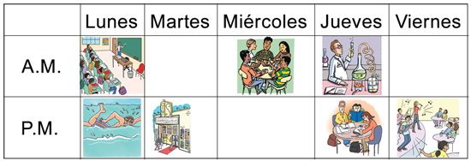
B. It is Saturday and you are planning to go hiking with a friend the following morning. Your friend calls you to ask you what food you are planning to bring with you. The images below represent what you have at home. Decide what you are going to bring and:

Tell your friend what you are going to pack for the picnic.

