COMP6009 Assignment Part B
Biogas Plant Intelligent Monitoring and Decision System
Lithma Perera | Student ID: [insert] | Word count: 1947 (excluding captions, tables, references and appendices)

1. Introduction and Problem Formulation
Anaerobic digestion converts the organic residues of a red-meat processing facility into methane-rich biogas, but the microbial community that drives it is sensitive to changes in loading and waste composition [1], [2]. Its true biological condition cannot be measured directly, so operators infer it from indicators such as methane yield, pH and volatile fatty acids (VFAs), which are noisy and only partly informative. This report develops a monitoring and decision-support agent that reasons explicitly about this uncertainty.
The hidden condition is modelled as X_{t} ∈ {Stable, Stressed, Critical}. It is observed through Sensor 1 readings E_{t} ∈ {Normal, Warning, Alarm} and, in Task 1, a pH sensor. The agent recommends an action A_{t} ∈ {Continue, Reduce Feed, Intervene}. The approach has three layers [3]. Bayes’ rule first turns a set of readings into a posterior belief over states. A hidden Markov model (HMM) then filters a 30-step sequence of readings so that belief accumulates over time. Finally, the filtered belief is combined with a utility model, and the action with the highest expected utility is recommended. All algorithms were implemented in Python with NumPy, without inference libraries, and a sensitivity analysis tests how the recommendations depend on the modelling assumptions.

2. Probabilistic Modelling and Bayesian Inference

2.1 Model and inference method
The prior P(X₀) = (0.70, 0.20, 0.10) describes a digester that is usually stable. Each sensor is described by an observation model P(E_{i} | X), stored as a matrix whose rows are states (Appendix A). Assuming the two sensors are conditionally independent given the state, the posterior is
P(X | e₁, e₂) = α P(X) P(e₁ | X) P(e₂ | X)
where α normalises the result to sum to one. The function bayes_posterior multiplies the prior by the likelihood column of each reported reading, so any valid combination of evidence is processed without hard-coded results. Table 1 shows the manual calculation for Sensor 1 = Warning. The unnormalised values sum to P(Warning) = 0.250, and dividing by this gives (0.42, 0.48, 0.10), which matches the Python output exactly; an assertion in main.py checks this on every run.
State | Prior P(X) | P(Warning | X) | Unnormalised P(X)P(Warning | X) | Posterior
Stable | 0.70 | 0.15 | 0.70 × 0.15 = 0.105 | 0.105 / 0.250 = 0.420
Stressed | 0.20 | 0.60 | 0.20 × 0.60 = 0.120 | 0.120 / 0.250 = 0.480
Critical | 0.10 | 0.25 | 0.10 × 0.25 = 0.025 | 0.025 / 0.250 = 0.100
Sum | 1.00 |  | P(Warning) = 0.250 | 1.000
Table 1. Manual Bayesian calculation for Sensor 1 = Warning, showing the unnormalised values, the normalisation constant and the final posterior.

2.2 Single-sensor and combined evidence
Table 2 and Figure 1 summarise the posteriors. A Normal reading raises P(Stable) from 0.70 to 0.91 and confirms the prior. A Warning makes Stressed the most probable state, but only marginally (0.48 against 0.42 for Stable), so a single Warning is weak evidence. An Alarm makes Critical most probable (0.52), yet 0.48 of the belief remains on the other states, because the strong prior on Stable partly offsets the sensor’s 0.70 detection rate.
Adding Abnormal pH to the Warning shifts the belief to (0.11, 0.65, 0.23). P(Stable) falls from 0.42 to 0.11, because a stable digester rarely produces abnormal pH (0.10), while P(Critical) more than doubles. Both readings point towards an unhealthy digester, so together they give a much more decisive belief than either alone; Abnormal pH by itself gives only (0.27, 0.39, 0.33).
Evidence | P(evidence) | P(Stable) | P(Stressed) | P(Critical) | Most probable
None (prior) |  | 0.700 | 0.200 | 0.100 | Stable
S1 = Normal | 0.615 | 0.911 | 0.081 | 0.008 | Stable
S1 = Warning | 0.250 | 0.420 | 0.480 | 0.100 | Stressed
S1 = Alarm | 0.135 | 0.259 | 0.222 | 0.519 | Critical
S2 = Abnormal pH | 0.255 | 0.275 | 0.392 | 0.333 | Stressed
S1 = Warning + S2 = Abnormal pH | 0.092 | 0.114 | 0.654 | 0.232 | Stressed
Table 2. Posterior belief for each Sensor 1 reading, for Abnormal pH alone, and for the combined Warning + Abnormal pH evidence.
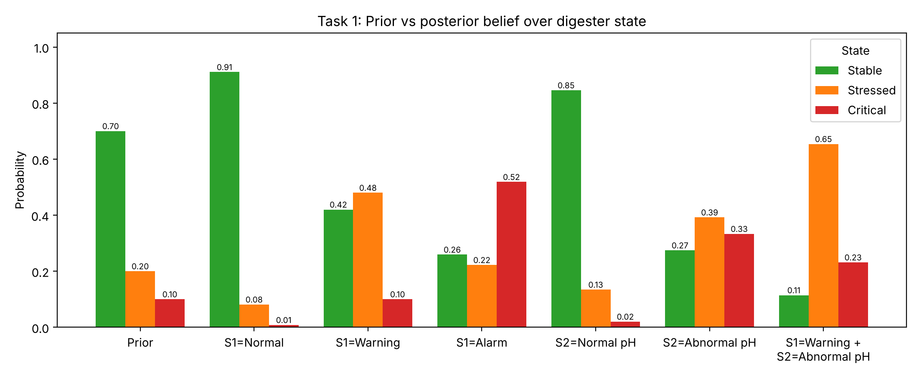
Figure 1. Prior and posterior beliefs for every single-sensor reading and for the combined Sensor 1 and pH evidence.

2.3 Interpretation and limitations
The posterior is a belief about the true state, not the state itself. The state is the physical condition of the microbial community, while an observation is a noisy measurement of it. Even after Warning and Abnormal pH, there is an 11% chance that the digester is stable and both readings are false alarms, which is why the agent keeps a full distribution rather than a single label.
Conditional independence is the most questionable assumption. In a real digester, VFA accumulation both lowers pH and triggers process warnings [2], so the two readings share a cause beyond the state label. Treating them as independent counts that evidence twice and makes the combined posterior overconfident. In addition, the likelihoods are fixed point estimates that ignore sensor drift, fouling and calibration error, and three discrete states coarsen what is really a continuous process.

3. HMM-Based State Estimation

3.1 Transition model and filtering
The transition model P(X_{t} | X_{t−1}) (Appendix A) makes each state persistent, with diagonal probabilities of 0.80, 0.60 and 0.65, and allows both gradual deterioration and recovery. Filtering computes the belief b_{t}(x) = P(X_{t} = x | e_{1:t}) recursively [3], [4]. At t = 1 the prior is updated directly with the first reading. At every later step, hmm_filter performs three explicit steps:
- Prediction: b̄_{t}(x′) = Σ_{x} b_{t−1}(x) P(x′ | x), applying the transition model to the previous belief.
- Observation update: multiply b̄_{t} element-wise by P(e_{t} | X_{t}).
- Normalisation: divide by the sum so that the belief sums to one.
The predicted, unnormalised and filtered beliefs for every step of each scenario are saved in results/tables, and Figure 2 plots the filtered beliefs.
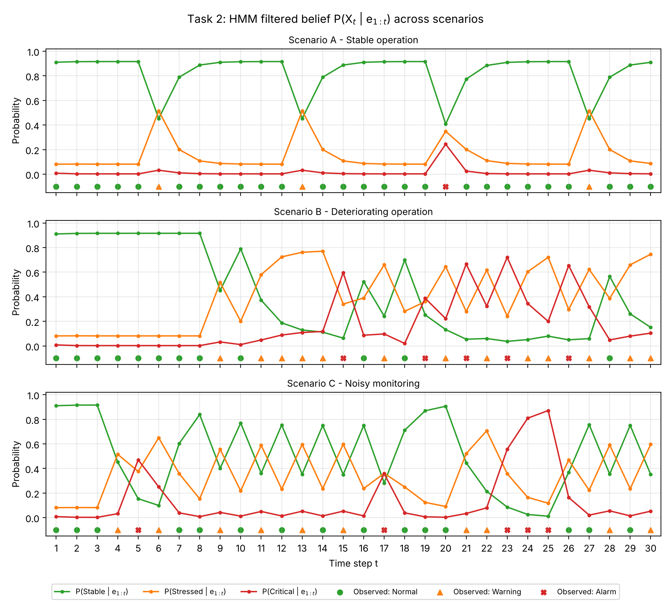
Figure 2. Filtered beliefs P(Stable | e_{1:t}), P(Stressed | e_{1:t}) and P(Critical | e_{1:t}) for Scenarios A–C. Markers below each panel show the Sensor 1 reading received at each step.

3.2 Results and notable belief changes
Scenario A (stable). Under repeated Normal readings the belief settles at (0.916, 0.082, 0.002) within three steps. Each isolated Warning (t = 6, 13, 27) flips the most probable state to Stressed (0.515), but the next Normal reading restores P(Stable) to 0.79. The Alarm at t = 20 is the largest change, yet P(Critical) rises only to 0.24 and Stable stays most probable (0.41), because the prediction from a confident Stable belief gave Critical just 0.03.
Scenario B (deteriorating). The first Warning at t = 9 is discounted in the same way, but the run of Warnings from t = 11 to 14 accumulates: each prediction already favours Stressed, so P(Stressed) climbs to 0.77. The Alarm at t = 15 then raises P(Critical) to 0.60, far above the same reading in Scenario A, because the belief entering that step had already degraded (predicted P(Critical) of 0.19 against 0.03). From t = 19 the belief alternates between Stressed and Critical with the Warning and Alarm readings, and P(Stable) stays below 0.10 apart from brief recoveries after Normal readings.
Scenario C (noisy). Alternating Normal and Warning readings from t = 7 to 16 produce a saw-tooth in which the most probable state flips between Stable and Stressed at every step. The Alarm at t = 17 leaves the states almost equally likely (0.28, 0.36, 0.36). Three consecutive Alarms at t = 23 to 25 drive P(Critical) to 0.87, yet a single Normal at t = 26 drops it to 0.16, because a Normal reading is sixteen times more likely in the Stable state than in the Critical state.
Comparison. In all three scenarios the HMM acts as an evidence accumulator. Consistent readings produce confident, stable beliefs, while the same single reading has a very different effect depending on the belief that precedes it. Scenario B shows a genuine trend that the filter tracks, whereas Scenario C shows that the filter cannot tell short real disturbances from sensor noise and passes the volatility straight into the belief.

3.3 Assumptions and limitations
The first-order Markov assumption means the next state depends only on the current one, so the model cannot represent slow processes such as gradual VFA build-up or the recovery time of a stressed microbial community. The transition matrix is also stationary and ignores feed changes and temperature, which are known drivers of instability [2]. As a result the inferred state reacts strongly to individual readings, and the belief at any one step, especially in Scenario C, is less reliable than its numbers suggest.

4. Expected-Utility Decision Making

4.1 Method
At each step the belief b_{t} from Task 2 is combined with the utility table U(a, x) (Appendix A):
EU(a) = Σ_{x} b_{t}(x) U(a, x), a* = argmax_{a} EU(a)
The reusable function recommend_action(belief, utility_table) computes this as one matrix–vector product and returns the best action with all three expected utilities, so it works with any belief or utility table.

4.2 Recommended actions and decision points
Figure 3 shows the recommended action over time for each scenario. Scenario A recommends Continue at 26 of 30 steps; Scenario B splits between Continue (11), Reduce Feed (11) and Intervene (8); and Scenario C intervenes 6 times but switches action 20 times, against 8 in A and 13 in B. Table 3 lists four notable decision points:
- A, t = 6 (Warning): Reduce Feed narrowly beats Continue (5.19 against 4.91). One Warning is enough to move a confident Stable belief just across the decision boundary.
- A, t = 20 (Alarm): Stable is still most probable, but Continue falls to −0.10 because the 0.24 probability of Critical carries a −20 penalty, so Reduce Feed (2.91) is the safest compromise.
- B, t = 15 (Alarm): P(Critical) = 0.60 makes Intervene clearly best (5.54) and Continue very costly (−10.61). This is where the deteriorating trend is first acted on.
- B, t = 22 (Warning): Stressed is most probable (0.62), but Intervene (4.20) beats Reduce Feed (2.38) because P(Critical) is still 0.32 after the previous Alarm.
Scenario, t | Reading | Belief (S, St, C) | EU Continue | EU Reduce Feed | EU Intervene | Max-EU action | Most-probable-state action
A, 6 | Warning | 0.45, 0.52, 0.03 | 4.91 | 5.19 | −0.01 | Reduce Feed | Reduce Feed
A, 20 | Alarm | 0.41, 0.35, 0.24 | −0.10 | 2.91 | 1.36 | Reduce Feed | Continue
B, 15 | Alarm | 0.06, 0.34, 0.60 | −10.61 | −0.62 | 5.54 | Intervene | Intervene
B, 22 | Warning | 0.06, 0.62, 0.32 | −4.64 | 2.38 | 4.20 | Intervene | Reduce Feed
Table 3. Belief and expected utility at four notable decision points. The highest expected utility at each step is shown in bold.
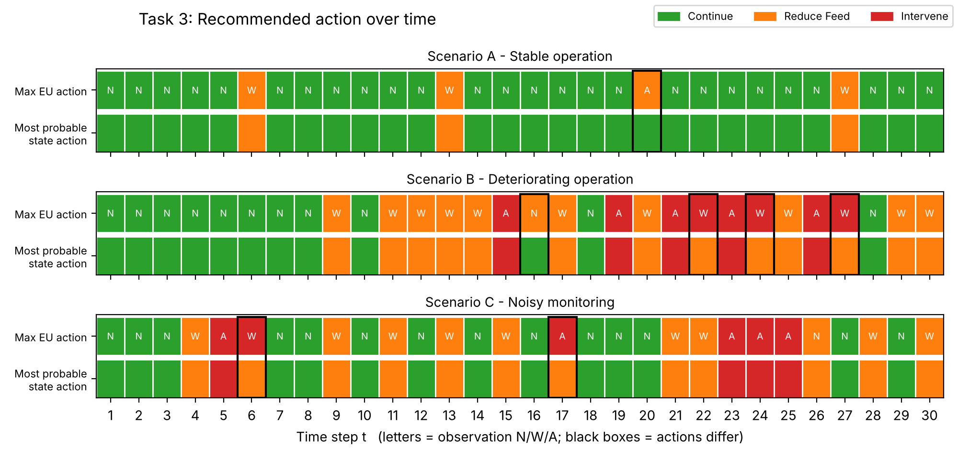
Figure 3. Maximum-expected-utility action (top row of each panel) and the action for the most probable state (bottom row). Letters give the Sensor 1 reading; black boxes mark steps where the two differ.

4.3 Maximum expected utility versus the most probable state
Acting on the most probable state picks the best action for that state alone and ignores the rest of the distribution. Expected utility weighs every state by both its probability and its consequences. Because the utility table is asymmetric, with a −20 loss for continuing in a critical digester, a minority probability of Critical can decide the action. Comparing rows of the table, Continue beats Reduce Feed only when 5P(Stable) > 4P(Stressed) + 15P(Critical), so each unit of Critical probability counts almost four times as much as Stressed. Figure 4 shows this geometrically: the action regions are tilted away from the most-probable-state boundaries, and 7 of the 90 decisions (1 in A, 4 in B, 2 in C) fall between them. In every one of these cases the expected-utility agent is more cautious.
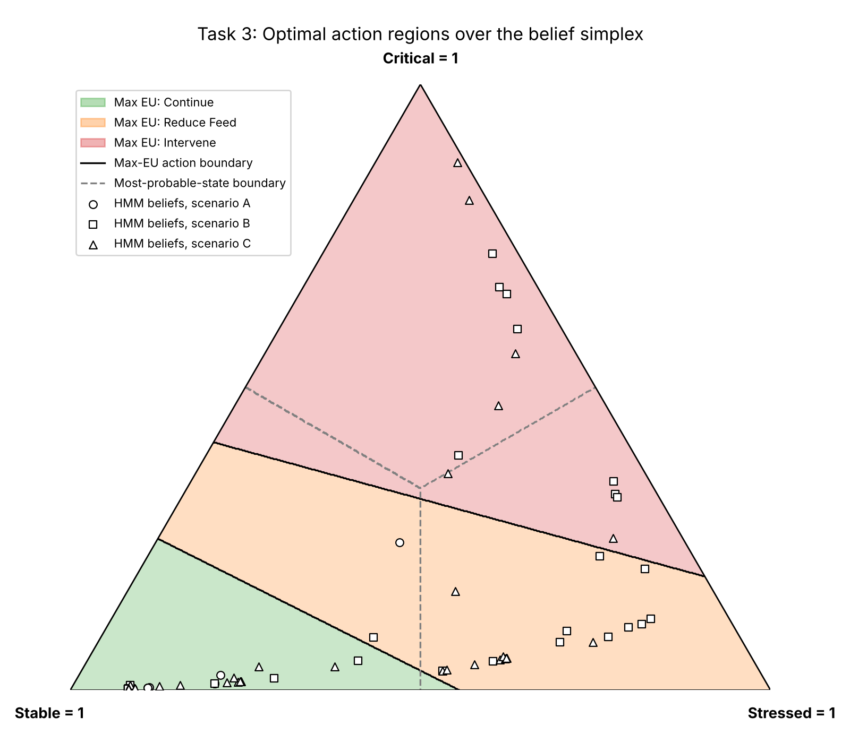
Figure 4. Optimal action regions over the belief simplex (shaded, solid boundaries) against the most-probable-state regions (dashed), with the HMM beliefs from all three scenarios overlaid.

4.4 Sensitivity to modelling assumptions
To test how the recommendations depend on the assumptions, one part of the model was changed at a time and Tasks 2 and 3 were rerun (Figure 5). Making the Continue/Critical penalty harsher than −20 changed at most one decision, but softening it to −5 removed every Reduce Feed action from Scenario A, so the cautious behaviour depends on that penalty being large. Blending Sensor 1 with uniform noise (ε = 0.6) changed four to six decisions per scenario and halved the interventions in Scenario B, so an unreliable sensor makes the agent slower to act on real deterioration. More persistent transitions (λ = 0.6) cut switching in A (8 to 0) and B (13 to 7) but barely in C (20 to 18). Because the data has no ground-truth state, these results measure decision stability, not accuracy.
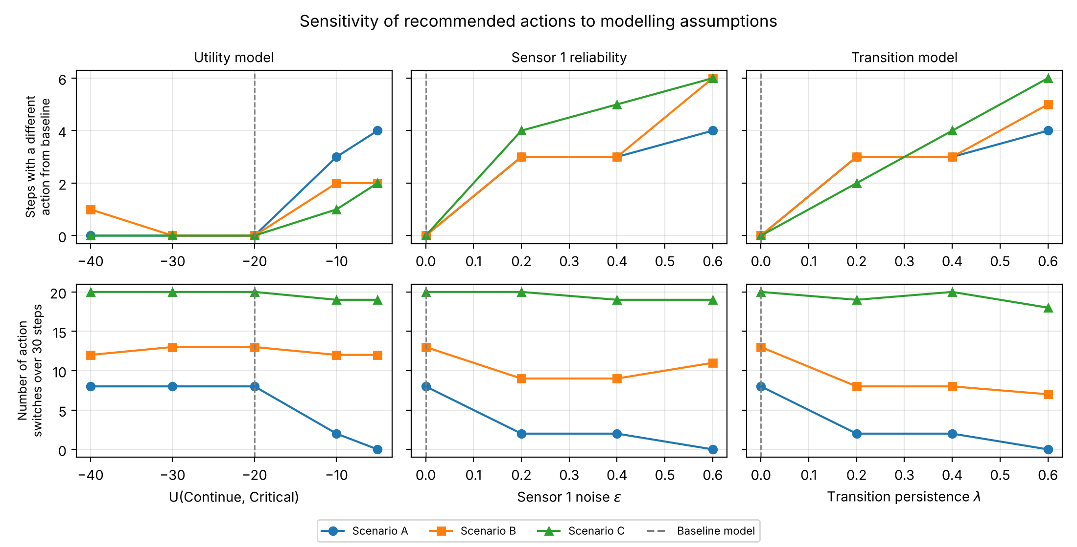
Figure 5. Number of decisions that differ from the baseline (top) and number of action switches (bottom) as the Continue/Critical utility, Sensor 1 noise ε and transition persistence λ are varied. Dashed lines mark the baseline model.

4.5 Assumptions and limitations
The utility model assumes that one fixed table captures energy, throughput, cost and risk on a common scale, and that the operator is risk-neutral. Each decision is also myopic: it ignores the cost of switching and the effect of the action on future states, so Reduce Feed does not make the digester more likely to recover in the model. In practice this would cause frequent, costly changes of operation in Scenario C. A partially observable Markov decision process, or a simple rule requiring several consistent readings before switching, would address this [3].

5. Conclusion
The agent turned uncertain sensor readings into a belief and a recommended action at every step. Bayesian inference showed that a single Sensor 1 reading is often ambiguous and that pH evidence sharpens the belief, provided the sensors really are independent. HMM filtering accumulated evidence over time: it held a confident Stable belief in Scenario A, tracked the shift to Stressed and Critical in Scenario B, and reflected sensor noise as an oscillating belief in Scenario C. Expected-utility decisions were consistently more cautious than acting on the most probable state, because the large penalty for continuing in a critical digester lets a minority probability decide the action.
The approach is transparent, inexpensive and reusable, and every recommendation can be traced to a belief and a utility. Its main limitations are the independence and first-order Markov assumptions, fixed parameters, and myopic decisions that switch frequently on noisy data. The sensitivity analysis showed that the recommendations are robust to a harsher penalty but sensitive to sensor reliability. Calibrating the models on plant data and adding a switching cost would be the most valuable next steps.

References
[1] D. J. Batstone et al., “The IWA Anaerobic Digestion Model No 1 (ADM1),” Water Sci. Technol., vol. 45, no. 10, pp. 65–73, 2002.
[2] Y. Chen, J. J. Cheng, and K. S. Creamer, “Inhibition of anaerobic digestion process: A review,” Bioresour. Technol., vol. 99, no. 10, pp. 4044–4064, 2008.
[3] S. Russell and P. Norvig, Artificial Intelligence: A Modern Approach, 4th ed. Hoboken, NJ, USA: Pearson, 2021.
[4] L. R. Rabiner, “A tutorial on hidden Markov models and selected applications in speech recognition,” Proc. IEEE, vol. 77, no. 2, pp. 257–286, 1989.

Appendix A. Model Parameters
 | Stable | Stressed | Critical
P(X₀) | 0.70 | 0.20 | 0.10
Table A1. Prior belief over the digester state.
True state | Normal | Warning | Alarm
Stable | 0.80 | 0.15 | 0.05
Stressed | 0.25 | 0.60 | 0.15
Critical | 0.05 | 0.25 | 0.70
Table A2. Sensor 1 observation model P(E₁ | X).
True state | Normal pH | Abnormal pH
Stable | 0.90 | 0.10
Stressed | 0.50 | 0.50
Critical | 0.15 | 0.85
Table A3. Sensor 2 (pH) observation model P(E₂ | X).
Current → Next | Stable | Stressed | Critical
Stable | 0.80 | 0.18 | 0.02
Stressed | 0.25 | 0.60 | 0.15
Critical | 0.05 | 0.30 | 0.65
Table A4. Transition model P(X_{t} | X_{t−1}).
Action | Stable | Stressed | Critical
Continue | +10 | +2 | −20
Reduce Feed | +5 | +6 | −5
Intervene | −4 | +3 | +8
Table A5. Utility model U(a, x).

Appendix B. Decision Summary and Reproducibility
Scenario | Continue | Reduce Feed | Intervene | Action switches | Differs from most probable state
A (stable) | 26 | 4 | 0 | 8 | 1
B (deteriorating) | 11 | 11 | 8 | 13 | 4
C (noisy) | 14 | 10 | 6 | 20 | 2
Table B1. Number of steps (out of 30) recommending each action, number of action switches, and steps where the maximum-expected-utility action differs from the action for the most probable state.
All results, tables and figures in this report are produced by running python main.py from the submitted code (see README.md). Per-step beliefs, expected utilities and sensitivity results are saved as CSV files in results/tables.

