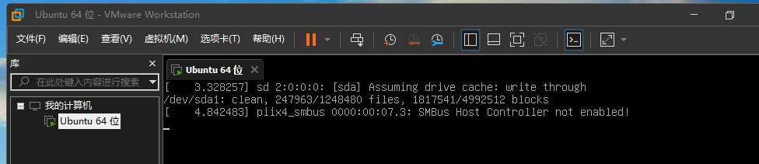

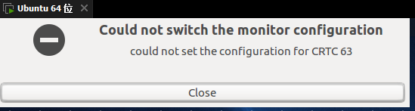

ltl ltl439431 Guest Session

**ZVUXZ-VAXKE-G1QCZ-4FN9J-WQEPZ**

**VMware卡死：直接重装VMware**

**Ubuntu卡死：保存文件->重新做个镜像**