# 创建项目

在LoongIDE开发软件左上方工具栏中点击”文件”、”新建”、”新建项目向导”，在弹出的“新建项目向导”窗口中设置如下参数：

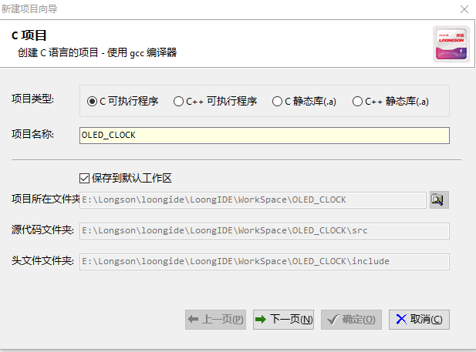

项目类型：C可执行程序。

项目名称：OLED_CLOCK。

勾选“保存到默认工作区” 选项。

点击“下一页”。

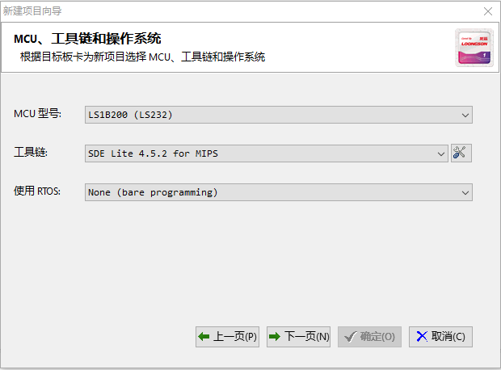

MCU型号：LS1B200（LS232）。

工具链：SDE Lite 4.5.2 for MIPS。

点击“下一页“。

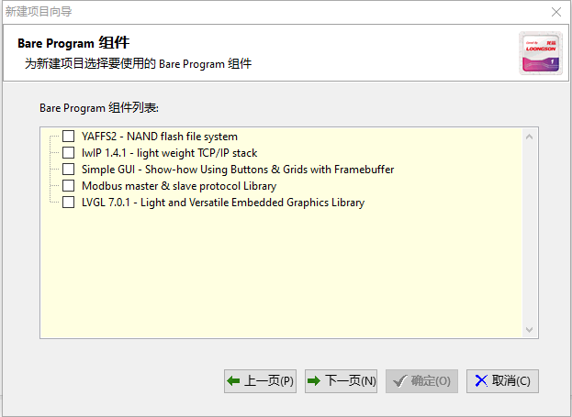

保持默认，点击“下一页“。

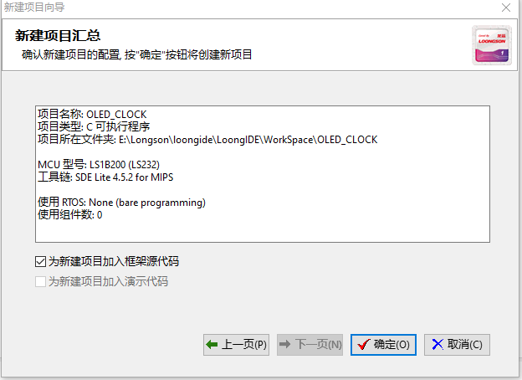

保持默认，点击“确定“。

工程创建成功。

# 修改main.c主程序文件

此文件是函数的主程序文件，主要执行如下功能：

1. 初始化实时时钟RTC，为其设定初始时间。设置RTC中断触发间隔，启用实时时钟RTC。初始化IIC总线。初始化OLED显示屏控制芯片。在OLED显示时钟背景（图片）。进入空循环，等待RTC中断到来。
2. RTC中断到来后执行中断回调函数id ls1x_rtc_callback，然后向串口五输出RTC的值。利用函数get_date将获取到的日期以字符串形式保存在字符串数组aShowDate中，利用函数get_time将获取到的时间以字符串形式保存在字符串数组aShowTime中，最后调用函数将字符串中缓存的信息输出到IIC驱动的OLED显示屏。最后，中断结束。

将此文件原有代码删除，添加如下代码：

#include "mips.h"

#include "ls1b.h"

#include "bsp.h"

#include "ls1x_i2c_bus.h"

#include "ls1x_rtc.h"

#include <stdio.h>

#include <errno.h>

#include <stdint.h>

typedef unsigned char uint8_t;

uint8_t space[11] = " ";

uint8_t aShowTime[9] = "hh:mm:ss";

uint8_t aShowDate[11] = "dd-mm-yyyy";

//-------------------------------------------------------------------------------------------------

// RTC程序

//-------------------------------------------------------------------------------------------------

//driver coding

void get_date(int year,int mon,int day)

{

aShowDate[0]= day / 10 + 48;

aShowDate[1]= day % 10 + 48;

aShowDate[3]= mon / 10 + 48;

aShowDate[4]= mon % 10 + 48;

aShowDate[6]= year / 1000 + 48;

aShowDate[7]= (year % 1000)/100 + 48;

aShowDate[8]= (year % 100)/10 + 48;

aShowDate[9]= year % 10 + 48;

}

void get_time(int hour,int min,int sec)

{

aShowTime[0]= hour / 10 + 48;

aShowTime[1]= hour % 10 + 48;

aShowTime[3]= min / 10 + 48;

aShowTime[4]= min % 10 + 48;

aShowTime[6]= sec / 10 + 48;

aShowTime[7]= sec % 10 + 48;

}

static void ls1x_rtc_isr(int vector, void *arg)

{

int device, index;

if (arg == NULL)

return;

device = (int)arg & 0xFF00;

index = (int)arg & 0x00FF;

printk("isr from device=%i, index=%i\r\n", device, index);

}

static void ls1x_rtc_callback(int device, unsigned match, int *stop)

{

struct tm dt;

switch (device & 0xFF00)

{

case LS1X_TOY:

ls1x_toymatch_to_tm(&dt, match);

normalize_tm(&dt, false);

printk("isr = %i.%i.%i-%i:%i:%i <-\r\n",dt.tm_year, dt.tm_mon, dt.tm_mday, dt.tm_hour, dt.tm_min, dt.tm_sec);

get_date(dt.tm_year,dt.tm_mon,dt.tm_mday);

OLED_ShowString(22,2,aShowDate); //字符串显示日期

get_time(dt.tm_hour,dt.tm_min,dt.tm_sec);

OLED_ShowString_Short(28,4,aShowTime,8); //限定长度8位

break;

case LS1X_RTC:

printk("rtc%i <-\r\n", device & 0xFF);

break;

}

}

//-------------------------------------------------------------------------------------------------

// 主程序

//-------------------------------------------------------------------------------------------------

int main()

{

struct tm dt;

rtc_cfg_t cfg;

//设置RTC初始时间

dt.tm_year=2021;

dt.tm_mon=11;

dt.tm_mday=5;

dt.tm_hour=22;

dt.tm_min=30;

dt.tm_sec=59;

ls1x_rtc_init(NULL, &dt);

dt.tm_sec+=10;

cfg.interval_ms=1000; //RTC中断触发间隔

cfg.trig_datetime=NULL;

cfg.cb=ls1x_rtc_callback; //中断回调函数

cfg.isr=NULL;

ls1x_rtc_open(DEVICE_TOYMATCH0, &cfg);

//初始化IIC总线与OLED控制芯片ssd1306

ls1x_i2c_initialize(busI2C0);

Initial_M096128x64_ssd1306();

//unsigned char y=0;

delay_ms(5);

Picture(1);//显示一张图片--壁纸

OLED_ShowString(22,2,space); //清空原图片中间部分（准备显示日期与时间）

OLED_ShowString(22,4,space);

while (1)

{

}

return 0;

}

# 修改bsp.h文件

在LoingIDE开发软件左侧“项目视图“窗口下，双击打开”include“文件夹，该路径下双击打开”bsp.h“文件。

按下图所示，将#define BSP_USE_I2C0取消注释。通过此修改，启用开发板的I2C设备。

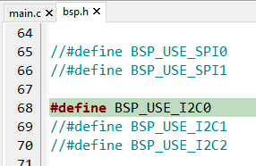

# 创建chars.h文件

此文件存储字符的字模，包含ASCII码表绝大多数字符。

右键单击“项目视图“下的OLED_CLOCK（即工程名）,选择“新建头文件“，在弹出的对话框中输入”chars.h“，并点击”确定“。

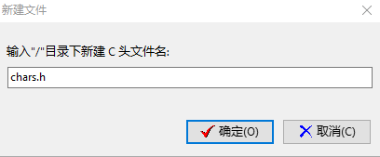

在chars.h文件下输入以下代码并保存：

/*

* mem2.h

*

* created: 2021/11/12

* author:

*/

#ifndef _MEM2_H

#define _MEM2_H

#endif // _MEM2_H

const unsigned char L8H16[][8]=

{

{0x00,0x00,0x00,0x00,0x00,0x00,0x00,0x00},

{0x00,0x00,0x00,0x00,0x00,0x00,0x00,0x00},//space 0

{0x00,0x00,0x00,0xF8,0x00,0x00,0x00,0x00},

{0x00,0x00,0x00,0x33,0x30,0x00,0x00,0x00},//! 1

{0x00,0x10,0x0C,0x06,0x10,0x0C,0x06,0x00},

{0x00,0x00,0x00,0x00,0x00,0x00,0x00,0x00},//" 2

{0x40,0xC0,0x78,0x40,0xC0,0x78,0x40,0x00},

{0x04,0x3F,0x04,0x04,0x3F,0x04,0x04,0x00},//# 3

{0x00,0x70,0x88,0xFC,0x08,0x30,0x00,0x00},

{0x00,0x18,0x20,0xFF,0x21,0x1E,0x00,0x00},//$ 4

{0xF0,0x08,0xF0,0x00,0xE0,0x18,0x00,0x00},

{0x00,0x21,0x1C,0x03,0x1E,0x21,0x1E,0x00},//% 5

{0x00,0xF0,0x08,0x88,0x70,0x00,0x00,0x00},

{0x1E,0x21,0x23,0x24,0x19,0x27,0x21,0x10},//& 6

{0x10,0x16,0x0E,0x00,0x00,0x00,0x00,0x00},

{0x00,0x00,0x00,0x00,0x00,0x00,0x00,0x00},//' 7

{0x00,0x00,0x00,0xE0,0x18,0x04,0x02,0x00},

{0x00,0x00,0x00,0x07,0x18,0x20,0x40,0x00},//( 8

{0x00,0x02,0x04,0x18,0xE0,0x00,0x00,0x00},

{0x00,0x40,0x20,0x18,0x07,0x00,0x00,0x00},//) 9

{0x40,0x40,0x80,0xF0,0x80,0x40,0x40,0x00},

{0x02,0x02,0x01,0x0F,0x01,0x02,0x02,0x00},//* 10

{0x00,0x00,0x00,0xF0,0x00,0x00,0x00,0x00},

{0x01,0x01,0x01,0x1F,0x01,0x01,0x01,0x00},//+ 11

{0x00,0x00,0x00,0x00,0x00,0x00,0x00,0x00},

{0x80,0xB0,0x70,0x00,0x00,0x00,0x00,0x00},//, 12

{0x00,0x00,0x00,0x00,0x00,0x00,0x00,0x00},

{0x00,0x01,0x01,0x01,0x01,0x01,0x01,0x01},//- 13

{0x00,0x00,0x00,0x00,0x00,0x00,0x00,0x00},

{0x00,0x30,0x30,0x00,0x00,0x00,0x00,0x00},//. 14

{0x00,0x00,0x00,0x00,0x80,0x60,0x18,0x04},

{0x00,0x60,0x18,0x06,0x01,0x00,0x00,0x00},/// 15

{0x00,0xE0,0x10,0x08,0x08,0x10,0xE0,0x00},

{0x00,0x0F,0x10,0x20,0x20,0x10,0x0F,0x00},//0 16

{0x00,0x10,0x10,0xF8,0x00,0x00,0x00,0x00},

{0x00,0x20,0x20,0x3F,0x20,0x20,0x00,0x00},//1 17

{0x00,0x70,0x08,0x08,0x08,0x88,0x70,0x00},

{0x00,0x30,0x28,0x24,0x22,0x21,0x30,0x00},//2 18

{0x00,0x30,0x08,0x88,0x88,0x48,0x30,0x00},

{0x00,0x18,0x20,0x20,0x20,0x11,0x0E,0x00},//3 19

{0x00,0x00,0xC0,0x20,0x10,0xF8,0x00,0x00},

{0x00,0x07,0x04,0x24,0x24,0x3F,0x24,0x00},//4 20

{0x00,0xF8,0x08,0x88,0x88,0x08,0x08,0x00},

{0x00,0x19,0x21,0x20,0x20,0x11,0x0E,0x00},//5 21

{0x00,0xE0,0x10,0x88,0x88,0x18,0x00,0x00},

{0x00,0x0F,0x11,0x20,0x20,0x11,0x0E,0x00},//6 22

{0x00,0x38,0x08,0x08,0xC8,0x38,0x08,0x00},

{0x00,0x00,0x00,0x3F,0x00,0x00,0x00,0x00},//7 23

{0x00,0x70,0x88,0x08,0x08,0x88,0x70,0x00},

{0x00,0x1C,0x22,0x21,0x21,0x22,0x1C,0x00},//8 24

{0x00,0xE0,0x10,0x08,0x08,0x10,0xE0,0x00},

{0x00,0x00,0x31,0x22,0x22,0x11,0x0F,0x00},//9 25

{0x00,0x00,0x00,0xC0,0xC0,0x00,0x00,0x00},

{0x00,0x00,0x00,0x30,0x30,0x00,0x00,0x00},//: 26

{0x00,0x00,0x00,0x80,0x00,0x00,0x00,0x00},

{0x00,0x00,0x80,0x60,0x00,0x00,0x00,0x00},//; 27

{0x00,0x00,0x80,0x40,0x20,0x10,0x08,0x00},

{0x00,0x01,0x02,0x04,0x08,0x10,0x20,0x00},//< 28

{0x40,0x40,0x40,0x40,0x40,0x40,0x40,0x00},

{0x04,0x04,0x04,0x04,0x04,0x04,0x04,0x00},//= 29

{0x00,0x08,0x10,0x20,0x40,0x80,0x00,0x00},

{0x00,0x20,0x10,0x08,0x04,0x02,0x01,0x00},//> 30

{0x00,0x70,0x48,0x08,0x08,0x08,0xF0,0x00},

{0x00,0x00,0x00,0x30,0x36,0x01,0x00,0x00},//? 31

{0xC0,0x30,0xC8,0x28,0xE8,0x10,0xE0,0x00},

{0x07,0x18,0x27,0x24,0x23,0x14,0x0B,0x00},//@ 32

{0x00,0x00,0xC0,0x38,0xE0,0x00,0x00,0x00},

{0x20,0x3C,0x23,0x02,0x02,0x27,0x38,0x20},//A 33

{0x08,0xF8,0x88,0x88,0x88,0x70,0x00,0x00},

{0x20,0x3F,0x20,0x20,0x20,0x11,0x0E,0x00},//B 34

{0xC0,0x30,0x08,0x08,0x08,0x08,0x38,0x00},

{0x07,0x18,0x20,0x20,0x20,0x10,0x08,0x00},//C 35

{0x08,0xF8,0x08,0x08,0x08,0x10,0xE0,0x00},

{0x20,0x3F,0x20,0x20,0x20,0x10,0x0F,0x00},//D 36

{0x08,0xF8,0x88,0x88,0xE8,0x08,0x10,0x00},

{0x20,0x3F,0x20,0x20,0x23,0x20,0x18,0x00},//E 37

{0x08,0xF8,0x88,0x88,0xE8,0x08,0x10,0x00},

{0x20,0x3F,0x20,0x00,0x03,0x00,0x00,0x00},//F 38

{0xC0,0x30,0x08,0x08,0x08,0x38,0x00,0x00},

{0x07,0x18,0x20,0x20,0x22,0x1E,0x02,0x00},//G 39

{0x08,0xF8,0x08,0x00,0x00,0x08,0xF8,0x08},

{0x20,0x3F,0x21,0x01,0x01,0x21,0x3F,0x20},//H 40

{0x00,0x08,0x08,0xF8,0x08,0x08,0x00,0x00},

{0x00,0x20,0x20,0x3F,0x20,0x20,0x00,0x00},//I 41

{0x00,0x00,0x08,0x08,0xF8,0x08,0x08,0x00},

{0xC0,0x80,0x80,0x80,0x7F,0x00,0x00,0x00},//J 42

{0x08,0xF8,0x88,0xC0,0x28,0x18,0x08,0x00},

{0x20,0x3F,0x20,0x01,0x26,0x38,0x20,0x00},//K 43

{0x08,0xF8,0x08,0x00,0x00,0x00,0x00,0x00},

{0x20,0x3F,0x20,0x20,0x20,0x20,0x30,0x00},//L 44

{0x08,0xF8,0xF8,0x00,0xF8,0xF8,0x08,0x00},

{0x20,0x3F,0x00,0x3F,0x00,0x3F,0x20,0x00},//M 45

{0x08,0xF8,0x30,0xC0,0x00,0x08,0xF8,0x08},

{0x20,0x3F,0x20,0x00,0x07,0x18,0x3F,0x00},//N 46

{0xE0,0x10,0x08,0x08,0x08,0x10,0xE0,0x00},

{0x0F,0x10,0x20,0x20,0x20,0x10,0x0F,0x00},//O 47

{0x08,0xF8,0x08,0x08,0x08,0x08,0xF0,0x00},

{0x20,0x3F,0x21,0x01,0x01,0x01,0x00,0x00},//P 48

{0xE0,0x10,0x08,0x08,0x08,0x10,0xE0,0x00},

{0x0F,0x18,0x24,0x24,0x38,0x50,0x4F,0x00},//Q 49

{0x08,0xF8,0x88,0x88,0x88,0x88,0x70,0x00},

{0x20,0x3F,0x20,0x00,0x03,0x0C,0x30,0x20},//R 50

{0x00,0x70,0x88,0x08,0x08,0x08,0x38,0x00},

{0x00,0x38,0x20,0x21,0x21,0x22,0x1C,0x00},//S 51

{0x18,0x08,0x08,0xF8,0x08,0x08,0x18,0x00},

{0x00,0x00,0x20,0x3F,0x20,0x00,0x00,0x00},//T 52

{0x08,0xF8,0x08,0x00,0x00,0x08,0xF8,0x08},

{0x00,0x1F,0x20,0x20,0x20,0x20,0x1F,0x00},//U 53

{0x08,0x78,0x88,0x00,0x00,0xC8,0x38,0x08},

{0x00,0x00,0x07,0x38,0x0E,0x01,0x00,0x00},//V 54

{0xF8,0x08,0x00,0xF8,0x00,0x08,0xF8,0x00},

{0x03,0x3C,0x07,0x00,0x07,0x3C,0x03,0x00},//W 55

{0x08,0x18,0x68,0x80,0x80,0x68,0x18,0x08},

{0x20,0x30,0x2C,0x03,0x03,0x2C,0x30,0x20},//X 56

{0x08,0x38,0xC8,0x00,0xC8,0x38,0x08,0x00},

{0x00,0x00,0x20,0x3F,0x20,0x00,0x00,0x00},//Y 57

{0x10,0x08,0x08,0x08,0xC8,0x38,0x08,0x00},

{0x20,0x38,0x26,0x21,0x20,0x20,0x18,0x00},//Z 58

{0x00,0x00,0x00,0xFE,0x02,0x02,0x02,0x00},

{0x00,0x00,0x00,0x7F,0x40,0x40,0x40,0x00},//[ 59

{0x00,0x0C,0x30,0xC0,0x00,0x00,0x00,0x00},

{0x00,0x00,0x00,0x01,0x06,0x38,0xC0,0x00},//\ 60

{0x00,0x02,0x02,0x02,0xFE,0x00,0x00,0x00},

{0x00,0x40,0x40,0x40,0x7F,0x00,0x00,0x00},//] 61

{0x00,0x00,0x04,0x02,0x02,0x02,0x04,0x00},

{0x00,0x00,0x00,0x00,0x00,0x00,0x00,0x00},//^ 62

{0x00,0x00,0x00,0x00,0x00,0x00,0x00,0x00},

{0x80,0x80,0x80,0x80,0x80,0x80,0x80,0x80},//_ 63

{0x00,0x02,0x02,0x04,0x00,0x00,0x00,0x00},

{0x00,0x00,0x00,0x00,0x00,0x00,0x00,0x00},//` 64

{0x00,0x00,0x80,0x80,0x80,0x80,0x00,0x00},

{0x00,0x19,0x24,0x22,0x22,0x22,0x3F,0x20},//a 65

{0x08,0xF8,0x00,0x80,0x80,0x00,0x00,0x00},

{0x00,0x3F,0x11,0x20,0x20,0x11,0x0E,0x00},//b 66

{0x00,0x00,0x00,0x80,0x80,0x80,0x00,0x00},

{0x00,0x0E,0x11,0x20,0x20,0x20,0x11,0x00},//c 67

{0x00,0x00,0x00,0x80,0x80,0x88,0xF8,0x00},

{0x00,0x0E,0x11,0x20,0x20,0x10,0x3F,0x20},//d 68

{0x00,0x00,0x80,0x80,0x80,0x80,0x00,0x00},

{0x00,0x1F,0x22,0x22,0x22,0x22,0x13,0x00},//e 69

{0x00,0x80,0x80,0xF0,0x88,0x88,0x88,0x18},

{0x00,0x20,0x20,0x3F,0x20,0x20,0x00,0x00},//f 70

{0x00,0x00,0x80,0x80,0x80,0x80,0x80,0x00},

{0x00,0x6B,0x94,0x94,0x94,0x93,0x60,0x00},//g 71

{0x08,0xF8,0x00,0x80,0x80,0x80,0x00,0x00},

{0x20,0x3F,0x21,0x00,0x00,0x20,0x3F,0x20},//h 72

{0x00,0x80,0x98,0x98,0x00,0x00,0x00,0x00},

{0x00,0x20,0x20,0x3F,0x20,0x20,0x00,0x00},//i 73

{0x00,0x00,0x00,0x80,0x98,0x98,0x00,0x00},

{0x00,0xC0,0x80,0x80,0x80,0x7F,0x00,0x00},//j 74

{0x08,0xF8,0x00,0x00,0x80,0x80,0x80,0x00},

{0x20,0x3F,0x24,0x02,0x2D,0x30,0x20,0x00},//k 75

{0x00,0x08,0x08,0xF8,0x00,0x00,0x00,0x00},

{0x00,0x20,0x20,0x3F,0x20,0x20,0x00,0x00},//l 76

{0x80,0x80,0x80,0x80,0x80,0x80,0x80,0x00},

{0x20,0x3F,0x20,0x00,0x3F,0x20,0x00,0x3F},//m 77

{0x80,0x80,0x00,0x80,0x80,0x80,0x00,0x00},

{0x20,0x3F,0x21,0x00,0x00,0x20,0x3F,0x20},//n 78

{0x00,0x00,0x80,0x80,0x80,0x80,0x00,0x00},

{0x00,0x1F,0x20,0x20,0x20,0x20,0x1F,0x00},//o 79

{0x80,0x80,0x00,0x80,0x80,0x00,0x00,0x00},

{0x80,0xFF,0xA1,0x20,0x20,0x11,0x0E,0x00},//p 80

{0x00,0x00,0x00,0x80,0x80,0x80,0x80,0x00},

{0x00,0x0E,0x11,0x20,0x20,0xA0,0xFF,0x80},//q 81

{0x80,0x80,0x80,0x00,0x80,0x80,0x80,0x00},

{0x20,0x20,0x3F,0x21,0x20,0x00,0x01,0x00},//r 82

{0x00,0x00,0x80,0x80,0x80,0x80,0x80,0x00},

{0x00,0x33,0x24,0x24,0x24,0x24,0x19,0x00},//s 83

{0x00,0x80,0x80,0xE0,0x80,0x80,0x00,0x00},

{0x00,0x00,0x00,0x1F,0x20,0x20,0x00,0x00},//t 84

{0x80,0x80,0x00,0x00,0x00,0x80,0x80,0x00},

{0x00,0x1F,0x20,0x20,0x20,0x10,0x3F,0x20},//u 85

{0x80,0x80,0x80,0x00,0x00,0x80,0x80,0x80},

{0x00,0x01,0x0E,0x30,0x08,0x06,0x01,0x00},//v 86

{0x80,0x80,0x00,0x80,0x00,0x80,0x80,0x80},

{0x0F,0x30,0x0C,0x03,0x0C,0x30,0x0F,0x00},//w 87

{0x00,0x80,0x80,0x00,0x80,0x80,0x80,0x00},

{0x00,0x20,0x31,0x2E,0x0E,0x31,0x20,0x00},//x 88

{0x80,0x80,0x80,0x00,0x00,0x80,0x80,0x80},

{0x80,0x81,0x8E,0x70,0x18,0x06,0x01,0x00},//y 89

{0x00,0x80,0x80,0x80,0x80,0x80,0x80,0x00},

{0x00,0x21,0x30,0x2C,0x22,0x21,0x30,0x00},//z 90

{0x00,0x00,0x00,0x00,0x80,0x7C,0x02,0x02},

{0x00,0x00,0x00,0x00,0x00,0x3F,0x40,0x40},//{ 91

{0x00,0x00,0x00,0x00,0xFF,0x00,0x00,0x00},

{0x00,0x00,0x00,0x00,0xFF,0x00,0x00,0x00},//| 92

{0x00,0x02,0x02,0x7C,0x80,0x00,0x00,0x00},

{0x00,0x40,0x40,0x3F,0x00,0x00,0x00,0x00},//} 93

{0x00,0x06,0x01,0x01,0x02,0x02,0x04,0x04},

{0x00,0x00,0x00,0x00,0x00,0x00,0x00,0x00},//~ 94

};

# 创建picture.h文件

此文件存储图片，显示屏背景图等。

右键单击“项目视图“下的OLED_CLOCK（即工程名）,选择“新建头文件“，在弹出的对话框中输入”picture.h“并点击”确定“。

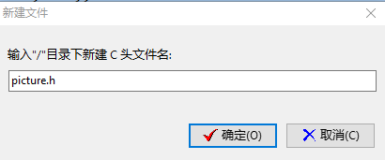

在picture.h文件下输入以下代码并保存：

/*

* mem1.h

*

* created: 2021/11/12

* author:

*/

#ifndef _MEM1_H

#define _MEM1_H

#endif // _MEM1_H

const unsigned char biaoqinbao[][128] =

{

{0X00,0X00,0X00,0X00,0X00,0X00,0X00,0X00,0X00,0X00,0X00,0X00,0X00,0X00,0X00,0X00,

0X00,0X00,0X00,0X00,0X00,0X00,0X00,0X00,0X00,0X00,0X00,0X00,0X00,0X00,0X00,0X00,

0X00,0X00,0X00,0X00,0X00,0X00,0X00,0X00,0X00,0X00,0X00,0X00,0X00,0X00,0X00,0X00,

0X00,0X00,0X00,0X00,0X00,0X00,0X00,0X00,0X00,0X00,0X00,0X00,0X00,0X00,0X00,0X00,

0X00,0X00,0X00,0X00,0X00,0X00,0X00,0X00,0X00,0X00,0X00,0X00,0X00,0X00,0X00,0X00,

0X00,0X00,0X00,0X00,0X00,0X00,0X00,0X00,0X00,0X00,0X00,0X00,0X00,0X00,0X00,0X00,

0X00,0X00,0X00,0X00,0X00,0X00,0X00,0X00,0X00,0X00,0X00,0X00,0X00,0X00,0X00,0X00,

0X00,0X00,0X00,0X00,0X00,0X00,0X00,0X00,0X00,0X00,0X00,0X00,0X00,0X00,0X00,0X00},

{0X00,0X00,0X00,0X00,0X00,0X00,0X00,0X00,0X00,0X00,0X00,0X00,0X00,0X00,0X00,0X00,

0X00,0X00,0X00,0X00,0X00,0X00,0X00,0X00,0X00,0X00,0X00,0X00,0X00,0X00,0X00,0X00,

0X00,0X00,0X00,0X00,0X00,0X00,0X00,0X00,0X00,0X00,0X00,0X00,0X00,0X00,0X00,0X00,

0X00,0X00,0X00,0X00,0X00,0X00,0X00,0X80,0X80,0XC0,0XC0,0X60,0X60,0X30,0X30,0X30,

0X30,0X30,0X30,0X30,0X30,0X30,0X30,0X30,0XB0,0X30,0X20,0X60,0X60,0XC0,0XC0,0X80,

0X80,0X00,0X00,0X00,0X00,0X00,0X00,0X00,0X00,0X00,0X00,0X00,0X00,0X00,0X00,0X00,

0X00,0X00,0X00,0X00,0X00,0X00,0X00,0X00,0X00,0X00,0X00,0X00,0X00,0X00,0X00,0X00,

0X00,0X00,0X00,0X00,0X00,0X00,0X00,0X00,0X00,0X00,0X00,0X00,0X00,0X00,0X00,0X00},

{0X00,0X00,0X00,0X00,0X00,0X00,0X00,0X00,0X00,0X00,0X00,0X00,0X00,0X00,0X00,0X00,

0X00,0X00,0X00,0X00,0X00,0X00,0X00,0X00,0X00,0X00,0X00,0X00,0X00,0X00,0X00,0X00,

0X00,0X00,0X00,0X00,0X00,0X00,0X00,0X00,0X00,0X00,0X00,0X00,0X00,0X00,0X00,0X00,

0X00,0X80,0XE0,0X78,0X1C,0X0E,0X07,0X03,0X01,0X00,0X80,0X03,0X03,0X01,0X00,0X00,

0X00,0X00,0X00,0X00,0X00,0X80,0X80,0X01,0X03,0X03,0X00,0X00,0X00,0X00,0X00,0X01,

0X03,0X07,0X0E,0X1C,0X70,0XE0,0X00,0X00,0X00,0X00,0X00,0X00,0X00,0X00,0X00,0X00,

0X00,0X00,0X00,0X00,0X00,0X00,0X00,0X00,0X00,0X00,0X00,0X00,0X00,0X00,0X00,0X00,

0X00,0X00,0X00,0X00,0X00,0X00,0X00,0X00,0X00,0X00,0X00,0X00,0X00,0X00,0X00,0X00},

{0X00,0X00,0X00,0X00,0X00,0X00,0X00,0X00,0X00,0X00,0X00,0X00,0X00,0X00,0X00,0X00,

0X00,0X00,0X00,0X00,0X00,0X00,0X00,0X00,0X00,0X00,0X00,0X00,0X00,0X00,0X00,0X00,

0X00,0X00,0X00,0X00,0X00,0X00,0X00,0X00,0X00,0X00,0X00,0X00,0X00,0X00,0XF0,0XF8,

0X0E,0X07,0X01,0X08,0X1C,0X1C,0X1C,0X1C,0X1C,0X0F,0X07,0X33,0X30,0X60,0X60,0X60,

0X60,0X60,0X60,0X30,0X33,0X03,0X0F,0X0D,0X0C,0X0C,0X0C,0X0C,0X0C,0X00,0X00,0X00,

0X00,0X00,0X00,0X00,0X00,0X87,0XFF,0X30,0X00,0X00,0X00,0X00,0X00,0X00,0X00,0X00,

0X00,0X00,0X00,0X00,0X00,0X00,0X00,0X00,0X00,0X00,0X00,0X00,0X00,0X00,0X00,0X00,

0X00,0X00,0X00,0X00,0X00,0X00,0X00,0X00,0X00,0X00,0X00,0X00,0X00,0X00,0X00,0X00},

{0X00,0X00,0X00,0X00,0X00,0X00,0X00,0X00,0X00,0X00,0X00,0X00,0X00,0X00,0X00,0X00,

0X00,0X00,0X00,0X00,0X00,0X00,0X00,0X00,0X00,0X00,0X00,0X00,0X00,0X00,0X00,0X00,

0X00,0X00,0X00,0X00,0X00,0X00,0X00,0X00,0X00,0X00,0X00,0X00,0X00,0X00,0X07,0X1F,

0X38,0X70,0X60,0XC0,0XC0,0X80,0X80,0X80,0X80,0X80,0X20,0X60,0X40,0XC0,0XC0,0X80,

0XC0,0XC0,0XC0,0X60,0X30,0X00,0X00,0X00,0X00,0X00,0X00,0X00,0X00,0X80,0X80,0X80,

0XC0,0X60,0X70,0X38,0X1C,0X0F,0X03,0X00,0X00,0X00,0X00,0X00,0X00,0X00,0X00,0X00,

0X00,0X00,0X00,0X00,0X00,0X00,0X00,0X00,0X00,0X00,0X00,0X00,0X00,0X00,0X00,0X00,

0X00,0X00,0X00,0X00,0X00,0X00,0X00,0X00,0X00,0X00,0X00,0X00,0X00,0X00,0X00,0X00},

{0X00,0X00,0X00,0X00,0X00,0X00,0X00,0X00,0X00,0X00,0X00,0X00,0X00,0X00,0X00,0X00,

0X00,0X00,0X00,0X00,0X00,0X00,0X00,0X00,0X00,0X00,0X00,0X00,0X00,0X00,0X00,0X00,

0X00,0X00,0X00,0X00,0X00,0X00,0X00,0X00,0X00,0X00,0X00,0X00,0X00,0X00,0X00,0X00,

0X80,0XC0,0XE0,0X70,0X1C,0X8F,0XC3,0X61,0X31,0X19,0X08,0X00,0X80,0XC0,0X61,0X39,

0X1D,0X01,0X81,0XE0,0X70,0X38,0X00,0X00,0XF0,0XFE,0X0F,0X03,0X03,0X01,0X01,0X01,

0X00,0X00,0X00,0X00,0X00,0X00,0X00,0X00,0X00,0X00,0X00,0X00,0X00,0X00,0X00,0X00,

0X00,0X00,0X00,0X00,0X00,0X00,0X00,0X00,0X00,0X00,0X00,0X00,0X00,0X00,0X00,0X00,

0X00,0X00,0X00,0X00,0X00,0X00,0X00,0X00,0X00,0X00,0X00,0X00,0X00,0X00,0X00,0X00},

{0X00,0X00,0X00,0X00,0X00,0X00,0X00,0X00,0X00,0X00,0X00,0X00,0X00,0X00,0X00,0X00,

0X00,0X00,0X00,0X00,0X00,0X00,0X00,0X00,0X00,0X00,0X00,0X00,0X00,0X00,0X00,0X00,

0X00,0X00,0X00,0X00,0X00,0X00,0X00,0X00,0X00,0X00,0XE0,0XE0,0XF0,0XF8,0XFE,0XE6,

0XC3,0XC7,0XC6,0X83,0X83,0XF9,0XFC,0X86,0X86,0X82,0X82,0X07,0X0D,0X0C,0X9C,0X9E,

0X9F,0X9B,0X99,0XB0,0XF0,0XF0,0XF8,0XFF,0XF7,0XF0,0XE0,0X00,0X00,0X00,0X00,0X00,

0X00,0X00,0X00,0X00,0X00,0X00,0X00,0X00,0X00,0X00,0X00,0X00,0X00,0X00,0X00,0X00,

0X00,0X00,0X00,0X00,0X00,0X00,0X00,0X00,0X00,0X00,0X00,0X00,0X00,0X00,0X00,0X00,

0X00,0X00,0X00,0X00,0X00,0X00,0X00,0X00,0X00,0X00,0X00,0X00,0X00,0X00,0X00,0X00},

{0X00,0X00,0X00,0X00,0X00,0X00,0X00,0X00,0X00,0X00,0X00,0X00,0X00,0X00,0X00,0X00,

0X00,0X00,0X00,0X00,0X00,0X00,0X00,0X00,0X00,0X00,0X00,0X00,0X00,0X00,0X00,0X00,

0X00,0X00,0X00,0X00,0X00,0X00,0X00,0X00,0X00,0X00,0X00,0X01,0X01,0X03,0X03,0X03,

0X07,0X07,0X07,0X07,0X07,0X07,0X07,0X07,0X07,0X07,0X07,0X07,0X07,0X07,0X07,0X07,

0X07,0X07,0X07,0X07,0X03,0X03,0X03,0X03,0X01,0X01,0X00,0X00,0X00,0X00,0X00,0X00,

0X00,0X00,0X00,0X00,0X00,0X00,0X00,0X00,0X00,0X00,0X00,0X00,0X00,0X00,0X00,0X00,

0X00,0X00,0X00,0X00,0X00,0X00,0X00,0X00,0X00,0X00,0X00,0X00,0X00,0X00,0X00,0X00,

0X00,0X00,0X00,0X00,0X00,0X00,0X00,0X00,0X00,0X00,0X00,0X00,0X00,0X00,0X00,0X00}

};

unsigned char show[][128]=

{

{0x00,0x00,0x06,0x0A,0xFE,0x0A,0xC6,0x00,0xE0,0x00,0xF0,0x00,0xF8,0x00,0x00,0x00,

0x00,0x00,0x00,0xFE,0x7D,0xBB,0xC7,0xEF,0xEF,0xEF,0xEF,0xEF,0xEF,0xEF,0xC7,0xBB,

0x7D,0xFE,0x00,0x00,0x00,0x00,0x00,0x00,0x00,0x00,0x00,0x00,0x00,0x00,0x00,0x00,

0x00,0x00,0x00,0x00,0x00,0x00,0x00,0x00,0x00,0x00,0x00,0x00,0x00,0x00,0x00,0x00,

0x00,0x00,0x00,0x00,0x00,0x00,0x00,0x00,0x00,0x00,0x00,0x00,0x00,0x00,0x00,0x00,

0x00,0x00,0x00,0x00,0x00,0x00,0x00,0x00,0x00,0x00,0x00,0x00,0x00,0x00,0x00,0x00,

0x08,0x0C,0xFE,0xFE,0x0C,0x08,0x20,0x60,0xFE,0xFE,0x60,0x20,0x00,0x00,0x00,0x78,

0x48,0xFE,0x82,0xBA,0xBA,0x82,0xBA,0xBA,0x82,0xBA,0xBA,0x82,0xBA,0xBA,0x82,0xFE},

{0x00,0x00,0x00,0x00,0x00,0x00,0x00,0x00,0x00,0x00,0x00,0x00,0x00,0x00,0x00,0x00,

0x00,0x00,0x00,0x00,0x00,0x01,0x01,0x01,0x01,0x01,0x01,0x01,0x01,0x01,0x01,0x01,

0x01,0x01,0x00,0x00,0x00,0x00,0x00,0x00,0x00,0x00,0x00,0x00,0x00,0x00,0x00,0x00,

0x00,0x00,0x00,0x00,0x00,0x00,0x00,0x00,0x00,0x00,0x00,0x00,0x00,0x00,0x00,0x00,

0x00,0x00,0x00,0x00,0x00,0x00,0x00,0x00,0x00,0x00,0x00,0x00,0x00,0x00,0x00,0x00,

0x00,0x00,0x00,0x00,0x00,0x00,0x00,0x00,0x00,0x00,0x00,0x00,0x00,0x00,0x00,0x00,

0x00,0x00,0x00,0x00,0x00,0x00,0x00,0x00,0x00,0x00,0x00,0x00,0x00,0x00,0x00,0x00,

0x00,0x00,0x00,0x00,0x00,0x00,0x00,0x00,0x00,0x00,0x00,0x00,0x00,0x00,0x00,0x00},

{0x00,0x00,0x00,0x00,0x00,0x00,0x00,0x00,0x00,0x00,0x00,0x00,0x00,0x00,0x00,0x00,

0x00,0x00,0x00,0x00,0x00,0x00,0x00,0x00,0x00,0x00,0x00,0x00,0x00,0x00,0x00,0x00,

0xFE,0xFF,0x03,0x03,0x03,0x03,0x03,0x03,0x03,0x03,0x03,0xFF,0xFF,0x00,0x00,0xFE,

0xFF,0x03,0x03,0x03,0x03,0x03,0x03,0x03,0x03,0x03,0xFF,0xFE,0x00,0x00,0x00,0x00,

0xC0,0xC0,0xC0,0x00,0x00,0x00,0x00,0xFE,0xFF,0x03,0x03,0x03,0x03,0x03,0x03,0x03,

0x03,0x03,0xFF,0xFE,0x00,0x00,0xFE,0xFF,0x03,0x03,0x03,0x03,0x03,0x03,0x03,0x03,

0x03,0xFF,0xFE,0x00,0x00,0x00,0x00,0x00,0x00,0x00,0x00,0x00,0x00,0x00,0x00,0x00,

0x00,0x00,0x00,0x00,0x00,0x00,0x00,0x00,0x00,0x00,0x00,0x00,0x00,0x00,0x00,0x00},

{0x00,0x00,0x00,0x00,0x00,0x00,0x00,0x00,0x00,0x00,0x00,0x00,0x00,0x00,0x00,0x00,

0x00,0x00,0x00,0x00,0x00,0x00,0x00,0x00,0x00,0x00,0x00,0x00,0x00,0x00,0x00,0x00,

0xFF,0xFF,0x00,0x00,0x00,0x00,0x00,0x00,0x00,0x00,0x00,0xFF,0xFF,0x00,0x00,0xFF,

0xFF,0x0C,0x0C,0x0C,0x0C,0x0C,0x0C,0x0C,0x0C,0x0C,0xFF,0xFF,0x00,0x00,0x00,0x00,

0xE1,0xE1,0xE1,0x00,0x00,0x00,0x00,0xFF,0xFF,0x00,0x00,0x00,0x00,0x00,0x00,0x00,

0x00,0x00,0xFF,0xFF,0x00,0x00,0xFF,0xFF,0x0C,0x0C,0x0C,0x0C,0x0C,0x0C,0x0C,0x0C,

0x0C,0xFF,0xFF,0x00,0x00,0x00,0x00,0x00,0x00,0x00,0x00,0x00,0x00,0x00,0x00,0x00,

0x00,0x00,0x00,0x00,0x00,0x00,0x00,0x00,0x00,0x00,0x00,0x00,0x00,0x00,0x00,0x00},

{0x00,0x00,0x00,0x00,0x00,0x00,0x00,0x00,0x00,0x00,0x00,0x00,0x00,0x00,0x00,0x00,

0x00,0x00,0x00,0x00,0x00,0x00,0x00,0x00,0x00,0x00,0x00,0x00,0x00,0x00,0x00,0x00,

0x0F,0x1F,0x18,0x18,0x18,0x18,0x18,0x18,0x18,0x18,0x18,0x1F,0x0F,0x00,0x00,0x0F,

0x1F,0x18,0x18,0x18,0x18,0x18,0x18,0x18,0x18,0x18,0x1F,0x0F,0x00,0x00,0x00,0x00,

0x00,0x00,0x00,0x00,0x00,0x00,0x00,0x0F,0x1F,0x18,0x18,0x18,0x18,0x18,0x18,0x18,

0x18,0x18,0x1F,0x0F,0x00,0x00,0x0F,0x1F,0x18,0x18,0x18,0x18,0x18,0x18,0x18,0x18,

0x18,0x1F,0x0F,0x00,0x00,0x00,0x00,0x00,0x00,0x00,0x00,0x00,0x00,0x00,0x00,0x00,

0x00,0x00,0x00,0x00,0x00,0x00,0x00,0x00,0x00,0x00,0x00,0x00,0x00,0x00,0x00,0x00},

{0x00,0x00,0x00,0x00,0x00,0x00,0x00,0x00,0x00,0x00,0x00,0x00,0x00,0x00,0x00,0x00,

0x00,0x00,0x00,0x00,0x00,0x00,0x00,0x00,0x00,0x00,0x00,0x00,0x00,0x00,0x00,0x00,

0x00,0x00,0x00,0x00,0x00,0x00,0x00,0xE2,0x92,0x8A,0x86,0x00,0x00,0x7C,0x82,0x82,

0x82,0x7C,0x00,0xFE,0x00,0x82,0x92,0xAA,0xC6,0x00,0x00,0xC0,0xC0,0x00,0x7C,0x82,

0x82,0x82,0x7C,0x00,0x00,0x02,0x02,0x02,0xFE,0x00,0x00,0xC0,0xC0,0x00,0x7C,0x82,

0x82,0x82,0x7C,0x00,0x00,0xFE,0x00,0x00,0x00,0x00,0x00,0x00,0x00,0x00,0x00,0x00,

0x00,0x00,0x00,0x00,0x00,0x00,0x00,0x00,0x00,0x00,0x00,0x00,0x00,0x00,0x00,0x00,

0x00,0x00,0x00,0x00,0x00,0x00,0x00,0x00,0x00,0x00,0x00,0x00,0x00,0x00,0x00,0x00},

{0x00,0x00,0x00,0x24,0xA4,0x2E,0x24,0xE4,0x24,0x2E,0xA4,0x24,0x00,0x00,0x00,0xF8,

0x4A,0x4C,0x48,0xF8,0x48,0x4C,0x4A,0xF8,0x00,0x00,0x00,0x00,0x00,0x00,0x00,0x00,

0x00,0x00,0x00,0x00,0x00,0x00,0x00,0x00,0x00,0x00,0x00,0x00,0x00,0x00,0x00,0x00,

0x00,0x00,0x00,0x00,0x00,0x00,0x00,0x00,0x00,0x00,0x00,0x00,0x00,0x00,0x00,0x00,

0x00,0x00,0x00,0x00,0x00,0x00,0x00,0x00,0x00,0x00,0x00,0x00,0x00,0x00,0x00,0x00,

0x00,0x00,0x00,0x00,0x00,0x00,0x00,0x00,0x00,0x00,0x00,0x00,0x00,0x00,0x00,0x00,

0x00,0x00,0x00,0x00,0x00,0x00,0x00,0x00,0x00,0x00,0x00,0x00,0x00,0x00,0xC0,0x20,

0x10,0x10,0x10,0x10,0x20,0xC0,0x00,0x00,0xC0,0x20,0x10,0x10,0x10,0x10,0x20,0xC0},

{0x00,0x00,0x00,0x12,0x0A,0x07,0x02,0x7F,0x02,0x07,0x0A,0x02,0x00,0x00,0x00,0x0B,

0x0A,0x0A,0x0A,0x7F,0x0A,0x0A,0x0A,0x0B,0x00,0x00,0x00,0x00,0x00,0x00,0x00,0x00,

0x00,0x00,0x00,0x00,0x00,0x00,0x00,0x00,0x00,0x00,0x00,0x00,0x00,0x00,0x00,0x00,

0x00,0x00,0x00,0x00,0x00,0x00,0x00,0x00,0x00,0x00,0x00,0x00,0x00,0x00,0x00,0x00,

0x00,0x00,0x00,0x00,0x00,0x00,0x00,0x00,0x00,0x00,0x00,0x00,0x00,0x00,0x00,0x00,

0x00,0x00,0x00,0x00,0x00,0x00,0x00,0x00,0x00,0x00,0x00,0x00,0x00,0x00,0x00,0x00,

0x00,0x00,0x00,0x00,0x00,0x00,0x00,0x00,0x00,0x00,0x00,0x00,0x00,0x00,0x1F,0x20,

0x40,0x40,0x40,0x50,0x20,0x5F,0x80,0x00,0x1F,0x20,0x40,0x40,0x40,0x50,0x20,0x5F}

};

# 创建oled_driver.h文件

此文件中声明了IIC驱动OLED的函数，包括IIC基本函数（发送数据，发送命令，初始化OLED控制芯片），IIC图片显示函数，IIC字符显示函数。

右键单击“项目视图“下的OLED_CLOCK（即工程名）,选择“新建头文件“，在弹出的对话框中输入”oled_driver.h“并点击”确定“。

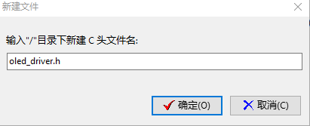

在oled_driver.h文件下输入以下代码并保存：

/*

* oled_driver.h

*

* created: 2021/11/5

* author:

*/

#ifndef _OLED_DRIVER_H

#define _OLED_DRIVER_H

unsigned char cmd_buf[2] = {0x00, 0x00};

unsigned char data_buf[2] = {0x40, 0x00};

unsigned int Addr = 0b0111100;

int rw = 0;

typedef unsigned char uint8_t;

void Write_IIC_Command(unsigned char IIC_Command);

void Write_IIC_Data(unsigned char IIC_Data);

void Initial_M096128x64_ssd1306(void);

void Picture(int i);

void fill_picture(unsigned char fill_Data);

void OLED_ShowChar(unsigned char x,unsigned char y,unsigned char chr);

void OLED_ShowString(unsigned char x,unsigned char y,unsigned char *chr);

void OLED_ShowString_Short(unsigned char x,unsigned char y, unsigned char *chr,unsigned char l);

#endif // _OLED_DRIVER_H

# 创建oled_driver.c文件

此文件中保存了IIC驱动OLED函数的实现，包括IIC基本函数（发送数据，发送命令，初始化OLED控制芯片），IIC图片显示函数，IIC字符显示函数。

右键单击“项目视图“下的OLED_CLOCK（即工程名）,选择“新建源代码文件“，在弹出的对话框中输入”oled_driver.c“并点击”确定“。

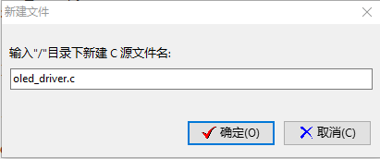

在oled_driver.c文件下输入以下代码并保存：

/*

* oled_driver.c

*

* created: 2021/11/5

* author:

*/

#include "oled_driver.h"

#include "ls1x_i2c_bus.h"

#include "picture.h"

#include "chars.h"

//-------------------------------------------------------------------------------------------------

// IIC基本函数

//-------------------------------------------------------------------------------------------------

void Write_IIC_Command(unsigned char IIC_Command){

//start the transimition

ls1x_i2c_send_start(busI2C0, Addr);

//ask the device and config to write mode

ls1x_i2c_send_addr(busI2C0, Addr, rw);

//get the command need to be sent

cmd_buf[1] = IIC_Command;

//send the command

ls1x_i2c_write_bytes(busI2C0, (uint8_t*)cmd_buf, 2);

//close the trasmition

ls1x_i2c_send_stop(busI2C0, Addr);

}

void Write_IIC_Data(unsigned char IIC_Data){

//start the transmition

ls1x_i2c_send_start(busI2C0, Addr);

//ask for the write and wait for reply

ls1x_i2c_send_addr(busI2C0, Addr, rw);

//get the data to sent

data_buf[1] = IIC_Data;

//sent the data

ls1x_i2c_write_bytes(busI2C0, (uint8_t*)data_buf, 2);

//data sented close the transmition

ls1x_i2c_send_stop(busI2C0, Addr);

}

void Initial_M096128x64_ssd1306()

{

Write_IIC_Command(0xAE); //display off

Write_IIC_Command(0x20); //Set Memory Addressing Mode

Write_IIC_Command(0x10); //00,Horizontal Addressing Mode;01,Vertical Addressing Mode;10,Page Addressing Mode (RESET);11,Invalid

Write_IIC_Command(0xb0); //Set Page Start Address for Page Addressing Mode,0-7

Write_IIC_Command(0xc8); //Set COM Output Scan Direction

Write_IIC_Command(0x00);//---set low column address

Write_IIC_Command(0x10);//---set high column address

Write_IIC_Command(0x40);//--set start line address

Write_IIC_Command(0x81);//--set contrast control register

Write_IIC_Command(0xdf);

Write_IIC_Command(0xa1);//--set segment re-map 0 to 127

Write_IIC_Command(0xa6);//--set normal display

Write_IIC_Command(0xa8);//--set multiplex ratio(1 to 64)

Write_IIC_Command(0x3F);//

Write_IIC_Command(0xa4);//0xa4,Output follows RAM content;0xa5,Output ignores RAM content

Write_IIC_Command(0xd3);//-set display offset

Write_IIC_Command(0x00);//-not offset

Write_IIC_Command(0xd5);//--set display clock divide ratio/oscillator frequency

Write_IIC_Command(0xf0);//--set divide ratio

Write_IIC_Command(0xd9);//--set pre-charge period

Write_IIC_Command(0x22); //

Write_IIC_Command(0xda);//--set com pins hardware configuration

Write_IIC_Command(0x12);

Write_IIC_Command(0xdb);//--set vcomh

Write_IIC_Command(0x20);//0x20,0.77xVcc

Write_IIC_Command(0x8d);//--set DC-DC enable

Write_IIC_Command(0x14);//

Write_IIC_Command(0xaf);//--turn on oled panel

}

//-------------------------------------------------------------------------------------------------

// IIC图片显示

//-------------------------------------------------------------------------------------------------

void Picture(int i)

{

unsigned char y;

unsigned char x;

for(y=0;y<8;y++)

{

Write_IIC_Command(0xb0+y);

Write_IIC_Command(0x0);

Write_IIC_Command(0x10);

for(x=0;x<128;x++)

{

if(i==1)

Write_IIC_Data(show[y][x]);

else if(i==2)

Write_IIC_Data(biaoqinbao[y][x]);

else ;

}

}

}

void fill_picture(unsigned char fill_Data)

{

unsigned char m;

unsigned char n;

for(m=0;m<8;m++)

{

Write_IIC_Command(0xb0+m); //page0-page1

Write_IIC_Command(0x00); //low column start address

Write_IIC_Command(0x10); //high column start address

for(n=0;n<128;n++)

{

Write_IIC_Data(fill_Data);

}

}

}

//-------------------------------------------------------------------------------------------------

// IIC字符显示

//-------------------------------------------------------------------------------------------------

void OLED_ShowChar(unsigned char x,unsigned char y,unsigned char chr)

{

unsigned char nomber=0;

int i;

nomber=chr-' ';//得到偏移后的值即ASC码偏移量 设置空格为0号字符

if(x>127) //如果超出这一行自动跳转到下一行（+2）

{

x=0;

y=y+2;

}

Write_IIC_Command(0xb0+y);

Write_IIC_Command(0x00+x%16); //低四位横坐标

Write_IIC_Command(0x10+x/16);//高四位横坐标

for(i=0;i<8;i++)

Write_IIC_Data(L8H16[nomber*2][i]);

Write_IIC_Command(0xb0+y+1);

Write_IIC_Command(0x00+x%16);

Write_IIC_Command(0x10+x/16);

for(i=0;i<8;i++)

Write_IIC_Data(L8H16[nomber*2+1][i]);

}

void OLED_ShowString(unsigned char x,unsigned char y,unsigned char *chr)

{

unsigned char i=0;

while (chr[i]!='\0') //不是字符串的结束则一直循环

{

OLED_ShowChar(x,y,chr[i]); //在x，y处显示字符

x+=8; //x=x+8 列地址加8准备显示下一字符

if(x>120) //位置不够显示当前字符，去下一行显示

{

x=0;

y+=2;

}

i++; //扫描下一字符

}

}

void OLED_ShowString_Short(unsigned char x,unsigned char y, unsigned char *chr,unsigned char l)

{

unsigned char i=0;

while (chr[i]!='\0'&&i<l) //不是字符串并且小于长度

{

OLED_ShowChar(x,y,chr[i]); //在x，y处显示字符

x+=8; //x=x+8 列地址加8准备显示下一字符

if(x>120) //位置不够显示当前字符，去下一行显示

{

x=0;

y+=2;

}

i++; //扫描下一字符

}

}

# 代码编写完成

完成上述步骤之后可以在左侧项目视图窗口下观察到如下文件信息：

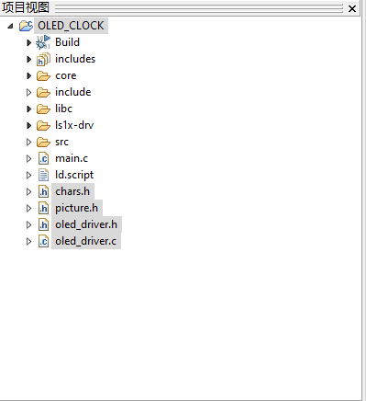

# 编译调试

在LoongIDE软件上方工具栏中，点击“项目”并选择“编译”选项。

可以在下方“消息窗口”看到如下图所示无报错信息，并成功生成OLED_CLOCK.exe可执行文件。

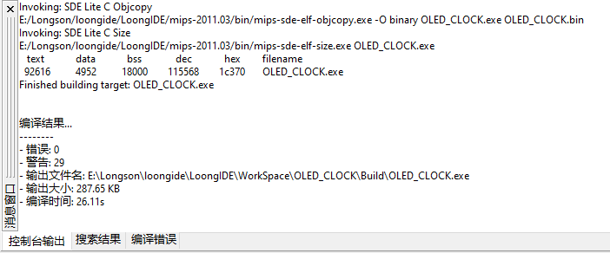

根据开发板背面的界限规则，用杜邦线连接开发板和OLED显示屏。用EJTAG连接电脑和开发板，并给卡发板上电，点击“运行”（快捷键F9）即可看到结果。

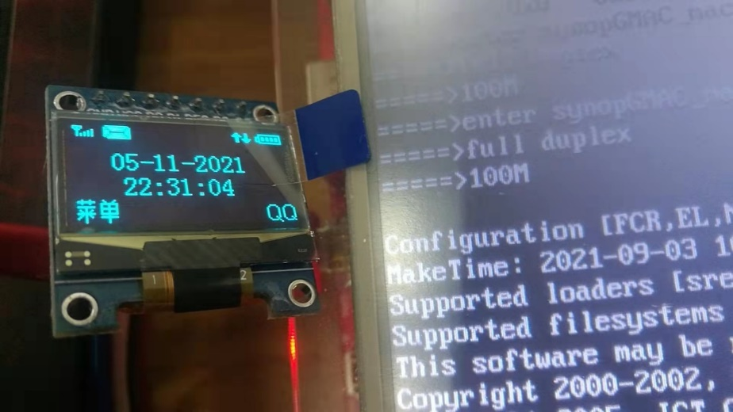

此时钟将在串口五同步显示，可以用串口线连接开发板与电脑，并使用PUTTY软件进行同步观测。

