## 2.5 实现剪刀石头布程序

2.5.1 设计方案

（1）根据视频中学习相关函数

（2）利用信号量机制与上锁实现线程抢占左右位置，并利用伪随机出剪刀石头布，并根据左右情况判断哪方胜利。

2.5.2 实现方法

/*

* Copyright (c) 2006-2018, RT-Thread Development Team

*

* SPDX-License-Identifier: Apache-2.0

*

* Change Logs:

* Date Author Notes

* 2018-08-24 yangjie the first version

*/

#include <rtthread.h>

#define THREAD_PRIORITY 25

#define THREAD_STACK_SIZE 1024

#define THREAD_TIMESLICE 5

#define MAXSEM 2

static rt_uint32_t set, i;

static rt_thread_t left_tid = RT_NULL;

static rt_thread_t right_tid = RT_NULL;

//static rt_thread_t tid3 = RT_NULL;

static rt_uint32_t array[MAXSEM];

struct rt_semaphore sem_lock;

struct rt_semaphore sem_empty;

void thread1_signal_handler(int sig)

{

rt_kprintf("thread1 received signal %d\n", sig);

}

static void thread_entry(void *parameter)

{

int cnt = 0;

while(cnt < 10){

rt_sem_take(&sem_empty, RT_WAITING_FOREVER);

rt_sem_take(&sem_lock, RT_WAITING_FOREVER);

if(set % MAXSEM == 0){

array[set%MAXSEM] = (cnt + 1) % 3;

if((cnt + 1) % 3 == 0)

rt_kprintf("the %d hao chu de shi shitou\n", set%MAXSEM);

else if((cnt + 1) % 3 == 1)

rt_kprintf("the %d hao chu de shi jiandao\n", set%MAXSEM);

else if((cnt + 1) % 3 == 2)

rt_kprintf("the %d hao chu de shi bu\n", set%MAXSEM);

}

else{

array[set%MAXSEM] = (cnt + 2) % 3;

if((cnt + 2) % 3 == 0)

rt_kprintf("the %d hao chu de shi shitou\n", set%MAXSEM);

else if((cnt + 2) % 3 == 1)

rt_kprintf("the %d hao chu de shi jiandao\n", set%MAXSEM);

else if((cnt + 2) % 3 == 2)

rt_kprintf("the %d hao chu de shi bu\n", set%MAXSEM);

}

i++;

set++;

if(i % 2 == 0)

{

if(array[0] == 0 && array[1] == 1)

rt_kprintf("shi tou ying\n", set%MAXSEM);

if(array[0] == 1 && array[1] == 2)

rt_kprintf("jiandao ying\n", set%MAXSEM);

if(array[0] == 0 && array[1] == 2)

rt_kprintf("bu ying\n", set%MAXSEM);

if(array[0] == array[1])

rt_kprintf("ping\n", set%MAXSEM);

if(array[0] == 1 && array[1] == 0)

rt_kprintf("shitou ying\n", set%MAXSEM);

if(array[0] == 2 && array[1] == 1)

rt_kprintf("jiandao\n", set%MAXSEM);

if(array[0] == 2 && array[1] == 0)

rt_kprintf("buying\n", set%MAXSEM);

}

rt_sem_release(&sem_lock);

rt_sem_release(&sem_empty);

cnt++;

rt_thread_mdelay(20);

}

//rt_signal_install(SIGUSR1, thread1_signal_handler);

//rt_signal_unmask(SIGUSR1);

//while (cnt < 10)

//{

//rt_kprintff("thread1 count : %d\n", cnt);

//cnt++;

//rt_thread_mdelay(100);

//}

}

int signal_sample(void)

{

//tid1 = rt_thread_create("thread1",

//thread1_entry, RT_NULL,

//THREAD_STACK_SIZE,

//THREAD_PRIORITY, THREAD_TIMESLICE);

//if (tid1 != RT_NULL)

//rt_thread_startup(tid1);

//rt_thread_mdelay(300);

//rt_thread_kill(tid1, SIGUSR1);

set = 0;

i = 0;

rt_sem_init(&sem_lock, "lock", 1, RT_IPC_FLAG_FIFO);

rt_sem_init(&sem_empty, "lock", MAXSEM, RT_IPC_FLAG_FIFO);

/* 初始化两个信号量 */

//rt_sem_init()

left_tid = rt_thread_create("left",

thread_entry, RT_NULL,

THREAD_STACK_SIZE,

THREAD_PRIORITY - 1, THREAD_TIMESLICE);

if (left_tid != RT_NULL)

{

rt_thread_startup(left_tid);

}

else

{

rt_kprintf("create thread left failed");

return -1;

}

right_tid = rt_thread_create("right",

thread_entry, RT_NULL,

THREAD_STACK_SIZE,

THREAD_PRIORITY - 1, THREAD_TIMESLICE);

if (right_tid != RT_NULL)

{

rt_thread_startup(right_tid);

}

else

{

rt_kprintf("create thread right failed");

return -1;

}

return 0;

}

MSH_CMD_EXPORT(signal_sample, signal sample);

**3.4 实现剪刀石头布**

输入signal_sample

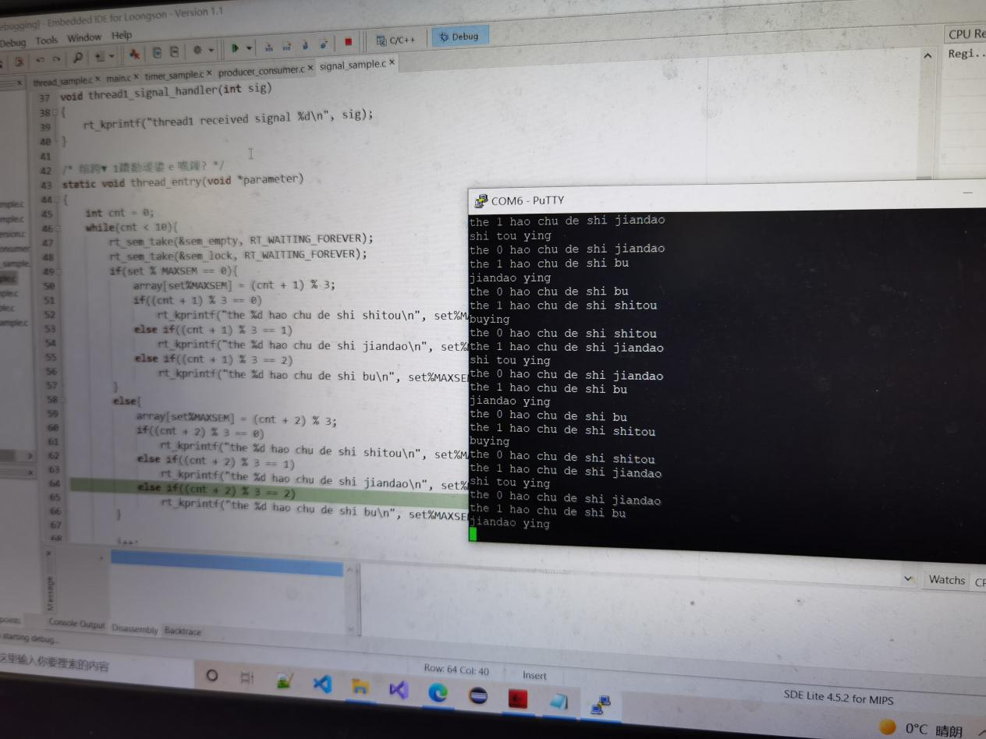

遇到问题的解决办法：

具体实现上不会用相关函数实现自己的想法，通过观看视频与阅读sample完成。