陈工新发过来的3.0测试内核可以正常启动

加载内核load tftp://192.168.31.163/vmlinux

设置启动参数g console=ttyS3,115200 rdinit=/sbin/init

启动后屏幕如下：

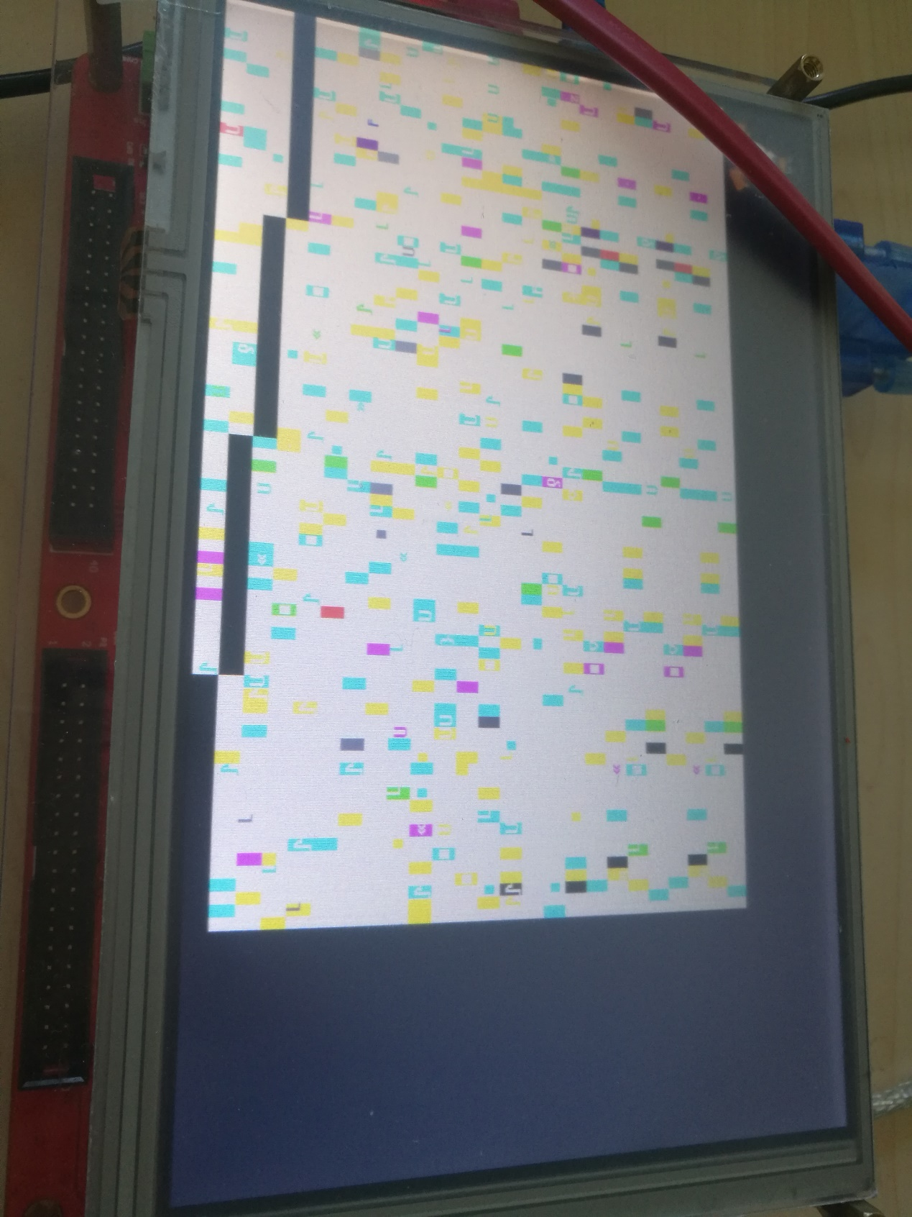

网口可以启用

用ifconfig eth0 192.168.31.122可以启用网口

但是系统会不定时卡死：如下在ping过程中会卡死

Unzip is completed

FREQ

DONE

DEVI

NAND dete

data_buff_addr:0xa01fafe0, dma_addr:0xa01fdfe0

NAND device: Manufacturer ID: 0x9b, Chip ID: 0xf1 (Unknown NAND 128MiB 3,3V 8-bit)

Scanning device for bad blocks

Creat MTD partitions on "ls1x-nand": name="kernel" size=14680064Byte

Creat MTD partitions on "ls1x-nand": name="rootfs" size=104857600Byte

Creat MTD partitions on "ls1x-nand": name="data" size=14680064Byte

ENVI

MAPV

in envinit

NVRAM@801fac20

STDV

80100000: memory between 801fa400-80200000 is already been allocated,heap is already above this point

SBDD

DINI

NETI

RTCL

in fb_init

cfb_console init, fb=0xa3108000, xres=800, yres=480

in configure

mainbus0 (root)

localbus0 at mainbus0

syn0 at localbus0

phy id = 181 b8a0

phy base = 17

in if attach

loopdev0 at mainbus0

out configure

devconfig done.

network configure 'syn0:192.168.31.111'

bootp=8000bc2c

Version = 0x1137

MacAddr = 0x0 0x55 0x7b 0xb5 0x7d 0xf7

=====>enter synopGMAC_mac_init:1006

=====>full duplex

=====>100M

=====>enter synopGMAC_mac_init:1006

=====>full duplex

=====>100M

HSTI

SYMI

SBDE

Configuration [FCR,EL,NET]

MakeTime: 2021-09-03 10:49:51.

Supported loaders [srec, elf, bin]

Supported filesystems [mtd, net, fat, fs, disk, socket, tty, ram]

This software may be redistributed under the BSD copyright.

Copyright 2000-2002, Opsycon AB, Sweden.

Copyright 2005, ICT CAS.

CPU (null) @ 200.00 MHz / Bus @ 100.00 MHz

Memory size 64 MB ( 64 MB Low memory, 0 MB High memory) .

Primary Instruction cache size 8kb (32 line, 2 way)

Primary Data cache size 8kb (32 line, 2 way)

BEV1

BEV0

BEV in SR set to zero.

update_usb, no !

AUTO

Press <Enter> to execute loading image:/dev/mtd0

Press any other key to abort. 00

Loading file: /dev/mtd0

/dev/mtd0: boot failed

PMON> ifconfig syn0

ip:192.168.31.111

netmask:255.255.255.0

boradcast:255.255.255.0

status:up running

PMON> load tftp://192.168.31.163/vmlinux

Loading file: tftp://192.168.31.163/vmlinux (elf)

0x80200000/10125172 + 0x80ba7f74/266124(z) +

Entry address is 802042a0

PMON> g console=ttyS3,115200 rdinit=/sbin/init

zero at v0 v1 a0 a1 a2 a3

00000000 00000000 00000000 00000000 00000003 a30ffcd0 a30ffce0 8008e170

t0 t1 t2 t3 t4 t5 t6 t7

00000000 00000000 00000000 00000000 00000000 00000000 00000000 00000000

s0 s1 s2 s3 s4 s5 s6 s7

00000000 00000000 00000000 00000000 00000000 00000000 00000000 00000000

t8 t9 k0 k1 gp sp s8 ra

00000000 00000000 00000000 00000000 00000000 a30ffcb0 00000000 8005aa00

Linux version 2.6.32.13 (root@weirdo-X555LI) (gcc version 4.3.6 20101004 (prerelease) (GCC) ) #86 Mon Oct 18 16:13:38 CST 2021

busclock=100000000, cpuclock=200000000, memsize=64, highmemsize=0

bootconsole [early0] enabled

CPU revision is: 00004220 (ICT Loongson-232)

Determined physical RAM map:

memory: 04000000 @ 00000000 (usable)

Initrd not found or empty - disabling initrd

Zone PFN ranges:

Normal 0x00000000 -> 0x00001000

Movable zone start PFN for each node

early_node_map[1] active PFN ranges

0: 0x00000000 -> 0x00001000

Built 1 zonelists in Zone order, mobility grouping off. Total pages: 4088

Kernel command line: console=ttyS3,115200 rdinit=/sbin/init root=/dev/hda1

PID hash table entries: 256 (order: -4, 1024 bytes)

Dentry cache hash table entries: 8192 (order: 1, 32768 bytes)

Inode-cache hash table entries: 4096 (order: 0, 16384 bytes)

Primary instruction cache 8kB, VIPT, 2-way, linesize 32 bytes.

Primary data cache 8kB, 2-way, VIPT, no aliases, linesize 32 bytes

Memory: 52720k/65536k available (4689k kernel code, 12816k reserved, 1244k data, 3952k init, 0k highmem)

Hierarchical RCU implementation.

NR_IRQS:256

Console: colour VGA+ 80x25

Calibrating delay loop... 197.12 BogoMIPS (lpj=394240)

Mount-cache hash table entries: 2048

devtmpfs: initialized

NET: Registered protocol family 16

bio: create slab <bio-0> at 0

SCSI subsystem initialized

usbcore: registered new interface driver usbfs

usbcore: registered new interface driver hub

usbcore: registered new device driver usb

Switching to clocksource MIPS

NET: Registered protocol family 2

IP route cache hash table entries: 4096 (order: 0, 16384 bytes)

TCP established hash table entries: 2048 (order: 0, 16384 bytes)

TCP bind hash table entries: 2048 (order: -1, 8192 bytes)

TCP: Hash tables configured (established 2048 bind 2048)

TCP reno registered

NET: Registered protocol family 1

RPC: Registered udp transport module.

RPC: Registered tcp transport module.

RPC: Registered tcp NFSv4.1 backchannel transport module.

Installing knfsd (copyright (C) 1996 okir@monad.swb.de).

NTFS driver 2.1.29 [Flags: R/W].

fuse init (API version 7.13)

msgmni has been set to 102

alg: No test for stdrng (krng)

Block layer SCSI generic (bsg) driver version 0.4 loaded (major 253)

io scheduler noop registered

io scheduler anticipatory registered

io scheduler deadline registered

io scheduler cfq registered (default)

ls1x_fb_setup:Option: <NULL>

power:0x1 - 0x00100103 - 0x00000000

xres = 800, yres = 480

videomemorysize=bb800

videomemory:a3d00000::3d00000

xres = 800, yres = 480

Console: switching to colour frame buffer device 100x30

fb0: Virtual frame buffer device, using 750K of video memory

Serial: 8250/16550 driver, 4 ports, IRQ sharing disabled

serial8250.0: ttyS0 at MMIO 0x1fe40000 (irq = 2) is a 16550A

serial8250.0: ttyS1 at MMIO 0x1fe4c000 (irq = 5) is a 16550A

serial8250.0: ttyS2 at MMIO 0xbfe6c000 (irq = 29) is a 16550A

serial8250.0: ttyS3 at MMIO 0xbfe7c000 (irq = 30) is a 16550A

console [ttyS3] enabled, bootconsole disabled

console [ttyS3] enabled, bootconsole disabled

NAND device: Manufacturer ID: 0x9b, Chip ID: 0xf1 (Unknown NAND 128MiB 3,3V 8-bit)

Scanning device for bad blocks

Creating 3 MTD partitions on "nand-flash":

0x000000000000-0x000000e00000 : "kernel"

0x000000e00000-0x000007500000 : "os"

0x000007500000-0x000008000000 : "data"

vcan: Virtual CAN interface driver

CAN device driver interface

sja1000 CAN netdevice driver

sja1000_platform sja1000_platform.1: sja1000_platform device registered (reg_base=bfe50000, irq=6)

stmmac - user ID: 0x11, Synopsys ID: 0x37

DMA HW capability register supported

Normal descriptors

RX Checksum Offload Engine supported

TX Checksum insertion supported

Wake-Up On Lan supported

Initializing USB Mass Storage driver...

usbcore: registered new interface driver usb-storage

USB Mass Storage support registered.

mice: PS/2 mouse device common for all mice

i2c /dev entries driver

usbcore: registered new interface driver usbhid

usbhid: v2.6:USB HID core driver

Advanced Linux Sound Architecture Driver Version 1.0.21.

Algorithmics/MIPS FPU Emulator v1.5

ALSA device list:

No soundcards found.

TCP cubic registered

NET: Registered protocol family 17

can: controller area network core (rev 20090105 abi 8)

NET: Registered protocol family 29

can: raw protocol (rev 20090105)

can: broadcast manager protocol (rev 20090105 t)

drivers/rtc/hctosys.c: unable to open rtc device (rtc0)

Freeing unused kernel memory: 3952k freed

mount: mounting n on /proc/bus/usb failed: No such file or directory

mdev: /sys/class: No such file or directory

login

Godson2@[/]>ifconfig

lo Link encap:Local Loopback

inet addr:127.0.0.1 Mask:255.0.0.0

UP LOOPBACK RUNNING MTU:16436 Metric:1

RX packets:0 errors:0 dropped:0 overruns:0 frame:0

TX packets:0 errors:0 dropped:0 overruns:0 carrier:0

collisions:0 txqueuelen:0

RX bytes:0 (0.0 B) TX bytes:0 (0.0 B)

Godson2@[/]>ifconfig eth0 192.168.31.123

eth0: device MAC address 66:f7:fa:09:e4:cc

stmmac: probed

eth0: PHY ID 0181b8a0 at 17 IRQ 0 (stmmac-0:11) active

Godson2@[/]>PHY: stmmac-0:11 - Link is Up - 100/Full

Godson2@[/]>ifconfiUnzip is completed

FREQ

DONE

DEVI

NAND dete

data_buff_addr:0xa01fafe0, dma_addr:0xa01fdfe0

NAND device: Manufacturer ID: 0x9b, Chip ID: 0xf1 (Unknown NAND 128MiB 3,3V 8-bit)

Scanning device for bad blocks

Creat MTD partitions on "ls1x-nand": name="kernel" size=14680064Byte

Creat MTD partitions on "ls1x-nand": name="rootfs" size=104857600Byte

Creat MTD partitions on "ls1x-nand": name="data" size=14680064Byte

ENVI

MAPV

in envinit

NVRAM@801fac20

STDV

80100000: memory between 801fa400-80200000 is already been allocated,heap is already above this point

SBDD

DINI

NETI

RTCL

in fb_init

cfb_console init, fb=0xa3108000, xres=800, yres=480

in configure

mainbus0 (root)

localbus0 at mainbus0

syn0 at localbus0

phy id = 181 b8a0

phy base = 17

in if attach

loopdev0 at mainbus0

out configure

devconfig done.

network configure 'syn0:192.168.31.111'

bootp=8000bc2c

Version = 0x1137

MacAddr = 0x0 0x55 0x7b 0xb5 0x7d 0xf7

=====>enter synopGMAC_mac_init:1006

=====>full duplex

=====>100M

=====>enter synopGMAC_mac_init:1006

=====>full duplex

=====>100M

HSTI

SYMI

SBDE

Configuration [FCR,EL,NET]

MakeTime: 2021-09-03 10:49:51.

Supported loaders [srec, elf, bin]

Supported filesystems [mtd, net, fat, fs, disk, socket, tty, ram]

This software may be redistributed under the BSD copyright.

Copyright 2000-2002, Opsycon AB, Sweden.

Copyright 2005, ICT CAS.

CPU (null) @ 200.00 MHz / Bus @ 100.00 MHz

Memory size 64 MB ( 64 MB Low memory, 0 MB High memory) .

Primary Instruction cache size 8kb (32 line, 2 way)

Primary Data cache size 8kb (32 line, 2 way)

BEV1

BEV0

BEV in SR set to zero.

update_usb, no !

AUTO

Press <Enter> to execute loading image:/dev/mtd0

Press any other key to abort. 00

Loading file: /dev/mtd0

/dev/mtd0: boot failed

PMON> load tftp://192.168.31.163/vmlinux

Loading file: tftp://192.168.31.163/vmlinux (elf)

0x80200000/10125172 + 0x80ba7f74/266124(z) +

Entry address is 802042a0

PMON> g console=ttyS3,115200 rdinit=/sbin/init

zero at v0 v1 a0 a1 a2 a3

00000000 00000000 00000000 00000000 00000003 a30ffcd0 a30ffce0 8008e170

t0 t1 t2 t3 t4 t5 t6 t7

00000000 00000000 00000000 00000000 00000000 00000000 00000000 00000000

s0 s1 s2 s3 s4 s5 s6 s7

00000000 00000000 00000000 00000000 00000000 00000000 00000000 00000000

t8 t9 k0 k1 gp sp s8 ra

00000000 00000000 00000000 00000000 00000000 a30ffcb0 00000000 8005aa00

Linux version 2.6.32.13 (root@weirdo-X555LI) (gcc version 4.3.6 20101004 (prerelease) (GCC) ) #86 Mon Oct 18 16:13:38 CST 2021

busclock=100000000, cpuclock=200000000, memsize=64, highmemsize=0

bootconsole [early0] enabled

CPU revision is: 00004220 (ICT Loongson-232)

Determined physical RAM map:

memory: 04000000 @ 00000000 (usable)

Initrd not found or empty - disabling initrd

Zone PFN ranges:

Normal 0x00000000 -> 0x00001000

Movable zone start PFN for each node

early_node_map[1] active PFN ranges

0: 0x00000000 -> 0x00001000

Built 1 zonelists in Zone order, mobility grouping off. Total pages: 4088

Kernel command line: console=ttyS3,115200 rdinit=/sbin/init root=/dev/hda1

PID hash table entries: 256 (order: -4, 1024 bytes)

Dentry cache hash table entries: 8192 (order: 1, 32768 bytes)

Inode-cache hash table entries: 4096 (order: 0, 16384 bytes)

Primary instruction cache 8kB, VIPT, 2-way, linesize 32 bytes.

Primary data cache 8kB, 2-way, VIPT, no aliases, linesize 32 bytes

Memory: 52720k/65536k available (4689k kernel code, 12816k reserved, 1244k data, 3952k init, 0k highmem)

Hierarchical RCU implementation.

NR_IRQS:256

Console: colour VGA+ 80x25

Calibrating delay loop... 189.44 BogoMIPS (lpj=378880)

Mount-cache hash table entries: 2048

devtmpfs: initialized

NET: Registered protocol family 16

bio: create slab <bio-0> at 0

SCSI subsystem initialized

usbcore: registered new interface driver usbfs

usbcore: registered new interface driver hub

usbcore: registered new device driver usb

Switching to clocksource MIPS

NET: Registered protocol family 2

IP route cache hash table entries: 4096 (order: 0, 16384 bytes)

TCP established hash table entries: 2048 (order: 0, 16384 bytes)

TCP bind hash table entries: 2048 (order: -1, 8192 bytes)

TCP: Hash tables configured (established 2048 bind 2048)

TCP reno registered

NET: Registered protocol family 1

RPC: Registered udp transport module.

RPC: Registered tcp transport module.

RPC: Registered tcp NFSv4.1 backchannel transport module.

Installing knfsd (copyright (C) 1996 okir@monad.swb.de).

NTFS driver 2.1.29 [Flags: R/W].

fuse init (API version 7.13)

msgmni has been set to 102

alg: No test for stdrng (krng)

Block layer SCSI generic (bsg) driver version 0.4 loaded (major 253)

io scheduler noop registered

io scheduler anticipatory registered

io scheduler deadline registered

io scheduler cfq registered (default)

ls1x_fb_setup:Option: <NULL>

power:0x1 - 0x00100103 - 0x00000000

xres = 800, yres = 480

videomemorysize=bb800

videomemory:a3d00000::3d00000

xres = 800, yres = 480

Console: switching to colour frame buffer device 100x30

fb0: Virtual frame buffer device, using 750K of video memory

Serial: 8250/16550 driver, 4 ports, IRQ sharing disabled

serial8250.0: ttyS0 at MMIO 0x1fe40000 (irq = 2) is a 16550A

serial8250.0: ttyS1 at MMIO 0x1fe4c000 (irq = 5) is a 16550A

serial8250.0: ttyS2 at MMIO 0xbfe6c000 (irq = 29) is a 16550A

serial8250.0: ttyS3 at MMIO 0xbfe7c000 (irq = 30) is a 16550A

console [ttyS3] enabled, bootconsole disabled

console [ttyS3] enabled, bootconsole disabled

NAND device: Manufacturer ID: 0x9b, Chip ID: 0xf1 (Unknown NAND 128MiB 3,3V 8-bit)

Scanning device for bad blocks

Creating 3 MTD partitions on "nand-flash":

0x000000000000-0x000000e00000 : "kernel"

0x000000e00000-0x000007500000 : "os"

0x000007500000-0x000008000000 : "data"

vcan: Virtual CAN interface driver

CAN device driver interface

sja1000 CAN netdevice driver

sja1000_platform sja1000_platform.1: sja1000_platform device registered (reg_base=bfe50000, irq=6)

stmmac - user ID: 0x11, Synopsys ID: 0x37

DMA HW capability register supported

Normal descriptors

RX Checksum Offload Engine supported

TX Checksum insertion supported

Wake-Up On Lan supported

Initializing USB Mass Storage driver...

usbcore: registered new interface driver usb-storage

USB Mass Storage support registered.

mice: PS/2 mouse device common for all mice

i2c /dev entries driver

usbcore: registered new interface driver usbhid

usbhid: v2.6:USB HID core driver

Advanced Linux Sound Architecture Driver Version 1.0.21.

Algorithmics/MIPS FPU Emulator v1.5

ALSA device list:

No soundcards found.

TCP cubic registered

NET: Registered protocol family 17

can: controller area network core (rev 20090105 abi 8)

NET: Registered protocol family 29

can: raw protocol (rev 20090105)

can: broadcast manager protocol (rev 20090105 t)

drivers/rtc/hctosys.c: unable to open rtc device (rtc0)

Freeing unused kernel memory: 3952k freed

mount: mounting n on /proc/bus/usb failed: No such file or directory

mdev: /sys/class: No such file or directory

login

Godson2@[/]>ifconfig eth0 192.168.31.122

eth0: device MAC address a2:68:3f:20:6d:28

stmmac: probed

eth0: PHY ID 0181b8a0 at 17 IRQ 0 (stmmac-0:11) active

Godson2@[/]>PHY: stmmac-0:11 - Link is Up - 100/Full

Godson2@[/]>

Godson2@[/]>ifconfig

eth0 Link encap:Ethernet HWaddr A2:68:3F:20:6D:28

inet addr:192.168.31.122 Bcast:192.168.31.255 Mask:255.255.255.0

UP BROADCAST RUNNING MULTICAST MTU:1500 Metric:1

RX packets:0 errors:0 dropped:0 overruns:0 frame:0

TX packets:0 errors:0 dropped:0 overruns:0 carrier:0

collisions:0 txqueuelen:1000

RX bytes:0 (0.0 B) TX bytes:0 (0.0 B)

Interrupt:34

lo Link encap:Local Loopback

inet addr:127.0.0.1 Mask:255.0.0.0

UP LOOPBACK RUNNING MTU:16436 Metric:1

RX packets:0 errors:0 dropped:0 overruns:0 frame:0

TX packets:0 errors:0 dropped:0 overruns:0 carrier:0

collisions:0 txqueuelen:0

RX bytes:0 (0.0 B) TX bytes:0 (0.0 B)

Godson2@[/]>ping 192.168.31.163

PING 192.168.31.163 (192.168.31.163): 56 data bytes